Supplemental Digital:

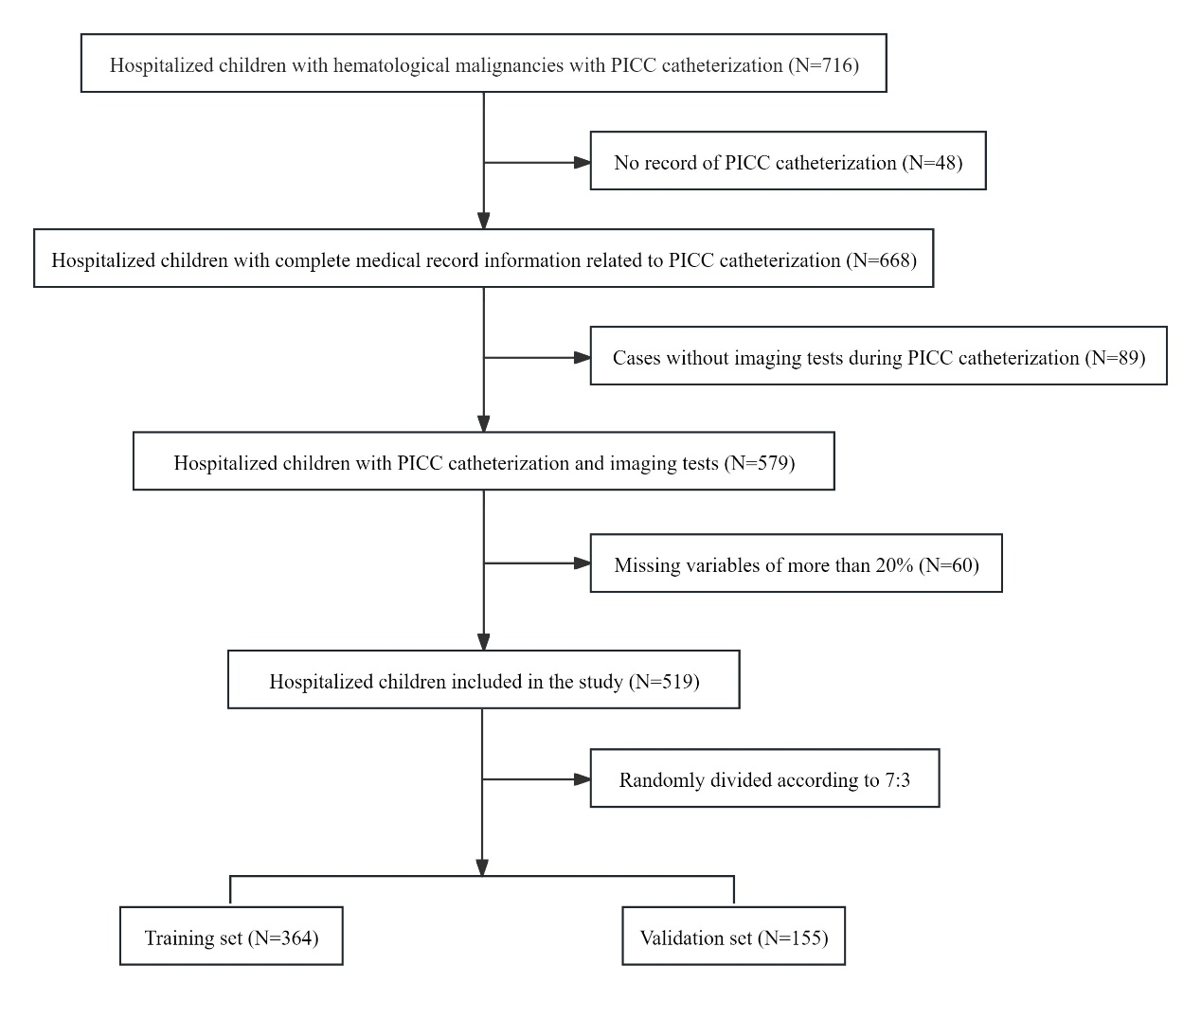
Fig. S1 Patient screening flowchart

Table S1. Baseline characteristics of the enrolled hospitalized children with PICC
Characteristics | Total  （519） | Training set（364） | Validation set （155） | P value
PICC-related thrombosis, n (%) | 98 (18.9) | 68 (18.7) | 30 (19.4) | 0.858
age (years), mean±SD | 6.10±3.61 | 6.20±3.59 | 5.89±3.67 | 0.380
sex, n (%) |  |  |  | 0.428
male | 318 (61.3) | 219 (60.2) | 99 (63.9)
female | 201 (38.7) | 145 (39.8) | 56 (36.1)
leukemia, n (%) | 347 (66.9) | 247 (67.9) | 100 (64.5) | 0.459
history of thrombosis, n (%) | 5 (1.0) | 4 (1.1) | 1 (0.6) | 1.000ª
infection, n (%) | 492 (94.8) | 343 (94.2) | 149 (96.1) | 0.373
sepsis, n (%) | 268 (51.6) | 178 (48.9) | 90 (58.1) | 0.056
co-morbid cardiac disease, n (%) | 98 (18.9) | 61 (16.8) | 37 (23.9) | 0.058
cardiac arrest, n (%) | 3 (0.6) | 3 (0.8) | 0 (0) | 0.558*
dyspnoea/asphyxia, n (%) | 50 (9.6) | 30 (8.2) | 20 (12.9) | 0.100
trauma, n (%) | 10 (1.9) | 5 (1.4) | 5 (3.2) | 0.291ª
renal disease, n (%) | 117 (22.5) | 87 (23.9) | 30 (19.4) | 0.257
gastrointestinal disease, n (%) | 164 (31.6) | 112 (30.8) | 52 (33.5) | 0.533
hepatobiliary disease, n (%) | 307 (59.2) | 207 (56.9) | 100 (64.5) | 0.105
respiratory disease, n (%) | 334 (64.4) | 239 (65.7) | 95 (61.3) | 0.342
neurological disease, n (%) | 57 (11.0) | 38 (10.4) | 19 (12.3) | 0.544
autoimmune disease, n (%) | 31 (6.0) | 18 (4.9) | 13 (8.4) | 0.130
location of insertion, n (%) |  |  |  | 0.637ª
Basilic vein | 445 (85.7) | 314 (86.3) | 131 (84.5)
Median cubital vein | 7 (1.3) | 3 (0.8) | 4 (2.6)
Cephalic vein | 24 (4.6) | 17 (4.7) | 7 (4.5)
Brachial Vein | 34 (6.6) | 25 (6.9) | 9 (5.8)
Great saphenous vein | 4 (0.8) | 2 (0.5) | 2 (1.3)
Femoral vein | 5 (1.0) | 3 (0.8) | 2 (1.3)
catheter size, n (%) |  |  |  | 0.414
3F | 321 (61.8) | 221 (60.7) | 100 (64.5)
4F | 198 (38.2) | 143 (39.3) | 55 (35.5)
side of insertion, n (%) |  |  |  | 0.591
right | 429 (82.7) | 303 (83.2) | 126 (81.3)
left | 90 (17.3) | 61 (16.8) | 29 (18.7)
number of lumens, n (%) |  |  |  | -
1 | 519 (100) | 364 (100) | 155 (100)
>=2 | 0 (0) | 0 (0) | 0 (0)
number of catheters, n (%) |  |  |  | 0.922
1 | 461 (88.8) | 323 (88.7) | 138 (89.0)
>=2 | 58 (11.2) | 41 (11.3) | 17 (11.0)
insertion length (cm), mean±SD | 26.2±5.38 | 26.3±5.39 | 25.9±5.38 | 0.453
vessel diameter (mm), mean±SD | 2.24±0.34 | 2.24±0.35 | 2.23±0.31 | 0.791
vein-to-catheter ratio, n (%) |  |  |  | 0.165ª
<2 | 166 (32.0) | 122 (33.5) | 44 (28.4)
2-3 | 350 (67.4) | 239 (65.7) | 110 (71.6)
>=3 | 3 (0.6) | 3 (0.8) | 0 (0)
arm position, n (%) |  |  |  | 0.338ª
upper section | 60 (11.6) | 47 (13.1) | 13 (8.6)
middle section | 440 (84.8) | 305 (85.0) | 135 (89.4)
lower section | 10 (1.9) | 7 (1.9) | 3 (2.0)
catheter displacement, n (%) | 275 (53.0) | 193 (53.0) | 82 (52.9) | 0.980
repeated insertions in the same arm, n (%) | 7 (1.3) | 3 (0.8) | 4 (2.6) | 0.241ª
history of catheterization, n (%) | 68 (13.1) | 49 (13.5) | 19 (12.3) | 0.710
catheter indwelling time (day), mean±SD | 178±82.7 | 175±82.9 | 184±82.1 | 0.291
chemotherapy, n (%) | 492 (94.8) | 348 (95.6) | 144 (92.9) | 0.205
ICU admission, n (%) | 84 (16.2) | 57 (15.7) | 27 (17.4) | 0.618
surgery, n (%) | 23 (4.4) | 12 (3.3) | 11 (7.1) | 0.054
mechanical ventilation, n (%) | 24 (4.6) | 14 (3.8) | 10 (6.5) | 0.196
TPN, n (%) | 139 (26.8) | 94 (25.8) | 45 (29.0) | 0.450
glucocorticoids, n (%) | 495 (95.4) | 344 (94.5) | 151 (97.4) | 0.148
vasoactive drugs, n (%) | 61 (11.8) | 46 (12.6) | 15 (9.7) | 0.338
blood products, n (%) | 469 (90.4) | 327 (89.8) | 142 (91.6) | 0.530
dialysis, n (%) | 11 (2.1) | 5 (1.4) | 6 (3.9) | 0.140ª
hypertonic liquid, n (%) | 104 (20.0) | 66 (18.1) | 38 (24.5) | 0.096
furosemide, n (%) | 204 (39.3) | 149 (40.9) | 55 (35.5) | 0.245
antibiotics, n (%) | 504 (97.1) | 351 (96.4) | 153 (98.7) | 0.257ª
anticoagulants, n (%) | 50 (9.6) | 31 (8.5) | 19 (12.3) | 0.186
cardiac catheterization, n (%) | 2 (0.4) | 1 (0.3) | 1 (0.6) | 0.509*
ECMO, n (%) | 0 (0) | 0 (0) | 0 (0) | -
pre-catheterization D-dimer, n (%) |  |  |  | 0.738
<0.5 | 214 (41.2) | 154 (42.3) | 60 (38.7)
0.5-1 | 144 (27.7) | 96 (26.4) | 48 (31.0)
1-1.5 | 64 (12.3) | 46 (12.6) | 18 (11.6)
>=1.5 | 97 (18.7) | 68 (18.7) | 29 (18.7)
pre-catheterization APTT, n (%) |  |  |  | 0.986
<=37 | 291 (56.1) | 204 (56.0) | 87 (56.1)
>37 | 228 (43.9) | 160 (44.0) | 68 (43.9)
pre-catheterization FIB, n (%) |  |  |  | 0.416
<2 | 98 (18.9) | 64 (17.6) | 34 (21.9)
2-4 | 322 (62.0) | 232 (63.7) | 90 (58.1)
>=4 | 99 (19.1) | 68 (18.7) | 31 (20.0)
pre-catheterization PT, n (%) |  |  |  | 0.387ª
<=17 | 511 (98.5) | 360 (98.9) | 151 (97.4)
>17 | 8 (1.5) | 4 (1.1) | 4 (2.6)
pre-catheterization platelet count, n (%) |  |  |  | 0.780
<125 | 271 (52.2) | 188 (51.6) | 83 (53.5)
125-350 | 176 (33.9) | 123 (33.8) | 53 (34.2)
>=350 | 72 (13.9) | 53 (14.6) | 19 (12.3)
post-catheterization D-dimer, n (%) |  |  |  | 0.986
<0.5 | 282 (54.3) | 199 (54.7) | 83 (53.5)
0.5-1 | 112 (21.6) | 79 (21.7) | 33 (21.3)
1-1.5 | 71 (13.7) | 49 (13.5) | 22 (14.2)
>=1.5 | 54 (10.4) | 37 (10.2) | 17 (11.0)
post-catheterization APTT, n (%) |  |  |  | 0.814
<=37 | 304 (58.6) | 212 (58.2) | 92 (59.4)
>37 | 215 (41.4) | 152 (41.8) | 63 (40.6)
post-catheterization FIB, n (%) |  |  |  | 0.746
<2 | 214 (41.2) | 149 (40.9) | 65 (41.9)
2-4 | 268 (51.6) | 187 (51.4) | 81 (52.3)
>=4 | 37 (7.1) | 28 (7.7) | 9 (5.8)
post-catheterization PT, n (%) |  |  |  | 0.995ª
<=17 | 514 (99.0) | 361 (99.2) | 153 (98.7)
>17 | 5 (1.0) | 3 (0.8) | 2 (1.3)
post-catheterization platelet count, n (%) |  |  |  | 0.488
<125 | 201 (38.7) | 147 (40.4) | 54 (34.8)
125-350 | 241 (46.4) | 165 (45.3) | 76 (49.0)
>=350 | 77 (14.8) | 52 (14.3) | 25 (16.1)
* Fisher’s exact test were adopted
ª The continuity correction χ2 test were adopted, and the rest adopted Pearson χ2 test
Abbreviations: PICC, Peripheral Intravenous Central Catheter; SD, standard deviation; ICU, intensive care unit; TPN, total parenteral nutrition; ECMO, extracorporeal membrane oxygenation; APTT, activated partial thromboplastin time; FIB, fibrinogen; PT, prothrombin time.

