Supplementary Table 1. Primers and siRNA sequence
Gene | For primer (5'→ 3') | Rew primer (5'→ 3')
hsa-miR-491-5p | GCAGAGGGGAACCCAACC | AGTGCAGGGTCCGAGGTATT
hsa-miR-24-1-5p | GCGAGCCAACAGAGCAGAA | AGTGCAGGGTCCGAGGTATT
hsa-miR-3926-1-5p | GCGAGGCCAAAAAGCAGG | AGTGCAGGGTCCGAGGTATT
hsa-miR-483-5p | GCGAAGACGGGAGGAAAGA | AGTGCAGGGTCCGAGGTATT
hsa-miR-489-5p | GCGGGACGAAAGAGAGACG | AGTGCAGGGTCCGAGGTATT
hsa-miR-6788-5p | GCGCAGGGAGAAGAGAGG | AGTGCAGGGTCCGAGGTATT
hsa-U6 | CTCGCTTCGGCAGCACA | AACGCTTCACGAATTTGCGT
hsa-AC112721.1 | CTGCCAGGTGGAAGTGAGG | GAGGTGACGCCAAAATGAAGC
hsa-THBS1 | AGACTCCGCATCGCAAAGG | TCACCACGTTGTTGTCAAGGG
hsa-C2CD2L | CGCCCAGAACTCAGCCTAAA | GGGTAGGTCTGGGGATGGAT
hsa-GAPDH | GGTGGTCTCCTCTGACTTCAACA | GTTGCTGTAGCCAAATTCGTTGT
Gene | Sequence
AC112721.1 siRNA | GCGATCTGTTATCACTGCA
THBS1 siRNA | GACGGAAGGTGCTGAGAAA
C2CD2L siRNA | GGCCATCTGTGGATGATAT
miR-491-5p mimic | AGUGGGGAACCCUUCCAUGAGG
miR-491-5p inhibitor | CCUCAUGGAAGGGUUCCCCACU

Supplementary Table 2. The sequence of AC112721.1
Name |  |  |  |  | Sequence
The exact sequence  cloned into pcDNA-AC112721.1, |  |  |  |  | GACAGAAAACTACACCTTGGAGACTGCACACAATTTCCTTCTACTGCTGTTTTGAAAGGT  GACCCTGTTTGTAGCACGTTGTTACAGCAGCCCTAGCAAACTAACACAGAGAGTGTGTGT  GCCCACTGCTGCCCAACATGCTGGCCAATGGGACAGGAGCTTGACGGCCTCAGCTCAGTC  TTGGAAAATAACGGGAGCCTCCAGTTCCTGAGCGATCTGTTATCACTGCAGATCGGATTT  CCAGTTTACACGTTCCTCAGGGCTTCCTGCCAGGTGGAAGTGAGGGCGCCCTCTTCTGGC  GTCTCCAGCATCCTCCCGGCCCGTCTCGGCCGGCCCCTTAGCTCCGGTTCTCCGCGGGTC  TGCAATGAGATCCTCGAGGTCCACGCCTGCTTCATTTTGGCGTCACCTCCACTTCCTAGG  GCAGGGCTTCCCCACACAATAGCCCCTCAGTGCACATTTGTTGAGTAAGTGAAGGAATGA  AGGAGTTGAGATGACTTTGAAGCTAAAATGAGTAGACATCTGACTTTGTGCCTAAGAGAA  AATTCTTCCTAAGGCTAAGATTGTTAAATAAAGGAACTGGTCCACCCA
The exact sequence used for  RNA-pulldown / mass spec |  |  |  |  | GCTAGCGACAGAAAACTACACCTTGGAGACTGCACACAATTTCCTTCTAC  TGCTGTTTTGAAAGGTGACCCTGTTTGTAGCACGTTGTTACAGCAGCCCTA  GCAAACTAACACAGAGAGTGTGTGTGCCCACTGCTGCCCAACATGCTGGC  CAATGGGACAGGAGCTTGACGGCCTCAGCTCAGTCTTGGAAAATAACGGG  AGCCTCCAGTTCCTGAGCGATCTGTTATCACTGCAGATCGGATTTCCAGTT  TACACGTTCCTCAGGGCTTCCTGCCAGGTGGAAGTGAGGGCGCCCTCTTCT  GGCGTCTCCAGCATCCTCCCGGCCCGTCTCGGCCGGCCCCTTAGCTCCGGT  TCTCCGCGGGTCTGCAATGAGATCCTCGAGGTCCACGCCTGCTTCATTTTG  GCGTCACCTCCACTTCCTAGGGCAGGGCTTCCCCACACAATAGCCCCTCAG  TGCACATTTGTTGAGTAAGTGAAGGAATGAAGGAGTTGAGATGACTTTGA  AGCTAAAATGAGTAGACATCTGACTTTGTGCCTAAGAGAAAATTCTTCCT  AAGGCTAAGATTGTTAAATAAAGGAACTGGTCCACCCAAAGCTT
Supplementary Table 3. 14 novel lncRNAs related to the survival of patients with triple negative breast cancer
number | ensembl_gene_id | external_gene_name | HR | lower 95%CI | uper 95%CI | p.val | log2 FoldChange | chromosome  name
1 | ENSG00000254966 | AC103974.1 | 3.152 | 1.283 | 7.742 | 0.012 | -1.082325989 | 11
2 | ENSG00000229512 | AC068580.1 | 3.077 | 1.254 | 7.548 | 0.014 | 1.570521868 | 11
3 | ENSG00000222022 | AC112721.1 | 2.457 | 1.088 | 5.545 | 0.031 | 3.857537807 | 2
4 | ENSG00000203971 | AL354984.1 | 0.437 | 0.199 | 0.96 | 0.039 | 3.499946397 | 20
5 | ENSG00000259976 | AC093010.3 | 0.433 | 0.191 | 0.983 | 0.045 | -1.122077748 | 3
6 | ENSG00000206249 | AL359555.1 | 0.4 | 0.177 | 0.904 | 0.028 | 3.254381129 | 20
7 | ENSG00000271888 | AL136162.1 | 0.397 | 0.16 | 0.982 | 0.046 | 1.823991381 | 6
8 | ENSG00000272853 | AC069544.1 | 0.393 | 0.181 | 0.854 | 0.018 | 1.404830839 | 10
9 | ENSG00000253348 | AC008514.1 | 0.383 | 0.165 | 0.89 | 0.026 | 2.858502068 | 5
10 | ENSG00000263884 | AP000845.1 | 0.38 | 0.155 | 0.93 | 0.034 | 1.406441787 | 18
11 | ENSG00000260645 | AL359715.2 | 0.377 | 0.167 | 0.852 | 0.019 | -1.314372795 | 6
12 | ENSG00000235545 | AC103923.1 | 0.37 | 0.151 | 0.905 | 0.029 | 1.666886824 | 1
13 | ENSG00000263893 | AC080037.2 | 0.362 | 0.146 | 0.894 | 0.028 | 5.558929685 | 17
14 | ENSG00000275479 | AC087741.2 | 0.224 | 0.076 | 0.657 | 0.006 | 1.313372332 | 17

Supplementary Table 4. Proteins specifically bound to LncAC112721.1 were identified using mass spectrometry technology
N | Unused | Total | %Cov | %Cov(50) |  | %Cov(95) | Accession | Citable Accession | Gene name | Name
73 | 7.56 | 7.56 | 10.31 | 10.31000018 |  | 7.806000113 | sp|P38646|GRP75_HUMAN | P38646 | HSPA9 | Stress-70 protein, mitochondrial OS=Homo sapiens OX=9606 GN=HSPA9 PE=1 SV=2
89 | 6.44 | 6.44 | 7.732 | 5.95600009 |  | 4.910999909 | sp|O75400|PR40A_HUMAN | O75400 | PRPF40A | Pre-mRNA-processing factor 40 homolog A OS=Homo sapiens OX=9606 GN=PRPF40A PE=1 SV=2
104 | 5.51 | 5.51 | 48.11 | 47.17000127 |  | 22.64000028 | sp|Q969Q0|RL36L_HUMAN | Q969Q0 | RPL36AL | 60S ribosomal protein L36a-like OS=Homo sapiens OX=9606 GN=RPL36AL PE=1 SV=3
109 | 5.34 | 5.34 | 13.68 | 13.6800006 |  | 13.6800006 | sp|P01594|KV133_HUMAN | P01594 | IGKV1-33 | Immunoglobulin kappa variable 1-33 OS=Homo sapiens OX=9606 GN=IGKV1-33 PE=1 SV=2
119 | 4.67 | 4.67 | 6.099 | 4.941999912 |  | 3.680000082 | sp|Q12872|SFSWA_HUMAN | Q12872 | SFSWAP | Splicing factor, suppressor of white-apricot homolog OS=Homo sapiens OX=9606 GN=SFSWAP PE=1 SV=3
134 | 4.03 | 4.03 | 34.11 | 24.77000058 |  | 8.878999949 | sp|P27635|RL10_HUMAN | P27635 | RPL10 | 60S ribosomal protein L10 OS=Homo sapiens OX=9606 GN=RPL10 PE=1 SV=4
137 | 4 | 4 | 2.995 | 1.472000033 |  | 1.472000033 | sp|P24928|RPB1_HUMAN | P24928 | POLR2A | DNA-directed RNA polymerase II subunit RPB1 OS=Homo sapiens OX=9606 GN=POLR2A PE=1 SV=2
138 | 4 | 4 | 8.523 | 8.523000032 |  | 8.523000032 | sp|Q9NQ39|RS10L_HUMAN | Q9NQ39 | RPS10P5 | Putative 40S ribosomal protein S10-like OS=Homo sapiens OX=9606 GN=RPS10P5 PE=5 SV=1
140 | 3.92 | 3.92 | 4.364 | 3.116999939 |  | 3.116999939 | sp|Q99459|CDC5L_HUMAN | Q99459 | CDC5L | Cell division cycle 5-like protein OS=Homo sapiens OX=9606 GN=CDC5L PE=1 SV=2
146 | 3.7 | 3.7 | 5.596 | 1.703000069 |  | 1.703000069 | sp|Q14683|SMC1A_HUMAN | Q14683 | SMC1A | Structural maintenance of chromosomes protein 1A OS=Homo sapiens OX=9606 GN=SMC1A PE=1 SV=2
147 | 3.62 | 3.62 | 9.416 | 5.838000029 |  | 3.954999894 | sp|Q6P1J9|CDC73_HUMAN | Q6P1J9 | CDC73 | Parafibromin OS=Homo sapiens OX=9606 GN=CDC73 PE=1 SV=1
149 | 3.59 | 3.59 | 3.743 | 1.841999963 |  | 1.841999963 | sp|Q8WWI1|LMO7_HUMAN | Q8WWI1 | LMO7 | LIM domain only protein 7 OS=Homo sapiens OX=9606 GN=LMO7 PE=1 SV=3
150 | 3.57 | 3.57 | 11.57 | 5.431000143 |  | 2.834000066 | sp|Q8IY81|SPB1_HUMAN | Q8IY81 | FTSJ3 | pre-rRNA 2'-O-ribose RNA methyltransferase FTSJ3 OS=Homo sapiens OX=9606 GN=FTSJ3 PE=1 SV=2
153 | 3.49 | 3.49 | 35.57 | 30.86999953 |  | 22.14999944 | sp|P0DP25|CALM3_HUMAN | P0DP25 | CALM3 | Calmodulin-3 OS=Homo sapiens OX=9606 GN=CALM3 PE=1 SV=1
156 | 3.44 | 3.44 | 2.087 | 2.087000012 |  | 2.087000012 | sp|Q9H2P0|ADNP_HUMAN | Q9H2P0 | ADNP | Activity-dependent neuroprotector homeobox protein OS=Homo sapiens OX=9606 GN=ADNP PE=1 SV=1
168 | 3.03 | 3.03 | 5.897 | 5.897000059 |  | 5.897000059 | sp|Q14240|IF4A2_HUMAN | Q14240 | EIF4A2 | Eukaryotic initiation factor 4A-II OS=Homo sapiens OX=9606 GN=EIF4A2 PE=1 SV=2
170 | 2.99 | 3 | 13.85 | 13.8500005 |  | 8.845999837 | sp|O95478|NSA2_HUMAN | O95478 | NSA2 | Ribosome biogenesis protein NSA2 homolog OS=Homo sapiens OX=9606 GN=NSA2 PE=1 SV=1
172 | 2.98 | 2.98 | 24.76 | 19.05000061 |  | 19.05000061 | sp|Q9Y3U8|RL36_HUMAN | Q9Y3U8 | RPL36 | 60S ribosomal protein L36 OS=Homo sapiens OX=9606 GN=RPL36 PE=1 SV=3
174 | 2.96 | 2.96 | 24.44 | 17.03999937 |  | 17.03999937 | sp|P62910|RL32_HUMAN | P62910 | RPL32 | 60S ribosomal protein L32 OS=Homo sapiens OX=9606 GN=RPL32 PE=1 SV=2
175 | 2.94 | 2.94 | 15.5 | 15.50000012 |  | 15.50000012 | sp|Q9BTM1|H2AJ_HUMAN | Q9BTM1 | H2AJ | Histone H2A.J OS=Homo sapiens OX=9606 GN=H2AJ PE=1 SV=1
179 | 2.85 | 2.85 | 2.386 | 1.412000041 |  | 1.021999959 | sp|Q92614|MY18A_HUMAN | Q92614 | MYO18A | Unconventional myosin-XVIIIa OS=Homo sapiens OX=9606 GN=MYO18A PE=1 SV=3
181 | 2.81 | 2.81 | 44.29 | 34.2900008 |  | 31.43000007 | sp|P63173|RL38_HUMAN | P63173 | RPL38 | 60S ribosomal protein L38 OS=Homo sapiens OX=9606 GN=RPL38 PE=1 SV=2
182 | 2.78 | 2.78 | 3.944 | 3.943999857 |  | 2.676000074 | sp|P19338|NUCL_HUMAN | P19338 | NCL | Nucleolin OS=Homo sapiens OX=9606 GN=NCL PE=1 SV=3
185 | 2.67 | 2.67 | 5.594 | 5.593999848 |  | 5.245000124 | sp|P52907|CAZA1_HUMAN | P52907 | CAPZA1 | F-actin-capping protein subunit alpha-1 OS=Homo sapiens OX=9606 GN=CAPZA1 PE=1 SV=3
190 | 2.51 | 2.51 | 2.5 | 0.714300014 |  | 0.312500005 | sp|Q9BTC0|DIDO1_HUMAN | Q9BTC0 | DIDO1 | Death-inducer obliterator 1 OS=Homo sapiens OX=9606 GN=DIDO1 PE=1 SV=5
192 | 2.47 | 2.47 | 13.68 | 13.6800006 |  | 13.6800006 | sp|A0A0C4DH69|KV109_HUMAN | A0A0C4DH69 | IGKV1-9 | Immunoglobulin kappa variable 1-9 OS=Homo sapiens OX=9606 GN=IGKV1-9 PE=3 SV=1
194 | 2.42 | 2.42 | 5.069 | 5.068999901 |  | 2.765000053 | sp|Q7L4I2|RSRC2_HUMAN | Q7L4I2 | RSRC2 | Arginine/serine-rich coiled-coil protein 2 OS=Homo sapiens OX=9606 GN=RSRC2 PE=1 SV=1
200 | 2.39 | 2.39 | 7.277 | 3.262000158 |  | 1.25500001 | sp|Q9Y4W6|AFG32_HUMAN | Q9Y4W6 | AFG3L2 | AFG3-like protein 2 OS=Homo sapiens OX=9606 GN=AFG3L2 PE=1 SV=2
203 | 2.34 | 2.34 | 8.201 | 3.438999876 |  | 1.720000058 | sp|Q5QJE6|TDIF2_HUMAN | Q5QJE6 | DNTTIP2 | Deoxynucleotidyltransferase terminal-interacting protein 2 OS=Homo sapiens OX=9606 GN=DNTTIP2 PE=1 SV=2
204 | 2.32 | 2.32 | 2.852 | 2.851999924 |  | 0.950600021 | sp|O60264|SMCA5_HUMAN | O60264 | SMARCA5 | SWI/SNF-related matrix-associated actin-dependent regulator of chromatin subfamily A member 5 OS=Homo sapiens OX=9606 GN=SMARCA5 PE=1 SV=1
205 | 2.31 | 2.31 | 20 | 15.62999934 |  | 11.2499997 | sp|P46778|RL21_HUMAN | P46778 | RPL21 | 60S ribosomal protein L21 OS=Homo sapiens OX=9606 GN=RPL21 PE=1 SV=2
206 | 2.29 | 2.29 | 5.069 | 5.068999901 |  | 2.995000035 | sp|P06733|ENOA_HUMAN | P06733 | ENO1 | Alpha-enolase OS=Homo sapiens OX=9606 GN=ENO1 PE=1 SV=2
207 | 2.27 | 2.27 | 30.34 | 14.04000074 |  | 7.864999771 | sp|Q9Y3C1|NOP16_HUMAN | Q9Y3C1 | NOP16 | Nucleolar protein 16 OS=Homo sapiens OX=9606 GN=NOP16 PE=1 SV=2
208 | 2.23 | 2.23 | 33.91 | 33.91000032 |  | 7.825999707 | sp|P62854|RS26_HUMAN | P62854 | RPS26 | 40S ribosomal protein S26 OS=Homo sapiens OX=9606 GN=RPS26 PE=1 SV=3
209 | 2.2 | 2.2 | 7.388 | 4.123999923 |  | 2.404999919 | sp|Q9NVN8|GNL3L_HUMAN | Q9NVN8 | GNL3L | Guanine nucleotide-binding protein-like 3-like protein OS=Homo sapiens OX=9606 GN=GNL3L PE=1 SV=1
211 | 2.12 | 2.12 | 5.778 | 1.926000044 |  | 1.926000044 | sp|O60506|HNRPQ_HUMAN | O60506 | SYNCRIP | Heterogeneous nuclear ribonucleoprotein Q OS=Homo sapiens OX=9606 GN=SYNCRIP PE=1 SV=2
212 | 2.12 | 2.12 | 6.484 | 3.313999996 |  | 1.872999966 | sp|Q86XJ1|GA2L3_HUMAN | Q86XJ1 | GAS2L3 | GAS2-like protein 3 OS=Homo sapiens OX=9606 GN=GAS2L3 PE=1 SV=1
214 | 2.08 | 2.08 | 1.765 | 0.882599968 |  | 0.617800001 | sp|Q8WYP5|ELYS_HUMAN | Q8WYP5 | AHCTF1 | Protein ELYS OS=Homo sapiens OX=9606 GN=AHCTF1 PE=1 SV=3
216 | 2.06 | 2.06 | 8.568 | 6.266000122 |  | 3.835999966 | sp|P06396|GELS_HUMAN | P06396 | GSN | Gelsolin OS=Homo sapiens OX=9606 GN=GSN PE=1 SV=1
217 | 2.05 | 2.05 | 1.82 | 1.195000019 |  | 0.796400011 | sp|Q7Z3J3|RGPD4_HUMAN | Q7Z3J3 | RGPD4 | RanBP2-like and GRIP domain-containing protein 4 OS=Homo sapiens OX=9606 GN=RGPD4 PE=2 SV=3
219 | 2.04 | 2.04 | 20.62 | 12.06 |  | 3.502000123 | sp|P82914|RT15_HUMAN | P82914 | MRPS15 | 28S ribosomal protein S15, mitochondrial OS=Homo sapiens OX=9606 GN=MRPS15 PE=1 SV=1
220 | 2.04 | 2.04 | 3.493 | 1.81099996 |  | 1.81099996 | sp|Q96TA2|YMEL1_HUMAN | Q96TA2 | YME1L1 | ATP-dependent zinc metalloprotease YME1L1 OS=Homo sapiens OX=9606 GN=YME1L1 PE=1 SV=2
224 | 2.02 | 2.02 | 2.542 | 0.95309997 |  | 0.95309997 | sp|P28290|ITPI2_HUMAN | P28290 | ITPRID2 | Protein ITPRID2 OS=Homo sapiens OX=9606 GN=ITPRID2 PE=1 SV=3
226 | 2.02 | 2.02 | 10.41 | 7.69200027 |  | 7.69200027 | sp|Q01130|SRSF2_HUMAN | Q01130 | SRSF2 | Serine/arginine-rich splicing factor 2 OS=Homo sapiens OX=9606 GN=SRSF2 PE=1 SV=4
227 | 2.01 | 2.01 | 5.018 | 1.792000048 |  | 1.792000048 | sp|Q9UBB9|TFP11_HUMAN | Q9UBB9 | TFIP11 | Tuftelin-interacting protein 11 OS=Homo sapiens OX=9606 GN=TFIP11 PE=1 SV=1
228 | 2.01 | 2.01 | 2.654 | 0.789100025 |  | 0.789100025 | sp|P42704|LPPRC_HUMAN | P42704 | LRPPRC | Leucine-rich PPR motif-containing protein, mitochondrial OS=Homo sapiens OX=9606 GN=LRPPRC PE=1 SV=3
235 | 2 | 2.66 | 6.406 | 6.406000257 |  | 4.270000011 | sp|P29692|EF1D_HUMAN | P29692 | EEF1D | Elongation factor 1-delta OS=Homo sapiens OX=9606 GN=EEF1D PE=1 SV=5
239 | 2 | 2 | 4.019 | 1.339999959 |  | 1.339999959 | sp|Q9Y4F1|FARP1_HUMAN | Q9Y4F1 | FARP1 | FERM, ARHGEF and pleckstrin domain-containing protein 1 OS=Homo sapiens OX=9606 GN=FARP1 PE=1 SV=1
242 | 2 | 2 | 4.04 | 2.222000062 |  | 2.222000062 | sp|Q9UHK0|NUFP1_HUMAN | Q9UHK0 | NUFIP1 | Nuclear fragile X mental retardation-interacting protein 1 OS=Homo sapiens OX=9606 GN=NUFIP1 PE=1 SV=2
244 | 2 | 2 | 5.322 | 2.598999999 |  | 2.598999999 | sp|Q4KMP7|TB10B_HUMAN | Q4KMP7 | TBC1D10B | TBC1 domain family member 10B OS=Homo sapiens OX=9606 GN=TBC1D10B PE=1 SV=3
253 | 2 | 2 | 0.9558 | 0.438100006 |  | 0.438100006 | sp|P49327|FAS_HUMAN | P49327 | FASN | Fatty acid synthase OS=Homo sapiens OX=9606 GN=FASN PE=1 SV=3
255 | 2 | 2 | 5.672 | 4.478000104 |  | 4.478000104 | sp|P04406|G3P_HUMAN | P04406 | GAPDH | Glyceraldehyde-3-phosphate dehydrogenase OS=Homo sapiens OX=9606 GN=GAPDH PE=1 SV=3
256 | 2 | 2 | 4.87 | 4.870000109 |  | 4.870000109 | sp|Q9UHR5|S30BP_HUMAN | Q9UHR5 | SAP30BP | SAP30-binding protein OS=Homo sapiens OX=9606 GN=SAP30BP PE=1 SV=1
257 | 2 | 2 | 4.149 | 4.148999974 |  | 4.148999974 | sp|Q9P031|TAP26_HUMAN | Q9P031 | CCDC59 | Thyroid transcription factor 1-associated protein 26 OS=Homo sapiens OX=9606 GN=CCDC59 PE=1 SV=2
258 | 2 | 2 | 2.113 | 2.112999931 |  | 2.112999931 | sp|Q9BRS2|RIOK1_HUMAN | Q9BRS2 | RIOK1 | Serine/threonine-protein kinase RIO1 OS=Homo sapiens OX=9606 GN=RIOK1 PE=1 SV=2
265 | 2 | 2 | 5.882 | 5.882000178 |  | 5.882000178 | sp|P61353|RL27_HUMAN | P61353 | RPL27 | 60S ribosomal protein L27 OS=Homo sapiens OX=9606 GN=RPL27 PE=1 SV=2
271 | 2 | 2 | 0.9402 | 0.940200035 |  | 0.940200035 | sp|P07996|TSP1_HUMAN | P07996 | THBS1 | Thrombospondin-1 OS=Homo sapiens OX=9606 GN=THBS1 PE=1 SV=2
273 | 2 | 2 | 1.977 | 1.977000013 |  | 1.977000013 | sp|P04843|RPN1_HUMAN | P04843 | RPN1 | Dolichyl-diphosphooligosaccharide--protein glycosyltransferase subunit 1 OS=Homo sapiens OX=9606 GN=RPN1 PE=1 SV=1
274 | 1.96 | 2 | 0.9455 | 0.945500005 |  | 0.945500005 | sp|Q8IY17|PLPL6_HUMAN | Q8IY17 | PNPLA6 | Patatin-like phospholipase domain-containing protein 6 OS=Homo sapiens OX=9606 GN=PNPLA6 PE=1 SV=3
276 | 1.92 | 1.92 | 12.73 | 12.72999942 |  | 12.72999942 | sp|P81605|DCD_HUMAN | P81605 | DCD | Dermcidin OS=Homo sapiens OX=9606 GN=DCD PE=1 SV=2
279 | 1.89 | 1.89 | 3.863 | 3.863000125 |  | 3.863000125 | sp|Q13283|G3BP1_HUMAN | Q13283 | G3BP1 | Ras GTPase-activating protein-binding protein 1 OS=Homo sapiens OX=9606 GN=G3BP1 PE=1 SV=1
281 | 1.79 | 1.85 | 23.86 | 6.863000244 |  | 6.863000244 | sp|P07910|HNRPC_HUMAN | P07910 | HNRNPC | Heterogeneous nuclear ribonucleoproteins C1/C2 OS=Homo sapiens OX=9606 GN=HNRNPC PE=1 SV=4
286 | 1.72 | 1.72 | 4.202 | 2.101000026 |  | 2.101000026 | sp|P61619|S61A1_HUMAN | P61619 | SEC61A1 | Protein transport protein Sec61 subunit alpha isoform 1 OS=Homo sapiens OX=9606 GN=SEC61A1 PE=1 SV=2
287 | 1.7 | 1.7 | 4.967 | 2.197000012 |  | 2.197000012 | sp|Q9Y5B9|SP16H_HUMAN | Q9Y5B9 | SUPT16H | FACT complex subunit SPT16 OS=Homo sapiens OX=9606 GN=SUPT16H PE=1 SV=1
289 | 1.68 | 1.68 | 3.867 | 3.866999969 |  | 3.866999969 | sp|Q9P035|HACD3_HUMAN | Q9P035 | HACD3 | Very-long-chain (3R)-3-hydroxyacyl-CoA dehydratase 3 OS=Homo sapiens OX=9606 GN=HACD3 PE=1 SV=2
291 | 1.65 | 1.65 | 6.87 | 4.070999846 |  | 4.070999846 | sp|Q99536|VAT1_HUMAN | Q99536 | VAT1 | Synaptic vesicle membrane protein VAT-1 homolog OS=Homo sapiens OX=9606 GN=VAT1 PE=1 SV=2
292 | 1.62 | 1.62 | 3.803 | 1.123999991 |  | 1.123999991 | sp|Q8IY37|DHX37_HUMAN | Q8IY37 | DHX37 | Probable ATP-dependent RNA helicase DHX37 OS=Homo sapiens OX=9606 GN=DHX37 PE=1 SV=1
293 | 1.59 | 1.59 | 2.841 | 1.025999989 |  | 1.025999989 | sp|Q92610|ZN592_HUMAN | Q92610 | ZNF592 | Zinc finger protein 592 OS=Homo sapiens OX=9606 GN=ZNF592 PE=1 SV=2
295 | 1.54 | 1.54 | 6.478 | 3.156000003 |  | 3.156000003 | sp|Q07065|CKAP4_HUMAN | Q07065 | CKAP4 | Cytoskeleton-associated protein 4 OS=Homo sapiens OX=9606 GN=CKAP4 PE=1 SV=2
296 | 1.53 | 1.53 | 2.947 | 1.472999994 |  | 1.472999994 | sp|P07947|YES_HUMAN | P07947 | YES1 | Tyrosine-protein kinase Yes OS=Homo sapiens OX=9606 GN=YES1 PE=1 SV=3
297 | 1.5 | 1.5 | 7.062 | 2.763999999 |  | 1.023999974 | sp|Q96T37|RBM15_HUMAN | Q96T37 | RBM15 | RNA-binding protein 15 OS=Homo sapiens OX=9606 GN=RBM15 PE=1 SV=2
299 | 1.48 | 1.48 | 6.726 | 6.725999713 |  | 6.725999713 | sp|Q5T3I0|GPTC4_HUMAN | Q5T3I0 | GPATCH4 | G patch domain-containing protein 4 OS=Homo sapiens OX=9606 GN=GPATCH4 PE=1 SV=2
300 | 1.47 | 1.48 | 4.405 | 4.405000061 |  | 4.405000061 | sp|P00403|COX2_HUMAN | P00403 | MT-CO2 | Cytochrome c oxidase subunit 2 OS=Homo sapiens OX=9606 GN=MT-CO2 PE=1 SV=1
303 | 1.42 | 1.42 | 3.684 | 3.297999874 |  | 3.297999874 | sp|Q86YZ3|HORN_HUMAN | Q86YZ3 | HRNR | Hornerin OS=Homo sapiens OX=9606 GN=HRNR PE=1 SV=2
304 | 1.39 | 1.39 | 1.525 | 1.525000017 |  | 1.525000017 | sp|Q02413|DSG1_HUMAN | Q02413 | DSG1 | Desmoglein-1 OS=Homo sapiens OX=9606 GN=DSG1 PE=1 SV=2
306 | 1.35 | 1.35 | 5.228 | 1.854999922 |  | 1.854999922 | sp|Q8WXI9|P66B_HUMAN | Q8WXI9 | GATAD2B | Transcriptional repressor p66-beta OS=Homo sapiens OX=9606 GN=GATAD2B PE=1 SV=1
308 | 1.3 | 1.3 | 2.412 | 2.411999926 |  | 2.411999926 | sp|P50991|TCPD_HUMAN | P50991 | CCT4 | T-complex protein 1 subunit delta OS=Homo sapiens OX=9606 GN=CCT4 PE=1 SV=4

Supplementary Table 5. Correlation analysis between LncRNAs and miRNAs.

Symbol | Correlation
AC112721.1 | 1
Has-miR-24-1-5p | -0.159931035
Has-miR-3926-1 | -0.230807672
Has-miR-483-5p | -0.341861952
Has-miR-489-5p | -0.27903169
has-miR-491-5p | -0.305601253
Has-miR-6788-5p | -0.353105424

Supplementary Table 6. Target genes of miR-491-5p
Genes | TargetScan | PolymiRTs | RNA22 | MiRBase | Sum
SYNGAP1 | 1 | 1 | 1 | 1 | 4
GATAD2B | 1 | 1 | 1 | 1 | 4
FOXP4 | 1 | 1 | 0 | 1 | 3
ELOVL1 | 1 | 0 | 1 | 1 | 3
DERL3 | 1 | 1 | 0 | 1 | 3
NOVA2 | 1 | 0 | 1 | 1 | 3
TAF10 | 1 | 0 | 1 | 1 | 3
ZNF703 | 1 | 1 | 0 | 1 | 3
DNAJB5 | 1 | 1 | 0 | 1 | 3
PEA15 | 1 | 1 | 0 | 1 | 3
CREB3L2 | 1 | 1 | 0 | 1 | 3
B4GALT5 | 1 | 1 | 0 | 1 | 3
SYT2 | 1 | 1 | 0 | 1 | 3
CYP26B1 | 1 | 1 | 0 | 1 | 3
CNN2 | 1 | 1 | 1 | 0 | 3
BCL6B | 1 | 0 | 1 | 1 | 3
ZBTB4 | 1 | 0 | 1 | 1 | 3
GIPC1 | 1 | 0 | 1 | 1 | 3
ZBTB8A | 1 | 1 | 0 | 1 | 3
CLIP2 | 1 | 0 | 1 | 1 | 3
C2CD2L | 1 | 0 | 1 | 1 | 3
CELF3 | 1 | 0 | 1 | 1 | 3
IQGAP3 | 1 | 0 | 1 | 1 | 3
RASL10B | 1 | 0 | 1 | 1 | 3
PADI2 | 1 | 1 | 0 | 1 | 3
PDGFRA | 1 | 1 | 0 | 1 | 3
LRRC4B | 1 | 0 | 1 | 1 | 3
CDYL2 | 1 | 1 | 0 | 1 | 3
SRGAP3 | 1 | 1 | 0 | 1 | 3
CHD3 | 1 | 0 | 1 | 1 | 3
CSMD2 | 1 | 0 | 1 | 1 | 3
SFTPB | 0 | 1 | 1 | 1 | 3
CRX | 0 | 1 | 1 | 1 | 3
PKD1L2 | 0 | 1 | 1 | 1 | 3
SRC | 0 | 1 | 1 | 1 | 3
HSPG2 | 0 | 1 | 1 | 1 | 3
SH3PXD2A | 0 | 1 | 1 | 1 | 3
LRRTM2 | 0 | 1 | 1 | 1 | 3
KIF21B | 0 | 1 | 1 | 1 | 3
TBC1D22B | 0 | 1 | 1 | 1 | 3
SLC6A20 | 0 | 1 | 1 | 1 | 3
C6orf106 | 0 | 1 | 1 | 1 | 3
ELFN2 | 0 | 1 | 1 | 1 | 3
C11orf45 | 0 | 1 | 1 | 1 | 3
PTK7 | 0 | 1 | 1 | 1 | 3

Supplementary Figure 1
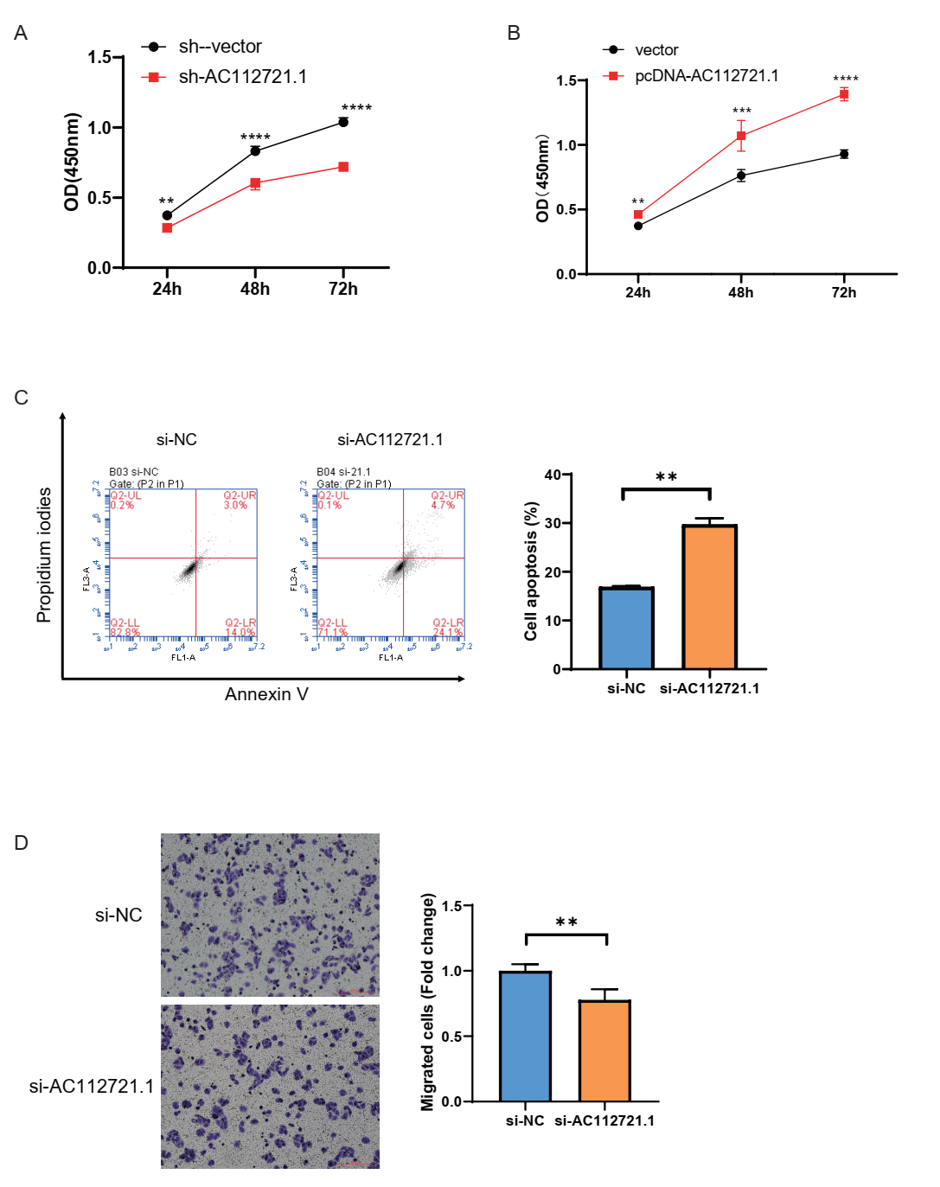

Supplementary Figure 1. A. CCK-8 assays showing the growth of MDA-MB-468 cells treated with sh-AC112721.1. B. CCK-8 assays assessed proliferation of MDA-MB-468 cells transfected with pcDNA-AC112721.1. C. Knockdown of AC112721.1 promoted MDA-MB-468 cell apoptosis. I. Knockdown of AC112721.1 inhibited MDA-MB-468 cell migration. All experiments were performed at least thrice with triplicate samples. **p < 0.01, ***p < 0.001, ****p < 0.0001.

Supplementary Figure 2
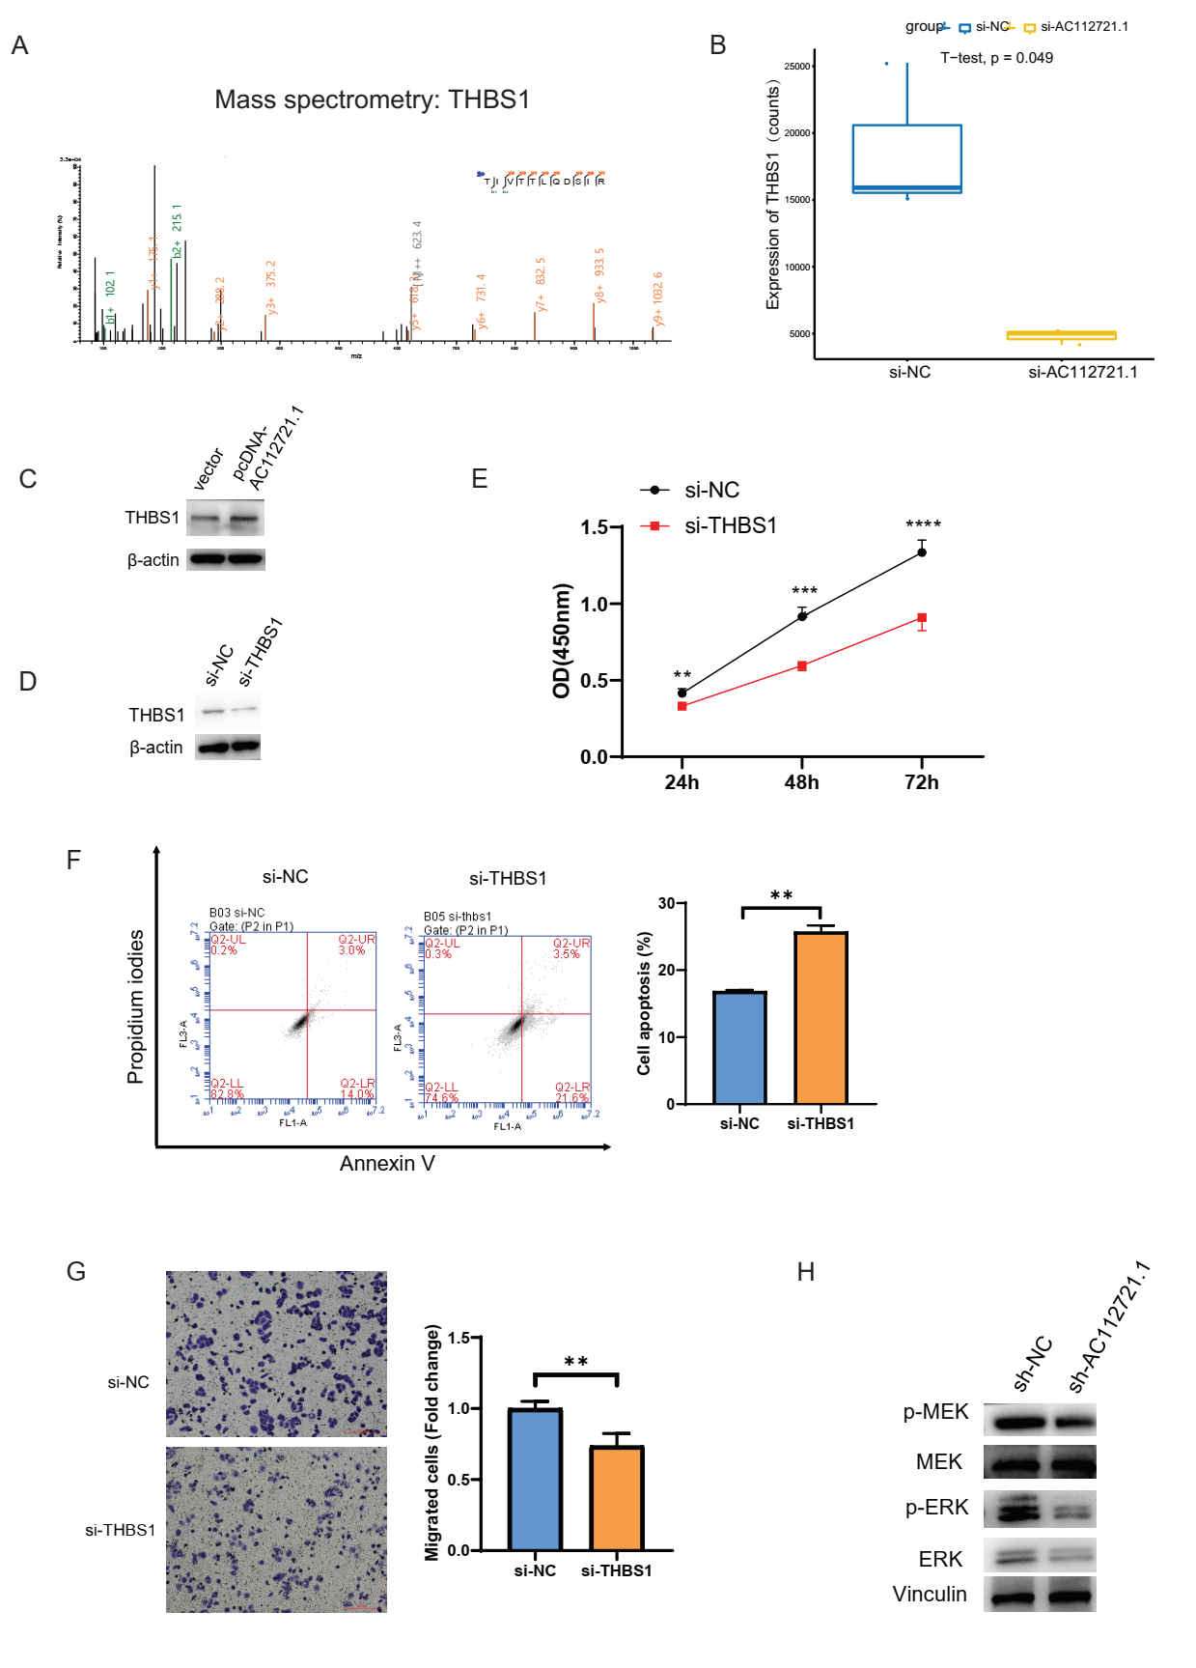
Supplementary Figure 2. A. Mass spectrometry analysis of THBS1. B. The relative expression of AC112721.1 based on RNA-sequencing. C. The relative expression level of THBS1 after AC112721.1 overexpression. D. The knockdown efficiency of THBS1 was assessed using western blot. E. Cell proliferation of MDA-MB-468 cells was detected by CCK-8 assay with the indicated treatment. F. FACS was performed to determine the apoptosis rate of MDA-MB-468 cells after knockdown of THBS1. G. Cell migration ability of MDA-MB-468 cells was determined after transfection with si-THBS1. H. The impact of knocking down AC112721.1 on the Ras pathway was measured using Western blot. All experiments were performed at least thrice with triplicate samples. **p < 0.01, ***p < 0.001, ****p < 0.0001.

Supplementary Figure 3.
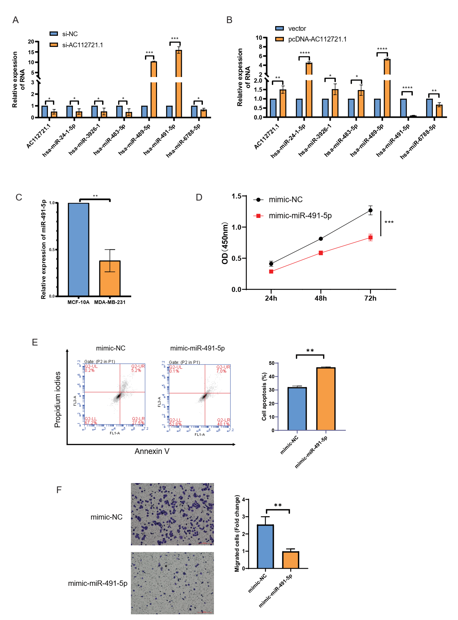

Supplementary Figure 3. qRT-PCR analysis of miRNAs expression in MDA-MB-231 cells transfected with si-AC112721.1 (A) or pcDNA- AC112721.1 (B). C. The relative expression level of miR-491-5p in different cell lines. D. Overexpression of miR-491-5p inhibited MDA-MB-468 cell proliferation. D. Overexpression of miR-491-5p promoted MDA-MB-468 cell apoptosis. E. Overexpression of miR-491-5p inhibited MDA-MB-468 cell migration. All experiments were performed at least thrice with triplicate samples. *p < 0.05, **p < 0.01, ***p < 0.001, ****p < 0.0001.

Supplementary Figure 4.
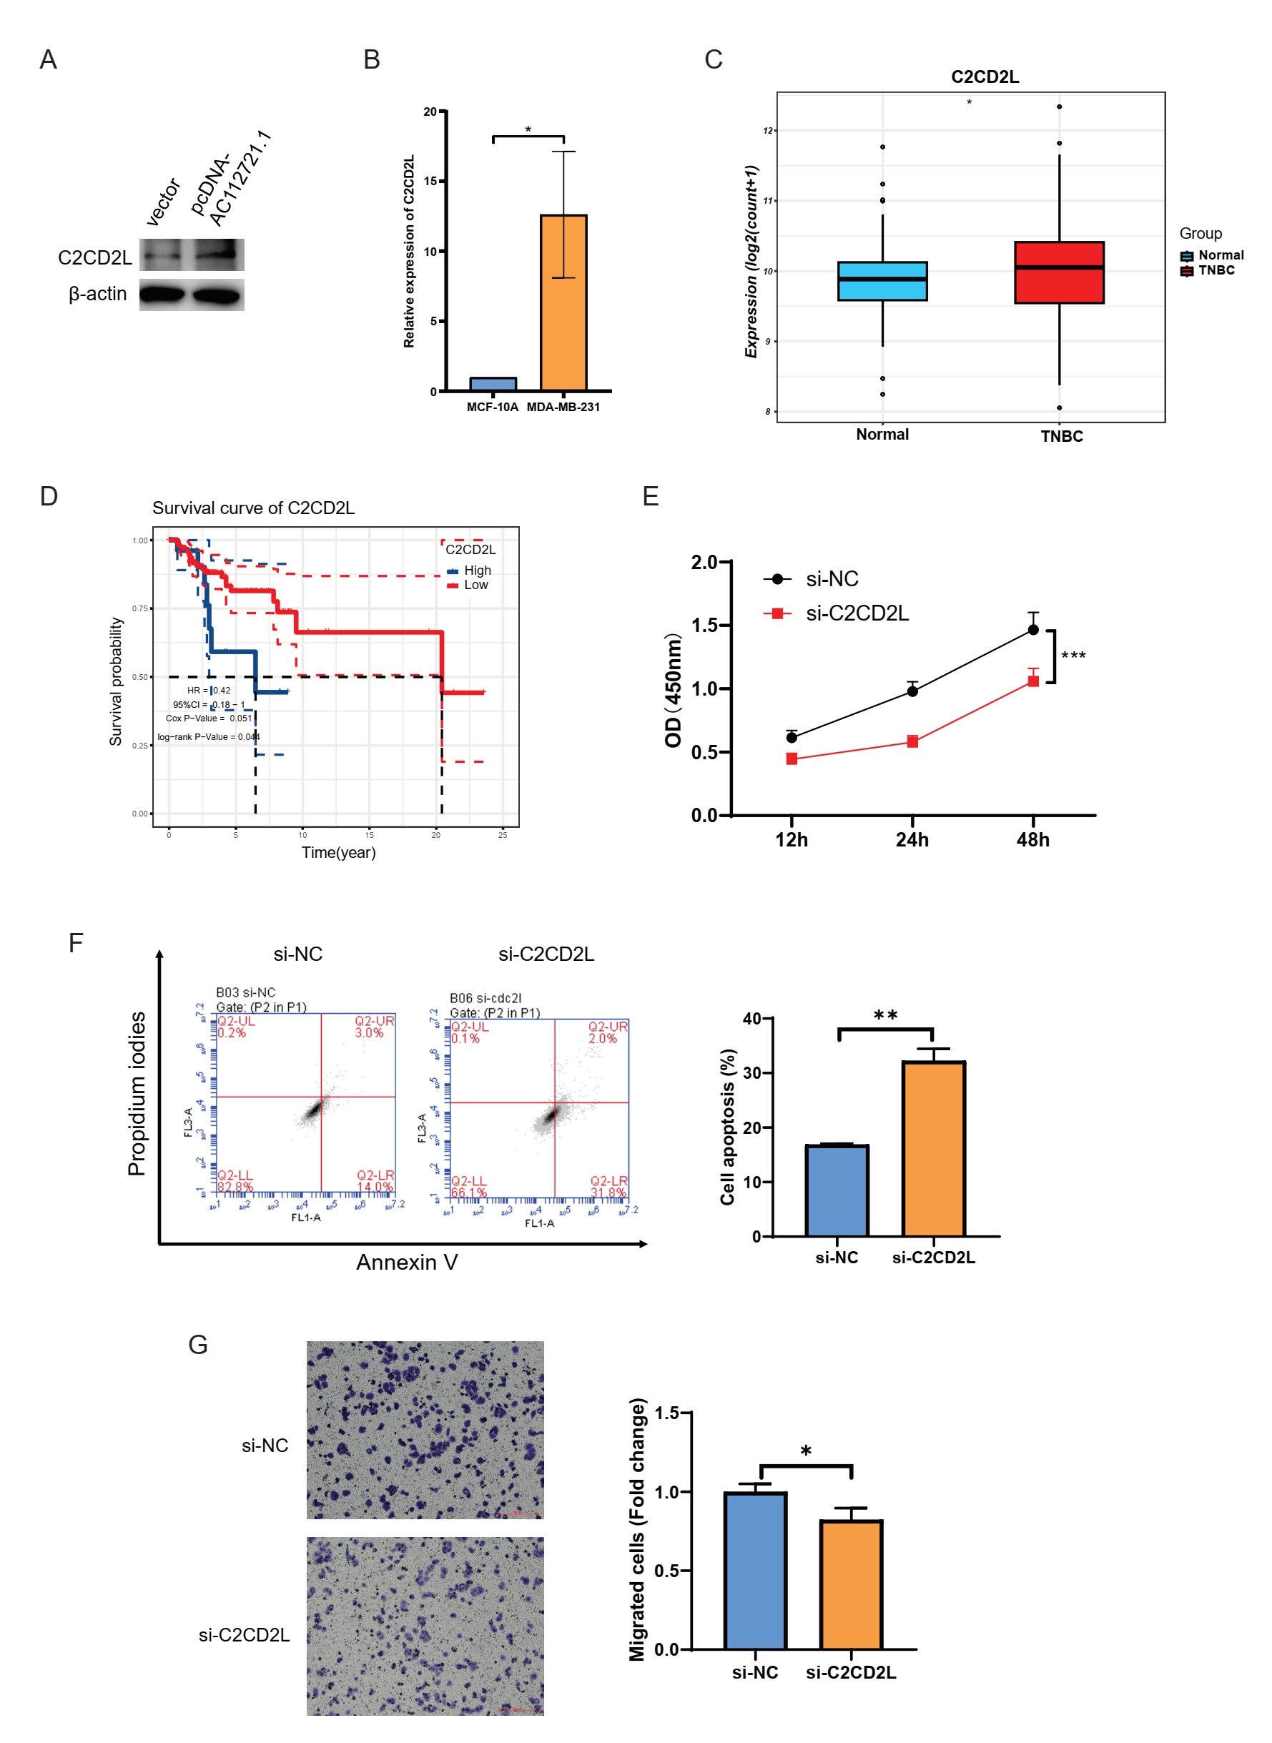

Supplementary Figure 4. A. The relative expression level of C2CD2L after AC112721.1 overexpression. B. The relative expression level of C2CD2L in different cell lines. C. The expression levels of C2CD2L in TNBC tissues and normal tissues in the TCGA database. D. Kaplan-Meier survival analysis of TNBC patients stratified by C2CD2L expression level. E. Cell proliferation of MDA-MB-468 cells was detected by CCK-8 assay with the indicated treatment. F. FACS was performed to determine the apoptosis rate of MDA-MB-468 cells after knockdown of C2CD2L. G. Cell migration ability of MDA-MB-468 cells was determined after transfection with si-C2CD2L. **p < 0.01, ***p < 0.001,.

