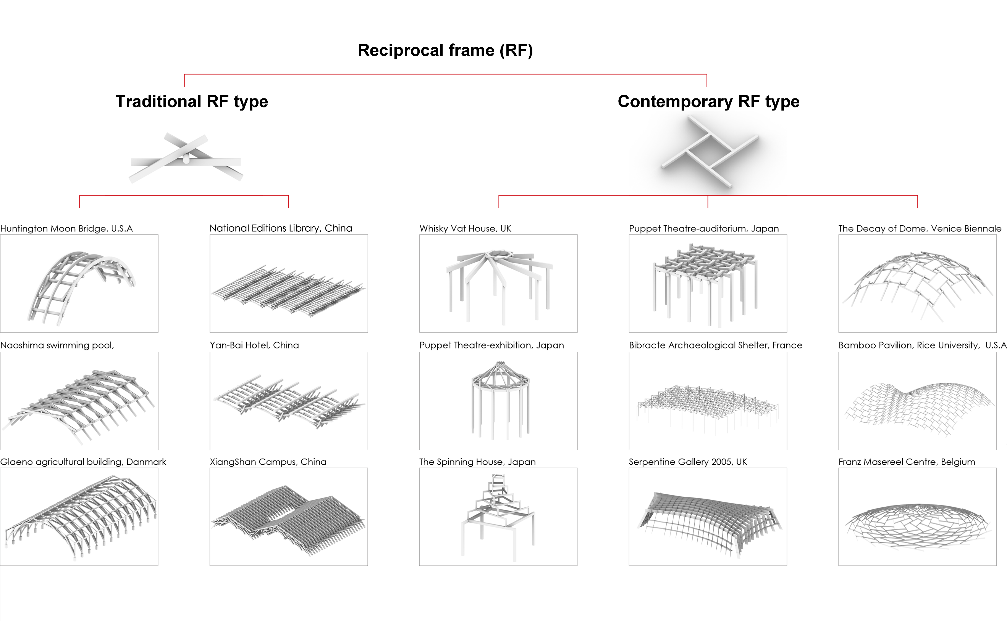
Fig.1 Reciprocal Frame cases illustration.
This work proposes parametric modelling of RF built cases, in order to extract relevant data information of design parameters.
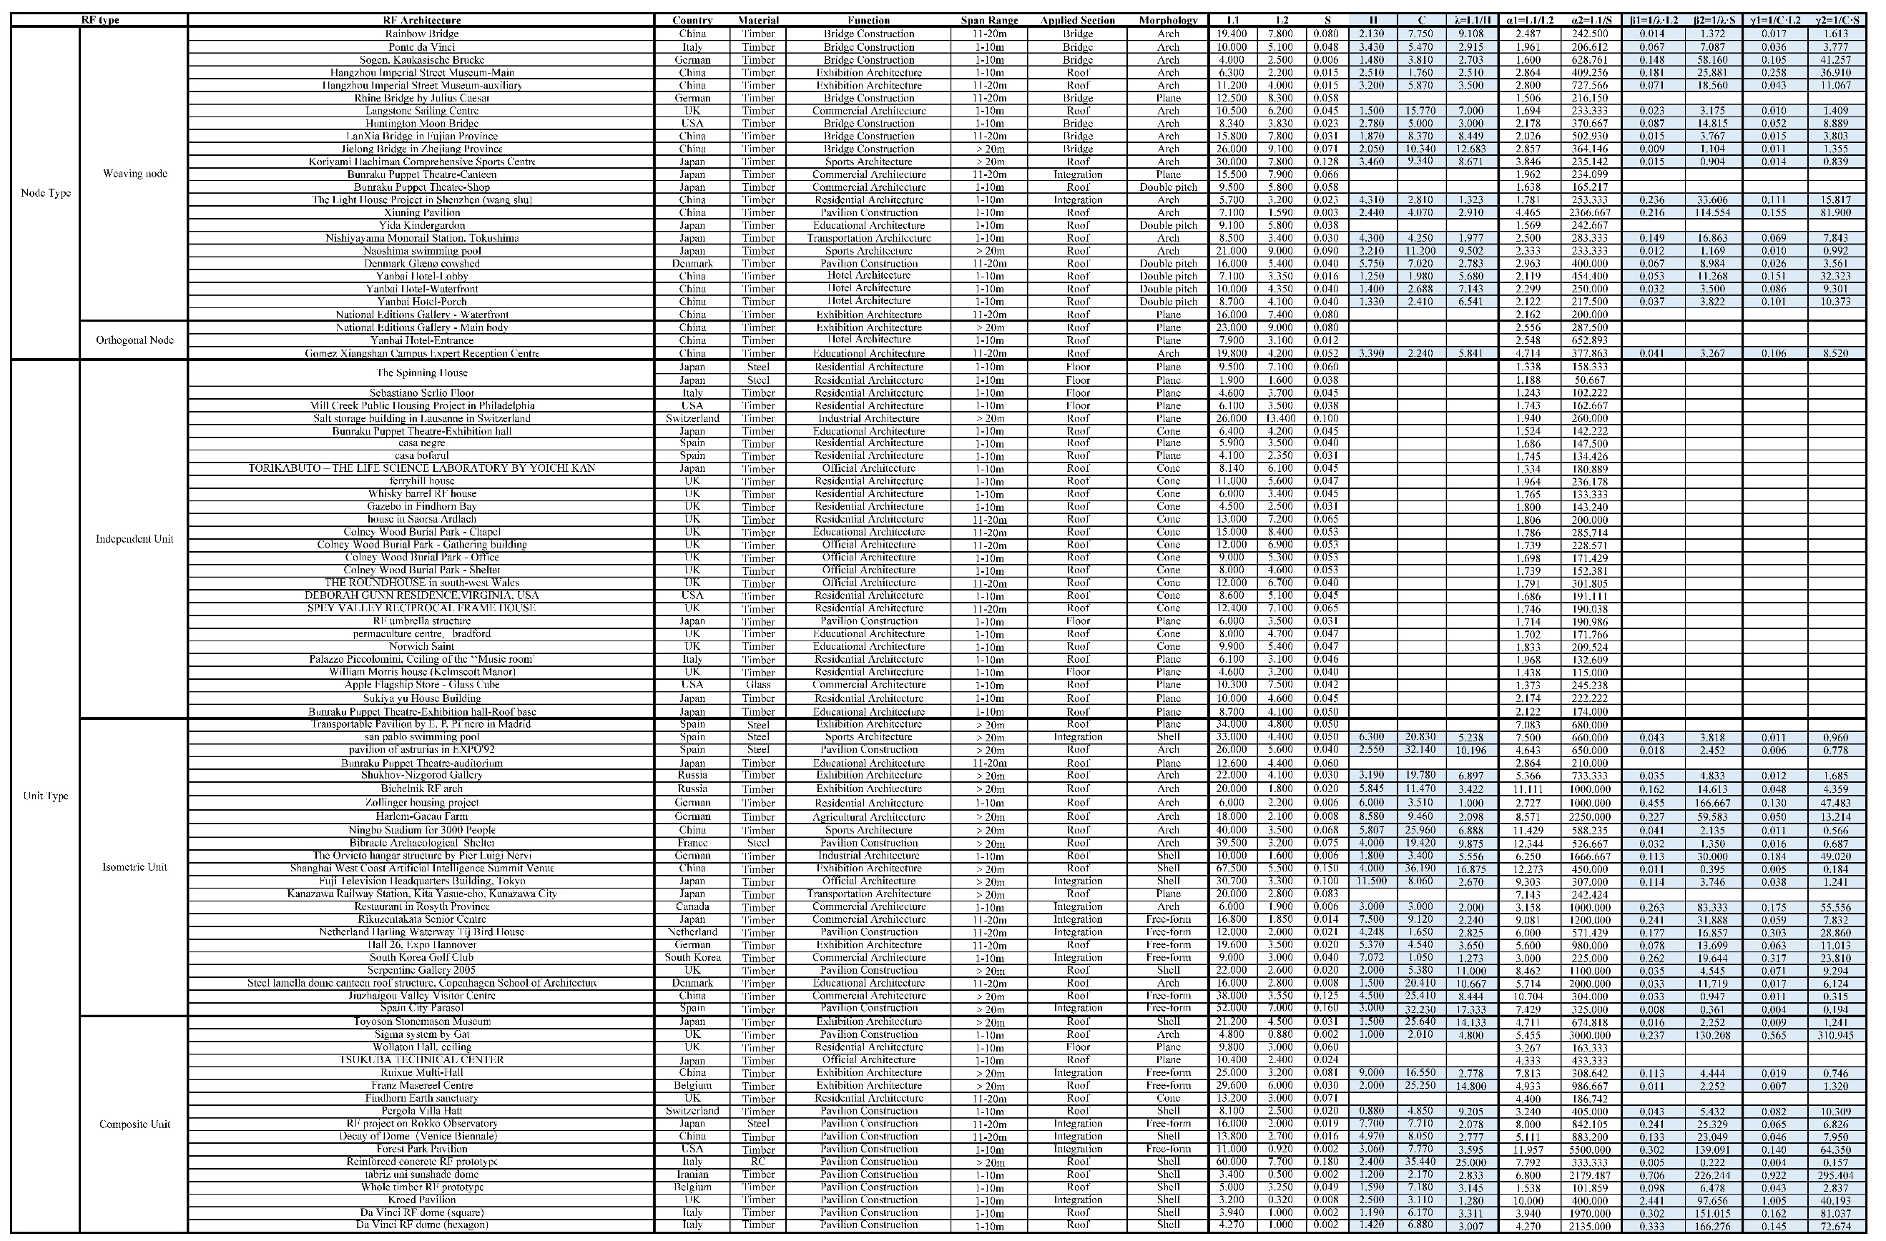
Table.1 The data collection of 94 contemporary RF built cases.
The methodology for case collection involved the keyword search on prominent architectural websites such as Google and ArchDaily, supplemented with e-books, papers and other literature. Sources of case data were relatively scattered. Pertinent dimension information was deduced from drawings delineated with dimensions or text demonstrating scale-related elucidation.
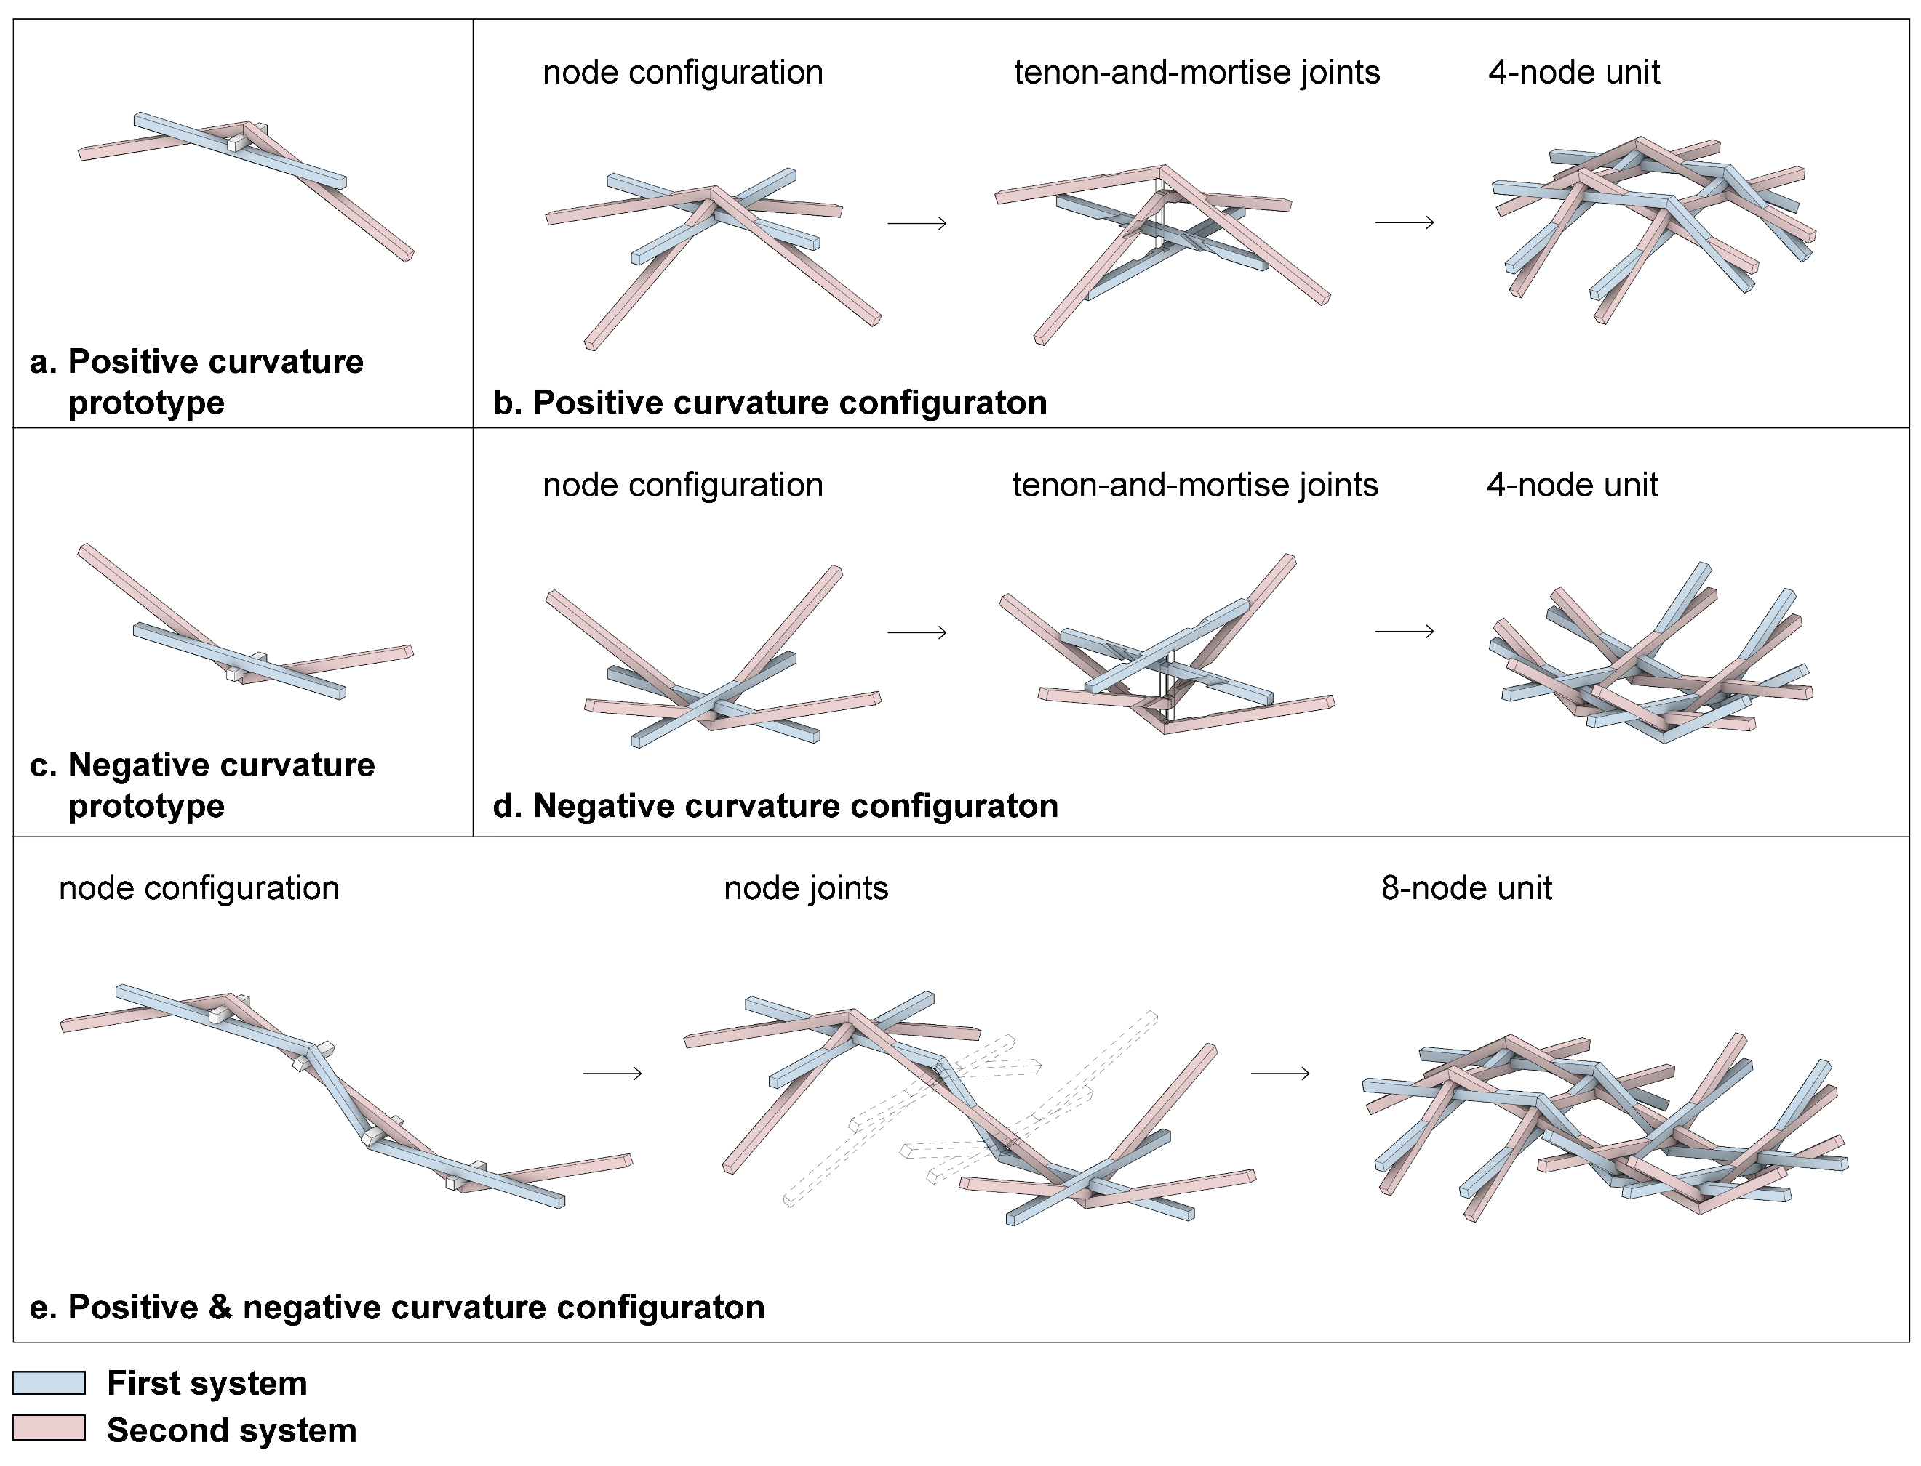
Fig.2 Morphological Adaptability of the new RF prototype.
This figure shows how the structural configuration adapt the positive, negative and mixed curvature surfaces in detail.

Rx | Ry | Dx | Dy | Tf | Ft | Fc | V | M | α1 | α2 | β1 | β2
0.395 | 0.090 | 3.600 | 3.600 | 1.310 | 515.335 | 15.005 | 0.489 | 56.651 | 0.598 | 0.033 | 35.544 | 1.946
0.390 | 0.095 | 3.600 | 3.600 | 1.168 | 502.725 | 15.732 | 0.489 | 55.706 | 0.598 | 0.032 | 35.558 | 1.898
0.386 | 0.100 | 3.600 | 3.600 | 1.047 | 490.271 | 16.377 | 0.490 | 54.795 | 0.598 | 0.031 | 35.571 | 1.851
0.381 | 0.105 | 3.600 | 3.600 | 0.944 | 477.974 | 16.932 | 0.490 | 53.917 | 0.598 | 0.030 | 35.584 | 1.805
0.376 | 0.110 | 3.600 | 3.600 | 0.855 | 465.832 | 17.394 | 0.491 | 53.073 | 0.599 | 0.030 | 35.598 | 1.759
0.371 | 0.115 | 3.600 | 3.600 | 0.779 | 453.847 | 17.756 | 0.492 | 52.263 | 0.599 | 0.029 | 35.611 | 1.713
0.366 | 0.120 | 3.600 | 3.600 | 0.712 | 442.018 | 18.014 | 0.492 | 51.486 | 0.599 | 0.028 | 35.624 | 1.669
0.361 | 0.125 | 3.600 | 3.600 | 0.653 | 430.345 | 18.166 | 0.493 | 50.742 | 0.599 | 0.027 | 35.638 | 1.625
0.356 | 0.130 | 3.600 | 3.600 | 0.601 | 418.828 | 18.619 | 0.494 | 50.032 | 0.600 | 0.027 | 35.651 | 1.581
0.351 | 0.135 | 3.600 | 3.600 | 0.555 | 407.468 | 19.480 | 0.494 | 49.357 | 0.600 | 0.026 | 35.664 | 1.538
0.347 | 0.140 | 3.600 | 3.600 | 0.514 | 396.264 | 20.285 | 0.495 | 48.714 | 0.600 | 0.025 | 35.678 | 1.496
0.342 | 0.145 | 3.600 | 3.600 | 0.478 | 385.216 | 21.028 | 0.496 | 48.106 | 0.600 | 0.024 | 35.691 | 1.454
0.337 | 0.150 | 3.600 | 3.600 | 0.445 | 374.324 | 21.703 | 0.496 | 47.532 | 0.600 | 0.024 | 35.704 | 1.413
0.332 | 0.155 | 3.600 | 3.600 | 0.416 | 363.588 | 22.303 | 0.497 | 46.992 | 0.601 | 0.023 | 35.718 | 1.373
0.327 | 0.160 | 3.600 | 3.600 | 0.390 | 353.009 | 22.824 | 0.498 | 46.486 | 0.601 | 0.022 | 35.731 | 1.333
0.322 | 0.165 | 3.600 | 3.600 | 0.366 | 342.875 | 23.269 | 0.498 | 46.044 | 0.601 | 0.022 | 35.744 | 1.294
0.397 | 0.170 | 3.600 | 3.600 | 0.332 | 520.691 | 28.476 | 0.533 | 64.864 | 0.598 | 0.033 | 35.539 | 1.966
0.393 | 0.175 | 3.600 | 3.600 | 0.312 | 508.520 | 29.265 | 0.534 | 64.266 | 0.598 | 0.032 | 35.552 | 1.920
0.388 | 0.180 | 3.600 | 3.600 | 0.294 | 496.494 | 29.983 | 0.535 | 63.701 | 0.598 | 0.032 | 35.564 | 1.874
0.398 | 0.185 | 3.600 | 3.600 | 0.275 | 522.613 | 31.562 | 0.542 | 67.037 | 0.598 | 0.033 | 35.537 | 1.973
0.393 | 0.190 | 3.600 | 3.600 | 0.260 | 510.471 | 32.219 | 0.543 | 66.500 | 0.598 | 0.032 | 35.550 | 1.927
0.389 | 0.195 | 3.600 | 3.600 | 0.246 | 498.472 | 32.796 | 0.544 | 65.996 | 0.598 | 0.032 | 35.562 | 1.882
0.384 | 0.200 | 3.600 | 3.600 | 0.233 | 486.616 | 33.290 | 0.544 | 65.524 | 0.598 | 0.031 | 35.575 | 1.837
0.379 | 0.205 | 3.600 | 3.600 | 0.221 | 474.902 | 33.697 | 0.545 | 65.085 | 0.598 | 0.030 | 35.588 | 1.793
0.375 | 0.210 | 3.600 | 3.600 | 0.210 | 463.331 | 34.014 | 0.546 | 64.679 | 0.599 | 0.029 | 35.601 | 1.749
0.370 | 0.215 | 3.600 | 3.600 | 0.200 | 451.903 | 34.238 | 0.547 | 64.305 | 0.599 | 0.029 | 35.613 | 1.706
0.365 | 0.220 | 3.600 | 3.600 | 0.190 | 440.618 | 34.367 | 0.547 | 63.965 | 0.599 | 0.028 | 35.626 | 1.664
0.397 | 0.225 | 3.600 | 3.600 | 0.177 | 520.415 | 38.362 | 0.564 | 72.934 | 0.598 | 0.033 | 35.539 | 1.965
0.393 | 0.230 | 3.600 | 3.600 | 0.169 | 508.243 | 38.567 | 0.565 | 72.548 | 0.598 | 0.032 | 35.552 | 1.919
0.388 | 0.235 | 3.600 | 3.600 | 0.161 | 496.215 | 38.677 | 0.565 | 72.195 | 0.598 | 0.032 | 35.565 | 1.873
0.383 | 0.240 | 3.600 | 3.600 | 0.154 | 484.332 | 38.688 | 0.566 | 71.876 | 0.598 | 0.031 | 35.578 | 1.829
0.379 | 0.245 | 3.600 | 3.600 | 0.148 | 472.592 | 38.600 | 0.567 | 71.589 | 0.599 | 0.030 | 35.590 | 1.784
0.374 | 0.250 | 3.600 | 3.600 | 0.142 | 460.996 | 38.411 | 0.568 | 71.336 | 0.599 | 0.029 | 35.603 | 1.740
0.369 | 0.255 | 3.600 | 3.600 | 0.136 | 449.544 | 38.119 | 0.569 | 71.116 | 0.599 | 0.029 | 35.616 | 1.697
0.398 | 0.260 | 3.600 | 3.600 | 0.126 | 521.219 | 42.589 | 0.584 | 79.390 | 0.598 | 0.033 | 35.538 | 1.968
0.393 | 0.265 | 3.600 | 3.600 | 0.125 | 509.111 | 42.358 | 0.585 | 79.148 | 0.598 | 0.032 | 35.551 | 1.922
0.388 | 0.270 | 3.600 | 3.600 | 0.125 | 497.146 | 42.026 | 0.585 | 78.939 | 0.598 | 0.032 | 35.564 | 1.877
0.384 | 0.275 | 3.600 | 3.600 | 0.125 | 485.323 | 41.591 | 0.586 | 78.763 | 0.598 | 0.031 | 35.576 | 1.832
0.379 | 0.280 | 3.600 | 3.600 | 0.125 | 473.643 | 41.053 | 0.587 | 78.620 | 0.599 | 0.030 | 35.589 | 1.788
0.374 | 0.285 | 3.600 | 3.600 | 0.125 | 462.104 | 40.412 | 0.588 | 78.510 | 0.599 | 0.029 | 35.602 | 1.745
Table.2 The FEA results of the new configuration. The FEA produced 1500 sets of data, this table presents 40 sets as a demonstration of the data structure due to the limited space.

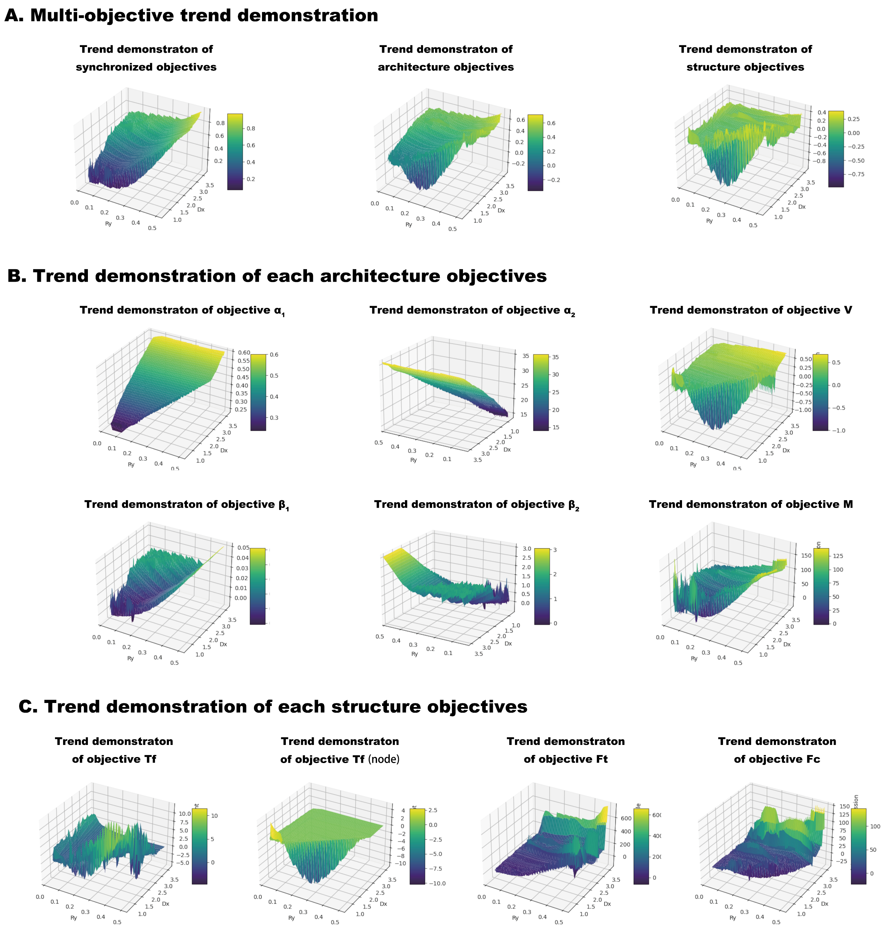
Fig.3 Full results of AI surrogate model optimization.
This figure shows the specific trending relationship between the design variables and each objective.

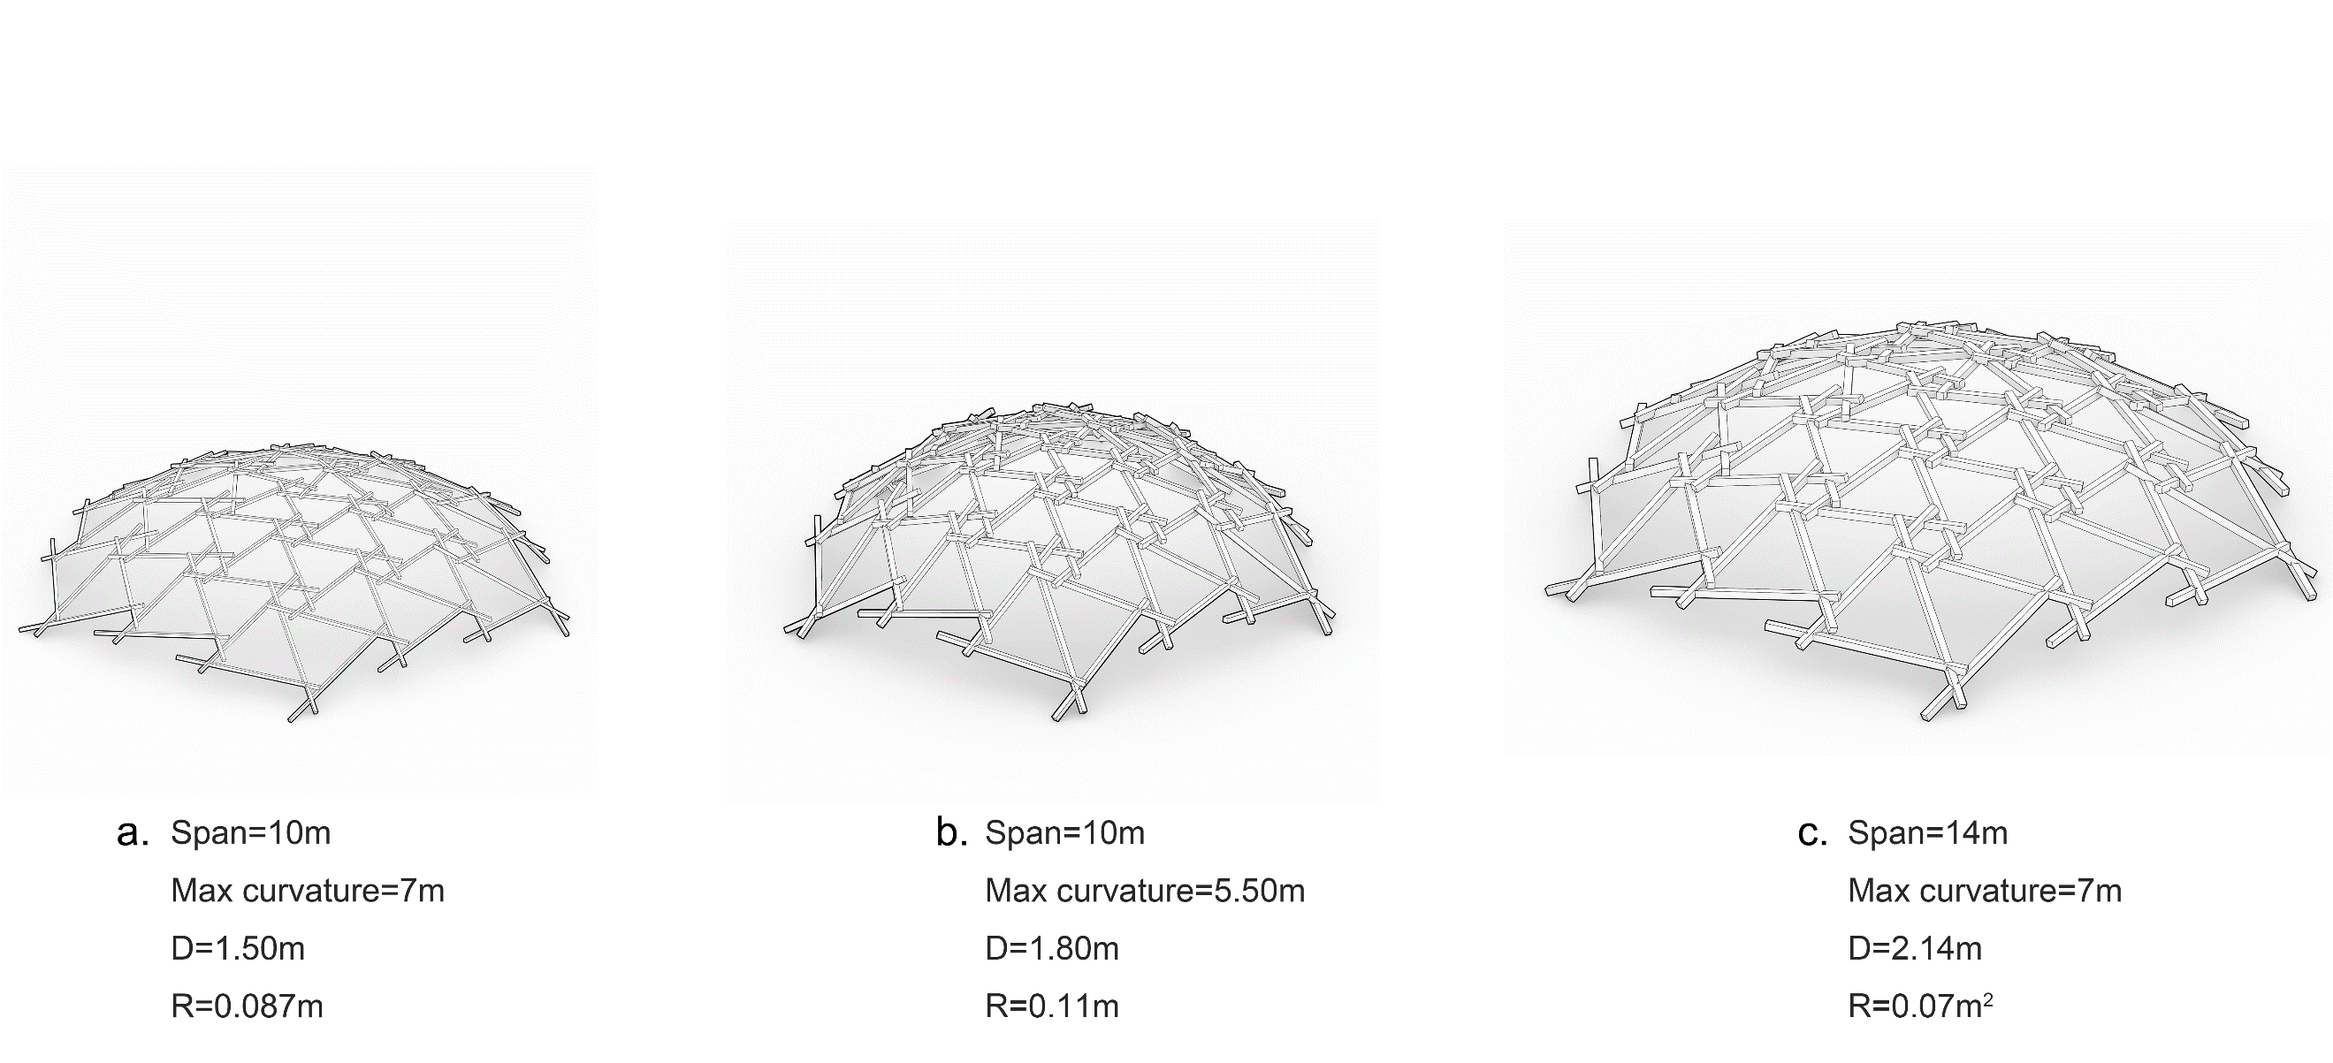
Fig.4 Morphological generation of contemporary RF configuration
Similar with the new configuration, this algorithm of contemporary RF configuration controls the generated morphology based on design variable D and R. This generation algorithm has been integrated into the Kangaroo plugin on the Grasshopper parametric design platform.

D | R | M | V | T_{f}
5.739 | 0.800 | 898.545 | 0.727 | 0.110
5.739 | 0.040 | 2.246 | 0.062 | 17.322
5.739 | 0.060 | 5.054 | 0.092 | 3.345
5.739 | 0.080 | 8.985 | 0.120 | 1.639
5.739 | 0.100 | 14.040 | 0.148 | 0.988
5.739 | 0.120 | 20.217 | 0.175 | 0.658
5.739 | 0.140 | 27.518 | 0.201 | 0.466
5.739 | 0.160 | 35.942 | 0.226 | 0.343
5.739 | 0.180 | 45.489 | 0.250 | 0.260
5.739 | 0.200 | 56.159 | 0.274 | 0.202
5.739 | 0.220 | 67.952 | 0.297 | 0.159
5.739 | 0.240 | 80.869 | 0.319 | 0.127
5.739 | 0.260 | 94.909 | 0.341 | 0.105
5.739 | 0.280 | 110.072 | 0.362 | 0.105
5.739 | 0.300 | 126.358 | 0.382 | 0.105
5.739 | 0.320 | 143.767 | 0.401 | 0.105
5.739 | 0.340 | 162.300 | 0.420 | 0.105
5.739 | 0.360 | 181.955 | 0.439 | 0.106
5.739 | 0.380 | 202.734 | 0.457 | 0.106
5.739 | 0.400 | 224.636 | 0.474 | 0.106
5.739 | 0.420 | 247.661 | 0.491 | 0.106
5.739 | 0.440 | 271.810 | 0.507 | 0.106
5.739 | 0.460 | 297.081 | 0.523 | 0.107
5.739 | 0.480 | 323.476 | 0.538 | 0.107
5.739 | 0.500 | 350.994 | 0.553 | 0.107
5.739 | 0.520 | 379.635 | 0.567 | 0.107
5.739 | 0.540 | 409.399 | 0.581 | 0.107
5.739 | 0.560 | 440.287 | 0.595 | 0.107
5.739 | 0.580 | 472.298 | 0.608 | 0.108
5.739 | 0.600 | 505.431 | 0.620 | 0.108
5.739 | 0.620 | 539.688 | 0.633 | 0.108
5.739 | 0.640 | 575.069 | 0.644 | 0.108
5.739 | 0.660 | 611.572 | 0.656 | 0.108
5.739 | 0.680 | 649.198 | 0.667 | 0.109
5.739 | 0.700 | 687.948 | 0.678 | 0.109
5.739 | 0.720 | 727.821 | 0.689 | 0.109
5.739 | 0.740 | 768.817 | 0.699 | 0.109
5.739 | 0.760 | 810.937 | 0.709 | 0.109
Table.3 The FEA simulation data of contemporary RF system.
Due to the extensive space that 3000 data sets would occupy, this table presents 40 sets as a demonstration of the data structure. Additionally, as contemporary RF system is commonly polygonal configuration and do not adhere strictly to the X and Y axes, this study simplifies the design variables to D and R for ease of analysis.

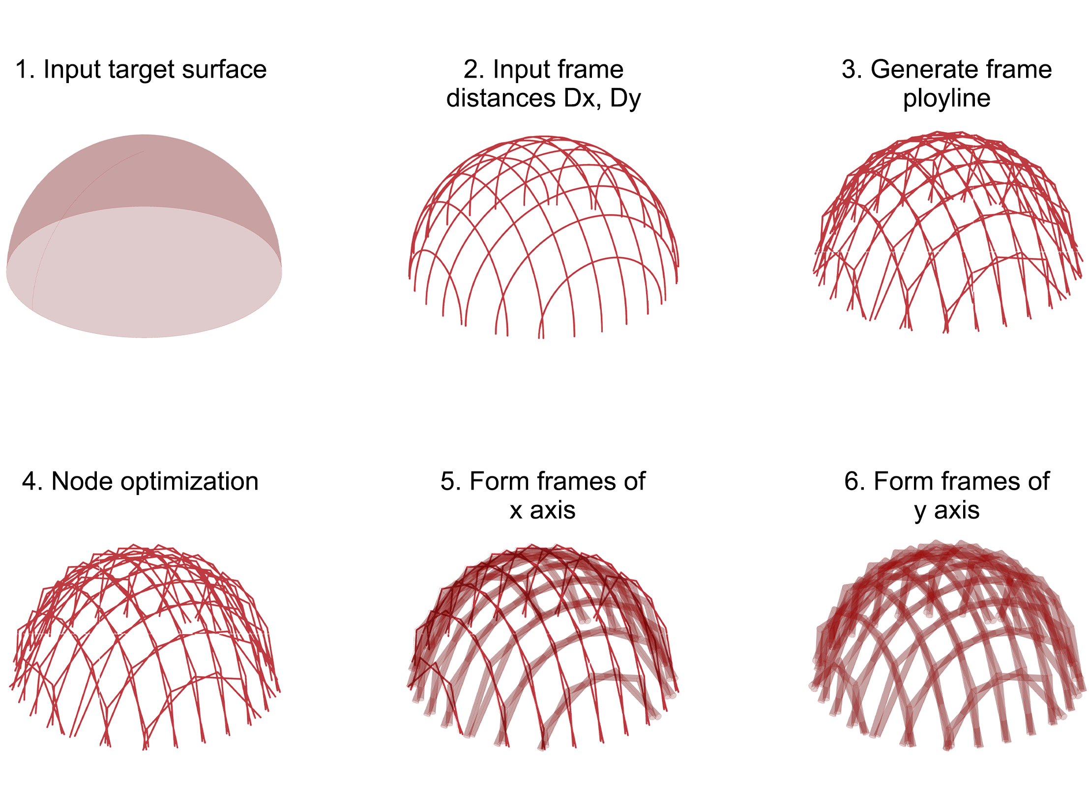
Fig.5 The parametric algorithm of morphologic generation.
Initially, the target surface should be imported into the algorithm, and the arch spacings along the x and y axes (Dx and Dy) are input according to the design intent. The algorithm then divides the surface based on these spacings, as depicted in Figure, with the intersections formed by this division serving as the intersecting nodes of the new configuration. Consequently, polylines are generated according to those intersections, which are then subject to spatial Boolean assessments and corresponding optimizations. If the vertical alignment of the arches along the x and y axes does not conform to the construction prototype—particularly in areas with high geodesic curvature—further spatial adjustments are required. Once the spatial relationships of the components meet the necessary constraints, the section shapes (rectangular, circular, etc.) and dimensions of the components should be inputted to generate the frame entities along the x and y axes.
Moreover, the fourth step of the morphogenesis algorithm also relies on component section information to assess spatial relationships, determining the tangential, intersecting, or separated states of adjacent components and selecting the separated parts for parametric adjustment.

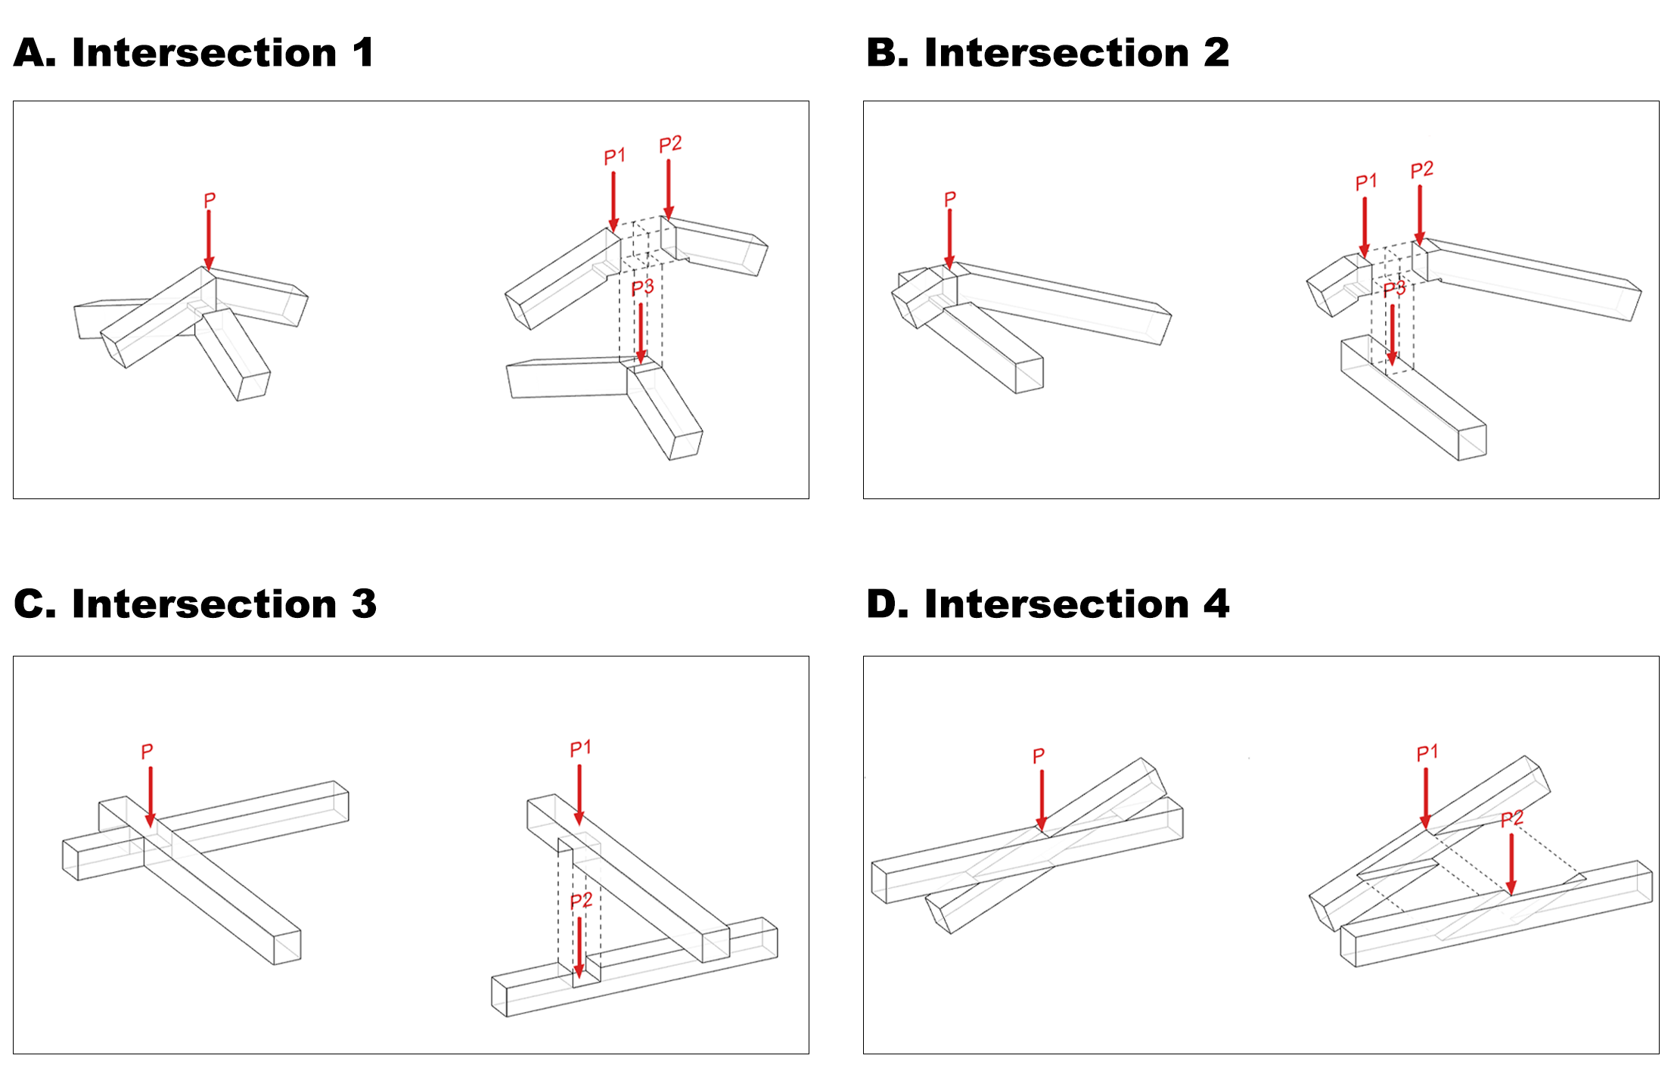
Fig.6 calculations of key structural parameters.
In the finite element analysis, forces at the four typical intersections are decomposed and calculated separately for each component. The calculation formulas are detailed in the methods section of the manuscript.

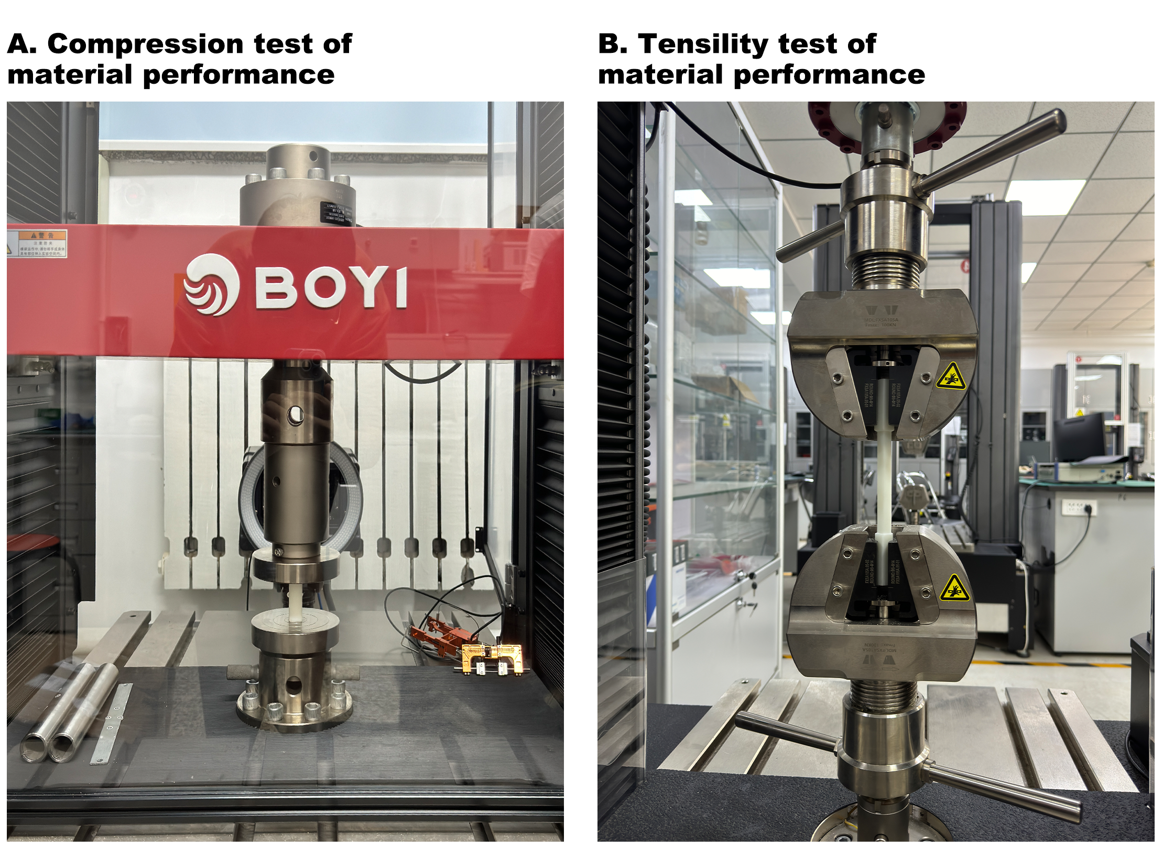
Fig.7 Determination of material performance for experiment.
Due to discrepancies between the actual deformation data observed in experiments and the simulated deformation data from Finite Element Analysis (FEA), we evaluated the elastic modulus of the 3D printed materials based on an experiment. The findings indicate that the actual elastic modulus is not constant, which can be attributed to voids within the material created by the 3D printing process. This variability explains the initial discrepancies observed between the simulated and experimental data during the compression tests.

