Appendix A – Zero-Order Tier 2 OSeMOSYS Model
The data described above were used to create a simple zero-order Tier 2 energy systems model. As it is open source and free an OSeMOSYS model is calibrated and run with three example scenarios. Note that these scenarios in no way represent development trajectories of the country. This model and its results are intended to act as an example of what can be produced using the data in this article and a starting point for further model development.
U4RIA are goals to improve energy modelling [2]. They are short for Ubuntu (meaning community focused), retrievability, reusability, repeatability, interoperability and auditability. The model moves to partially meet U4RIA goals in that:
- We develop examples of results that can be used by other research communities, including energy and transport, and to aid mitigation strategies.
- The illustrative analyses are retrievable, reusable, repeatable.
- As data are defined, elements of interoperability are feasible.
- And by virtue of the above the analysis could be audited or verified (that is not to say that it is ‘accurate’ but simply reproducible).
In the OSeMOSYS model, the electricity supply system is represented by importing and extraction technologies, conversion technologies, power plants, transmission and distribution network systems and final energy demands for the different available fuels considered. The Reference Energy System is shown below. The main modelling assumptions consist of power generation capacity per type of technology (centralized, decentralized), fuel prices, emissions, transmission and distribution network capacity and losses, and refineries, which are exogenous parameters into the model. Furthermore, the final energy demands which are exogenously entered into the model are disaggregated by fuel and sector. The data described in this article were used as input data to define these assumptions in the model.
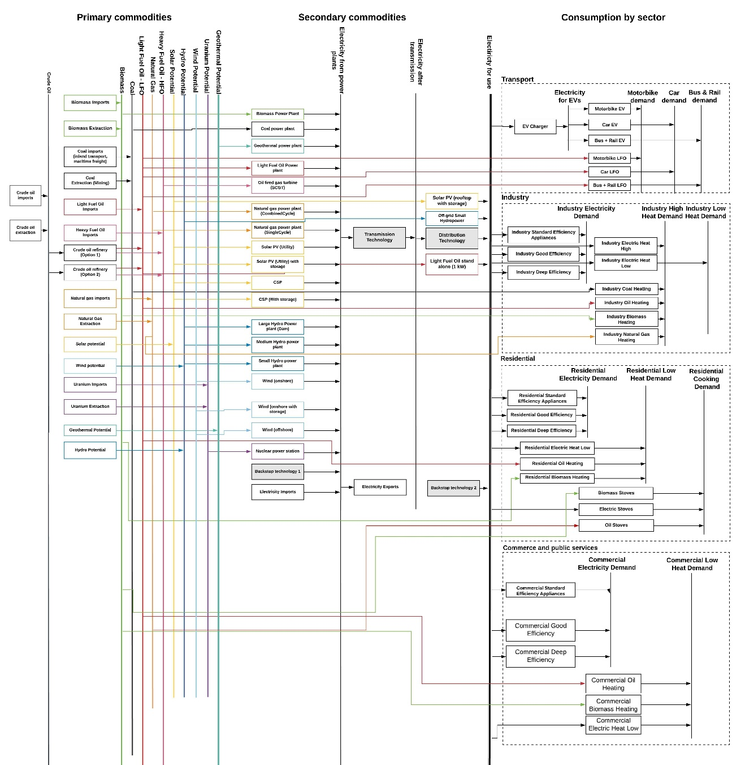
Figure A1: Reference Energy System

A1 Model Assumptions
Key assumptions used in model development are outlined below.

Supply-Side Assumptions
The share of total demand that can be met by off-grid solar PV is constrained based on the optimal balance of on- and off-grid provision in a least cost scenario for 100% electricity access by 2030 from the Global Electrification Platform [25]. Additional technologies were modelled to represent utility-scale solar PV and onshore wind with storage capacity. Utility-scale PV with two-hour storage and onshore wind with half-hour storage were modelled, with the additional costs of storage estimated based on data from the NREL ATB 2020 Database, which provides cost projections for different durations of storage up to 2050 [26]. The maximum share of total demand that can be met by variable renewables is constrained as follows: utility-scale PV, onshore wind and utility-scale PV with storage are each permitted to meet up to 15% of demand; offshore wind can meet up to 10% of demand and onshore wind with storage can meet up to 25% of demand. This analysis is not intended to offer a detailed study of system flexibility; however these constraints are included to ensure the system is operational under high renewable shares. Biomass is permitted to meet up to 30% of electricity demand. Electricity imports and exports were modelled in a simplified manner whereby single import and exports technologies are constrained to import and export electricity in line with energy balance data [27].

Demand-Side Assumptions
Generic techno-economic data for demand-side technologies (cooking, heating and transport) were used [28,29]. The total electricity demand shown in Figure 3 was split by sector based on the proportions of demand in historical energy balance data [27]. In each sector, moderate and high energy efficiency technologies were modelled, with input activity ratios of 1 and output activity ratios of 1.15 and 1.3 respectively. This is a simplified way of allowing the model to invest in energy efficiency in each sector, with costs estimated based on the costs of electricity generation by a coal power plant in the model. In the Least Cost and Net Zero scenario (detailed in Section A2), there is a constraint on the speed at which fuel switching and energy efficiency investments can occur to better align results to reality. This is done by limiting the annual investment in electric vehicles, stoves, heating technologies and energy efficiency to 5% of the 2050 capacity. The electricity demand profile was sourced from the PLEXOS dataset [3,4], which provides estimated hourly demand by country throughout one calendar year. This was used to estimate demand across the 8 time slices (see below) used in the model.

Time Representation and Discount Rate
Within each model year, four seasons, each with two 12-hour dayparts, are defined. Daypart 1 starts at 06:00 and finishes at 18:00, while daypart 2 starts at 18:00 and finishes at 06:00. The seasons are defined so that season 1 runs from December to February, season 2 runs from March to May, season 3 from June to August and season 4 from September to November. A discount rate of 10% is used.

A2 Scenario Definitions
Three stylized scenarios are modelled: Fossil Future, Least Cost and Net Zero by 2050. These scenarios are defined in the table below. Nuclear power is not considered in any of these scenarios; however it can be added using the techno-economic data provided in the main article.
Table A1: Definitions of the three model scenarios.
Scenario | Definition
Fossil Future | No new investments in renewable or nuclear power generation, electric stoves and heating, electric transport or energy efficiency are permitted.
Least Cost | No new investment in nuclear power is permitted. Gradual investment constraints are applied to demand-side fuel-switching and energy efficiency, whereby only up to 5% of each technology’s 2050 capacity in a run without demand-side investment constraints can be invested in annually. No additional constraints are applied to find the cost-optimal solution.
Net Zero by 2050 | Domestic production and imports of fossil fuels and biomass gradually decline to 0 in 2050, beginning in 2021. No new investment in nuclear power is permitted. Gradual investment constraints are applied to demand-side fuel-switching and energy efficiency, whereby only up to 5% of each technology’s 2050 capacity in a run without demand-side investment constraints can be invested in annually from 2021-2039, rising to 10% from 2040-2050 to reflect greater ambition.

A3 Scenario Results for Sudan
The graphs below show selected results for the three modelled scenarios, including yearly electricity generation and supply capacity, fuel use in the transport sector and total annual carbon dioxide emissions for 2020-2050.

A3.1 Electricity Generation Results
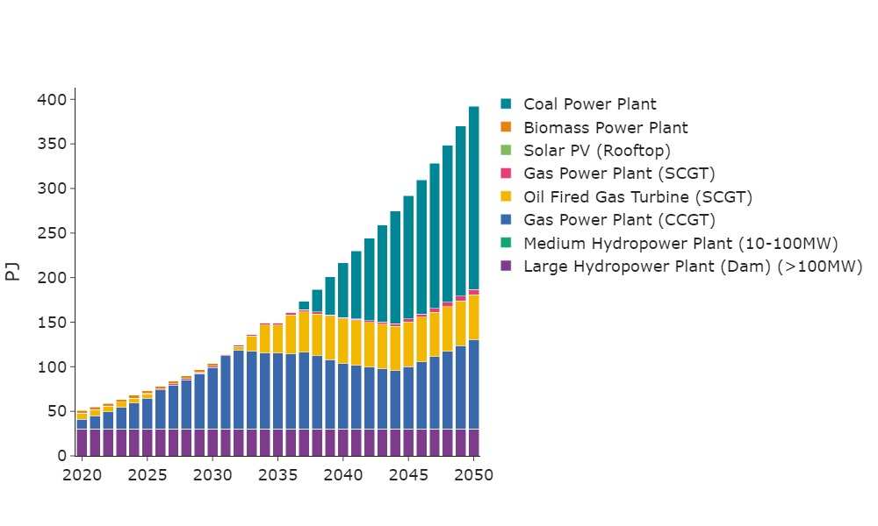Figure A2: Electricity Generation in Sudan in the Fossil Future scenario
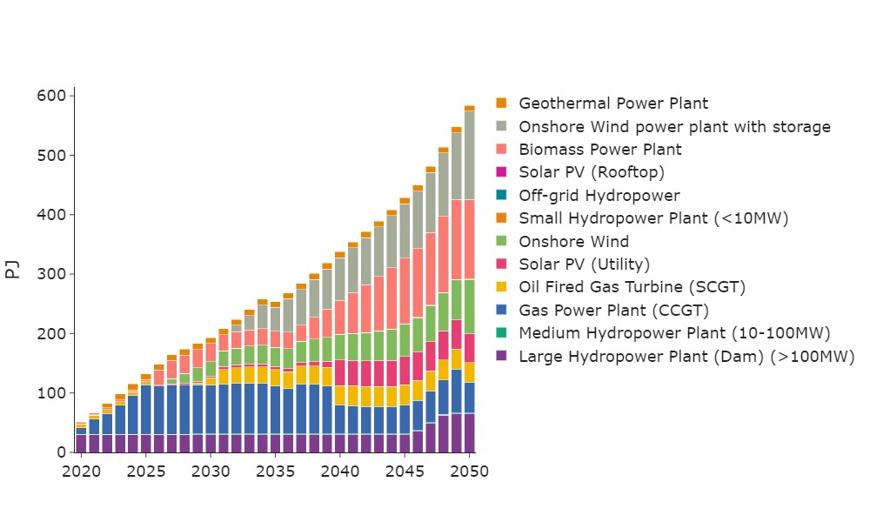Figure A3: Electricity Generation in Sudan in the Least Cost scenario
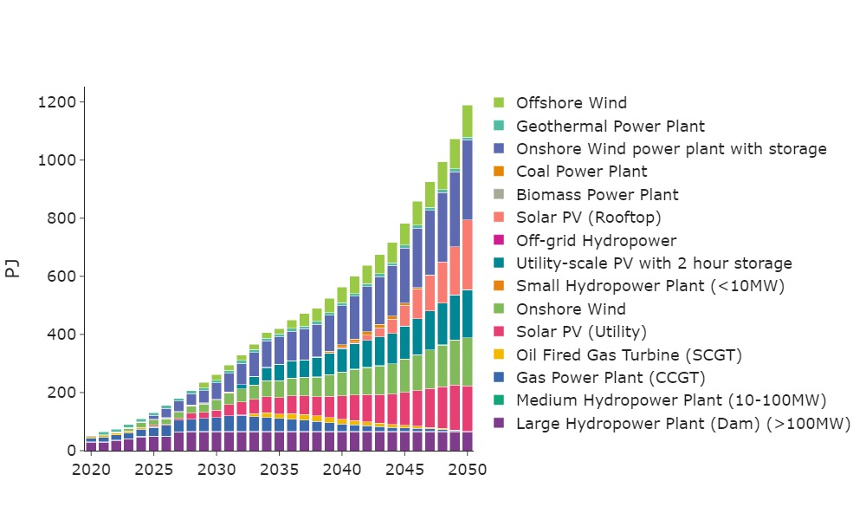Figure A4: Electricity Generation in Sudan in the Net Zero by 2050 scenario

A3.2 Capacity Expansion Results
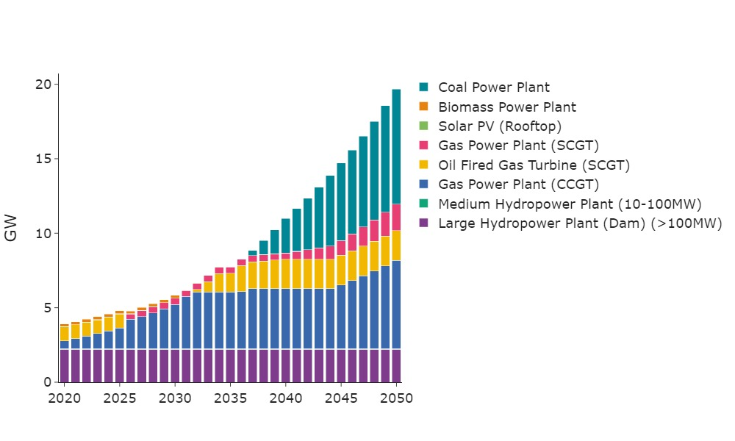Figure A5: Installed capacity in Sudan in the Fossil Future scenario
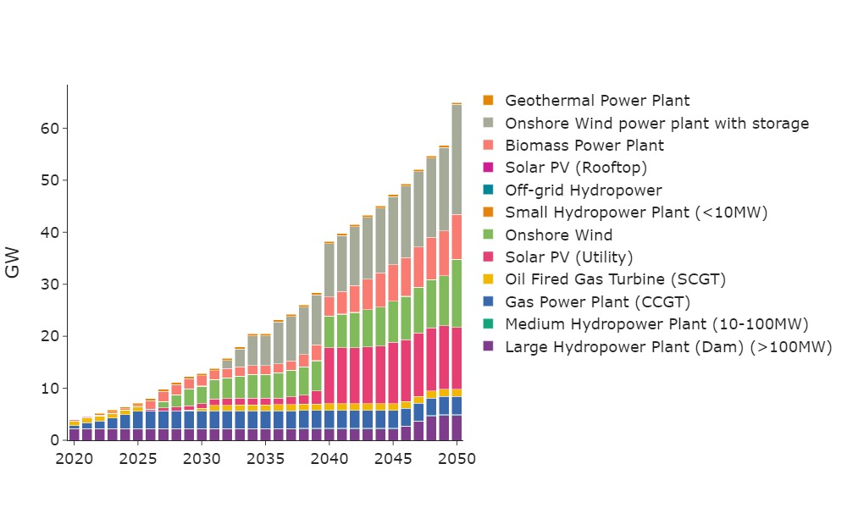Figure A6: Installed capacity in Sudan in the Least Cost scenario
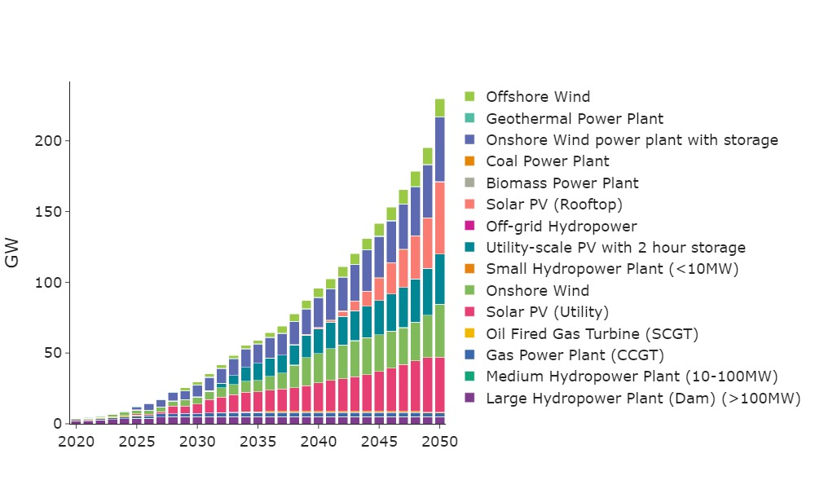Figure A7: Installed capacity in Sudan in the Net Zero scenario

A3.3 Transport Results
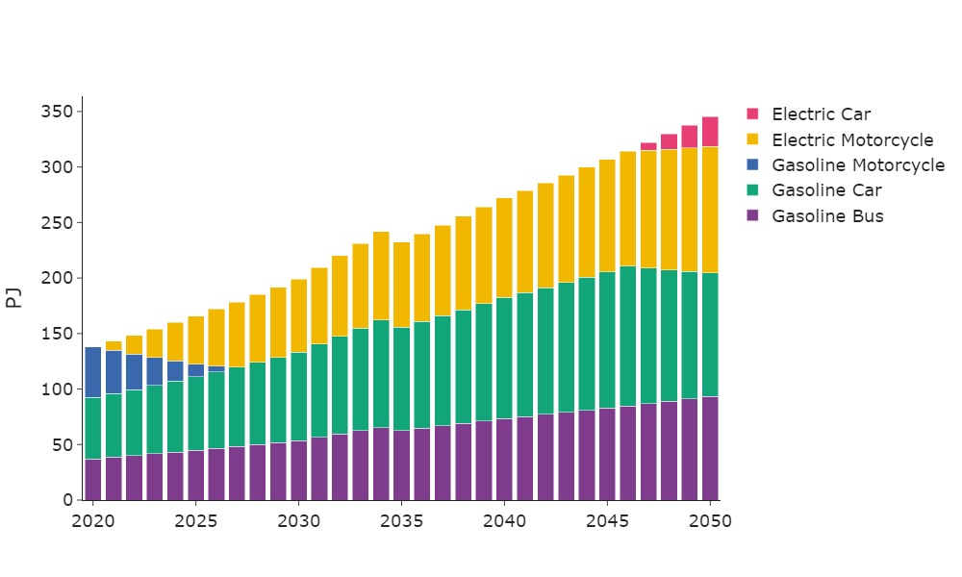Figure A8: Transport demand met by each technology type in Sudan in the Least Cost scenario
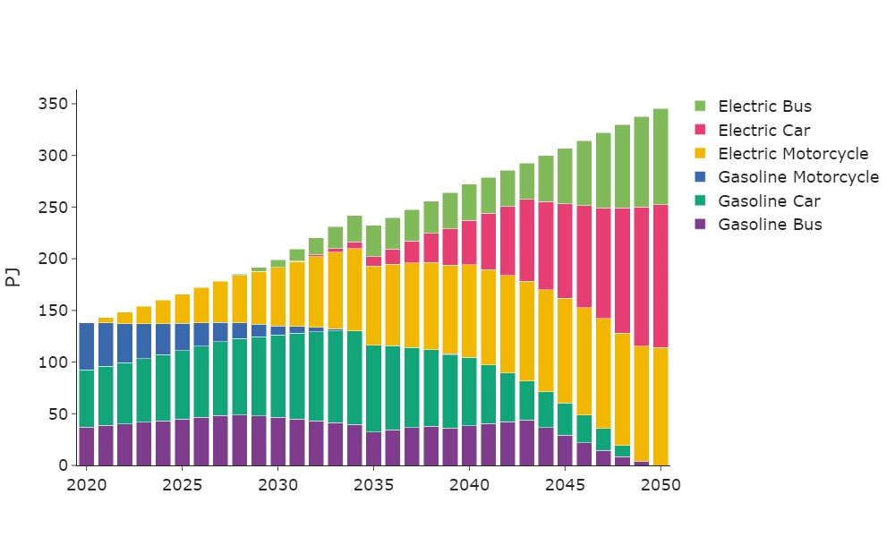Figure A9: Transport demand¹ met by each technology type in Sudan in the Net Zero scenario

A3.4 Annual Carbon Dioxide Emissions Results
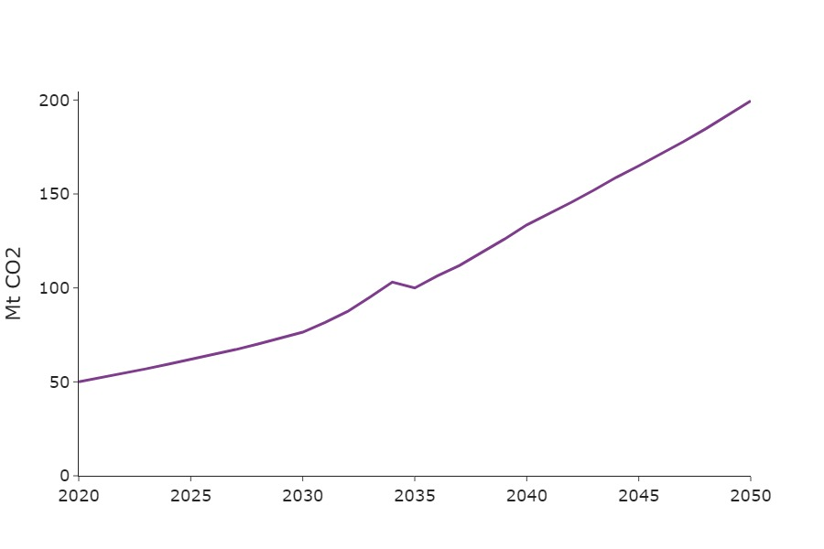
Figure A10: Annual Carbon Dioxide emissions in Sudan in the Fossil Future scenario
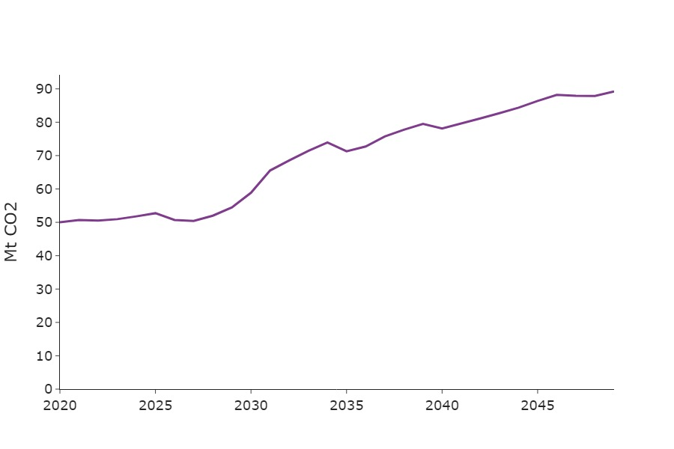
Figure A11: Annual Carbon Dioxide emissions in Sudan in the Least Cost scenario
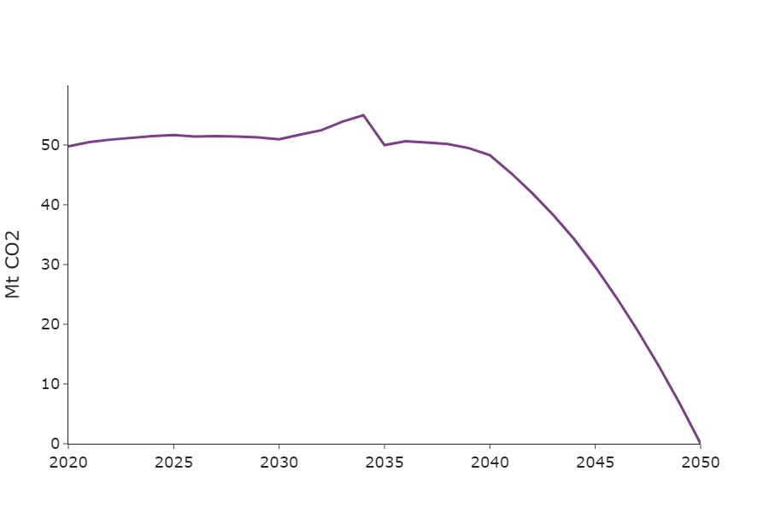
Figure A12: Annual Carbon Dioxide emissions in Sudan in the Net Zero scenario

A4 Further Work
These example results represent zero-order model and were generated using the clicSAND Interface [30] and OSeMOSYS code [31]. Those interested in further developing this work are directed to the dataset available on Zenodo [32] and guidance on model development using clicSAND and OSeMOSYS [33].

Note that the underlaying model spilt data from which this graphic is calculated uncertain and based on authors’ estimates. However, the insights relating to the timing of phasing of transitions (rather than the magnitude of the transition) is of value.

