Additional File 1 for
Aftershock analysis and forecasting for the crustal seismicity in Romania: the cases of the 2014 Vrancea-Marasesti and 2023 Gorj earthquake sequences

Author #1: Cristian Ghita
National Institute for Earth Physics, Calugareni str. 12, P.O. Box MG-2, 077125, Bucharest, Romania; cristi.ghita@infp.ro
Author #2: Bogdan Enescu (corresponding author)
Depart. of Geophysics, Kyoto University, Kitashirakawa, Oiwake-cho, Sakyo-ku, Kyoto 606-8502, Japan; benescu@kugi.kyoto-u.ac.jp & National Institute for Earth Physics, Romania
Author #3: Alexandru Marinus
National Institute for Earth Physics, Calugareni str. 12, P.O. Box MG-2, 077125, Bucharest, Romania; alex.marinus94@gmail.com
Author #4: Iren-Adelina Moldovan
National Institute for Earth Physics, Calugareni str. 12, P.O. Box MG-2, 077125, Bucharest, Romania; iren@infp.ro
Author #5: Constantin Ionescu
National Institute for Earth Physics, Calugareni str. 12, P.O. Box MG-2, 077125, Bucharest, Romania; viorel@infp.ro
Author #6: Eduard Gabriel Constantinescu
National Institute for Earth Physics, Calugareni str. 12, P.O. Box MG-2, 077125, Bucharest, Romania; constantinescu.eduard@gmail.com
The 2014 Vrancea-Marasesti earthquake sequence

- (b)
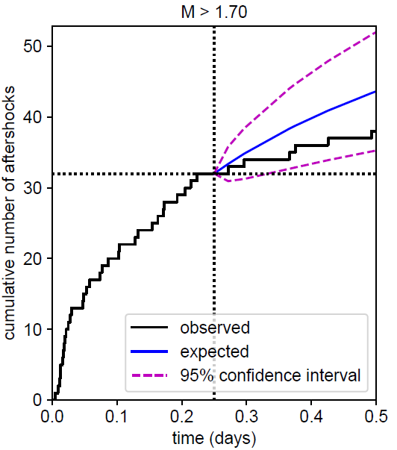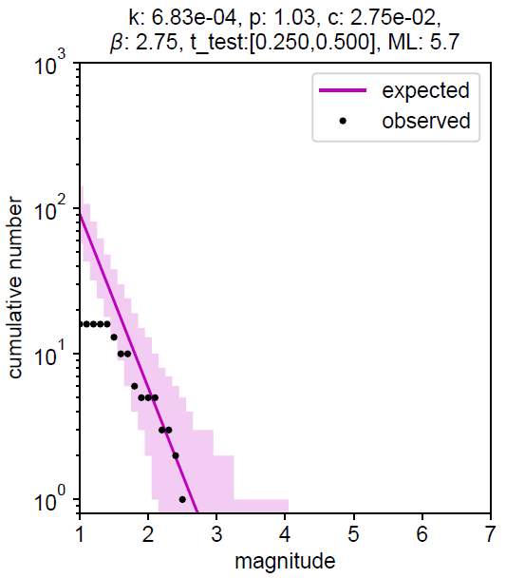
Figure S1 (a) Aftershock cumulative number (black thick curve) for the learning period [0, 6h] and forecast period [6h, 12h] for the Vrancea-Marasesti area. The expected values for the forecasted period are indicated by the blue curve, together with the 95% confidence interval (dotted magenta). The threshold magnitude (1.7) is determined as the magnitude of completeness during the learning period (108 events). (b) The frequency-magnitude distribution for the forecasting window (black – observed numbers, magenta – expected numbers). The Omori-Utsu law parameter values, the β-value estimated during learning, the test (forecasted) period and the magnitude of the mainshock are given at the top of the figure.

(a) (b)
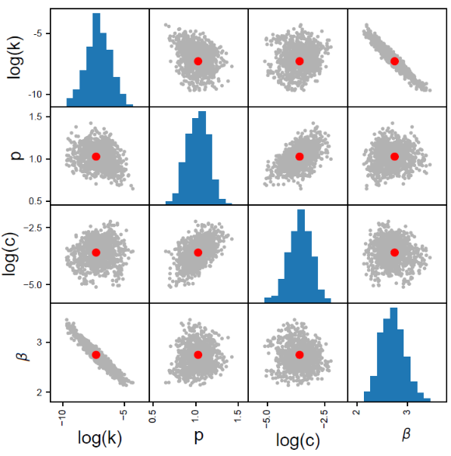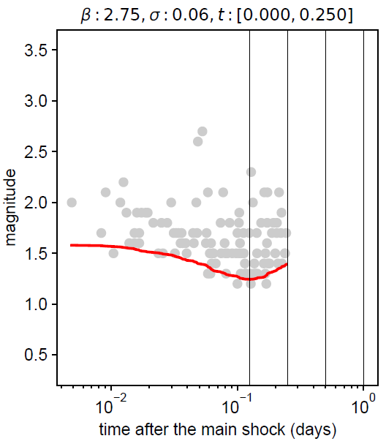
Figure S2 (a) Scatter plot distributions for the estimated parameter sets for the Vrancea-Marasesti sequence (red dots: estimated parameters, gray dots: sampled parameter sets). (b) Evolution of the detection magnitude µ(t) during the learning period of [0,6h] after the mainshock.
- (b)
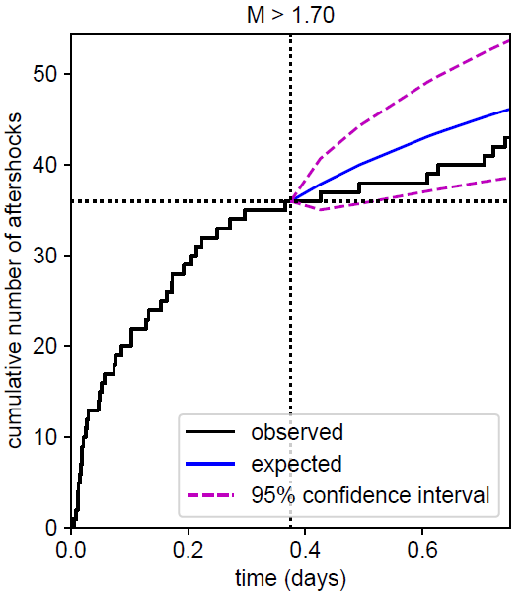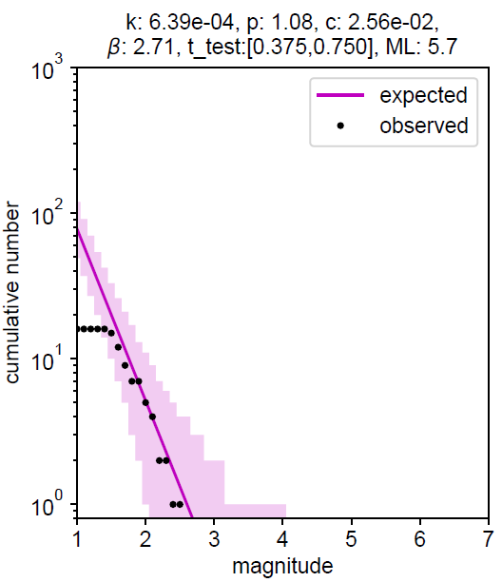
Figure S3 (a) Aftershock cumulative number (black thick curve) for the learning period [0, 9h] and forecast period [9h, 18h] for the Vrancea-Marasesti area. The expected values for the forecasted period are indicated by the blue curve, together with the 95% confidence interval (dotted magenta). The threshold magnitude (1.7) is determined as the magnitude of completeness during the learning period (117 events). (b) The frequency-magnitude distribution for the forecasting window (black – observed numbers, magenta – expected numbers). The Omori-Utsu law parameter values, the β-value estimated during learning, the test (forecasted) period and the magnitude of the mainshock are given at the top of the figure.
- (b)
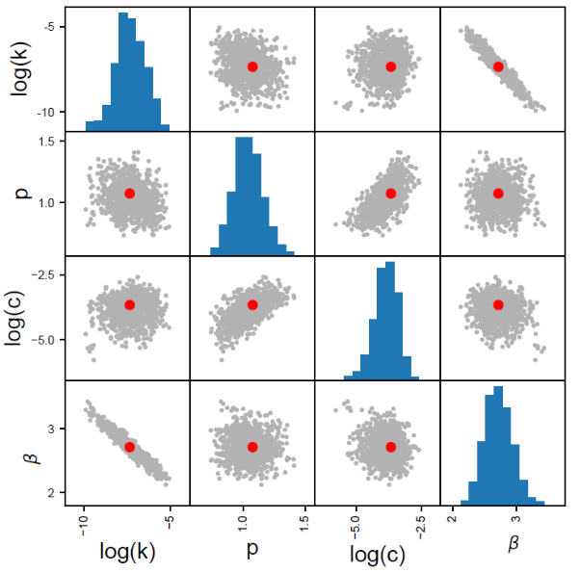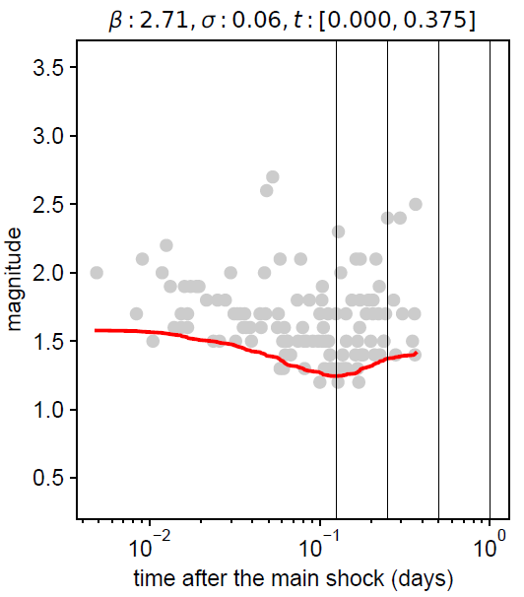
Figure S4 a) Scatter plot distributions for the estimated parameter sets for the Vrancea-Marasesti sequence (red dots: estimated parameters, gray dots: sampled parameter sets). (b) Evolution of the detection magnitude µ(t) during the learning period of [0,9h] after the mainshock.

- (b)
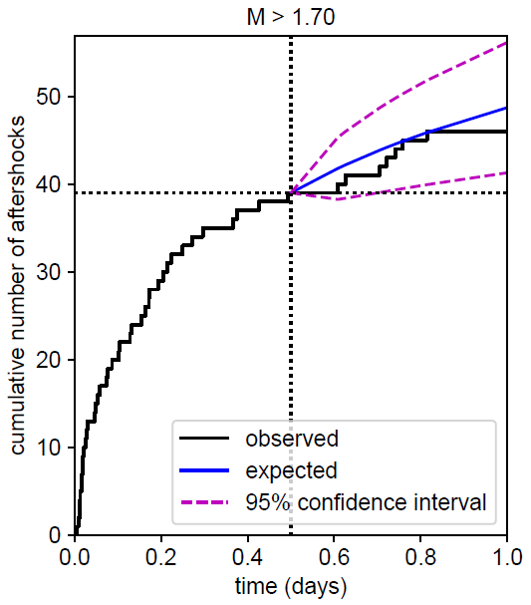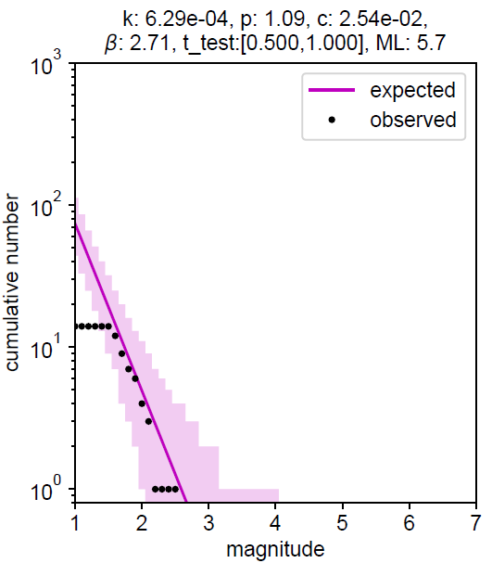
Figure S5 (a) Aftershock cumulative number (black thick curve) for the learning period [0, 12h] and forecast period [12h, 24h] for the Vrancea-Marasesti area. The expected values for the forecasted period are indicated by the blue curve, together with the 95% confidence interval (dotted magenta). The threshold magnitude (1.7) is determined as the magnitude of completeness during the learning period (177 events). (b) The frequency-magnitude distribution for the forecasting window (black – observed numbers, magenta – expected numbers). The Omori-Utsu law parameter values, the β-value estimated during learning, the test (forecasted) period and the magnitude of the mainshock are given at the top of the figure.

- (b)
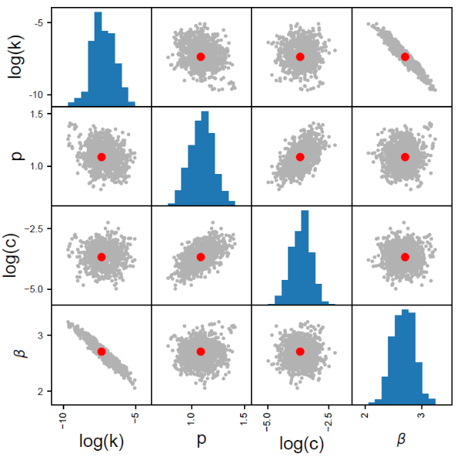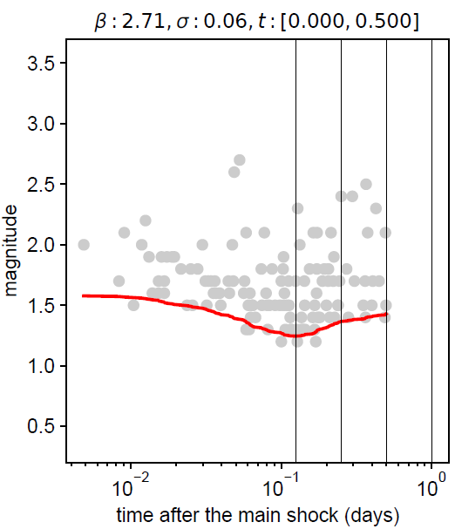
Figure S6 (a) Scatter plot distributions for the estimated parameter sets for the Vrancea-Marasesti sequence (red dots: estimated parameters, gray dots: sampled parameter sets). (b) Evolution of the detection magnitude µ(t) during the learning period of [0,12h] after the mainshock.
- (b)
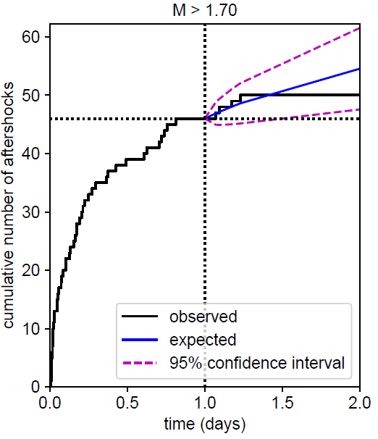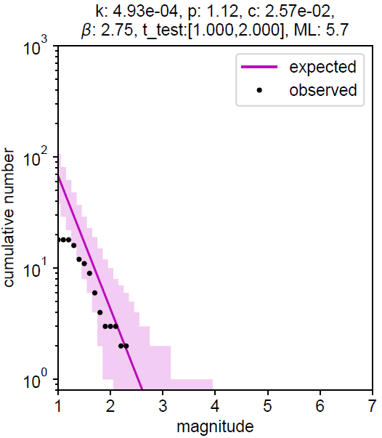
a) b)
Figure S7 (a) Aftershock cumulative number (black thick curve) for the learning period [0, 24h] and forecast period [24h, 48h] for the Vrancea-Marasesti area. The expected values for the forecasted period are indicated by the blue curve, together with the 95% confidence interval (dotted magenta). The threshold magnitude (1.7) is determined as the magnitude of completeness during the learning period (183 events). (b) The frequency-magnitude distribution for the forecasting window (black – observed numbers, magenta – expected numbers). The Omori-Utsu law parameter values, the β-value estimated during learning, the test (forecasted) period and the magnitude of the mainshock are given at the top of the figure.
- (b)
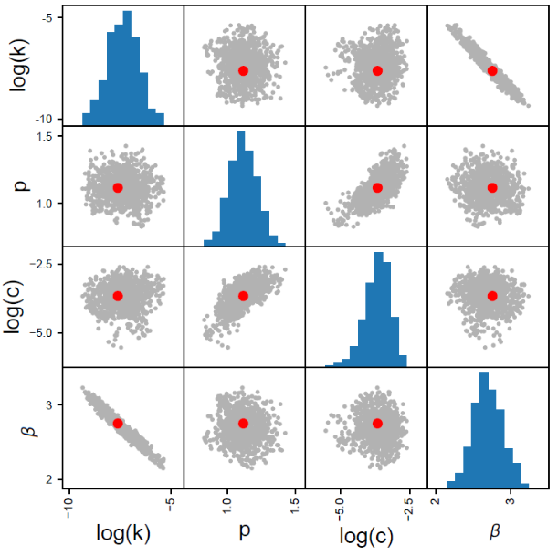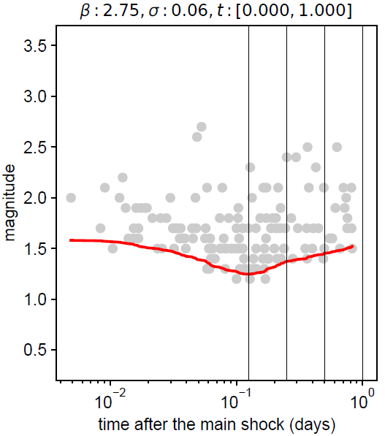
Figure S8 (a) Scatter plot distributions for the estimated parameter sets for the Vrancea-Marasesti sequence (red dots: estimated parameters, gray dots: sampled parameter sets). (b) Evolution of the detection magnitude µ(t) during the learning period of [0,24h] after the mainshock.

The 2023 Gorj earthquake sequence

(a) (b)
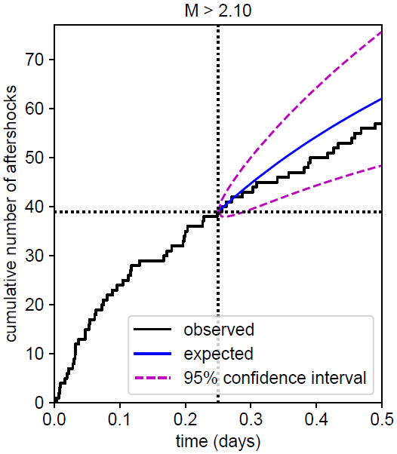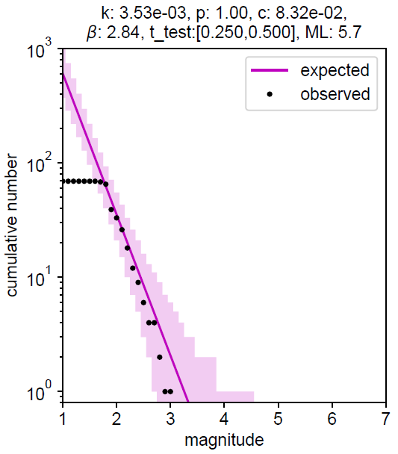
Figure S9 (a) Aftershock cumulative number (black thick curve) for the learning period [0, 6h] and forecast period [6h, 12h] for the Gorj area. The expected values for the forecasted period are indicated by the blue curve, together with the 95% confidence interval (dotted magenta). The threshold magnitude (2.1) is determined as the magnitude of completeness during the learning period (108 events). (b) The frequency-magnitude distribution for the forecasting window (black – observed numbers, magenta – expected numbers). The Omori-Utsu law parameter values, the β-value estimated during learning, the test (forecasted) period and the magnitude of the mainshock are given at the top of the figure.

- (b)
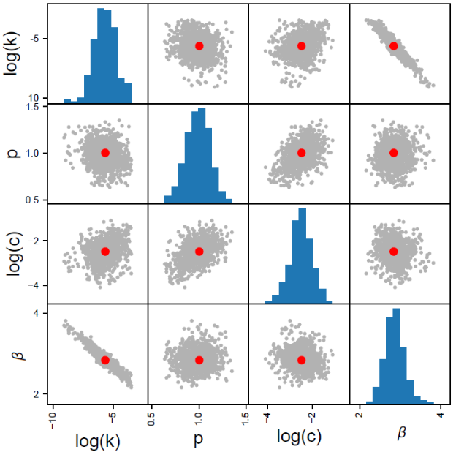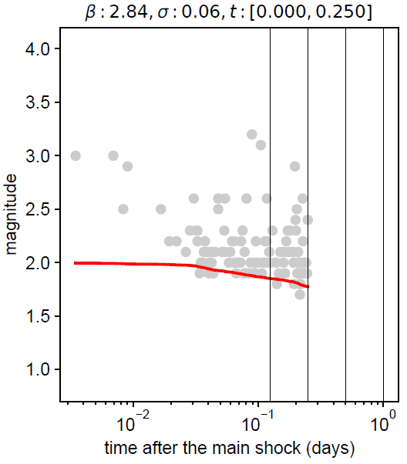
Figure S10 (a) Scatter plot distributions for the estimated parameter sets for the Gorj sequence (red dots: estimated parameters, gray dots: sampled parameter sets). (b) Evolution of the detection magnitude µ(t) during the learning period of [0,6h] after the mainshock.

- (b)
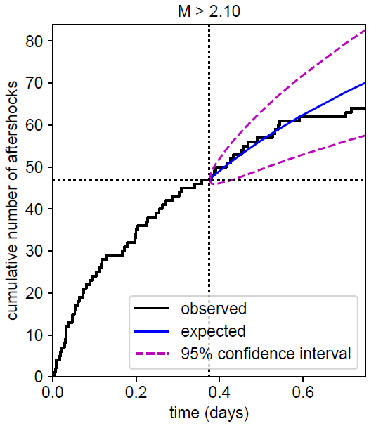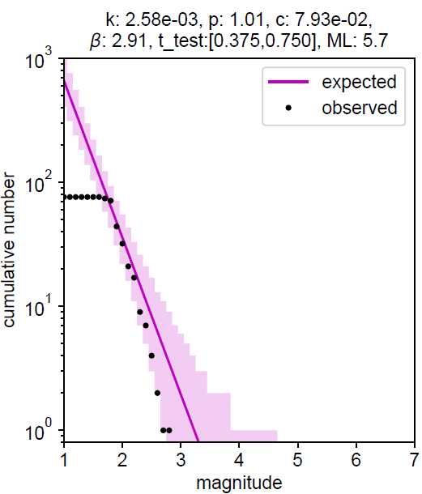

Figure S11 (a) Aftershock cumulative number (black thick curve) for the learning period [0, 9h] and forecast period [9h, 18h] for the Gorj area. The expected values for the forecasted period are indicated by the blue curve, together with the 95% confidence interval (dotted magenta). The threshold magnitude (2.1) is determined as the magnitude of completeness during the learning period (141 events). (b) The frequency-magnitude distribution for the forecasting window (black – observed numbers, magenta – expected numbers). The Omori-Utsu law parameter values, the β-value estimated during learning, the test (forecasted) period and the magnitude of the mainshock are given at the top of the figure.

- (b)
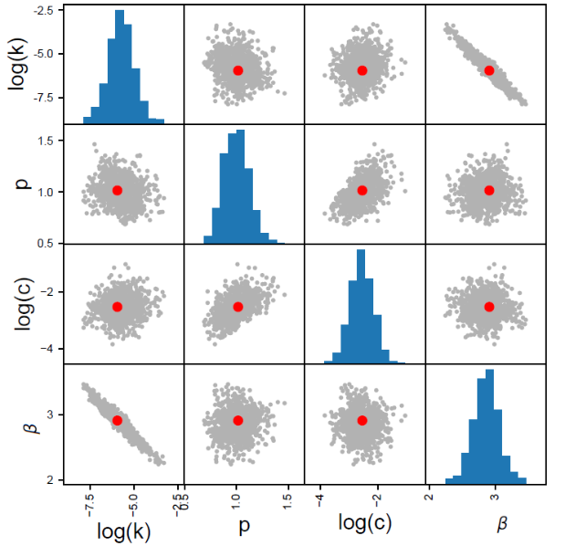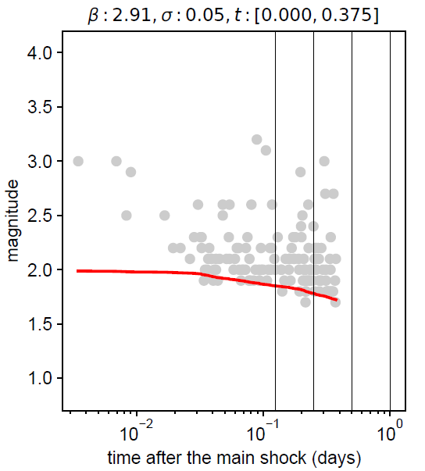
Figure S12 (a) Scatter plot distributions for the estimated parameter sets for the Gorj sequence (red dots: estimated parameters, gray dots: sampled parameter sets). (b) Evolution of the detection magnitude µ(t) during the learning period of [0,9h] after the mainshock.
(a) (b)
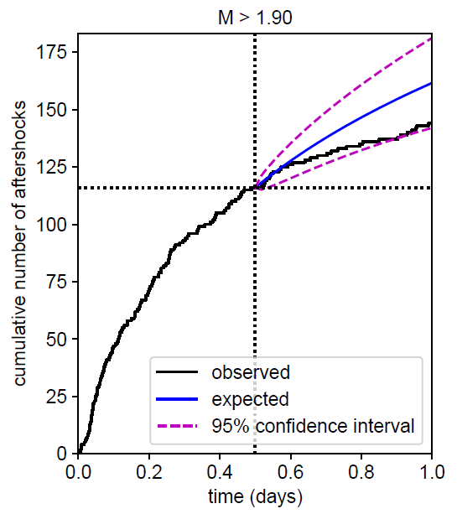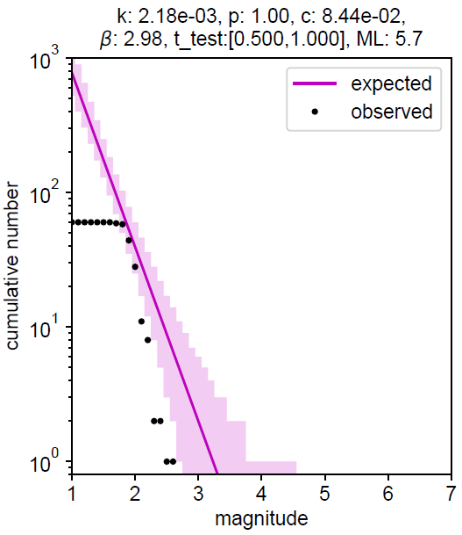
Figure S13 (a) Aftershock cumulative number (black thick curve) for the learning period [0, 12h] and forecast period [12h, 24h] for the Gorj area. The expected values for the forecasted period are indicated by the blue curve, together with the 95% confidence interval (dotted magenta). The threshold magnitude (1.9) is determined as the magnitude of completeness during the learning period (237 events). (b) The frequency-magnitude distribution for the forecasting window (black – observed numbers, magenta – expected numbers). The Omori-Utsu law parameter values, the β-value estimated during learning, the test (forecasted) period and the magnitude of the mainshock are given at the top of the figure.
(a) (b)
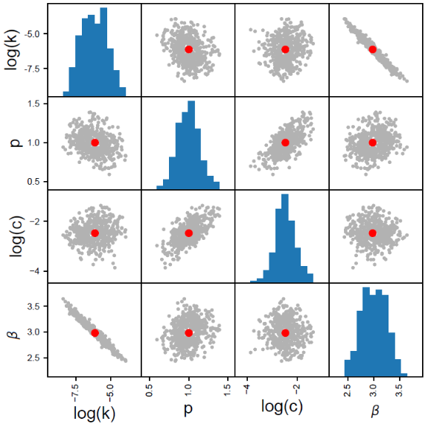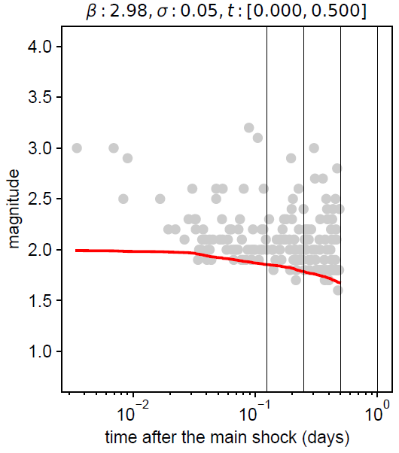
Figure S14 (a) Scatter plot distributions for the estimated parameter sets for the Gorj sequence (red dots: estimated parameters, gray dots: sampled parameter sets). (b) Evolution of the detection magnitude µ(t) during the learning period of [0,12h] after the mainshock.

(a) (b)
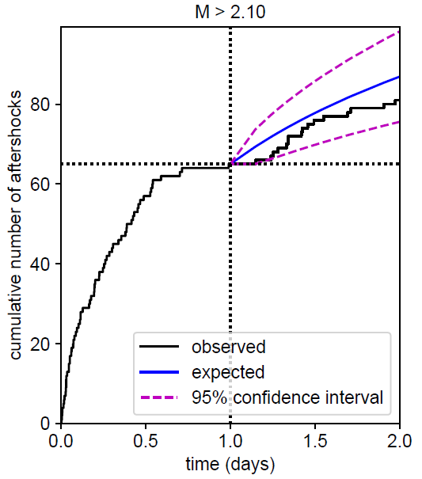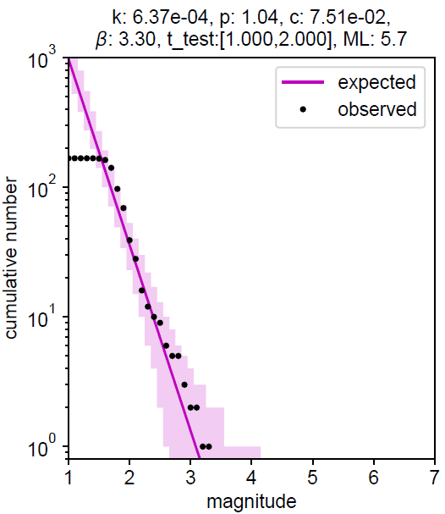
Figure S15 (a) Aftershock cumulative number (black thick curve) for the learning period [0, 24h] and forecast period [24h, 48h] for the Gorj area. The expected values for the forecasted period are indicated by the blue curve, together with the 95% confidence interval (dotted magenta). The threshold magnitude (2.1) is determined as the magnitude of completeness during the learning period (404 events). (b) The frequency-magnitude distribution for the forecasting window (black – observed numbers, magenta – expected numbers). The Omori-Utsu law parameter values, the β-value estimated during learning, the test (forecasted) period and the magnitude of the mainshock are given at the top of the figure.

(a) (b)
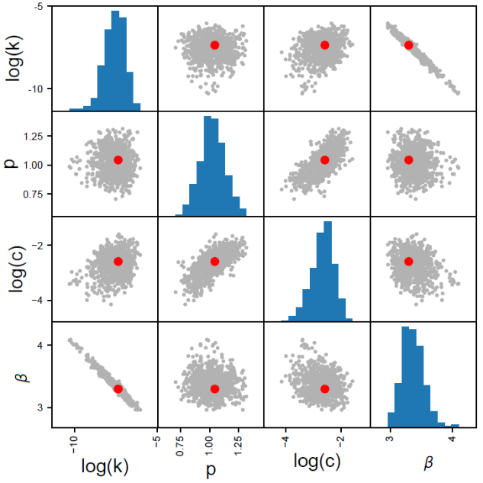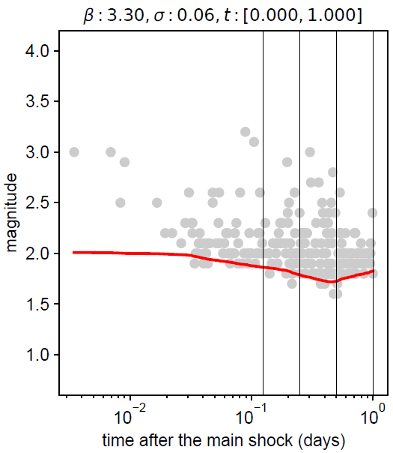
Figure S16 (a) Scatter plot distributions for the estimated parameter sets for the Gorj sequence (red dots: estimated parameters, gray dots: sampled parameter sets). (b) Evolution of the detection magnitude µ(t) during the learning period of [0,24h] after the mainshock.

Aftershock probabilities for the 2 sequences

(a) (b)
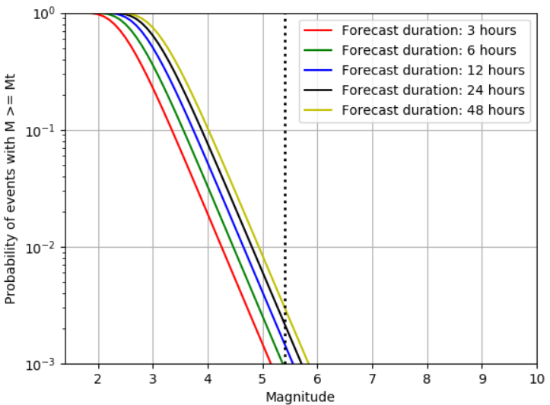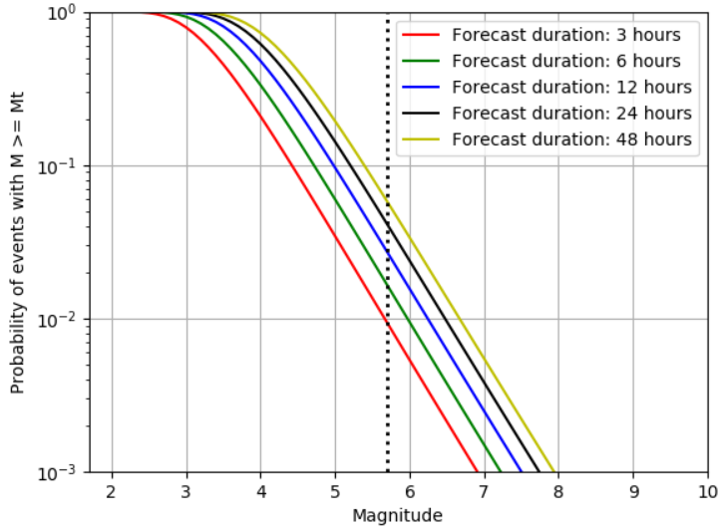
Figure S17. Aftershock probability forecasts as a function of magnitude for (a) the Vrancea-Marasesti and (b) the Gorj-Oltenia sequence, for a learning period of 6 hours from the respective mainshocks. The vertical dotted lines represent the mainshock magnitudes, while Mt represents the magnitude value used for the calculation.
(a) (b)
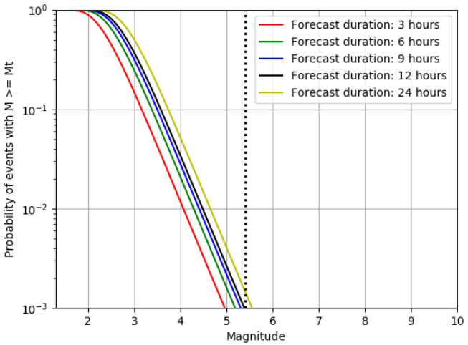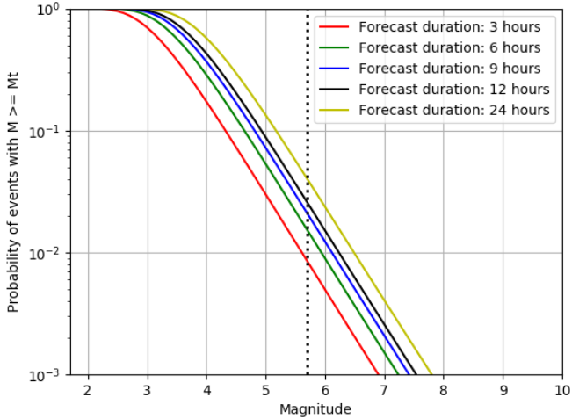
Figure S18. Aftershock probability forecasts as a function of magnitude for (a) the Vrancea-Marasesti and (b) the Gorj-Oltenia sequence, for a learning period of 9 hours from the respective mainshocks. The vertical dotted lines represent the mainshock magnitudes, while Mt represents the magnitude value used for the calculation.
(a) (b)
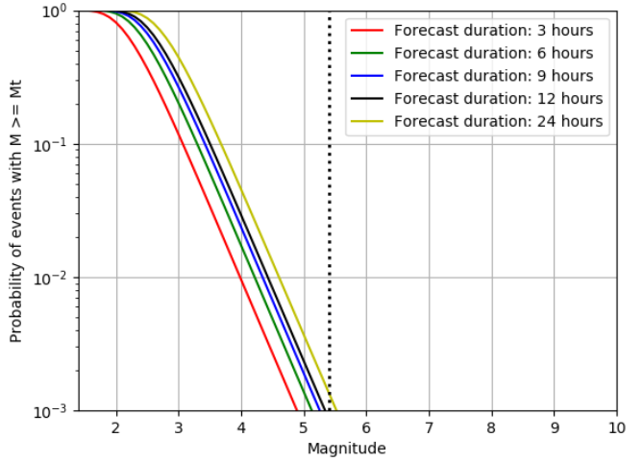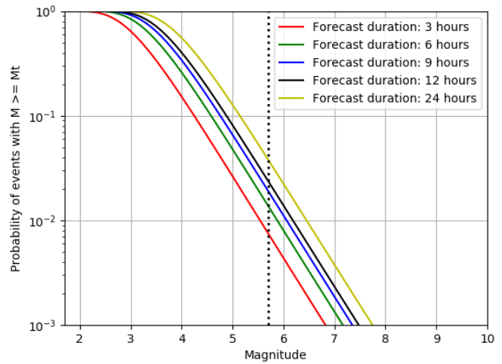
Figure S19. Aftershock probability forecasts as a function of magnitude for (a) the Vrancea-Marasesti and (b) the Gorj-Oltenia sequence, for a learning period of 12 hours from the respective mainshocks. The vertical dotted lines represent the mainshock magnitudes, while Mt represents the magnitude value used for the calculation.
- (b)
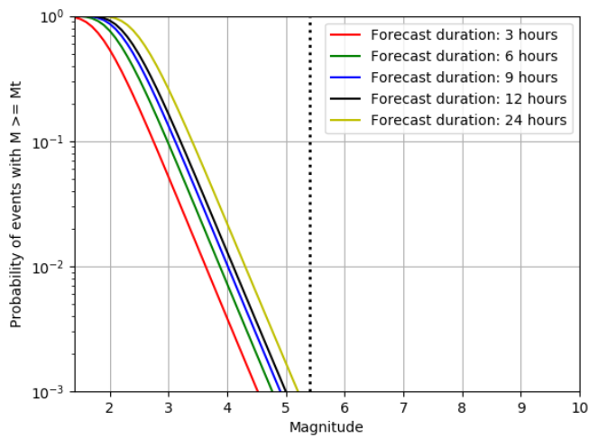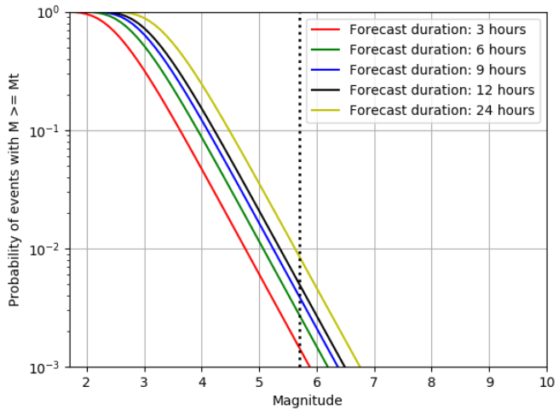
Figure S20. Aftershock probability forecasts as a function of magnitude for (a) the Vrancea-Marasesti and (b) the Gorj-Oltenia sequence, for a learning period of 24 hours from the respective mainshocks. The vertical dotted lines represent the mainshock magnitudes, while Mt represents the magnitude value used for the calculation.

