Supplementary Information
Supplementary Figures and legends
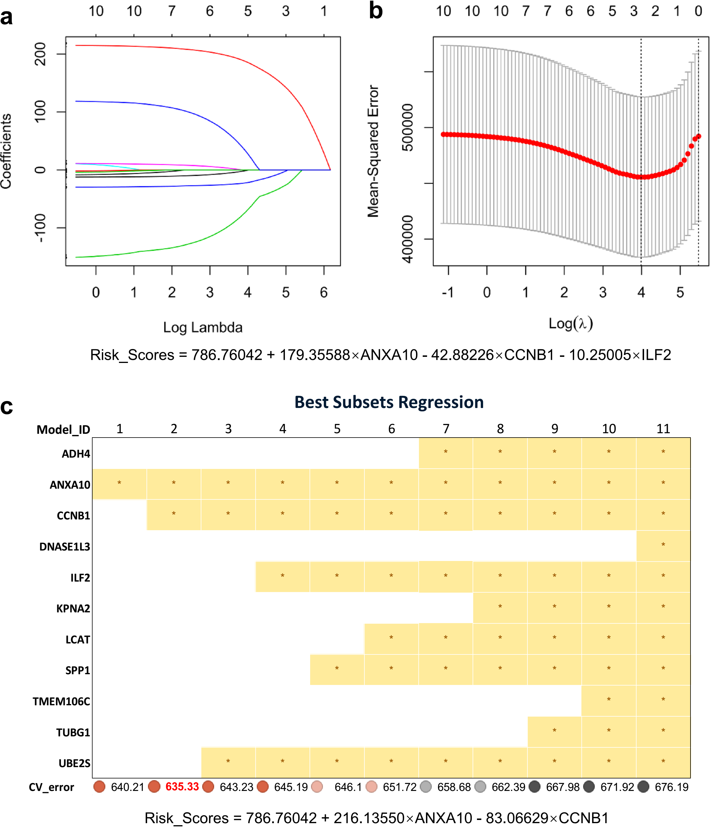
Supplementary Fig. 1 Determined the optimal genes from the hub gene by regression analysis. ENP analysis identifies 3 optimal genes (ANXA10, CCNB1 and ILF2) at minimum Mean-Squared Error with lambda of 4 (a, b). (c) ANXA10 and CCNB1 were identified as the optimal genes at minimum of CV_error on BSR analysis. Correspondent formulas were list blow the figures, repectively.
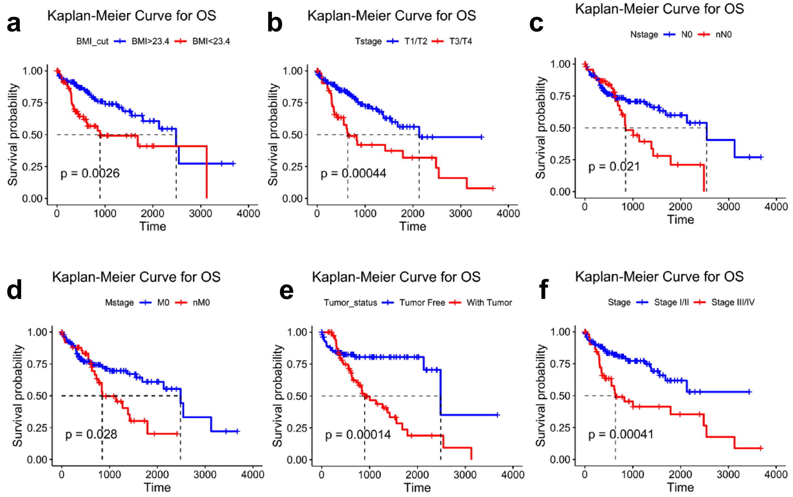
Supplementary Fig. 2 Analyzed clinical characteristics by Kaplan–Meier curves. OS curves shown that two subgroups come across with each other at the initial segment of plots in characteristics of N_stage (c), M_stage(d) and tumor_status(e). BMI_cut (a), T_stage (b) and Stage (f) are suitable characters for multivariate Cox regression (P<0.01).
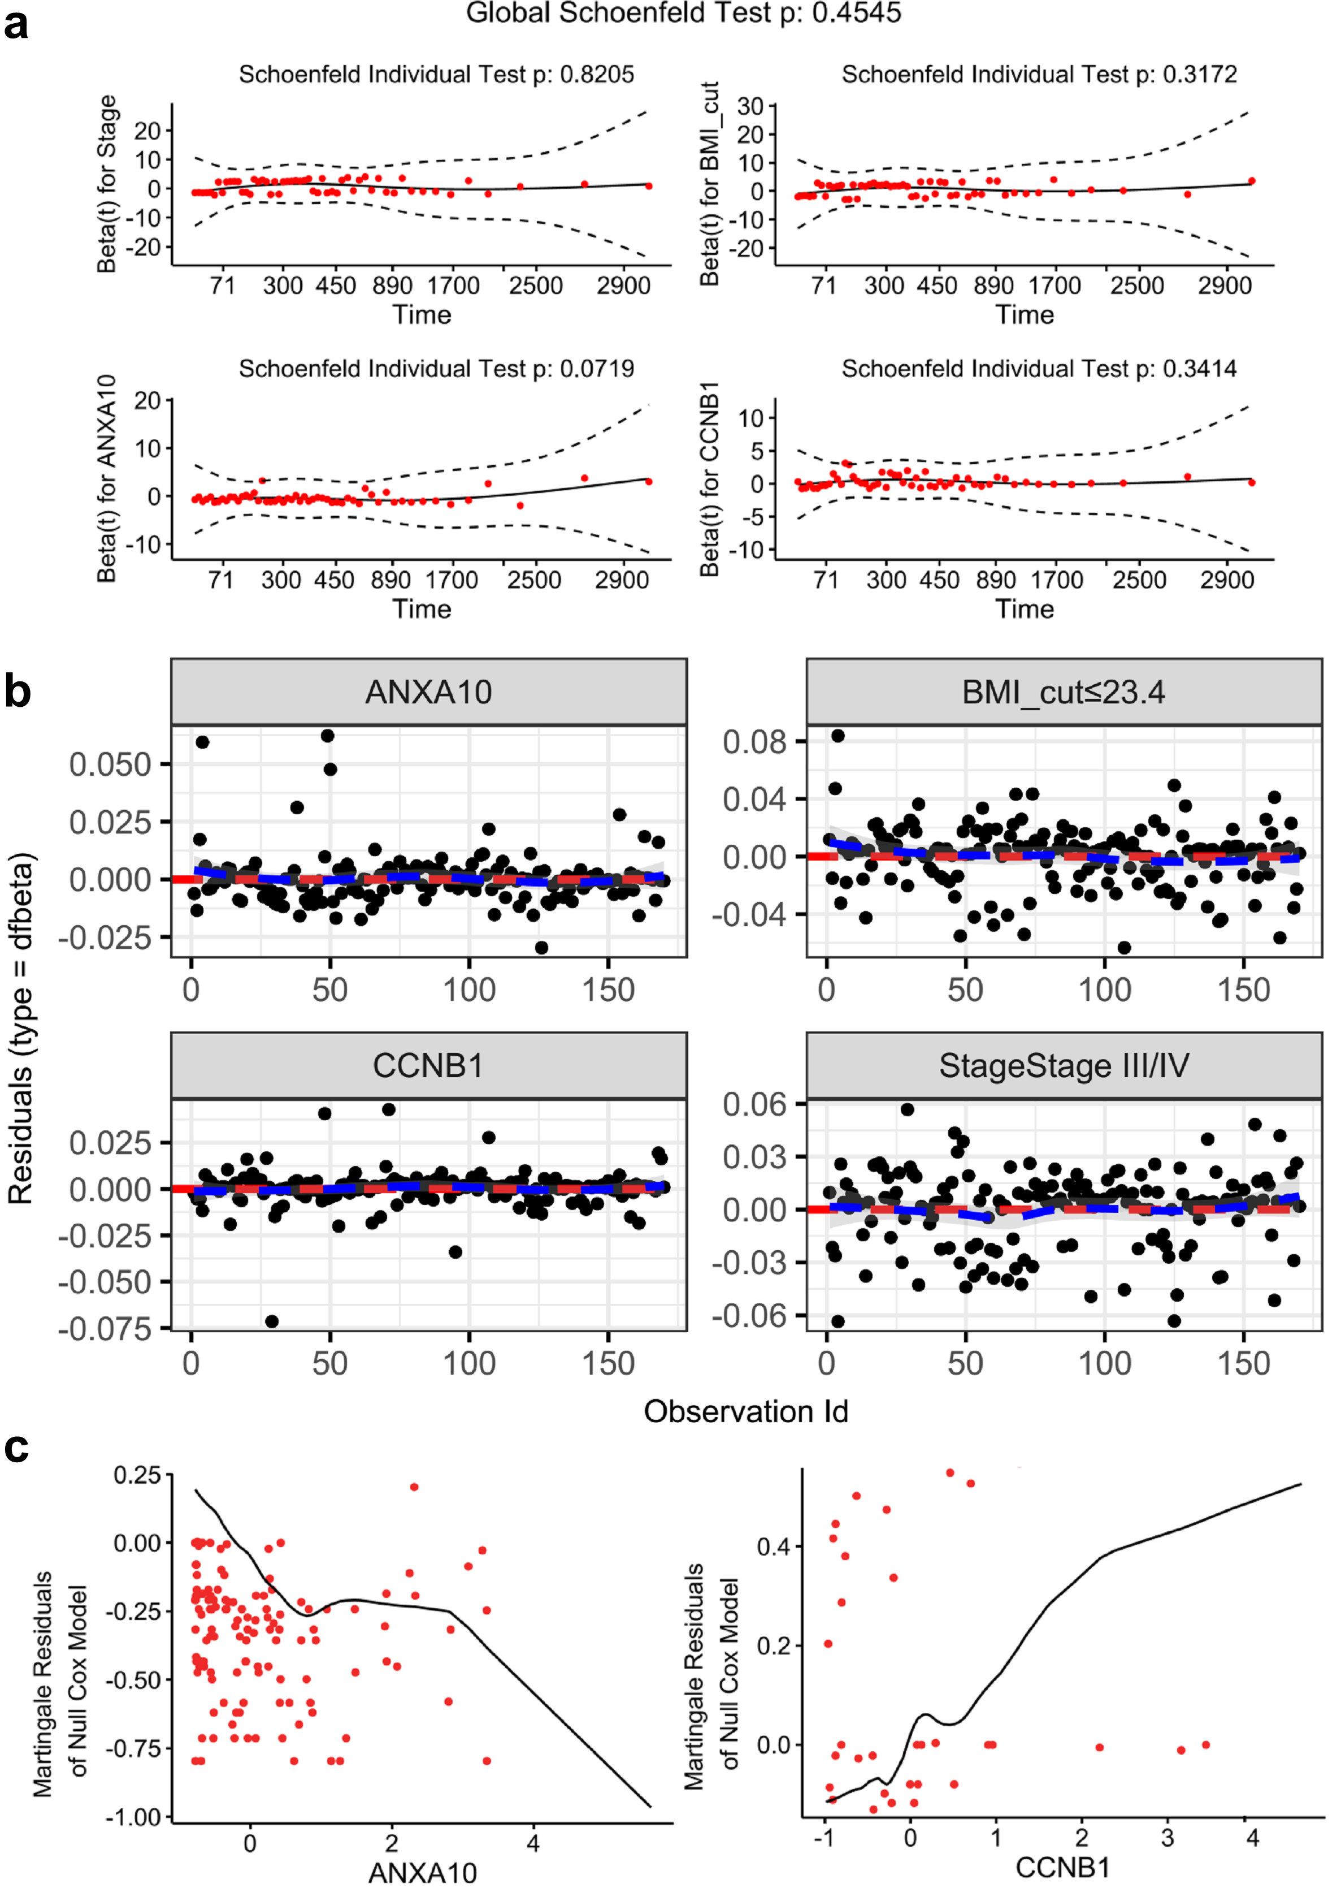
Supplementary Fig. 3 Evaluate the validity of the Multivariate Cox model assumptions. (a) The proportional hazards assumption to be supported by Schoenfeld residuals check for the covariates of ANXA10, CCNB1, BMI_cut and Stage (P>0.05). The solid line is a smoothing spline fit to the plot, with the dashed lines representing a +/- 2-standard-error band around the fit. (b) Index plots of dfbeta for the Cox regression of time to death on ANXA10, CCNB1, BMI_cut and Stage. The points contribute to a symmetric distribution across the red dashed line, and it almost overlaps with the blue dashed line, which suggests none of the observations is terribly influential individually. (c) Plotting the Martingale residuals against continuous covariates of ANXA10 and CCNB1. The plots shown that the covariates have a nonlinearity form.

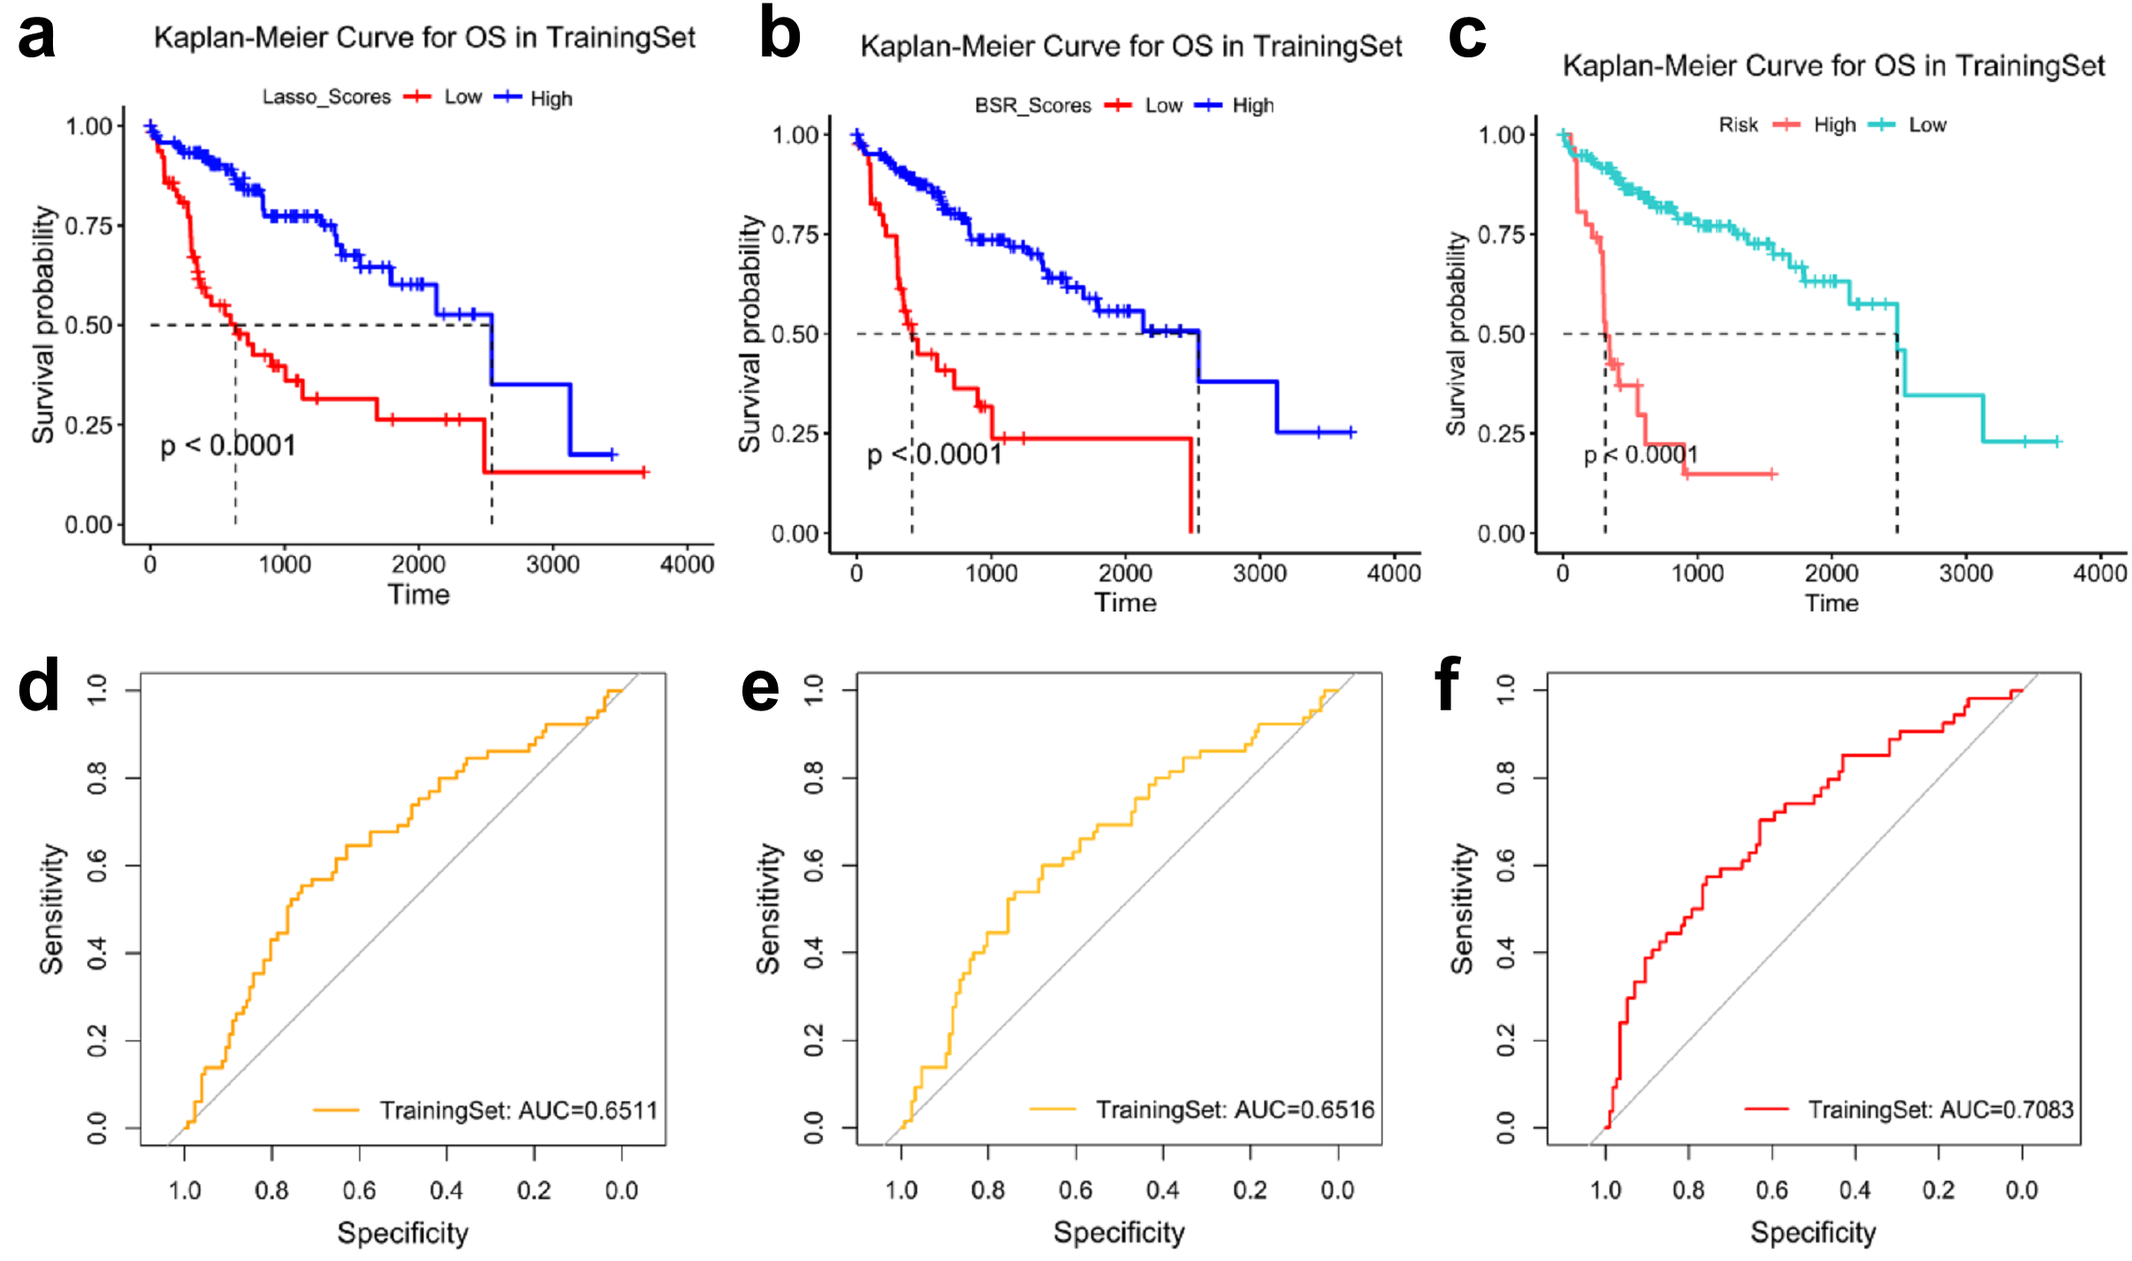
Supplementary Fig. 4 Determined the nomogram optimally to predict prognostic of patients with HCC. Kaplan–Meier curves show significant difference between subgroups in overall survival by ENP (P<0.0001) (a), BSR (P<0.0001) (b) and Cox regression analysis (P<0.0001) (c). ROC curves shown the predictive efficiency of ENP (AUC=0.65) (d), BSR (AUC=0.65) (e) and Cox Regression (AUC=0.71) (f) analysis in TCGA Training set (n=147).

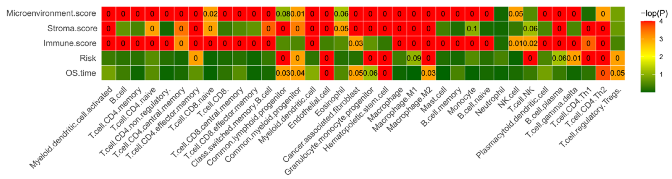
Supplementary Fig. 5 Correlation analysis of TME scores, Risk score and outcome with fractions of TME. Fractions of CLP, CMP, EC, HSC, M2, Th2 and Tregs were correlated with Risk scores and outcome (OS.time) at the same time. CLP: Common lymphoid progenitor, CMP: Common lymphoid progenitor, EC: Endothelial cell, HSC: Hematopoietic stem cell, M2: Macrophage M2, Th2: CD4T cell Th2, Tregs: T cell regulatory.

Supplementary Table legends
Supplementary Table1. The overlapped candidates of 5 datasets were defined as prognostic hub genes.
1. GEO_DEGs. 1733 DEGs were calculated by limma R package from GEO datasets. 2. TCGA_Trainingset_DEGs. 1857 DEGs were calculated by Wilcox test from TCGA_trainingset. 3. Mongolian_DEGs. 1228 DEGs were calculated by DESeq2 R package from Mongolian dataset. 4. OS_Quartile. Top500 OS related gene sets (OS_Quartile) were download from GEPIA2. 5. OS_Median. Top500 OS related gene sets (OS_Median) were download from GEPIA2.

Supplementary Table2. Univariate Cox regression of the clinical characters of HCC patients.

Supplementary Table 3. Hypoxia marker 15-gene signatures.

Supplementary Table 4. The relative expression of genes in related signaling pathways.
1. VEGF pathway. Relative expression of 62 genes in VEGF pathway. 2. HIF1A pathway. Relative expression of 19 genes in VEGF pathway.

HCC: Hepatocellular Carcinoma; OS: overall survival; AFP: alpha-fetoprotein; TME: tumor microenvironment; GEO: Gene Expression Omnibus; DEGs: different expression genes; TCGA: The Cancer Genome Atlas; ENP: elastic net penalty; BSR: Best subsets regression; ssGSEA: single sample gene set enrichment; ROC: receiver operating characteristic; CCNB1: Cyclin B1; ANXA10: Annexin A10; CV: coefficient variable; BMI: body mass index; CLP: common lymphoid progenitor; CMP: common lymphoid progenitor; EC: endothelial cell; HSC: hematopoietic stem cell; M2: M2 macrophage; Th2: T helper 2 cells; Tregs: regulatory T cells.

