Table S1. OECD member countries list
Country | Year of accession | World Bank income group
Australia | 1971 | High
Austria | 1961 | High
Belgium | 1961 | High
Canada | 1961 | High
Chile | 2010 | High
Colombia | 2020 | Upper middle
Costa Rica | 2021 | Upper middle
Czechia | 1995 | High
Denmark | 1961 | High
Estonia | 2010 | High
Finland | 1969 | High
France | 1961 | High
Germany | 1961 | High
Greece | 1961 | High
Hungary | 1996 | High
Iceland | 1961 | High
Ireland | 1961 | High
Israel | 2010 | High
Italy | 1962 | High
Japan | 1964 | High
Latvia | 2016 | High
Lithuania | 2018 | High
Luxembourg | 1961 | High
Mexico | 1994 | Upper middle
Netherlands | 1961 | High
New Zealand | 1973 | High
Norway | 1961 | High
Poland | 1996 | High
Portugal | 1961 | High
Republic of Korea | 1996 | High
Slovak Republic | 2000 | High
Slovenia | 2010 | High
Spain | 1961 | High
Sweden | 1961 | High
Switzerland | 1961 | High
Turkey | 1961 | Upper middle
United Kingdom | 1961 | High
United States | 1961 | High

Table S2. Concordance file for 80 NCDs (80 level 3 GBD causes and 91 AIHW conditions)
GBD ID | GBD level 3 cause | AIHW condition | Disease group
411 | Esophageal cancer | Oesophageal cancer | Neoplasms
414 | Stomach cancer | Stomach cancer | Neoplasms
417 | Liver cancer | Liver cancer | Neoplasms
423 | Larynx cancer | Laryngeal cancer | Neoplasms
426 | Tracheal, bronchus, and lung cancer | Lung cancer | Neoplasms
429 | Breast cancer | Breast cancer | Neoplasms
432 | Cervical cancer | Cervical cancer | Neoplasms
435 | Uterine cancer | Uterine cancer | Neoplasms
438 | Prostate cancer | Prostate cancer | Neoplasms
441 | Colon and rectum cancer | Bowel cancer | Neoplasms
444 | Lip and oral cavity cancer | Lip and oral cavity cancer | Neoplasms
447 | Nasopharynx cancer | Nasopharyngeal cancer | Neoplasms
453 | Gallbladder and biliary tract cancer | Gallbladder cancer | Neoplasms
456 | Pancreatic cancer | Pancreatic cancer | Neoplasms
459 | Malignant skin melanoma | Melanoma of the skin | Neoplasms
462 | Non-melanoma skin cancer | Non-melanoma skin cancer | Neoplasms
465 | Ovarian cancer | Ovarian cancer | Neoplasms
468 | Testicular cancer | Testicular cancer | Neoplasms
471 | Kidney cancer | Kidney cancer | Neoplasms
474 | Bladder cancer | Bladder cancer | Neoplasms
477 | Brain and central nervous system cancer | Brain and CNS cancer | Neoplasms
480 | Thyroid cancer | Thyroid cancer | Neoplasms
483 | Mesothelioma | Mesothelioma | Neoplasms
484 | Hodgkin lymphoma | Hodgkin lymphoma | Neoplasms
485 | Non-Hodgkin lymphoma | Non-Hodgkin lymphoma | Neoplasms
486 | Multiple myeloma | Myeloma | Neoplasms
487 | Leukemia | Acute lymphoblastic leukaemia (ALL) | Neoplasms
487 | Leukemia | Acute myeloid leukaemia (AML) | Neoplasms
487 | Leukemia | Chronic lymphocytic leukaemia (CLL) | Neoplasms
487 | Leukemia | Chronic myeloid leukaemia (CML) | Neoplasms
487 | Leukemia | Other leukaemias | Neoplasms
492 | Rheumatic heart disease | Rheumatic heart disease (incl. acute rheumatic fever) | Cardiovascular diseases
493 | Ischemic heart disease | Coronary heart disease | Cardiovascular diseases
494 | Stroke | Stroke | Cardiovascular diseases
498 | Hypertensive heart disease | Hypertensive heart disease | Cardiovascular diseases
499 | Cardiomyopathy and myocarditis | Cardiomyopathy | Cardiovascular diseases
499 | Cardiomyopathy and myocarditis | Inflammatory heart disease | Cardiovascular diseases
500 | Atrial fibrillation and flutter | Atrial fibrillation and flutter | Cardiovascular diseases
501 | Aortic aneurysm | Aortic aneurysm | Cardiovascular diseases
502 | Peripheral artery disease | Peripheral vascular disease | Cardiovascular diseases
503 | Endocarditis | Inflammatory heart disease | Cardiovascular diseases
504 | Non-rheumatic valvular heart disease | Non-rheumatic valvular disease | Cardiovascular diseases
509 | Chronic obstructive pulmonary disease | COPD | Chronic respiratory diseases
510 | Pneumoconiosis | Asbestosis | Chronic respiratory diseases
510 | Pneumoconiosis | Other pneumoconiosis | Chronic respiratory diseases
510 | Pneumoconiosis | Silicosis | Chronic respiratory diseases
515 | Asthma | Asthma | Chronic respiratory diseases
516 | Interstitial lung disease and pulmonary sarcoidosis | Interstitial lung disease | Chronic respiratory diseases
516 | Interstitial lung disease and pulmonary sarcoidosis | Sarcoidosis | Chronic respiratory diseases
520 | Other chronic respiratory diseases | Upper respiratory conditions | Chronic respiratory diseases
521 | Cirrhosis and other chronic liver diseases | Chronic liver disease | Digestive diseases
530 | Paralytic ileus and intestinal obstruction | Intestinal obstruction (without hernia) | Digestive diseases
531 | Inguinal, femoral, and abdominal hernia | Abdominal wall hernia | Digestive diseases
532 | Inflammatory bowel disease | Inflammatory bowel disease (IBD) | Digestive diseases
533 | Vascular intestinal disorders | Vascular disorders of intestine | Digestive diseases
534 | Gallbladder and biliary diseases | Gallbladder and bile duct disease | Digestive diseases
535 | Pancreatitis | Pancreatitis | Digestive diseases
541 | Other digestive diseases | Diverticulitis | Digestive diseases
541 | Other digestive diseases | Other gastrointestinal diseases | Digestive diseases
543 | Alzheimer's disease and other dementias | Dementia | Neurological disorders
544 | Parkinson's disease | Parkinson disease | Neurological disorders
545 | Idiopathic epilepsy | Epilepsy | Neurological disorders
546 | Multiple sclerosis | Multiple sclerosis | Neurological disorders
554 | Motor neuron disease | Motor neurone disease | Neurological disorders
557 | Other neurological disorders | Guillain-Barre Syndrome | Neurological disorders
559 | Schizophrenia | Schizophrenia | Mental disorders
560 | Alcohol use disorders | Alcohol use disorders | Substance use disorders
561 | Drug use disorders | Drug use disorders (excl. alcohol) | Substance use disorders
567 | Depressive disorders | Depressive disorders | Mental disorders
570 | Bipolar disorder | Bipolar affective disorder | Mental disorders
571 | Anxiety disorders | Anxiety disorders | Mental disorders
572 | Eating disorders | Eating disorders | Mental disorders
575 | Autism spectrum disorders | Autism spectrum disorders | Mental disorders
578 | Attention-deficit/hyperactivity disorder | Attention deficit hyperactivity disorder | Mental disorders
579 | Conduct disorder | Conduct disorder | Mental disorders
582 | Idiopathic developmental intellectual disability | Intellectual disability | Mental disorders
587 | Diabetes mellitus | Type 1 diabetes | Diabetes and kidney diseases
587 | Diabetes mellitus | Type 2 diabetes | Diabetes and kidney diseases
589 | Chronic kidney disease | Chronic kidney disease | Diabetes and kidney diseases
627 | Rheumatoid arthritis | Rheumatoid arthritis | Musculoskeletal disorders
628 | Osteoarthritis | Osteoarthritis | Musculoskeletal disorders
630 | Low back pain | Back pain and problems | Musculoskeletal disorders
631 | Neck pain | Back pain and problems | Musculoskeletal disorders
632 | Gout | Gout | Musculoskeletal disorders
654 | Dermatitis | Dermatitis and eczema | Skin and subcutaneous diseases
655 | Psoriasis | Psoriasis | Skin and subcutaneous diseases
661 | Acne vulgaris | Acne | Skin and subcutaneous diseases
665 | Decubitus ulcer | Ulcers | Skin and subcutaneous diseases
972 | Headache disorders | Migraine | Neurological disorders
992 | Upper digestive system diseases | Gastro Oesophageal Reflux Disease (GORD) | Digestive diseases
992 | Upper digestive system diseases | Gastroduodenal disorders | Digestive diseases

Figure S1. Total health system expenditure by health care function across OECD member countries in 2019
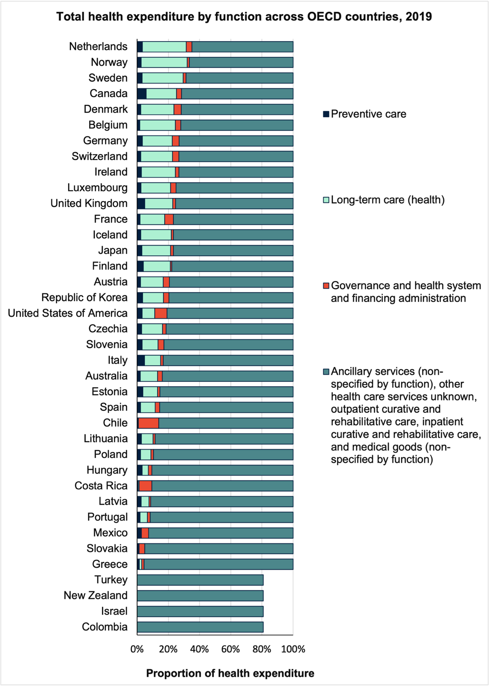

Table S3. Total health expenditure percentage by disease groups across OECD member countries in 2019.
Country | All other conditions | Cancer and other neoplasms | Cardiovascular diseases | Endocrine disorders | Gastrointestinal disorders | Kidney and urinary diseases | Mental and substance use disorders | Musculoskeletal disorders | Neurological conditions | Respiratory diseases | Skin disorders
Colombia | 45.5% | 3.7% | 5.4% | 4.2% | 7.5% | 5.0% | 6.1% | 13.3% | 2.8% | 1.6% | 5.0%
Israel | 45.4% | 6.5% | 6.3% | 3.2% | 4.3% | 3.2% | 6.7% | 15.8% | 3.1% | 1.7% | 3.9%
Chile | 44.3% | 5.0% | 6.3% | 4.1% | 5.1% | 3.8% | 8.0% | 14.9% | 3.0% | 2.1% | 3.4%
Mexico | 43.4% | 3.0% | 6.2% | 5.4% | 7.7% | 6.0% | 6.4% | 12.7% | 2.9% | 1.4% | 4.9%
Turkey | 42.8% | 3.8% | 7.3% | 3.2% | 5.4% | 4.6% | 6.2% | 16.8% | 3.1% | 2.1% | 4.6%
Costa Rica | 42.6% | 4.5% | 8.1% | 4.2% | 6.9% | 6.0% | 6.4% | 12.3% | 2.7% | 1.7% | 4.7%
Republic of Korea | 42.0% | 6.9% | 6.7% | 3.8% | 5.8% | 4.0% | 5.9% | 16.9% | 2.9% | 1.7% | 3.5%
Iceland | 41.8% | 7.9% | 7.5% | 3.2% | 3.9% | 2.6% | 6.2% | 17.1% | 3.7% | 2.4% | 3.6%
France | 40.7% | 9.0% | 7.8% | 2.2% | 4.2% | 3.0% | 6.9% | 16.3% | 3.7% | 2.0% | 4.3%
Australia | 40.5% | 9.4% | 9.5% | 2.7% | 4.7% | 3.3% | 7.4% | 13.6% | 3.1% | 2.7% | 3.2%
Luxembourg | 40.3% | 7.6% | 7.5% | 4.5% | 4.7% | 3.0% | 6.6% | 16.3% | 3.6% | 2.4% | 3.4%
Switzerland | 40.0% | 8.2% | 7.7% | 3.4% | 4.0% | 3.2% | 7.0% | 17.5% | 3.5% | 2.2% | 3.3%
Ireland | 39.9% | 8.7% | 7.2% | 3.0% | 4.1% | 3.2% | 7.6% | 16.8% | 3.7% | 2.5% | 3.3%
Belgium | 39.8% | 8.6% | 8.1% | 3.3% | 4.6% | 3.1% | 6.5% | 16.3% | 3.5% | 2.5% | 3.7%
New Zealand | 39.4% | 10.4% | 9.0% | 2.4% | 5.7% | 3.3% | 7.0% | 14.0% | 2.9% | 2.5% | 3.3%
Spain | 38.9% | 8.7% | 7.9% | 4.3% | 4.3% | 2.8% | 7.5% | 16.6% | 3.4% | 2.2% | 3.5%
Netherlands | 38.7% | 10.6% | 8.5% | 2.7% | 3.7% | 3.3% | 6.5% | 16.4% | 3.5% | 2.9% | 3.2%
Austria | 38.6% | 7.7% | 10.0% | 3.0% | 6.1% | 3.2% | 6.3% | 16.3% | 3.3% | 2.1% | 3.4%
Denmark | 38.5% | 9.1% | 8.5% | 2.9% | 4.8% | 3.1% | 6.6% | 17.4% | 3.5% | 2.6% | 2.9%
Greece | 38.4% | 8.5% | 8.8% | 3.4% | 4.5% | 3.9% | 7.5% | 16.7% | 3.0% | 2.2% | 3.2%
Slovakia | 38.3% | 7.1% | 9.9% | 3.2% | 6.9% | 3.8% | 5.7% | 15.6% | 3.1% | 1.4% | 5.1%
Portugal | 38.2% | 7.9% | 7.7% | 4.9% | 4.0% | 3.0% | 8.0% | 17.3% | 2.9% | 2.8% | 3.2%
Japan | 38.0% | 7.8% | 9.6% | 2.5% | 6.6% | 5.2% | 3.9% | 18.3% | 3.0% | 1.7% | 3.4%
Norway | 37.6% | 8.0% | 9.1% | 3.5% | 6.6% | 2.6% | 5.9% | 16.5% | 3.8% | 2.6% | 3.7%
Poland | 37.5% | 5.8% | 9.5% | 3.8% | 6.1% | 3.5% | 5.4% | 17.2% | 3.3% | 2.0% | 5.9%
Finland | 37.5% | 8.4% | 9.4% | 4.5% | 5.2% | 2.7% | 6.0% | 17.7% | 3.3% | 2.0% | 3.3%
Sweden | 37.4% | 7.8% | 9.7% | 3.1% | 4.9% | 3.3% | 6.4% | 17.9% | 3.6% | 2.6% | 3.2%
Germany | 37.1% | 9.1% | 9.1% | 4.9% | 4.7% | 3.2% | 6.1% | 16.5% | 3.7% | 2.1% | 3.7%
Lithuania | 36.7% | 5.7% | 12.2% | 2.0% | 7.3% | 4.3% | 7.0% | 16.1% | 2.9% | 1.1% | 4.7%
Slovenia | 36.3% | 7.4% | 11.0% | 3.2% | 6.2% | 3.6% | 6.2% | 16.0% | 3.1% | 1.9% | 5.2%
Latvia | 36.3% | 5.8% | 12.8% | 2.5% | 6.5% | 4.4% | 6.9% | 16.0% | 2.8% | 1.1% | 4.7%
United Kingdom | 35.9% | 7.9% | 7.5% | 4.9% | 7.0% | 2.5% | 6.5% | 18.6% | 3.4% | 2.9% | 3.1%
Czechia | 35.7% | 7.1% | 11.2% | 5.8% | 6.1% | 3.6% | 5.4% | 15.4% | 3.0% | 1.7% | 5.0%
Estonia | 35.6% | 7.0% | 14.1% | 2.4% | 5.9% | 4.6% | 6.6% | 15.4% | 2.9% | 1.0% | 4.5%
Hungary | 35.3% | 6.8% | 12.5% | 3.9% | 6.9% | 3.6% | 5.5% | 15.6% | 2.9% | 2.0% | 5.0%
Canada | 35.0% | 15.5% | 8.8% | 2.5% | 5.0% | 2.9% | 4.9% | 14.7% | 3.3% | 2.0% | 5.3%
Italy | 34.1% | 8.9% | 11.1% | 3.9% | 7.5% | 2.9% | 5.7% | 17.9% | 3.3% | 1.8% | 2.8%
United States of America | 31.8% | 10.6% | 9.5% | 4.2% | 4.4% | 3.3% | 6.2% | 18.3% | 3.0% | 2.9% | 5.7%
Combined | 35.3% | 9.4% | 9.1% | 3.9% | 5.0% | 3.5% | 6.1% | 17.4% | 3.2% | 2.5% | 4.7%

