Suppl.Fig 1. :Establishment of HBV replication cell model and regulation of Gal-3 expression. A,B: ELISA was used to detect the relative expression of HBsAg and HBsAe in the cell supernatant 48 hours after pHBV4.1 transfection. C: Western blot was used to detect the expression of Gal-3 after pHBV4.1 transfection. D, E: Western blot was used to detect the protien expression of Gal-3 after Co-transfection of pHBV4.1 with pEnter-Gal-3 or siRNA-Gal-3. F: qPCR was used to detect the RNA expression of Gal-3 after Co-transfection of pHBV4.1 with pEnter-Gal-3 or siRNA-Gal-3.

Suppl. Table1: Antibodies involved in this study
Antibodies | Manufacturer | The state
galectin-3 | Abcam | UK
p65 | CST | USA
IκBα | CST | USA
USA | proteintech | China
GAPDH | Jackson ImmunoResearch | USA
Goat Anti-Mouse IgG | Jackson ImmunoResearch | USA
Goat Anti-Rabbit IgG | Jackson ImmunoResearch | USA
Alexa Fluor 594 | Invitrogen | USA
Suppl. Table2: Primers involved in this study
Gene | Primers
Gal-3 | 3’-GTGAAGCCCAATGCAAACAGA-5’  5’-AGCGTGGGTTAAAGTGGAAGG-3’
NF-κB-p65 | 3’-ATGTGGAGATCATTGAGCAGC-5’  5’-CCTGGTCCTGTGTAGCCATT-3’
IκBα | 3’-CTCCGAGACTTTCGAGGAAATAC-5’  5’-GCCATTGTAGTTGGTAGCCTTCA-3’
IL1-β | 3’-GATGATAACCTGCTGGTGTGTGA-5’  5’-GTTGTTCATCTCGGAGCCTGTAG-3’
NLRP3 | 3’-GATCTTCGCTGCGATCAACAG-5’  5’-CGTGCATTATCTGAACCCCAC-3’
GAPDH | 3’-GGAGCGAGATCCCTCCAAAAT-5’  5’-GGCTGTTGTCATACTTCTCATGG-3’

Suppl.Fig 2. : Original picture of the full-length blots. (A) Southern blot. (B) GAPDH. (C) IκBα.
- Casepase-1. (E)P65. (F)Gal-3.

A B

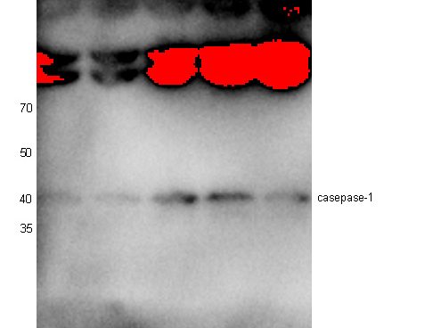
C D

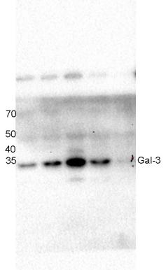
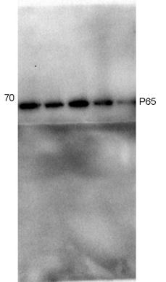
E F

