Compositional engineering of phase-stable and highly efficient deep-red emitting phosphor for advanced plant lighting systems
Jianwei Qiao^{1*}, Dehong Li¹, Qiufeng Shi^{1*}, Haijie Guo¹, Ping Huang¹, Lei Wang^{1*}

¹College of Physics, Taiyuan University of Technology, Taiyuan 030024, P.R. China

Correspondence:
Jianwei Qiao (qiaojianwei@tyut.edu.cn)
Qiufeng Shi (shiqiufeng@tyut.edu.cn)
Lei Wang (wanglei_keke@163.com)

Fig. S1 Rietveld refinement results of O-NaMgPO₄ XRD patern synthesized through arc-imaging furnace (a) and rapid quenching method (b) reported by Toda et al.^{1, 2} Obviously, there are impure phases in the samples using both synthesis methods.

Fig. S2 (a) XRD patterns of NaMgPO₄:Eu synthesized by traditional high-temperature solid state and rapid quenching method, and the simulated standard card of O-NaMgPO₄, G-NaMgPO₄, and Na_{5.52}Mg_{1.4}(PO₄)₃. (b-f) Rietveld refinement results of Na_{1+x}MgP_{1-x}Si_{x}O₄:Eu²⁺ (x = 0-0.08) X-ray powder diffraction pattern.

Fig. S3 (a) SEM images of the NaMgPO₄:Eu microcrystal particles and the enlarged particles (b). (c) EDS elemental mapping of the cross section of NaMgPO₄:Eu. (d) SEM images of the Na_{1.06}MgP_{0.96}Si_{0.04}O₄:Eu microcrystal particles and the enlarged particles (e). (f) EDS elemental mapping of the cross section of Na_{1.06}MgP_{0.96}Si_{0.04}O₄:Eu.

Fig. S4 EDX spectra of NaMgPO₄:Eu (a) and Na_{1.06}MgP_{0.96}Si_{0.04}O₄:Eu (b). The detected mole ratio of Na, Mg, P elements is close to the stoichiometric ratio of NaMgPO₄.

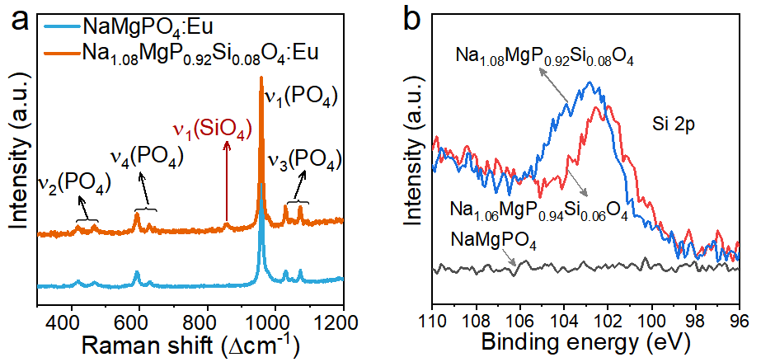
Fig. S5 (a) Raman spectra of NaMgPO₄:Eu and Na_{1.06}MgP_{0.94}Si_{0.06}O₄:Eu samples. (b) Si-2p XPS binding energies of NaMgPO₄:Eu, Na_{1.06}MgP_{0.94}Si_{0.06}O₄:Eu and Na_{1.08}MgP_{0.92}Si_{0.08}O₄:Eu.

Fig. S6 Emission spectra (a) and integration intensity of Na_{1+x}MgP_{1-x}Si_{x}O₄:Eu²⁺ (x = 0-0.08) phosphors (b).

Fig. S7 The emission spectrum of the NaMgPO₄:Eu²⁺ measured at low temperature 78 K and Gaussian fitting curves.

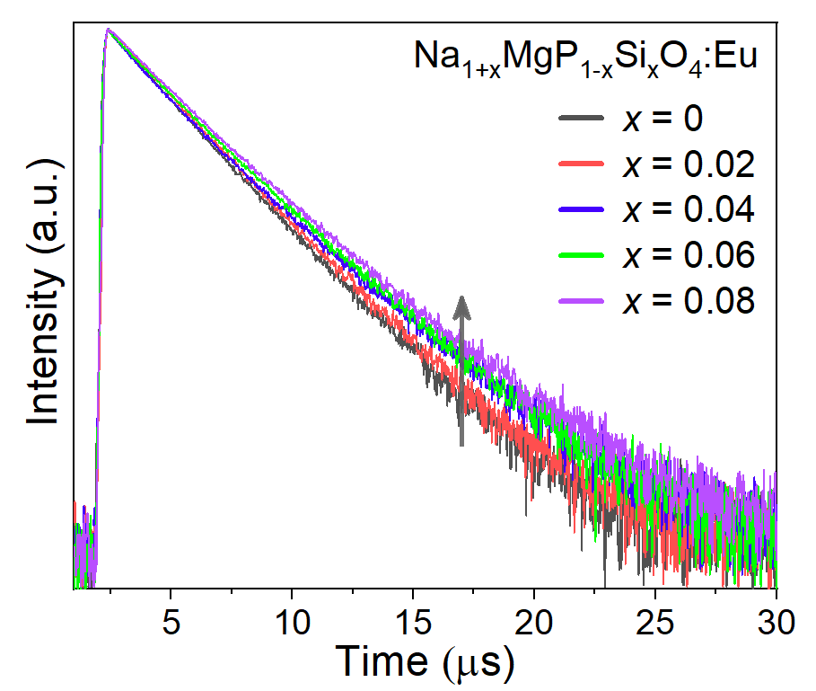

Fig. S8 Decay curves of Na_{1+x}MgP_{1-x}Si_{x}O₄:Eu²⁺ (x = 0-0.08) measured at 300 K under 450 nm pulse laser diode excitation.

Fig. S9 The distortion indexes (a) and bond lengths (b) of NaO₆, MgO₆ and PO₄ polyhedra in Na_{1+x}MgP_{1-x}Si_{x}O₄:Eu²⁺ (x=0-0.08) depending on x values.

Fig. S10 (a) Diffuse reflection spectra of Na_{1+x}MgP_{1-x}Si_{x}O₄:Eu²⁺ (x=0-0.08) phosphors (a) and NaMgPO₄, Na_{1.06}MgP_{0.94}Si_{0.06}O₄ host (b). (c) The calculated energy gap by Tauc equation for NaMgPO₄ and Na_{1.06}MgP_{0.94}Si_{0.06}O₄.

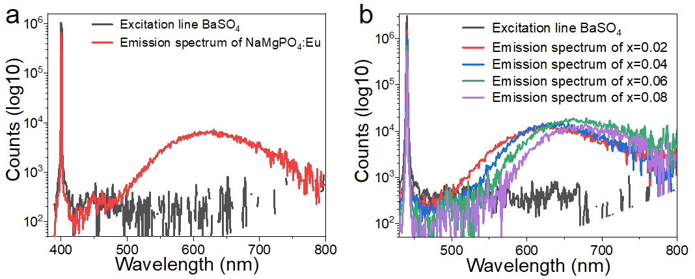
Fig. S11 Excitation line of BaSO₄ and the emission spectra of the NaMgPO₄:Eu (a) and Na_{1+x}MgP_{1-x}Si_{x}O₄:Eu²⁺ (x = 0.02-0.08) phosphors (b) collected using an integrating sphere.
In this work, the quantum yield (QY) test was performed at room temperature by using a barium sulfate coated integrating sphere (150 mm in diameter) that attached to FLS1000. The internal quantum efficiencies (η) were calculated by using the following equations:
$$η=\frac{ε}{α}=\frac{\int{L_{S}}}{\int{E_{R}}-\int{E_{S}}}$$
where ε is the number of photons emitted by the sample, and α is the number of photons absorbed by the sample. L_{S} is the luminescence emission spectrum of the sample; E_{S} is the spectrum of the light used for exciting the sample; E_{R} is the spectrum of the excitation light without the sample in the sphere; and all the spectra were collected using the sphere.

Fig. S12 Band structure of NaMgPO₄ (a) and Na_{1.06}MgP_{0.94}Si_{0.06}O₄ (b) host.

Fig. S13 O1s XPS spectra of NaMgPO₄:Eu²⁺(a) and Na_{1.06}MgP_{0.94}Si_{0.06}O₄:Eu²⁺ (b).

Fig. S14 (a) The PL spectra of Na_{1.06}MgP_{0.94}Si_{0.06}O₄:Eu²⁺ when immersed in water for 0-365 days. (b) The PL spectra of the pristine Na_{1.06}MgP_{0.94}Si_{0.06}O₄:Eu²⁺ and the samples treated in degradation conditions at 80% relative humidity (RH) and 80 ºC for different time, respectively.

Table S1 Main parameters of processing and refinement of the Na_{1+x}MgP_{1-x}Si_{x}O₄:Eu (x = 0-0.08) samples.
x | 0 | 0.02 | 0.04 | 0.06 | 0.08
Sp. Gr. | Pnma | Pnma | Pnma | Pnma | Pnma
a, Å | 10.27008(18) | 10.26847(23) | 10.27376(15) | 10.27793(17) | 10.27195(16)
b, Å | 6.18430(10) | 6.18614(12) | 6.183361(87) | 6.18196(11) | 6.186442(93)
c, Å | 4.936995(86) | 4.93706(11) | 4.938817(74) | 4.939748(91) | 4.939643(80)
V, Å³ | 313.5648(93) | 313.613(12) | 313.7450(80) | 313.8603(96) | 313.8986(85)
Z | 4 | 4 | 4 | 4 | 4
R_{wp}, % | 5.245 | 4.595 | 4.868 | 6.548 | 4.507
R_{p}, % | 3.824 | 3.526 | 3.71 | 4.718 | 3.483
R_{exp}, % | 2.838 | 2.843 | 2.840 | 2.873 | 2.891
χ² | 1.848 | 1.616 | 1.714 | 2.279 | 1.559
R_{B}, % | 2.682 | 2.125 | 2.252 | 3.867 | 2.259

Table S2 Fractional atomic coordinates and isotropic displacement parameters (Å²) of Na_{1+x}MgP_{1-x}Si_{x}O₄:Eu (x = 0-0.08) samples.
Atom | x | y | z | B_{iso} | Occ.
x = 0
Na | 0 | 0 | 0 | 0.698 | 1
Mg | 0.28140(11) | 0.25 | 0.99838(27) | 0.2 | 1
P | 0.10956(11) | 0.25 | 0.44465(19) | 0.469(27) | 1
O1 | 0.11091(23) | 0.25 | 0.75769(41) | 0.2 | 1
O2 | 0.46627(23) | 0.25 | 0.15088(40) | 0.2 | 1
O3 | 0.17633(18) | 0.05264(25) | 0.31232(27) | 0.3503 | 1
x = 0.02
Na | 0 | 0 | 0 | 0.6978 | 1
Na_{insert} | 0.06118(31) | 0.5630(37) | 0.0229(52) | 0.6978 | 0.01
Mg | 0.28103(13) | 0.25 | 0.99998(33) | 0.2 | 1
P | 0.11014(13) | 0.25 | 0.44488(24) | 0.577(35) | 0.98
Si | 0.11014(13) | 0.25 | 0.44488(24) | 0.577(35) | 0.02
O1 | 0.11700(29) | 0.25 | 0.75794(48) | 0.2 | 1
O2 | 0.46615(28) | 0.25 | 0.15279(48) | 0.2 | 1
O3 | 0.17632(23) | 0.05216(31) | 0.31105(34) | 0.3503 | 1
x = 0.04
Na | 0 | 0 | 0 | 0.6978 | 1
Na_{insert} | 0.06205(23) | 0.5652(46) | 0.0234(36) | 0.6978 | 0.02
Mg | 0.28163(11) | 0.25 | 0.99880(28) | 0.2 | 1
P | 0.11002(11) | 0.25 | 0.44401(20) | 0.568(27) | 0.96
Si | 0.11002(11) | 0.25 | 0.44401(20) | 0.568(27) | 0.04
O1 | 0.11756(24) | 0.25 | 0.75427(41) | 0.2 | 1
O2 | 0.46644(23) | 0.25 | 0.15241(40) | 0.2 | 1
O3 | 0.17788(19) | 0.05180(26) | 0.30858(29) | 0.3503 | 1
x = 0.06
Na | 0 | 0 | 0 | 0.6978 | 1
Na_{insert} | 0.0623(27) | 0.5668(35) | 0.0202(60) | 0.6978 | 0.03
Mg | 0.28158(14) | 0.25 | 0.99768(35) | 0.2 | 1
P | 0.10790(13) | 0.25 | 0.44265(26) | 0.557(33) | 0.94
Si | 0.10790(13) | 0.25 | 0.44265(26) | 0.557(33) | 0.06
O1 | 0.11462(31) | 0.25 | 0.74988(52) | 0.2 | 1
O2 | 0.4600(30) | 0.25 | 0.14957(51) | 0.2 | 1
O3 | 0.17690(24) | 0.05285(32) | 0.30557(32) | 0.3503 | 1
x = 0.08
Na | 0 | 0 | 0 | 0.6978 | 1
Na_{insert} | 0.0621(17) | 0.5672(28) | 0.0205(45) | 0.6978 | 0.04
Mg | 0.28191(10) | 0.25 | 0.99811(26) | 0.2 | 1
P | 0.108041(99) | 0.25 | 0.44384(18) | 0.392(25) | 0.92
Si | 0.108041(99) | 0.25 | 0.44384(18) | 0.392(25) | 0.08
O1 | 0.12098(22) | 0.25 | 0.75518(38) | 0.2 | 1
O2 | 0.46465(22) | 0.25 | 0.15137(37) | 0.2 | 1
O3 | 0.17894(18) | 0.05108(24) | 0.30621(27) | 0.3503 | 1

Table S3 Main bond lengths (d, Å), volumes (V, Å³) and Distortion index (Dis) of NaO₆, MgO₆ and PO₆ polyhedra in Na_{1+x}MgP_{1-x}Si_{x}O₄:Eu (x = 0-0.08) crystal structure.
 | Na-d (Å) | Na-V (Å³) | Na-Dis | Mg-d (Å) | Mg-V (Å³) | Mg-Dis | P-d (Å) | P-V (Å³) | P-Dis
x=0 | 2.3348 | 14.9496 | 0.0206 | 2.1525 | 12.3133 | 0.0297 | 1.5452 | 1.8802 | 0.0034
x=0.02 | 2.3416 | 15.0593 | 0.0154 | 2.1428 | 12.1661 | 0.0298 | 1.5496 | 1.8981 | 0.0018
x=0.04 | 2.3478 | 15.2077 | 0.0151 | 2.1402 | 12.1246 | 0.0283 | 1.5514 | 1.9046 | 0.0059
x=0.06 | 2.3484 | 15.3905 | 0.0129 | 2.1376 | 12.0902 | 0.029 | 1.5586 | 1.9301 | 0.0126
x=0.08 | 2.3559 | 15.4032 | 0.0128 | 2.1288 | 11.9356 | 0.0300 | 1.5641 | 1.9513 | 0.0123

Table S4 The crystal radii and ionic radii of Eu²⁺, Na⁺, Mg²⁺, P⁵⁺, Si⁴⁺ in the different fold of coordination.
Ion | Coordination number | Crystal radii (Å) | Ionic radii (Å)
Na⁺ | 6 | 1.16 | 1.02
Mg²⁺ | 6 | 0.86 | 0.72
P⁵⁺ | 4 | 0.31 | 0.17
Si⁴⁺ | 4 | 0.4 | 0.26
Eu²⁺ | 6 | 1.31 | 1.17

Table S5 Luminescent decay times (τ₁, τ₂) and the fitting constants (A₁, A₂) of the fast and slow components, average decay times (τ_{av}) and standard error of τ_{av}. These decay times were measured by FLS1000 equipped with 450 nm pulse laser diode as excitation. All the datas were fitted by the Origin software.
λ_{ex}= 440 nm, Temperature = 300 K
x | A1 | τ₁ | A₂ | τ₂ | τ_{av} (μs) | R²
0 | 15570.63 | 1.943 | 13019.06 | 2.582 | 2.27 | 0.9997
0.02 | 15160.08 | 2.128 | 10138.45 | 2.605 | 2.34 | 0.9998
0.04 | 19813.94 | 2.112 | 17565.382 | 2.713 | 2.43 | 0.9996
0.06 | 13078.69 | 1.851 | 13886.94 | 2.906 | 2.51 | 0.9997
0.08 | 25110.06 | 2.414 | 1219.99 | 4.923 | 2.58 | 0.9996
λ_{ex}= 440 nm, Temperature = 78 K
0 | 40067.25 | 2.339 | 1227.36 | 4.426 | 2.45 | 0.9997
0.04 | 25412.04 | 2.373 | 1388.18 | 4.232 | 2.53 | 0.9998
0.08 | 40499.6 | 2.357 | 4225.87 | 4.083 | 2.62 | 0.9998
Average decay times are calculated by the following question:
$τ_{av}=\frac{A_{1}τ_{1}^{2}+A_{1}τ_{2}^{2}}{A_{1}τ_{1}+A_{2}τ_{2}}$
Where A₁ and A₂ are the corresponding fitting constants; $τ_{1}$, $τ_{2}$ are lifetimes for the fast and slow components.

Table S6 Hirshfeld surface analysis calculates the NaO₆ and MgO₆ as the center, volume, surface area and the contribution of P-O and Si-O to the HS surface in Na_{1+x}MgP_{1-x}Si_{x}O₄:Eu (x = 0-0.08).
 | Na-V  (Å³) | Na-A  (Å²) | Na-[ P-O]  (%) | Na-[O-Si]  (%) | Mg-V  (Å³) | Mg-A  (Å²) | Mg-[P-O]  (%) | Mg-[Si-O]  (%)
x=0 | 56.53 | 106.26 | 33.7 | 0 | 61.85 | 94.33 | 38.5 | 0
x=0.02 | 56.82 | 106.65 | 22.1 | 12.3 | 61.70 | 93.92 | 12.0 | 26.5
x=0.04 | 57.04 | 107.06 | 20.9 | 12.4 | 61.71 | 93.80 | 11.9 | 26.4
x=0.06 | 57.29 | 107.47 | 20.7 | 12.5 | 61.80 | 93.77 | 11.6 | 26.2
x=0.08 | 57.49 | 107.84 | 20.5 | 12.4 | 61.68 | 93.34 | 11.6 | 26.3

References
1. Kim, S. W. et al. Efficient red emission of blue-light excitable new structure type NaMgPO₄:Eu²⁺ phosphor. ECS Solid State Lett. 2, R49 (2013).
2. Hasegawa, T. et al. Phase stabilization of red-emitting olivine-type NaMgPO₄:Eu²⁺phosphorsviamolten-phase quenching. Inorg. Chem. Front. 7, 4040-4051 (2020).

