Supplementary Material
Figure 1(a) and Figure 1(b) demonstrate GPT’s confusion in accessing SNOMED. Figures 2(a) and 2(b) demonstrate the change in codes with a change in prompt. Figures 3(a) and 3(b) demonstrate the inconsistent output styles while using the same prompt for different diseases.
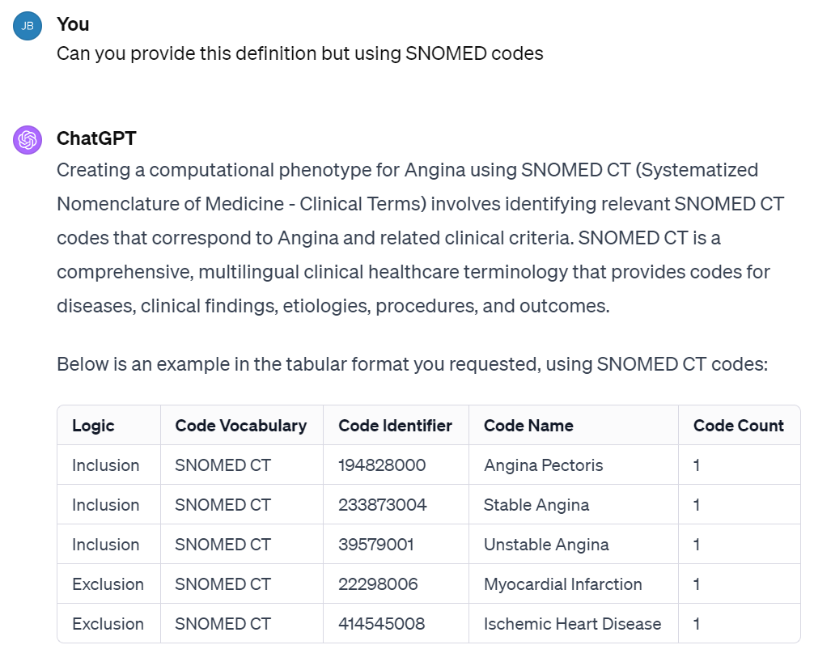
Fig. 1(a). GPT’s confusion about SNOMED license and access

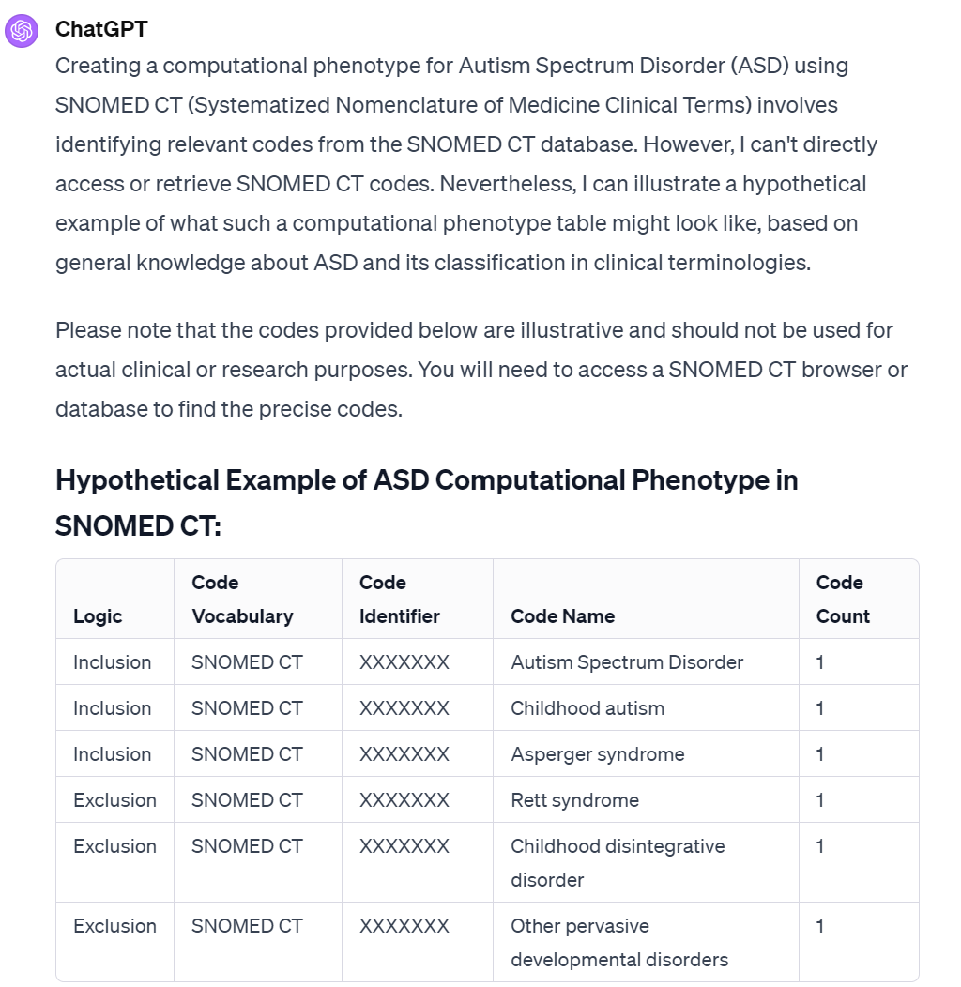
Fig. 1(b). GPT’s confusion about SNOMED license and access
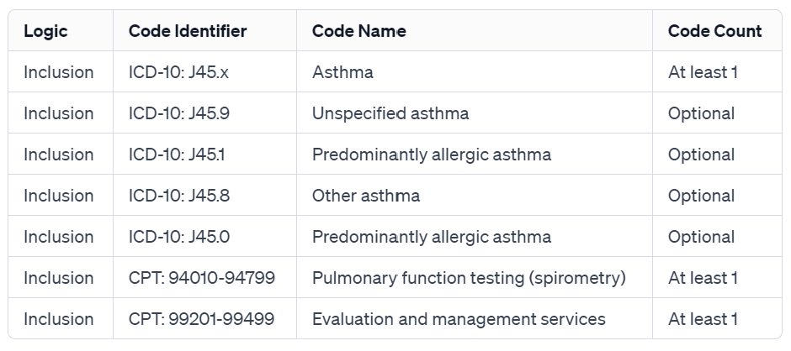
Fig. 2(a). Coding results change with the prompt

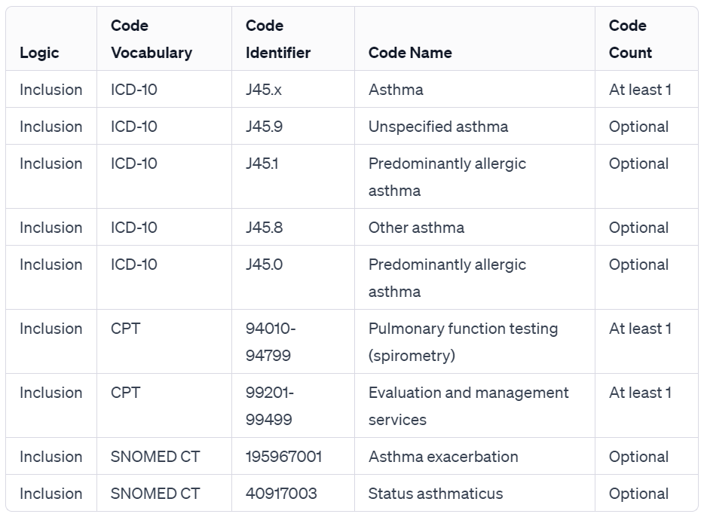
Fig. 2(b). Coding results change with the prompt
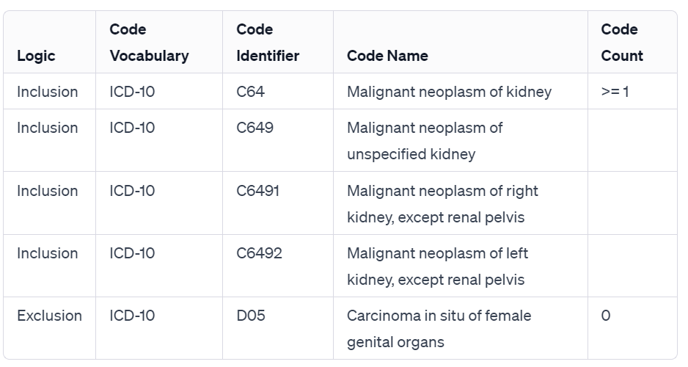
Fig. 3(a). Inconsistent output styles when using the same prompt for different diseases

Fig. 3(b). Inconsistent output styles when using the same prompt for different diseases

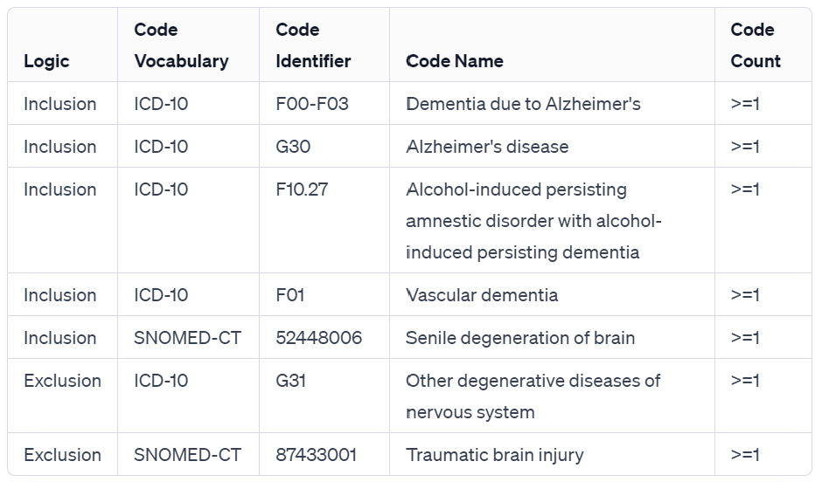
Fig. 3(c). Inconsistent output styles when using the same prompt for different diseases

Table 5. Hallucinations of GPT 3.5 and 4
Model | Vocab | Logic | Code | String
GPT 3.5 | ICD-10 | Exclusion | Z91.010 | Allergy to nuts
GPT 4 | ICD-10 | Inclusion | Z91.010 | History of peanut allergy

