Cyanobacteria dynamics and Microcystins: an emphasis on late autumn mass development of Woronichinia and Microcystis in the Reservoir
Zit-Emba, North-East Algeria

Fatma Zohra Guellati¹ Hassen Touati² Lamia Seridi¹ Aicha Djabourabi¹ Nadira Sehili¹ Skander El-Hadi Kadri¹ Mourad Bensouilah¹

¹ Ecobiology Laboratory for Marine Environments and Coastal Areas. Badji Mokhtar University of Annaba, 12.P.O. BOX, 23000 Annaba, Algeria
² Laboratory Biology, Water and Environment (LBEE), SNV-STU Faculty, May 8, 1945 University, Guelma, Algeria

*Author to whom correspondence should be addressed
E-mail: guellati.fatma@yahoo.fr / fatma-zohra.guellati@univ-annaba.dz
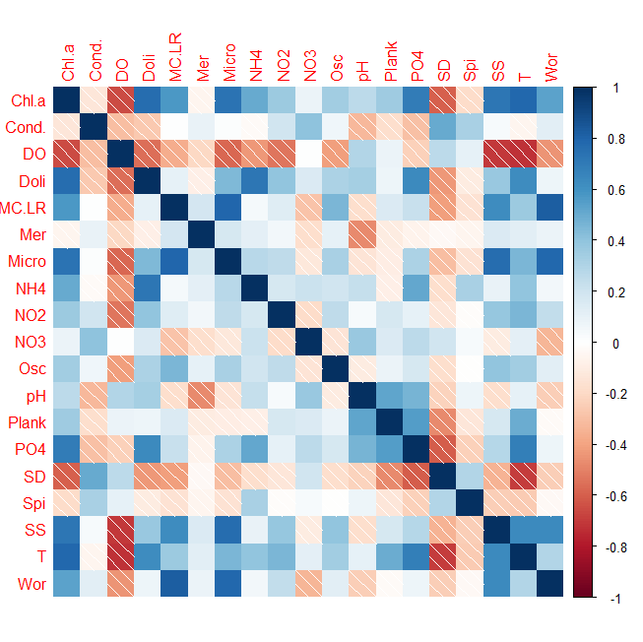

Supp. Fig. 1. Correlogram generated from the Spearman correlation between Cyanobacteria genera and abiotic variables. The blue color indicate the positive correlations and the red color indicate the negative correlation.

