Negative-emission Waste-to-Cement via Tandem Supercritical Water Oxidation and Hydrothermal Mineralization
David H. Kenneyª, Andrew M. Charleboisª, Shuai Wang^{b}, Nima Rahbar^{b},
Michael T. Timkoª, Andrew R. Teixeira^{a*}
- Department of Chemical Engineering, Worcester Polytechnic Institute, Worcester, Massachusetts 01609, United States
- Department of Civil, Environmental, and Architectural Engineering, Worcester Polytechnic Institute, Worcester, Massachusetts 01609, United States
* Correspondence should be addressed to arteixeira@wpi.edu
Keywords: Bioenergy carbon capture utilization and sequestration (BECCUS), Waste-to-Energy, Green Cement, CO₂ Oxidation
Table of Contents
1. Results 3
1.1. SCWO of Food Waste to Produce High-Pressure CO₂ 3
Table S1. Chemical and elemental analysis of VA hospital food waste 3
Table S2. Experimental conditions for SCWO reactions 4
Figure S2. Carbon distributions within SCWO products. 4
Figure S3. SCWO aqueous phase HPLC analysis 5
Figure S4. SCWO aqueous phase UV-Vis analysis 6
1.2. Rapid and Complete Mineralization of High-Pressure CO₂ 6
Figure S5. Speciation of CO₂ in aqueous solutions 6
1.3. Carbon Negativity 7
Figure S6. Developed ASPEN/HYSYS model process flow diagram 7
Table S3. Mass and energy balance for 20 wt% solids loading with O:C = 3 8
Figure S7. SCWO energy balances 9
Figure S8. TGA analysis of ACM sample 10
2. Methods 10
2.1.1. Supercritical Water Oxidation of Food Waste 10
Figure S9. Reaction and analysis diagram 10
Figure S10. Parr reactor vessel used for SCWO experiments 10
Figure S11. GC-TCD calibration curves 11
2.1.2. Modeling the SCWO mechanism 11
Table S4. Normalized elemental compositions for dehydrated food waste 12
Table S5. Elemental molar ratios within dehydrated food waste 12
Figure S12. ODE solution for isothermal SCWO conversion. 13
Figure S13. ODE solution for constant oxidant loading 14
2.2. CaCO₃ yield analysis and kinetic parameters 14
Figure S14. XRD calibration of mineralization products. 15
Figure S15. Solution of mineralization rate expression 15
2.3. Process Model Development 15
2.4. Development of lifecycle analysis 17
Figure S16. Process flow diagram for waste-to-cement process in GREET 17
Figure S17. Process inputs and outputs for SCWO in GREET 18
Figure S18. Process inputs and outputs for calcium hydroxide production 19
Figure S19. Process inputs and outputs for ACM production 19
3. References 20

Results

SCWO of Food Waste to Produce High-Pressure CO₂
Food waste obtained from the New Hampshire VA Hospital (Manchester, NH) was selected as a representative wet waste given the availability and abundance of food waste.¹ Food waste characterization data are shown in Table S1. Food waste is typically a highly variable feed as it not only changes seasonally but is also impacted by the source type, region and even socioeconomics of the collection area.² It is typically made up of a high-energy organic fraction (23.6 MJ/kg) primarily consisting of carbohydrates, proteins, and lipids. Compared with green wastes and biosolids, food waste has low-ash content (1.9 wt%) which poses less risk of reactor due to salt precipitation under supercritical water conditions.³

Table S1. Chemical and elemental composition of dehydrated food waste used in this study
Proximate Analysis (wt%)ª
Moisture | 0.7$±$0.1
Ash | 1.9$±$0.9
Elemental Analysis (wt%)^{a-e}
Carbon | 52.2$±$0.9
Hydrogen | 7.5$±$0.2
Nitrogen | 4.3$±$0.1
Sulfur | 1.0$±$0.1
Oxygen^{c} | 33.2$±2.1$
Biochemical Analysis (wt%)^{a-e}
Carbohydrates | 29.8
Lipids | 38.9
Protein^{d} | 26.8$±$0.6
Solubility (mg/ml)^{f} | 2.4$±$0.49
HHV (MJ/kg) | 23.6$±$3.0
ª Dry Basis
^{b} As Received
^{c} Oxygen determined by difference
^{d} Protein = N-Content $∙$ 6.25
^{e} Standard deviation reported as $±$, where n=3
^{f} Standard deviation reported as $±$, where n=2

Table S2. Experimental ratios for each feed component within the supercritical water oxidation experiments
O:C | Food Waste (g) | Water (g) | 30 wt% Peroxide Solution (g) | Operating Pressure (atm)
0 | 1 | 50 | 0 | 211
1 | 1 | 46.5 | 4.9 | 231
2 | 1 | 43.1 | 9.9 | 245
3 | 1 | 14.8 | 39.6 | 265
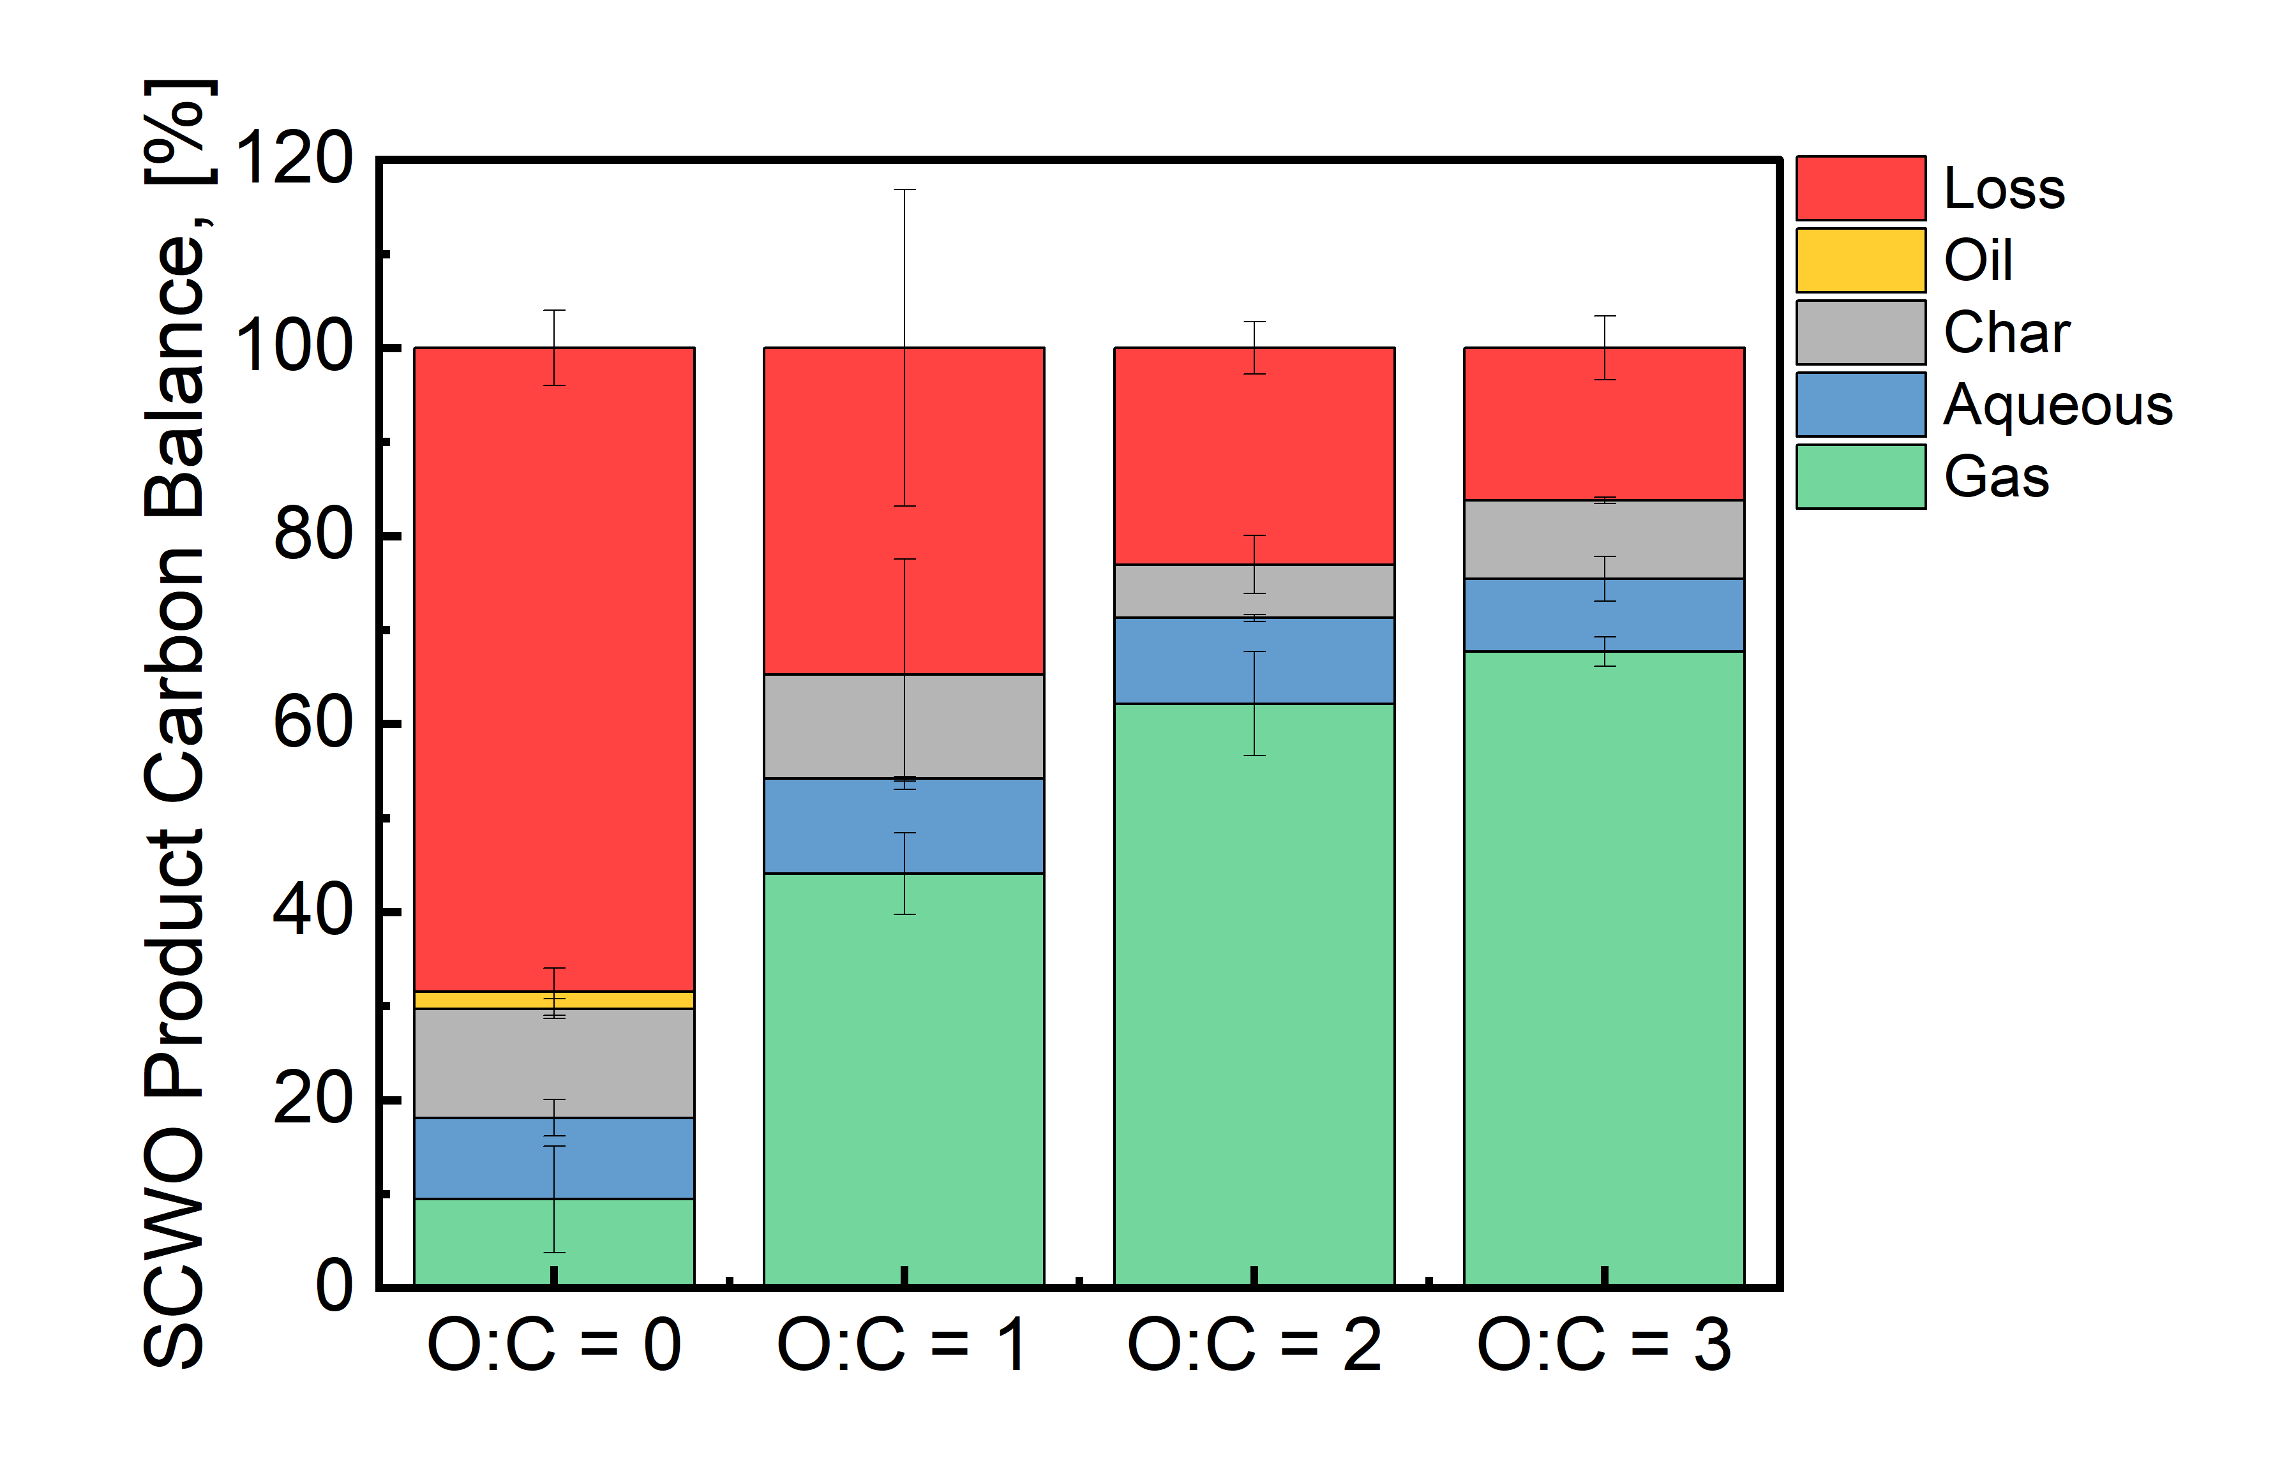

Figure S2. Product carbon distribution for SCWO of solid food waste. Beyond O:C = 0, the oil phase is not recovered in a quantifiable amount. Loss is reduced as the oxidant loading is increased, increasing the amount of CO₂ produced. It is possible that there was a partial oxidation of the carbon causing a co-elution with oxygen/nitrogen which would prevent us from detecting it on the GC.

The HPLC analysis shows a myriad of peaks over the 25-minute analysis. For this study, the compound of interest was acetic acid as it has proven to be a recalcitrant compound in further oxidation steps for SCWO systems. Other small chain carboxylic acids that could be present are: tartaric acid (2 min), protocatechuic (18 min), dihydrobenzoic (19 min) and hydrobenzoic acids (22 min).⁴
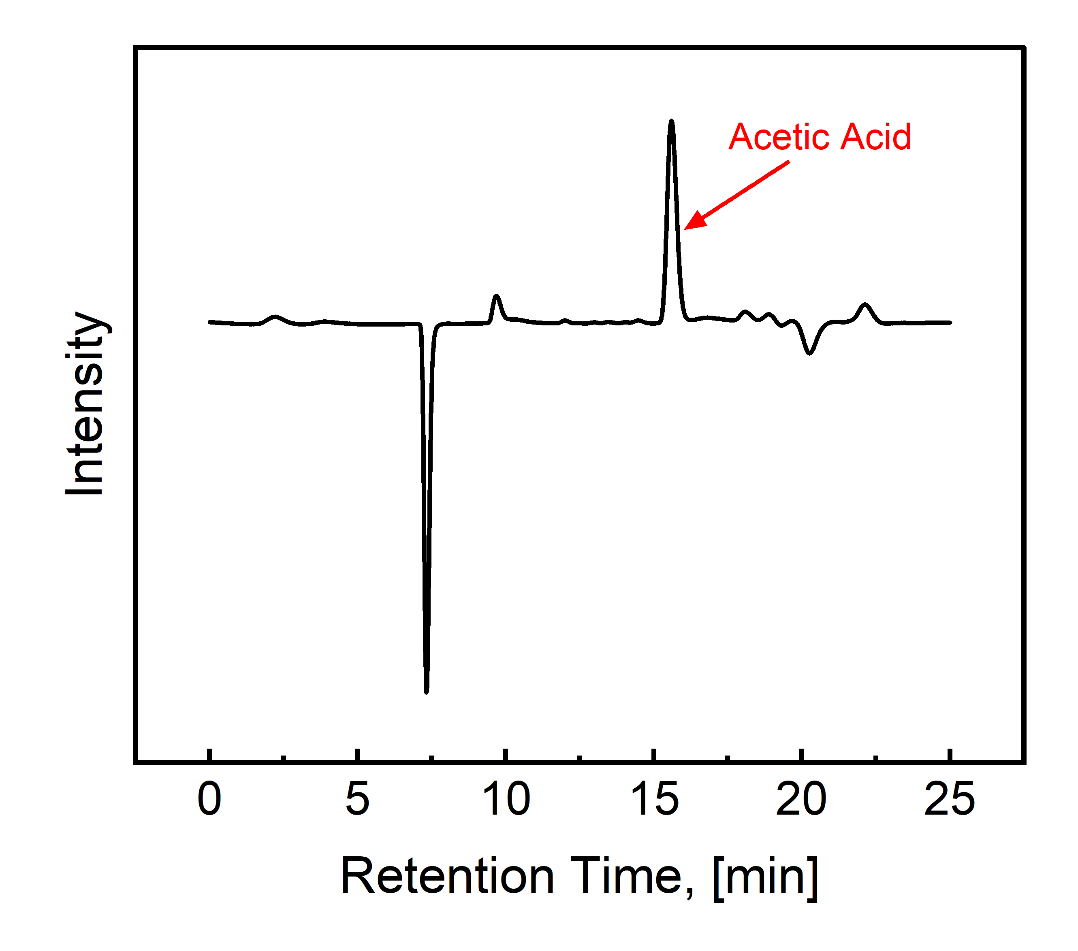

Figure S3. HPLC of aqueous phase identifying acetic acid as one of the primary aqueous products

The UV-Vis analysis of the aqueous phase showed activity in the 220 – 340 range, indicating aromatic compounds.⁵ Based on previous studies and the HPLC analysis in Fig. S3, the activity in this range is likely due to dihydro- and hydroxybenzoic acids.^{6,7}
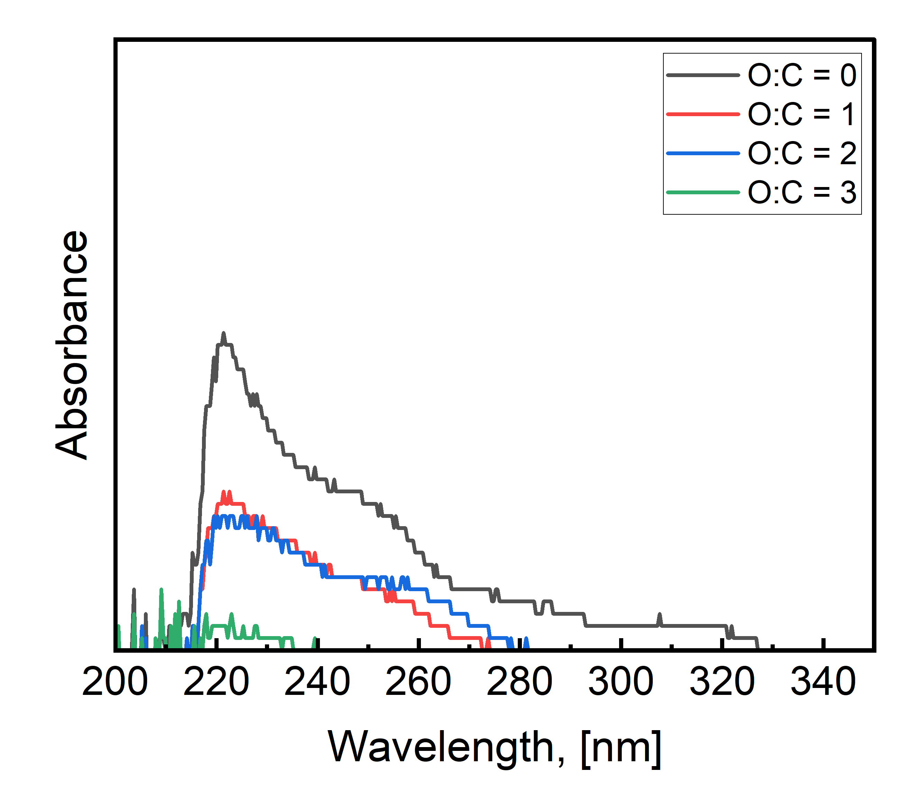

Figure S4. UV-Vis analysis of aqueous phase products after a 1:100 dilution with DI water

Rapid and Complete Mineralization of High-Pressure CO₂
When dissolved in water, carbon dioxide can form carbonic acid (H₂CO₃) which can dissociate into bicarbonate ions (HCO₃⁻) and then further into carbonate ions (CO₃²⁻). However, this process is heavily dependent on pH as described by the Bjerrum plot equations:
$$\begin{aligned}x_{CO_{2},eq}=\frac{{\left[H^{+}\right]}_{eq}^{2}}{{\left[H^{+}\right]}_{eq}^{2}+K_{1}{\left[H^{+}\right]}_{eq}+K_{1}K_{2}} \#\left(1\right)\end{aligned}$$
$$\begin{aligned}x_{HCO_{3}^{-} ,eq}=\frac{K_{1}{\left[H^{+}\right]}_{eq}}{{\left[H^{+}\right]}_{eq}^{2}+K_{1}{\left[H^{+}\right]}_{eq}+K_{1}K_{2}} \#\left(2\right)\end{aligned}$$
$$\begin{aligned}x_{CO_{3}^{2-} ,eq}=\frac{K_{1}K_{2}}{{\left[H^{+}\right]}_{eq}^{2}+K_{1}{\left[H^{+}\right]}_{eq}+K_{1}K_{2}} \#\left(3\right)\end{aligned}$$
Here, K₁ and K₂ are the two acid equilibrium constants associated with carbonic acid, where K₁ is 1.42$∙$10⁻⁰⁶ and K₂ is 1.26$∙$10⁻⁰⁹.⁸ In Figure S2, it is apparent that carbon dioxide no longer forms carbonic acid below a pH of 6, therefore highlighting the need to add a base or buffer to the solution to maintain a basic solution.
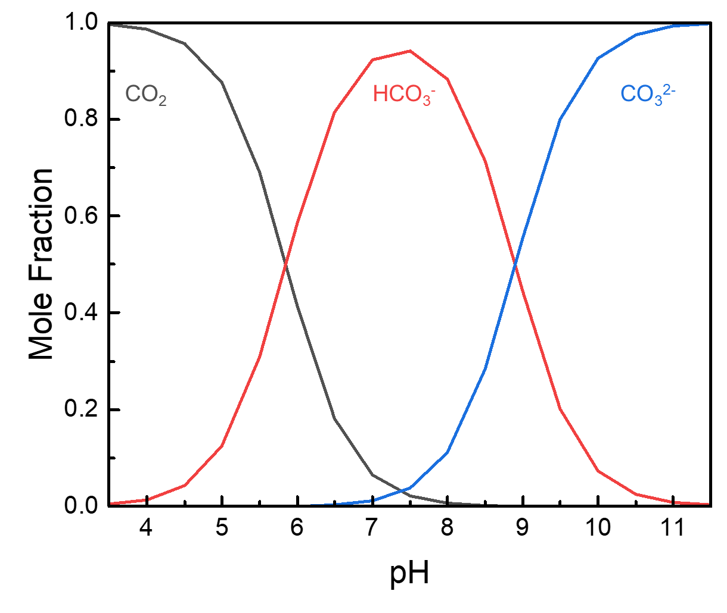

Figure S5. Speciation of carbon dioxide when dissolved in water as a function of solution pH

Carbon Negativity
The ASPEN/HYSYS model was developed to model both the supercritical water oxidation (SCWO) and mineralization aspects of the hydrothermal mineralization (HTM) process.
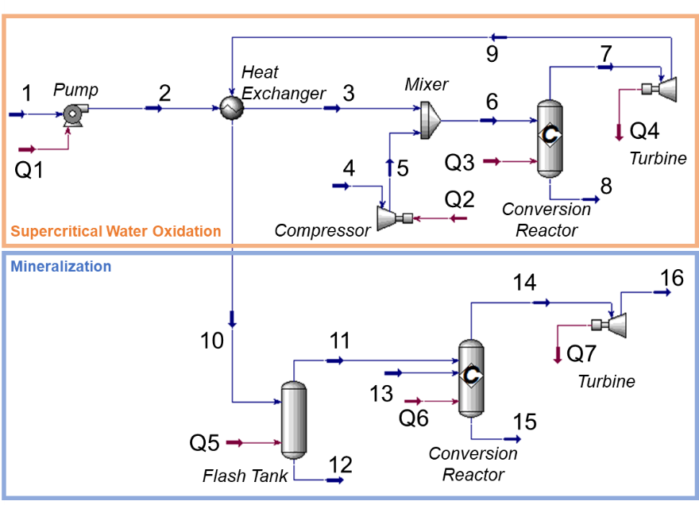

Figure S6. ASPEN/HYSYS model developed to understand the mass and energy balances with the hydrothermal mineralization process

Table S3. Mass and energy balance for 20 wt% solids loading with O:C = 3
 | 1 |  | 2 | 3 | 4 | 5 | 6 | 7 | 8 | 9 | 10 | 11 | 12 | 13 | 14 | 15 | 16
Vapour Fraction | 0.00 |  | 0.00 | 0.00 | 1.00 | 1.00 | 1.00 | 0.00 | 1.00 | 1.00 | 0.80 | 0.00 | 1.00 | 0.00 | 0.00 | 1.00 | 1.00
Temperature, [$°$C] | 20.00 |  | 22.45 | 295.20 | 20.00 | 1328.94 | 535.98 | 450.00 | 450.00 | 366.63 | 245.69 | 40.00 | 40.00 | 40.00 | 40.00 | 40.00 | -154.14
Pressure [atm] | 1.00 |  | 272.00 | 272.00 | 1.00 | 272.00 | 272.00 | 272.00 | 272.00 | 145.00 | 145.00 | 145.00 | 145.00 | 158.20 | 145.00 | 145.00 | 1.00
Molar Flow [kgmole/h] | 9.57 |  | 9.57 | 9.57 | 12.74 | 12.74 | 22.31 | 0.00 | 22.72 | 22.72 | 22.72 | 10.68 | 12.04 | 4.02 | 4.83 | 11.23 | 11.23
Mass Flow [kg/h] | 189.00 |  | 189.00 | 189.00 | 364.71 | 364.71 | 553.71 | 0.00 | 553.71 | 553.71 | 553.71 | 198.15 | 355.55 | 117.40 | 152.96 | 320.03 | 320.03
Liquid Volume Flow [m³/h] | 0.20 |  | 0.20 | 0.20 | 0.42 | 0.42 | 0.62 | 0.00 | 0.63 | 0.63 | 0.63 | 0.20 | 0.42 | 0.08 | 0.10 | 0.38 | 0.38
$${\text{x}}_{\text{Ca}{\left(\text{OH}\right)}_{\text{2}}}$$ | 0.00 |  | 0.00 | 0.00 | 0.00 | 0.00 | 0.00 | 0.00 | 0.00 | 0.00 | 0.00 | 0.00 | 0.00 | 0.20 | 0.00 | 0.00 | 0.00
$${\text{x}}_{\text{CaC}{\text{O}}_{\text{3}}}$$ | 0.00 |  | 0.00 | 0.00 | 0.00 | 0.00 | 0.00 | 0.00 | 0.00 | 0.00 | 0.00 | 0.00 | 0.00 | 0.00 | 0.17 | 0.00 | 0.00
$${\text{x}}_{{\text{O}}_{\text{2}}}$$ | 0.00 |  | 0.00 | 0.00 | 0.21 | 0.21 | 0.12 | 0.06 | 0.06 | 0.06 | 0.06 | 0.00 | 0.12 | 0.00 | 0.00 | 0.13 | 0.13
$${\text{x}}_{{\text{N}}_{\text{2}}}$$ | 0.00 |  | 0.00 | 0.00 | 0.77 | 0.77 | 0.44 | 0.43 | 0.43 | 0.43 | 0.43 | 0.00 | 0.81 | 0.00 | 0.00 | 0.87 | 0.87
$${\text{x}}_{{\text{H}}_{\text{2}}{\text{O}}_{\text{2}}}$$ | 0.88 |  | 0.88 | 0.88 | 0.02 | 0.02 | 0.39 | 0.45 | 0.45 | 0.45 | 0.45 | 0.96 | 0.00 | 0.80 | 0.83 | 0.00 | 0.00
$${\text{x}}_{\text{C}{\text{O}}_{\text{2}}}$$ | 0.00 |  | 0.00 | 0.00 | 0.00 | 0.00 | 0.00 | 0.04 | 0.04 | 0.04 | 0.04 | 0.00 | 0.07 | 0.00 | 0.00 | 0.00 | 0.00
$${\text{x}}_{\text{C}{\text{H}}_{\text{3}}\text{OH}}$$ | 0.12 |  | 0.12 | 0.12 | 0.00 | 0.00 | 0.05 | 0.02 | 0.02 | 0.02 | 0.02 | 0.03 | 0.00 | 0.00 | 0.00 | 0.00 | 0.00

The energy balance around the HTM system shows that hydrothermal liquefaction (O:C = 0) requires an input of energy. Unlike the other scenarios, the HTL condition requires no air compression (Yellow), but the reaction is largely endothermic (Green) and thus energy must be put into the system to maintain the supercritical temperature. When oxidant is introduced to the system, the reaction shifts towards combustion and drives the process to an energy negative process.
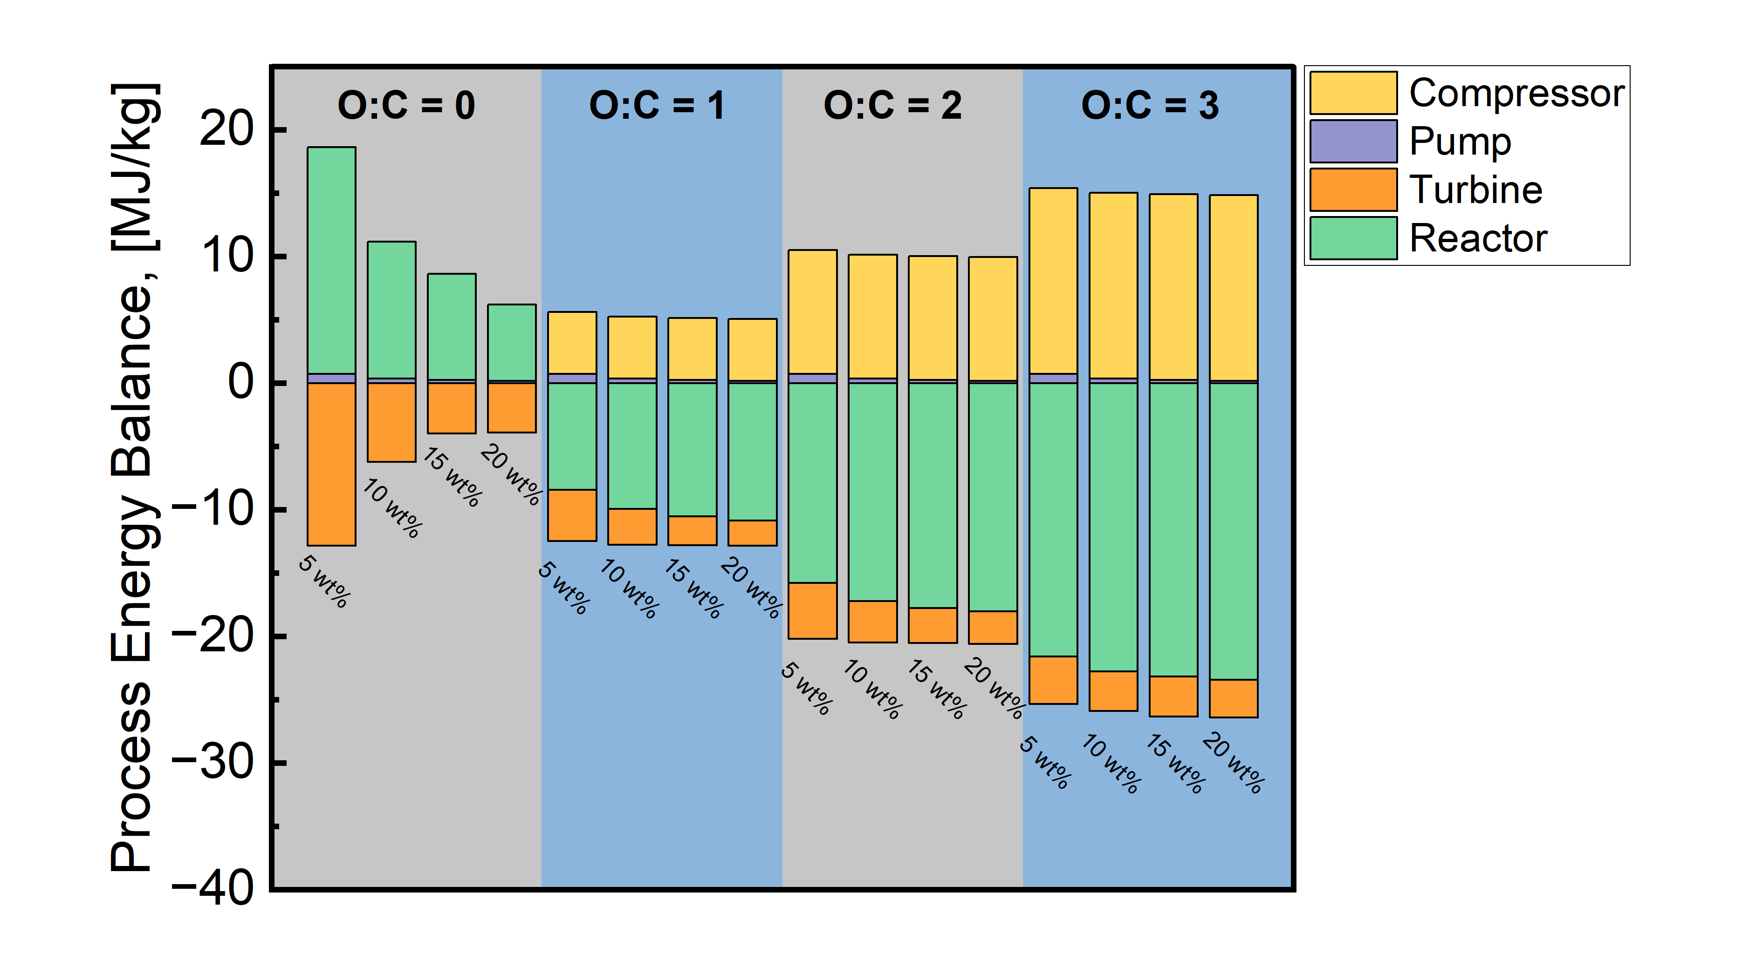

Figure S7. Breakdown of energy balance as a function of unit operations within the HTM process
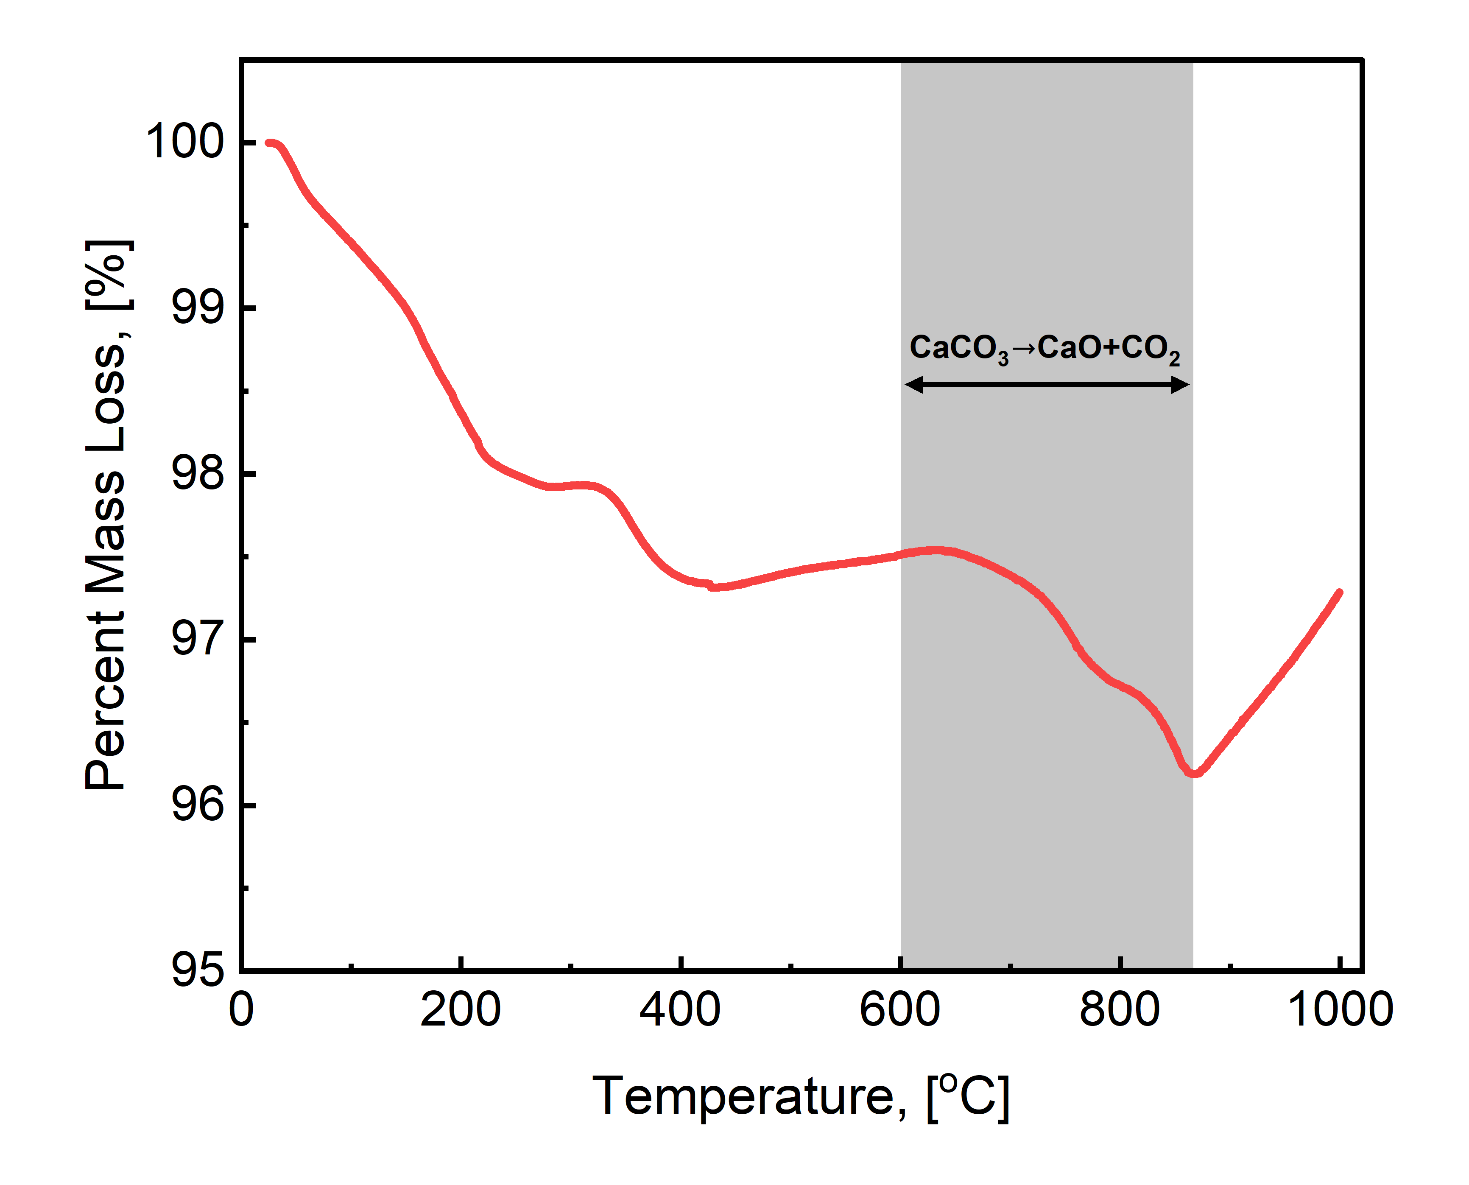

Figure S8. Thermogravimetric analysis of a produced ACM sample

Methods

Supercritical Water Oxidation of Food Waste
Using a Parr 4756A high-temperature, high-pressure reactor the food waste, oxidant and water were reacted at 400-450$°$C. After the 1-hour reaction time, the vessel was rapidly cooled to 40$°$C at which point the headspace was vented into a 2 L graduated cylinder through a three-way valve to measure the gas volume via liquid displacement. Once the gas has equilibrated, gas was withdrawn from the graduated cylinder through a septum attachment which prevented mixing and contamination of the produced gas and the external air. Using a gas-tight syringe, 1 mL of the reaction gas was injected onto the GC to be measured via TCD analysis.
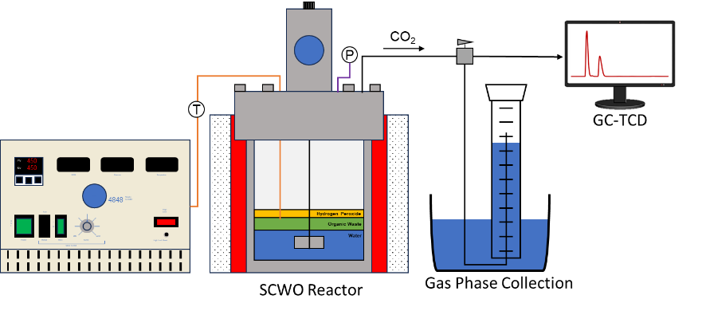

Figure S9. Reaction and analysis diagram

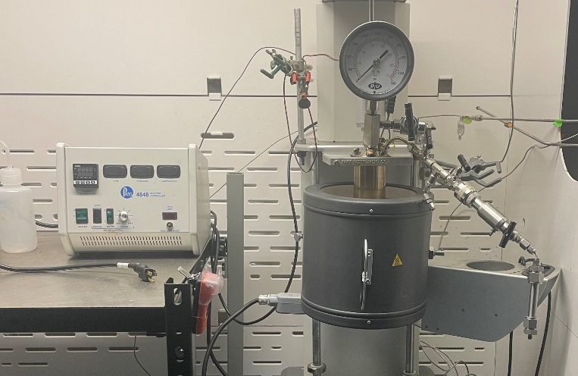

Figure S10. Parr reactor vessel used for SCWO experiments

The GC analysis was calibrated through individual injections of nitrogen and carbon dioxide of varying volumes. The peak area of each injection was correlated with their respective volume. For nitrogen, beyond 0.4 mL there appeared to be a different response that required a 2-part calibration. It should be noted that O₂ and N₂ have a similar elution time within the GC-TCD and were considered to be a single gas volume during the headspace analyses.
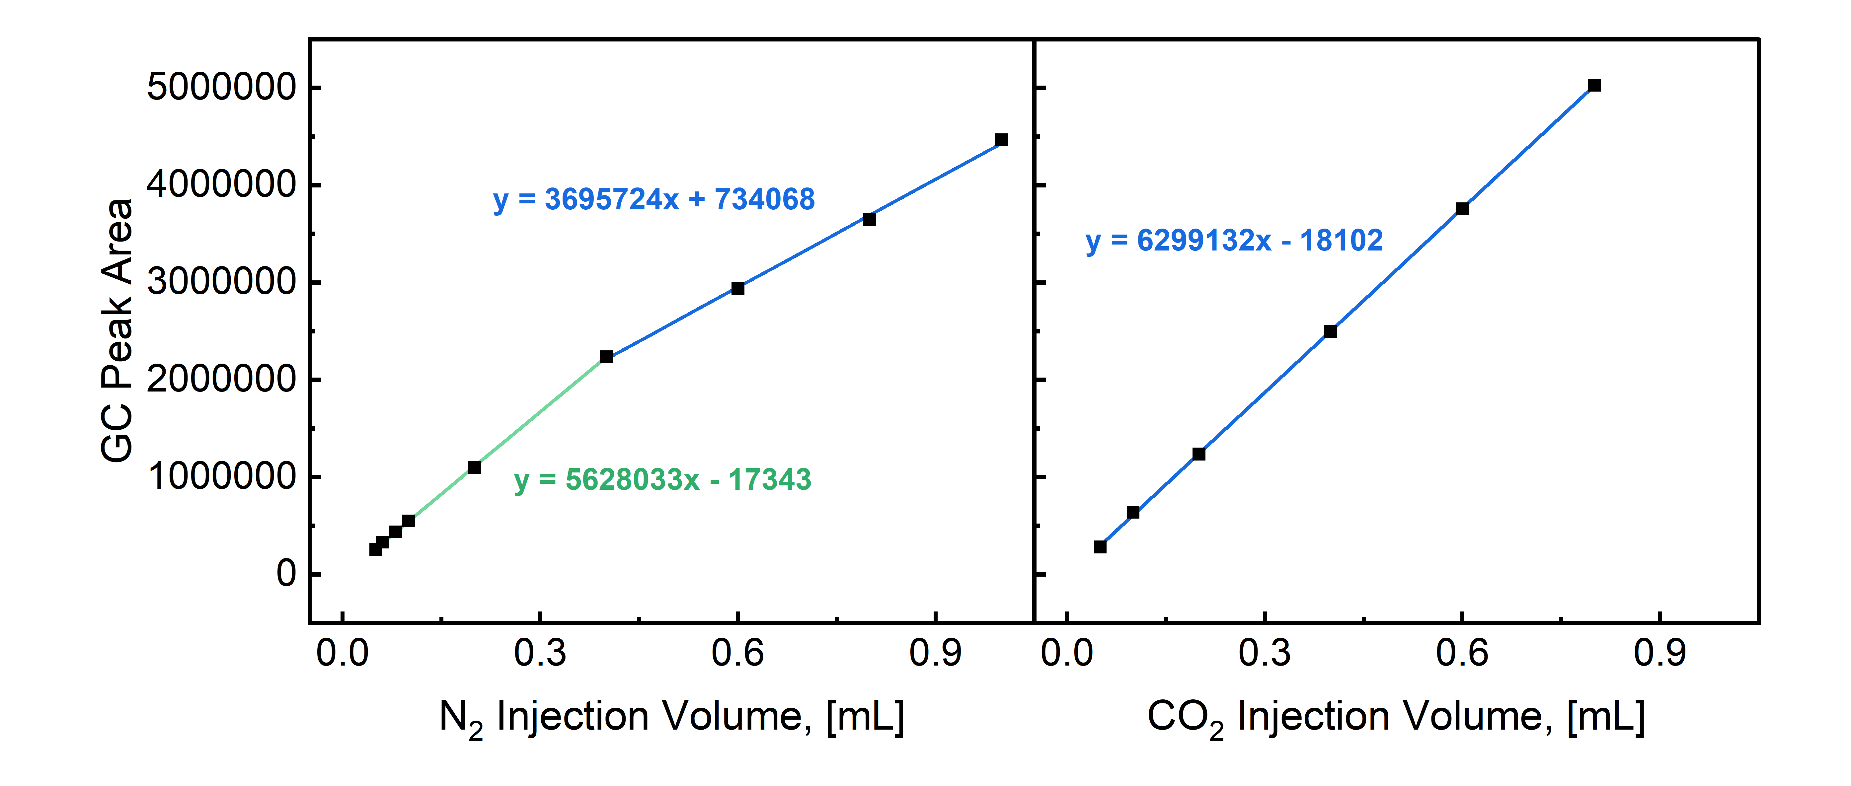

Figure S11. GC-TCD calibrations of nitrogen (LEFT) and carbon dioxide (RIGHT). Nitrogen required a two-part calibration to capture the TCD response of low injection volumes and high injection volumes

Modeling the SCWO mechanism
The lumped kinetic model for this system was simplified to be the conversion of food waste directly to carbon dioxide, with a representative rate expression:
$$r_{CO_{2}}=A_{CO_{2}}exp\left(-\frac{Ea_{FW}}{RT}\right){\left[FW\right]}^{n}{\left[O_{2}\right]}^{m}$$
All concentrations were determined by dividing molar quantities by the total reactor volume (250 mL), since the reaction takes place in the supercritical regime all reactants and products were assumed to be well mixed. To determine the concentration of food waste ($[FW]$) a representative molecular formula was needed to convert weight to moles. Previous SCWO studies have shown that nitrogen will form N₂ or N₂O whereas sulfur will form inorganic salts.⁹ Additionally, since nitrogen and sulfur were less than 10% of the food waste by mass the waste was assumed to be composed solely of carbon, hydrogen, and oxygen. The normalized weight percents were calculated to be:

Table S4. Normalized elemental compositions for dehydrated food waste
Element | Weight Percent (%)
C | 56.19
H | 8.07
O | 35.74
After obtaining the weight percents, each species was converted to moles to determine the molar ratio.
$$100 g FW \left(0.5619\frac{g C}{g FW}\right)\left(\frac{1 mol C}{12 g C}\right)=4.6825 mol C$$
$$100 g FW \left(0.0807\frac{g H}{g FW}\right)\left(\frac{1 mol H}{1 g H}\right)=8.07 mol H$$
$$100 g FW \left(0.3574\frac{g O}{g FW}\right)\left(\frac{1 mol O}{16 g O}\right)=2.2338 mol O$$

All species were normalized to oxygen since it has the smallest number of moles, giving the following mole ratios:

Table S5. Elemental molar ratios within dehydrated food waste
Element | Mole Ratio (mol/mol O)
C | 2.1
H | 3.6
O | 1

Lastly, all ratios were multiplied by a factor of 10 to eliminate partial molar ratios, giving the final molecular formula of $C_{21}H_{36}O_{10}$ with a molecular weight of 448 g/mol.
The model was fit in two steps, the first fitting isothermal conversion were modeled to obtain $k$(450ºC), $n$, and $m$. For this model, the value of $n$ was constrained to be a first order reaction with respect to food waste, based on previous literature.¹⁰ Parameter values were solved by using MATLAB’s lsqnonlin non-linear solver to minimize the error between the final predicted CO₂ concentration and experimental CO₂ concentrations. The ordinary differential equation (ODE) system was solved using ode45. To ensure the identified parameters produce the global minimum solution, MATLAB’s globalsearch function was used to vary initial parameter guesses to find the optimal parameter solutions. Figure S10 shows the optimal solution for $\left[k:0.0011 n:1 m:0.6534\right]$.
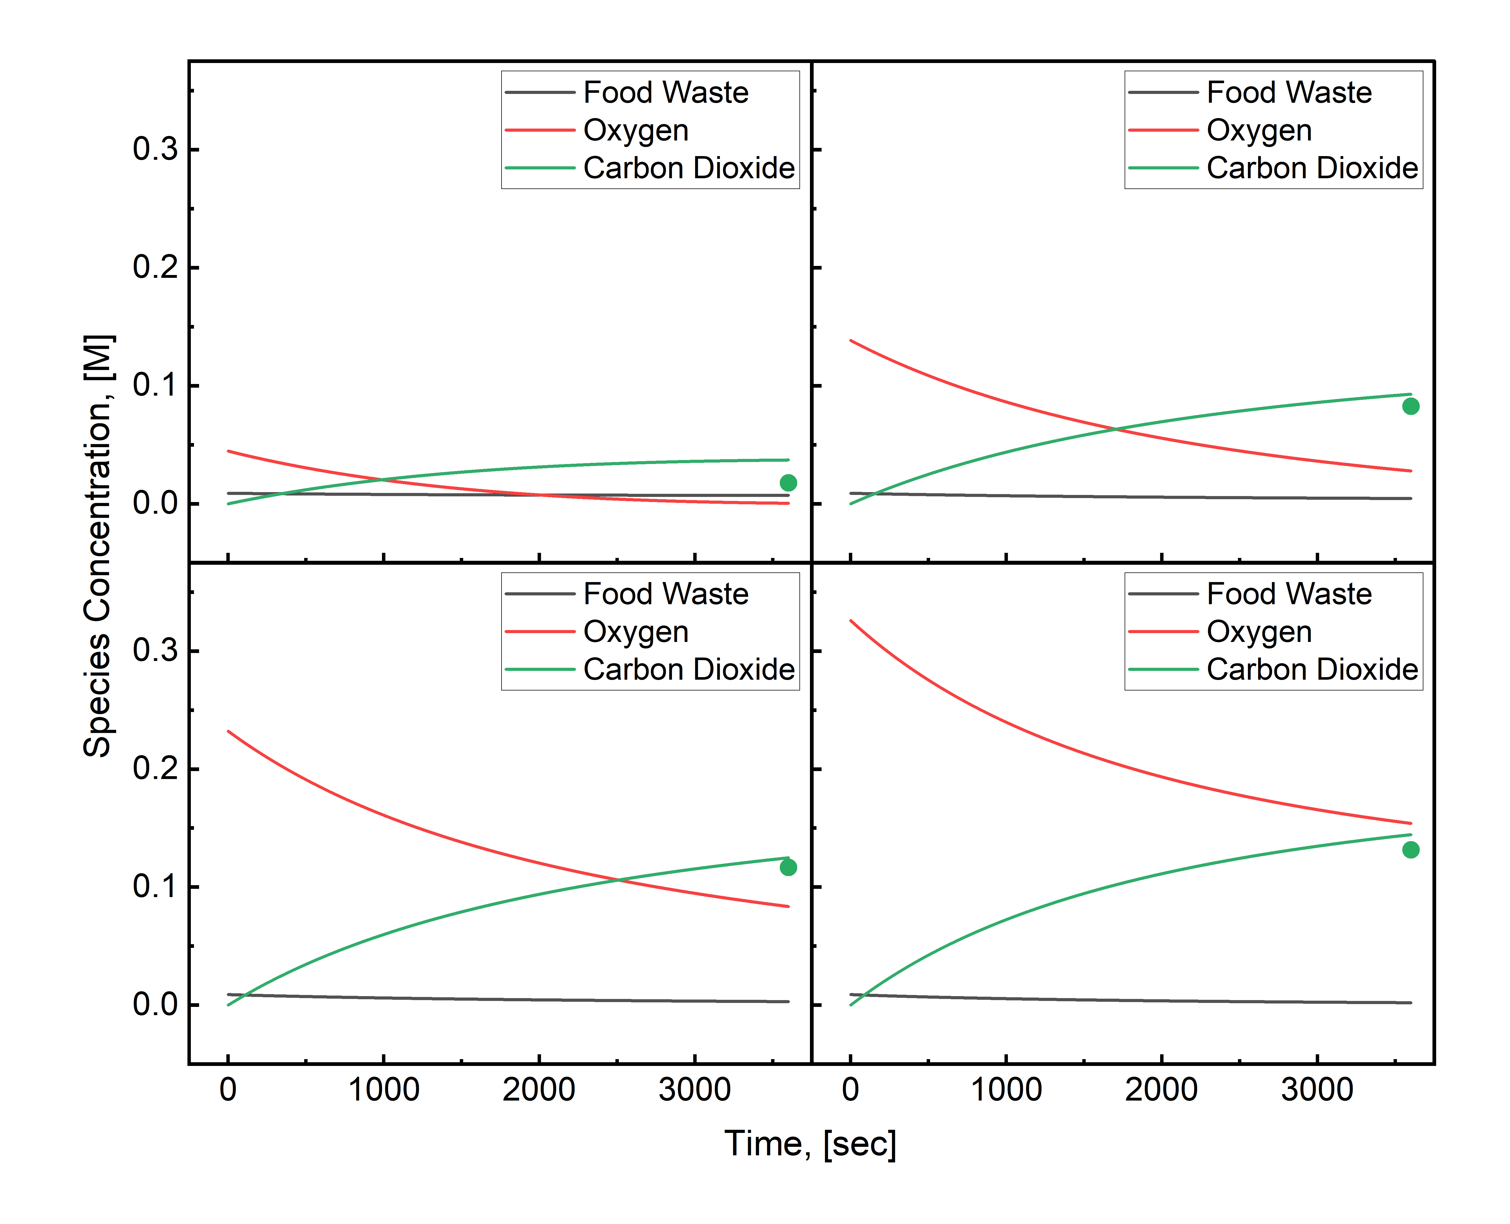

Figure S12. ODE solutions for optimized $k$, $n$, and $m$ for isothermal conversion at 450$°$C. As the oxidant loading is increased there is a resultant increase in CO₂ concentration.

The second model fit was fitting conversion at O:C = 3 from 400 – 450$°$C to solve for the apparent activation energy ($Ea$) of food waste combustion under hydrothermal conditions. Since the rate coefficient can be expanded to:
$$k=Aexp(\frac{-Ea}{RT})$$
The rate expression being solved in MATLAB was transformed to:
$$r_{CO_{2}}=\frac{0.0011}{\exp\left(\frac{-Ea_{FW}}{R∙723K}\right)}\exp\left(\frac{-Ea_{FW}}{RT}\right){\left[FW\right]}^{1}{\left[O_{2}\right]}^{0.6534}$$
The apparent activation energy was solved using the same workflow and suite of MATLAB functions as the first model fit.
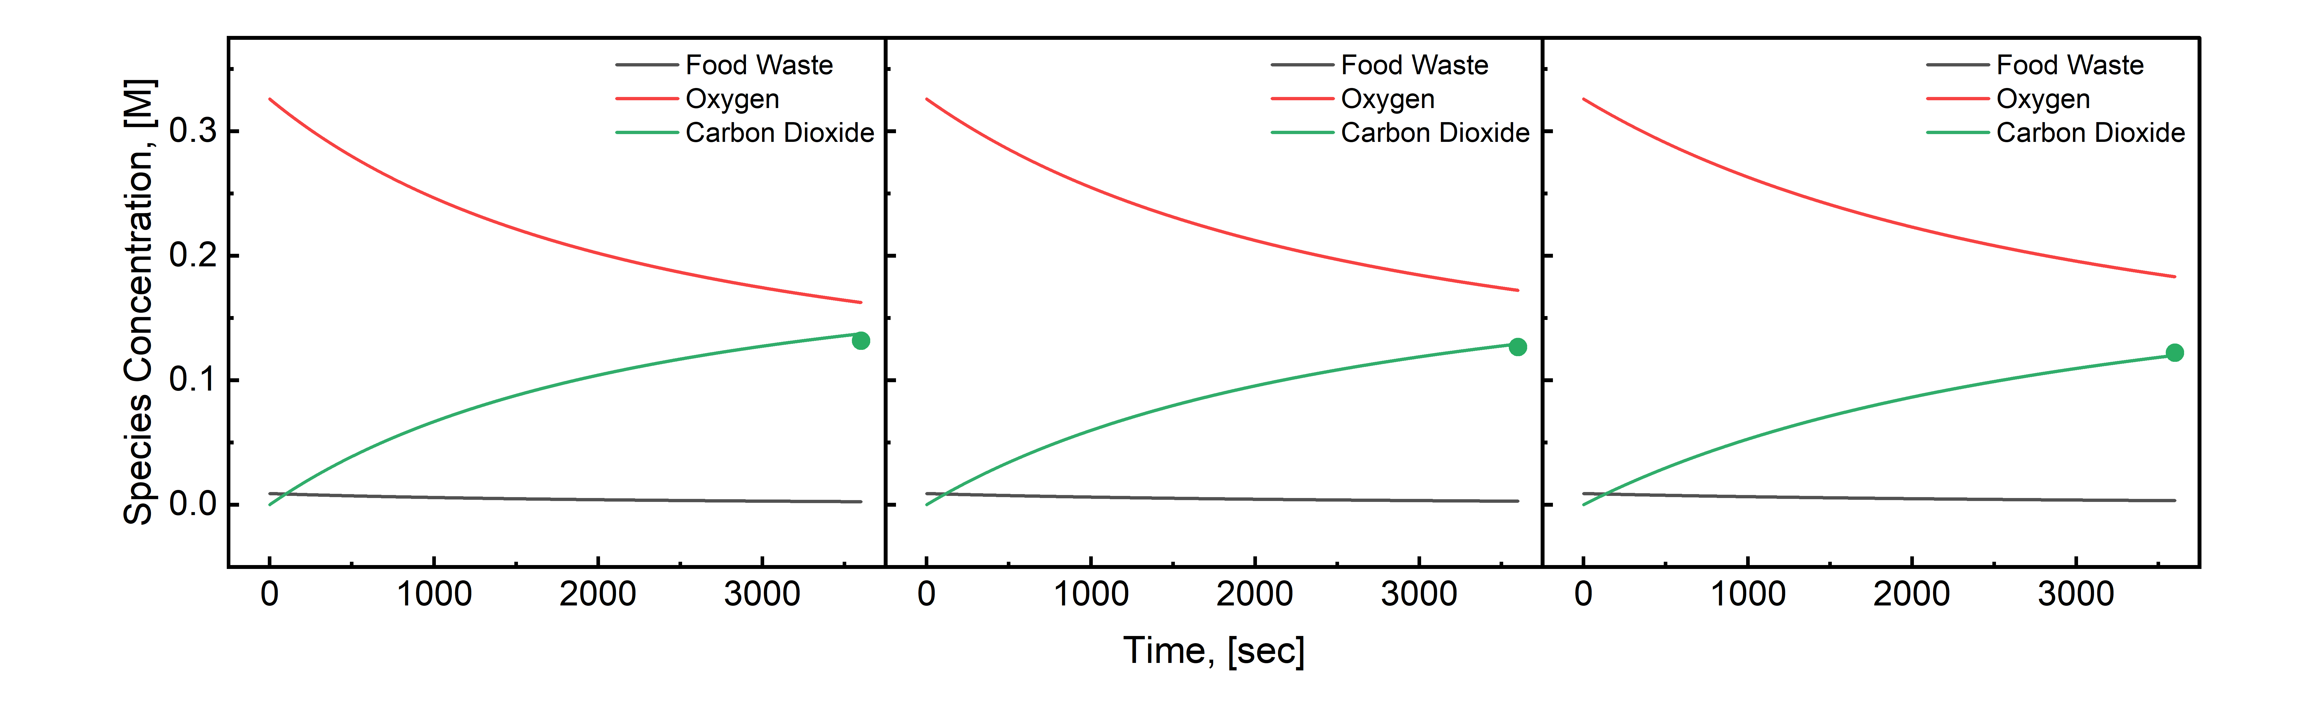

Figure S13. The conversion is found to decrease subtly as temperature decreases (LEFT to RIGHT)

Lastly, confidence intervals for each fitting parameter using nlparci which required residuals and Jacobian matrices from the lsqnonlin function as well as the fitted parameters, giving the final fitted equation of:
$$r_{CO_{2}}={10}^{-1.13±2.28}\exp\left(\frac{-25.3±29.4}{RT}\right)\left[FW\right]{\left[O_{2}\right]}^{0.6534±6.5375}$$

CaCO₃ yield analysis and kinetic parameters
X-ray diffraction was chosen as the primary method of measuring the conversion of Ca(OH)₂ to CaCO₃. This method was possible because the primary mineralization product was calcite which had enough distinct characteristic peaks that were different from Ca(OH)₂ that they could be correlated to solids loading within the sample. Powder mixtures of various solids loading of Ca(OH)₂ and CaCO₃ were mixed well and analyzed on the XRD (Fig. S12, LEFT). While the largest calcite characteristic peak is at 29$°$, the peak between 37.6 and 41.1$°$ was chosen due to the linear correlation between peak area and solids loading (Fig. S12, RIGHT). The peak area was found by taking the raw XRD data and using MATLAB’s cumtrapz function to calculate the cumulative area beneath the curve.
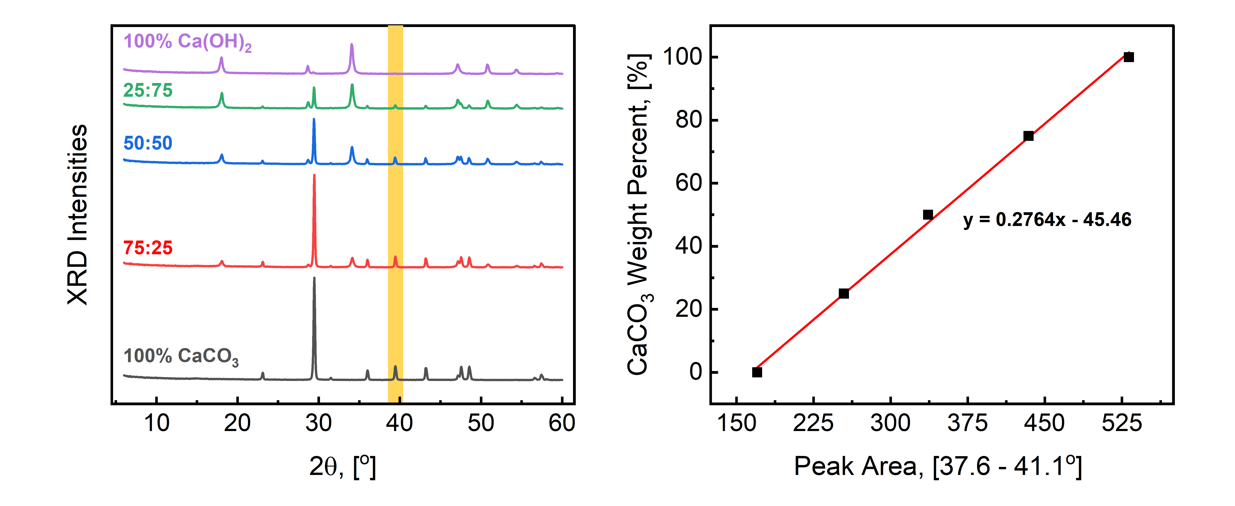

Figure S14. (LEFT) XRD analysis of powder mixtures of pure CaCO₃ and Ca(OH)₂ at different solid loadings. (RIGHT) Correlation of peak area between 37.6 – 41.1 for each solid loading.

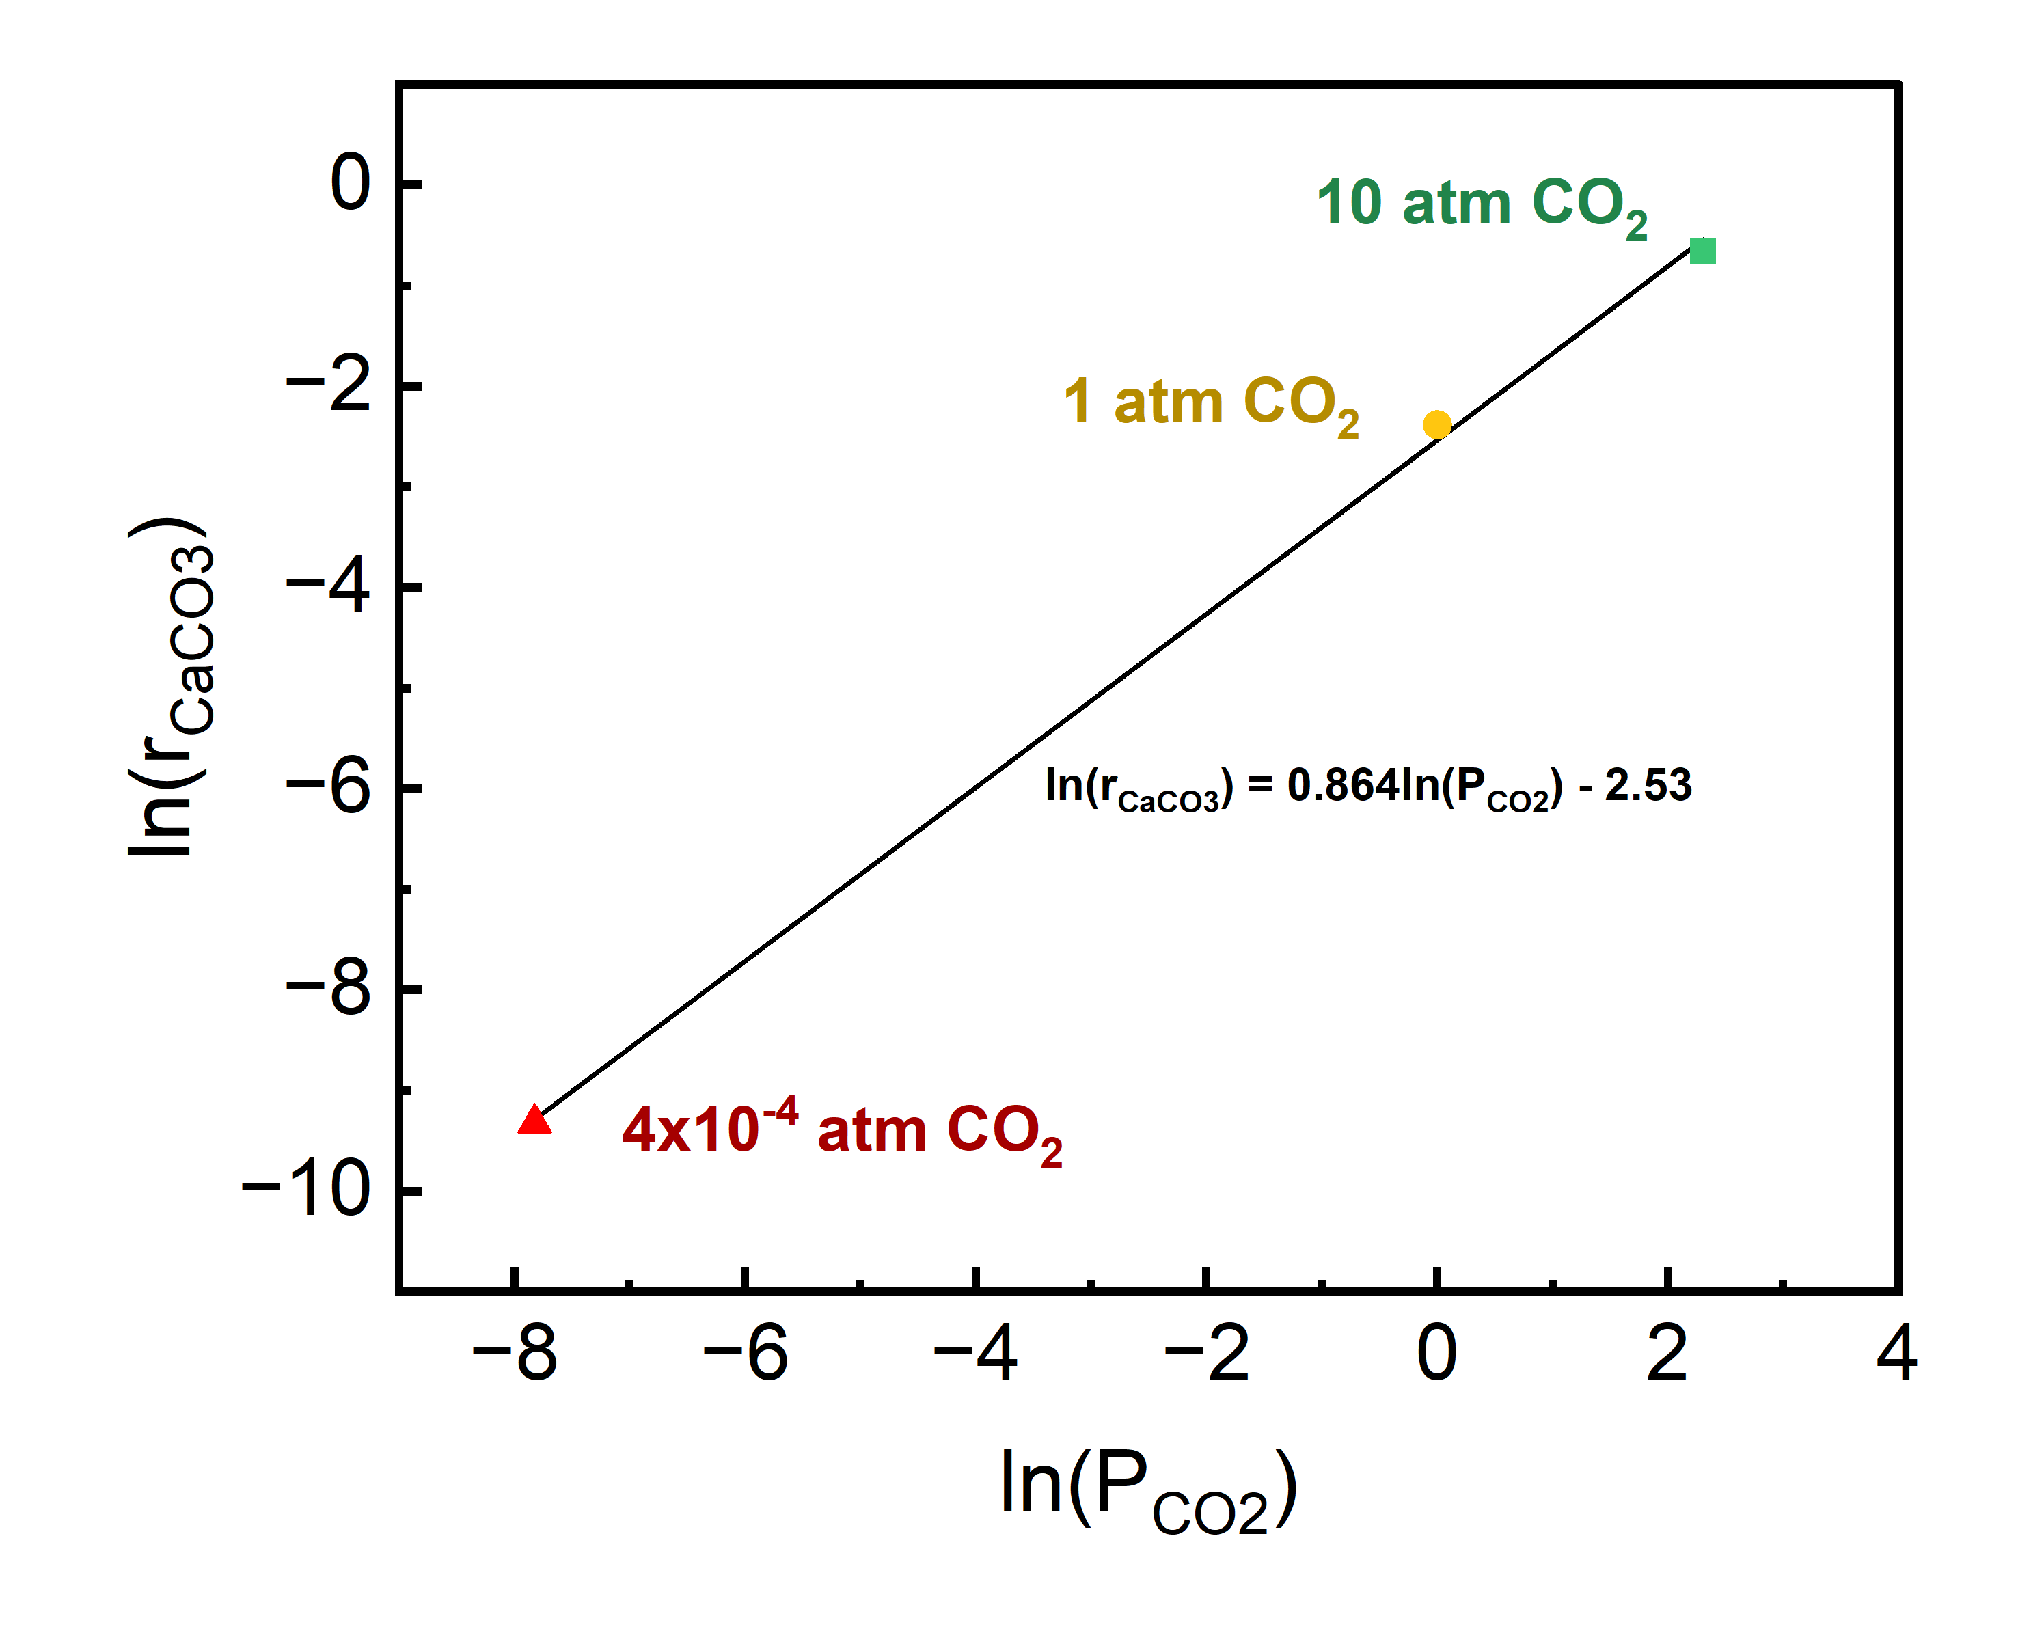

Figure S15. Plot of ln(r) vs ln(P)

Process Model Development
The SCWO system was modeled in Aspen HYSYS v14. To simplify the model, methanol (CH₃OH) was used to represent the food waste because methanol is a predefined compound within Aspen HYSYS, has a similar carbon weight percent (38 wt%) compared to food waste (52 wt%) and has a comparable energy content (24 MJ/kg).¹¹ Due to the high-pressure within the reaction systems there was no concern of the methanol creating a biphasic mixture with water. The process was assigned the Peng-Robinson fluid package to accurately represent the conversion reactions. Using more ideal fluid packages produce a bottoms product in the SCWO reactor when all products should leave from the top stream as a supercritical fluid. The reactions defined in this model is the combustion of methanol:
$$2CH_{3}OH+{3O}_{2}→2CO_{2}+{4H}_{2}O$$
For the reaction, various conversions were assigned based on the experimental SCWO findings at 450$°$C and O:C = 0 – 3.

Development of lifecycle analysis

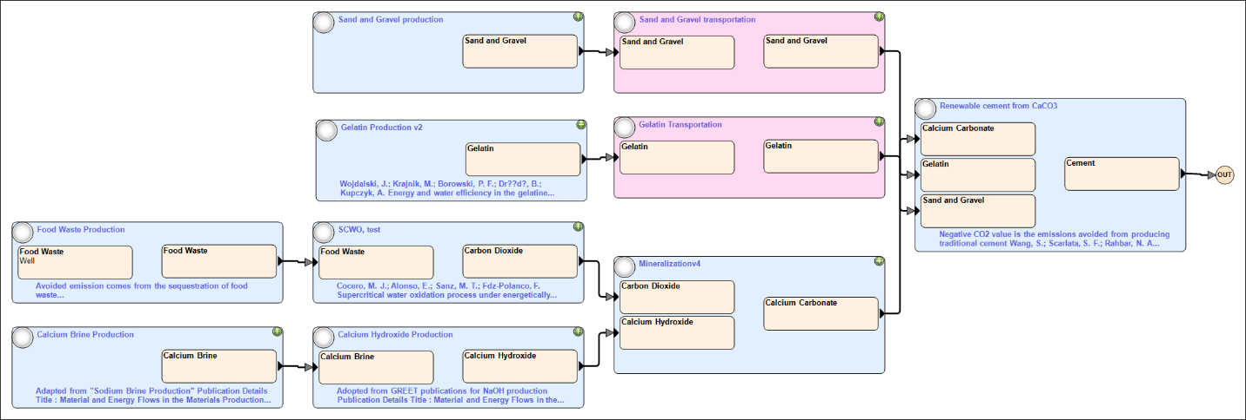

Figure S16. Process flow diagram for waste-to-cement process in GREET

The supercritical water oxidation block within the model can be tuned to vary conversion, solids loading, O:C ratio, and if the process is consuming or producing energy.
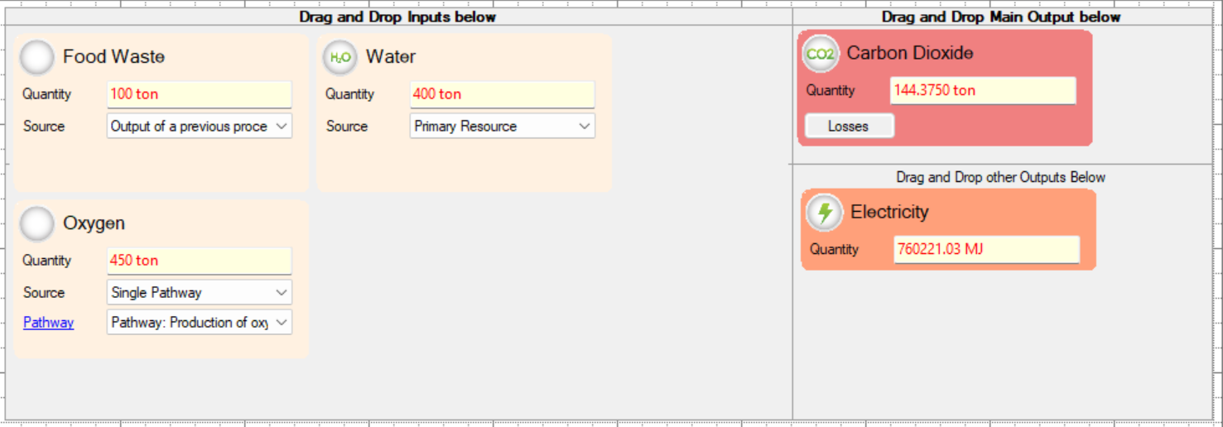

Figure S17. Process inputs and outputs for SCWO in GREET

The mineralization process assumes full conversion as was seen in Fig. 2f. The calcium hydroxide production pathways were self-defined but based on calculations for the chloroalkyl process of sodium hydroxide. The chloroalkyl process for sodium hydroxide is defined as:
$$2NaCl+2H_{2}O→2NaOH+Cl_{2}+H_{2}$$
Argonne National Laboratory (ANL) defines that 1 ton of Cl₂ requires 7.6 mmBtu where 20% of the energy is supplied by natural gas and the remaining energy is supplied through electricity.¹²⁻¹⁴ If a sodium brine is replaced with $NaCl$ then the reaction becomes:
$$CaCl_{2}+2H_{2}O→Ca{\left(OH\right)}_{2}+Cl_{2}+H_{2}$$
Based on stoichiometry, we can calculate the energy demand to be 7,693.4 MJ/ton Ca(OH)₂ maintaining the 80/20 split between electricity and natural gas. To produce 1 ton of Ca(OH)₂ requires 1.5 tons of CaCl₂ which is 3.5 tons of CaCl₂ brine, considering the solubility of CaCl₂ in solution is 42.7 weight percent. ANL additionally provides that the chloroalkyl process of NaOH requires 3773.9 gal of water per ton NaOH produced. This means that the production of Ca(OH)₂ requires 4016.13 gal/ton Ca(OH)₂.
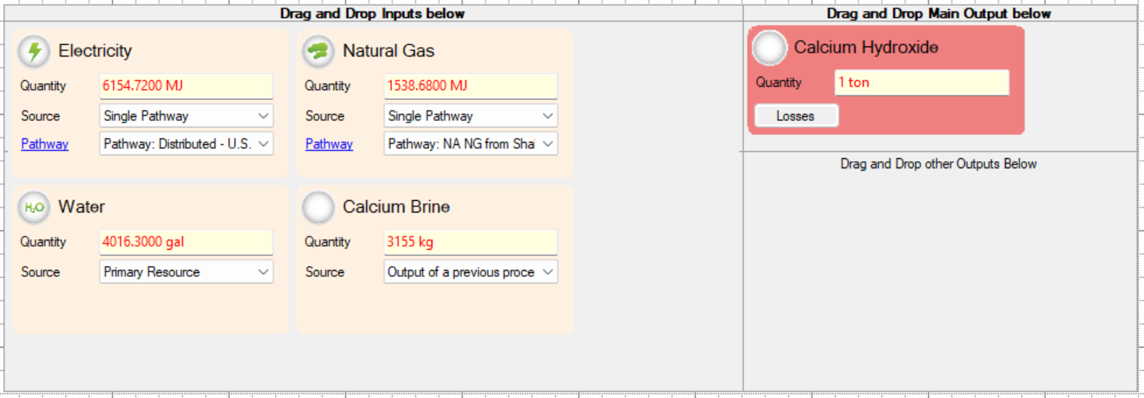

Figure S18. Process inputs and outputs for calcium hydroxide production

Lastly, the production of the alternative cement mortar follows the recipe laid out by Wang et al. in the production of enzymatic construction materials as well as the experiments carried out in this study. The cement mixture called for 3 g of sand, 0.08 g of gelatin, and 0.26 g of CaCl₂$∙$2H₂O.
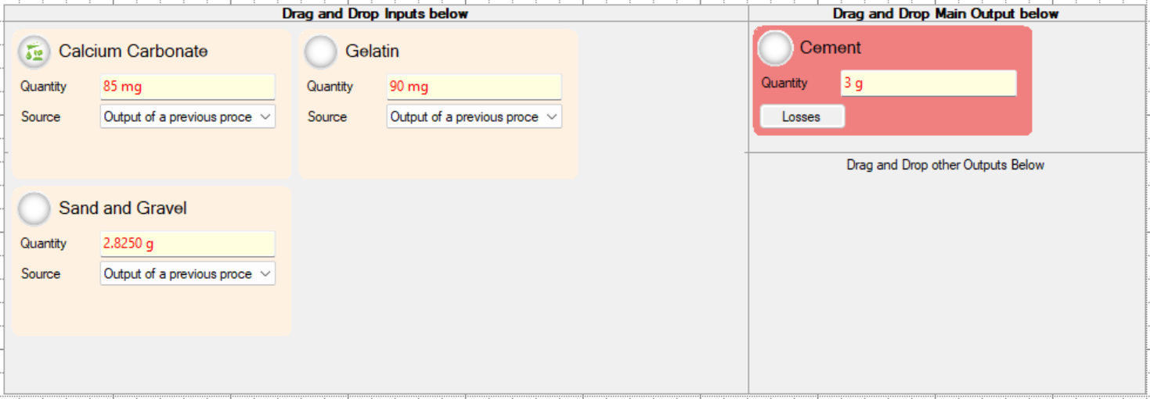

Figure S19. Process inputs and outputs for ACM production

References
1 National Overview: Facts and Figures on Materials, Wastes and Recycling, <https://www.epa.gov/facts-and-figures-about-materials-waste-and-recycling/national-overview-facts-and-figures-materials> (2022).
2 Kamran, A., Chaudhry, M. N. & Batool, S. A. Effects of socio-economic status and seasonal variation on municipal solid waste composition: a baseline study for future planning and development. Environmental Sciences Europe 27, 16, doi:10.1186/s12302-015-0050-9 (2015).
3 Hla, S. S. & Roberts, D. Characterisation of chemical composition and energy content of green waste and municipal solid waste from Greater Brisbane, Australia. Waste Management 41, 12-19, doi:https://doi.org/10.1016/j.wasman.2015.03.039 (2015).
4 Fujiwara, T., Inoue, R., Ohtawa, T. & Tsunoda, M. Liquid-Chromatographic Methods for Carboxylic Acids in Biological Samples. Molecules 25, doi:10.3390/molecules25214883 (2020).
5 Stair, R. Ultraviolet Absorption Spectra of Seven Substituted Benzenes.
6 Sager, E. E., Schooley, M. R., Carr, A. S. & Acree, S. Ultraviolet spectra and dissociation constants of p-hydroxybenzoic acid, methyl, ethyl, n-butyl, and benzyl p-hydroxybenzoate and potassium p-phenolsulfonate. J. Res. Nat. Bur. Stand. 35, 521-538 (1945).
7 Lisov, A., Vrublevskaya, V., Lisova, Z., Leontievsky, A. & Morenkov, O. A 2,5-Dihydroxybenzoic Acid–Gelatin Conjugate: The Synthesis, Antiviral Activity and Mechanism of Antiviral Action Against Two Alphaherpesviruses. Viruses 7, 5343-5360 (2015).
8 Mojica Prieto, F. J. & Millero, F. J. The values of pK1 + pK2 for the dissociation of carbonic acid in seawater. Geochimica et Cosmochimica Acta 66, 2529-2540, doi:https://doi.org/10.1016/S0016-7037(02)00855-4 (2002).
9 Marrone, P. A. Supercritical water oxidation—Current status of full-scale commercial activity for waste destruction. The Journal of Supercritical Fluids 79, 283-288, doi:https://doi.org/10.1016/j.supflu.2012.12.020 (2013).
10 Chen, S., Qu, X., Zhang, R. & Bi, J. Destruction of representative submarine food waste using supercritical water oxidation. Environmental Science and Pollution Research 22, 4527-4533, doi:10.1007/s11356-014-3689-7 (2015).
11 Linstrom, P. Vol. NIST Standard Reference Database Number 69 (NIST Office of Data and Informatics, 2021).
12 Dunn, J. B., Gaines, L., Barnes, M., Sullivan, J. L. & Wang, M. Material and energy flows in the materials production, assembly, and end-of-life stages of the automotive lithium-ion battery life cycle. (Argonne National Lab.(ANL), Argonne, IL (United States), 2014).
13 Sullivan, J. & Gaines, L. A review of battery life-cycle analysis: state of knowledge and critical needs. (2010).
14 Lampert, D. J. et al. Development of a life cycle inventory of water consumption associated with the production of transportation fuels. (Argonne National Lab.(ANL), Argonne, IL (United States), 2015).

