Supplementary information for

Global ammonia emission could be halved with cost-effective measures.
Xiuming Zhang^{1,2}, Yi Sun³, Yujing Gao^{1,4}, Chen Wang¹, Xia Liang⁵, Shu Kee Lam⁵, Shaohui Zhang², Wilfried Winiwarter^{2,6}, Hans J.M. van Grinsven⁷, Mark A. Sutton⁸, Deli Chen⁵, Baojing Gu^{1,9,10*}

¹ College of Environmental and Resource Sciences, Zhejiang University, Hangzhou 310058, PR China
² International Institute for Applied Systems Analysis, Schlossplatz 1, A-2361, Laxenburg, Austria
³ City Brain Institute, Hangzhou City University, Hangzhou, 310015, P.R. China
⁴ College of Biosystems Engineering and Food Science, Zhejiang University, Hangzhou, China
⁵ School of Agriculture, Food and Ecosystem Sciences, The University of Melbourne, Victoria 3010, Australia
⁶ Institute of Environmental Engineering, University of Zielona Góra, Licealna 9, PL 65-417, Zielona Góra, Poland
⁷ PBL Netherlands Environmental Assessment Agency, PO BOX 30314, 2500 GH The Hague, The Netherlands
⁸ UK Centre for Ecology & Hydrology, Edinburgh Research Station, Bush Estate, Penicuik, Midlothian, EH26 0QB, UK
⁹ Zhejiang Provincial Key Laboratory of Agricultural Resources and Environment, Zhejiang University, Hangzhou, 310058, China
¹⁰ Ministry of Education Key Laboratory of Environment Remediation and Ecological Health, Zhejiang University, Hangzhou 310058, China

*Corresponding Author. E-mail addresses: bjgu@zju.edu.cn (B. Gu)

The supplementary information provides the necessary data source and explanation for the global assessment of reducing NH₃ emissions, including:

Supplementary Text
S1. Literature review and ammonia emission datasets integration.
S2. Use of the Shared Socio-economic Pathway (SSP) approach
S3. NH₃ mitigation and SDGs
S4. NH₃ mitigation and GHG emissions
S5. NH₃ mitigation and green ammonia production

Figures S1-15
Figure S1 Sectoral NH₃ emissions by region in 1980-2020.
Figure S2. Regional NH₃ emission density and intensity in 1980-2020.
Figure S3. Marginal NH₃ abatement cost curves of China.
Figure S4. Marginal NH₃ abatement cost curves of India.
Figure S5. Marginal NH₃ abatement cost curves of Brazil.
Figure S6. Marginal NH₃ abatement cost curves of Europe.
Figure S7. Marginal NH₃ abatement cost curves of FSU.
Figure S8. Marginal NH₃ abatement cost curves of other Asian countries.
Figure S9. Marginal NH₃ abatement cost curves of Latin America.
Figure S10. Marginal NH₃ abatement cost curves of North America.
Figure S11. Marginal NH₃ abatement cost curves of Oceania.
Figure S12. Marginal NH₃ abatement cost curves of SSA.
Figure S13. Marginal NH₃ abatement cost curves of MENA.
Figure S14. The optimization of global NH₃ emission inventory (1980-2020) by multi-datasets integration
Figure S15. Comparison of global NH₃ emission by studies

Table S1-6
Table S1 Region classification and income definition in this study.
Table S2 Source classification of NH₃ emissions
Table S3 Description of the NH₃ mitigation options/practices and its mitigation efficiency.
Table S4 Description of the application scope, implementation cost and co-benefits of selected NH₃ mitigation options/practices.
Table S5 Major social-economic indicators of different scenarios according to the SSP-RCP approach
Table S6 Implementation rate of the assumed mitigation options by 2050 under different SSP- RCP scenarios

Supplementary text

S1: Model datasets integration.
CHANS. CHANS (Coupled Human And Natural Systems) is a N-flow process-based model that accounts for the complex biogeochemical processes of N cycling ¹. The CHANS model integrates the fluxes of N input, output and accumulation among 14 subsystems (cropland, feedlot, grassland, human, industry, aquaculture, forest, pets, urban lawn, solid waste, wastewater, atmosphere, surface water, and groundwater) based on the embedded mass balance approach. The model treats N cycling with multiple N fluxes, including N₂, N₂O, NO_{x} and NH₃ emissions to air, and NO₃⁻ and organic N fluxes to water. A detailed description of the CHANS model framework and calculation can be found in Gu et al.^{1, 2}. Various subsystems’ NH₃ fluxes are extracted to compile the NH₃ emission inventory.

CEDS. The Community Emissions Data System for Historical Emissions (CEDS) is a comprehensive and detailed database that provides historical emissions data for a wide range of pollutants, including greenhouse gases (GHGs) like CO₂, CH₄, and N₂O, as well as other significant air pollutants such as sulfur dioxide (SO₂), carbon monoxide (CO), non-methane volatile organic compounds (NMVOCs), NO_{x} and NH₃. The database provides historical emission data at the global scale, covering many countries and regions, and offers detailed emissions data broken down by sector (e.g., energy, industry, transportation, agriculture) and by fuel type. Developed to support the climate and atmospheric research community, CEDS offers extensive data essential for understanding past emission trends and modeling future environmental changes. Documentation of CEDS assumptions and system operation, including a user guide, is available in the CEDS project wiki and journal papers ^{3, 4}. Here we collected the NH₃ emission inventory during 1980-2019 from the CEDS v_ 2021_04_21 (https://github.com/JGCRI/CEDS) for further comparison and validation.

EDGAR. The EDGAR (Emissions Database for Global Atmospheric Research) database is a comprehensive resource that provides detailed information on greenhouse gas (GHG) and other air pollutant (e.g., NO_{x}, NH₃, PM_{2.5}, SO₂, BC, CO, OC, NMVOCs) emissions. Developed and maintained by the Joint Research Centre of the European Commission, EDGAR provides independent emission estimates compared to what is reported by the European Member States or by Parties under the United Nations Framework Convention on Climate Change (UNFCCC), using international statistics and a consistent IPCC methodology ⁵. Here, we collected the NH₃ emission inventory from 1980 to 2020 from the EDGAR v8.1_AP (https://edgar.jrc.ec.europa.eu/index.php/dataset_ap81), which provides both NH₃ emissions as national and sectoral totals and grid maps at 0.1 x 0.1 degree resolution at global level, with yearly and monthly data⁶. Note that NH₃ emissions from large-scale biomass burning with Savannah burning, forest fires, and sources and sinks from land use, land-use change, and forestry (LULUCF) are excluded in EDGAR.

IMAGE. IMAGE (Integrated Model to Assess the Global Environment) is an integrated assessment model that simulates the environmental consequences of human activities worldwide⁷. It represents interactions between society, the biosphere and the climate system to assess sustainability issues such as climate change, biodiversity, and human well-being. Detailed introduction to the IMAGE model and user guidelines can be found on the IMAGE website (https://models.pbl.nl/image/index.php/Welcome_to_IMAGE_3.2_Documentation). Here we derived global agricultural NH₃ emission inventory (2000-2015) from the IMAGE model to help validate and optimize the agricultural NH₃ parameters and EFs used in the CHANS model.

MAgPIE. MAgPIE (Model of Agricultural Production and its Impact on the Environment) model is a global land-use allocation model with a spatial resolution of 0.5°x0.5° that is linked to the grid-based dynamic vegetation model Lund-Potsdam-Jena managed land model (LPJmL)⁸. The model extended by a nitrogen mass-balance module, could simulate the major nitrogen flows on cropland soils, in livestock production, in food processing, and in household consumption, and create long-term scenarios of the agricultural nitrogen cycle and nitrogen-related pollution⁹. Here in this study, we derived the agricultural NH₃ emission inventory （1980-2015）from MAgPIE to constrain the uncertainty of CHANS-NH₃ emissions.

National Emission Inventory (NEI) dataset. The NEI is a comprehensive and detailed estimate of air emissions of criteria pollutants, here we collected three available National Emission Inventory of the US (https://www.epa.gov/air-emissions-inventories/national-emissions-inventory-nei), the UK (Data - NAEI, UK (beis.gov.uk)), and Australia (https://www.dcceew.gov.au/climate-change/publications/national-inventory-reports) for national data’s validation.

GAINS. The GAINS (Greenhouse Gas and Air Pollution Interactions and Synergies) model is an advanced tool developed by the International Institute for Applied Systems Analysis (IIASA) for analyzing strategies to reduce air pollutants and greenhouse gases (GHGs) simultaneously ¹⁰. The model covers a wide range of pollutants, including SO₂, NO_{x}, CO, NH₃, PM, VOCs, and GHGs like CO₂, CH₄, and N₂O. It also encompasses various sectors, such as energy, transport, industry, agriculture, and residential. GAINS is used here to provide a cost-benefit analysis of different emission control options and allow users to create scenarios based on various assumptions about economic development, energy use, technological progress, and policy implementation, helping identify cost-effective strategies to achieve environmental goals.

We integrated the various NH₃ emission inventories from different data sources to get an understanding of the uncertainty of NH₃ emissions (Fig. S14). NH₃ emission-related parameters (emission fraction and emission factors) were extracted from the three datasets to get the average-weighted values, which were then reimported into the CHANS model to optimize the parameters of the CHANS model. The multi-model integration provides the new adjusted NH₃ emission inventories by nation and sector. For the further assessment of mitigation potential, cost, and pathways, available NH₃ mitigation options and their relevant parameters were integrated into the optimized CHANS model to assess the potential, cost, and benefits under assumed scenarios.

S2: Scenario description
SSP1_1.9: sustainability—taking the green road. This scenario applies SSP1 in combination with RCP1.9, i.e. assuming an increase in radiative forcing of 1.9 W m⁻² by 2050. This scenario assumes the highest ambition policies for NH₃ emission control. According to this scenario, countries attach great importance to NH₃ emission reduction and formulate ambitious emission reduction targets and strategies. Effective international cooperation frameworks are established for NH₃ emission reduction with active technology transfer. Major emitting countries promote systemic emission reduction measures, covering agriculture, industry and other sectors. Clean alternative technologies and low-carbon materials are promoted, accelerating the phase-out of high-emission processes and products. Agricultural emission reduction technologies are vigorously developed, promoting precision fertilization, waste recycling, etc. End-of-pipe technologies make significant progress and are widely applied in industry and daily life. Capabilities for NH₃ monitoring and statistics are substantially enhanced, supporting emission reduction policymaking. The public has strong environmental awareness and actively supports NH₃ emission reduction actions. Overall, under the SSP1_1.9 scenario, NH₃ emission reduction policies and technologies will be highly valued and quickly advanced, leading to significant reduction results.

SSP2_4.5: middle of the road. This scenario applies SSP2 in combination with RCP4.5, i.e. assuming an increase in radiative forcing of 4.5 W m⁻² by 2050. This scenario assumes medium ambition policies for NH₃ emission control. According to this scenario, greenhouse gas emission reduction remains the focus of countries, but NH₃ emission reduction receives less attention. Some developed countries may formulate policies to control agricultural and industrial NH₃ emissions, but the efforts are weak. Some rapidly developing emerging economies may overlook NH₃ reduction and prioritize economic growth in other directions. International organizations and environmental groups advocate for NH₃ emission reduction, but national responses are moderate. Accordingly, NH₃ emission reduction technologies make some progress, with increased application of end-of-pipe technologies like scrubbing, catalytic conversion, biofiltration, etc. However, cleaner production and process transformation technologies advance slowly, limiting emission reduction effects. Application of agricultural NH₃ emission reduction technologies is also relatively slow, with reduction potential not fully tapped. In general, under the SSP2_4.5 scenario, NH₃ emission reduction policies and technologies progress slowly overall, lacking systematic strength.

SSP3_7.0: regional rivalry—a rocky road. This scenario applies SSP3 in combination with RCP7.0, i.e. assuming an increase in radiative forcing of 7.0 W m⁻² by 2050. This scenario assumes low-ambition policies for NH₃ emission control. According to this scenario the government prioritizes maximizing national economic interests and pays inadequate attention to NH₃ emission reduction (even where this could contribute to improving national economic performance). There is a lack of unified and effective international targets and roadmaps for NH₃ emission reduction. Emission reduction actions in different countries and regions lack coordination. Major emitting countries progress slowly on NH₃ emission reduction policies, focusing on supporting economic growth. Environmental groups advocate for emission reduction but have limited influence. Accordingly, NH₃ emission reduction technologies advance slowly due to insufficient investment. End-of-pipe controls take a higher share than source reduction. Cleaner production and resource utilization technologies have low promotion levels. Agricultural emission reduction technologies are applied slowly, remaining mostly in traditional management approaches. Overall, under the SSP3_7.0 scenario, progress in NH₃ emission reduction policies and technologies is slow, resulting in very limited reduction. Economic growth takes priority over environmental protection, even where environmental protection could contribute to economic growth.

SSP5_8.5: fossil-fueled development—taking the highway. This scenario applies SSP5 in combination with RCP8.5, i.e. assuming an increase in radiative forcing of 8.5 W m⁻² by 2050. This scenario assumes the lowest ambition policies for NH₃ emission control. According to this scenario, the global economy is highly dependent on fossil fuels, and countries prioritize energy security and economic growth. Accordingly, NH₃ emission reduction policies lack unified deployment and binding force, with major emitting countries progressing slowly. Effective international NH₃ emission reduction targets and mechanisms are absent. Agricultural and industrial sectors lack systematic emission reduction strategies, focusing on maintaining output. Investment in new NH₃ emission reduction technology R&D and application is lacking. The promotion of clean alternative technologies is limited. End-of-pipe control technologies are popular but have a limited impact on total emissions. The application of low-carbon and eco-friendly material alternatives is constrained. Progress in NH₃ resource utilization technologies is slow. Overall, under the SSP5_8.5 scenario, economic growth is prioritized, while ignoring NH₃ emission reduction, even where this could promote economic growth. Advancement of policies and technologies is slow, resulting in very limited reduction effects.

S3: Ammonia mitigation and SDGs
Mitigation of NH₃ is closely linked to several Sustainable Development Goals (SDGs, ¹¹). Specifically, it contributes to SDG 2 (Zero Hunger) by preserving soil and water quality, thus supporting agricultural sustainability and food security. It also aligns with SDG 3 (Good Health and Well-being) by reducing air pollution and improving respiratory health. The safeguarding of water quality through NH₃ mitigation supports SDG 6 (Clean Water and Sanitation), while its role in reducing aerosol formation aligns with SDG 13 (Climate Action). Mitigation of NH₃ also contributes to reducing impacts on terrestrial biodiversity consistent with SDG 15 (Life on Land) ¹². Therefore, the reduction of NH₃ emissions represents an opportunity for more efficient use of nitrogen with co-benefits for air and water quality, climate, biodiversity, and human health, ultimately, global sustainable development.

S4: Ammonia mitigation and GHG emissions
The concept of "win-win" measures in the context of NH₃ mitigation and greenhouse gas (GHG) emission reduction is a multifaceted approach that aims to address environmental challenges holistically ^{13, 14}. By improving agricultural practices, such as precision farming and optimizing fertilizer use, it is possible to significantly reduce the amount of NH₃ released into the atmosphere, while retaining valuable reactive nitrogen resources within the farming system. Precision farming involves using advanced technologies like Global Positioning Systems (GPS), soil sensors and data analytics to apply fertilizers and other inputs in an efficient and targeted manner. This not only minimizes the excess use of nitrogen-based fertilizers, which are a major source of NH₃ emissions but also enhances crop yields and reduces the overall carbon footprint of farming activities.

Optimizing fertilizer use is another critical aspect. This involves selecting the right type of fertilizer, applying it at the optimal time, and using the correct application methods to minimize volatilization and leaching of nitrogen. These practices not only reduce NH₃ emissions but also improve the efficiency of nitrogen use, leading to lower GHG emissions associated with fertilizer production and application. For nitrogen fertilizers that lose a substantial fraction of the fertilizer value by NH₃ emissions, like urea, specific techniques such as immediate incorporation into soil or urease inhibitors substantially reduce emissions ¹⁴. Immediate incorporation of solid and liquid manures and other band-spreading approaches are central to reducing ammonia emissions alongside covering of manure stores and low-emission housing practices ¹⁵.

Promoting sustainable management of organic wastes/residues (e.g. municipal solid waste, wastewater) is another key strategy. By implementing practices such as composting and anaerobic digestion, organic waste/residues can be transformed into valuable resources like biofertilizers and biogas, reducing the need for synthetic fertilizers and the GHG emissions associated with their production. Moreover, these practices prevent the release of NH₃ and other harmful gases that occur during the decomposition of organic waste (i.e., municipal solid waste) in landfills.

The adoption of renewable energy sources plays a crucial role in this integrated approach. Switching to green energy sources like solar, wind and hydroelectric power reduces reliance on fossil fuels, thereby cutting down CO₂ emissions. Additionally, renewable energy can power agricultural and waste processing operations more sustainably. For instance, using solar energy to power electric vehicles and machinery in agriculture can reduce both CO₂ and NH₃ emissions by decreasing the use of diesel and gasoline.

Realizing the synergies between NH₃ mitigation and GHG emission reduction requires a concerted effort to integrate these considerations into the policymaking process. This involves developing policies that recognize the interconnections between air quality and climate change and promote practices that have co-benefits for both. It also requires collaboration between various stakeholders, including farmers, organic waste/residue managers, energy producers, and policymakers, to implement these measures effectively.

S5: Ammonia mitigation and ‘Green Ammonia’ production
In recent decades, research attention has increasingly focused on green ammonia production ¹⁶, which should be distinctly understood from NH₃ mitigation. Green ammonia is produced via renewable energy sources, typically electrolysis of water and nitrogen ¹⁷. By avoiding the conventional Haber-Bosch process, green ammonia represents a potentially significant carbon-neutral fuel for electricity generation and shipping ¹⁸. However, the combustion of ammonia as a fuel can still yield some unreacted NH₃ emissions¹⁹. To minimize environmental impacts, exhaust abatement is necessary for ammonia-fueled systems. Integrating NH₃ mitigation and green ammonia production into net-zero GHG plans could provide synergistic climate and air quality benefits. Well-designed policies supporting both agricultural NH₃ abatement and green ammonia technologies can establish a more holistic, sustainable framework. Further techno-economic analyses are warranted to optimize implementation strategies for these complementary approaches.

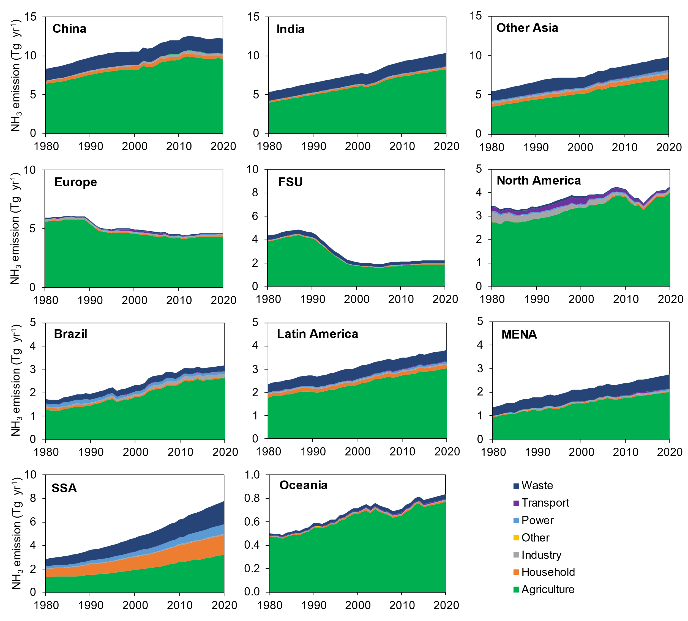

Figure S1. Sectoral NH₃ emissions by region in 1980-2020.
Europe, includes 27 countries of the European Union and other 5 countries of Albania, Switzerland, United Kingdom, Iceland, and Norway; FSU, Former Soviet Union; MENA, Middle East and North Africa; SSA, sub-Saharan Africa. Detailed country group defined in this study could be found in Table S1.

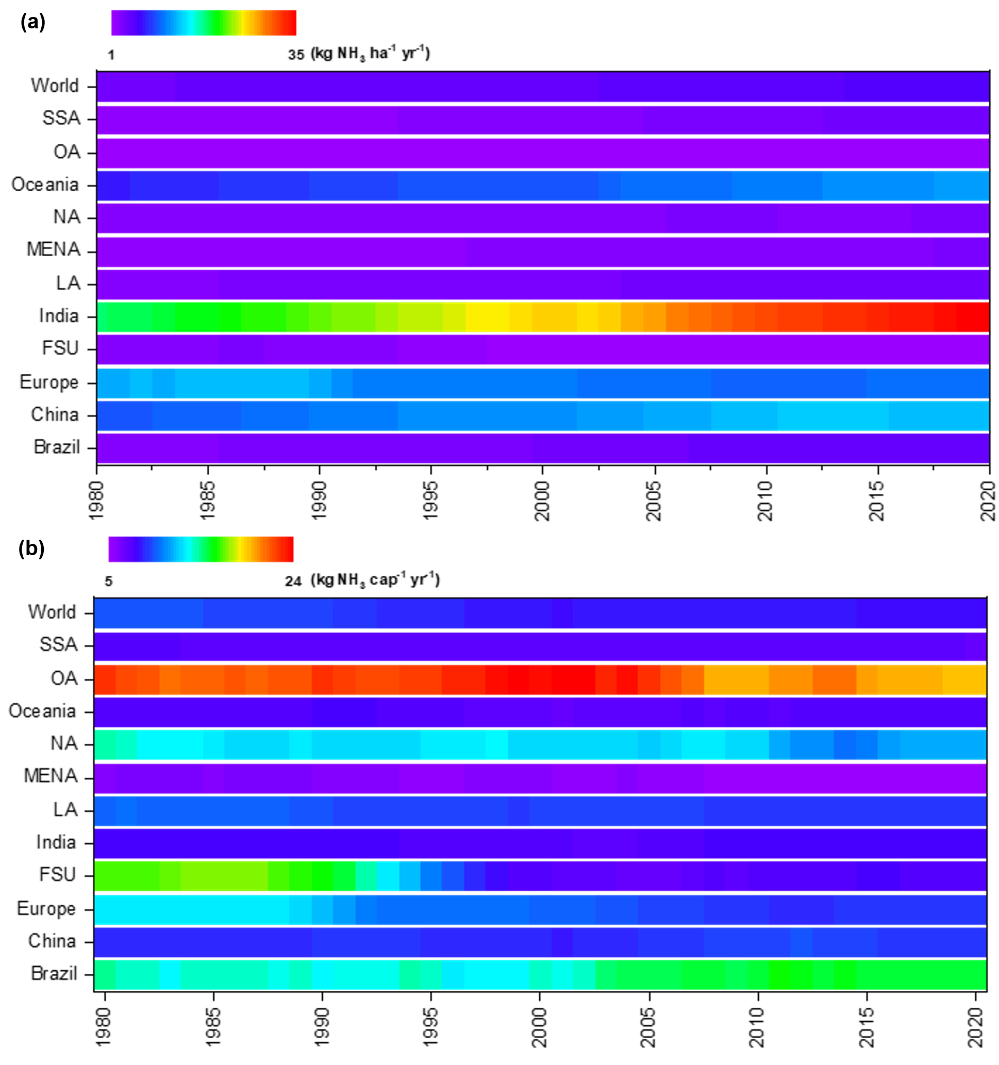

Figure S2. Regional NH₃ emission density and intensity during 1980-2020
a, NH₃ emission density (kg NH₃ ha⁻¹ yr⁻¹); b, NH₃ emission intensity (kg NH₃ cap⁻¹ yr⁻¹).

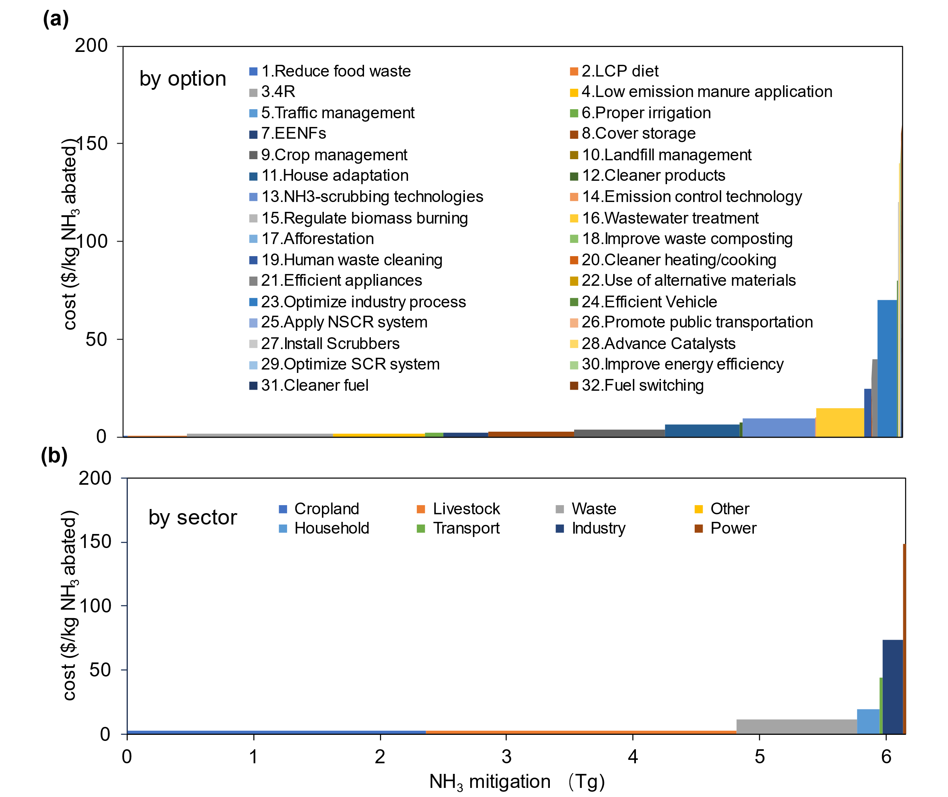

Figure S3. Marginal NH₃ abatement cost curves of China.
(a) Marginal NH₃ abatement cost curves (MACC) with options; (b) Marginal NH₃ abatement cost curves with sectors; the X-axis stands for the value of NH₃ mitigation, the Y-axis is the marginal abatement cost of the specific mitigation option or emission sector in $ per kg NH₃ mitigated, note that the values do not include the financial value of N saved by reduced NH₃ emissions of the measures listed; each bar in the MACCs represents a different mitigation option or sector, and is ranked according to its unit average cost, with the least costly on the left. LCP, low-crude protein; 4R, right time, right type, right rate and right place fertilization; EENF, enhanced efficiency nitrogen fertilizer; SCR, Selective catalytic reduction; NSCR, Non-Selective Catalytic Reduction. Detailed descriptions of options could be found in Table S3-4.

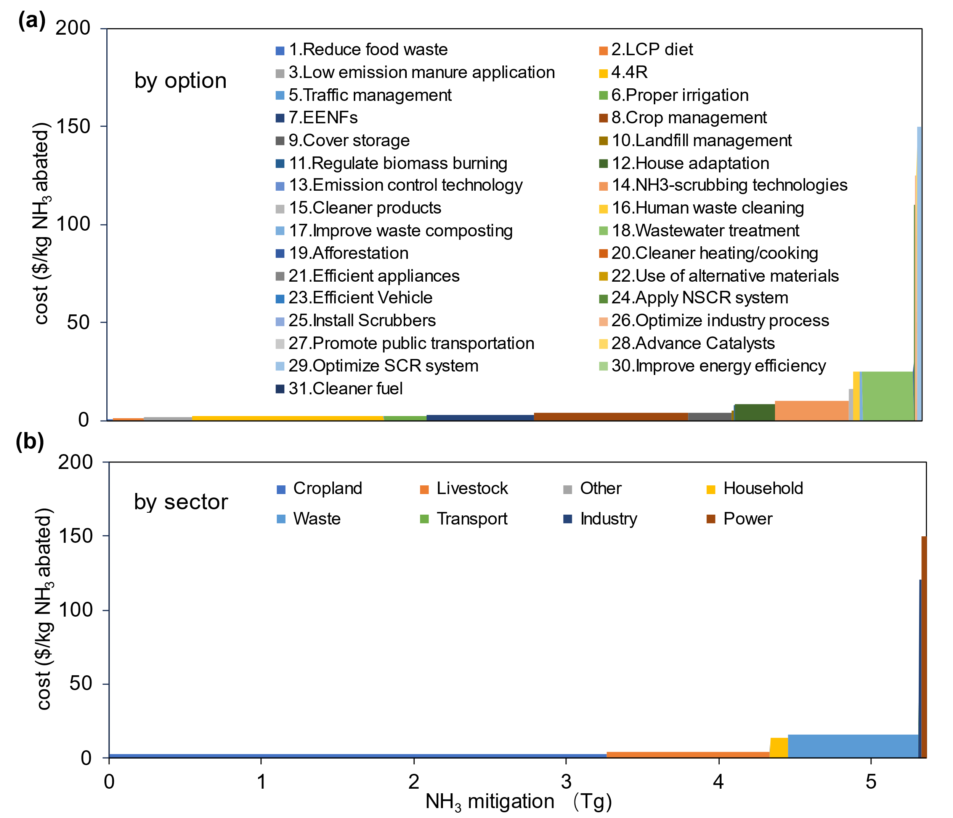

Figure S4. Marginal NH₃ abatement cost curves of India.
(a) MACC with options; (b) MACC with sectors. LCP, low-crude protein; 4R, right time, right type, right rate and right place fertilization; EENF, enhanced efficiency nitrogen fertilizer; SCR, Selective catalytic reduction; NSCR, Non-Selective Catalytic Reduction. Detailed descriptions of options could be found in Table S3-4.

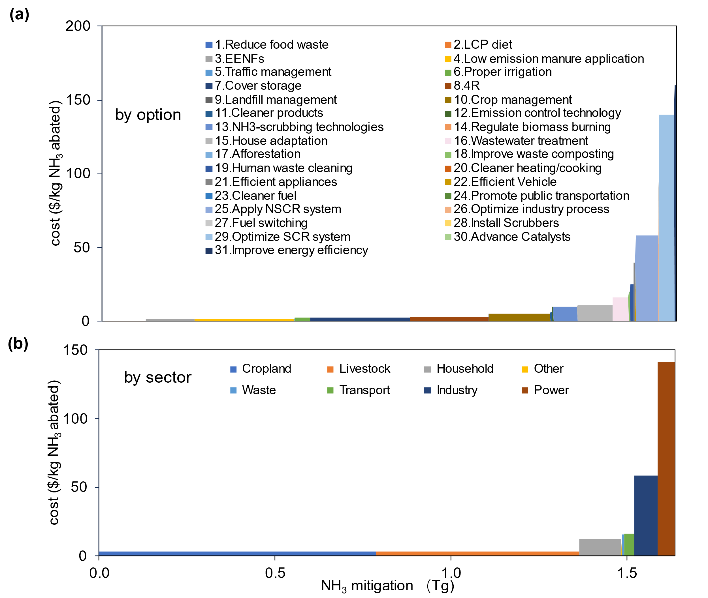

Figure S5. Marginal NH₃ abatement cost curves of Brazil.
(a) MACC with options; (b) MACC with sectors. LCP, low-crude protein; 4R, right time, right type, right rate and right place fertilization; EENF, enhanced efficiency nitrogen fertilizer; SCR, Selective catalytic reduction; NSCR, Non-Selective Catalytic Reduction. Detailed descriptions of options could be found in Table S3-4.

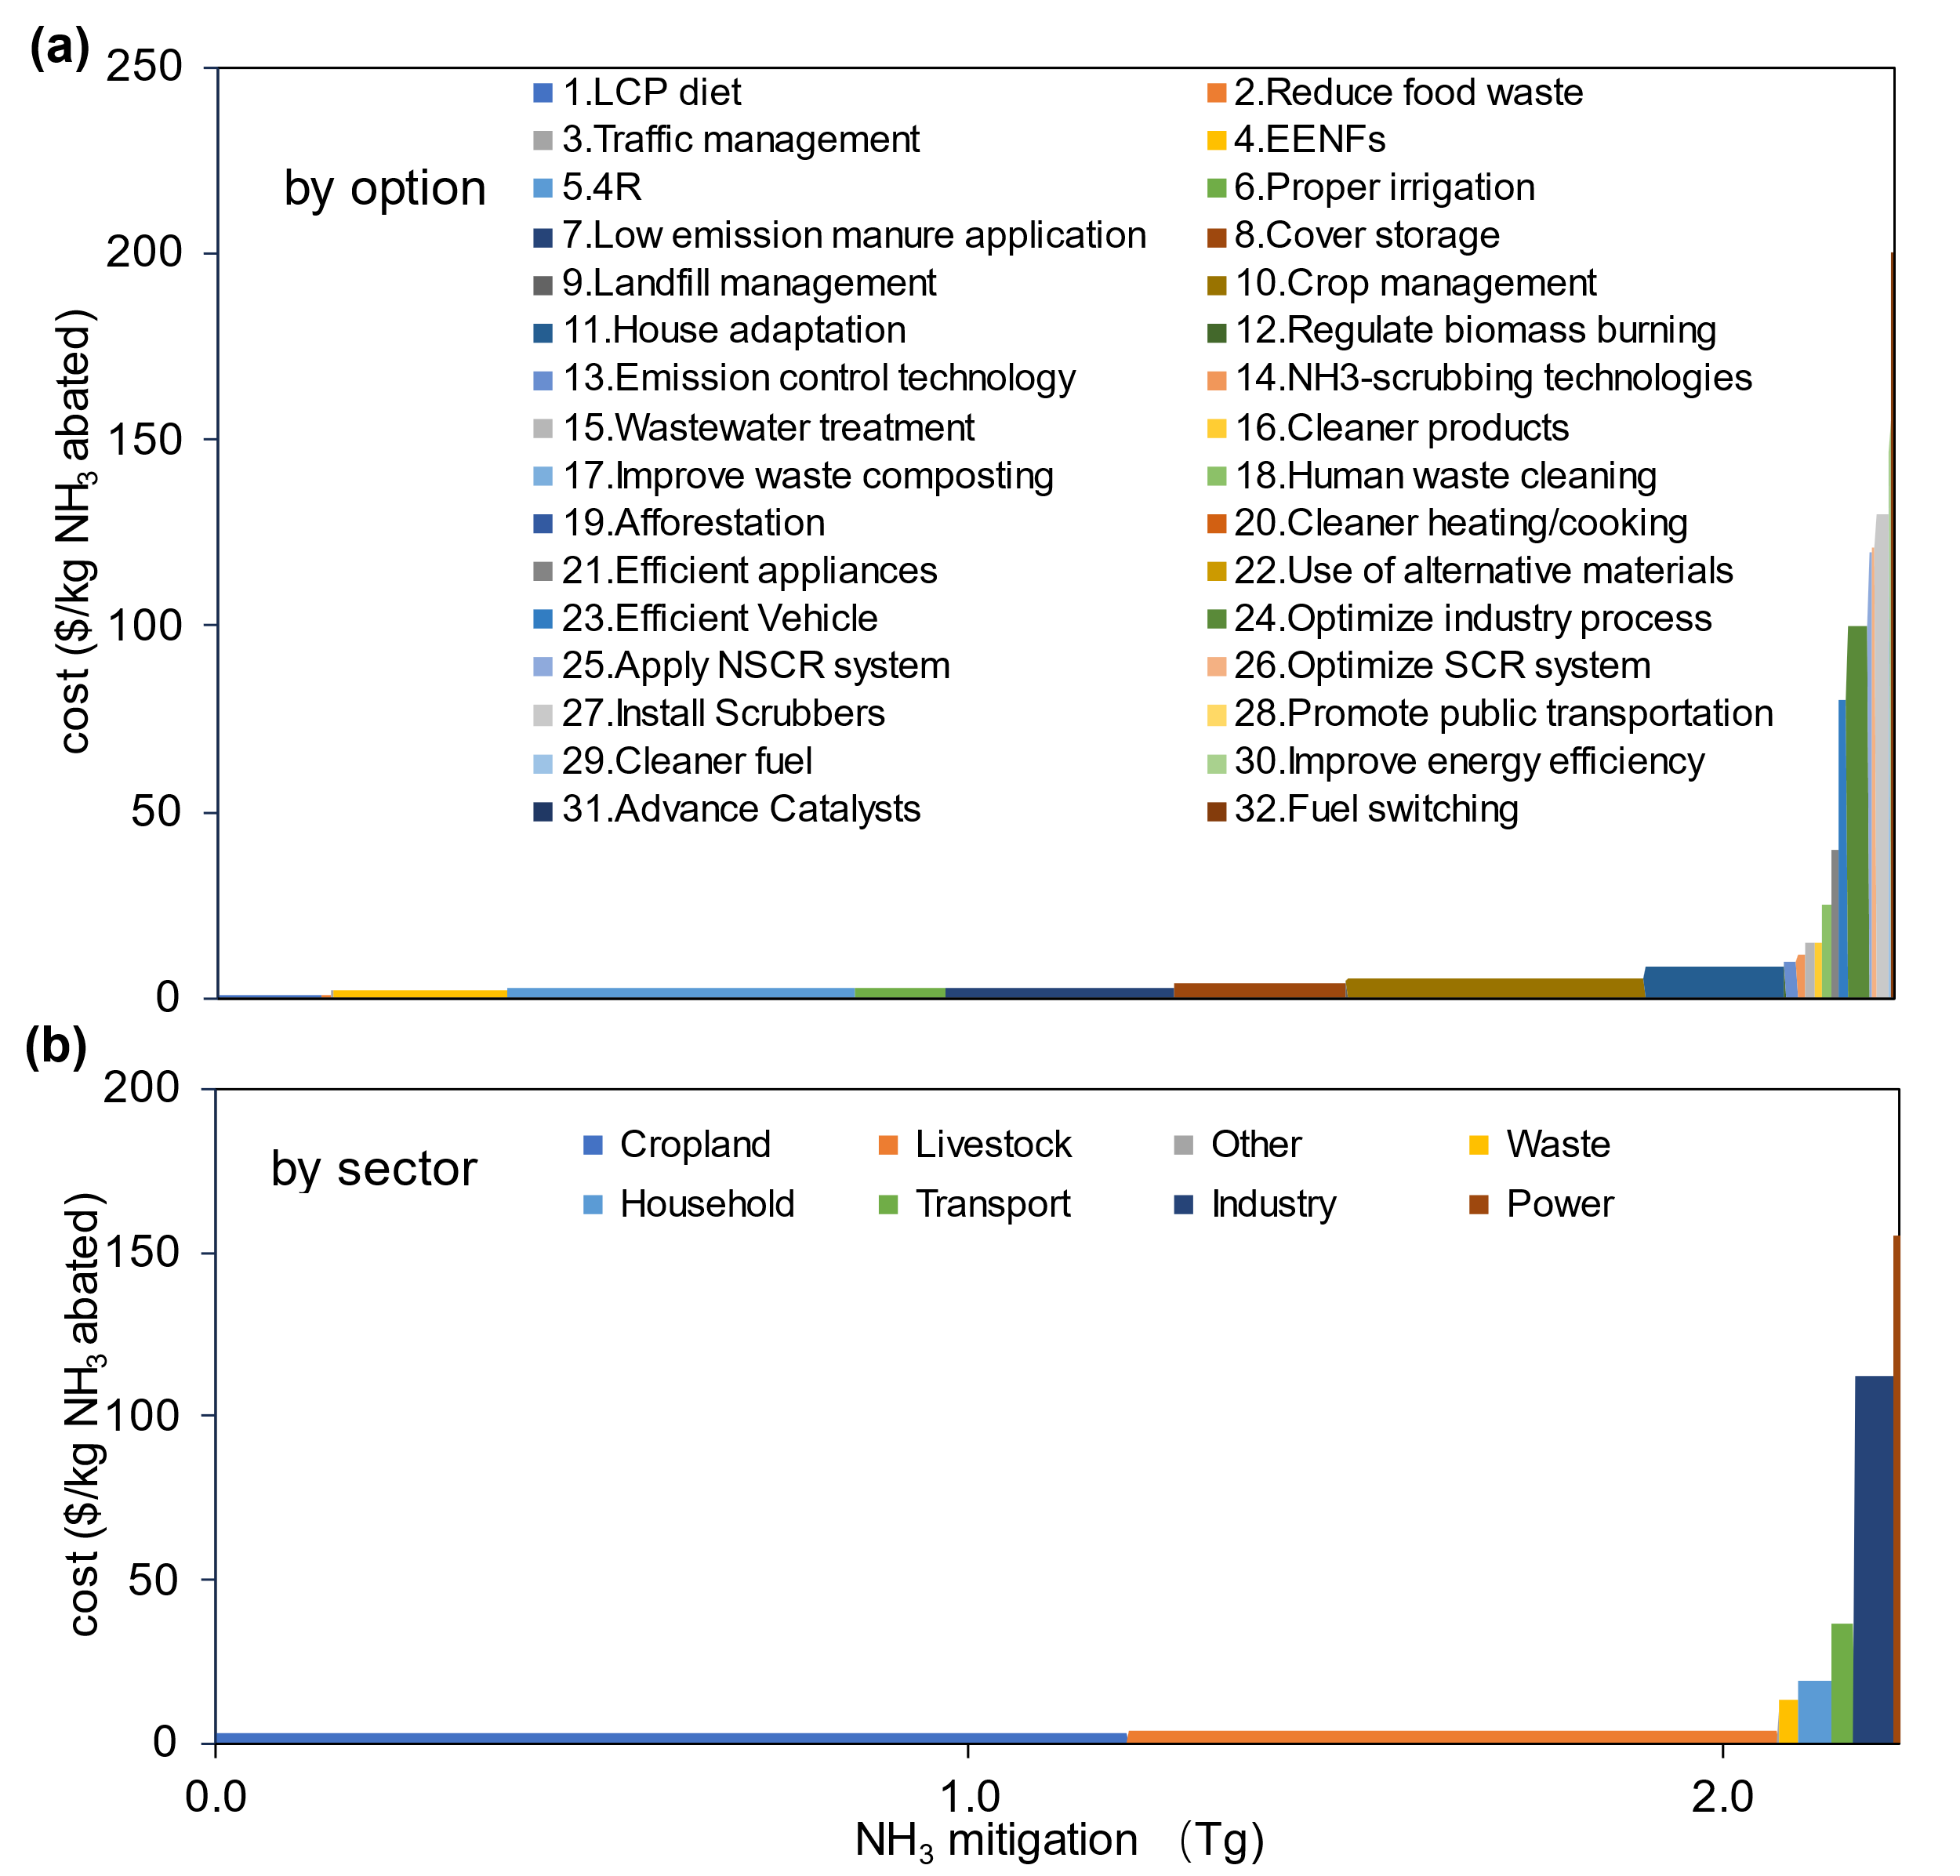

Figure S6. Marginal NH₃ abatement cost curves of Europe
(a) MACC with options; (b) MACC with sectors. The division of regions and covering countries of the Europe could be found in Table S1. LCP, low-crude protein; 4R, right time, right type, right rate and right place fertilization; EENF, enhanced efficiency nitrogen fertilizer; SCR, Selective catalytic reduction; NSCR, Non-Selective Catalytic Reduction. Detailed descriptions of options could be found in Table S3-4.

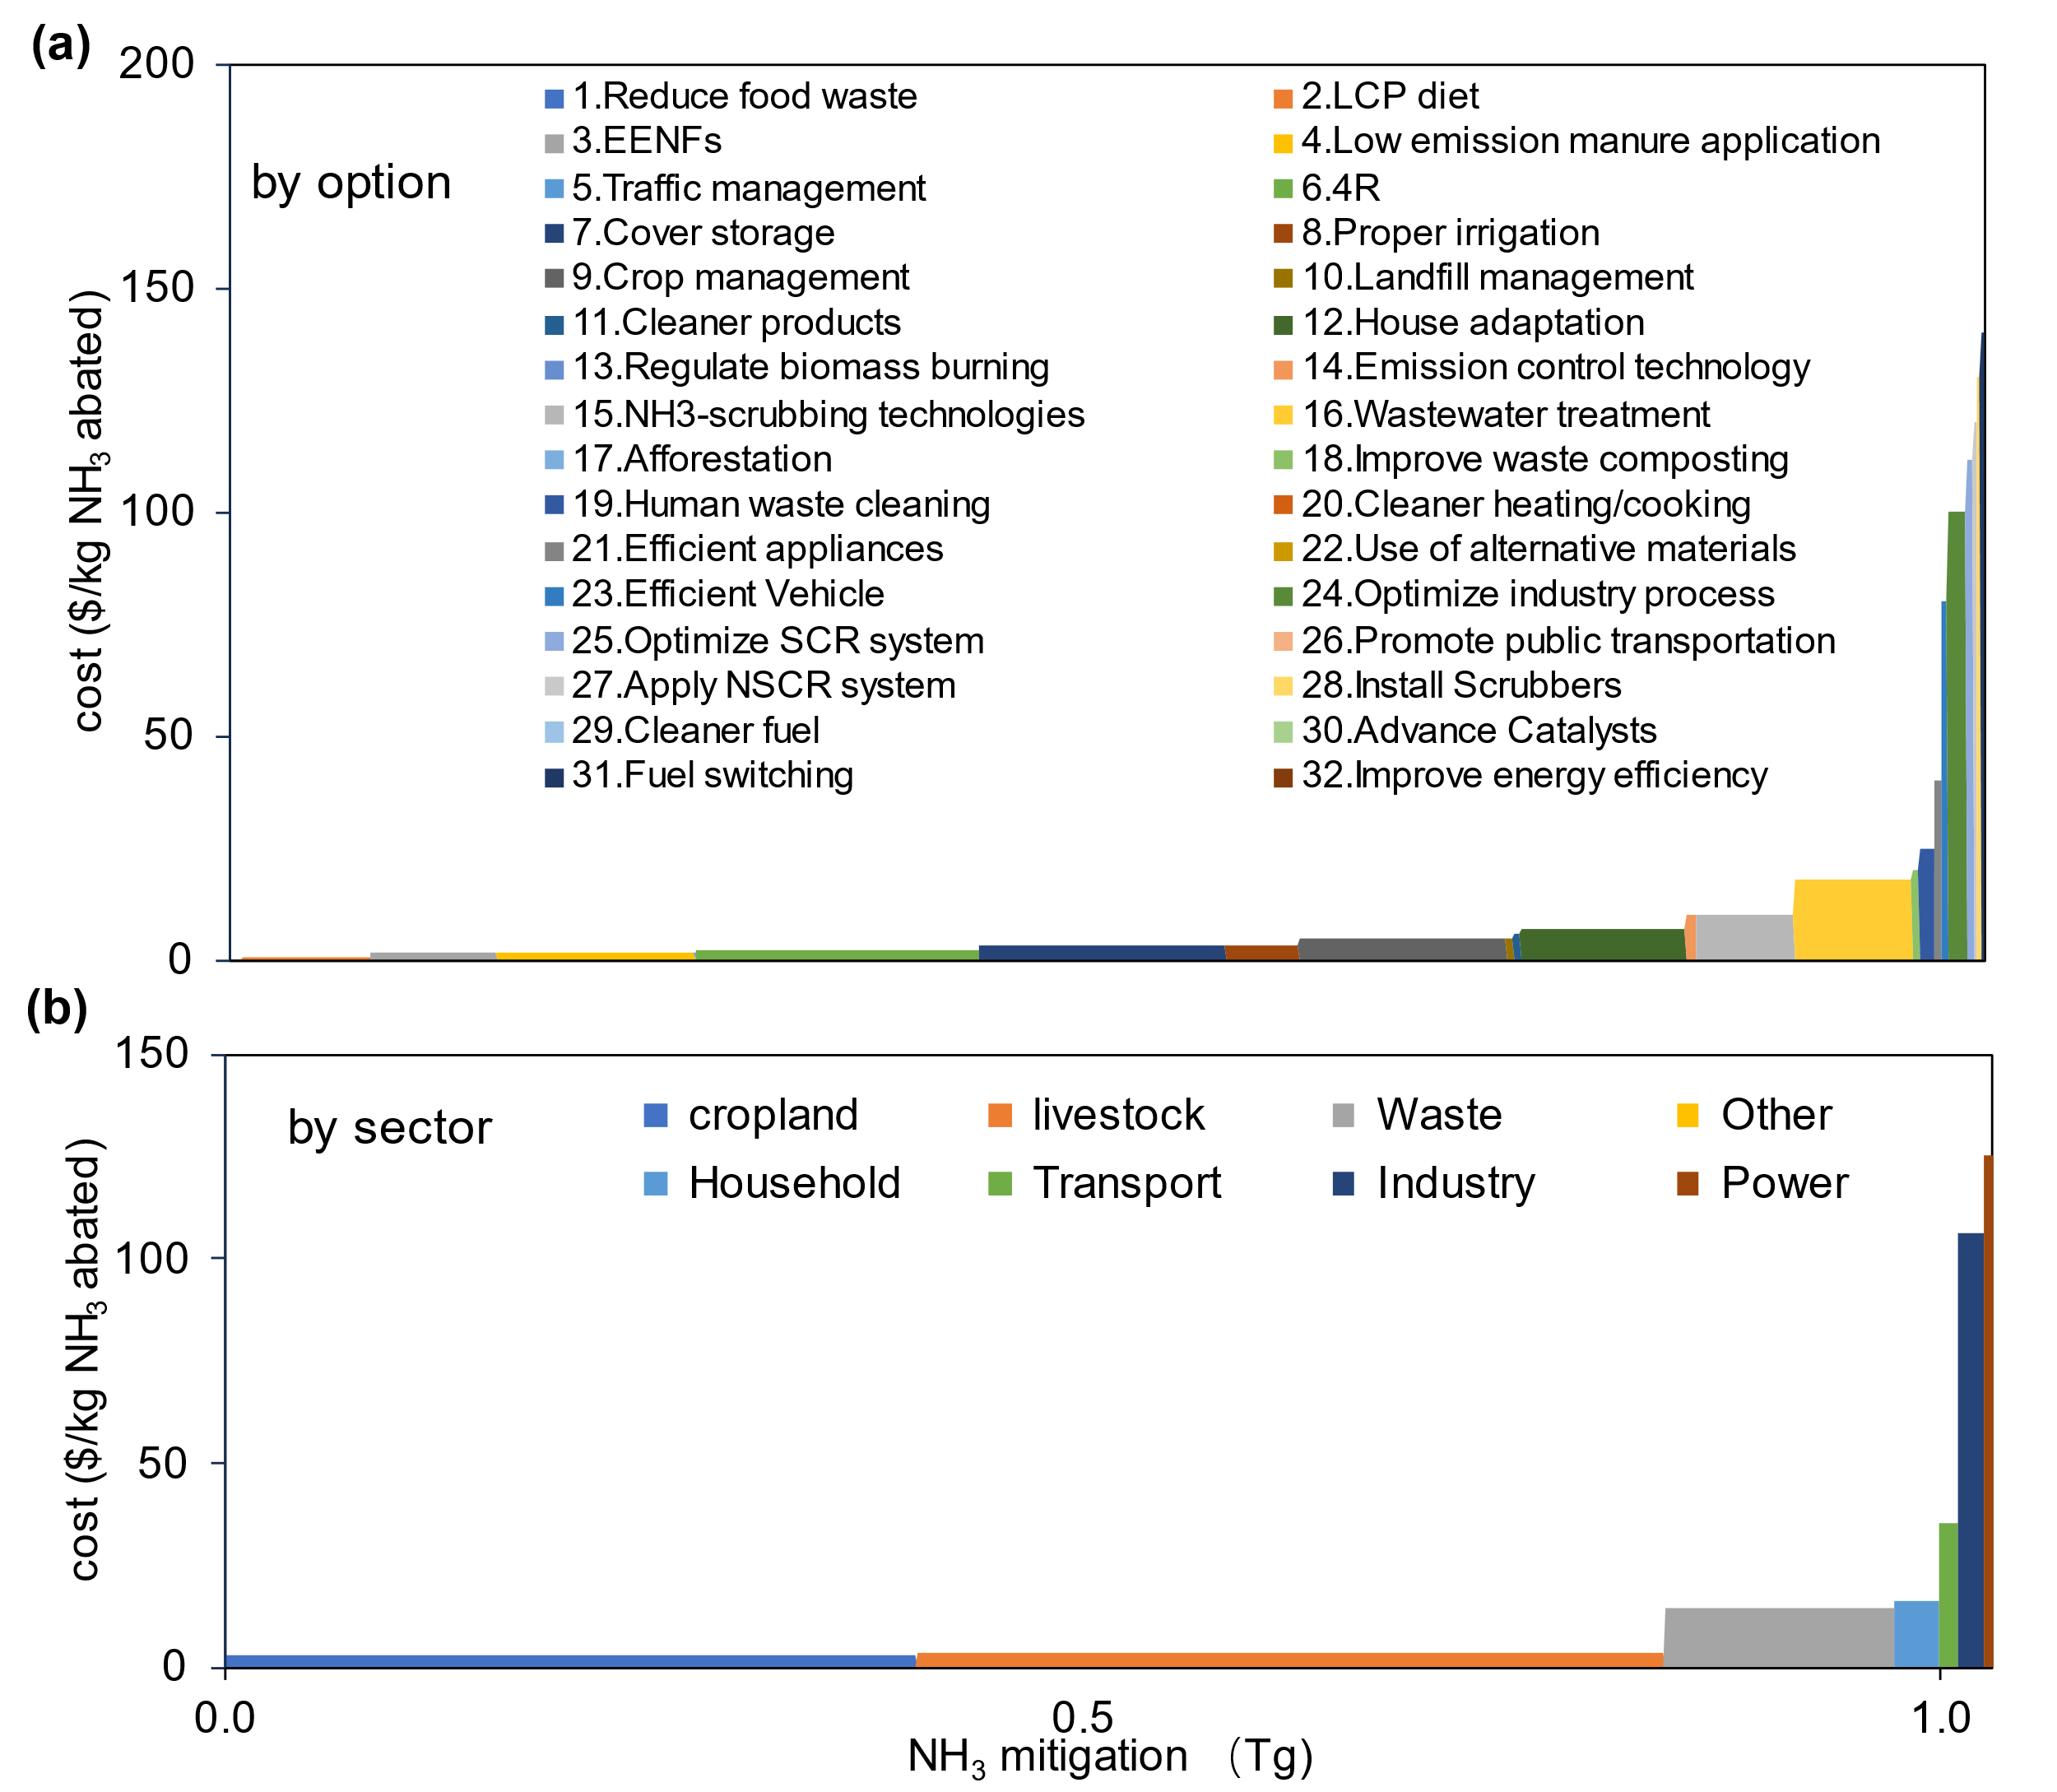

Figure S7. Marginal NH₃ abatement cost curves of FSU.
(a) MACC with options; (b) MACC with sectors. The division of regions and covering countries of the FSU could be found in Table S1. LCP, low-crude protein; 4R, right time, right type, right rate and right place fertilization; EENF, enhanced efficiency nitrogen fertilizer; SCR, Selective catalytic reduction; NSCR, Non-Selective Catalytic Reduction. Detailed descriptions of options could be found in Table S3-4.

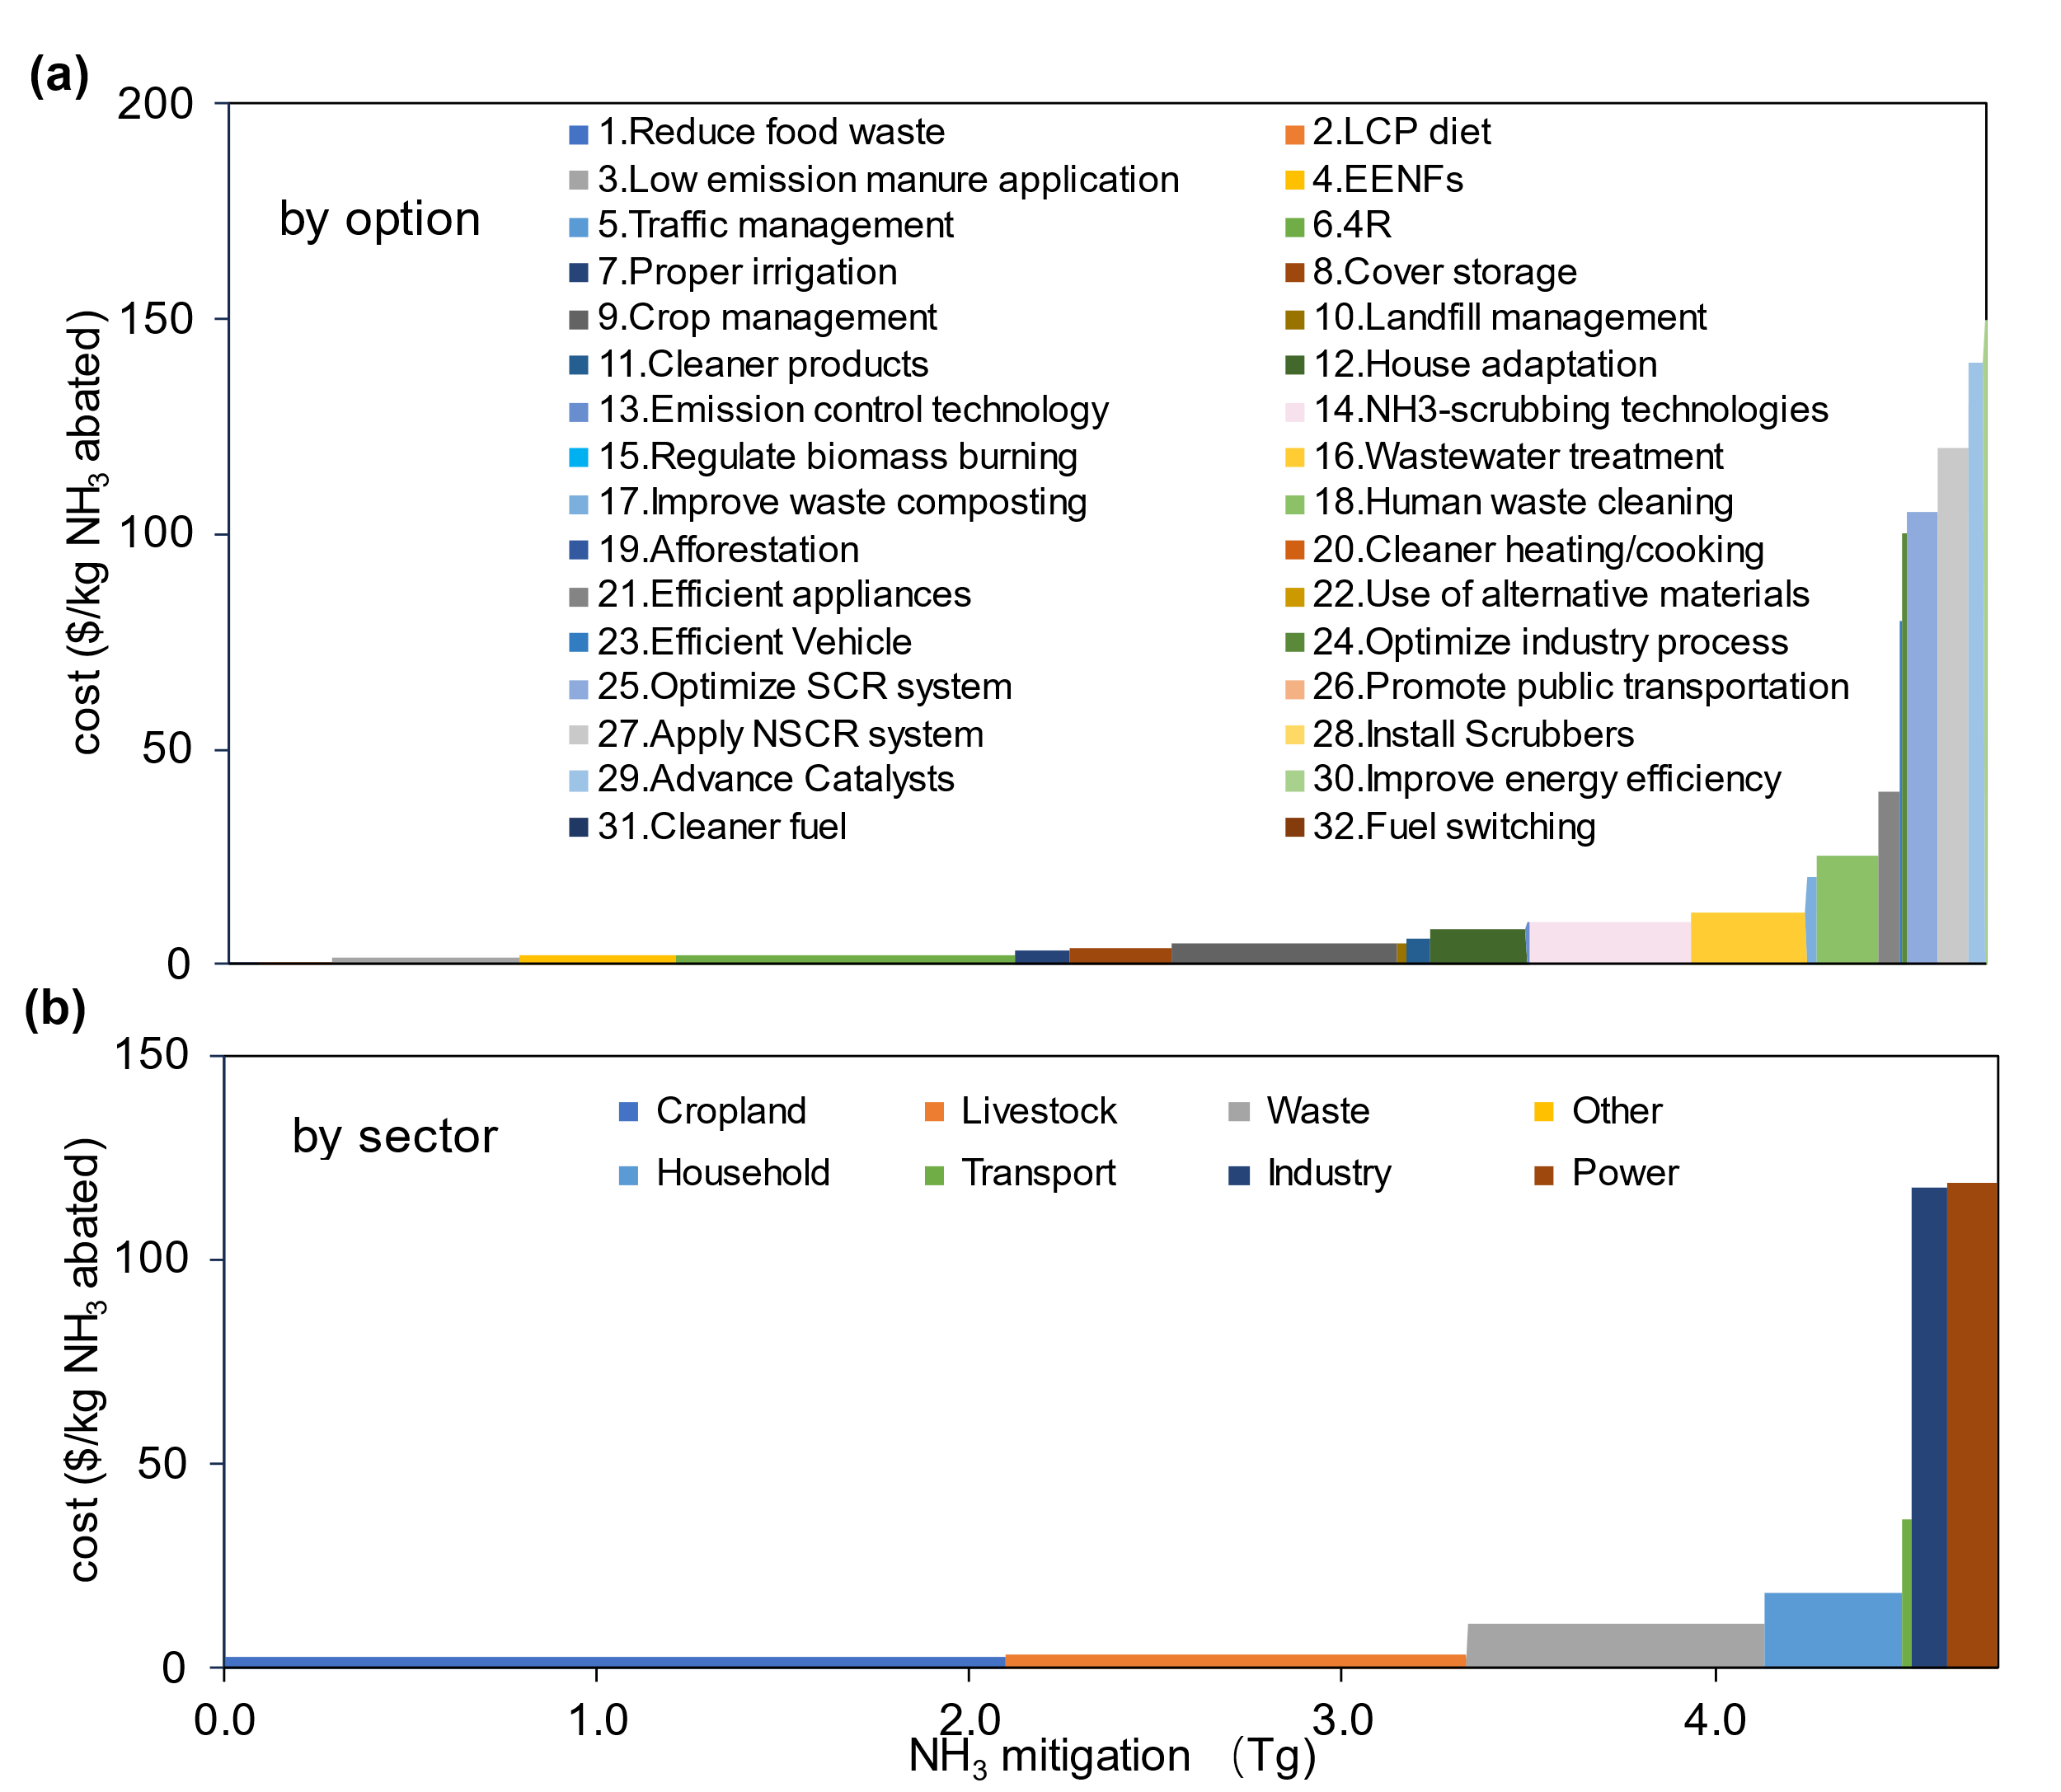

Figure S8. Marginal NH₃ abatement cost curves of other Asian countries (OA).
(a) MACC with options; (b) MACC with sectors. The division of regions and covering countries of the other Asian countries (OA) could be found in Table S1. LCP, low-crude protein; 4R, right time, right type, right rate and right place fertilization; EENF, enhanced efficiency nitrogen fertilizer; SCR, Selective catalytic reduction; NSCR, Non-Selective Catalytic Reduction. Detailed descriptions of options could be found in Table S3-4.

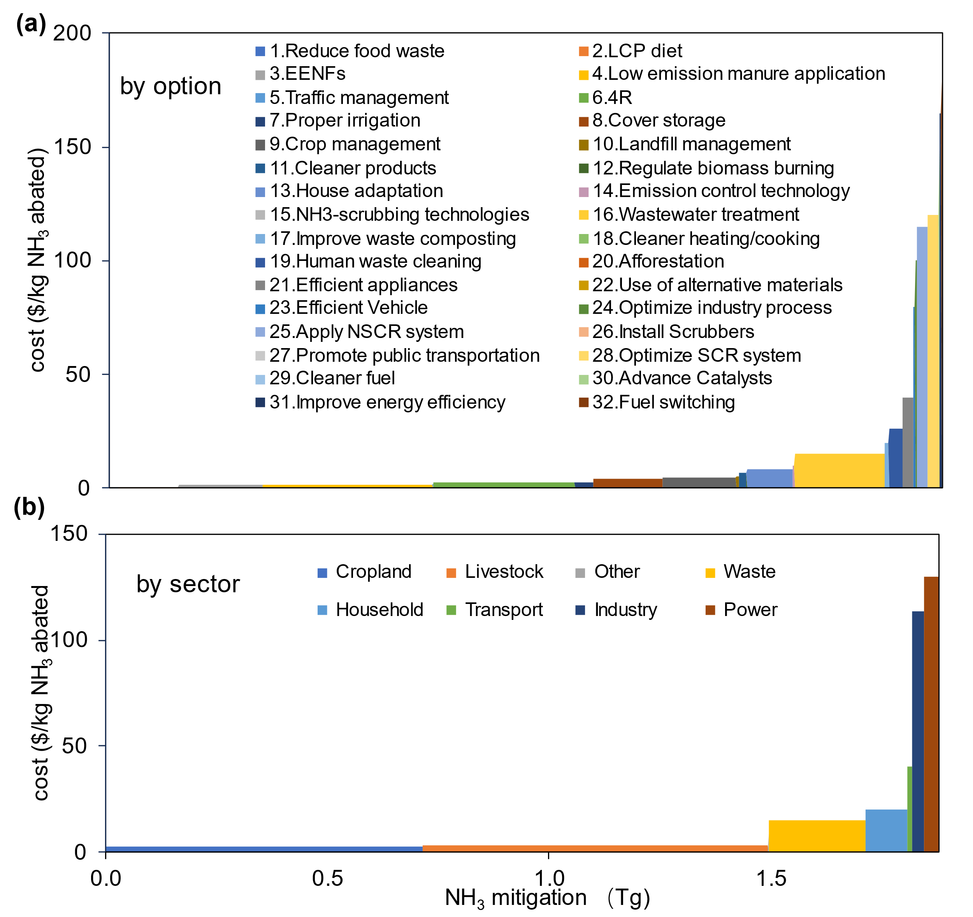

Figure S9. Marginal NH₃ abatement cost curves of Latin America (LA).
(a) MACC with options; (b) MACC with sectors. The division of regions and covering countries of the Latin America (LA) could be found in Table S1. LCP, low-crude protein; 4R, right time, right type, right rate and right place fertilization; EENF, enhanced efficiency nitrogen fertilizer; SCR, Selective catalytic reduction; NSCR, Non-Selective Catalytic Reduction. Detailed descriptions of options could be found in Table S3-4.

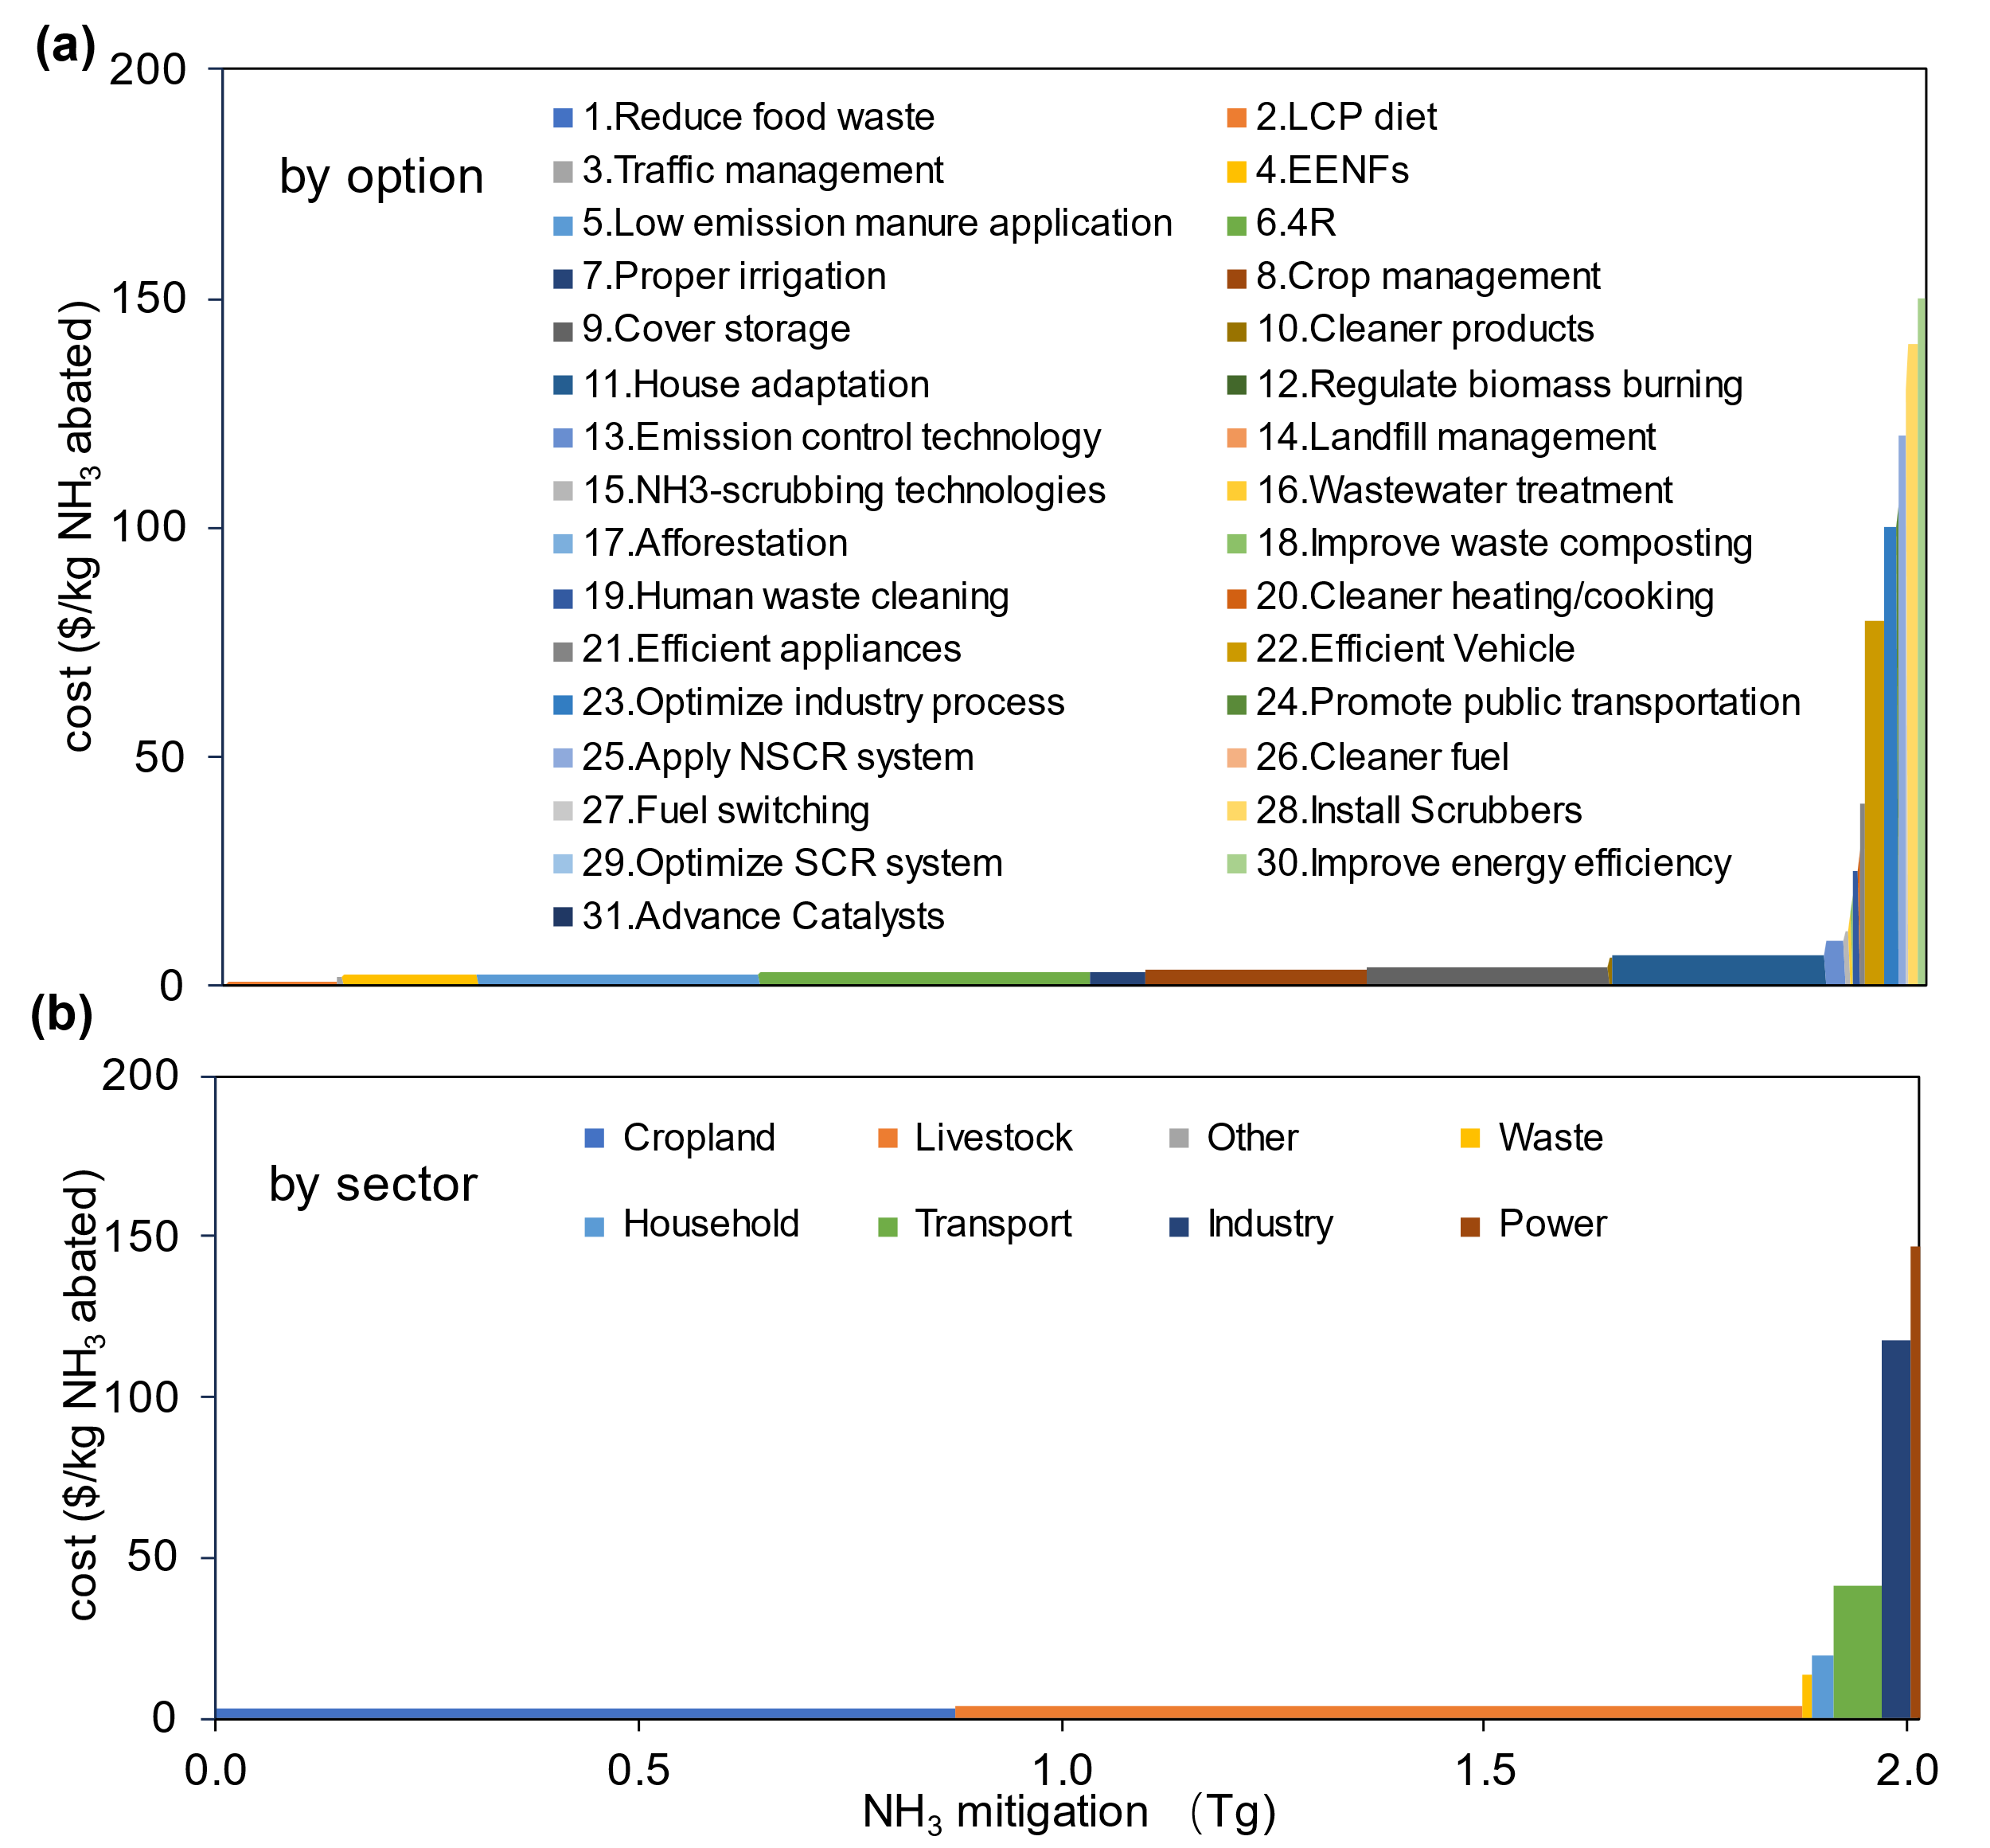

Figure S10. Marginal NH₃ abatement cost curves of North America (NA).
(a) MACC with options; (b) MACC with sectors. The division of regions and covering countries of the North America (NA) could be found in Table S1. LCP, low-crude protein; 4R, right time, right type, right rate and right place fertilization; EENF, enhanced efficiency nitrogen fertilizer; SCR, Selective catalytic reduction; NSCR, Non-Selective Catalytic Reduction. Detailed descriptions of options could be found in Table S3-4.

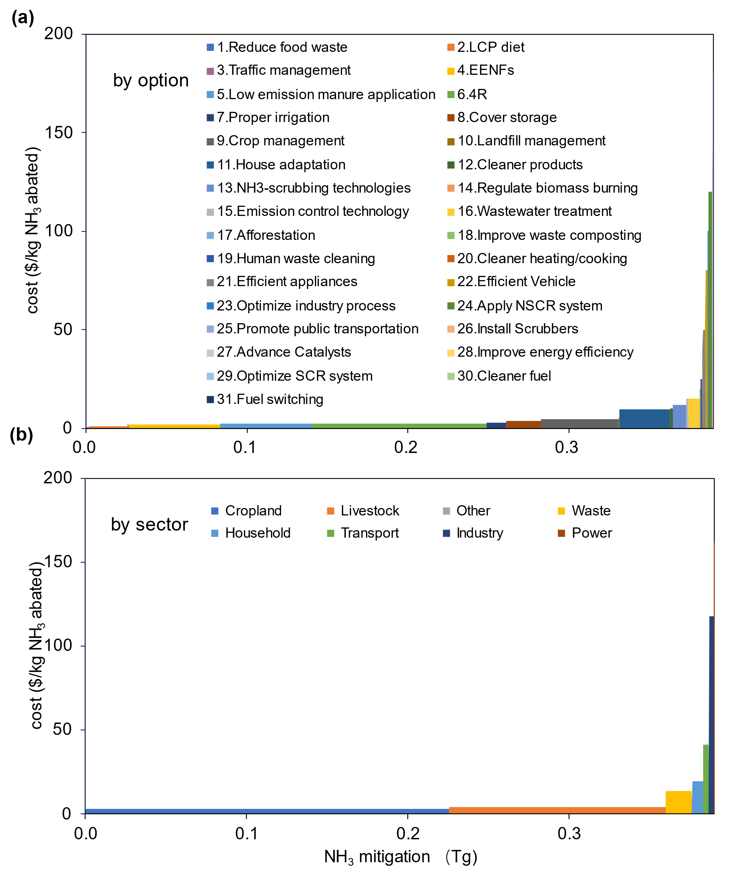

Figure S11. Marginal NH₃ abatement cost curves of Oceania.
(a) MACC with options; (b) MACC with sectors. The division of regions and covering countries of the Oceania could be found in Table S1. LCP, low-crude protein; 4R, right time, right type, right rate and right place fertilization; EENF, enhanced efficiency nitrogen fertilizer; SCR, Selective catalytic reduction; NSCR, Non-Selective Catalytic Reduction. Detailed descriptions of options could be found in Table S3-4.

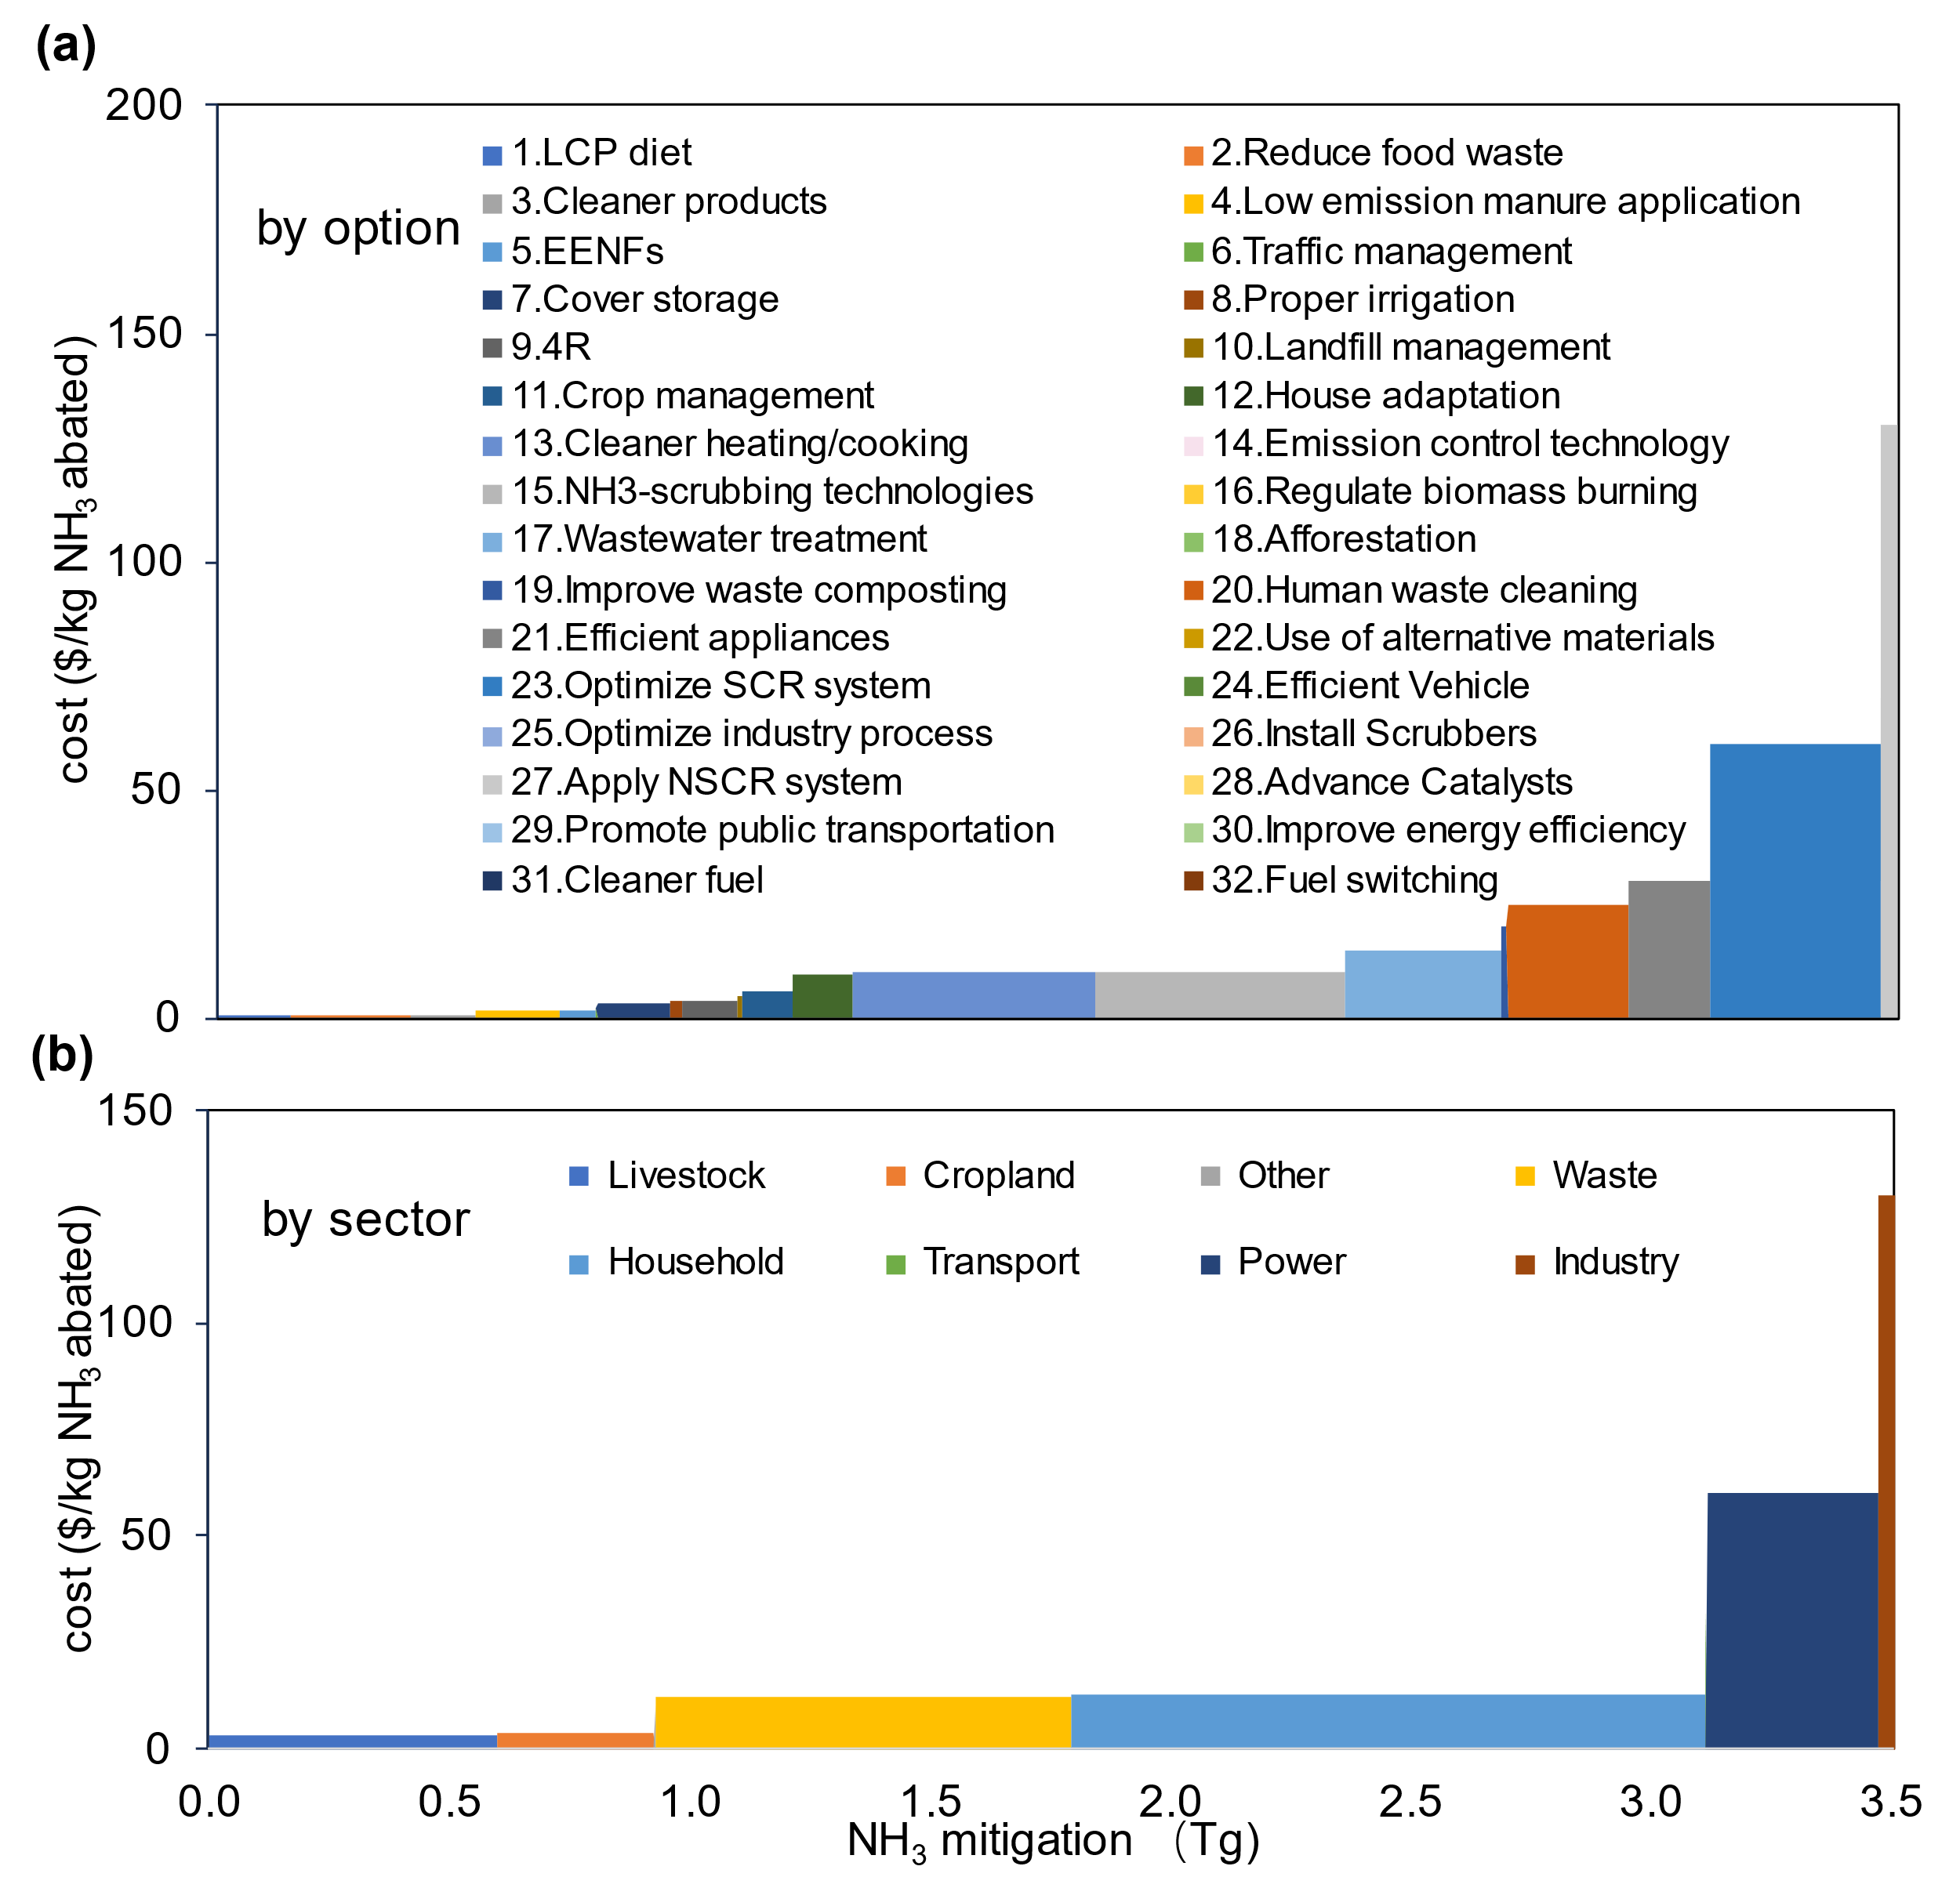

Figure S12. Marginal NH₃ abatement cost curves of Sub-Saharan Africa (SSA).
(a) MACC with options; (b) MACC with sectors. The division of regions and covering countries of Sub-Saharan Africa (SSA) could be found in Table S1. LCP, low-crude protein; 4R, right time, right type, right rate and right place fertilization; EENF, enhanced efficiency nitrogen fertilizer; SCR, Selective catalytic reduction; NSCR, Non-Selective Catalytic Reduction. Detailed descriptions of options could be found in Table S3-4.

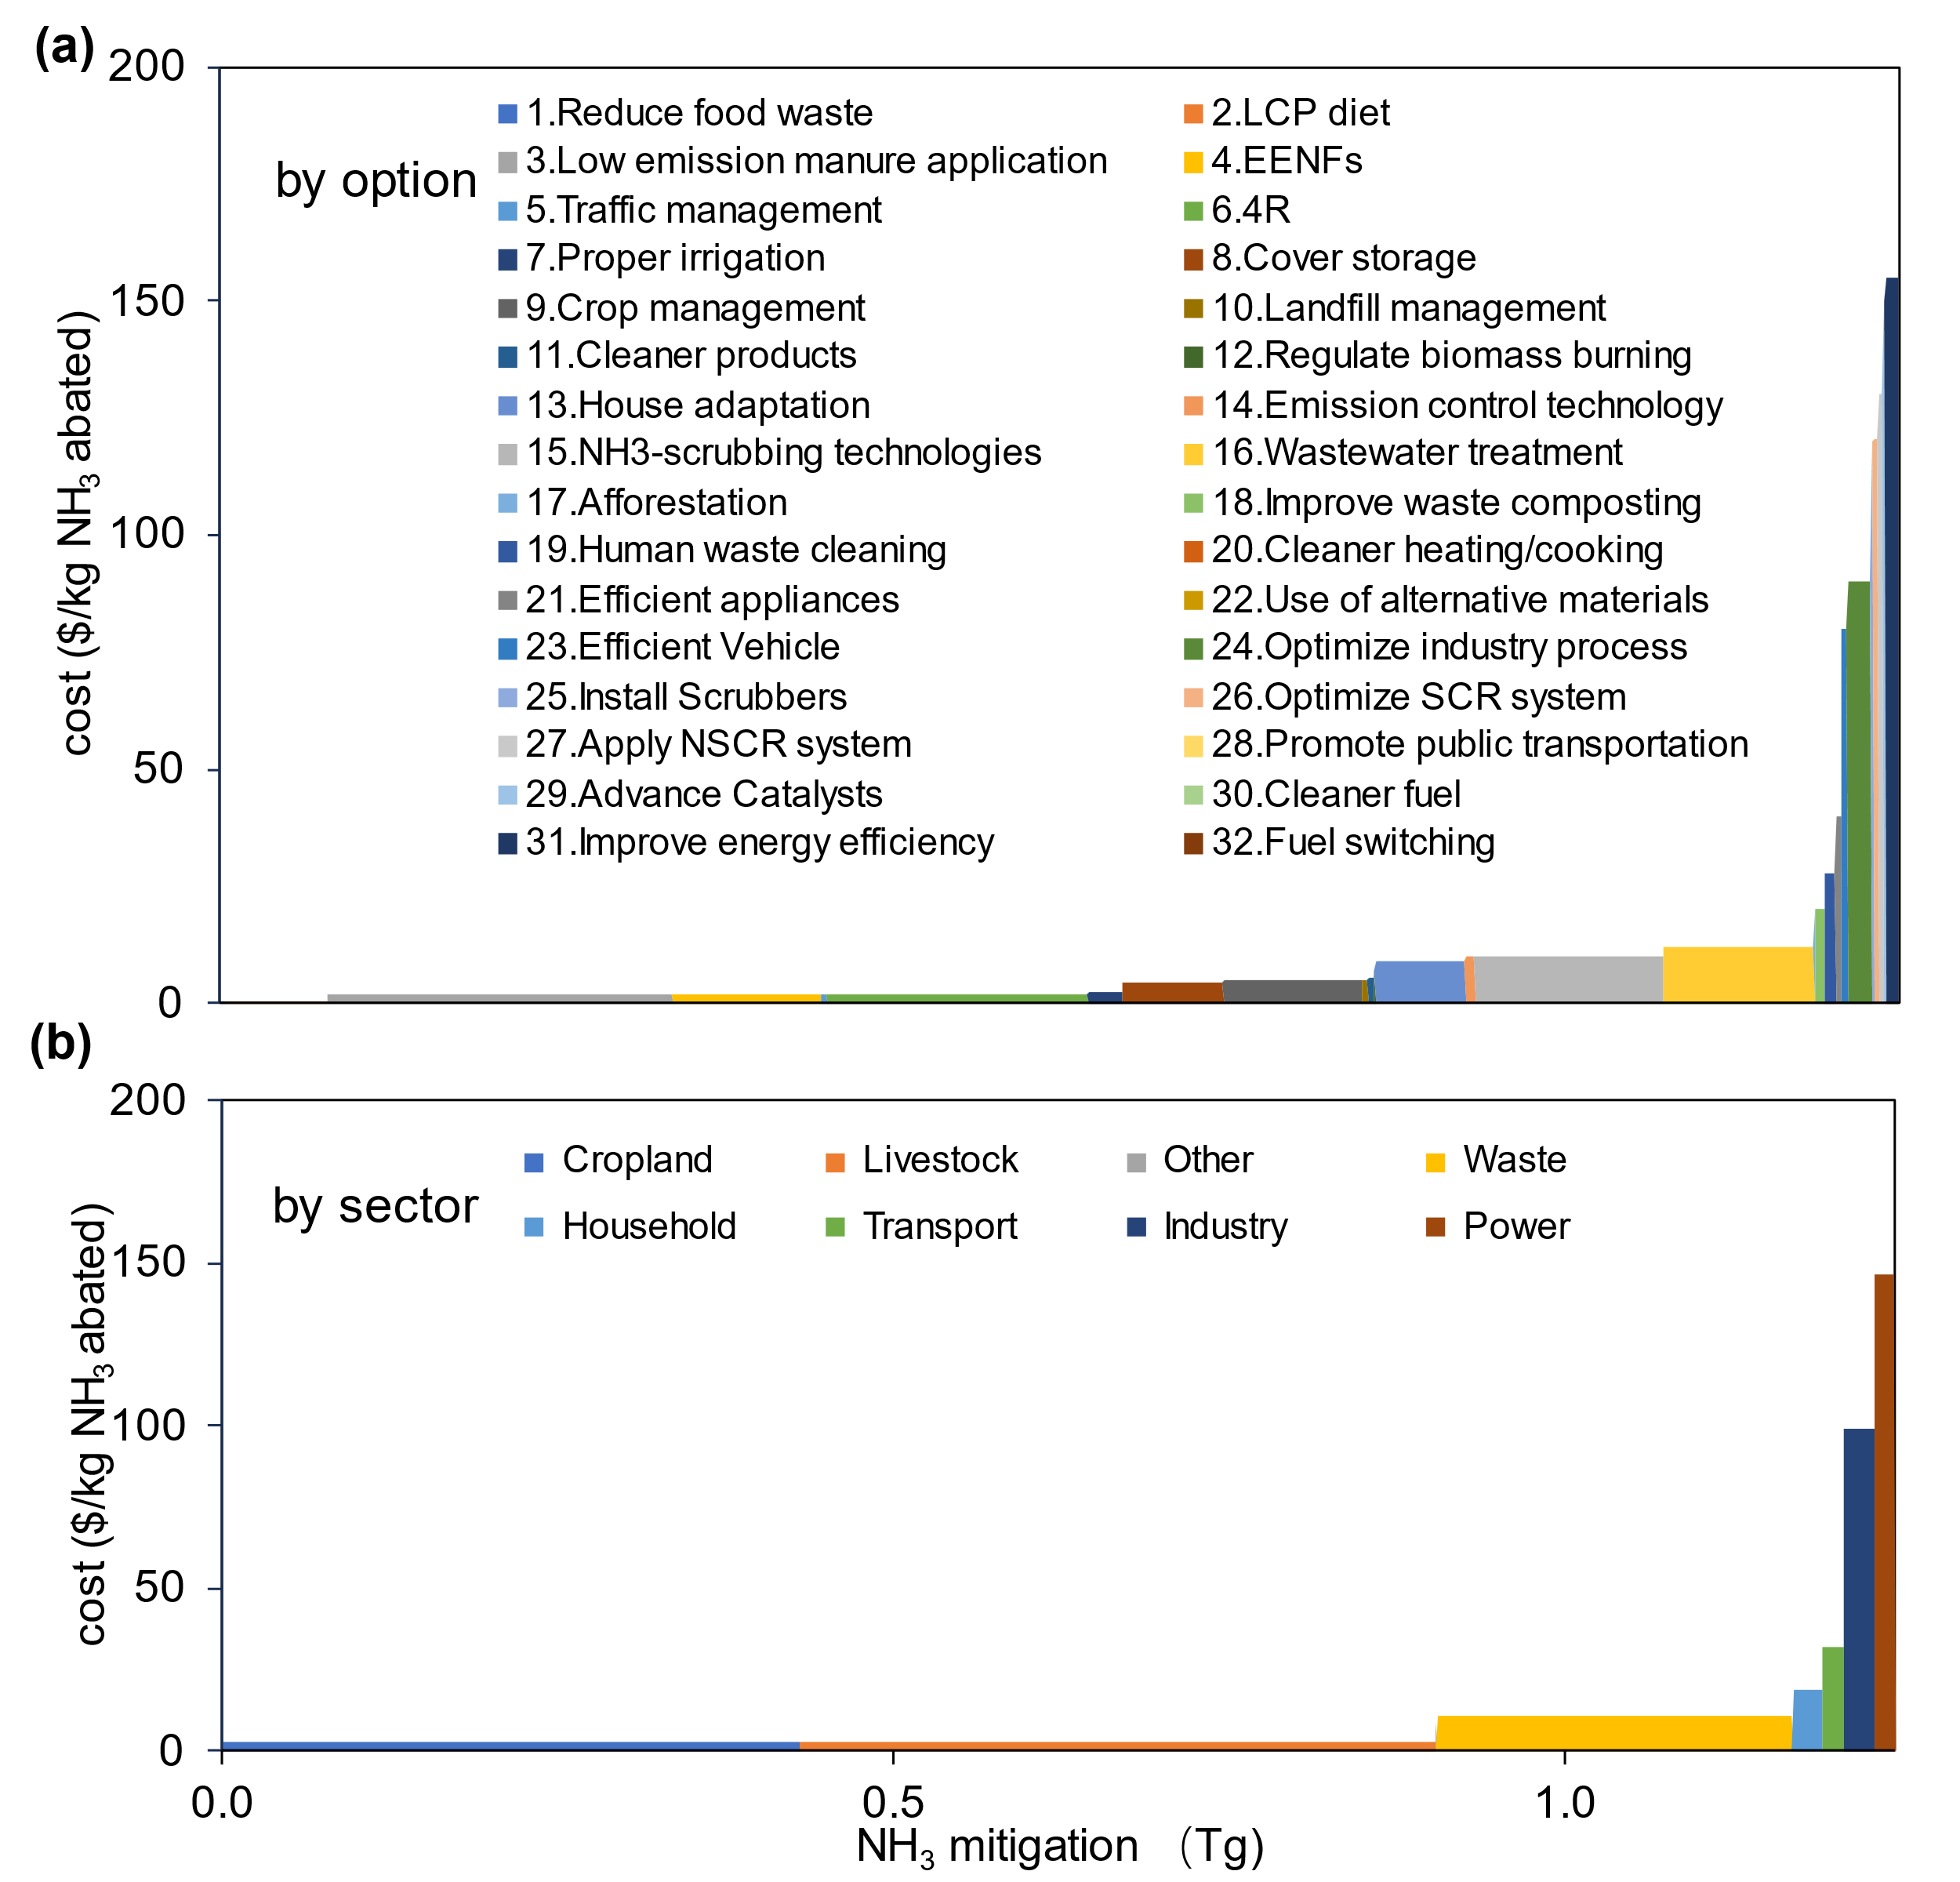

Figure S13. Marginal NH₃ abatement cost curves of Middle East and North Africa (MENA).
(a) MACC with options; (b) MACC with sectors. The division of regions and covering countries of the Middle East and North Africa (MENA) could be found in Table S1. LCP, low-crude protein; 4R, right time, right type, right rate and right place fertilization; EENF, enhanced efficiency nitrogen fertilizer; SCR, Selective catalytic reduction; NSCR, Non-Selective Catalytic Reduction. Detailed descriptions of options could be found in Table S3-4.

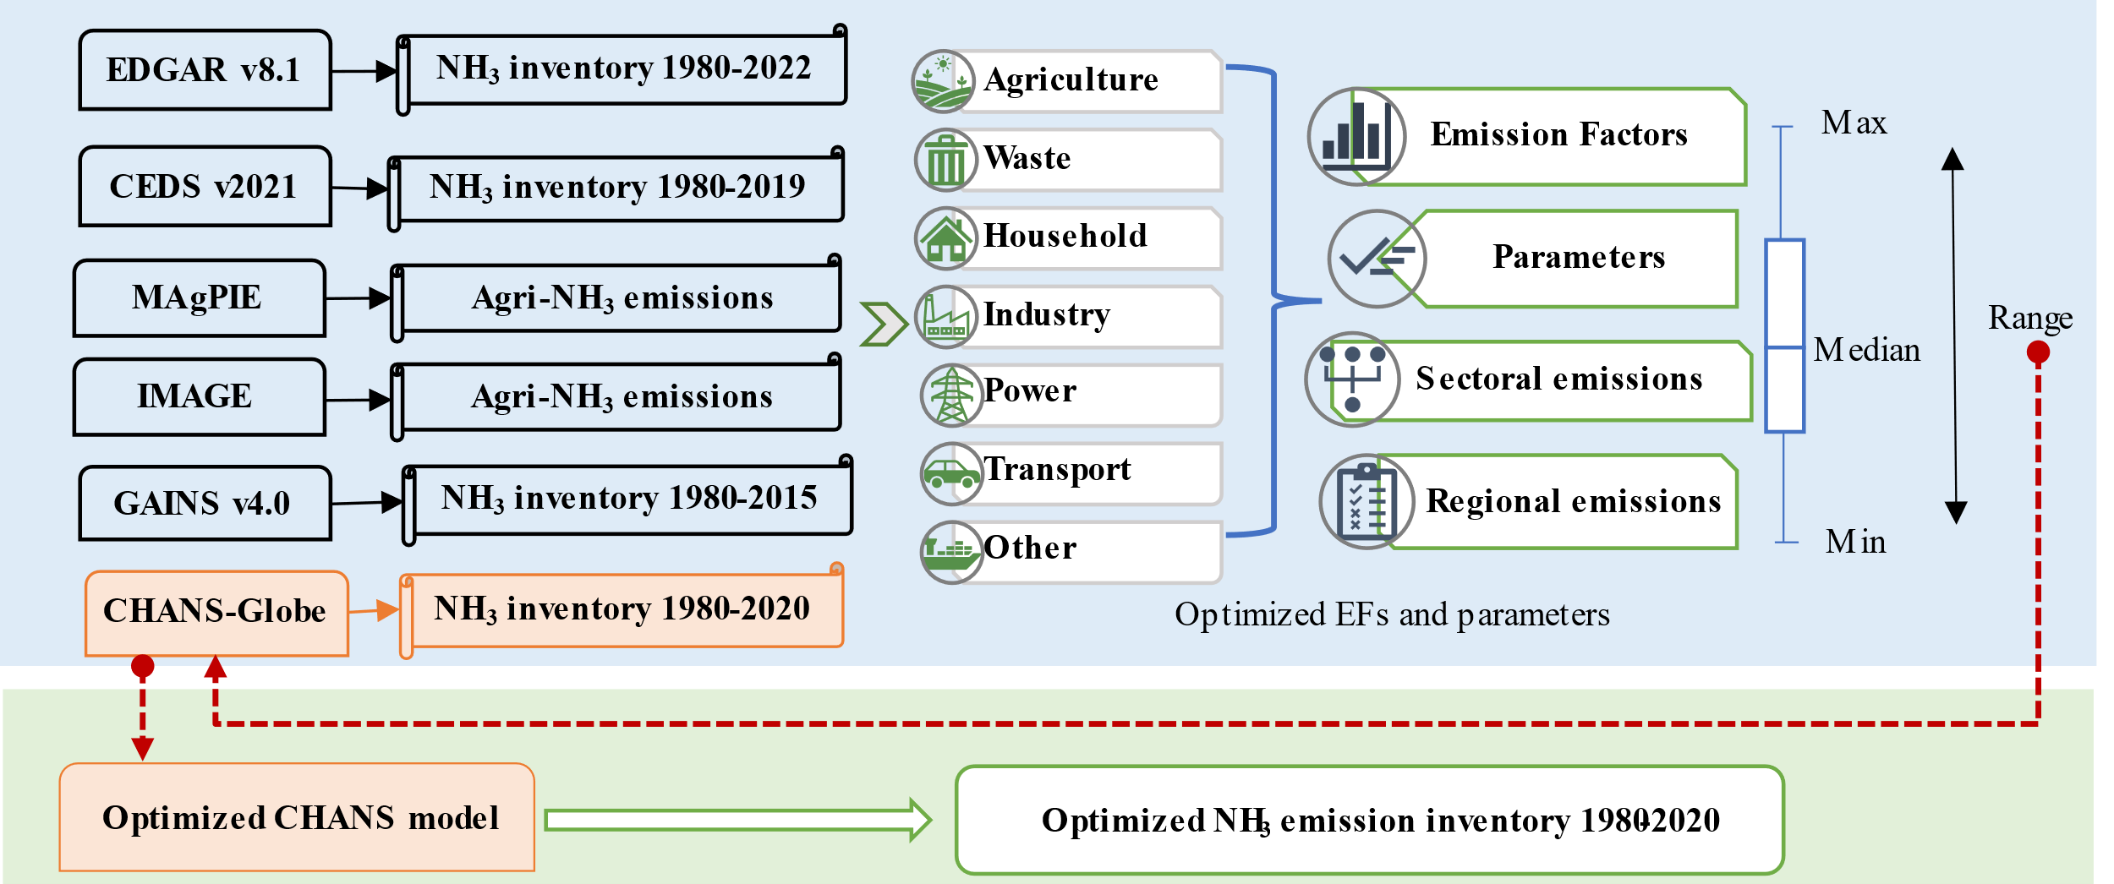

Figure S14. The optimization of global NH₃ emission inventory (1980-2020) by multi-datasets integration

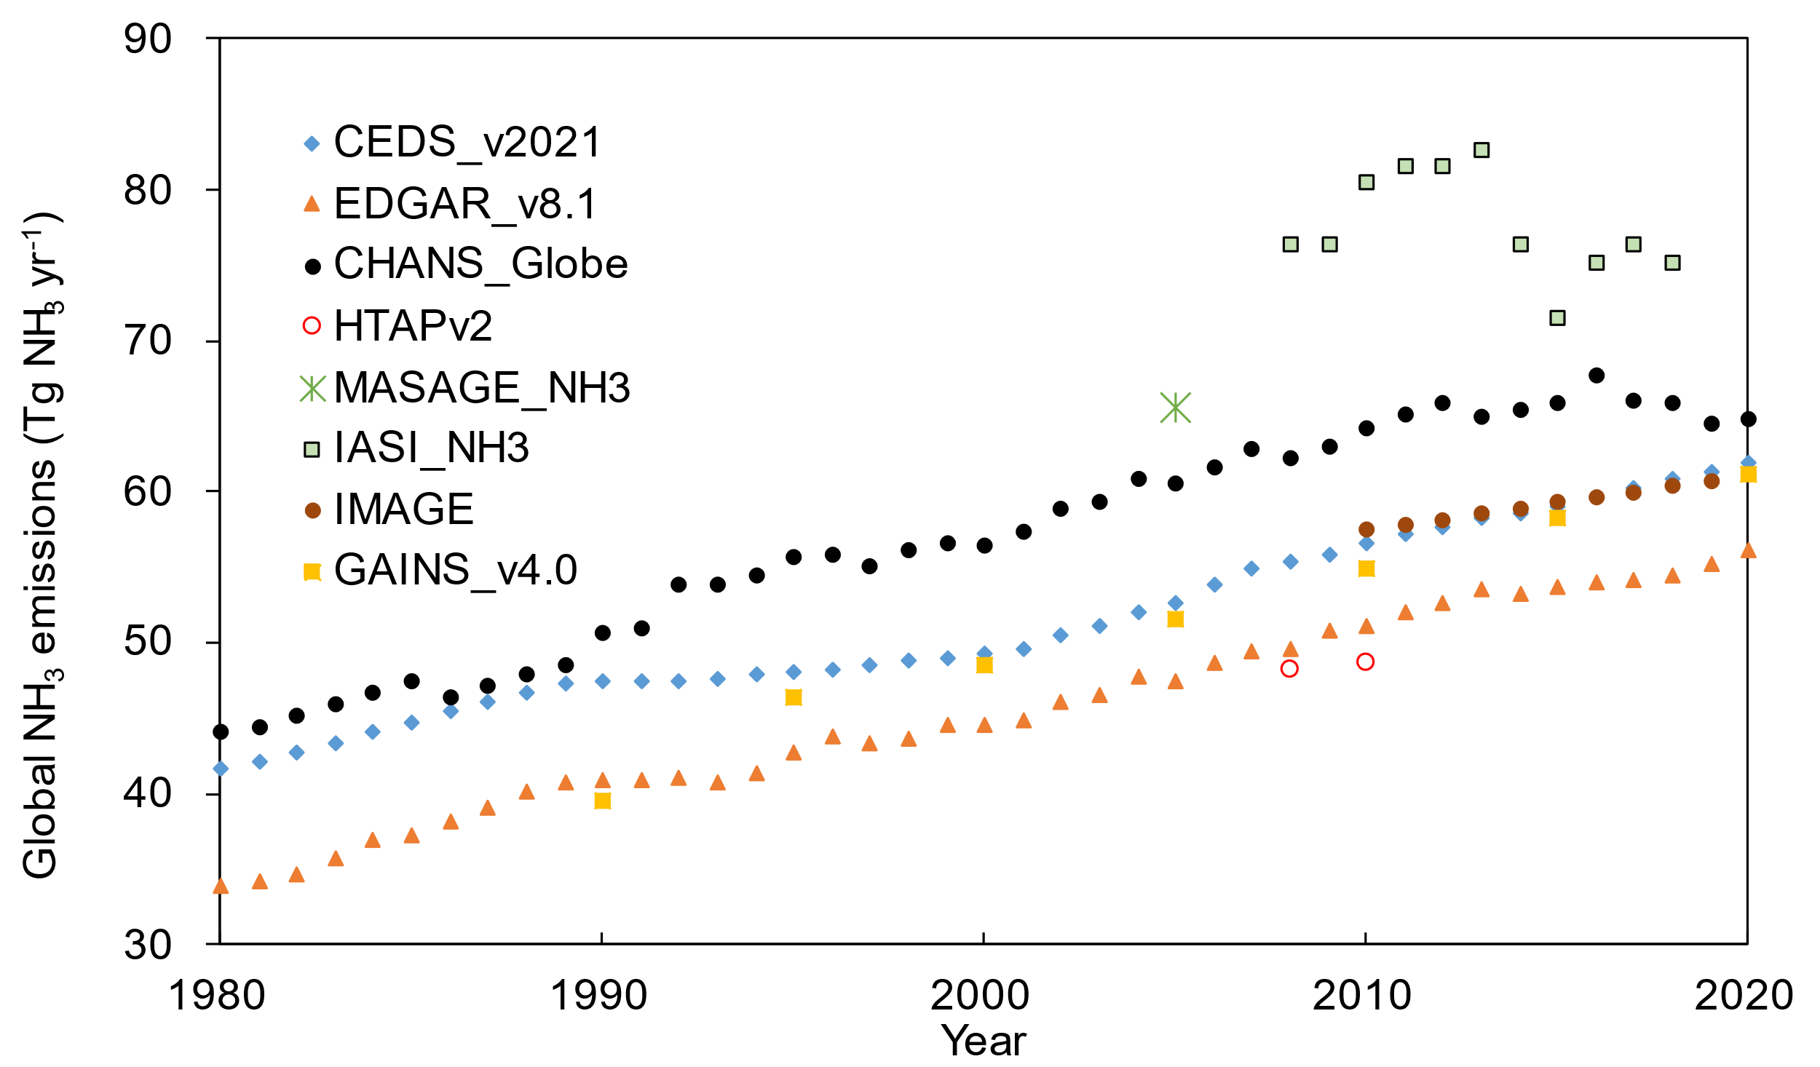

Figure S15. Comparison of global NH₃ emission by studies
CHANS-Globe, this study; CEDS_v2021 ; EDGAR-v8.1 ²⁰ ; HTAPv2²¹ ; MASAGE_NH₃²² ; IASI_NH₃²³; IMAGE⁷; GAINS_v4.0 ¹⁰.

Table S1 Region classification and income definition in this study.
Order | Country | ISO-3 | Income | NH₃ emission (Gg yr⁻¹)
 |  |  |  | 1980 | 2000 | 2020
Brazil
1 | Brazil | BRA | UMI | 1740 | 2345 | 3173
China
2 | China | CHN | UMI | 8326 | 10528 | 12329
Europe
3 | Albania | ALB | UMI | 35 | 36 | 44
4 | Austria | AUT | HI | 75 | 69 | 72
5 | Bulgaria | BGR | UMI | 186 | 75 | 74
6 | Cyprus | CYP | HI | 4 | 8 | 7
7 | Denmark | DNK | HI | 140 | 115 | 101
8 | Estonia | EST | HI | 23 | 10 | 14
9 | Finland | FIN | HI | 47 | 52 | 46
10 | France | FRA | HI | 791 | 772 | 717
11 | Germany | DEU | HI | 854 | 691 | 693
12 | Greece | GRC | HI | 90 | 75 | 65
13 | Hungary | HUN | HI | 199 | 110 | 91
14 | Croatia | HRV | HI | 77 | 43 | 36
15 | Iceland | ISL | HI | 4 | 5 | 5
16 | Ireland | IRL | HI | 129 | 153 | 159
17 | Italy | ITA | HI | 531 | 508 | 432
18 | Latvia | LVA | HI | 43 | 18 | 25
19 | Lithuania | LTU | HI | 79 | 28 | 47
20 | Netherlands | NLD | HI | 211 | 182 | 161
21 | Norway | NOR | HI | 25 | 37 | 37
22 | Czechia | CZE | HI | 170 | 92 | 97
23 | Poland | POL | HI | 539 | 337 | 335
24 | Portugal | PRT | HI | 78 | 77 | 60
25 | Romania | ROU | UMI | 379 | 195 | 201
26 | Slovenia | SVN | HI | 30 | 25 | 16
27 | Slovakia | SVK | HI | 74 | 37 | 31
28 | Spain | ESP | HI | 424 | 536 | 511
29 | Sweden | SWE | HI | 91 | 72 | 61
30 | Switzerland | CHE | HI | 103 | 55 | 55
31 | UK | GBR | HI | 411 | 422 | 364
32 | Belgium | BEL | HI | 97 | 103 | 91
33 | Luxembourg | LUX | HI | 5 | 5 | 5
Former Soviet Union (FSU)
34 | Armenia | ARM | UMI | 19 | 15 | 17
35 | Azerbaijan | AZE | UMI | 64 | 52 | 75
36 | Belarus | BLR | UMI | 280 | 154 | 235
37 | Georgia | GEO | UMI | 47 | 36 | 30
38 | Kazakhstan | KAZ | UMI | 51 | 35 | 47
39 | Kyrgyzstan | KGZ | Lower middle income | 12 | 14 | 18
40 | Republic of Moldova | MDA | UMI | 55 | 26 | 33
41 | Russia | RUS | UMI | 2614 | 1194 | 1177
42 | Tajikistan | TJK | LMI | 13 | 16 | 24
43 | Turkmenistan | TKM | UMI | 10 | 12 | 17
44 | Ukraine | UKR | LMI | 1091 | 431 | 433
45 | Uzbekistan | UZB | LMI | 40 | 50 | 63
India
46 | India | IND | LMI | 5327 | 7660 | 10361
Latin America (LA, except Brazil)
47 | Antigua and Barbuda | ATG | HI | 0 | 0 | 0
48 | Argentina | ARG | UMI | 420 | 445 | 513
49 | Bahamas | BHS | HI | 1 | 1 | 2
50 | Barbados | BRB | HI | 2 | 2 | 2
51 | Bolivia | BOL | LMI | 57 | 87 | 149
52 | Belize | BLZ | LMI | 1 | 2 | 2
53 | Chile | CHL | HI | 81 | 154 | 204
54 | Colombia | COL | UMI | 259 | 400 | 447
55 | Costa Rica | CRI | UMI | 27 | 39 | 54
56 | Cuba | CUB | UMI | 123 | 88 | 81
57 | Dominica | DMA | UMI | 0 | 0 | 0
58 | Dominican Republic | DOM | UMI | 43 | 60 | 108
59 | Ecuador | ECU | UMI | 84 | 113 | 151
60 | El Salvador | SLV | LMI | 42 | 39 | 37
61 | Grenada | GRD | UMI | 0 | 0 | 0
62 | Guatemala | GTM | UMI | 56 | 97 | 164
63 | Guyana | GUY | UMI | 7 | 7 | 11
64 | Haiti | HTI | LMI | 47 | 49 | 83
65 | Honduras | HND | LMI | 32 | 49 | 65
66 | Jamaica | JAM | UMI | 10 | 18 | 17
67 | Mexico | MEX | UMI | 593 | 806 | 898
68 | Nicaragua | NIC | LMI | 34 | 49 | 72
69 | Panama | PAN | UMI | 17 | 22 | 25
70 | Paraguay | PRY | UMI | 50 | 81 | 106
71 | Peru | PER | UMI | 122 | 173 | 224
72 | Puerto Rico | PRI | HI | 11 | 10 | 8
73 | Saint Kitts and Nevis | KNA | HI | 0 | 0 | 0
74 | Saint Lucia | LCA | UMI | 1 | 1 | 1
75 | Saint Vincent | VCT | UMI | 0 | 0 | 0
76 | Suriname | SUR | UMI | 3 | 3 | 3
77 | Trinidad and Tobago | TTO | HI | 6 | 11 | 15
78 | Uruguay | URY | HI | 84 | 83 | 106
79 | Venezuela | VEN | LMI | 140 | 214 | 279
Middle East & North Africa (MENA)
80 | Algeria | DZA | LMI | 58 | 83 | 116
81 | Bahrain | BHR | HI | 1 | 2 | 2
82 | Brunei Darussalam | BRN | HI | 3 | 6 | 10
83 | Egypt | EGY | LMI | 192 | 362 | 515
84 | Djibouti | DJI | LMI | 2 | 4 | 5
85 | Iran | IRN | LMI | 236 | 460 | 579
86 | Iraq | IRQ | UMI | 61 | 99 | 134
87 | Israel | ISR | HI | 21 | 24 | 29
88 | Jordan | JOR | UMI | 7 | 12 | 17
89 | Kuwait | KWT | HI | 6 | 11 | 21
90 | Lebanon | LBN | UMI | 12 | 16 | 26
91 | Libya | LBY | UMI | 18 | 27 | 32
92 | Malta | MLT | HI | 1 | 2 | 1
93 | Morocco | MAR | LMI | 95 | 106 | 125
94 | Qatar | QAT | HI | 2 | 5 | 9
95 | Saudi Arabia | SAU | HI | 26 | 89 | 127
96 | Syrian Arab Republic | SYR | LI | 39 | 78 | 60
97 | Oman | OMN | HI | 3 | 6 | 15
98 | Tunisia | TUN | LMI | 27 | 49 | 60
99 | Turkey | TUR | UMI | 503 | 605 | 742
100 | United Arab Emirates | ARE | HI | 2 | 11 | 23
101 | Yemen | YEM | LI | 27 | 59 | 99
North America (NA)
102 | Canada | CAN | HI | 373 | 484 | 499
103 | USA | USA | HI | 3071 | 3389 | 3633
Other Asian Countries (OA)
104 | Afghanistan | AFG | LI | 82 | 119 | 189
105 | Bangladesh | BGD | LMI | 522 | 799 | 1076
106 | Bhutan | BTN | LMI | 29 | 39 | 50
107 | Myanmar | MMR | LMI | 265 | 333 | 462
108 | Sri Lanka | LKA | LMI | 94 | 119 | 144
109 | Indonesia | IDN | LMI | 996 | 1354 | 2024
110 | Japan | JPN | HI | 586 | 496 | 432
111 | Cambodia | KHM | LMI | 57 | 107 | 182
112 | North Korea | PRK | LI | 93 | 106 | 115
113 | South Korea | KOR | HI | 350 | 267 | 312
114 | Laos | LAO | LMI | 42 | 66 | 102
115 | Malaysia | MYS | UMI | 112 | 181 | 288
116 | Maldives | MDV | UMI | 0 | 0 | 1
117 | Mongolia | MNG | LMI | 84 | 119 | 145
118 | Nepal | NPL | LMI | 145 | 224 | 280
119 | Pakistan | PAK | LMI | 750 | 1281 | 2045
120 | Philippines | PHL | LMI | 287 | 400 | 521
121 | Timor-Leste | TLS | LMI | 2 | 5 | 8
122 | Singapore | SGP | HI | 10 | 7 | 13
123 | Thailand | THA | UMI | 427 | 551 | 739
124 | Viet Nam | VNM | LMI | 511 | 694 | 674
125 | Australia | AUS | HI | 371 | 525 | 583
126 | Solomon Islands | SLB | LMI | 1 | 1 | 2
127 | Fiji | FJI | UMI | 5 | 7 | 8
128 | French Polynesia | PYF | HI | 1 | 1 | 1
129 | Kiribati | KIR | LMI | 0 | 0 | 1
130 | Marshall Islands | MHL | UMI | 0 | 0 | 0
131 | Micronesia | FSM | LMI | 0 | 1 | 1
132 | New Caledonia | NCL | HI | 1 | 2 | 2
133 | Vanuatu | VUT | LMI | 1 | 2 | 3
134 | New Zealand | NZL | HI | 111 | 148 | 198
135 | Papua New Guinea | PNG | LMI | 13 | 24 | 33
136 | Tonga | TON | UMI | 1 | 1 | 1
137 | Samoa | WSM | LMI | 1 | 2 | 2
Sub-Saharan Africa (SSA)
138 | Angola | AGO | LMI | 62 | 96 | 179
139 | Botswana | BWA | UMI | 22 | 24 | 20
140 | Burundi | BDI | LI | 20 | 34 | 48
141 | Cameroon | CMR | LMI | 65 | 107 | 147
142 | Cabo Verde | CPV | LMI | 1 | 3 | 2
143 | Central African Republic | CAF | LI | 19 | 35 | 55
144 | Chad | TCD | LI | 40 | 65 | 112
145 | Comoros | COM | LMI | 1 | 2 | 3
146 | Congo | COG | LMI | 7 | 11 | 24
147 | Benin | BEN | LMI | 24 | 36 | 67
148 | Equatorial Guinea | GNQ | UMI | 1 | 2 | 3
149 | Gabon | GAB | UMI | 6 | 9 | 23
150 | Gambia | GMB | LI | 3 | 6 | 10
151 | Ghana | GHA | LMI | 47 | 81 | 139
152 | Guinea | GIN | LI | 27 | 54 | 90
153 | C?te d'Ivoire | CIV | LMI | 42 | 81 | 139
154 | Kenya | KEN | LMI | 140 | 241 | 430
155 | Lesotho | LSO | LMI | 10 | 15 | 15
156 | Liberia | LBR | LI | 11 | 18 | 33
157 | Madagascar | MDG | LI | 88 | 113 | 167
158 | Malawi | MWI | LI | 24 | 45 | 99
159 | Mali | MLI | LI | 58 | 80 | 153
160 | Mauritania | MRT | LMI | 18 | 31 | 43
161 | Mauritius | MUS | UMI | 5 | 6 | 6
162 | Mozambique | MOZ | LI | 69 | 104 | 152
163 | Namibia | NAM | UMI | 22 | 26 | 34
164 | Niger | NER | LI | 54 | 79 | 170
165 | Nigeria | NGA | LMI | 465 | 808 | 1377
166 | Guinea-Bissau | GNB | LI | 8 | 13 | 19
167 | Eritrea | ERI | LI | 15 | 24 | 34
168 | Zimbabwe | ZWE | LMI | 70 | 109 | 123
169 | Rwanda | RWA | LI | 19 | 31 | 57
170 | Sao Tome and Principe | STP | LMI | 0 | 1 | 1
171 | Senegal | SEN | LMI | 35 | 60 | 98
172 | Seychelles | SYC | HI | 0 | 0 | 0
173 | Sierra Leone | SLE | LI | 15 | 22 | 37
174 | Somalia | SOM | LI | 82 | 102 | 138
175 | South Africa | ZAF | UMI | 247 | 320 | 353
176 | Eswatini | SWZ | LMI | 7 | 9 | 10
177 | Tanzania | TZA | LMI | 144 | 239 | 452
178 | Togo | TGO | LI | 14 | 32 | 55
179 | Uganda | UGA | LI | 93 | 166 | 338
180 | Burkina Faso | BFA | LI | 47 | 82 | 168
181 | Ethiopia | ETH | LI | 324 | 536 | 998
182 | Congo | COD | LI | 99 | 183 | 403
183 | Zambia | ZMB | LMI | 50 | 78 | 164
184 | Sudan | SDN | LI | 180 | 337 | 444
185 | South Sudan | SSD | LI | 53 | 74 | 131
Note: UMI, upper middle income; LMI, lower middle income; HI, high income; LI, low income. The income classifications utilized in this study are derived from the 2023 World Bank Group's categorizations, which are determined by the Gross National Income (GNI) per capita ²⁴.

Table S2 Source classification of NH₃ emissions
Sector | Source | Description | Activity data/ parameters/
Agriculture | cropland fertilization | NH₃ emissions from cropland fertilization | Cropland area; fertilizer use
 | Soil emissions | agricultural soils | BNF; N deposition; irrigation
 | livestock feeding | NH₃ emission from feeding, housing and manure management | Animal population
 | livestock housing | NH₃ emission from feeding, housing and manure management | Farm size
 | Manure management | NH₃ emission from feeding, housing and manure management | Manure fate
 | Agriculture-forestry-fishing | Stationary machinery in agriculture, forestry and fishing activities. NH₃ emissions from biomass | Biomass, area, Production
Industry | Ind-Comb-Iron-steel | Stationary combustion in manufacturing industries and construction | Specific products production
 | Ind-Comb-Non-ferrous-metals |  | Specific products production
 | Ind-Comb-Chemicals |  | Specific products production
 | Ind-Comb-Pulp-paper |  | Specific products production
 | Ind-Comb-Food-tobacco |  | Specific products production
 | Ind-Comb-Non-metalic-minerals |  | Specific products production
 | Ind-Comb-Construction |  | Specific products production
 | Ind-Comb-machinery |  | Specific products production
 | Ind-Comb-mining-quarying |  | Specific products production
 | Ind-Comb-other |  | Specific products production
 | Ind-Comb-textile-leather |  | Specific products production
 | Ind-Comb-transpequip |  | Specific products production
 | Ind-Comb-wood-products |  | Specific products production
 | Chemical-industry | Ammonia production | Specific products production
 | Other-minerals | Quarrying and mining of minerals other than coal | Specific products production
 | Other-product-use | Other Solvents application  and production | Specific products production
Power | Electricity-autoproducer | Autoproducer electricity plants | Energy production
 | Electricity-public | Public electricity | Energy supply
 | Heat-production | heat production | Power plant
 | Other energy transformation | Petroleum refining; Manufacture of solid fuels and other energy industries | Power plant
 | Fugitive-solid-fuels | Fugitive emissions from solid fuels: Coal mining and handling | Fuel production
 | Fugitive-petroleum | which are fugitive and flaring emissions from production of liquid and gaseous fuels together with oil refining, is driven by a composite variable that combines domestic oil and gas production with 250 refinery inputs, derived from IEA Energy Statistics. | Petroleum production
Transport | Road | Road transportation | Amount/Type of Vehicles
 | Rail | Railways | Total annual miles traveled
 | Domestic aviation | National navigation (shipping) | Total annual miles traveled
 | Other transport | International aviation/shipping | Total annual miles traveled
Waste | Solid waste-combustion | Municipal waste incineration; sewage sludge incineration; Open burning of waste | Volume of waste
 | Solid waste-landfill | Landfill gas contains ammonia | Volume of waste
 | Wastewater-handling | Domestic/industrial/other wastewater handling | Volume of wastewater
 | Other- organic waste-handling | Other waste | Fate of other waste
Households | Residential cooking-heating |  | Per capita household energy use
 | household products | NH3 emissions from the use of cleaning products, laundry products or hair dyes | Per capita household product use
 | Commercial-institutional | Commercial/institutional | Per capita emission factor
Other | Wildfires/biomass burning | field burning of agricultural residues | Area/amount of burning
 | Other-unspecified | NH₃ emissions from other natural sources | Other natural emissions
Note: The classification of NH₃ emission sources and the sector setting in this study mainly refers to the classification systems of the EDGAR and CEDS to ensure consistency and facilitate comparison and verification across different data sources

Table S3 Description of the NH₃ mitigation options/practices and its mitigation efficiency.
Order | Options | Explanation | Mitigation efficiency | Reference
Cropland
1 | Reduce fertilizer use | Applying 10-40% less inorganic N fertilizer where this is used in excess of crop requirements can lower NH₃ emissions | 5-30% | ^{25, 26}
2 | Promote EENFs (Urease inhibitors) | Promote the enhanced efficiency nitrogen fertilizers (EENFs), which typically contain urease inhibitors, nitrification inhibitors, or a combination of both, which delay the conversion of urea to ammonium and ammonium to nitrate, respectively. This reduces the potential for NH3 volatilization. | 20-60% | ^{14, 15, 27}
3 | 4R Nutrient Stewardship | Precision fertilizer application (right source, rate, timing, and placement) | 30-60% | ²⁸
4 | Crop management | Several crop management methods could lower NH₃ emissions:  use of crops with high nitrogen use efficiency; incorporation of crop residues into the soil; crop rotation with leguminous crops; conservation tillage | 20-60% | ²⁹
Livestock
5 | Low Crude Protein (LCP) livestock diet | Feeding animals with balanced Low crude protein (LCP) diet, is a cost-effective strategy to mitigate NH₃ emissions from livestock operations.  Ruminants (Cattle, Sheep, Goats): 7-10% crude protein  Poultry (Chickens, Turkeys):14-16%  Swine (Pigs):12-14% | 10-20% | ^{14, 15}
6 | Housing adaptation | Improved animal housing design and materials can lower NH₃:  Improved ventilation systems; Use of smooth, non-porous surfaces for easy cleaning; Slatted or perforated flooring systems; Sloped floors for efficient manure drainage; Liquid and solid manure separation | 30-80% | ^{30, 31}
7 | Cover manure storage | Well-managed manure covers can reduce NH3 from storage of solid and liquid manure: slurry storages via acidification (83%) and covers of straw (78%) or artificial films (98%); solid manure storages via compaction and covering (61%) | 60-100% | ³¹
8 | Low-emission application | Proper application of manure/digestate to fields lowers synthetic fertilizer use and NH₃ emissions: Trailing shoe or trailing hose application; Manure injection into the soil; Acidification of manure | 10-50% | ³²
Waste
9 | Improve composting of solid organic waste/residues | Improving organic waste/residue composting practices can reduce NH₃ emissions during the composting process. Proper aeration and moisture control: 30-50% reduction in NH3 emissions; Use of biochar or other amendments: 50-70% reduction in NH3 emissions; pH control: 30-50% reduction in NH3 emissions. Covering compost piles also reduces emissions. | 30-70% | ^{33, 34}
10 | Landfill management | Waste disposal by landfilling has the potential to generate significant amounts of NH₃. Better landfill management, such as prompt coverage of fresh organic waste/residues with soil, capping landfill sites, collection of landfill gases, and establishing proper leachate collection systems, can substantially reduce NH₃ generation and release from landfills. | 50%-90% | ¹⁵
11 | NH3-scrubbing technologies | NH₃-scrubbing technologies typically use a liquid or solid absorbent to capture NH₃ from the wastewater, which could capture over 90% of NH₃ emissions from wastewater treatment facilities. The choice of NH₃ scrubbing technology for wastewater treatment depends on factors such as the ammonia concentration, wastewater characteristics, treatment goals, and economic considerations. | ~90% | ^{35, 36}
12 | Advanced wastewater treatment | Upgrading wastewater treatment plants to include nitrification/denitrification processes or to recover ammonium can reduce NH₃ discharges by 80% or more compared to basic primary treatment. Addition of anaerobic digestion and biogas capture can further reduce NH₃ if the ammonia is collected rather than vented. | >80% | ³⁵
Household
13 | Improve energy efficiency | Upgrading appliances, lighting, insulation, etc. can reduce energy usage and associated NH₃ emissions from electricity generation | 10-30% | ³⁷
14 | Use greener products | Choosing lower-NH₃ household cleaners, paints, cosmetics can directly reduce domestic NH₃ emissions. | 20-40% | ³⁸
15 | Cleaner cooking and heating | Implementing cleaner and more efficient technologies could reduce NH₃ emissions from cooking and heating sources: encouraging the use of cleaner-burning fuels; switching from biomass/kerosene stoves to gas or electric | 50-80% | ³⁷
16 | Reduce food waste | Preventing food spoilage and loss can lower NH₃ emissions from landfills/compost | 20-50% | ³⁴
17 | Human excretion treatment and recycling | Upgrading toilets and plumbing to reduce leaks and install low-flush models can lower NH₃ emissions from wastewater | 30-60% | ³⁹
Power
18 | Install oxidation catalysts (natural gas power plant) | Ammonia is a byproduct formed during the combustion process in natural gas-fired power plants, the installation of oxidation catalysts can help reduce NH₃ emissions by promoting the oxidation of ammonia to nitrogen and water vapor | 70-90% | ⁴⁰
19 | Advance SCR system (coal-fired power plant) | Selective catalytic reduction (SCR) is widely used for controlling nitrogen oxides (NOx) emissions from coal-fired power plants, but they can also contribute to ammonia slip, which is the release of unreacted ammonia into the exhaust stream. Advance SCRs can reduce NH₃ emissions: Improved catalyst design and formulations; | 50-80% | ⁴¹
20 | Improve combustion efficiency | improvements in combustion efficiency at coal plants could reduce fuel usage per MWh and therefore lower NH₃ emissions | 20-30% | ⁴²
21 | Fuel switching | Switching from high-emission fuels like coal and oil to cleaner alternatives such as natural gas, biofuels, or renewable energy sources can reduce NH₃ emissions due to lower nitrogen in the fuel. | 60-80% | ⁴³
Industry
22 | Optimize industrial process | Adjustments like lowering temperature and pH optimization can reduce NH₃ formation and emissions from industrial processes. | 10-40% | ⁴⁴
23 | Use alternative materials | Substituting raw materials with low-ammonia or ammonia-free chemicals and building materials can lower NH₃ emissions | 20-50%
24 | Install scrubbers | Wet scrubbing systems can remove 70-95% of NH₃ from industrial exhaust streams before emission. | 70-95%, depends on scrubber design | ¹⁴
25 | Apply SNCR system | Effective operation of Selective Non-Catalytic Reduction (SNCR) systems can also help in reducing NH₃ emissions | 30-70% | ^{45, 46}
Transport
26 | Traffic management | Smoothing traffic flow through methods like synchronized traffic lights can reduce NH₃ emissions from vehicles by 5-15%. Reducing congestion prevents extra acceleration/deceleration. | 5-15% | ⁴⁷
27 | Cleaner fuel | Switching to fuels with lower nitrogen content like CNG or biofuels can reduce NH3 emissions from vehicles compared to conventional gasoline/diesel. | 10-20% | ⁴⁷
28 | Advanced Catalytic Converters | Advanced catalytic converters like Modern 3-way catalytic converters remove 80-90% of NH3 emissions from gasoline vehicle exhaust. | 80-90% | ⁴⁷
29 | Efficient Vehicle Technology | Hybrid/electric vehicles produce almost no direct NH₃ emissions. Efficiency improvements depend on the market share of these vehicles displacing conventional ones. | 80-100% | ⁴⁷
30 | Promote public transportation | Shifting passenger trips to buses/trains can reduce associated NH₃ emissions per passenger-mile since they are more efficient modes. | 60-80% | ⁴⁷
Others
31 | Afforestation | Planting new forests provides an NH₃ sink as trees uptake and assimilate nitrogen compounds. Each 10% increase in forest cover can reduce NH3 by around 5-10% through enhanced deposition and assimilation. | 5-10% | ¹⁴
32 | Regulate biomass burning | Banning or restricting open burning and promoting alternative methods of biomass disposal or utilization could prevents release of NH3, depending on enforcement. | 50-80% | ⁴⁸

Table S4 Description of the application scope, implementation cost and co-benefits of selected NH₃ mitigation options/practices.
Order | Options | Application scope | Implementation cost | Co-benefits | Reference
Cropland
1 | Reduce fertilizer use | Relevant in regions with intensive farming and a history of over-fertilization. | Generally low. It involves reducing the quantity of fertilizer used, allowing to cost savings. However, it may require investment in soil testing and training for optimized application. | - Cost-saving  - Improved nitrogen use efficiency (NUE) | ^{26, 49, 50}
2 | Promote EENFs | Suitable for a wide range of agricultural systems, especially where high fertilizer input is common. | Higher than conventional fertilizers. The cost can be offset by the reduced need for fertilizer and potential yield benefits. | - reduced need for fertilizer  - potential yield increase | ^{26, 49}
3 | 4R fertilization | applicable to all forms of cropland fertilization. | Moderate. Requires training and education of farmers but can lead to more efficient use of resources and cost savings in the long term. | - Improved NUE  - reduced nitrate leaching into groundwater  - Soil health benefits | ⁴⁹
4 | Crop management | Suitable for diverse agricultural settings. | Varies. Some practices may require initial investment (e.g., equipment for no-till farming), but others may be low-cost or even cost-saving over time. | - Improved soil health and fertility  - Improved yield and profitability  - Reduced GHG (N₂O, CO₂) emissions | ⁴⁹
Livestock
5 | Low Crude Protein (LCP) livestock diet | Applicable primarily in the intensive animal husbandry. | Can be moderate to high. Formulating and maintaining a balanced diet that meets nutritional needs while reducing protein can require expert guidance and potentially more expensive feed ingredients. | - Lower feed costs  - Improved feed efficiency  - Reduced GHG (N₂O, CH₄) emissions  - Potential animal health benefits | ^{14, 15}
6 | Housing adaptation | Suitable for controlled livestock housing environments. | Includes a wide range of techniques from regular cleaning of floors (low cost) to scrubbing of NH₃ from exhaust air (high cost – see also Measure 11) (Adapting housing for livestock to reduce NH₃ emissions often requires significant structural changes, such as improved ventilation systems and specialized flooring. | - Improved air quality  - Enhanced animal welfare  - Reduced odor nuisance | ^{30, 31}
7 | Cover manure storage | Applicable to livestock operations with manure storage facilities. | Moderate. Involves the cost of installing covers or building covered storage facilities. Use of floating covers can reduce costs compared with roofed systems. | - Odor reduction  - Reduced GHG (N₂O, CH₄) emissions  - Improved manure quality as fertilizer | ³¹
8 | Low-emission manure application | applicable to regions with a significant amount of manure management. | Can range from the requirement that manure is applied to land (rather than dumped) to the reprocessing of manure to improved fertilize products. May involves investment in manure application facilities and technologies. | - Improved nutrient utilization:  - Reduced GHG (N₂O, CH₄) emissions | ³²
Waste
9 | Improve composting of solid organic waste/residues | Applicable in both agricultural and urban settings, wherever organic wastes/residues are generated. It is particularly relevant for managing agricultural residues, food waste and green waste. | Small-scale composting systems may have minimal costs, but larger, more sophisticated composting facilities, especially those designed to minimize ammonia emissions, can require significant investment in infrastructure and technology. | - Improved compost quality  - Odor reduction  - Reduced GHG (N₂O, CH₄) emissions  - resource recovery | ^{33, 51}
10 | Landfill management | Appliable for municipal and industrial solid waste management sectors. | Can be high, as it involves the development of advanced landfill sites with proper aeration, lining and leachate management systems to control NH₃ emissions. | - Reduced odor nuisance  - Reduced GHG (CH₄, CO₂) emissions | ⁵²
11 | NH₃-scrubbing technologies | Applicable in organic waste/residue treatment facilities as well as in livestock housing with forced ventilation (Measure 8) | NH-scrubbing systems are complex and require significant capital for installation and ongoing operational costs. The cost-effectiveness depends on the scale of operation and the required level of ammonia reduction. | - Improved air quality  - Odor reduction | ^{53, 54}
12 | Wastewater treatment | Applicable in both municipal and industrial contexts. | The costs can be substantial, particularly for the construction and upgrade of wastewater treatment facilities with advanced nitrogen removal technologies. Operational costs also need to be considered, including energy consumption and maintenance.  Approaches with nitrogen recovery hold the prospect of producing value added N products that can save money compared with approaches based on nitrification and denitrification, while reducing the waste of valuable N resources. | - Improved water quality  - provide opportunities for reactive N recovery. | ^{55, 56}
Household
13 | Improve energy efficiency | Broadly applicable across residential sector | Simple measures like upgrading to energy-efficient lighting and appliances can be relatively low-cost, | - Reduced energy costs  - GHG reduction  - Improved indoor air quality | ⁵⁷
14 | Use greener products | Applicable in both consumer and household contexts. | Can range from minimal to moderate. While some greener products may be more expensive than conventional ones, they often offer longer-term savings and environmental benefits. | - Improved indoor air quality | ^{58, 59}
15 | Cleaner cooking and heating | relevant in residential settings, especially in regions where biomass and coal are commonly used for cooking and heating. | Can be moderate to high. Switching to cleaner technologies like electric or gas stoves and heating systems may require upfront investment in new equipment and infrastructure. | - Improved indoor air quality  - GHG (CO₂, CH₄) reduction | ^{60, 61}
16 | Reduce food waste | Applicable at multiple levels, including individual households, commercial food services, and within the food supply chain | Generally low. Measures to reduce food waste can often save money and resources. Costs are primarily associated with education, planning, and developing more efficient food distribution and storage systems. | - CH₄ reduction  - Resource conservation | ⁶²
17 | Human waste cleaning and recycling | Relevant in areas without access to modern sanitation facilities and in municipal wastewater treatment | In areas without existing infrastructure, the cost of establishing new systems can be significant. the cost is also high for the development or upgrade of wastewater treatment facilities with advanced nitrogen removal capabilities. | - Improved public health  - Reduced water pollution  - Nutrient recovery and recycling | ⁶³
Power
18 | Install oxidation catalysts (natural gas power plant) | applicable primarily in industrial settings, including power plants, | Moderate to high. The cost includes purchasing the catalysts and modifying existing systems to accommodate them. Ongoing maintenance costs should also be considered. | - Improved air quality  - Reduced odor emissions | ⁶⁴
19 | Advance SCR system (coal-fired power plant) | Widely used in large-scale combustion facilities. | High. Advanced SCR systems are complex and require significant capital investment for installation and integration into existing systems, along with ongoing operational costs. | - Improved air quality | ^{65, 66}
20 | Improve combustion efficiency | Applicable to power generation facilities, particularly those using fossil fuels. | Very high. Upgrading power plants involves substantial investment in new technology and infrastructure, along with potential downtime during the upgrade process. | - Improved fuel efficiency and cost savings  - Reduced CO₂ emissions  - Reduced other air pollutant (NO_{x}, SO₂) emissions | ⁶⁷
21 | Fuel switching | Applicable across various sectors, including power generation. | Moderate to high, depending on the scale and existing infrastructure. Switching to cleaner fuels may require significant changes in equipment and supply chains. | - GHG reduction  - Improved air quality  - Energy security and diversification | ⁶⁸
Industry
22 | Optimize industry process | applicable across a wide range of industrial sectors, including manufacturing, chemical production, and power generation. | The costs can vary significantly based on the specific industry and the extent of the optimization required. Minor process adjustments may have low costs, while major overhauls of production processes can be quite expensive. However, these costs are often offset over time by savings in energy and materials. | - Enhanced resource efficiency  - Cost savings | ^{69, 70}
23 | Use of alternative materials | can be applied in various industries, particularly in manufacturing and construction | The cost of using alternative materials can range from comparable to traditional materials to significantly higher, depending on the availability and the technology involved in producing these alternatives. The long-term environmental and health benefits can, however, justify the initial investment. | - Reduced environmental impact | ^{71, 72}
24 | Scrubbers | Scrubbers are used in industrial settings, such as manufacturing facilities. | Moderate to high. $200 - $300 per ton of NH₃ emissions controlled or mitigated would be a moderately conservative estimate for the unit cost of a scrubbing system | - Improved air quality  - Odor control | ⁷³
25 | SNCR installation | widely used in medium to large industrial boilers, waste incinerators | Moderate to high. While SNCR systems are generally less complex than SCR systems, they still require significant investment in equipment and may have operational costs related to catalysts and maintenance. The levelized costs average approximately $1,000/short ton of NO_{x} removed, and $18000/ton of NH₃ remove. | - Reduced NO_{x} emissions | ^{45, 46}
Transportation
26 | Traffic management | Applicable in urban and suburban areas where vehicular traffic contributes significantly to air pollution. | Some traffic management solutions (like signal timing adjustments) are relatively low-cost, while others (like establishing congestion charge zones) can require more substantial investment in infrastructure and technology. | - Reduced traffic congestion  - Energy savings  - Noise reduction | ⁷⁴
27 | Cleaner fuel | Broadly applicable across all sectors that rely on fuel combustion, including transportation, industry, and power generation. | Can be moderate to high. While cleaner fuels can be more expensive than conventional fuels, they often offer long-term environmental and health benefits. The cost also depends on the availability and infrastructure for distribution. | - Improved air quality  - Reduced CO₂ emissions  - Energy security and fuel diversity | ⁷⁵
28 | Advanced Catalytic Converters | Applicable primarily in the automotive sector. | Moderate to high. The cost includes manufacturing and installing more sophisticated catalytic converter systems. For existing vehicles, retrofitting with advanced converters can be costly. | - Improved air quality  - Fuel efficiency improvements | ⁷⁶
29 | Efficient Vehicle Technology | Relevant to the automotive industry, including passenger cars, trucks, and buses. | High, particularly for developing and purchasing new, more efficient vehicles. However, these costs can be offset by fuel savings and environmental benefits over the vehicle's lifetime. | - Improved fuel efficiency and Potential for cost savings  - Reduced CO₂ emissions | ⁷⁷
30 | Promote public transportation | Applicable in urban and regional areas. | often involves investing in new infrastructure, such as bus lines, rail systems, and transit networks. Operational costs for maintaining and running public transportation systems also need to be considered. | - Improved air quality  - Reduced GHG emissions  - Congestion reduction | ⁷⁸
Others
31 | Afforestation | applicable in a wide range of geographical areas, including degraded lands, deforested areas, and urban environments. | cost can vary depending on the scale of the afforestation project and the region's specific conditions. Initial costs include land acquisition (if necessary), tree saplings, and planting. Long-term costs involve maintenance and protection of the new forest area. However, afforestation can also bring long-term economic benefits through improved ecosystem services. | - Air purification  - Carbon sequestration  - Soil conservation  - Water regulation  - Biodiversity conservation  - Cooling effect | ^{79, 80}
32 | Regulate biomass burning | Applicable in agricultural areas where crop residue burning is common, as well as in forested regions prone to wildfires. | The cost of regulating biomass burning can be relatively low, primarily involving enforcement and public awareness campaigns. However, providing farmers and land managers with viable alternatives to burning, such as equipment for biomass collection or processing, can incur additional costs. | - Improved air quality  - Reduced CO₂, CH₄ and BC (black carbon) emissions  - Climate change mitigation  - Soil conservation | ^{81, 82}
note: This table are used to inform the calculation of ammonia costs, as illustrated in the marginal cost curves shown in fig. S8 to S17. Except for Measure 1 and 5, the mitigation costs indicated here do not include the additional benefit of resource saving by reducing waste of reactive nitrogen resources. This can further reduce costs of many measures where the reduced reactive N from reduced emissions is recovered.

Table S5 Major social-economic indicators of different scenarios according to the SSP-RCP approach.
 | 2020 | 2025 | 2030 | 2035 | 2040 | 2045 | 2050
Population (million)¹
SSP1-1.9 | 7821 | 7925 | 7989 | 8171 | 8311 | 8404 | 8448
SSP2-4.5 | 7821 | 7943 | 8252 | 8530 | 8774 | 8983 | 9152
SSP3-7.0 | 7821 | 8090 | 8493 | 8872 | 9237 | 9592 | 9938
SSP5-8.5 | 7821 | 7938 | 8018 | 8213 | 8368 | 8479 | 8545
Urbanization (%)¹
SSP1-1.9 | 56% | 59% | 62% | 65% | 68% | 71% | 75%
SSP2-4.5 | 56% | 57% | 59% | 61% | 63% | 65% | 67%
SSP3-7.0 | 56% | 57% | 58% | 58% | 59% | 59% | 60%
SSP5-8.5 | 56% | 62% | 65% | 69% | 72% | 75% | 77%
Gross Domestic Product (GDP in constant 2017 international $)¹
SSP1-1.9 | 126510 | 158762 | 190988 | 224767 | 258763 | 292610 | 325430
SSP2-4.5 | 126510 | 155335 | 181877 | 207669 | 233059 | 258356 | 283464
SSP3-7.0 | 126510 | 146845 | 165877 | 182214 | 196731 | 209543 | 220539
SSP5-8.5 | 126510 | 164568 | 204965 | 250708 | 299457 | 350902 | 404055
Cropland area (million ha)²
SSP1-1.9 | 1553 | 1546 | 1539 | 1525 | 1511 | 1528 | 1545
SSP2-4.5 | 1553 | 1604 | 1655 | 1679 | 1702 | 1768 | 1834
SSP3-7.0 | 1553 | 1648 | 1742 | 1781 | 1819 | 1878 | 1936
SSP5-8.5 | 1553 | 1631 | 1709 | 1754 | 1799 | 1818 | 1837
N Fertilizer (Tg N)²
SSP1-1.9 | 110 | 93 | 93 | 91 | 92 | 92 | 94
SSP2-4.5 | 110 | 168 | 180 | 180 | 181 | 182 | 186
SSP3-7.0 | 110 | 209 | 228 | 236 | 245 | 253 | 259
SSP5-8.5 | 110 | 157 | 161 | 155 | 153 | 153 | 156
Cropland production (Tg N)²
SSP1-1.9 | 97 | 102 | 106 | 109 | 113 | 116 | 120
SSP2-4.5 | 97 | 102 | 115 | 120 | 125 | 128 | 132
SSP3-7.0 | 97 | 112 | 121 | 125 | 129 | 134 | 137
SSP5-8.5 | 97 | 112 | 121 | 126 | 130 | 136 | 140
Animal herd (million livestock unit)³
SSP1-1.9 | 2110 | 2323 | 2549 | 2620 | 2743 | 2807 | 2110
SSP2-4.5 | 2089 | 2304 | 2503 | 2555 | 2665 | 2727 | 2089
SSP3-7.0 | 2050 | 2233 | 2392 | 2409 | 2480 | 2506 | 2050
SSP5-8.5 | 2150 | 2411 | 2699 | 2829 | 3017 | 3146 | 2150
Manure application to cropland (Tg N)³
SSP1-1.9 | 27 | 28 | 29 | 30 | 30 | 31 | 32
SSP2-4.5 | 27 | 31 | 32 | 33 | 34 | 36 | 36
SSP3-7.0 | 27 | 33 | 35 | 36 | 37 | 38 | 45
SSP5-8.5 | 27 | 32 | 34 | 35 | 36 | 37 | 38
Energy demand (EJ)⁴
SSP1-1.9 | 430 | 412 | 392 | 352 | 313 | 271 | 245
SSP2-4.5 | 430 | 432 | 429 | 416 | 423 | 419 | 416
SSP3-7.0 | 430 | 460 | 500 | 527 | 548 | 567 | 588
SSP5-8.5 | 430 | 500 | 534 | 623 | 697 | 748 | 805
Transportation Freight (bn tonne km yr⁻¹)⁵
SSP1-1.9 | 39215 | 39274 | 41496 | 44807 | 48119 | 50430 | 52741
SSP2-4.5 | 39215 | 45514 | 51813 | 55912 | 60012 | 64096 | 68179
SSP3-7.0 | 39384 | 44588 | 49793 | 53070 | 56348 | 58699 | 61050
SSP5-8.5 | 39384 | 50100 | 60170 | 71344 | 82517 | 92926 | 103335
Transportation Passenger (bn passenger km yr⁻¹)⁵
SSP1-1.9 | 77844 | 78802 | 83258 | 86906 | 90555 | 92589 | 94624
SSP2-4.5 | 77844 | 86404 | 93698 | 99441 | 105184 | 110157 | 115129
SSP3-7.0 | 77844 | 83809 | 89774 | 94279 | 98783 | 102364 | 105944
SSP5-8.5 | 77844 | 90305 | 99893 | 109543 | 119192 | 127659 | 136125
Notes:
¹ dataset of population, urbanization and GDP was derived from the IIASA SSP Public Database (Version 2.0) https://tntcat.iiasa.ac.at/SspDb, the Values of GDP are adjusted to the constant 2017 international dollar.
² derived from Mogollón et al. ⁸³
³ Animal herd (expressed in livestock units) globally is derived from the future of food and agriculture – Alternative pathways to 2050⁸⁴.
⁴ Energy demand under different SSP-RCP scenarios is derived from van Ruijven et al.⁸⁵
⁵ energy service demand for freight and passenger transport, derived from IIASA SSP Public Database and Grubler et al. ⁸⁶

Table S6 Implementation rate of the assumed mitigation options by 2050 under different SSP- RCP scenarios
Sector | Options | SSP119 | SSP245 | SSP370 | SSP585
Agriculture | Reduce fertilizer use | 60% | 20% | 10% | 0
Agriculture | Promote EENFs | 80% | 40% | 20% | 10%
Agriculture | 4R fertilization | 100% | 50% | 20% | 10%
Agriculture | Crop management | 100% | 50% | 20% | 10%
Agriculture | LCP diet for Livestock | 90% | 40% | 20% | 10%
Agriculture | Animal housing adaptation | 90% | 50% | 20% | 10%
Agriculture | Cover manure storage | 95% | 50% | 30% | 10%
Agriculture | Low-emission manure application | 90% | 40% | 20% | 10%
Waste | Improve organic waste/residue composting | 100% | 70% | 30% | 20%
Waste | Landfill management | 100% | 80% | 50% | 30%
Waste | NH₃-scrubbing technologies | 90% | 50% | 30% | 15%
Waste | Enhanced wastewater treatment | 100% | 80% | 60% | 40%
Household | Improve energy efficiency | 100% | 70% | 50% | 20%
Household | Use greener products | 90% | 50% | 20% | 10%
Household | Cleaner cooking and heating | 90% | 50% | 20% | 10%
Household | Reduce food waste | 90% | 60% | 40% | 10%
Household | Human waste cleaning and recycling | 100% | 60% | 30% | 20%
Power | Install oxidation catalysts | 95% | 70% | 30% | 15%
Power | Advanced SCR system | 95% | 50% | 20% | 10%
Power | Power plants upgrades | 90% | 60% | 20% | 10%
Power | Fuel switching | 100% | 40% | 20% | 10%
Industry | Optimize industry process | 95% | 50% | 30% | 10%
Industry | Use of alternative materials | 95% | 50% | 30% | 10%
Industry | Install Scrubbers | 90% | 40% | 30% | 15%
Industry | Apply SNCR system | 90% | 40% | 30% | 15%
Transport | Traffic management | 95% | 70% | 40% | 30%
Transport | Switch to Cleaner fuel | 95% | 80% | 40% | 10%
Transport | Advanced Catalytic Converters | 95% | 60% | 30% | 20%
Transport | Efficient Vehicle Technology | 95% | 60% | 30% | 20%
Transport | Promote public transportation | 90% | 60% | 50% | 40%
Other | Afforestation | 90% | 60% | 30% | 10%
Other | Regulate biomass burning | 95% | 60% | 30% | 15%
Note: the assumed implementation rate above is for the year 2050 on a global scale, regional adaptation may vary due to their local economic conditions, environmental policies, and technological advancements, e.g. in the Netherlands, where NH₃ control measures have been in place since 1997, the implementation and impact of such measures may be more advanced compared to regions that are only beginning to adopt similar strategies.

References:
1. Gu, B., Ju, X., Chang, J., Ge, Y. & Vitousek, P.M. Integrated reactive nitrogen budgets and future trends in China. Proc. Natl Acad. Sci. USA 112, 8792-8797 (2015).
2. Gu, B. & Zhang, X. The Coupled Human And Natural Systems (CHANS) Nitrogen Cycling Model. (2020).
3. Hoesly, R.M., et al. Historical (1750-2014) anthropogenic emissions of reactive gases and aerosols from the Community Emissions Data System (CEDS). Geosci Model Dev 11, 369-408 (2018).
4. McDuffie, E.E., et al. A global anthropogenic emission inventory of atmospheric pollutants from sector- and fuel-specific sources (1970–2017): an application of the Community Emissions Data System (CEDS). Earth Syst Sci Data 12, 3413-3442 (2020).
5. Crippa, M., et al. Gridded emissions of air pollutants for the period 1970-2012 within EDGAR v4. 3.2. Earth Syst Sci Data 10, 1987-2013 (2018).
6. Crippa, M., et al. Insights into the spatial distribution of global, national, and subnational greenhouse gas emissions in the Emissions Database for Global Atmospheric Research (EDGAR v8.0). Earth Syst Sci Data 16, 2811-2830 (2024).
7. PBL. Integrated Model to Assess the Global Environment (IMAGE) model Documentation. (2020).
8. MAgPIE. Model of Agricultural Production and its Impact on the Environment. (2021).
9. Bodirsky, B.L. Agricultural nitrogen pollution. (2015).
10. IIASA. GAINS 4.0 Online model. (2023).
11. Zhang, C., et al. The role of nitrogen management in achieving global sustainable development goals. Resources, conservation and recycling 201, 107304 (2024).
12. Sutton, M.A., et al. Nitrogen-grasping the challenge. A manifesto for science-in-action through the International Nitrogen Management System. Summary Report. (2019).
13. Reis, S., Howard, C. & Sutton, M.A. Costs of Ammonia Abatement and the Climate Co-Benefits (Springer, 2015).
14. Sutton, M.A., Howard, C.M., Mason, K.E., Brownlie, W.J. & Cordovil, C. Nitrogen opportunities for Agriculture, Food & Environment. UNECE guidance document on integrated sustainable nitrogen management (2022).
15. Bittman, S., Dedina, M., Howard, C.M., Oenema, O. & Sutton, M.A.E. Options for Ammonia Mitigation: Guidance from the UNECE Task Force on Reactive Nitrogen (NERC/Centre for Ecology & Hydrology, Edinburgh, UK, 2014).
16. Ye, D. & Tsang, S.C.E. Prospects and challenges of green ammonia synthesis. Nature Synthesis 2, 612-623 (2023).
17. Bicer, Y., Dincer, I., Zamfirescu, C., Vezina, G. & Raso, F. Comparative life cycle assessment of various ammonia production methods. J Clean Prod 135, 1379-1395 (2016).
18. Valera-Medina, A., Xiao, H., Owen-Jones, M., David, W.I.F. & Bowen, P.J. Ammonia for power. Prog Energy Combust Sci 69, 63-102 (2018).
19. Sánchez, A., Castellano, E., Martín, M. & Vega, P. Evaluating ammonia as green fuel for power generation: A thermo-chemical perspective. Appl Energy 293, 116956 (2021).
20. Crippa, M., et al. EDGAR v8.1 global air pollutant emissions. (2024).
21. Janssens-Maenhout, G., et al. HTAP_v2.2: a mosaic of regional and global emission grid maps for 2008 and 2010 to study hemispheric transport of air pollution. Atmos Chem Phys 15, 11411-11432 (2015).
22. Paulot, F., et al. Ammonia emissions in the United States, European Union, and China derived by high-resolution inversion of ammonium wet deposition data: Interpretation with a new agricultural emissions inventory (MASAGE_NH3). J Geophys Res Atmos 119, 4343-4364 (2014).
23. Van Damme, M., et al. Temporal variations of atmospheric ammonia (NH3) derived from over a decade of IASI satellite measurements. (Copernicus Meetings, 2021).
24. World Bank. World Bank Income Classifications FY24 (Washington, DC: World Bank, 2024).
25. Xu, P., et al. Fertilizer management for global ammonia emission reduction. Nature (2024).
26. Zhang, X., et al. Societal benefits of halving agricultural ammonia emissions in China far exceed the abatement costs. Nat Commun 11 (2020).
27. Chen, D., et al. Prospects of improving efficiency of fertiliser nitrogen in Australian agriculture: a review of enhanced efficiency fertilisers. Soil Res 46, 289 (2008).
28. Pan, B., Lam, S.K., Mosier, A., Luo, Y. & Chen, D. Ammonia volatilization from synthetic fertilizers and its mitigation strategies: A global synthesis. Agriculture, Ecosystems & Environment 232, 283-289 (2016).
29. Sha, Z., et al. Improved soil-crop system management aids in NH₃ emission mitigation in China. Environ Pollut 289, 117844 (2021).
30. Ndegwa, P.M., Hristov, A.N., Arogo, J. & Sheffield, R.E. A review of ammonia emission mitigation techniques for concentrated animal feeding operations. Biosyst Eng 100, 453-469 (2008).
31. Hou, Y., Velthof, G.L. & Oenema, O. Mitigation of ammonia, nitrous oxide and methane emissions from manure management chains: a meta-analysis and integrated assessment. Glob Chang Biol 21, 1293-1312 (2015).
32. Ti, C., Xia, L., Chang, S.X. & Yan, X. Potential for mitigating global agricultural ammonia emission: A meta-analysis. Environ Pollut 245, 141-148 (2019).
33. Hoang, H.G., et al. The nitrogen cycle and mitigation strategies for nitrogen loss during organic waste composting: A review. Chemosphere 300, 134514 (2022).
34. Wang, S. & Zeng, Y. Ammonia emission mitigation in food waste composting: A review. Bioresour Technol 248, 13-19 (2018).
35. Xiang, S., et al. New progress of ammonia recovery during ammonia nitrogen removal from various wastewaters. World Journal of Microbiology and Biotechnology 36 (2020).
36. Brienza, C., Sigurnjak, I., Michels, E. & Meers, E. Ammonia stripping and scrubbing for mineral nitrogen recovery. Biorefinery of Inorganics: Recovering Mineral Nutrients from Biomass and Organic Waste, 95-106 (2020).
37. Li, Q., et al. Gaseous Ammonia Emissions from Coal and Biomass Combustion in Household Stoves with Different Combustion Efficiencies. Environ Sci Technol Lett 3, 98-103 (2016).
38. Ma, R., et al. Mitigation potential of global ammonia emissions and related health impacts in the trade network. Nat Commun 12 (2021).
39. Spangberg, J., Tidaker, P. & Jonsson, H. Environmental impact of recycling nutrients in human excreta to agriculture compared with enhanced wastewater treatment. Sci Total Environ 493, 209-219 (2014).
40. Jabƚońska, M. Selective catalytic oxidation of ammonia into nitrogen and water vapour over transition metals modified Al2O3, TiO2 and ZrO2. 69, 1141-1155 (2015).
41. Han, L., et al. Selective Catalytic Reduction of NOx with NH3 by Using Novel Catalysts: State of the Art and Future Prospects. Chem Rev 119, 10916-10976 (2019).
42. Chen, Z., et al. Significant contributions of combustion-related sources to ammonia emissions. Nat Commun 13 (2022).
43. Fan, W. & Chen, J. Research progress of combustion enhancement and NOx control strategies for ammonia combustion. J. Huazhong Univ. of Sci. & Tech. (Natural Science Edition) 50, 14-23 (2022).
44. Van Damme, M., et al. Industrial and agricultural ammonia point sources exposed. Nature 564, 99-103 (2018).
45. Wejkowski, R., Kalisz, S., Garbacz, P. & Maj, I. Combined NOx and NH3 Slip Reduction in a Stoker Boiler Equipped with the Hybrid SNCR + SCR System FJBS. Energies (Basel) 14, 8599 (2021).
46. Krawczyk, P., Kurkus-Gruszecka, M., Dzido, A. & Badyda, K. A method of designing an SNCR installation for small pulverized coal-fired boilers on the example of OP-50 boiler. Appl Therm Eng 235, 121321 (2023).
47. Meng, W., et al. Improvement of a Global High-Resolution Ammonia Emission Inventory for Combustion and Industrial Sources with New Data from the Residential and Transportation Sectors. Environ Sci Technol 51, 2821-2829 (2017).
48. Bray, C.D., Battye, W.H., Aneja, V.P. & Schlesinger, W.H. Global emissions of NH₃, NO_{x} and N₂O from biomass burning and the impact of climate change. J Air Waste Manag Assoc 71, 102-114 (2021).
49. Gu, B., et al. Cost-effective mitigation of nitrogen pollution from global croplands. Nature 613, 77-84 (2023).
50. Ren, K., et al. Optimizing nitrogen fertilizer use for more grain and less pollution. J Clean Prod 360, 132180 (2022).
51. Clarke, W.P. Cost-benefit analysis of introducing technology to rapidly degrade municipal solid waste. Waste Management \& Research 18, 510-524 (2000).
52. Zhou, C., Gong, Z., Hu, J., Cao, A. & Liang, H. A cost-benefit analysis of landfill mining and material recycling in China. Waste Manag 35, 191-198 (2015).
53. Brienza, C., Sigurnjak, I., Michels, E. & Meers, E. Ammonia stripping and scrubbing for mineral nitrogen recovery. Biorefinery of Inorganics: Recovering Mineral Nutrients from Biomass and Organic Waste, 95-106 (2020).
54. Wang, S., Liu, F., Chen, C. & Xu, X. Life cycle emissions of greenhouse gas for ammonia scrubbing technology. Korean J Chem Eng 24, 495-498 (2007).
55. Molinos-Senante, M., Hernández-Sancho, F. & Sala-Garrido, R. Economic feasibility study for wastewater treatment: A cost–benefit analysis. Sci Total Environ 408, 4396-4402 (2010).
56. Molinos-Senante, M., Garrido-Baserba, M., Reif, R., Hernández-Sancho, F. & Poch, M. Assessment of wastewater treatment plant design for small communities: Environmental and economic aspects. Sci Total Environ 427-428, 11-18 (2012).
57. Yushchenko, A. & Patel, M.K. Cost-effectiveness of energy efficiency programs: How to better understand and improve from multiple stakeholder perspectives? Energy Policy 108, 538-550 (2017).
58. Olson, E.L. It’s not easy being green: the effects of attribute tradeoffs on green product preference and choice. J Acad Mark Sci 41, 171-184 (2013).
59. Tukker, A., Cohen, M.J., Hubacek, K. & Mont, O. The Impacts of Household Consumption and Options for Change. J Ind Ecol 14, 13-30 (2010).
60. Zhou, M., et al. Environmental benefits and household costs of clean heating options in northern China. Nat Sustain 5, 329-338 (2022).
61. Zhang, J., Raufer, R. & Liu, L. Solar Home Systems for Clean Cooking: A Cost–Health Benefit Analysis of Lower-Middle-Income Countries in Southeast Asia. Sustainability 12, 3909 (2020).
62. Read, Q.D. & Muth, M.K. Cost-effectiveness of four food waste interventions: Is food waste reduction a “win–win?”. Resources, Conservation and Recycling 168, 105448 (2021).
63. Yi, S., Yoo, K. & Others. Greenhouse gas emissions and cost analyses for the treatment options of food waste and human excrement. Journal of Environmental Protection 5, 597 (2014).
64. Wang, B., Song, Z. & Sun, L. A review: Comparison of multi-air-pollutant removal by advanced oxidation processes – Industrial implementation for catalytic oxidation processes. Chem Eng J 409, 128136 (2021).
65. Jiang, K., et al. An advanced, ammonia-based combined NOx/SOx/CO2 emission control process towards a low-cost, clean coal technology. Appl Energy 260, 114316 (2020).
66. von der Heide, B. Advanced SNCR technology for power plants. Power-Gen International, Las Vegas 13, 15 (2011).
67. McLaughlin, E., Choi, J. & Kissock, K. Techno-economic impact assessments of energy efficiency improvements in the industrial combustion systems. Journal of Energy Resources Technology 144, 82109 (2022).
68. Varympopiotis, G., Tolis, A. & Rentizelas, A. Fuel switching in power-plants: Modelling and impact on the analysis of energy projects. Energy Convers Manag 77, 650-667 (2014).
69. Feng, X. & Chu, K.H. Cost Optimization of Industrial Wastewater Reuse Systems. Process Saf Environ Prot 82, 249-255 (2004).
70. Jiang, Z., et al. Reliability and cost optimization for remanufacturing process planning. J Clean Prod 135, 1602-1610 (2016).
71. Recent Industrial Applications of Lignin: A Sustainable Alternative to Nonrenewable Materials.
72. Aranda Usón, A., López-Sabirón, A.M., Ferreira, G. & Llera Sastresa, E. Uses of alternative fuels and raw materials in the cement industry as sustainable waste management options. Renewable and Sustainable Energy Reviews 23, 242-260 (2013).
73. Danzomo, B.A., Salami, M.E., Jibrin, S., Khan, M.R. & Nor, I.M. Performance evaluation of wet scrubber system for industrial air pollution control. (2012).
74. Kurzhanskiy, A.A. & Varaiya, P. Traffic management: An outlook. Econ Transp 4, 135-146 (2015).
75. Hung, W. Taxation on vehicle fuels: its impacts on switching to cleaner fuels. Energy Policy 34, 2566-2571 (2006).
76. Chalapathi, K.S., Rao, D.T.V., Principal, D.I.O.T. & Dept. Of Mechanical Engineering, K.L.E.F. Development of a Cost Effective Catalytic Converter for Diesel Automobiles. International journal of recent technology and engineering 8, 2989-2994 (2019).
77. Kobayashi, S., Plotkin, S. & Ribeiro, S.K. Energy efficiency technologies for road vehicles. Energy Effic 2, 125-137 (2009).
78. Buehler, R. & Pucher, J. Making public transport financially sustainable. Transp Policy (Oxf) 18, 126-138 (2011).
79. Doelman, J.C., et al. Afforestation for climate change mitigation: Potentials, risks and trade‐offs. Glob Chang Biol 26, 1576-1591 (2020).
80. Elberg Nielsen, A.S., Plantinga, A.J. & Alig, R.J. Mitigating climate change through afforestation: New cost estimates for the United States. Resour Energy Econ 36, 83-98 (2014).
81. HESSELN, H. The economics of prescribed burning : A research review. For Sci 46, 322-334 (2000).
82. Zauli-Sajani, S., et al. Reducing biomass burning is key to decrease PM2.5 exposure in European cities. Sci Rep 14 (2024).
83. Mogollón, J.M., et al. Assessing future reactive nitrogen inputs into global croplands based on the shared socioeconomic pathways. Environ Res Lett 13, 44008 (2018).
84. Food & FAO, A.O.O.T. The Future of Food and Agriculture—Alternative Pathways to 2050. (2018).
85. van Ruijven, B.J., De Cian, E. & Sue Wing, I. Amplification of future energy demand growth due to climate change. Nat Commun 10 (2019).
86. Grubler, A., et al. A low energy demand scenario for meeting the 1.5 C target and sustainable development goals without negative emission technologies. Nat Energy 3, 515-527 (2018).

