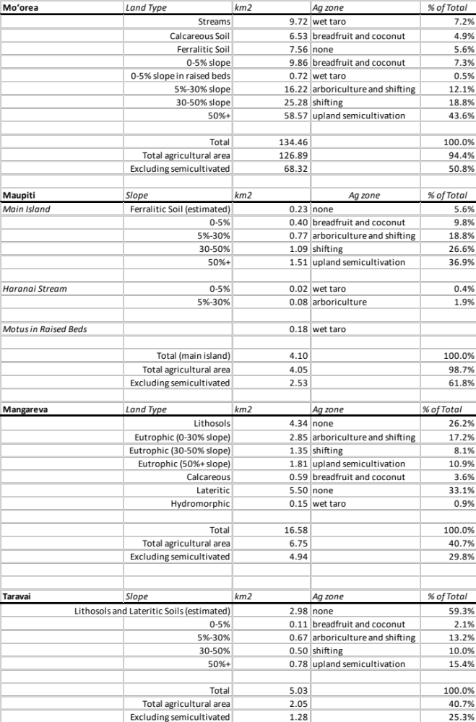
Table 1: Land use classification by island. In the absence of soil data for Maupiti and Taravai, we used Mo‘orea and Mangareva’s fractions of non-arable soils, respectively. See text for details.

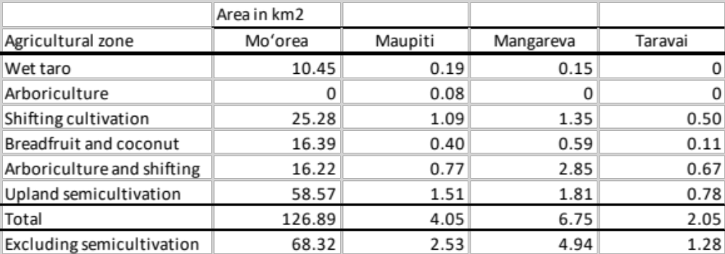
Table 2: Agricultural zone area by island.

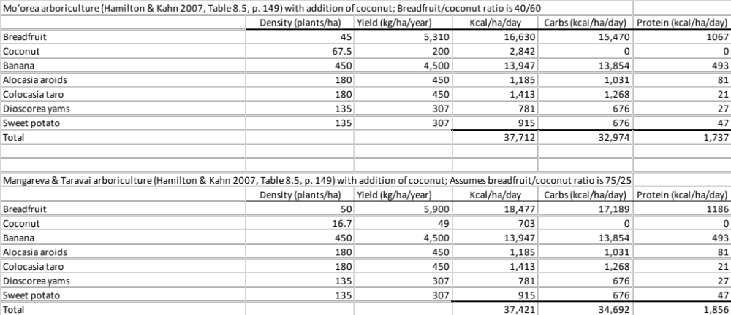
Table 3: Arboriculture yield estimates.

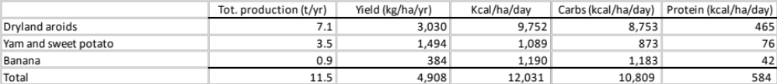
Table 4: Shifting cultivation yields after accounting for fallow.

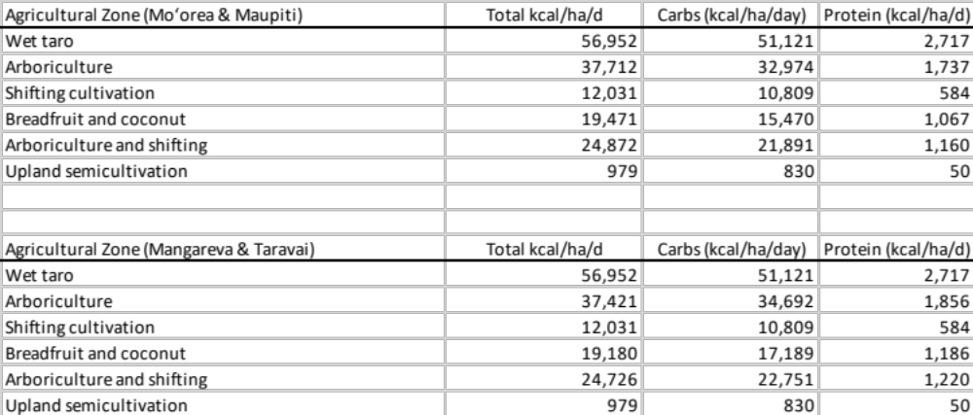
Table 5: Summary of yields by agricultural zones on each island.

To estimate the contribution of agricultural production to the diet of the islanders we scale the agricultural zone productivity (Table 5) by the zone-specific area on each island (Table 2). The potential agricultural energetic output by island is found in Table 6.

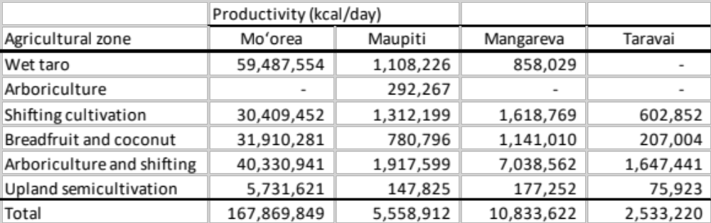
Table 6: Estimated agricultural energy availability by island in kcal/day.

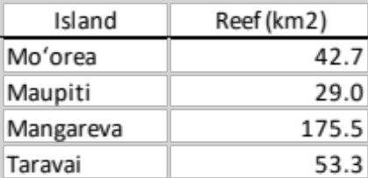
Table 7: Productive reef and lagoon area by island, with Mangareva and Taravai dividing the shared area proportional to land area.

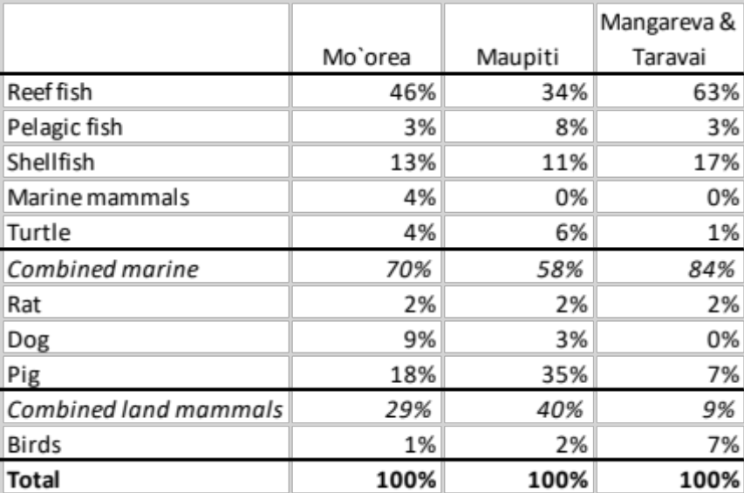
Table 8: Estimated diet biomass proportions, AD 1400-1800, excluding data from high-status sites.

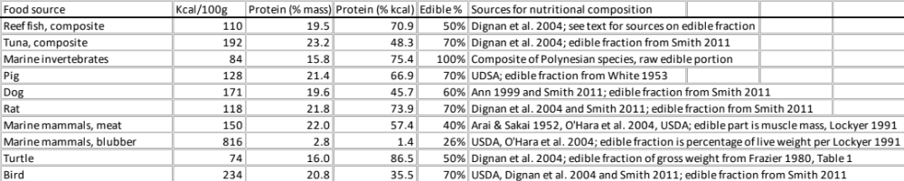
Table 9: Nutritional composition of raw flesh of animal foods, with edible fractions. (Dignan et al. 2004; Smith 2011; Haytowitz et al. 2005; White 1953; Ann 1999; Arai and Sakai 1952; O’Hara et al. 2004; Lockyer 1991; Frazier 1980)

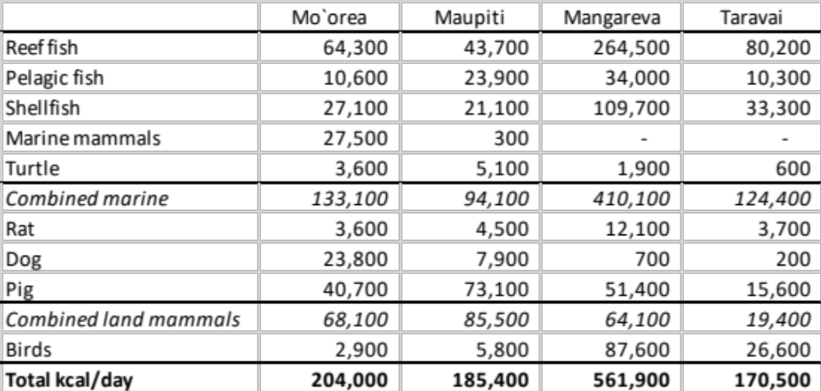
Table 10: Scenario A: Estimated faunal energy yield (kcal/day) by island at 1 mt/km²/year reef fish (rounded to nearest 100 kcal).

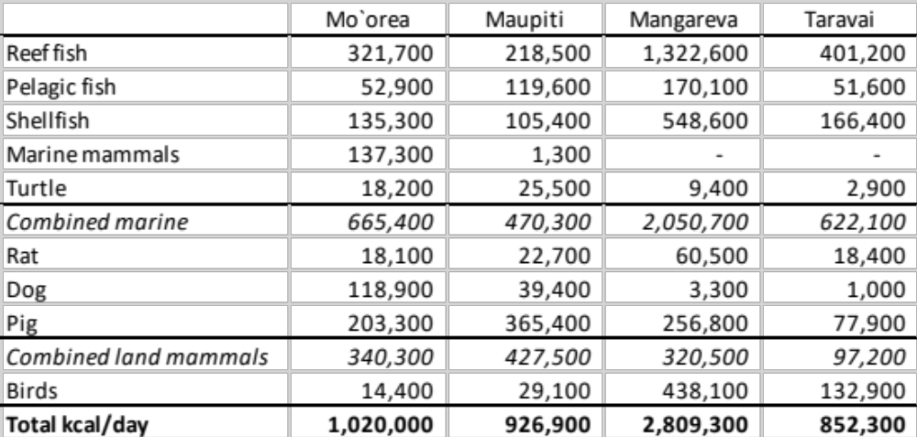
Table 11: Scenario B: Estimated faunal energy yield (kcal/day) by island at 5 mt/km²/year reef fish (rounded to nearest 100 kcal).

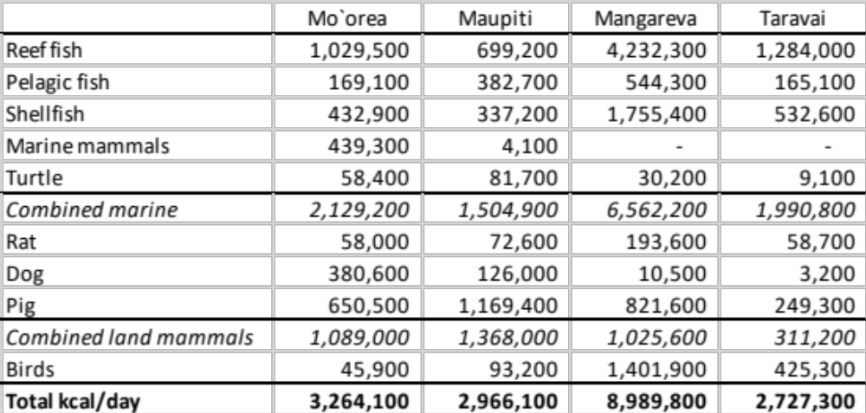
Table 12: Scenario C: Estimated faunal energy yield (kcal/day) by island at 16 mt/km²/year reef fish (rounded to nearest 100 kcal).

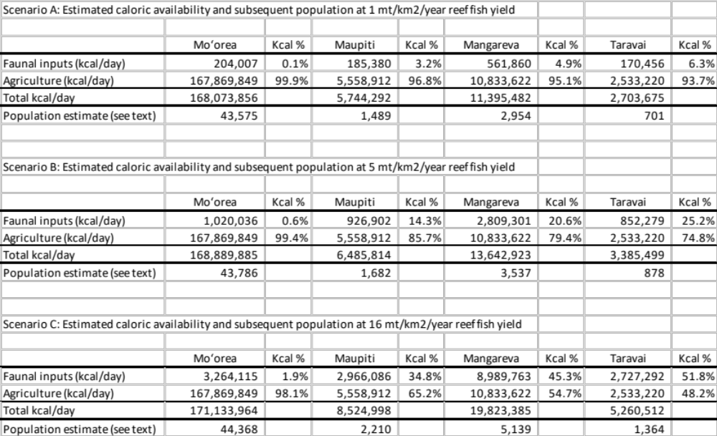
Table 13: Human population estimates by reef fish scenario, comparing faunal vs. agricultural inputs.

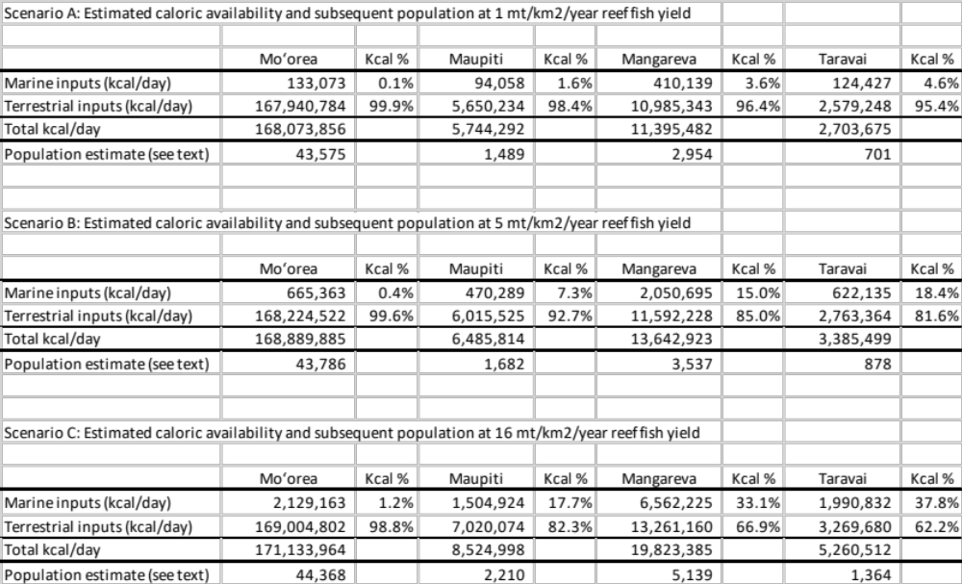
Table 14: Human population estimates by reef fish scenario, comparing marine vs. terrestrial inputs.

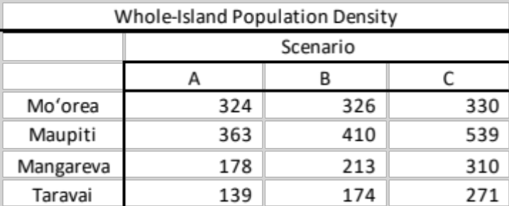
Table 15: Maximum population density (p/km²) measured across the whole island, excluding motus (from Table 1).

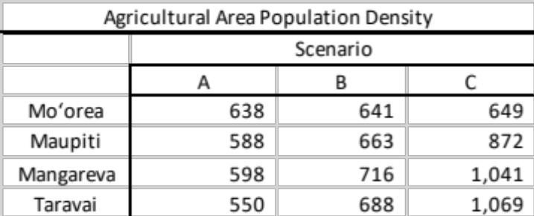
Table 16: Maximum population density (p/km²) measured across agricultural area, excluding semicultivation zones (from Table 2).

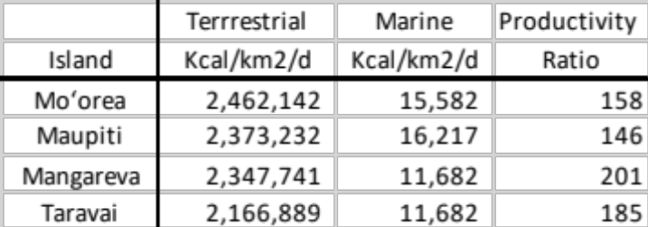
Table 17: Relative caloric productivity of agricultural land and the near-shore marine zone as a function of area, under the assumption of 5 mt/km²/y fish yield (Scenario B).

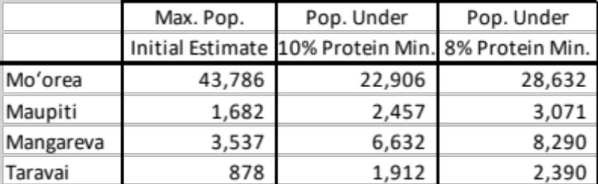
Table 18: Population size calculated from total calories and the maximum population sizes supported by the protein available, assuming that 10% or 8% of food energy must derive from protein, under Scenario B resource availability.

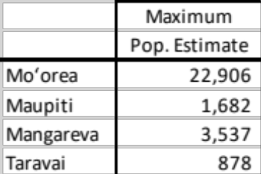
Table 19: Maximum sustainable population under the assumptions of Scenario B, and considering protein must supply 10% of the diet’s energy.

