Supplemental Materials
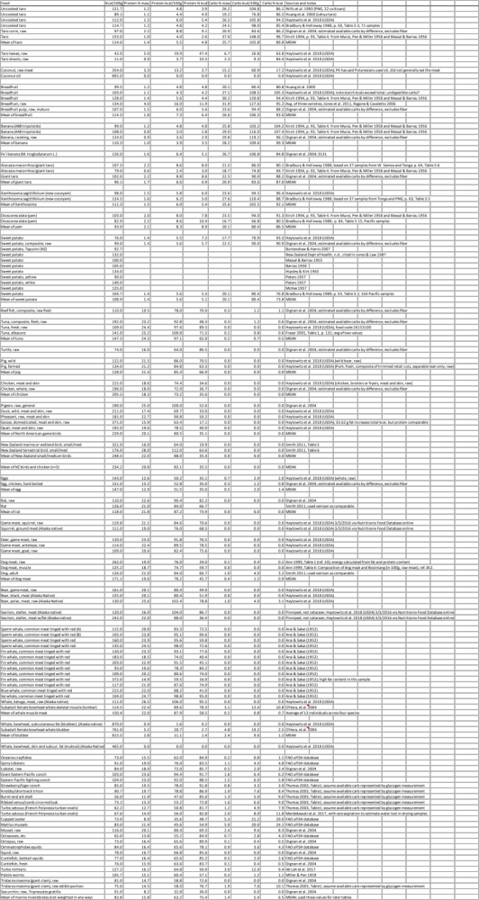
Table S1: Nutritional information on various Polynesian foods and their analogues. (Ab-Lah et al. 2017; Ann 1999; Arai and Sakai 1952; Barrau 1958; Bradbury and Holloway 1988; Burtenshaw and Harris 2007; Dignan et al. 2004; FAO 2016; Fraser 2001; Haytowitz et al. 2005; Hipsley and Kirk 1965; Huang, Titchenal, and Meilleur 2000; A. M. P. Jones et al. 2011; K. L. Jones and Law 1987; Kirch 1994; Massal and Barrau 1955; 1956; McKee 1957; Miller and Pen 1959; Murai, Miller, and Pen 1958; O’Hara et al. 2004; Peters 1957; Ragone and Cavaletto 2006; Smith 2011; Thomas 2003; Wills et al. 1983)

