Deep learning to estimate response of concurrent chemoradiotherapy in non-small-cell lung carcinoma

Supplemental Materials and Methods, Additional file 2

ResNet50 model
ResNet50, with its distinctive skip-connection technique integrating residual blocks, effectively promotes direct information flow, addressing the common issues of gradient vanishing and limited expressive capacity in deep networks. In ResNet50, each residual block consists of multiple convolutional layers, and these blocks are stacked together to form the entire network. This stacking structure enables the model to progressively extract and learn abstract representations of the data, thereby better capturing complex features in the images. Each residual block contains a non-linear mapping, denoted as F(x, {W_{i}}), representing the learning process from input feature map x to output feature map y. By incorporating such mappings, the model can capture non-linear relationships within the data at various levels, thereby augmenting its comprehension of complex patterns. Ultimately, the output feature map y of the residual block can be precisely expressed through a mathematical formula, deepening our insights into the model’s internal operations. The superiority of this structure lies in its capacity to address challenges encountered by many deep learning (DL) models when handling large-scale datasets, providing enhanced modeling capabilities for our prediction task. The output feature map y of a residual block, can be mathematically expressed as follows:
y = F(x, {W_{i}}) + x
In this explanation, {W_{i}} represents the weights of the residual block. The clever utilization of skip connections achieves the direct propagation of residual information, where residual information denotes the difference between the input and output feature maps of the residual block. By adding the output of the residual block to the input, the network effectively captures residual information, thereby enhancing optimization during the learning process. This mechanism enables the model to more precisely learn and discern subtle differences in the input data, improving the network's capacity to represent complex features and infusing stronger learning capabilities for ultimate predictive performance. The model’s architecture comprises convolutional and classification modules, accomplished through three crucial steps: 1) establishing a seamless connection between a linear classifier and the convolutional network to create an efficient feature extractor; 2) freezing the convolutional network and connecting it to a fully connected network with 1,024 hidden nodes, facilitating the integration of high-dimensional features for a high-precision classifier; and 3) unfreezing all network parameters to implement an end-to-end training approach with a reduced learning rate.

Gradient-weighted class activation mapping (Grad-CAM) visualization
The core principle of Grad-CAM lies in quantifying the correlation between category predictions and feature maps from convolutional layers, ultimately generating class activation maps. This technique accurately identifies crucial features and regions in the decision-making process of DL models, providing a powerful tool for model interpretability. Integrated with the previously described ResNet50 architecture, we further optimize the interpretability of the model. In the Grad-CAM framework, the initial steps involve executing forward propagation through a deep neural network to generate predictions for the target category. This step, working in tandem with the ResNet50 model described earlier, collectively forms a more robust and comprehensive DL system. Subsequently, the backpropagation algorithm extracts the gradients of the target category with respect to the intermediate feature maps, denoted by the symbol “c,” encompassing fundamental gradient information. The introduction of this step in Grad-CAM plays a crucial role, enabling a deeper understanding of the model's decision rationale for the target category. These gradient details complement the skip-connection technique in ResNet50, collectively building a comprehensive understanding of the internal operations of the model. Through this organic integration, we achieved more in-depth and accurate results in interpreting model decisions and visualizing essential features. This holistic approach not only enhances the interpretability capabilities of Grad-CAM but also further highlights the superiority of ResNet50 as the underlying architecture, providing more reliable and comprehensive interpretative support for the application of DL models. These gradients are denoted as “c” and represent essential gradient information:
where the variables y_{c} and A^{k} represent the predicted score of the target class c and the feature map of the k-th channel, respectively. The gradient values reflect the significance of different regions in the feature maps for the target class. Subsequently, we performed global average pooling on each channel of the feature maps to convert them into channel weights based on the following computation:
In this context, represents the channel weight and denotes a pixel in the feature map. The normalization constant Z is considered as well. Building upon the insights gained from evaluating the gradient weights in conjunction with the ResNet50 architecture, we derived the weights for individual channels, revealing the significance of different channels in predicting the target class. Higher weights assigned to specific channels indicate their substantial contributions to the prediction of the target class. To generate the definitive class activation map, we multiplied the gradient weights with their corresponding feature maps and conducted a channel-wise summation. This process, enriched by the interplay of Grad-CAM and ResNet50, leads to a comprehensive understanding of the model's decision-making process. The resulting map can be succinctly expressed as follows:
Here, represents the class activation map for the target class “c,” whereas ReLU denotes the activation function.

Supplementary Tables
Supplementary Table 1, Additional file 4: Selected radiomics associated with response in patients who received concurrent chemoradiotherapy
Group | Selected radiomics
Training cohort  (Radiomics, n = 3) | gradient_gldm_LargeDependenceHighGrayLevelEmphasis lbp-3D-k_gldm_LargeDependenceLowGrayLevelEmphasis wavelet-LLL_glcm_DifferenceVariance

Supplementary Table 2, Additional file 6: Univariate and multivariate analyses for the response in the training cohort
Variable | Univariate analysis |  | Multivariate analysis
Variable | OR (95% CI) | P-value | OR (95% CI) | P-value
Sex (female vs. male) | 1.05 (0.68–1.62) | 0.809 | -- | --
Age (years) (≤ 60 vs. > 60) | 0·56 (0·28–1·10) | 0·096 | -- | --
Smoking status (smoker vs. non-smoker) | 0·84 (0·42–1·66) | 0·630 | -- | --
Histology (squamous carcinoma vs. non-squamous carcinoma) | 0·97 (0·54–1·79) | 0·943 | -- | --
CEA (ng/mL) (≤ 20 vs. > 20) | 0·99 (0·99–1·00) | 0·507 | -- | --
T stage (T3–4 vs. T1–2) | 4·80 (2·36–10·00) | < 0·001* | 6·70 (2·49–20·28) | < 0·001*
N stage (N0–1 vs. N2–3) | 0·72 (0·29–1·67) | 0·457 | -- | --
M stage (M0 vs. M1) | 1·03 (0·47–2·34) | 0·926 | -- | --
DLS (high vs. low) | 0·01 (0·00–0·01) | < 0·001* | 0·01 (00·00–0·01) | < 0·001*
CEA, carcinoembryonic antigen; DLS, deep learning score; N, lymph node; M, metastasis; T, tumor; OR, odds ratio; CI, confidence interval
Supplementary Table 3, Additional file 8: Univariate and multivariate analyses for the overall survival in the training cohort
Variable | Univariate analysis |  | Multivariate analysis
Variable | HR (95% CI) | P-value | HR (95% CI) | P-value
Sex (female vs. male) | 0·56 (0·32–0·98) | 0·086 | -- | --
Age (years) (≤ 60 vs. > 60) | 1·31 (0·85–2·03) | 0·208 | -- | --
Smoking status (smoker vs. non-smoker) | 0·75 (0·48–1·18) | 0·231 | -- | --
Histology (squamous carcinoma vs. non-squamous carcinoma) | 1·22 (0·78–1·90) | 0·370 | -- | --
CEA (ng/mL) (≤ 20 vs. > 20) | 1.·05 (0·57–1·92) | 0·850 | -- | --
T stage (T3–4 vs. T1–2) | 1.·04 (0·65–1·66) | 0·848 | -- | --
N stage (N2–3 vs. N0–1) | 2.·95 (2·08–8·08) | 0·034* | 3·06 (1·10–8·50) | 0·031*
M stage (M1 vs. M0) | 1.·81 (1·13–2·89) | 0·013* | 1·96 (1·22–3·16) | 0·005*
DLS (high vs. low) | 0.·44 (0·28–0·68) | < 0·001* | 0·49 (0·30–0·78) | 0·003*
CEA, carcinoembryonic antigen; DLS, deep learning score; N, lymph node; M, metastasis; T, tumor; HR, hazard ratio; CI, confidence interval

3 Supplementary Figures

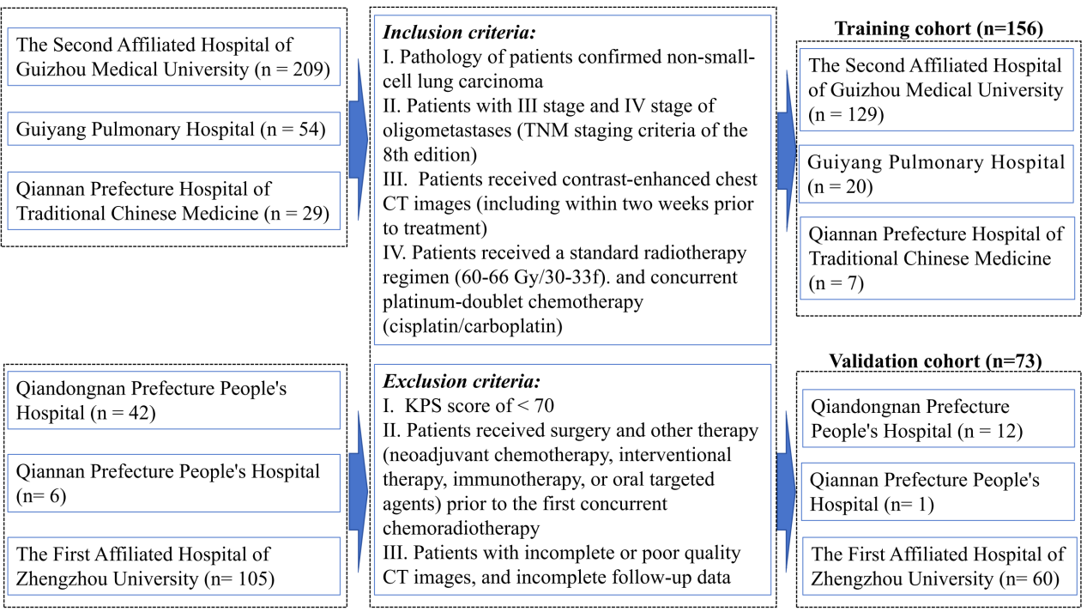
Supplementary Figure 1, Additional file 1: Flowchart of the recruited patients

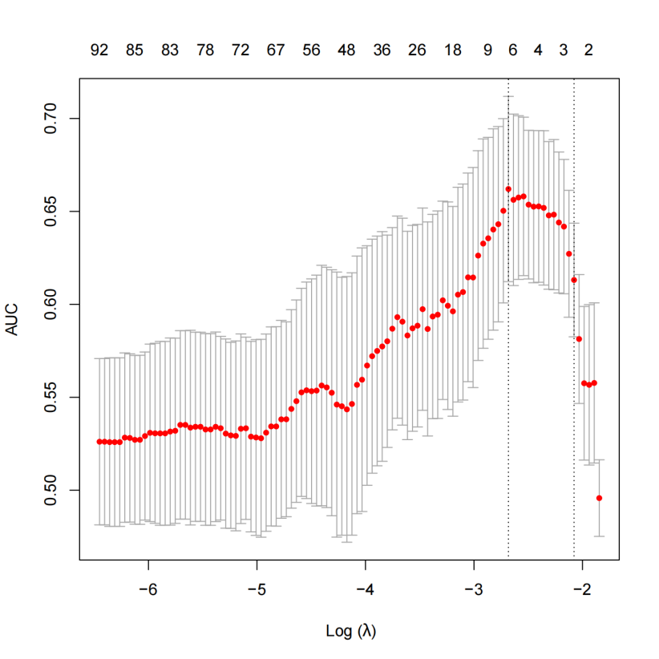
Supplementary Figure 2, Additional file 3: Least absolute shrinkage and selection operator was used to select features and construct the radiomics model

Supplementary Figure 3, Additional file 5: Comparison between the deep learning model and T stage for response prediction of concurrent chemoradiotherapy

Supplementary Figure 4, Additional file 7: Analysis of PFS and OS in DLS-low patients in both groups (A) Comparison of PFS between the CCRT-alone and combination (CCRT+ICI) groups (B) Comparison of OS between the CCRT-alone and combination (CCRT+ICI) groups
ICI, immune checkpoint inhibitor; CCRT, concurrent chemoradiotherapy; PFS, progression- free survival; OS, overall survival; DLS, deep learning score; HR, hazard ratio; CI, confidence interval

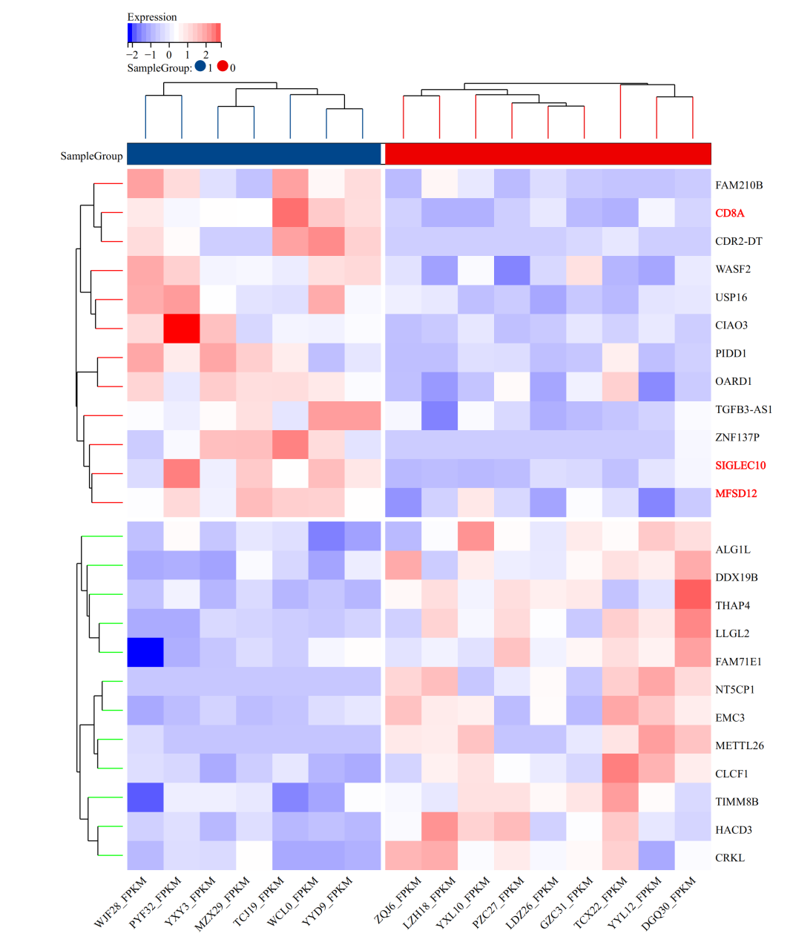
Supplementary Figure 5, Additional file 9: Heatmap presenting the differentially expressed genes in predictive response (sample group 1) vs. predictive no-response (sample group 0) groups

