Extended Data Figures
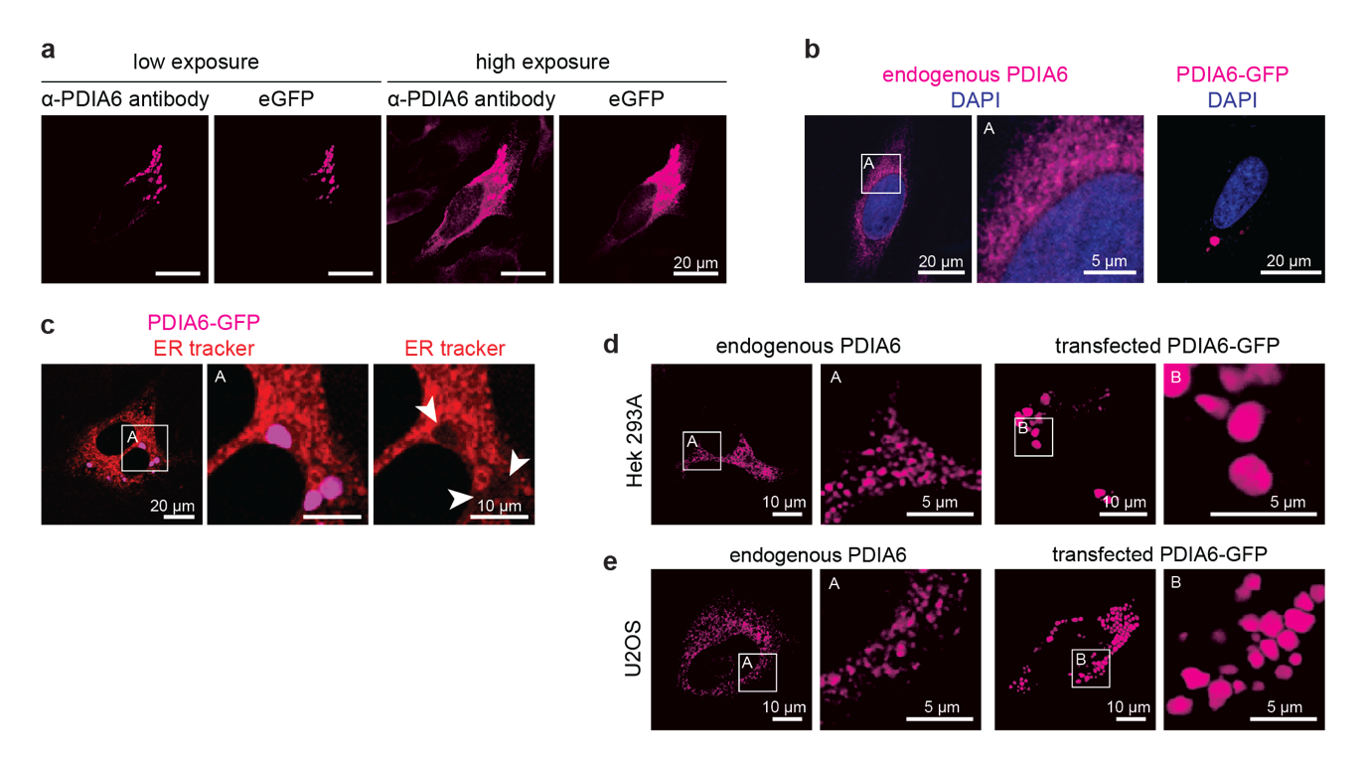Extended Data Fig. 1: In vivo phase separation of PDIA6. a, Fixed HeLa cells transfected with PDIA6-GFP (eGFP signal) and stained against PDIA6 (anti-PDIA6 antibody, imaged in red channel) recorded at low (left) and high exposure (right). b, Fixed HeLa cells expressing endogenous PDIA6 (left) and transfected with PDIA6-GFP (right) stained for DAPI. PDIA6-GFP was visualized by imaging eGFP. c, Live-cell imaging of HeLa cells transfected with PDIA6-GFP, treated with ER tracker (red). The white arrows indicate the position of PDIA6 condensates. d, Fixed HEK293A cells expressing endogenous PDIA6 (left) and live cell imaging of HEK293A cells transfected with PDIA6-GFP (right). Endogenous PDIA6 was stained with an anti-PDIA6 antibody, overexpressed PDIA6-GFP was visualized by imaging eGFP. e, Fixed U2OS cells expressing endogenous PDIA6 (left) and live cell imaging of U2OS cells transfected with PDIA6-GFP (right). Endogenous PDIA6 was stained with an anti-PDIA6 antibody, overexpressed PDIA6-GFP was visualized by imaging eGFP.
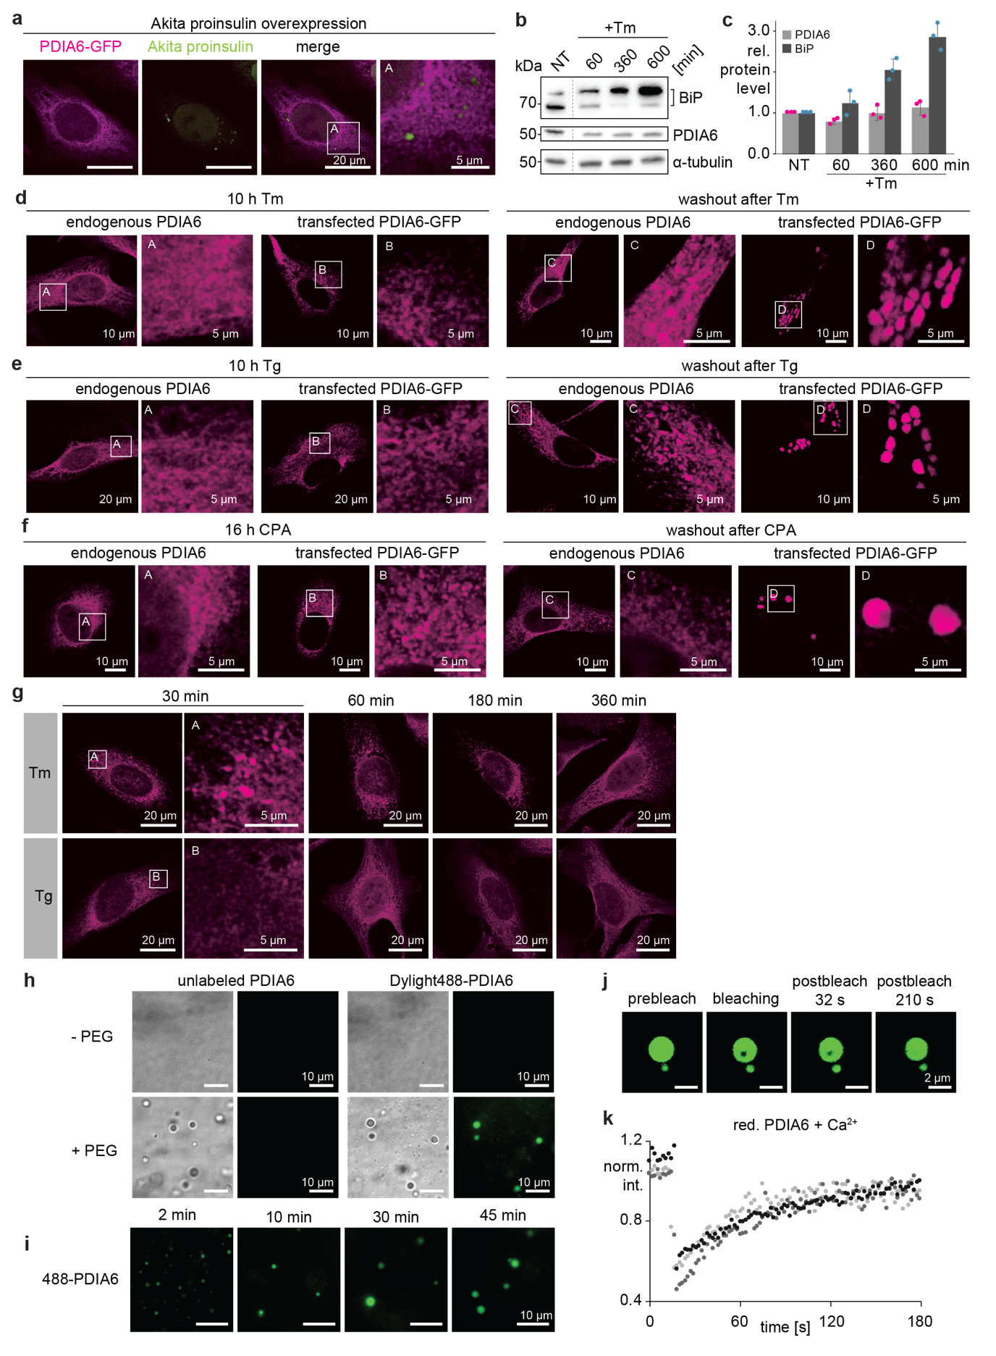
Extended Data Fig. 2: Effect of ER stress on PDIA6 condensates and in vitro droplet reconstitution. a, Fixed HeLa cells co-transfected with PDIA6-GFP (pink) and Akita proinsulin-myc (green). Akita proinsulin, a folding-defectve mutant of proinsulin¹⁶, was used to mimic the accumulation unfolded/misfolded proteins in the ER lumen. Akita proinsulin has been reported to form puncta⁶¹. PDIA6 was visualized by imaging eGFP, Akita proinsulin using an anti-myc antibody. b, Western blot showing expression levels of PDIA6, BiP and α-tubulin in HeLa cells and at different timepoints after Tm treatment. c, Quantification of the blot shown in (b). Data representative of an experimental triplicate (n=3). d-f, Fixed HeLa cells expressing endogenous PDIA6 and live cell imaging of HeLa cells transfected with PDIA6-GFP after 10 h of Tm treatment (d), 10 h of Tg treatment (e) or 16 h of CPA (reversible Tg analog) treatment (f) (left) and 24 h after drug washout (right). Endogenous PDIA6 was stained with an anti-PDIA6 antibody, overexpressed PDIA6-GFP was visualized by imaging eGFP. g, Fixed HeLa cells expressing endogenous PDIA6 observed at different timepoints after Tm (top) and Tg treatment (bottom). h, In vitro phase separation of PDIA6 (left) and Dylight488-PDIA6 (right) with 10 mM Ca²⁺ in absence (top) and presence (bottom) of 10% PEG3350. i, In vitro time evolution of Dylight488-PDIA6 droplets in presence of 10 mM Ca²⁺. j, FRAP experiments of Dylight488-PDIA6 in presence of 10 mM Ca²⁺. k, Fluorescence recovery analysis of the FRAP experiments presented in (j). Experimental triplicate in shades of grey.
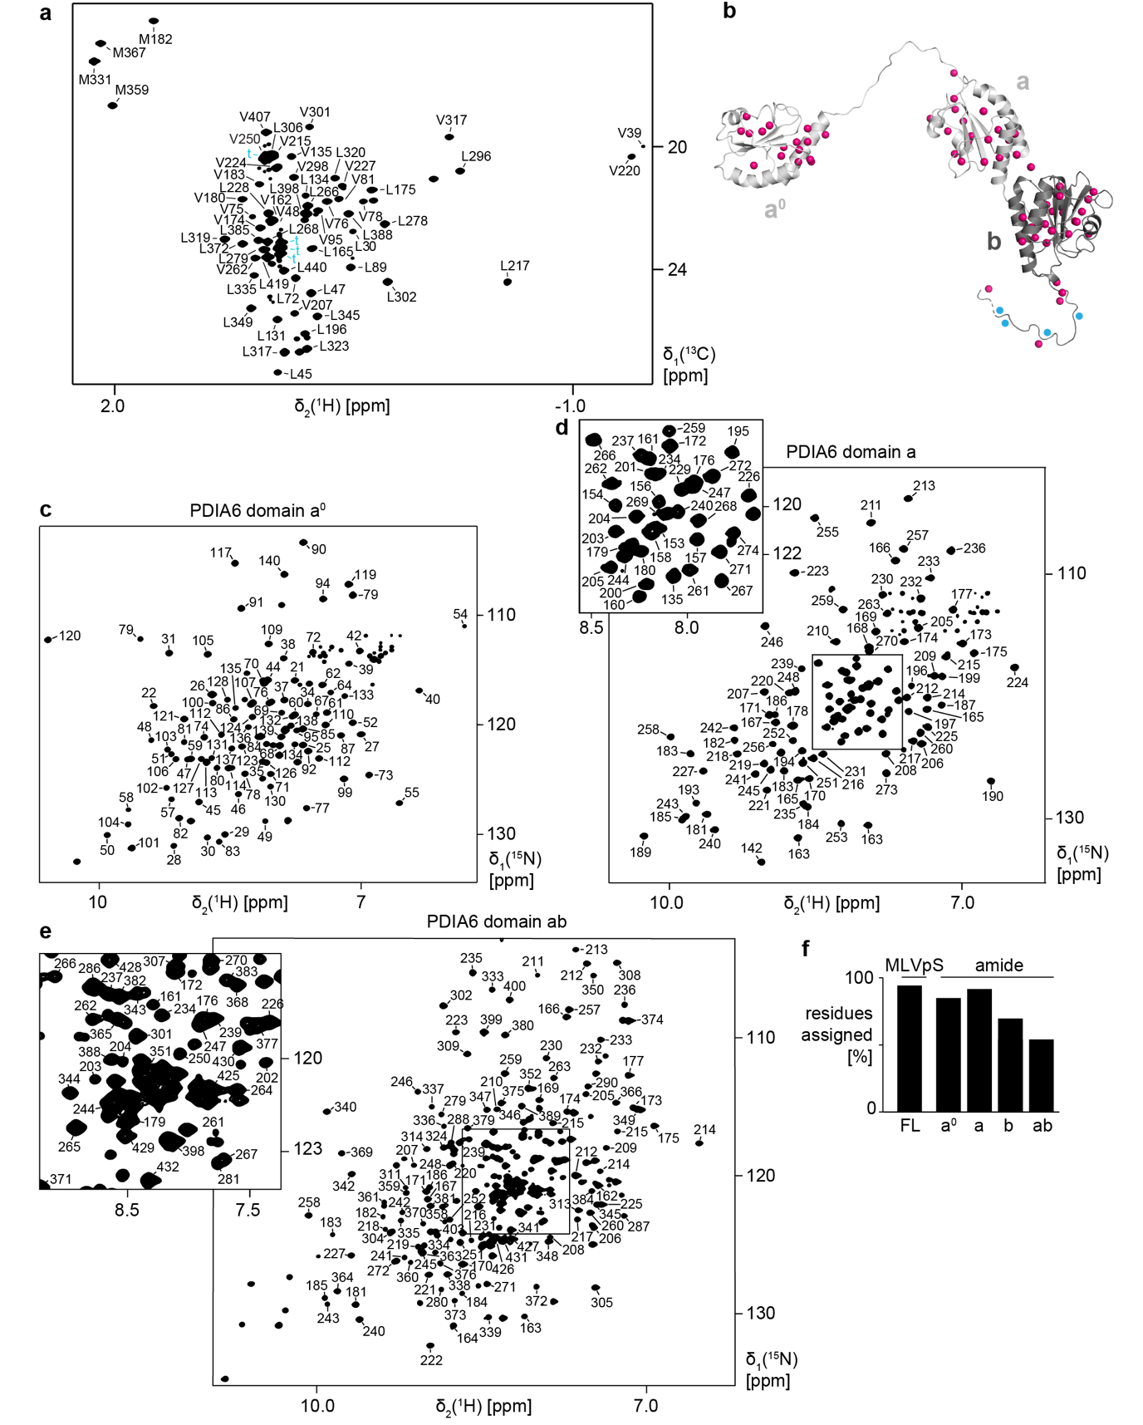
Extended Data Fig. 3: PDIA6 methyl group and amide backbone NMR assignments. a, 2D [¹³C,¹H]-HMQC spectrum of methyl-labeled PDIA6. Assignment of Met[¹³C¹H]^{ε}, Val-[¹³C¹H]^{γ2} and Leu-[¹³C¹H]^{δ2} methyl groups are indicated. b, Assigned methyl groups (pink spheres) displayed on the structure of PDIA6 established in Fig. 2. c-e, 2D [¹⁵N,¹H]-HSQC spectra of PDIA6 domain a⁰ (c), domain a (d) and domain ab (e). Sequence-specific resonance assignments are indicated. f, Percentages of assigned residues of methyl and amide groups in PDIA6 FL and domain constructs.
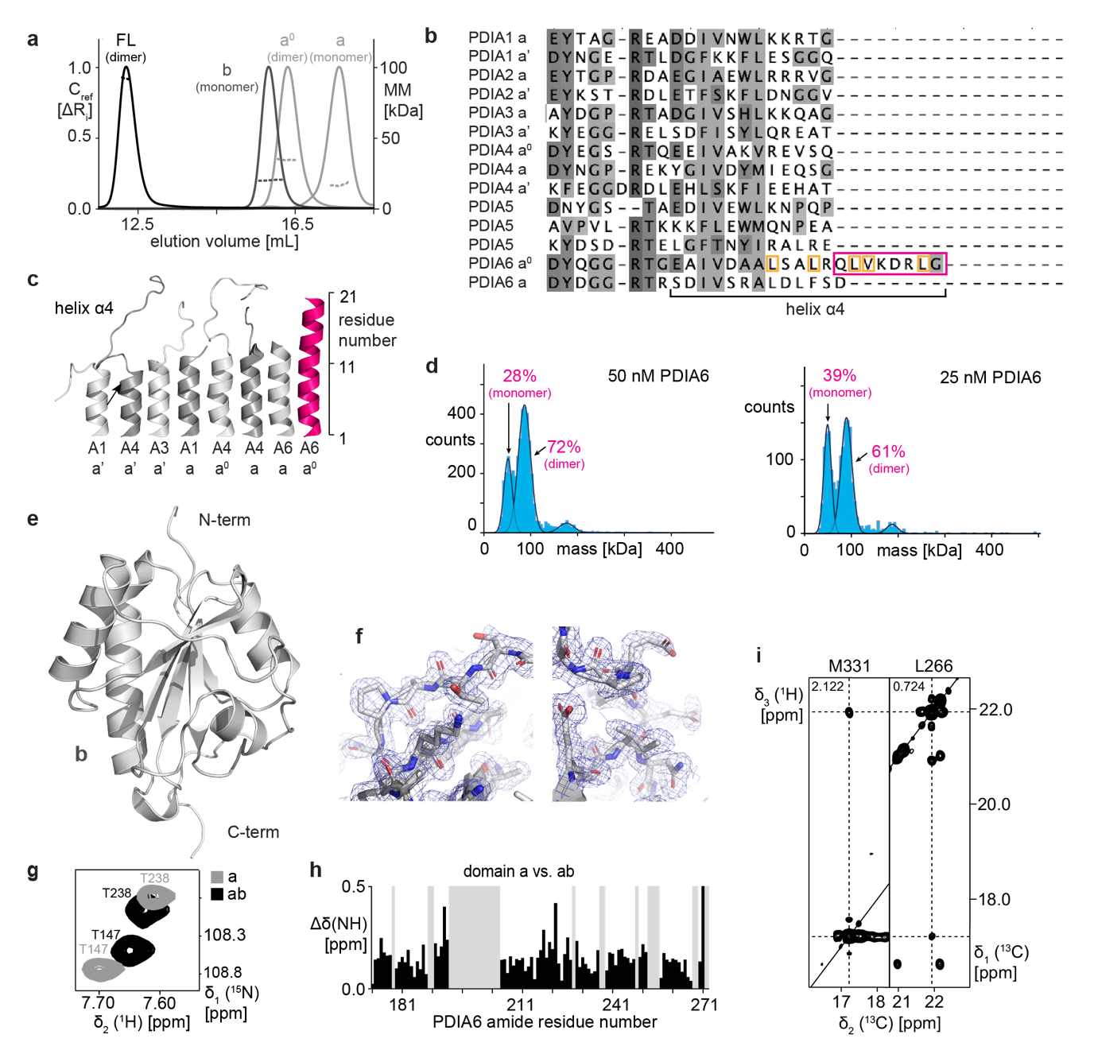Extended Data Fig. 4: Domain characterization of PDIA6. a, SEC elution profiles (solid lines, left axis) and MALS apparent molecular mass (dotted lines, right axis) of PDIA6 full-length (FL) and domains. b, Sequence alignment of helix α4 of PDI catalytically active domains. The extended helix α4 of PDIA6 is highlighted by a pink square. Residues forming the leucine-valine adhesive dimerization motif²³ are marked by an orange square. Domain delimitations as defined on uniport.org. or by available crystal structures. c, Structural comparison of PDI catalytically active domains helix α4. d, Mass photometry of PDIA6 at 50 nM and 25 nM. Occupancy and oligomeric state are indicated for each peak. e, Crystal structure of PDIA6 domain b at a resolution of 1.8 Å. f, Zoom on the electron density map of PDIA6 domain b crystal structure. g, Overlay of sections of 2D [¹⁵N,¹H]-HSQC spectra of 100 μM PDIA6 domain a (grey) and ab (black). h, Combined amide chemical shift perturbation of isolated domain a vs. domain ab construct. i, 2D strips of the 3D ¹³C, ¹³C-resolved [¹H, ¹H]-NOESY spectrum of 1 mM methyl-labeled PDIA6 for the residues M331 and L266.
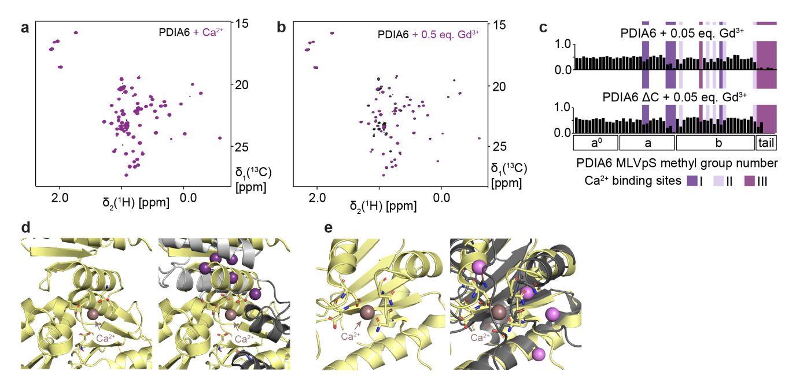Extended Data Fig. 5: Localization of three Ca²⁺ binding sites in PDIA6. a, Overlay of 2D [¹³C,¹H]-HMQC spectra of 100 μM methyl-labeled PDIA6 in absence (black) and presence of 10 mM Ca²⁺ (purple). b, Overlay of 2D [¹³C,¹H]-HMQC spectra of 100 μM methyl-labeled PDIA6 in absence (black) and presence of 0.05 eq. Gd³⁺ (purple). c, PRE-effect of 0.05 eq. Gd³⁺ on full-length (top) and truncated ΔC (bottom) PDIA6. Residues with significant loss in intensity are highlighted in shades of purple (I, II and III). d,e, Zoom on Ca²⁺ binding site of calsequestrin low Ca²⁺ form (PDB: 5kn3, yellow) (left) and overlay with PDIA6 (grey) Ca²⁺ binding sites I (d) and II (e) (right). Side chains of Ca²⁺ binding residues shown as sticks. Methyl groups with significant loss in intensity in (Fig. 2g) represented as spheres as in (Fig. 2h). The Ca²⁺ ions in calsequestrin are coordinated by the amino acid residues Asp/Glu/Asp for site I and Asn/Asn/Asp/Asp for site II, while in PDIA6 by Asp/Ser/Ser and Asn/Glu/Gln/Thr, respectively, resulting in weaker Ca²⁺ binding.
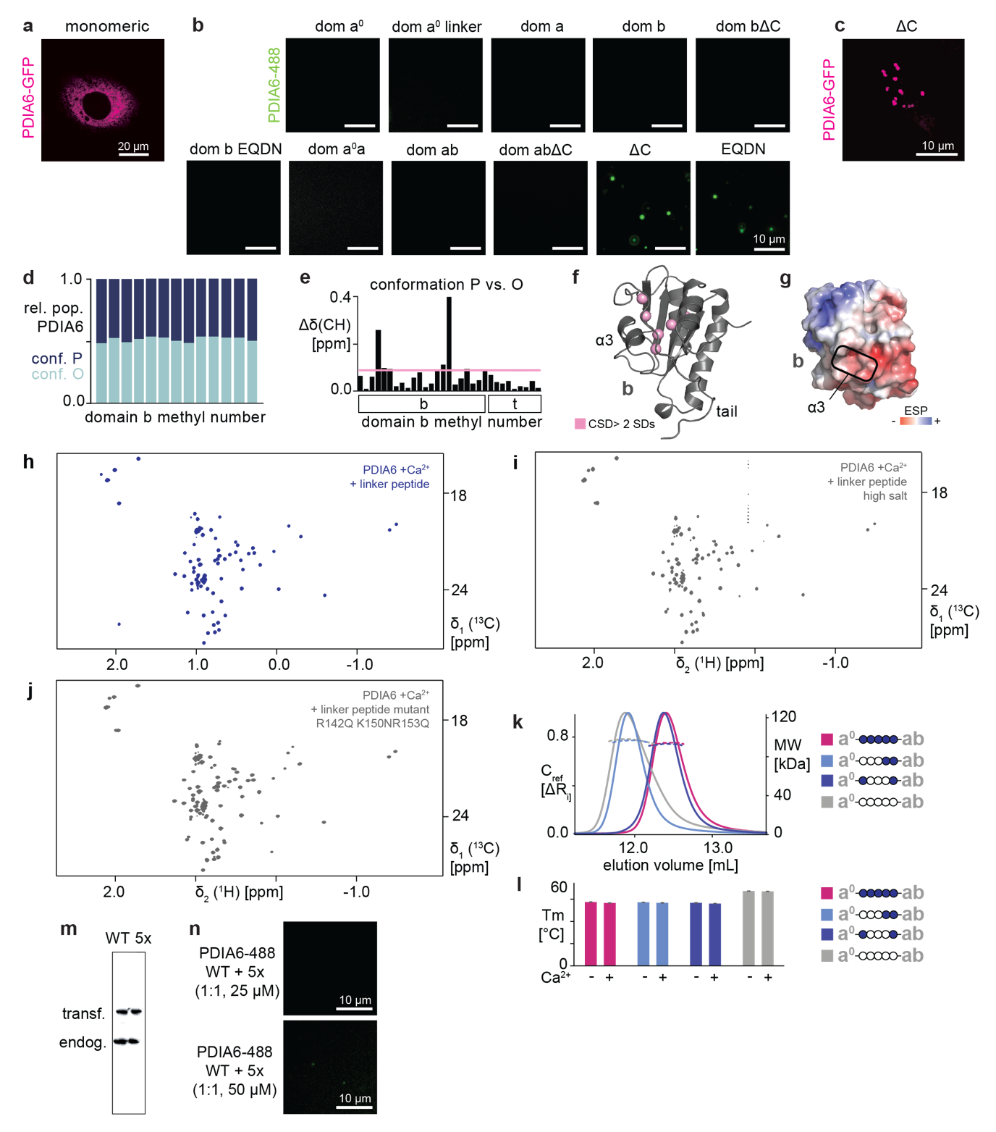Extended Data Fig. 6: Specificity of PDIA6 phase separation in cells and in vitro. a, Live cell imaging of HeLa cells transfected with a monomeric mutant²³ of PDIA6-GFP. b, In vitro phase separation of Dylight488-PDIA6 sub-constructs. The EQDN mutant has been described before²³ to not bind Ca²⁺ to the C-terminal tail (binding site III). c, HeLa cells transfected with PDIA6-GFP ΔC. d, Residue-specific populations of the conformation C (dark blue) and O (light blue). Each bar corresponds to one methyl group in domain b. e, Combined methyl chemical shift differences between conformations P and O in domain b. The significance threshold of 2 SDs is indicated by a pink line. f, Methyl groups with significant chemical shift difference between conformations P and O marked as pink spheres on the structure of domain b. Residues located around helix α3 show largest chemical shift differences between the two conformations. g, Electrostatic surface potential (ESP) of domain b. Helix α3 forms part of a negatively charged patch. h-j, 2D [¹³C,¹H]-HMQC spectra of 100 μM methyl-labeled PDIA6 in presence of 10 mM Ca²⁺ and 10 eq. linker peptide (h), in presence of 10 mM Ca²⁺, 10 eq. linker peptide and 500 mM KCl (i) and in presence of 10 mM Ca²⁺ and 10 eq. mutated linker peptide (R142Q, K150N,R153Q) (j). k, SEC elution profiles (solid lines, left axis) and MALS apparent molecular mass (dotted lines, right axis) of PDIA6 WT (pink), (R142Q, K150N, R153Q) (light blue), (K150N, R153Q, K159N) (dark blue) and 5x mutant (grey). All proteins eluted as a dimer. l, Melting temperature of PDIA6 WT and linker mutant constructs in SEC-buffer and in presence of 10 mM of Ca²⁺ determined by DSF. Error bars are s. d. from three measurements. Colour code as in (k). m, Protein expression levels of endogenous PDIA6 and transfected PDIA6-GFP in HeLa cells. (n) In vitro phase separation of Dylight488-PDIA6 WT + Dylight488-PDIA6 5x mutant at 1:1 stoichiometry in presence of 10 mM Ca²⁺ at a final protein concentration of 25 μM (top) and 50 μM (bottom).
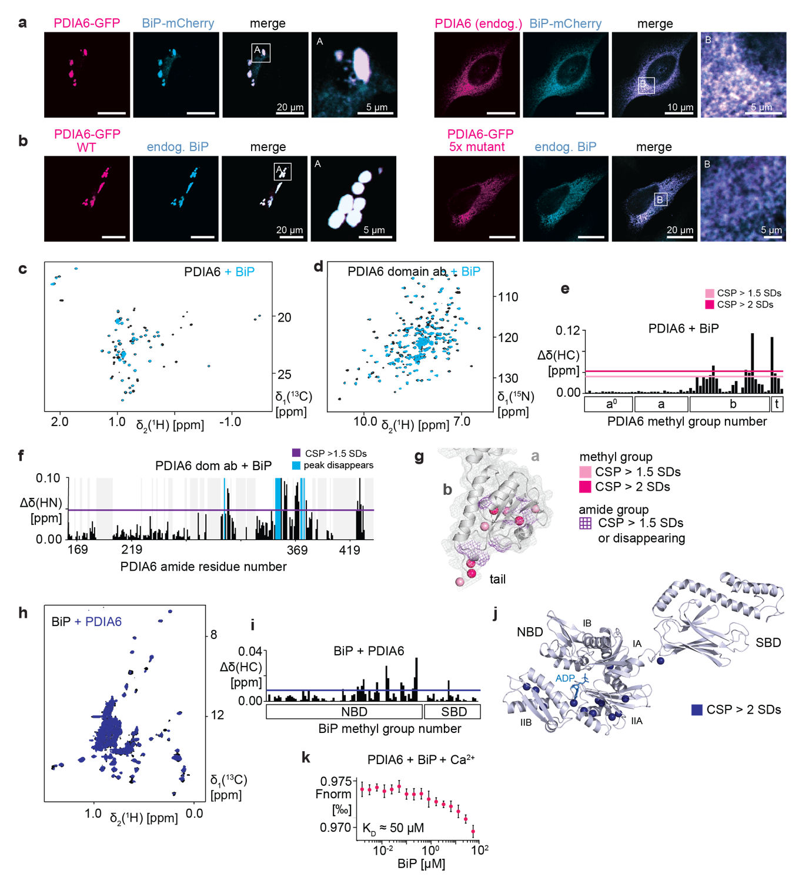Extended Data Fig. 7: PDIA6 domain b recruits BiP into the condensates. a, Colocalization of overexpressed PDIA6-GFP (pink) and overexpressed BiP-mCherry (blue) in live HeLa cells (left) and of endogenous PDIA6 (pink) and overexpressed BiP-mCherry (blue) in fixed HeLa cells (right). PDIA6-GFP was visualized by imaging eGFP, BiP-mCherry by imaging mCherry. b, Colocalization of overexpressed PDIA6-GFP WT (pink) and endogenous BiP (blue) (left) and overexpressed PDIA6-GFP 5x linker mutant (pink) and endogenous BiP (blue) (right) in fixed HeLa cells. PDIA6 was visualized using the eGFP signal. c, Overlay of 2D [¹³C,¹H]-HMQC spectra of 100 μM methyl-labeled PDIA6 in absence (black) and in presence of 2 eq. BiP (blue). d, Overlay of 2D [¹⁵N,¹H]-HSQC spectra of 100 μM PDIA6 domain ab in absence (black) and in presence of 2 eq. BiP (blue). e, Combined methyl chemical shift perturbation of PDIA6 upon titration of 2 eq. BiP. The magnitudes of 1.5 SD and 2 SDs are indicated by pink lines. f, Combined amide chemical shift perturbation of PDIA6 domain ab upon titration of BiP. The magnitude of 1.5 SD is indicated by a pink line, disappearing residues in blue. g, Methyl groups with significant CSP upon interaction with BiP shown as pink spheres on the structure of domain b. Amide groups with significant CSP are shown as purple surface. h, Overlay of 2D [¹³C,¹H]-HMQC spectra of 100 μM methyl-labeled BiP in absence (black) and in presence of 2 eq. PDIA6 (blue). i, Combined methyl chemical shift perturbation of BiP upon titration of 2 eq. PDIA6. The magnitudes of 2 SDs is indicated by a blue line. j, Methyl groups with significant CSP upon interaction with PDIA6 shown as blue spheres on the structure of the undocked ADP-bound BiP (modeled on pdb 2kho). k, Microscale thermophoresis signal of Dylight488-PDIA6 plotted against BiP concentration in presence of 1 mM Ca²⁺.
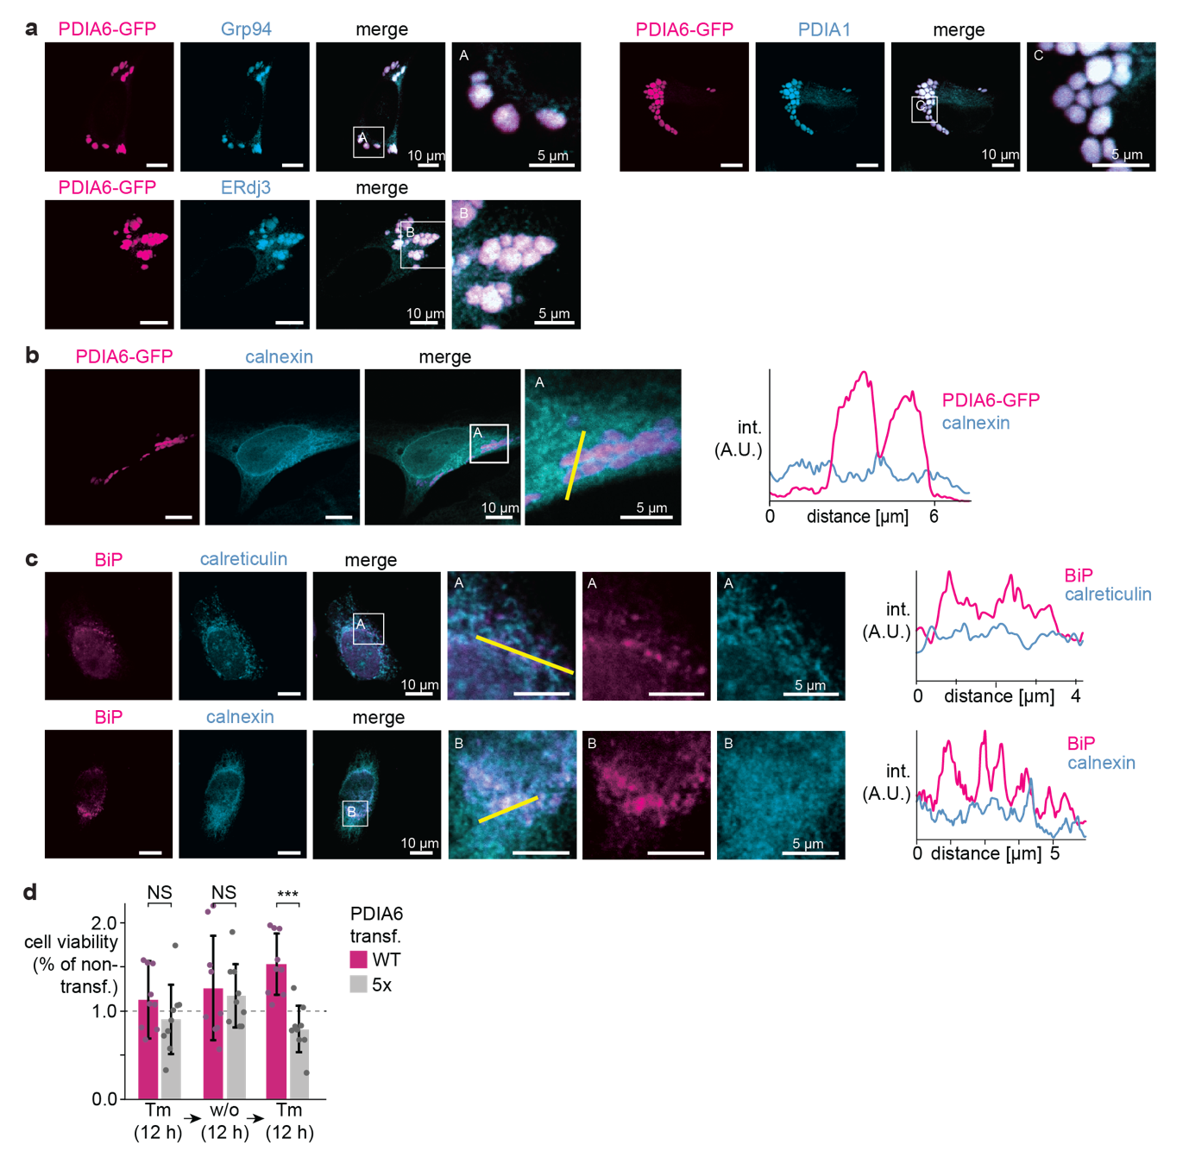Extended Data Fig. 8: Composition and function of the folding factories. a, Colocalization of overexpressed PDIA6-GFP (pink) and endogenous Grp94 (blue) (top), overexpressed PDIA6-GFP (pink) and endogenous ERdj3 (blue) (bottom) and overexpressed PDIA6-GFP (pink) and endogenous PDIA1 (blue) (right) in fixed HeLa cells. PDIA6 was visualized using the eGFP signal. b, Colocalization of overexpressed PDIA6-GFP (pink) and endogenous calnexin (grey) in fixed HeLa cells. PDIA6 was visualized using the eGFP signal. Fluorescence intensities across the condensates were measured along the yellow line and are shown as histograms (right). c, Colocalization of endogenous BiP (pink) and endogenous calreticulin (blue) (top) or calnexin (blue) (bottom) in fixed HeLa cells. Fluorescence intensities across the condensates were measured along the yellow line and are shown as histograms (right). d, Cell viability of PDIA6-GFP WT (pink) and PDIA6-GFP 5x linker mutant (grey) transfected cells relative to nontransfected cells by MTT after Tm treatment (12 h) (NS p=0.312), after subsequent Tm washout (12 h) (NS p=0.315) and after repeated Tm treatment (12 h) (***p=0.00016) (n=9).
Supplementary Information
Supplementary Table 1: Statistics on diffraction data and refinement of PDIA6 domain b (residues 274-427).
 | PDIA6 domain bΔC (P275-L427)
PDB ID | 8cpq
Wavelength (Å) | 1.000013
Resolution range (Å) | 50.4 – 1.80  (1.86 – 1.80)*
Space group | C2 2 21
Unit cell | 57.4 96.9 63.3
α, β, γ (°) | 90 90 90
Unique reflections | 16717 (1638)
Multiplicity | 10.2 (10.0)
Completeness (%) | 99.91 (99.88)
Mean I/sigma(I) | 10.5 (1.4)
Wilson B-factor | 20.7
R-meas | 0.202 (1.99)
CC1/2 | 0.998 (0.637)
R-work | 0.186 (0.277)
R-free | 0.216 (0.323)
Number of non-hydrogen atoms | 1318
macromolecules | 1163
ligands | 0
water | 155
Protein residues | 150
RMS(bonds) | 0.007
RMS(angles) | 1.07
Ramachandran  favored (%) | 97.3
Ramachandran  outliers (%) | 0.0
Rotamer  outliers (%) | 0.0
Clashscore | 2.2
B-factor (All) | 30.0
*Values in parenthesis are for the highest resolution shell.
Supplementary Table 2: Colocalization of ER chaperones in PDIA6 condensates. Pearson Correlation Coefficient (PCC) of indicated proteins (protein 1 and protein 2) in 10-15 cells (n).
Protein 1 | Protein 2 | PCC | n
PDIA6 (endog.) | BiP (endog.) | 0.936 ± 0.018 | 15
BiP (endog.) | ERdj3 (endog.) | 0.885 ± 0.038 | 15
PDIA6 (endog.) | Grp94 (endog.) | 0.952 ± 0.013 | 15
PDIA6 (endog.) | PDIA1 (endog.) | 0.944 ± 0.134 | 15
PDIA6-GFP (transf.) | BiP (endog.) | 0.964 ± 0.014 | 13
PDIA6-GFP (transf.) | ERdj3 (endog.) | 0.869 ± 0.102 | 10
PDIA6-GFP (transf.) | Grp94 (endog.) | 0.804 ± 0.043 | 15
PDIA6-GFP (transf.) | PDIA1 (endog.) | 0.858 ± 0.044 | 15
BiP (endog.) | calreticulin (endog.) | 0.393 ± 0.027 | 15
BiP (endog.) | calnexin (endog.) | 0.455 ± 0.032 | 15
PDIA6-GFP (transf.) | calreticulin (endog.) | 0.463 ± 0.075 | 10
PDIA6-GFP (transf.) | calnexin (endog.) | 0.377 ± 0.139 | 15
PDIA6 (endog.) | proinsulin (transf.) | 0.931 ± 0.013 | 15

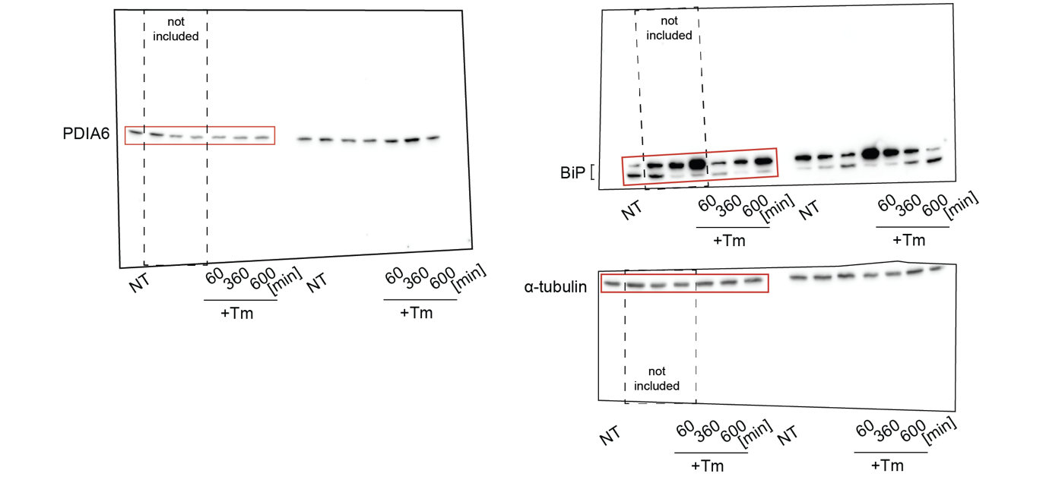
Supplementary Figure 1: Uncropped western blot presented in Extended Data Fig. 2b. The content of Extended Data Fig. 2b is highlighted by red boxes. Blots representative of three biological repetitions.
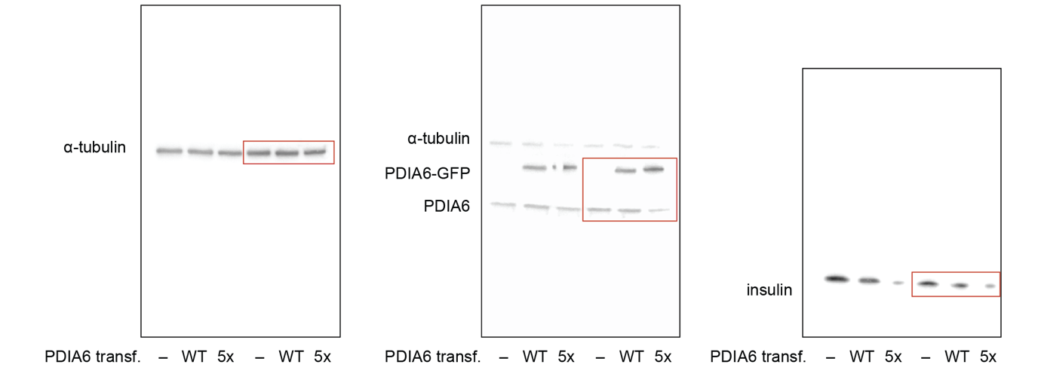
Supplementary Figure 2: Uncropped western blot presented in Fig. 4i. The content of Extended Data Fig. 4i is highlighted by red boxes. Blots representative of four biological repetitions.
Supplementary Video 1: Fusion event of PDIA6-GFP condensates in HeLa cells.
Supplementary Video 2: Fission event of PDIA6-GFP condensates in HeLa cells.
Supplementary Video 3: Fluorescence recovery after photobleaching of PDIA6-GFP condensates in HeLa cells.

