Supplementary Materials
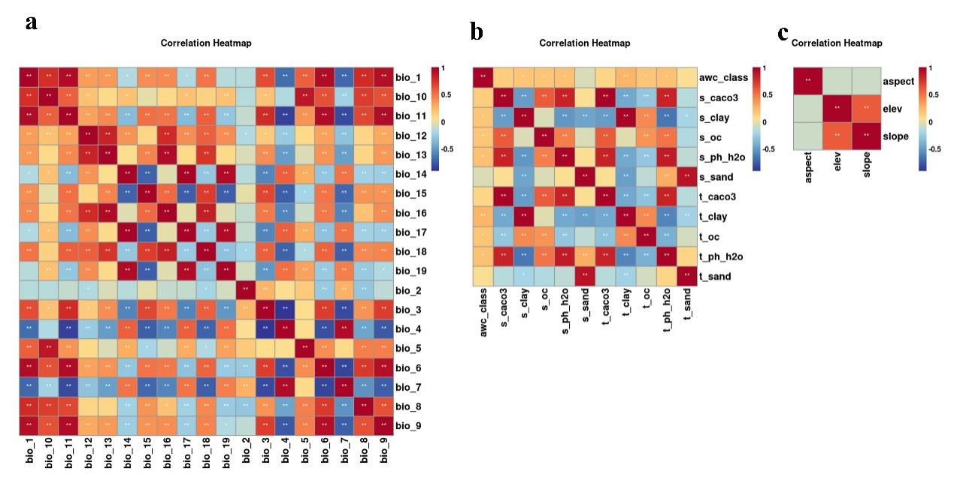
Fig. S1. (a) Correlation analysis of 19 bioclimatic variables, (b) correlation analysis of 11 soil variables, and (c) correlation analysis of 3 topographic variables.

Fig. S2. The standard curve of trans-cinnamaldehyde.

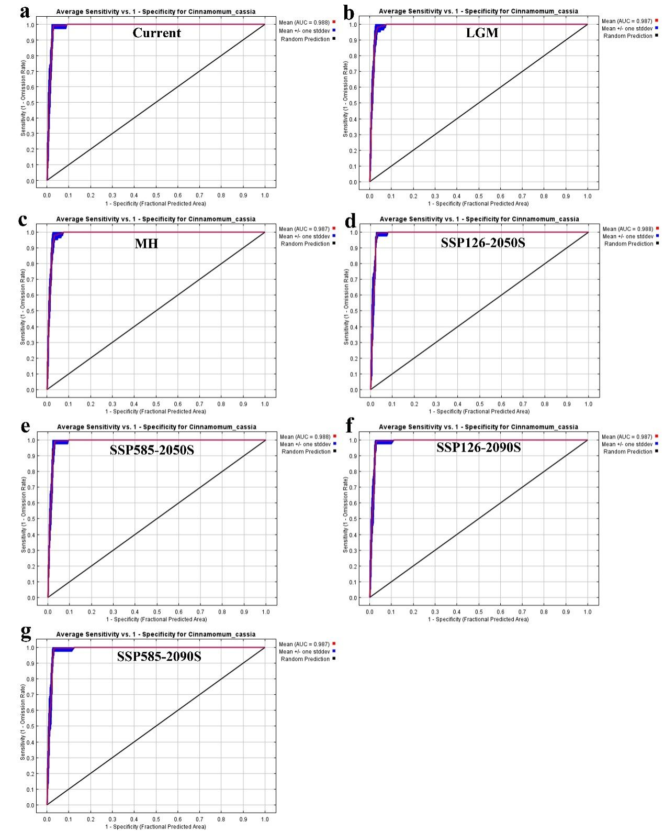
Fig. S3. The average receiver operating characteristic (ROC) curve of the training set and test set of the model in different climate scenarios.

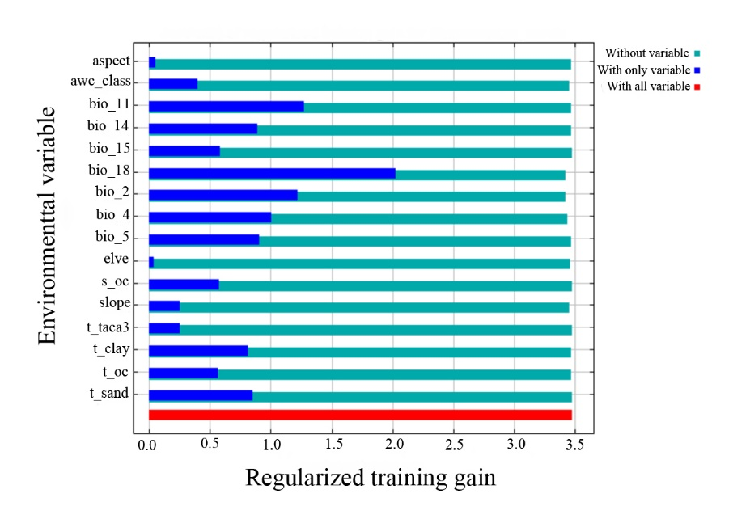

Fig. S4. Results of the jackknife test of variables’ contribution in modelling potentive distribution of C. cassia.

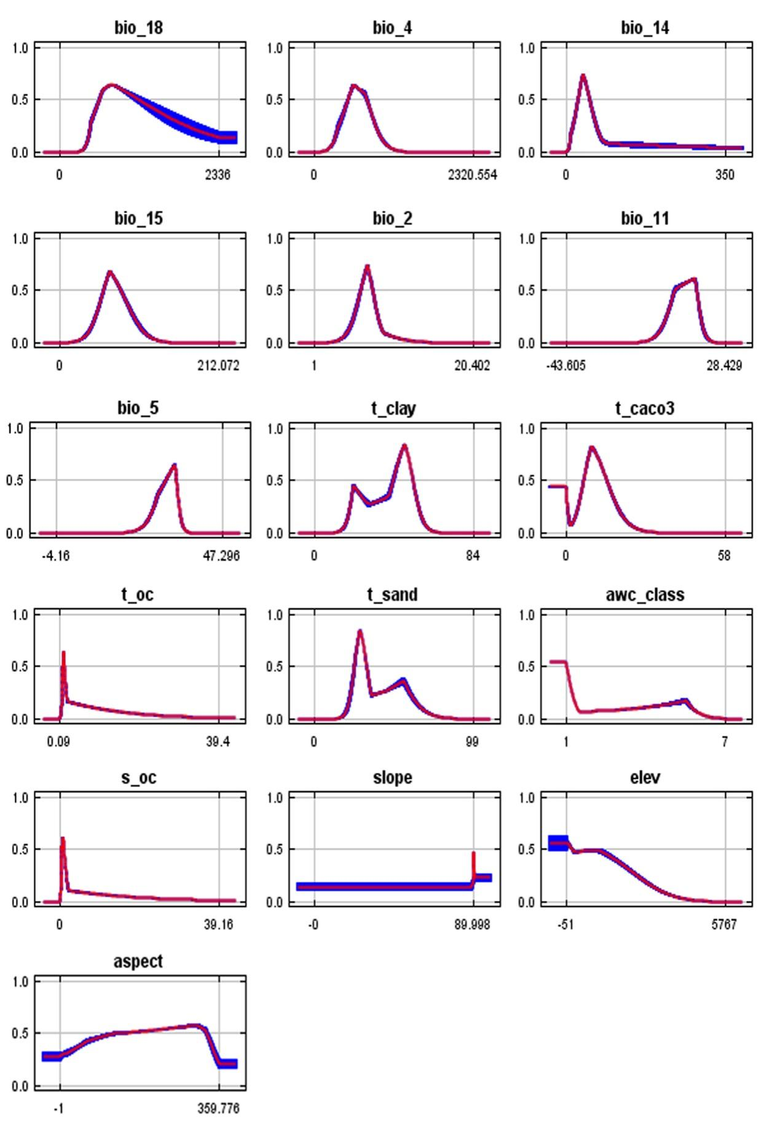
Fig. S5. The response curves of 16 environment variables.

Table S1 The 158 valid occurrence records of C. cassia.
No. | Occurrence records | Longitude | Latitude | Specimen ID |  | Gatherer | Time | Information sources
1 | Huang Mount, Anhui, China | 118.1476 | 30.27865 | Unknown | Unknown |  | 197907 | NSII
2 | Southern Anhui, China | 117.3305 | 31.73429 | 30144 | Unknown |  | 195008 | CVH
3 | Beijing, China | 116.3855 | 39.87128 | BJTC037871 | Unknown |  | Unknown | CVH
4 | Biological Park of Beijing Normal University, Haidian District, Beijing, China | 116.3054 | 39.96549 | Unknown | Q.R. Liu |  | 200806 | NSII
5 | Yongtai County, Fuzhou, Fujian, China | 118.9384 | 25.87279 | 11 | Provincial Southern Medicine Team |  | 197606 | NSII
6 | Maodi Town, Yangping District, Nanping, Fujian, China | 118.0867 | 26.70884 | 296 | Q.J. Wang |  | 195508 | CVH
7 | Anxi County, Quanzhou, Fujian, China | 118.1924 | 25.06176 | 2363 | Fujian Comprehensive Examination Tam |  | 196505 | NSII
8 | Xiamen, Fujian, China | 118.0964 | 24.48541 | 245 | G.D. Ye |  | 197703 | NSII
9 | Tongan County, Xiamen, Fujian, China | 118.1586 | 24.72911 | 7 | Provincial Southern Medicine Team |  | 197605 | NSII
10 | Fuzhou Arboretum, Fujian, China | 119.3035 | 26.08043 | 1186 | G.G. Tang |  | 198901 | CVH
11 | Xianfeng Ling, Wuyi Mount, Nanping, Fujian, China | 117.6672 | 27.7128 | 10144 | J.Y. Liu |  | 198208 | CVH
12 | Jinshan Forest Farm, Hua’an County, Zhangzhou, Fujian, China | 117.52 | 24.92372 | Unknown | D.W. Guo, H.S. Pan |  | 198005 | NSII
13 | Lingtong, Da xi town, Pinghe County, Zhangzhou, Fujian, China | 117.1534 | 24.1613 | ZXF38121 | X.F. Zeng |  | 201807 | CVH
14 | Jinxingxiang Forest Farm, Zhao’an County, Zhangzhou, Fujian, China | 117.2679 | 23.76531 | 22 | Provincial Southern Medicine Team |  | 197606 | CVH
15 | Jinshan Forest Farm, Hua’an County, Zhangzhou, Fujian, China | 117.519 | 24.92399 | 0094 | G.S. He |  | 197911 | NSII
16 | Nanjing County, Zhangzhou, Fujian, China | 117.3634 | 24.52085 | 6177 | W.X. Li, B.L. Liu |  | 200706 | NSII
17 | South China Botanical Garden, Guangzhou, Guangdong, China | 113.2714 | 23.13534 | 3489 | X.Q. Liu, C.X. Zeng |  | 199804 | NSII
18 | Gaoyao District, Zhaoqing, Guangdong, China | 112.4648 | 23.03098 | 0144 | L.D. Qiu |  | 195606 | NSII
19 | Danzhai County, Qiandongnan Miao and Dong Autonomous Prefecture, Guizhou, China | 107.7955 | 26.20442 | H-黔丹寨-Z-064 | T.R. Cheng, Q.Y. Zhang, et al. |  | 201104 | NSII
20 | Anlong County, Qiannan Buyi and Miao Autonomous Prefecture, Guizhou, China | 105.4495 | 25.10399 | 049 | Anshun Team |  | 195907 | NSII
21 | Doupeng Mount, Guiyang, Guizhou, China | 106.6047 | 26.62258 | 200811012 | D.K. Wang |  | 200806 | CVH
22 | Liping County, Qiandongnan Miao and Dong Autonomous Prefecture, Guizhou, China | 109.1436 | 26.23687 | 52263120190823751LY | Q.R. Li |  | 201908 | NSII
23 | MaolanGuo, Libo County, Qiannan Buyi and Miao Autonomous Prefecture, Guizhou, China | 107.9561 | 25.24537 | 20183152 | J.J. Li |  | 201804 | CVH
24 | Taohuayuan Village, Wuluo Town, Songtao County, Guizhou, China | 108.8005 | 27.95975 | 522229141016717LY | J. Li |  | 201410 | CVH
25 | Lao Lingou, Renhuai, Zunyi, Guizhou, China | 106.4075 | 27.79775 | MT461 | Z.X. Zhao |  | 201103 | NSII
26 | Xishui County, Zunyi, Guizhou, China | 106.2034 | 28.33912 | 520330160428017 LY | F.G. Zhao |  | 201604 | NSII
27 | Chinese Academy of Tropical Agricultural Sciences, Dan County, Danzhou, Hainan, China | 109.5104 | 19.51804 | 2829 | Ministry of Science and Technology |  | 199403 | CVH
28 | Jianfeng Hill, Dongfang, Hainan, China | 108.6586 | 19.1011 | 7652 | B.M. Zhang |  | 195105 | NSII
29 | Jianfeng, Ledong Li Autonomous County,Hainan, China | 108.9092 | 18.73047 | 990222 | S.X. Huang |  | 199905 | CVH
30 | Dalao Mount, Yichang, Hubei, China | 110.9313 | 31.0723 | YC-109 | X.Y. Mu |  | 200805 | NSII
31 | Jiugong Mountain, Tongshan County, Xianning, Hubei, China | 114.6615 | 29.39698 | 081 | J. Wang |  | 200006 | NSII
32 | Xinning County, Shaoyang, Hunan, China | 110.8635 | 26.43972 | Unknown | S.L. Wang |  | 195611 | NSII
33 | Baisha Township, Yizhang County, Bangzhou, Hunan, China | 112.9058 | 25.10252 | 233 | W.C. Chen |  | 198605 | CVH
34 | Tianzi Mount, Wulingyuan District, Zhangjiajie, Hunan, China | 110.4503 | 29.40724 | 715 | X.B. Yin |  | 200209 | CVH
35 | Shuangpai County, Yongzhou, Hunan, China | 111.6676 | 25.96717 | 20010337 | J.X. Li, Q.H. Xu |  | 200104 | NSII
36 | Yanling County, Zhuzhou, Hunan, China | 113.7794 | 26.49606 | LXP13--4367 | Y. Liu, et al. |  | 201307 | NSII
37 | Gulou District, Nanjing, Jiangsu, China | 118.7765 | 32.07241 | Unknown | Unknown |  | Unknown | NSII
38 | Zhongshan Botanical Garden System Garden, Xuanwu District, Nanjing, Jiangsu, China | 118.8044 | 32.05476 | 05157 | Q.X. Liu, et al. |  | 200505 | NSII
39 | You Mount, Xinfeng County, Ganzhou, Jiangxi, China | 114.7116 | 25.41453 | Unknown | X.L. Wu |  | 198307 | CVH
40 | Xinfeng County, Ganzhou, Jiangxi, China | 114.9295 | 25.39198 | LXP-13-15595 | W.B. Liao, et al. |  | 201409 | NSII
41 | Yongxin County, Jian, Jiangxi, China | 114.2494 | 26.95154 | Lxp-13-07714 | W.Y. Zhao, et al. |  | 201504 | NSII
42 | Fuliang County, Jingdezhen, Jiangxi, China | 117.2215 | 29.35779 | 933 | C. Chen, Q.H. Li |  | 195905 | NSII
43 | Under forest near South Tianmen, Dajue Mount, Zixi County, Fuzhou, Jiangxi, China | 117.1499 | 27.70274 | F389 | C. Fu |  | 201606 | CVH
44 | Qiyun Mount Nature Reserve, Sishun Township, Chongyi County, Ganzhou, Jiangxi, China | 114.0444 | 25.83515 | LXP03-05452 | Y.Y. Cong |  | 201408 | CVH
45 | Tianhua Mount, Guixi, Yingtan, Jiangxi, China | 117.3211 | 27.96218 | 03832 | M.X. Nie, S.S. Lai |  | 195807 | NSII
46 | Emei Mount, Leshan, Sichuan, China | 103.4916 | 29.60698 | 060803019 | H.P. Chen |  | 200608 | NSII
47 | Shigang Forest farm, Luzhou, Sichuan, China | 105.3992 | 29.17501 | 801437-03 | Z.Y. Liu |  | 198007 | NSII
48 | Nanxi District, Yibin, Sichuan, China | 104.9203 | 28.96665 | Unknown | Ying |  | Unknwon | CVH
49 | Shigang Forest farm, Pingshan County, Yibin, Sichuan, China | 103.7145 | 28.62764 | 0126 | Luxian Team |  | 197706 | CVH
50 | Taiwan, China | 121.5746 | 25.04094 | 981 | Chih-Hui Chen |  | 199107 | NSII
51 | HongKong, China | 114.1768 | 22.30918 | Unknwon | Ford |  | Unknown | CVH
52 | Funing County, Yunnan, China | 105.6375 | 23.63138 | 5326281603040716LY | Funing census team |  | 201603 | NSII
53 | Hekou County, Yunnan China | 103.967 | 22.51532 | 87510 | B.Q. Cheng |  | 198705 | NSII
54 | Malipo County, Yunnan, China | 104.7096 | 23.13159 | 5326240215 | Malipo census team |  | 201603 | NSII
55 | Maguan County, Yunnan, China | 104.4004 | 23.01899 | 5326250299 | Maguan County census team |  | 201505 | NSII
56 | Pingbian County, Yunnan, China | 103.6822 | 22.99482 | 5325231232 | Pingbian county Chinese medicine resources survey team |  | 201209 | NSII
57 | Jiangcheng County, Puer, Yunnan, China | 100.9726 | 22.83098 | 5308260328 | Jiangcheng County census team |  | 201206 | NSII
58 | Jinggu County, Puer, Yunnan, China | 100.6288 | 23.74012 | YN2429 | Z.X. Peng |  | 200703 | NSII
59 | Menglian County, Puer, Yunnan, China | 99.59087 | 22.33536 | YN2426 | J.K. Ye |  | 200703 | NSII
60 | Ruili, Yunnan, China | 97.86249 | 24.02282 | 1326 | J.S. Yang |  | 195411 | NSII
61 | Jinghong, Yunnan, China | 100.8064 | 22.017 | 00769 | S.R. Guo |  | Unknown | NSII
62 | Mengwang, Yunnan, China | 101.3003 | 22.495 | 19741103 | X.W. Ren |  | 197411 | NSII
63 | Dameonglong, Jinghong County, Xishuangbanna Prefecture, Yunnan, China | 100.6864 | 21.58614 | Unknown | S.R. Guo |  | Unknown | CVH
64 | Tropical Botanical Garden, Menglun Town, Mengla County, Xishuangbanna Prefecture, Yunnan, China | 101.263 | 21.9316 | 19402 | J.Y. Cui |  | 197911 | CVH
65 | Tangcun Town, Chun 'an County, Hangzhou, Zhejiang, China | 118.8632 | 29.81091 | 54 | Chun 'an County drug census team |  | 196010 | NSII
66 | Tianmu Mount, Lin’an District, Hangzhou, Zhejiang, China | 119.4365 | 30.35379 | 29099 | L.S. Que |  | 195908 | NSII
67 | Yin County, Haishu District, Ningbo, Zhejiang, China | 121.4733 | 29.83839 | 134 | Ningbo medicinal materials resources survey team |  | 196009 | NSII
68 | Tiantong Village, Ningbo, Zhejiang, China | 121.7846 | 29.7938 | 28757 | Zhejiang plant resources survey team |  | 195908 | NSII
69 | Lingyin Tao Guang Temple, Xihu District, Hangzhou, Zhejiang, China | 120.1073 | 30.24708 | 3828 | R.Q. Hu, Z.H. Lin, et al. |  | 197305 | CVH
70 | Siyan well, Xihu District, Hangzhou, Zhejiang, China | 120.1423 | 30.22178 | 59 | Lu |  | Unknown | CVH
71 | Yuhuang Mount, Xihu District, Hangzhou, Zhejiang, China | 120.1615 | 30.22488 | 39 | Wang |  | Unknown | CVH
72 | Yunxi, Xihu District, Hangzhou, Zhejiang, China | 120.0942 | 30.1355 | 1398 | Unknown |  | 196109 | CVH
73 | Siming Mount, Yuyao, Ningbo, Zhejiang, China | 121.0929 | 29.73133 | 7557 | Unknown |  | Unknown | CVH
74 | Kaihua County, Quzhou, Zhejiang, China | 118.4215 | 29.14319 | 3189 | Unknown |  | 196410 | CVH
75 | Siming Mount, Zhejiang, China | 120.9925 | 29.63902 | 399 | Unknown |  | 196009 | NSII
76 | Leqing County, Wenzhou, Zhejiang, China | 120.9925 | 28.11818 | 3268 | Unknown |  | 196009 | NSII
77 | Shanmen Town, Pingyang County, Wenzhou, Zhejiang, China | 120.2474 | 27.64026 | 4745 | Unknown |  | 196010 | NSII
78 | Taishun County, Wenzhou, Zhejiang, China | 119.7235 | 27.56217 | 8191 | Unknown |  | 196205 | NSII
79 | Jinfo Mountain National Nature Reserve, Nanchuan District, Chongqing, China | 107.1345 | 29.05536 | 19186 | Z.Y. Liu |  | 199605 | NSII
80 | Maoqiao, Qingxiu District, Nanning, Guangxi, China | 108.3692 | 22.84029 | Unknown | D.M. Su |  | 198307 | NSII
81 | Daming Mount, Shanglin County, Nanning, Guangxi, China | 108.446 | 23.50232 | D3401 | L. Wu, J.C. Yang |  | 201110 | NSII
82 | Jinxiu County, Laibin, Guangxi, China | 110.1953 | 24.13598 | 18567 | M.S. Wei, Y.F. Huang |  | 200805 | NSII
83 | Daxin County, Chongzuo, Guangxi, China | 107.2076 | 22.83623 | 7693 | X.C. Huang |  | 197808 | NSII
84 | Luocheng County, Guangxi, China | 108.9116 | 24.78308 | 451225130430032LY | Luocheng County census team |  | 201304 | NSII
85 | Longzhou County, Guangxi, China | 106.8606 | 22.3483 | 16 | H.X. Qiu |  | 197610 | NSII
86 | Mian Liang Village, Napo County, Baise, Guangxi, China | 105.6126 | 23.14624 | 451026121227067LY | H.Z. LV, Y.D. Peng, et al. |  | 201212 | NSII
87 | Ningming, Guangxi, China | 107.0835 | 22.14589 | 451422130122002LY | D.X. Nong, X.Y. Huang, et al. |  | 201301 | NSII
88 | Rongshui County, Guangxi, China | 109.1745 | 25.39539 | Y2133 | Yuanbao Mount comprehensive expedition team |  | 200511 | NSII
89 | Yangshuo County, Guangxi, China | 110.5035 | 24.78452 | A60805 | S.Q. Zhong |  | 195609 | NSII
90 | Dongxing, Guangxi, China | 107.9775 | 21.55361 | 81876 | Institute of plant Sciences |  | 197211 | NSII
91 | Debao County, Guangxi, China | 106.6216 | 23.32899 | 602090 | Z.T. Li |  | 195812 | NSII
92 | Pingle County, Guangxi, China | 110.6495 | 24.63963 | 402300 | Y.K. Li |  | 195810 | NSII
93 | Zhaoping County, Guangxi, China | 110.8176 | 24.17511 | 4321 | C.C. Jiang, M.S. Xia |  | 195708 | NSII
94 | Jingxi County, Guangxi, China | 106.4245 | 23.14013 | 810 | Y.C. Chen |  | 195811 | NSII
95 | Teng County, Guangxi, China | 110.9366 | 23.37654 | 11562 | S.Y. Li |  | 196011 | NSII
96 | Bobai County, Guangxi, China | 109.9826 | 22.27868 | 16139 | F.Q. Chen |  | 196011 | NSII
97 | Qinbei District, Guangxi, China | 108.6385 | 22.02037 | 450703141211016LY | H. Zhu, Z.N. Liang, et al. |  | 201412 | NSII
98 | Tianlin County, Guangxi, China | 106.2345 | 24.30054 | 451029121019009 | Tianlin census team |  | 201210 | NSII
99 | Babu District, Hezhou, Guangxi, China | 111.5586 | 24.41753 | 451102121122025LY | Q.B. Wu |  | 201211 | NSII
100 | Youjiang District, Baise, Guangxi, China | 106.1573 | 23.62751 | 451002140718014LY | Youjiang District census Team |  | 201407 | NSII
101 | Jiangzhou District, Chongzuo, Guangxi, China | 107.5504 | 22.76058 | 451402150913075LY | Y.D. Peng, Y.Y. Xie, et al. |  | 201509 | NSII
102 | Tiandong County, Guangxi, China | 107.1325 | 23.60313 | 451022151217014LY | Tiandong collection team |  | 201512 | NSII
103 | Pangyu Village, Pingguo County, Guangxi, China | 107.6394 | 23.74543 | 451023150327051LY | H.Z. Lv, Y. Lin, et al. |  | 201503 | NSII
104 | Longsheng Various Nationalities Autonomous County, Guangxi, China | 110.0182 | 25.80385 | 1-2369 | S.X. Li, Z.H. Huang |  | 198106 | NSII
105 | Darong Mount, Beiliu, Guangxi, China | 110.2897 | 22.8597 | Unknown | Unknown |  | 1955 | NSII
106 | Hepu County, Guangxi, China | 109.2136 | 21.6677 | 809292 | J.X. Zhong |  | 195212 | NSII
107 | Pingtianshan National Forest Park, Gangbei District, Guigang, Guangxi | 109.4751 | 23.17768 | 450802190518006LY | Z.H. Ma, H.F. Xu, et al. |  | 201905 | NSII
108 | Shaping Village, Zhongshan County, Guangxi, China | 111.1515 | 24.71687 | 451122170720033LY | Zhongshan County census team |  | 201707 | NSII
109 | Dajing Village, Luobu Town, Liubei District, Liuzhou, Guangxi | 109.4996 | 24.44285 | 450205200813037LY | Liubei District census team |  | 202008 | CVH
110 | Longtang Village, Lingjiao Town, Cangwu County, Wuzhou, Guangxi, China | 111.1802 | 23.7796 | 450421200729059LY | Cangwu County census team |  | 202007 | CVH
111 | Pulong Mount, Tongmian Town, Ningming County, Guangxi, China | 107.3156 | 21.81924 | 451422130122002LY | D.X. Nong, X.Y. Huang, et al. |  | 201301 | CVH
112 | Guangxi Institute of Botany, Yanshan, Guilin, Guangxi, China | 110.3124 | 25.08299 | 1506 | C.M. Tan, G.H. Yi |  | 200112 | CVH
113 | Gaofeng Forest farm, Wuming District, Guangxi | 108.5229 | 23.12837 | Unknown | S.M. Xian |  | 198308 | CVH
114 | Lingui District, Guangxi, China | 110.0732 | 25.54677 | 700129 | H.F.Qing |  | 195704 | CVH
115 | G207 (Cencang Road), Cenxi City, Wuzhou, Guangxi, China | 111.619 | 23.79 | 211215 | L.M. Pang |  | 2021.12.25 | NSII
116 | Pingzheng Xindu village, Tengzhou Town, Wuzhou Teng County, Guangxi, China | 110.5235 | 23.1839 | 211218 | L.M. Pang |  | 2022.01.03 | NSII
117 | Guigang, Guangxi, China | 108.222 | 22.5118 | 211219 | L.M. Pang |  | 2022.02.19 | NSII
118 | Guiping Langshi village, Guigang, Guangxi, China | 108.2975 | 23.0369 | 211221 | Y.Q. Li, Y. Yang, et al. |  | 2022.01.03 | NSII
119 | Distribution operation and maintenance class of Matong, Guigang, Guangxi, China | 110.1556 | 23.14726 | 211222 | Y.Q. Li, Y. Yang, et al. |  | 2022.06.27 | NSII
120 | Xiagaotian, Guigang, Guangxi, China | 110.4002 | 23.65611 | 211223 | Y.Q. Li, Y. Yang, et al. |  | 2022.06.26 | NSII
121 | Sijiuding, Cenxi, Guangxi, China | 111.1422 | 22.89857 | 211225 | Y.Q. Li, Y. Yang, et al. |  | 2022.07.04 | NSII
122 | Jinzhu town gas station, Cenxi, Guangxi, China | 110.3616 | 23.10722 | 211224 | Y.Q. Li, Y. Yang, et al. |  | 2022.07.04 | NSII
123 | Daan Town, Pingnan County, Guangxi, China | 110.5218 | 23.38868 | 211237 | Y.Q. Li, Y. Yang, et al. |  | 2022.07.02 | NSII
124 | Daan Town, Pingnan County, Guangxi, China | 110.5218 | 23.38868 | 211237 | Y.Q. Li, Y. Yang, et al. |  | 2022.07.02 | CVH
125 | Shexue Village, Longyu District, Wuzhou, Guangxi, China | 111.312 | 23.39349 | 211241 | Y.Q. Li, Y. Yang, et al. |  | 2022.07.02 | NSII
126 | 358 National Road Jinmao Titanium dioxide Co., LTD,Tengzhou Town, Teng County, Wuzhou, Guangxi, China | 113.2714 | 23.13534 | 211242 | Y.Q. Li, Y. Yang, et al. |  | 2022.07.02 | NSII
127 | Shatin Central Primary School, Songshan Town, Rongxian County, Guangxi, China | 110.4856 | 22.93692 | 211243 | Y.Q. Li, Y. Yang, et al. |  | 2022.07.02 | NSII
128 | Yongan,Shihua, Xingda, Yulin, Guangxi, China | 109.1686 | 22.31263 | 211244 | Y.Q. Li, Y. Yang, et al. |  | 2022.07.05 | NSII
129 | Shatian, Qinzhou, Guangxi, China | 109.6556 | 22.34476 | 211247 | Y.Q. Li, Y. Yang, et al. |  | 2022.07.05 | NSII
130 | Banshangtang, Qinzhou, Guangxi, China | 108.9066 | 22.38393 | 211248 | Y.Q. Li, Y. Yang, et al. |  | 2022.08.04 | NSII
131 | Institute of plant Sciences, Guangxi, China | 110.3124 | 25.08299 | 211249 | Y.Q. Li, Y. Yang, et al. |  | 2022.08.17 | NSII
132 | Damu, Fangchenggang, Guangxi, China | 107.892 | 21.80154 | 211251 | Y.Q. Li, Y. Yang, et al. |  | 2022.08.18 | SCAUB
133 | Zhongjiandong, Fangchenggang, Guangxi, China | 108.2069 | 21.95818 | 211252 | Y.Q. Li, Y. Yang, et al. |  | 2022.08.19 | SCAUB
134 | Jianshi Mount, Guilin, Guangxi, China | 110.175 | 24.65444 | 211254 | Y.Q. Li, Y. Yang, et al. |  | 2022.08.30 | SCAUB
135 | Dongfengzu, Longsheng Town, Beiliu, Guangxi, China | 110.4452 | 22.56657 | 211256 | L.M. Pang |  | 2022.09.15 | SCAUB
136 | Dongyou, Hechi, Guangxi, China | 107.2984 | 24.17524 | 211257 | L.M. Pang |  | 2022.09.18 | SCAUB
137 | Lingliu Road, Lingjiao Town, Teng County, Wuzhou, Guangxi, China | 110.9905 | 23.58406 | 211258 | Y.Q. Li, Y. Yang, et al. |  | 2022.09.25 | SCAUB
138 | Fuxin Town, Zuotiandeng County, Guangxi, China | 106.9366 | 22.94459 | 211262 | L.M. Pang |  | 2022.10.05 | SCAUB
139 | Rongshui 112 Township Road, Liuzhou City, Guangxi | 108.9837 | 25.21572 | 211264 | L.M. Pang |  | 2022.12.15 | SCAUB
140 | Napo, Baise, Guangxi, China | 105.9537 | 22.96227 | 211265 | L.M. Pang |  | 2023.01.08 | SCAUB
141 | Pingtou Gang Liangtang Village, Hehua Town, Gaozhou, Maomin, Guangdong, China | 110.7393 | 22.73926 | 211266 | H.Y. Bai |  | 2022.06.19 | SCAUB
142 | Jiangzui, Jiuqin Town, Deqin, Guangdong, China | 111.988 | 23.14362 | 211267 | Y.Q. Li, Y. Yang, et al. |  | 2022.06.12 | SCAUB
143 | 321 National Highway, Shunde Restaurant, Deqing, Guangdong, China | 112.2276 | 23.12048 | 211268 | Y.Q. Li, Y. Yang, et al. |  | 2022.06.12 | SCAUB
144 | 624 Provincial Highway,Gaoyao, Guangdong, China | 112.3348 | 23.30541 | 211270 | Y.Q. Li, Y. Yang, et al. |  | 2022.06.12 | SCAUB
145 | Tanbin Town central Primary school, Luoding, Guangdong, China | 111.4077 | 22.82125 | 211283 | Y.Q. Li, Y. Yang, et al. |  | 2022.06.11 | SCAUB
146 | Gutian, 352 Provincial Road, Xinyi, Guangdong, China | 110.9854 | 22.57749 | 211284 | Y.Q. Li, Y. Yang, et al. |  | 2022.06.10 | SCAUB
147 | 500m in front of 621 County Road Base, Xinyi, Guangdong, China | 111.1357 | 22.4633 | 211286 | Y.Q. Li, Y. Yang, et al. |  | 2022.06.10 | SCAUB
148 | Chetian, Xinyi, Guangdong, China | 111.1333 | 22.46536 | 211288 | Y.Q. Li, Y. Yang, et al. |  | 2022.06.10 | SCAUB
149 | Jiazhou, Yunan, Guangdong, China | 111.7685 | 23.0471 | 211293 | Y.Q. Li, Y. Yang, et al. |  | 2022.06.11 | SCAUB
150 | Shangluojia, Huaiji, Guangdong, China | 112.069 | 23.82417 | 211297 | Y.Q. Li, Y. Yang, et al. |  | 2022.07.01 | SCAUB
151 | 451 County Road, Fengkai, Guangdong, China | 111.6054 | 23.48387 | 211298 | Y.Q. Li, Y. Yang, et al. |  | 2022.07.01 | SCAUB
152 | Fuluchong, Deqin, Guangdong, China | 113.991 | 23.11006 | 211300 | Y.Q. Li, Y. Yang, et al. |  | 2022.07.01 | SCAUB
153 | Hongyang, Puning, Jieyang, Guangdong, China | 116.2399 | 23.43348 | 211302 | Y.Q. Li |  | 2022.08.17 | SCAUB
154 | No.91, Sanye Road, Jinghong, Xishuangbanna, Yunnan, China | 100.4717 | 22.021 | 211303 | L.M. Pang |  | 2022.06.25 | SCAUB
155 | Baizhai Town, Maguan County, Yunshan, Yunnan, China | 104.0712 | 23.01187 | 211304 | L.M. Pang |  | 2022.06.21 | SCAUB
156 | Zhongfang County, Huaihua, Hunan, China | 109.945 | 27.43988 | 211306 | Y. Yang |  | 2022.05.29 | SCAUB
157 | Haoli Village, Shatain Town, Guidong County, Chenzhou, Hunan, China | 113.8254 | 25.84374 | 211307 | Y.Q. Li |  | 2022.08.12 | SCAUB
158 | Banqiao Town, Enshi, Hubei, China | 109.2802 | 30.58818 | 211308 | Y.Q. Li |  | 2022.08.08 | SCAUB
NSII: National Specimen Information Infrastructure; CVH: Chinese Virtual Herbarium. SCAUB: Herbarium of the Department of Botany at South China Agricultural University

Table S2 Percentage percent contribution and permutation importance of 33 environment variables.
Variable |  | Description | Percent contribution（%） | Permutation importance (%) | Units
Bioclimatic variables | Bio_18 | Precipitation of warmest quarter | 55 | 11.2 | mm
Bioclimatic variables | Bio_4 | Temperature seasonality | 20.9 | 1.6 | -
Bioclimatic variables | Bio_13 | Precipitation of wettest month | 13.2 | 41.6 | mm
Bioclimatic variables | Bio_14 | Precipitation of driest month | 3.1 | 9.3 | mm
Bioclimatic variables | Bio_15 | Precipitation seasonality | 2.3 | 1.4 | -
Bioclimatic variables | Bio_2 | Mean diurnal range | 1.2 | 2.9 | ℃
Bioclimatic variables | Bio_5 | Max temperature of warmest month | 1.1 | 2.4 | ℃
Bioclimatic variables | Bio_11 | Mean temperature of coldest quarter | 1.1 | 3.7 | ℃
Bioclimatic variables | Bio_10 | Mean temperature of warmest quarter | 0.7 | 13.5 | ℃
Bioclimatic variables | Bio_1 | Annual mean temperature | 0.5 | 0.8 | ℃
Bioclimatic variables | Bio_6 | Min temperature of coldest month | 0.5 | 1.4 | ℃
Bioclimatic variables | Bio_7 | Temperature annual range | 0.1 | 0.1 | ℃
Bioclimatic variables | Bio_19 | Precipitation of coldest quarter | 0.1 | 1 | mm
Bioclimatic variables | Bio_8 | Mean temperature of wettest quarter | 0 | 0 | ℃
Bioclimatic variables | Bio_16 | Precipitation of wettest quarter | 0 | 1.4 | mm
Bioclimatic variables | Bio_17 | Precipitation of driest quarter | 0 | 1.6 | mm
Bioclimatic variables | Bio_3 | Isothermality | 0 | 0.8 | 1
Bioclimatic variables | Bio_12 | Annual precipitation | 0 | 0.5 | mm
Bioclimatic variables | Bio_9 | Mean temperature of driest quarter | 0 | 0 | ℃
Soil variables | T_clay | Topsoil clay content | 20.5 | 18.6 | % weight
Soil variables | T_oc | Topsoil organic carbon | 14.9 | 15.5 | % weight
Soil variables | T_sand | Topsoil sand content | 11.7 | 2.1 | % weight
Soil variables | S_clay | Substratesoil clay content | 11 | 3 | % weight
Soil variables | Awc_class | Soil available water content | 10.7 | 2.4 | -
Soil variables | T_caco3 | Topsoil carbonate or lime content | 8.3 | 8.8 | % weight
Soil variables | S_ph_h2o | Substratesoil pH | 7.8 | 11.6 | -
Soil variables | S_oc | Substratesoil organic carbon | 7.6 | 17.3 | % weight
Soil variables | T_ph_h2o | Topsoil pH | 5 | 8.9 | -
Soil variables | S_caco3 | Substratesoil carbonate or lime content | 2.1 | 5.1 | % weight
Soil variables | S_sand | Substratesoil sand content | 0.5 | 6.8 | % weight
Topographic variables | Slope | Slope | 49.9 | 46.1 | °
Topographic variables | Elev | Elevation | 36.1 | 42 | m
Topographic variables | Aspect | Aspect | 14 | 11.9 | °

Table S3 Maximum test sensitivity plus specificity (MTSPS) of different climate scenarios.
Periods | LGM | MH | Current | SSP126-2050S | SSP585-2050S | SSP126-2090S | SSP585-2090S
MTSPS | 0.1756 | 0.1756 | 0.2194 | 0.1638 | 0.1849 | 0.2274 | 0.2290

