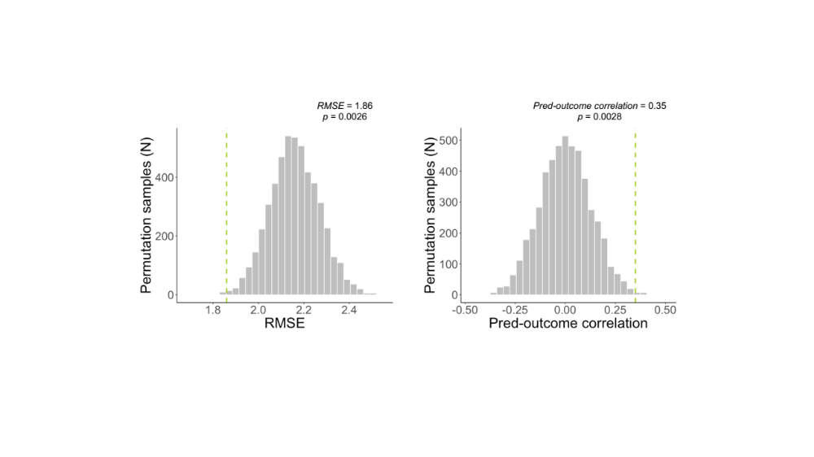

Supplementary figure 1. Results of the permutation test (Study 1). Delay discounting values were randomly permuted, and predictions were generated from 5000 randomly permuted samples to provide null distributions for standard metrics assessing the accuracy of prediction. The mean squared error (MSE) and mean absolute error (mean abs error) are shown in Figure 2. Here, we show results for complementary metrics: root mean squared error (RMSE) and prediction-outcome correlation. Histograms of null distribution are shown in gray bars, and the observed metrics are indicated by the green dotted lines.

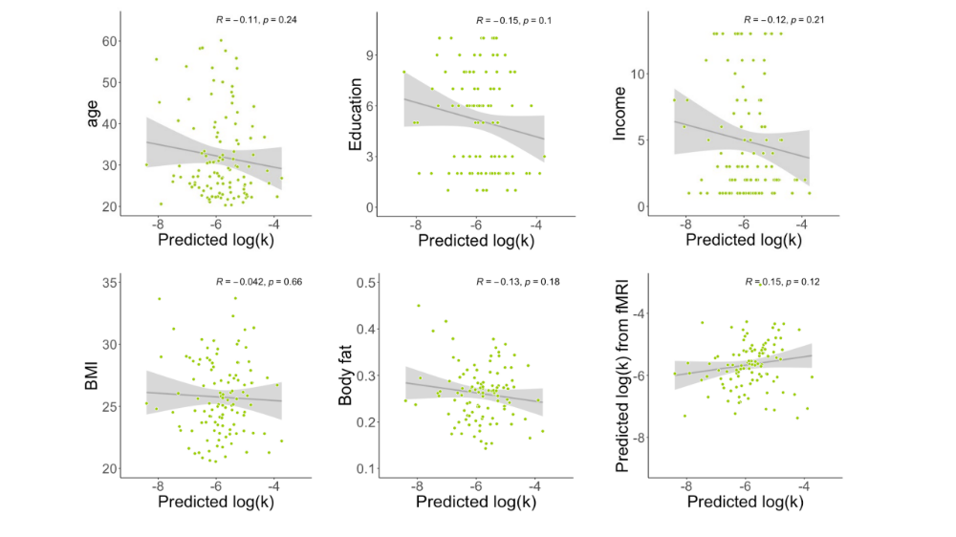

Supplementary figure 2. Correlations between log(k) predicted by the structural brain pattern and other individual characteristics in Study 1. The selected characteristics of interest are demographic variables and BMI / body fat which have previously been related to delay discounting. Moreover, we tested the correlation between individual brain responses of the fMRI-based brain marker of log(k) and individual brain responses of the structural MRI-based brain marker of log(k) (see bottom right-hand corner).
Supplementary Table 1. Demographical and main neuropsychological measures of bvFTD patients and controls. Data are given as Mean (SD). BvFTD patients: N= 24 / Controls: N= 18; FAB: Frontal Assessment Battery; Hayling – error: objective measure of inhibition deficit from the Hayling Sentence Completion Test; MMSE: Mini-Mental State Examination; DRS: Dementia Rating Scale; SAS: Starkstein Apathy Scale; HADS: Hospital Anxiety and Depression Scale.

 | bvFTD | Controls | bvFTD vs controls
% Women | 33.3% | 55.6% | $χ^{2}$ = 1.3 ; p = 0.26
Age | 66.6 (8.3) | 62.6 (7.2) | t = 1.6 ; p = 0.11
Education level | 6.3 (1.9) | 7.2 (1.0) | t = -2.0 ; p = 0.05
Hayling - error | 19.2(13.2) | 3.1(2.6) | t = 5.7 ; p < .001
FAB (/18) | 12.2 (3.3) | 17.3 (0.8) | t = -7.3 ; p < .001
MMSE (/30) | 23.8 (2.7) | 29.4 (0.8) | t = -9.7 ; p < .001
DRS (/144) | 118.5 (9.1) | 142.2 (1.3) | t = -12.6 ; p < .001
SAS (/42) | 16 (4.7) | 5.7 (3.1) | t = 8.5 ; p < .001
HADS-Anxiety (/21) | 7.7 (4.6) | 4.2 (2.4) | t = 3.2 ; p = 0.003
HADS-Depression (/21) | 1.2 (1.0) | 5.8 (3.2) | t = 6.5 ; p < .001

Supplementary Table 2. Significant positive and negative weights contributing to the structural brain marker predicting delay discounting in Study 1. Only FDR-corrected clusters (q < 0.05 across the whole brain), with at least three contingent voxels are listed. X, Y, Z are the MNI coordinates of the local maxima. In the column ‘Atlas label’, regions are labeled based on Harvard-Oxford structural atlas. Most important significant clusters (in terms of size) are indicated in italics.

Positive weights

Atlas label | X | Y | Z | Volume (voxels) | max(Z)
Right lingual gyrus | 14 | -51 | -2 | 96 | -0.0023203
Right precuneous cortex | 16 | -66 | 38 | 8 | -0.0034364
Right Frontal pole | 28 | 46 | 38 | 3 | -0.0016211

Negative weights

Atlas label | X | Y | Z | Volume (voxels) | max(Z)
Left lateral occipital cortex | -30 | -74 | 28 | 82 | 0.0032081
Left supramarginal gyrus | -46 | -48 | 45 | 36 | 0.0032853
Left supramarginal gyrus | -58 | -44 | 20 | 11 | 0.0027848
Right lingual gyrus | 12 | -78 | -9 | 7 | 0.0022673
Right precuneous cortex | 10 | -56 | 36 | 3 | 0.0031411
Precentral gyrus | 0 | -22 | 69 | 3 | 0.0014893

