Descriptive Analysis of Good Clinical Practice Inspection Findings from the Saudi Food and Drug Authority
Supplementary
Omaima O. Arab
2024
Contents
Table 1: GCP inspection findings by deficiency areas 3
Table 2: Grading deficiencies and definitions 4
Table 3: GCP Distribution of findings at clinical investigator site inspections 9
Table 4: GCP distribution of findings at CRO inspections 10
Table 5: GCP distribution of findings at BE inspections 11
Table 6: GCP distribution of findings at Phase I units inspections 12

Figure 1: Good Clinical Practice visits and observation (findings) 5
Figure 2: Number of planned inspections visit per year (2017-2023) 6
Figure 3: Geographical distribution of inspection visits (3A: global, 3B: national) 7
Figure 4: Percentage of phases/BE at inspection visits 8
Figure 5: Therapeutic areas and phases of inspected facilities 9
Figure 6: Clinical investigator site GCP observations and grades 10
Figure 7: CRO GCP observations and grades 11
Figure 8: BE GCP observations and grades 12
Figure 9: Phase I Units GCP observations and grades 12
Table 1: GCP inspection findings by deficiency areas
GCP findings | Definitions
The principles
Regulatory requirement | Applicable Regulatory Requirement(s)  Any law(s) and regulation(s) addressing the conduct of clinical trials of investigational products.
Investigator (Research team) | A person responsible for the conduct of the clinical trial at a trial site. If a trial is conducted by a team of individuals at a trial site, the investigator is the responsible leader of the team and may be called the principal investigator.
Sponsor | 1.53 Sponsor  An individual, company, institution, or organization which takes responsibility for the initiation, management, and/or financing of a clinical trial.  1.54 Sponsor-Investigator  An individual who both initiates and conducts, alone or with others, a clinical trial, and under whose immediate direction the investigational product is administered to, dispensed to, or used by a subject. The term does not include any person other than an individual (e.g., it does not include a corporation or an agency). The obligations of a sponsor-investigator include both those of a sponsor and those of an investigator.
Clinical trial protocol | A written description of a trial/study of any therapeutic, prophylactic, or diagnostic agent conducted in human subjects, in which the clinical and statistical description, presentations, and analyses are fully integrated into a single report
Investigators Brochure | A compilation of the clinical and nonclinical data on the investigational product(s) which is relevant to the study of the investigational product(s) in human subjects
Essential Documents | Documents which individually and collectively permit evaluation of the conduct of a study and the quality of the data produced

Table 2: Grading deficiencies and definitions
Grading deficiencies |  | Definition
Critical Deficiency | A deficiency which has produced, or leads to a significant risk of producing either a product which is harmful to the human or veterinary patient or a product which could result in a harmful residue in a food producing animal.  A “Critical” deficiency also occurs when it is observed that the manufacturer has engaged in fraud, misrepresentation or falsification of products or data.  A “Critical” deficiency may consist of several related deficiencies, none of which on its own may be “Critical”, but which may together represent a” Critical” deficiency, or systems’ failure where a risk of harm was identified and should be explained and reported as such.
Major Deficiency | A deficiency that is not a “Critical” deficiency, but which:  - has produced or may produce a product which does not comply with its Marketing Authorisation, Clinical Trial Authorisation, product specification; pharmacopoeia requirements or dossier;  - does not ensure effective implementation of the required GMP control measures;  - indicates a major deviation from the terms of the manufacturing authorisation;  - indicates a failure to carry out satisfactory procedures for release of batches or (within PIC/S) failure of the authorised person to fulfil his/her duties;  - consists of several “Other” related deficiencies, none of which on its own may be “Major”, but which may together represent a “Major” deficiency or systems failure and should be explained and reported as such.
Other Deficiency | A deficiency that is not classified as either “Critical” or “Major”, but indicates a departure from Good Manufacturing Practice (GMP).  A deficiency may be judged as “Other” because there is insufficient information to classify it as “Critical” or “Major”.
Comment | One-off minor discrepancies are usually not formally considered deficiencies, but are brought to the attention of the manufacturer as comments.

Figure 1: Good Clinical Practice visits and observation (findings)
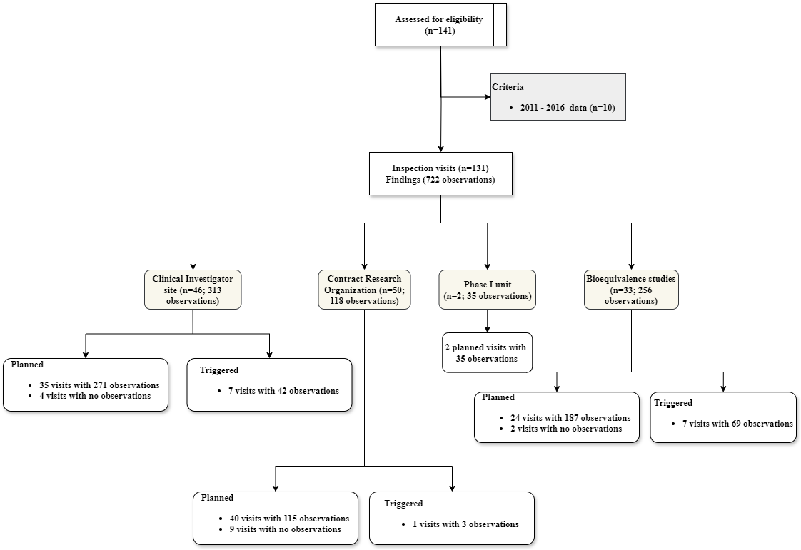

Figure 2: Number of inspection visits per year (2017-2023)

Figure 3: Geographical distribution of inspection visits (3A: global, 3B: national)

3A
3B
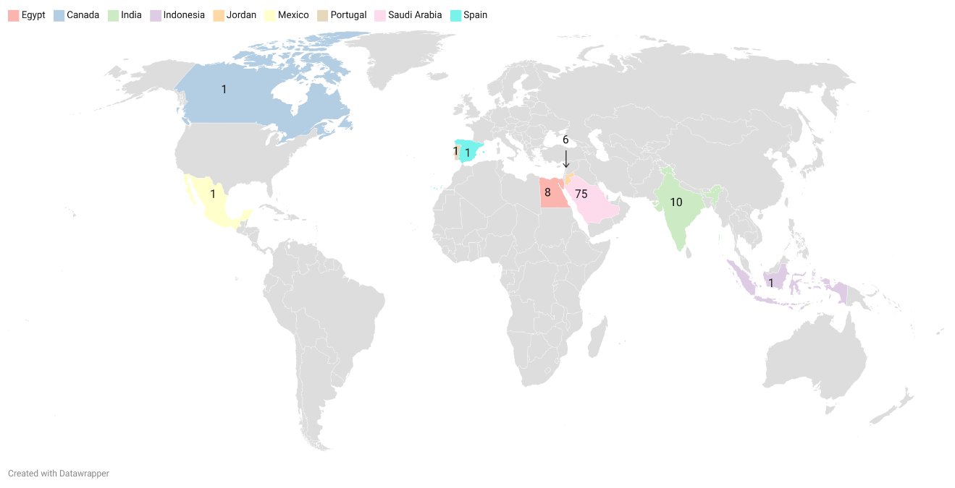
3A
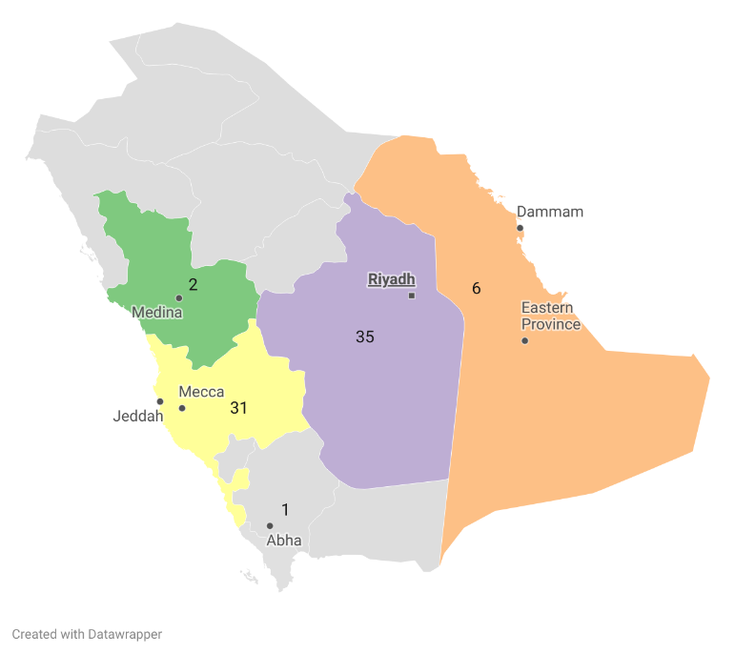
3B
Figure 4: Percentage of phases/BE at inspection visits

Figure 5: Therapeutic areas and phases of inspected facilities

Table 3: GCP Distribution of findings at clinical investigator site inspections
GCP distribution of findings | Critical | Major | Other | Comment | Grand Total
Investigator | 27 | 54 | 47 | 5 | 133
Clinical trial protocol | 28 | 25 | 16 | 2 | 71
Essential Documents | 15 | 17 | 13 | 3 | 48
Regulatory requirement | 13 | 16 | 1 | 1 | 30
Sponsor | 4 | 15 | 4 | 2 | 25
The principles | 4 | 1 | - | - | 5
Investigators Brochure | 1 | - | - | - | 1
Grand Total | 91 | 128 | 81 | 13 | 313

Figure 6: Clinical investigator site GCP observations and grades

Table 4: GCP distribution of findings at CRO inspections
GCP distribution of findings | Critical | Major | Other | Comment | Grand Total
Regulatory requirement | 25 | 20 | 11 |  | 56
Sponsor | 13 | 17 | 13 | 1 | 44
Essential Documents | 5 | 2 | - | - | 7
Investigator | - | 3 | 2 | 1 | 6
The principles | 5 | - | - | - | 5
Grand Total | 48 | 42 | 26 | 2 | 118
Figure 7: CRO GCP observations and grades

Table 5: GCP distribution of findings at BE inspections
GCP distribution of finding | Critical | Major | Other | Comment | Grand Total
Sponsor | 20 | 44 | 33 | 22 | 119
Regulatory requirement | 15 | 30 | 18 | 5 | 68
Investigator | 8 | 11 | 11 | 4 | 34
The principles | 6 | 9 | 4 | - | 19
Clinical trial protocol | 6 | 3 | - | 1 | 10
Essential Documents | 2 | 2 | 1 | - | 5
Investigators Brochure | - | 1 | - | - | 1
Grand Total | 57 | 100 | 67 | 32 | 256
Figure 8: BE GCP observations and grades

Table 6: GCP distribution of findings at Phase I units inspections
GCP distribution of finding | Critical | Major | Other | Comment | Grand Total
Regulatory requirement | 2 | 10 | 2 | 1 | 15
Sponsor | 3 | 6 | 1 | 1 | 11
Investigator | 2 | 3 | 3 | - | 8
Essential Documents | - | 1 | - | - | 1
Grand Total | 7 | 20 | 6 | 2 | 35
Figure 9: Phase I Units GCP observations and grades

International Council for Harmonisation Of Technical Requirements for Pharmaceuticals for Human Use (Ich) Ich Harmonised Guideline Integrated Addendum to ICH E6(R1): Guideline for Good Clinical Practice E6(R2). 2016.
Classification of GMP Deficiencies [Internet]. 2019. Available from: http://www.picscheme.org

