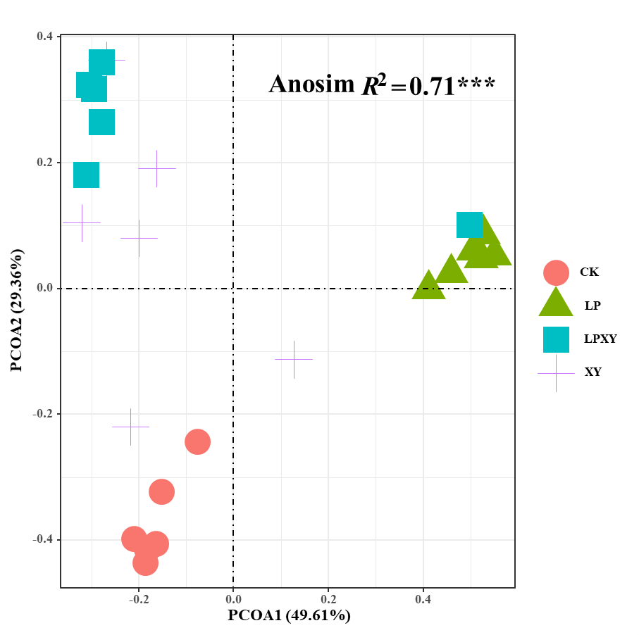
Fig. S1 Principal coordinate analysis of different treatments based on Bray-Curtis distance metrics.

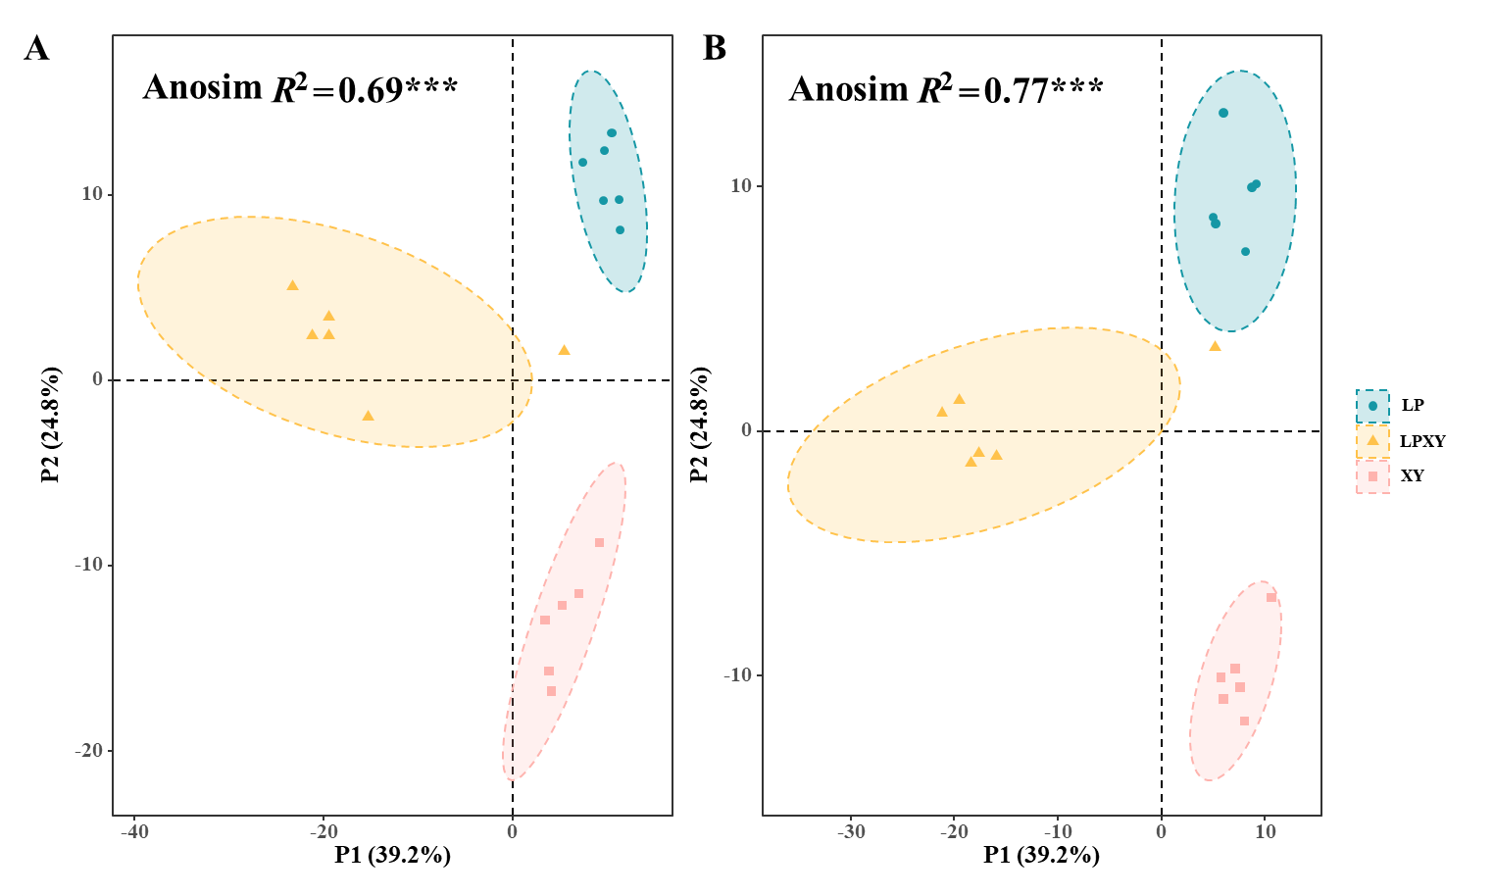
Fig. S2 Total principal component analysis of the wheat straw silage samples corresponding to different treatments following (A) positive and (B) negative mode ionization.

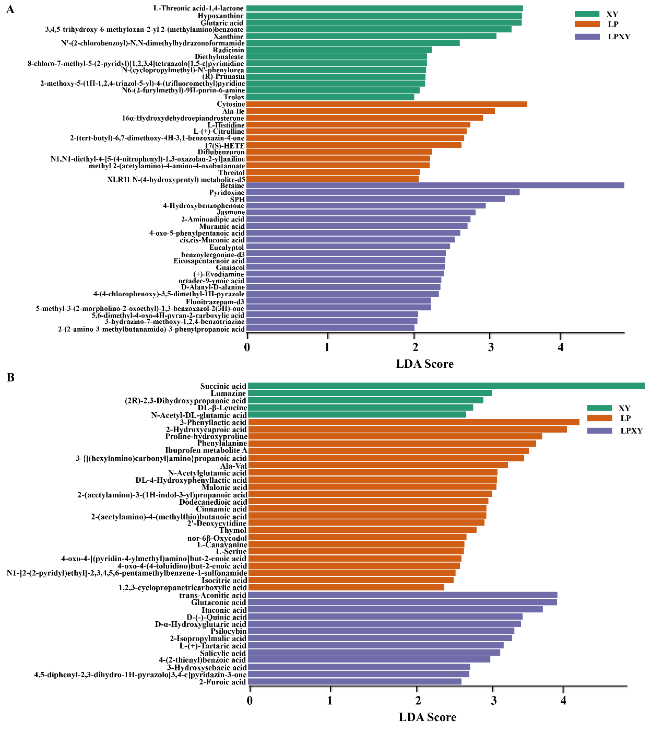
Fig. S3 Comparison of metabolites variations using the LDA analysis for wheat straw silages. A and B, positive and negative mode ionization (See supplement pdf).

