Enhancing Hepatocellular Carcinoma Therapy with DOX-Loaded SiO₂ Nanoparticles via mTOR-TFEB Pathway Autophagic Flux Inhibition
Huanyu Chen,^{ab§} Jun Liu,^{c§} Zhichao Cao,^{ad} Jiajia Li,^{e} Hong Zhang,^{ad} Qianqian Yang,^{ab} Yuxian Shen^{c}* and Kewu He^{ab}*
ªImaging Center, the Third Affiliated Hospital of Anhui Medical University, Hefei 230061,China
^{b}The Fifth Clinical Medical School of Anhui Medical University,Hefei 230032,China
^{c}Biopharmaceutical Research Institute, Anhui Medical University, Hefei 230032, China
^{d}Wannan Medical College,Wuhu, 241002, China
^{e}Central Laboratory, The First Affiliated Hospital of Anhui Medical University, Hefei, 230022, China
§ These authors made equal contributions to this work
*Corresponding authors

Supporting figures

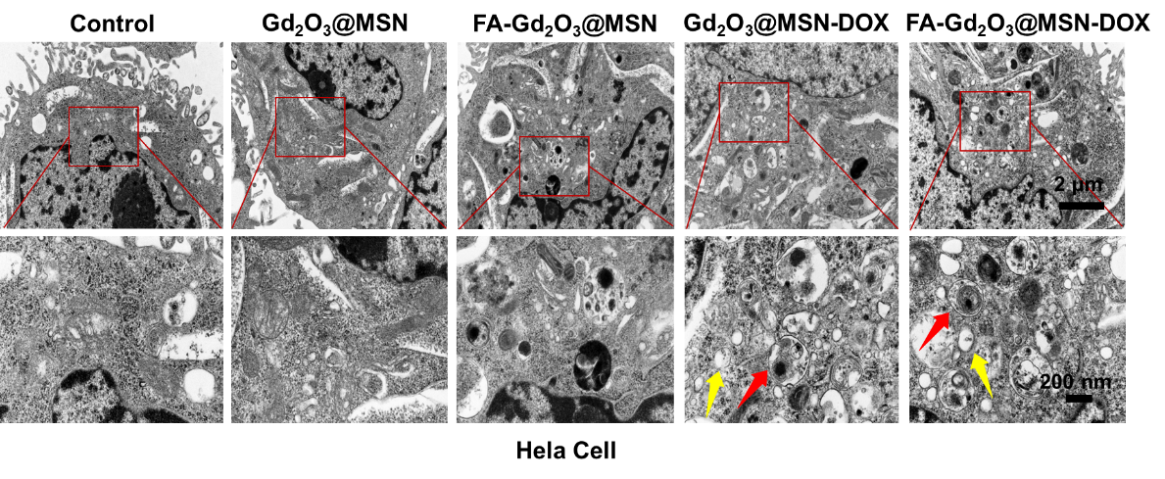
Figure S1. TEM image shows the effect on autophagy after different treatments for 48h of Hela cell.

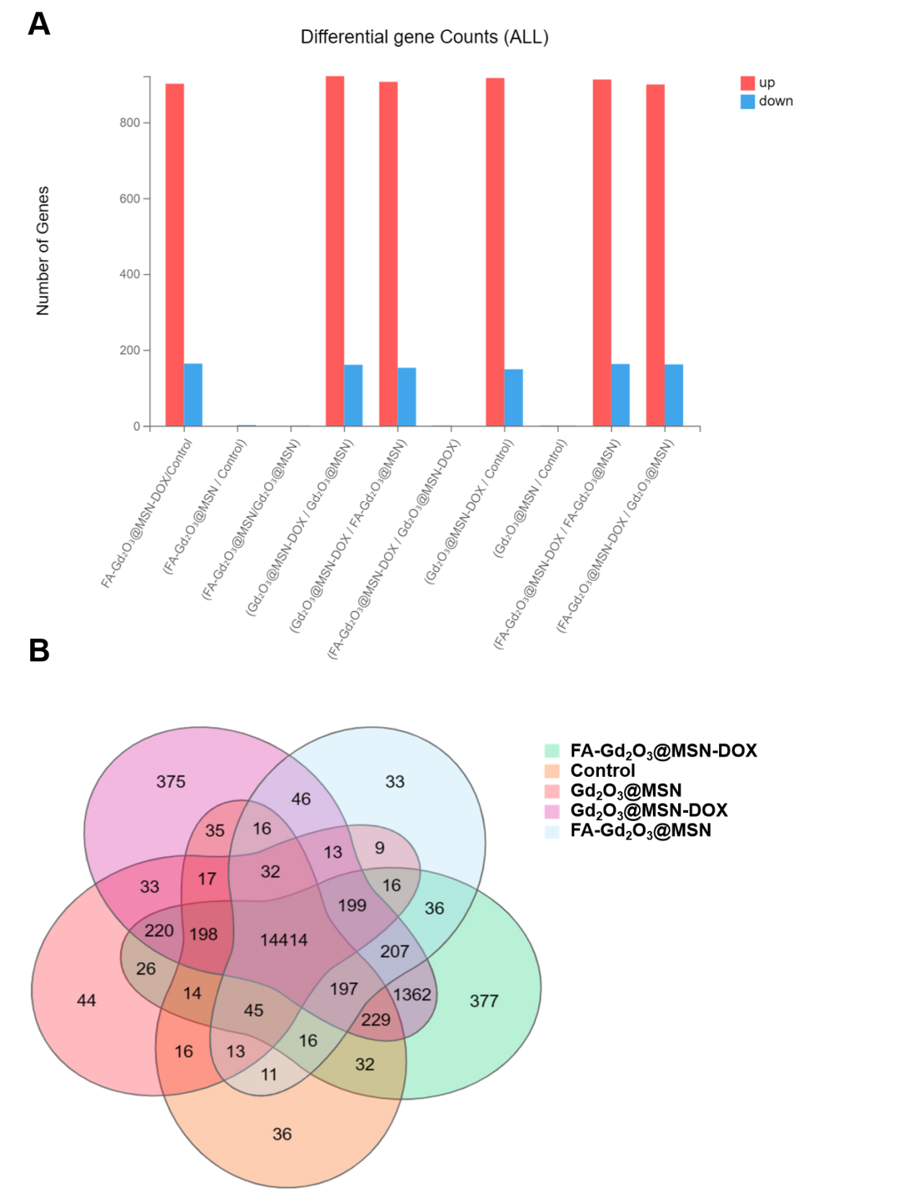
Figure S2. (A) Statistical map of the number of differential genes. (B) VENN diagram of differential gene expression in each group.

.
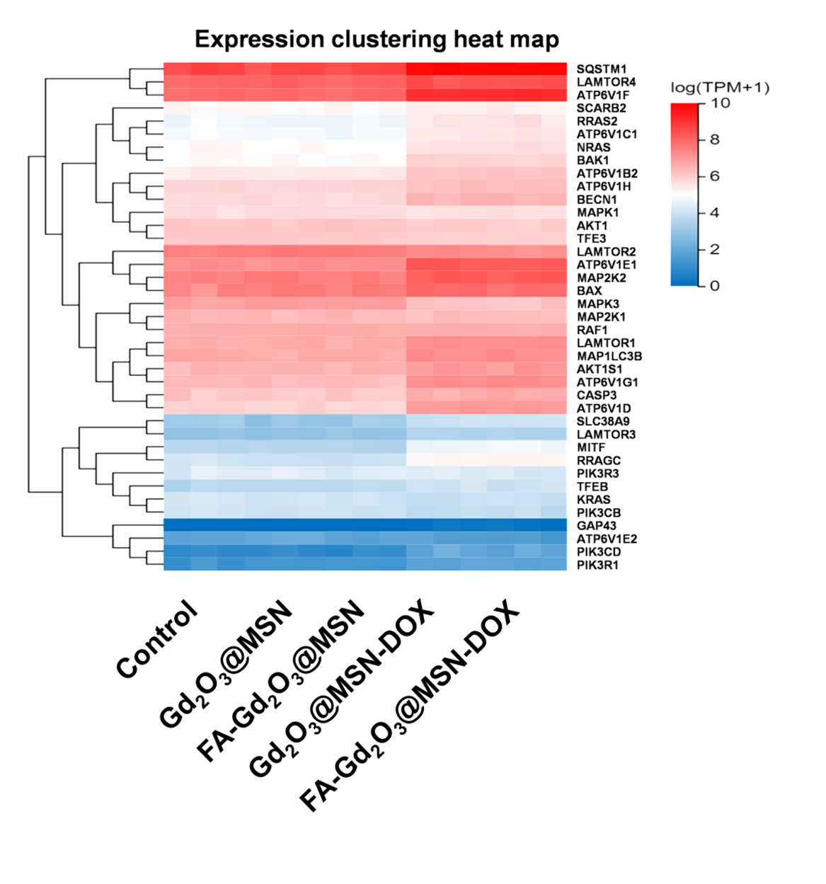
Figure S3. Calorimetric map of gene expression related to autophagy and apoptosis.
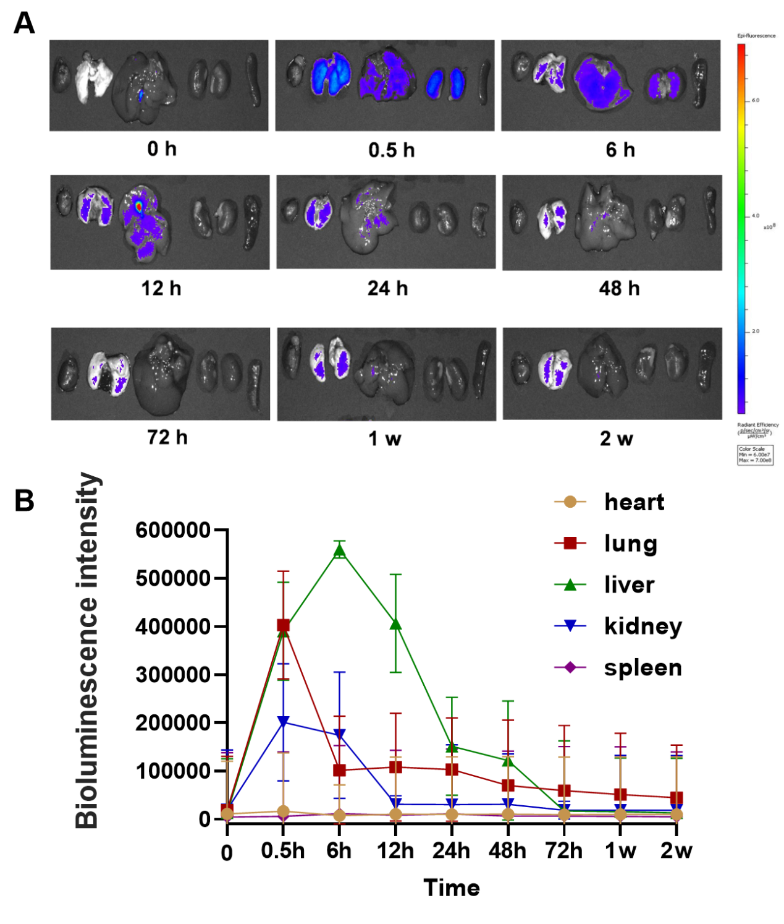
Figure S4 .(A) Imaging of mouse organs at different time points after FA-Gd₂O₃@MSN-DOX injection. (B) Fluorescence quantitative statistical diagram.
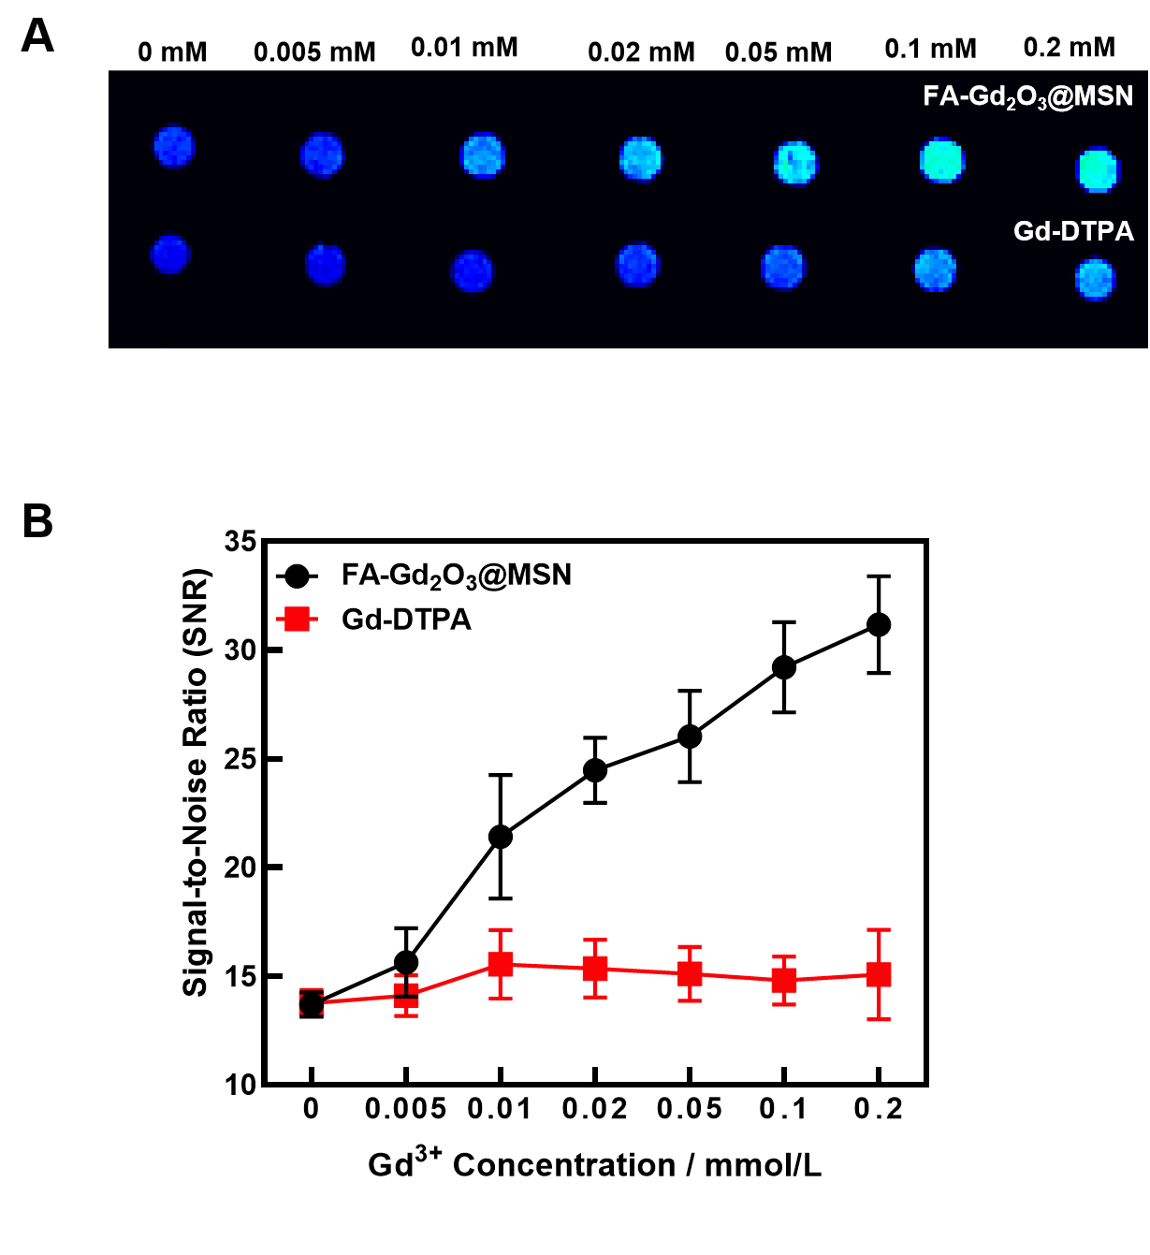
Figure S5. T1WI signal intensity and SNR of Hela cell after being treated with FA-Gd₂O₃@MSN and Gd-DTPA for 48h at various concentrations.

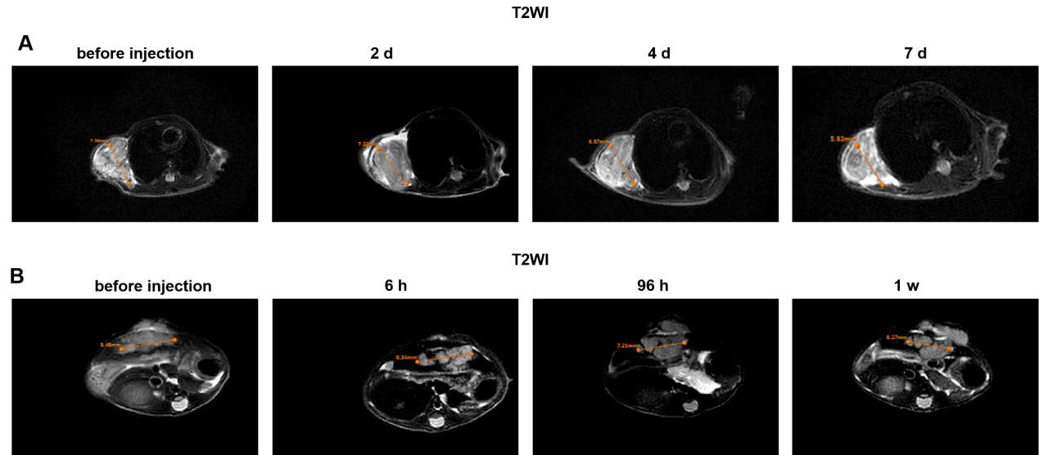
Figure S6. MRI T2 images of subcutaneous and orthotopic tumors in mice.
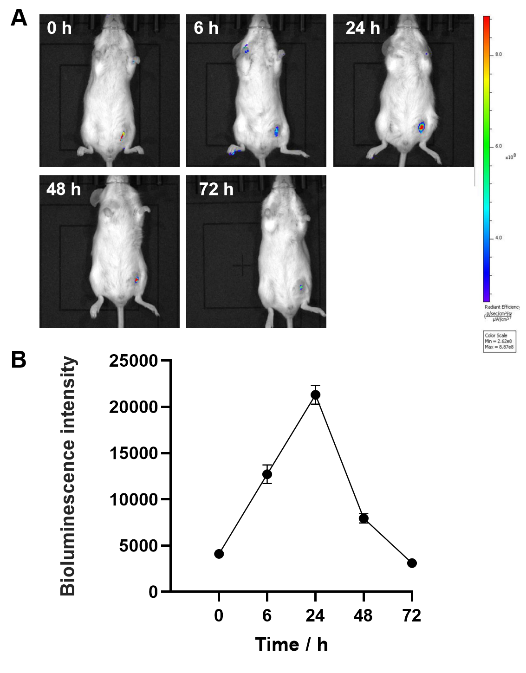
Figure S7. (A) Fluorescence images of drug release at different time points after intratumoral FA-Gd₂O₃@MSN-DOX injection. (B) Fluorescence quantitative statistical diagram.
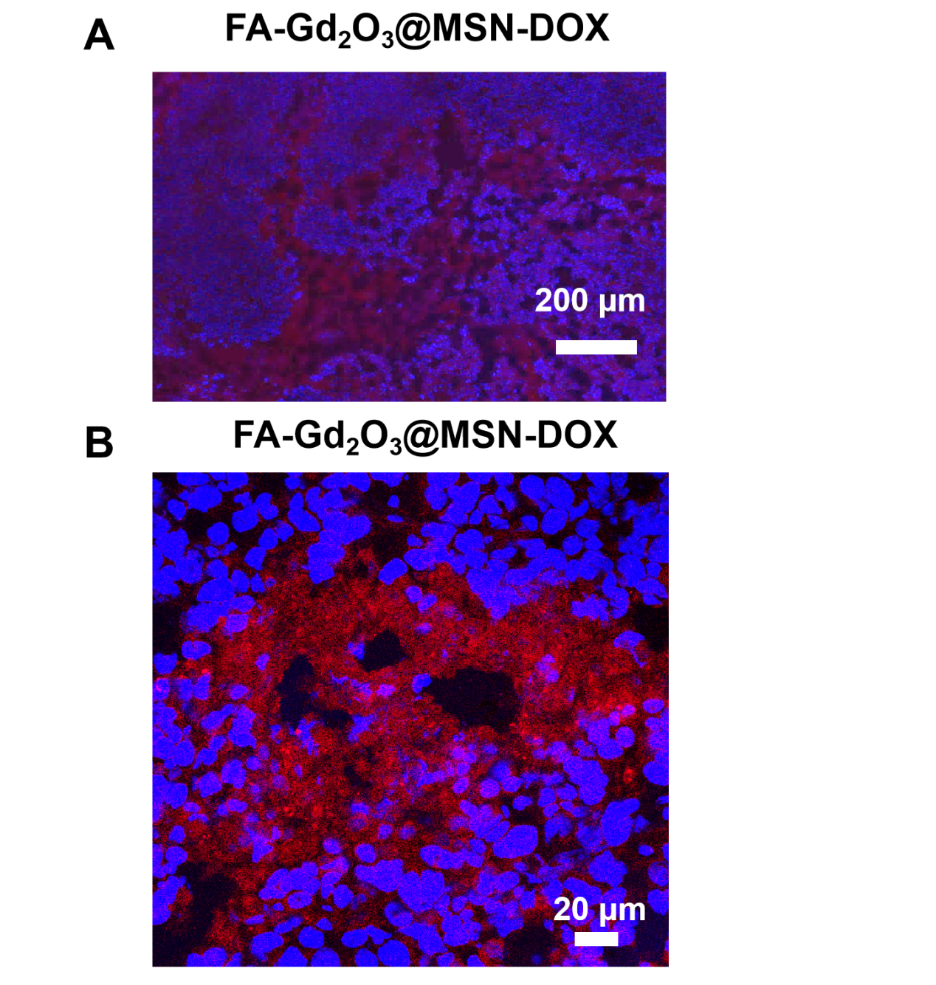
Figure S8. Digital pathological section (A) and laser confocal image (B) of mouse subcutaneous tumor after treatment.

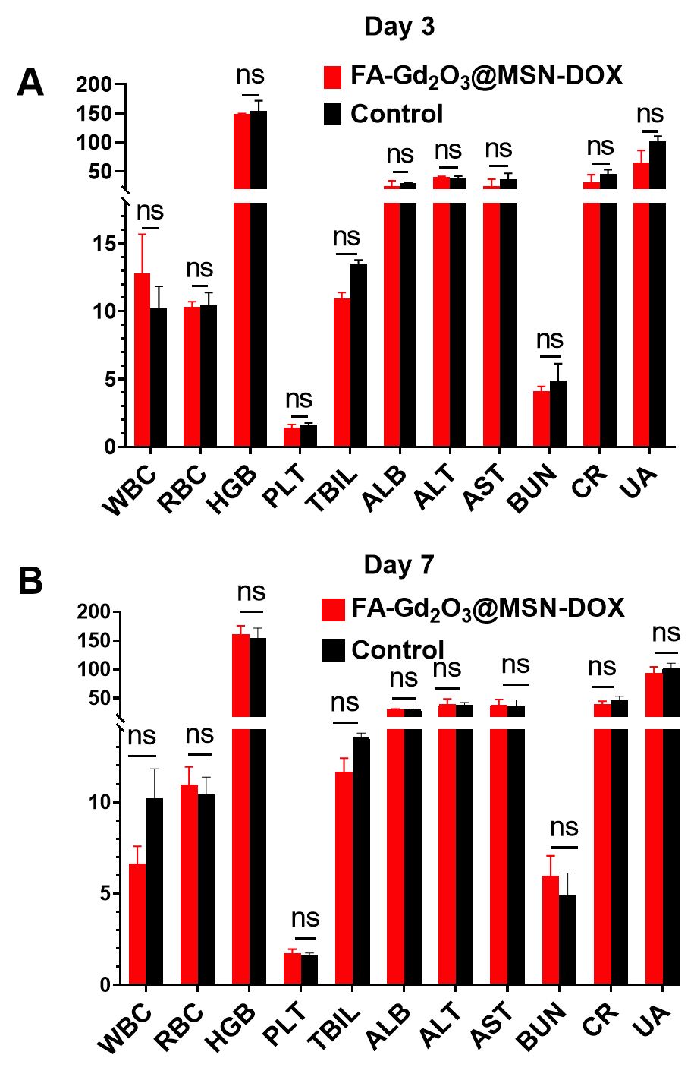
Figure S9. Blood test indicators 3(A) and 7(B) days after the FA-Gd₂O₃@MSN-DOX was injected through the tail vein.
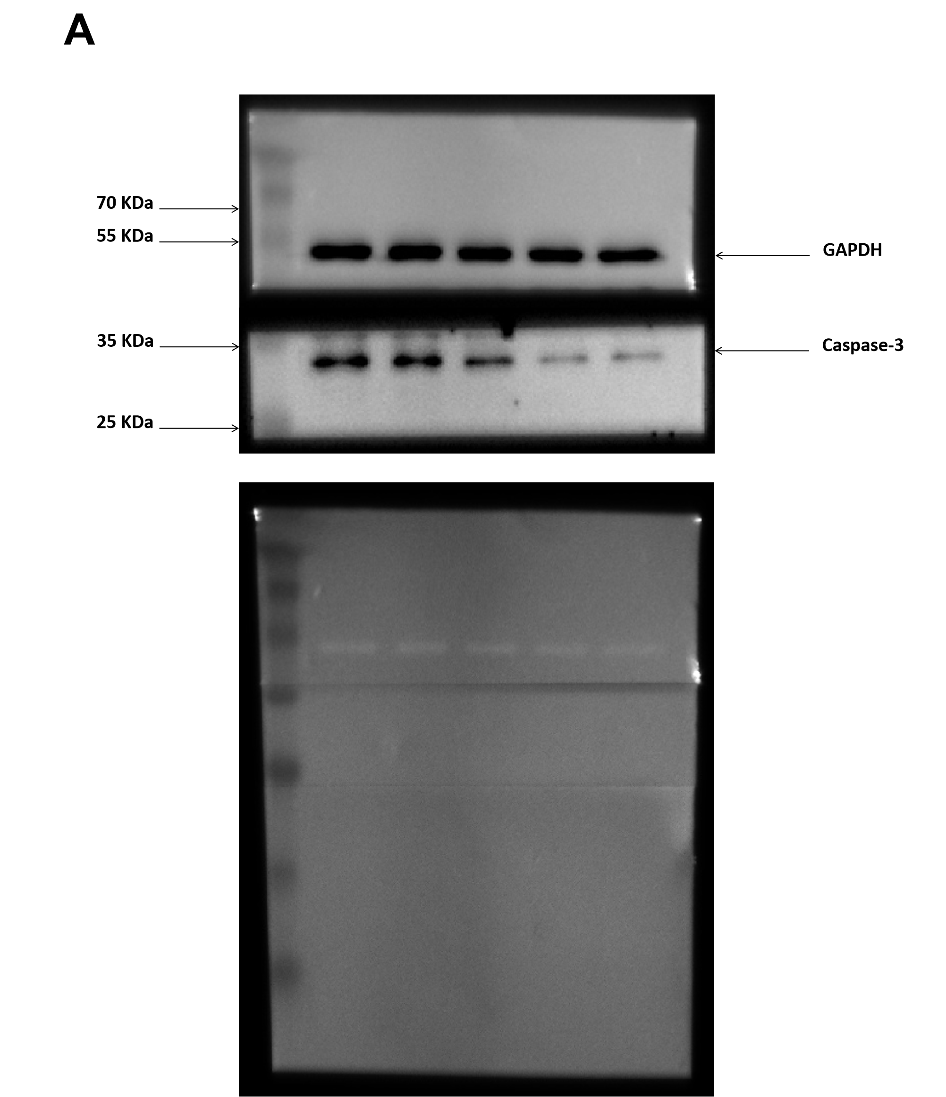
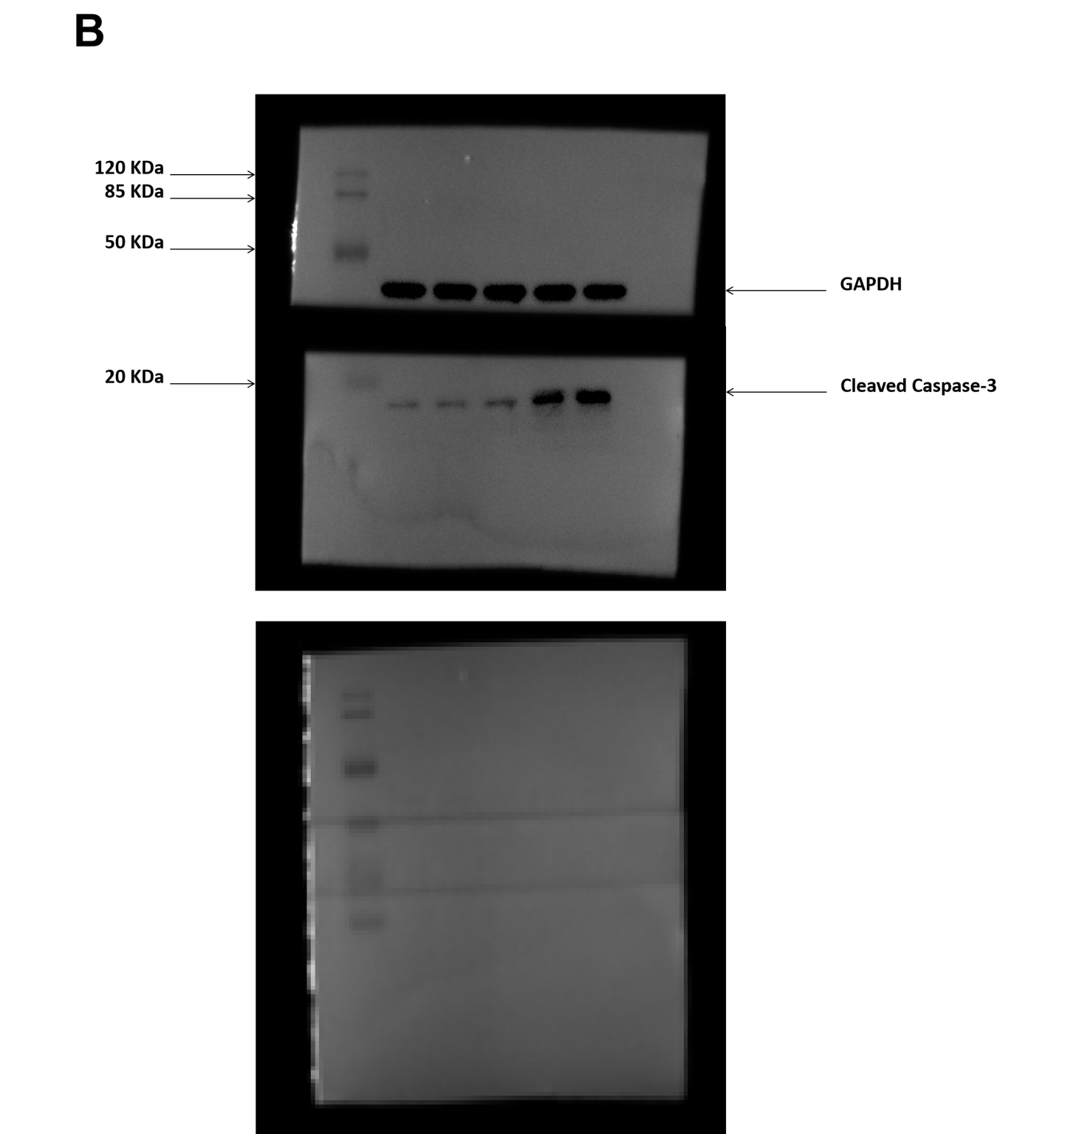
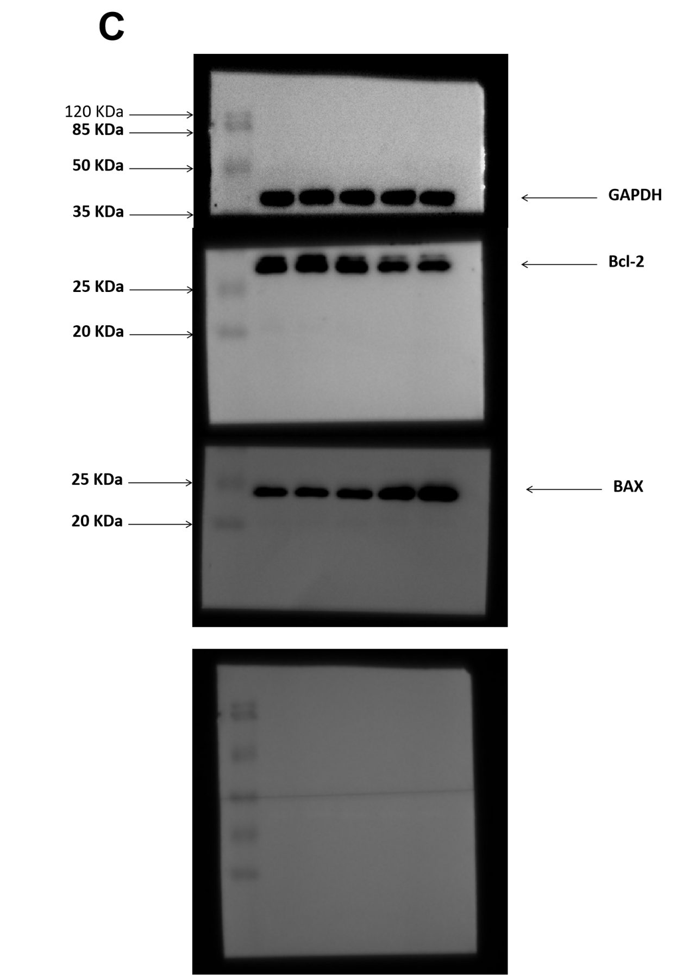

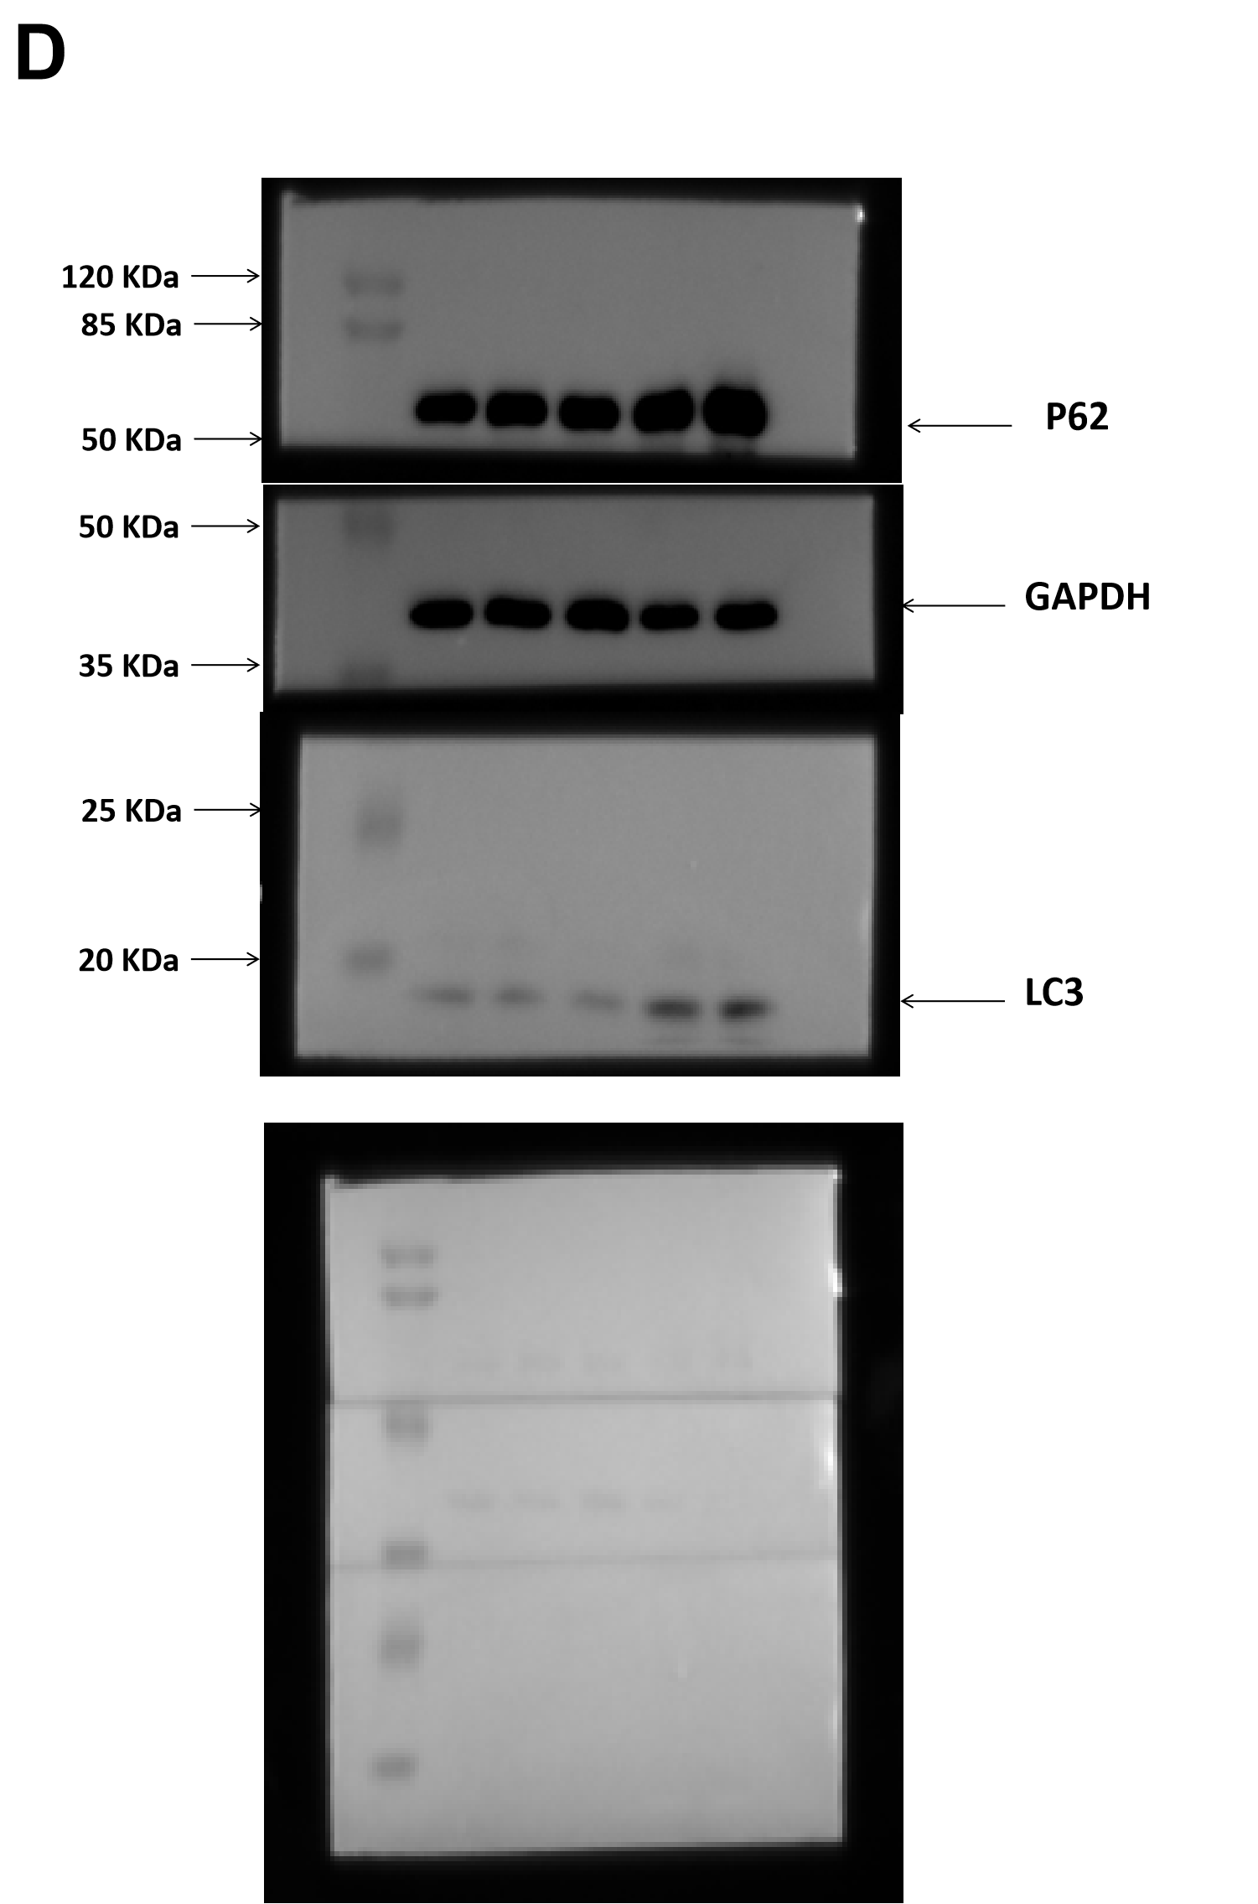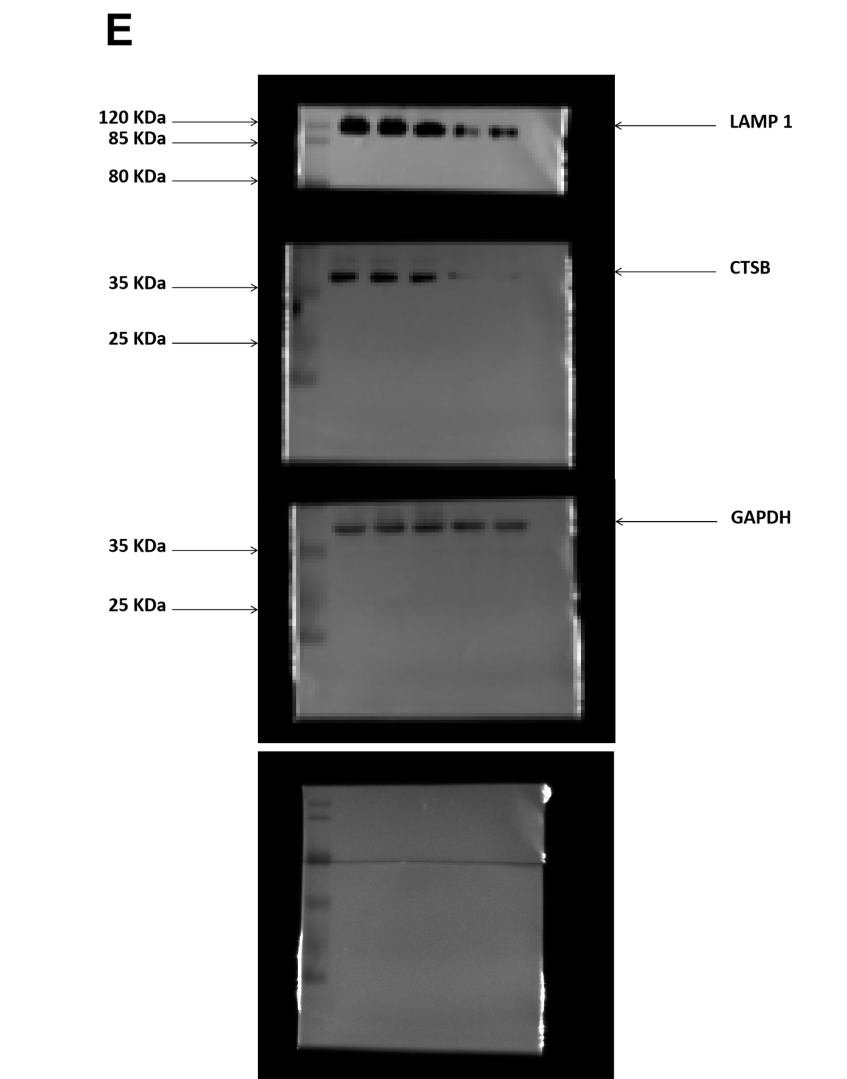
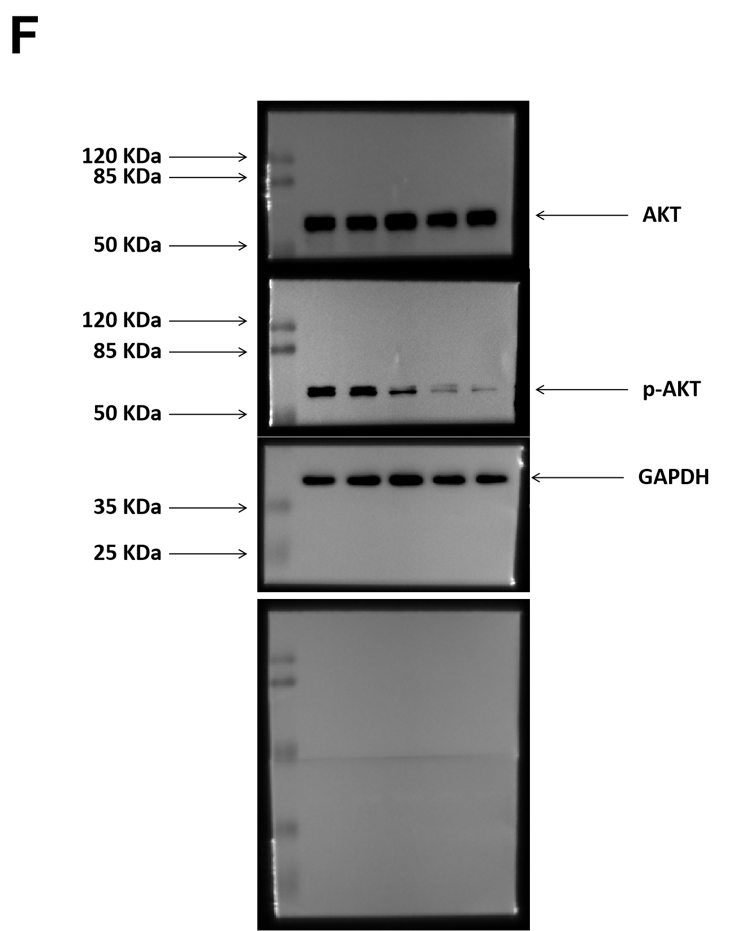
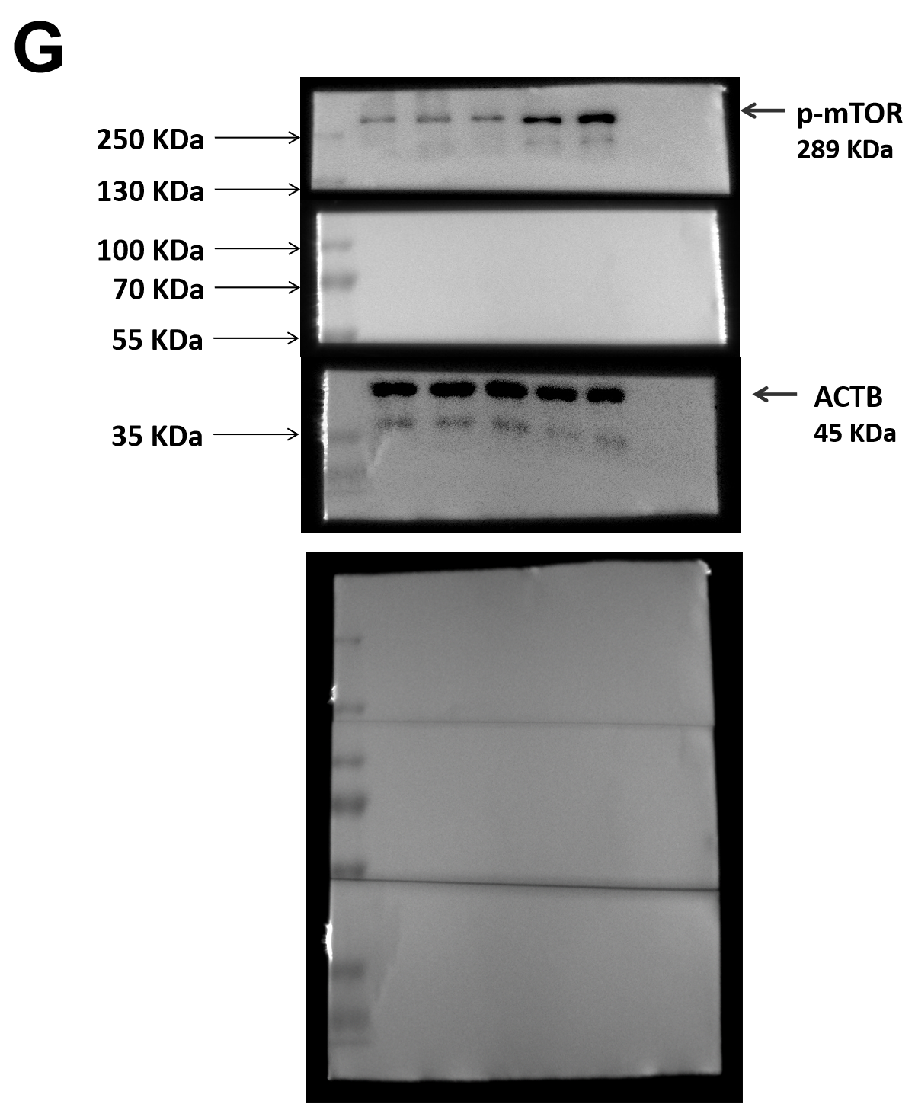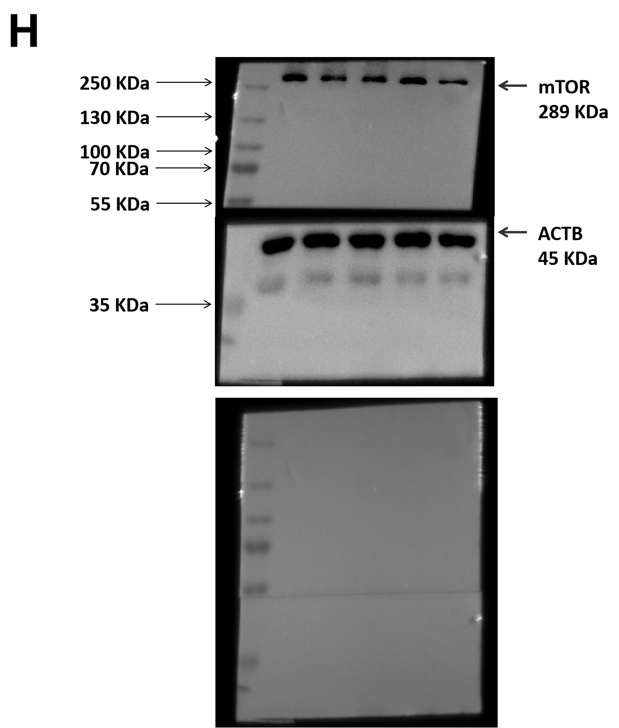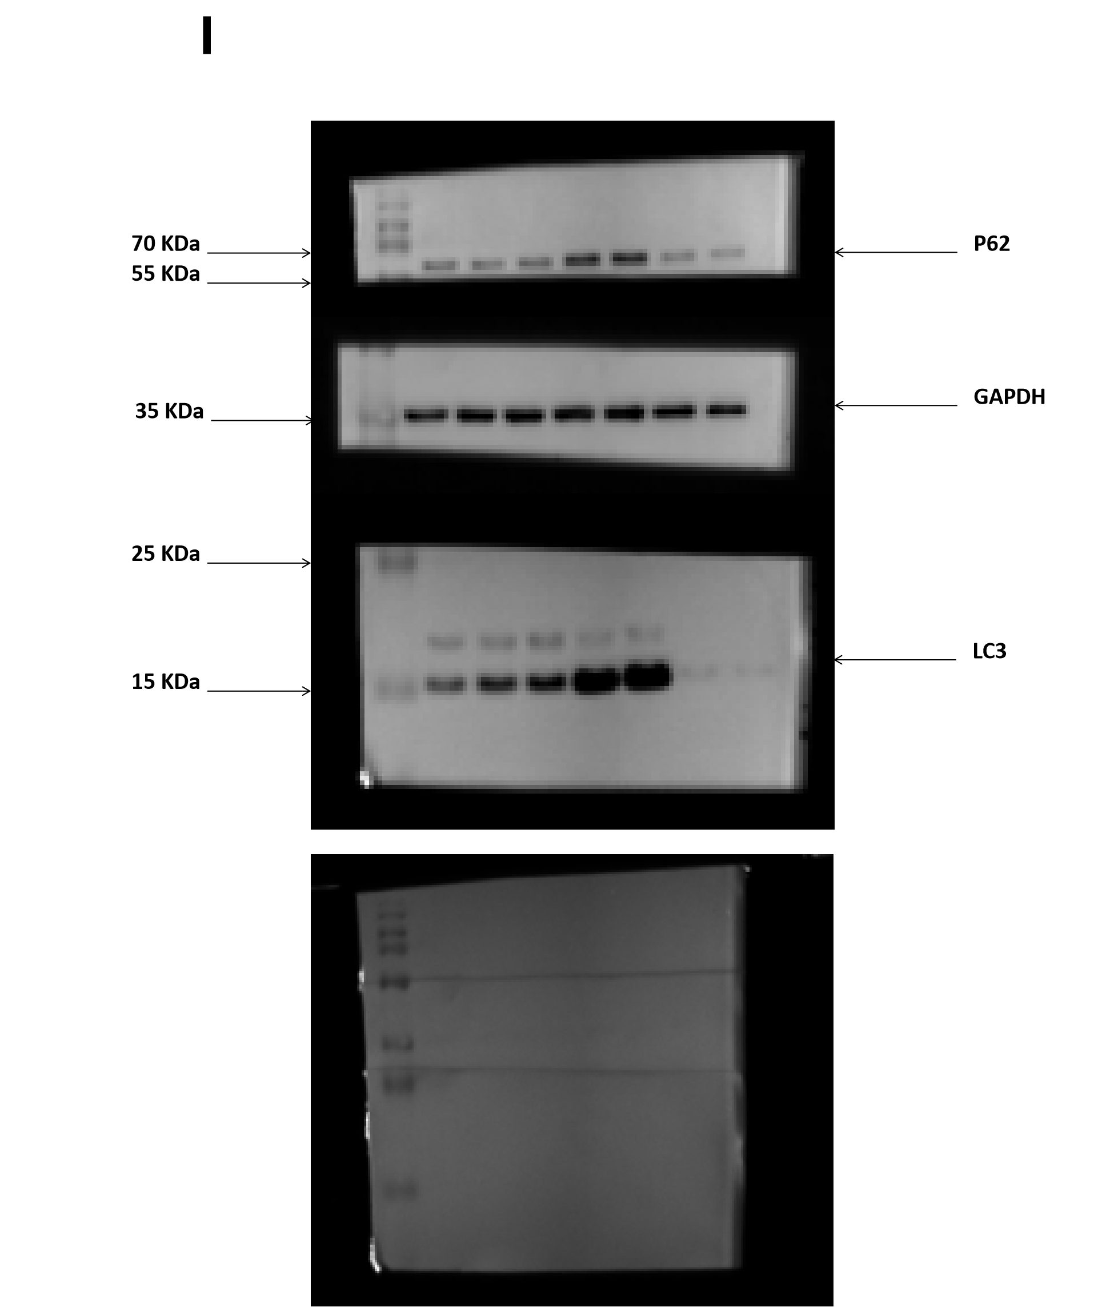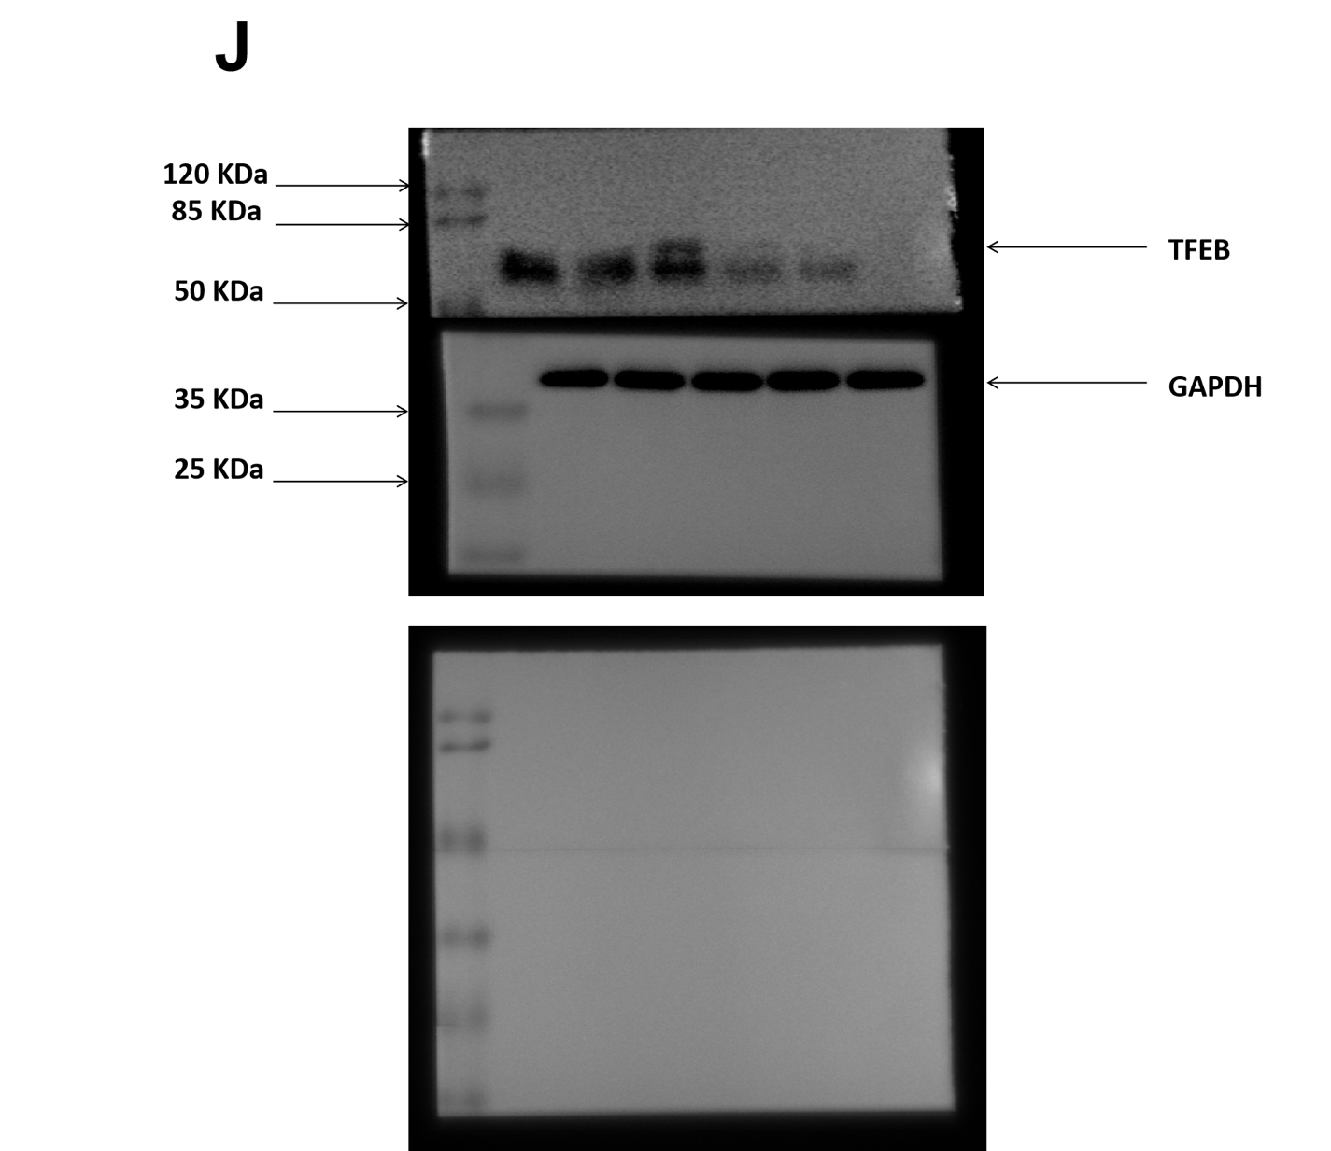
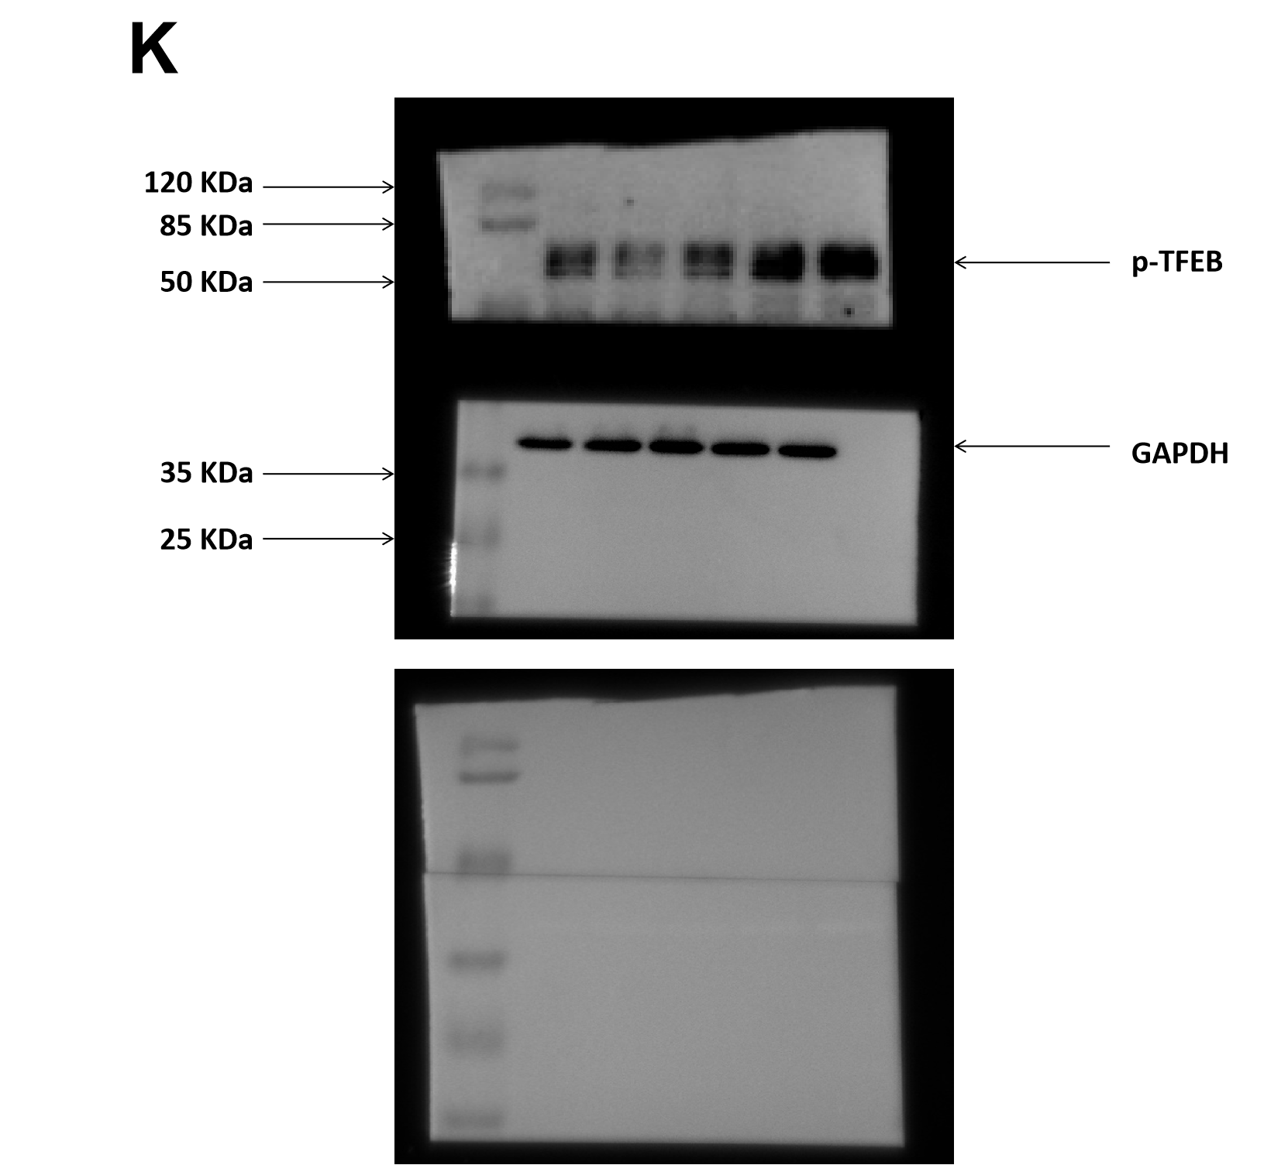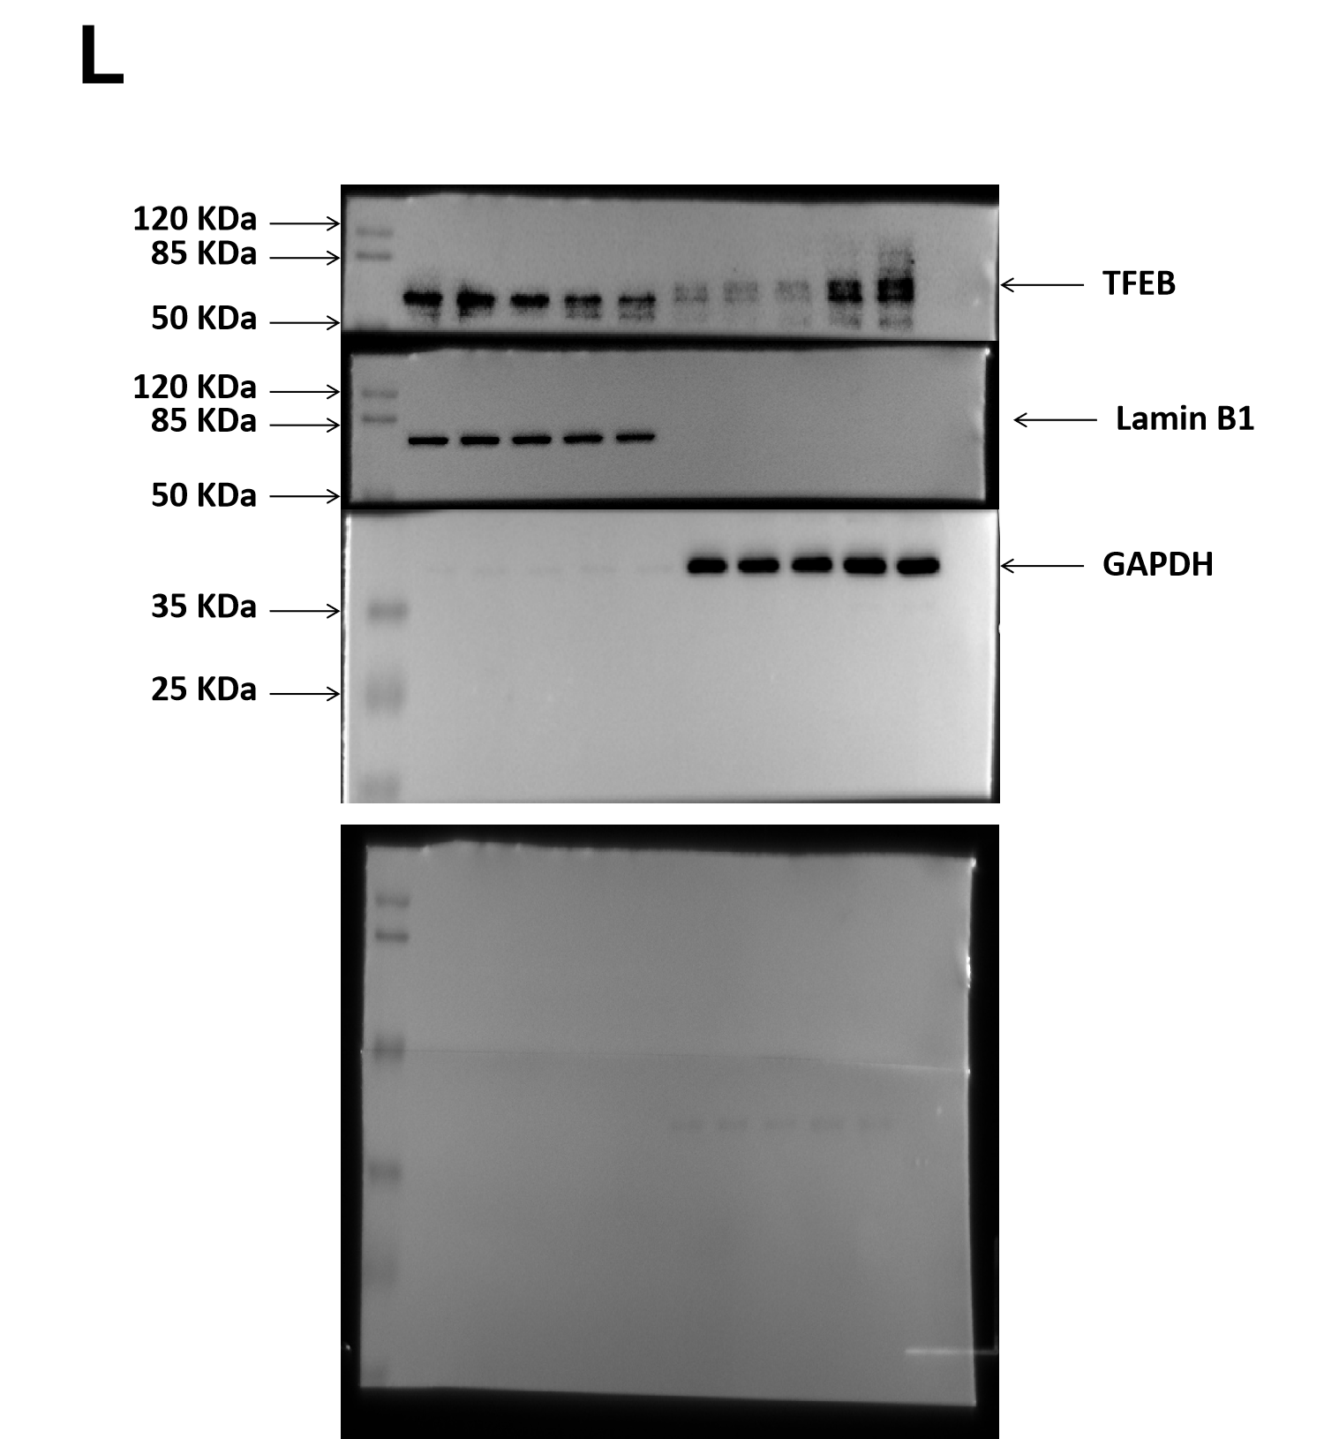
Figure S10. Raw data of the Western blot. (A-C) caspase-3, cleaved caspase-3, BAX, and Bcl-2 in Figure 2D.(D-E) P62, LC3, LAMP1 and CTSB in Figure 3B. (F-H) Akt, p-Akt, mTOR and p-mTOR in Figure 4B. (I) LC3 and P62 in Figure 4C. (J-K) TFEB and p-TFEB in Figure 5C. (L) TFEB, Lamin B1 and GAPDH in Figure 5B.

