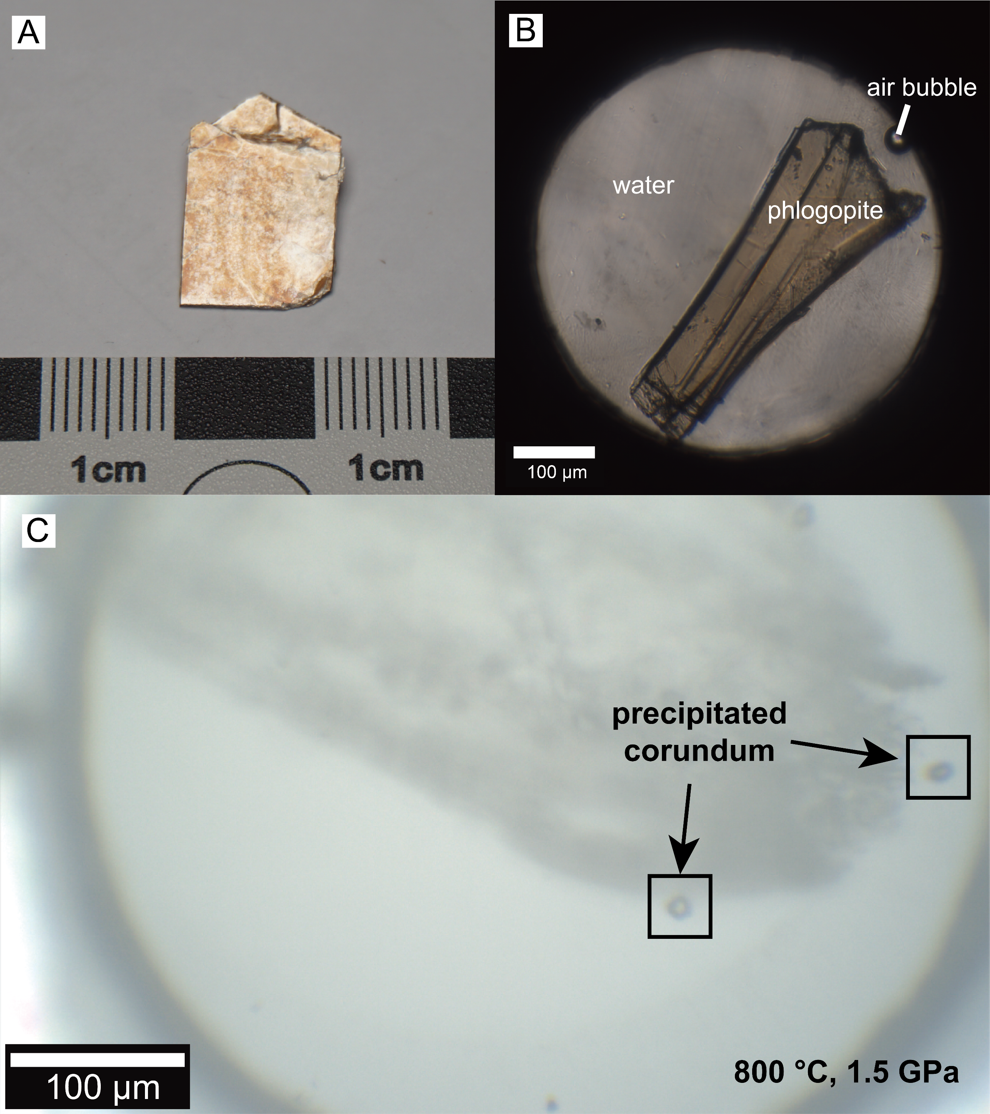
Extended Data Figure S1. The initial materials of HDAC experiments. (A) The pictures of the natural phlogopite. (B) The initial samples in the Diamond Anvil Cell. The small air bubbles were used to determine the system pressure. (C) In situ microscopic observation at 800 °C, 1.5 GPa.

Extended Data Figure S2. The Al₂O₃ precipitation of the “mineral-H₂O” systems. The feldspars and micas dissolve/melt incongruently in water at high P-T conditions, and the extra alumina forms corundum. The related references are listed in the main text. Abbreviation: Or-orthoclase, Ms-muscovite, Ab-albite, Pg-paragonite, Phl-phlogopite, Crn-corundum.

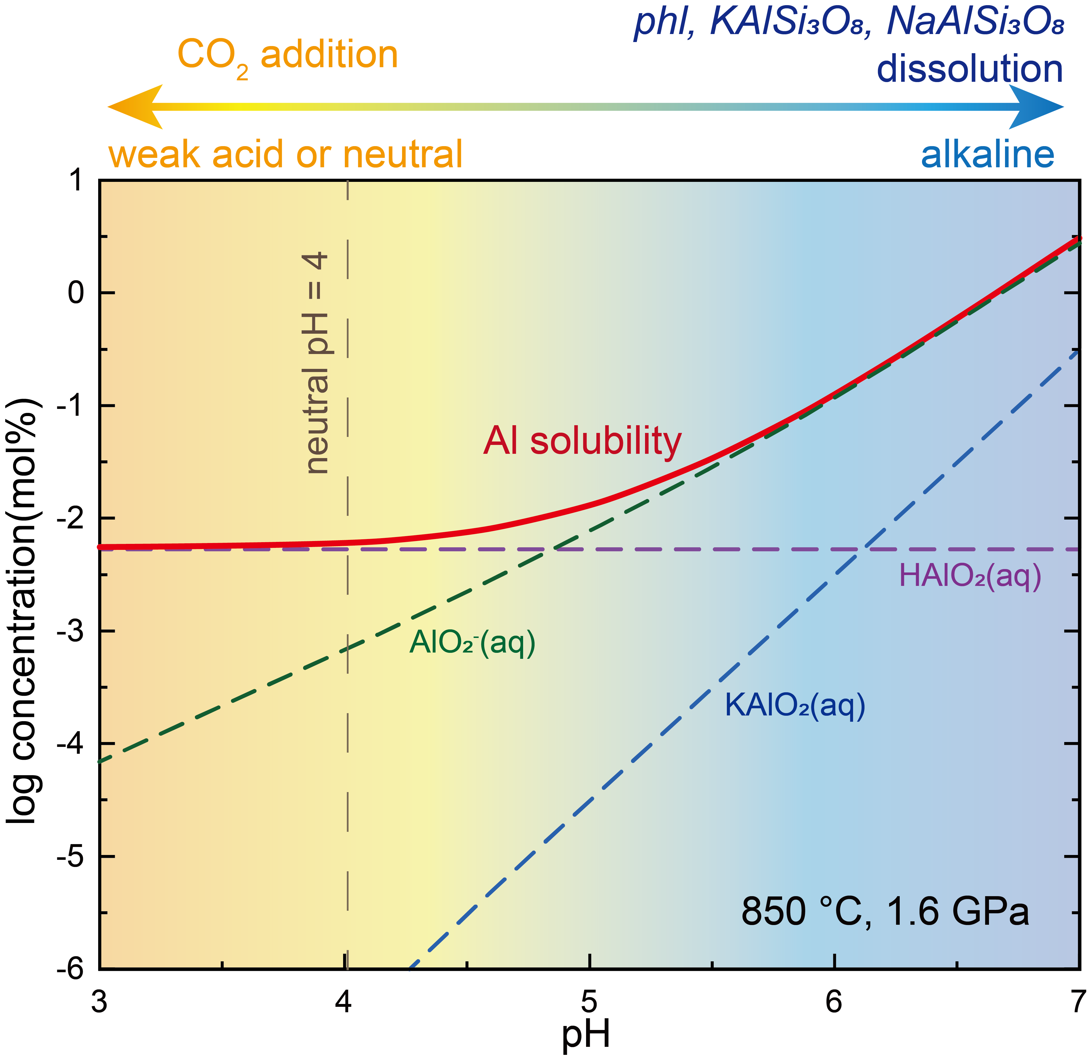
Extended Data Figure S3. pH control on the solubility of phlogopite in water. The Al solubility is controlled by pH as indicated by thermodynamic calculation based on SUPCRT92 software⁴⁷ and the thermodynamic data of Al species^{48,49,50}. The dissolved Al is dominated by aqueous HAlO₂ at neutral pH and aqueous AlO₂⁻ in alkaline solution, respectively. The dissolution of typical Al-bearing minerals, such as phlogopite, albite, and K-feldspar, makes the solution more alkaline, while the addition of CO₂ balances pH, inhibits Al dissolution, and promotes Al₂O₃ precipitation.

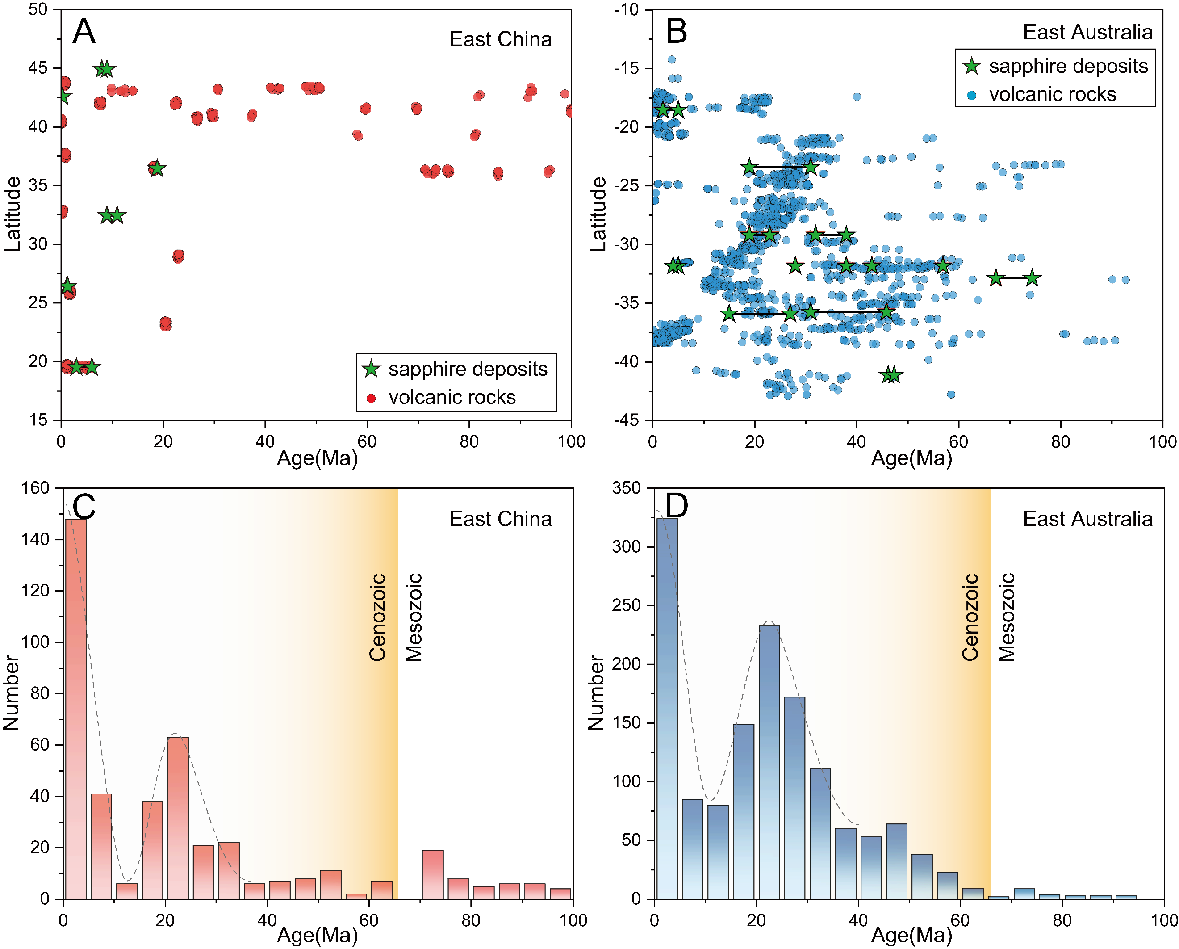
Extended Data Figure S4. Temporal and spatial statistics of the magmatic sapphire deposits and the volcanic rocks in East China (A, C) and East Australia (B, D). All the sapphire deposits in East China formed during 20-0 Ma, while the timescale of those deposits in East Australia is broader (details see the extended data and references therein). These sapphire deposits were mostly found in the initial volcanic rocks of the locality. The eruption of Cenozoic basalts in both areas has temporal similarities with the intense magmatism at 25-20 Ma and 5-0 Ma.

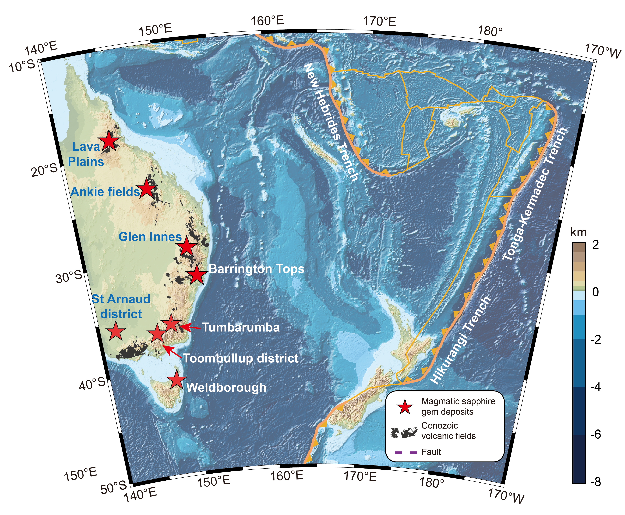
Extended Data Figure S5. The distribution of magmatic sapphire deposits in East Australia. These deposits in eastern Australia are distributed along the coastal areas and are also related to alkaline basalts. Due to the spreading of the Tasman Sea³⁸, these sapphire deposits are located farther from the subduction zone trench compared to those in eastern China.

