Table 5. (a) Alpha, (b) Heuristic, (c) Inductive miner expressed in petri-net
Algorithm | Mean wall time
(a) | 178 ms
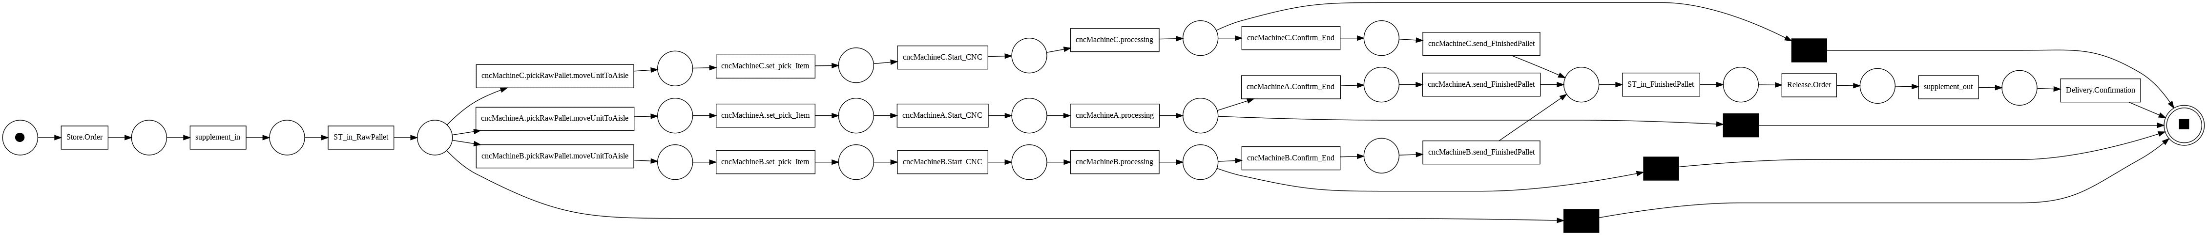  (b) | 214 ms
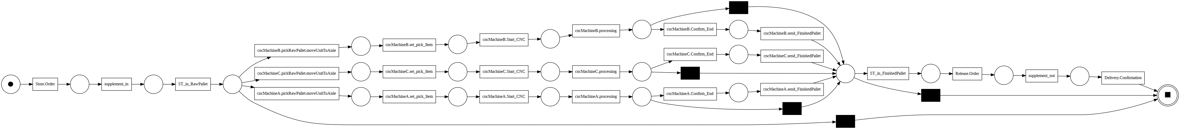  (c) | 305 ms

