On the freeze–thaw cycles of shallow soil and connections with environmental factors over the Tibetan Plateau
Ning Li,^{a,b,c} Lan Cuo,^{a,b,c,d} and Yongxin Zhang^{e}
ª Key Laboratory of Tibetan Environment Changes and Land Surface Processes, Institute of Tibetan Plateau Research, Chinese Academy of Sciences. Beijing, China
^{b} University of Chinese Academy of Sciences, Beijing, China
^{c} ECMI Team, State Key Laboratory of Tibetan Plateau Earth System Science, Institute of Tibetan Plateau Research, Chinese Academy of Sciences, Beijing, China.
^{d} Center for Excellence in Tibetan Plateau Earth Sciences, Chinese Academy of Sciences, Beijing, China
^{e} National Center for Atmospheric Research, Boulder, US

Corresponding author: Lan Cuo, lancuo@itpcas.ac.cn
1. Statistical analysis
1.1 Temporal trend test of time series
In this study, the temporal trends of shallow soil freeze–thaw indices, snow indices and air temperature are examined using the Mann–Kendall (MK) test (Mann 1945; Kendall 1975) and Sen’s slope approach (Sen 1968). In MK test, the test statistic S, which conforms to a normal distribution, is calculated using Equations (1) and (2):
$$S=\sum_{i=1}^{n-1}{\sum_{j=i+1}^{n}{sgn\left(x_{j}-x_{i}\right)}} (1)$$where $sgn\left(x_{j}-x_{i}\right)$ is calculated by Equation (2):
$sgn\left(x_{j}-x_{i}\right)=\left\{\begin{aligned}1, if\left(x_{j}-x_{i}\right)>0 \\ 0, if\left(x_{j}-x_{i}\right)=0 \\ -1, if\left(x_{j}-x_{i}\right)<0\end{aligned} (2)\right.$
Where n is the number of records in a time series, $x_{i}$ and $x_{j}$ represent the ith and jth records in the time series, respectively. Then the standard normal variable Z is calculated by Equation (3):
$$Z=\left\{\begin{aligned}\frac{S-1}{\sqrt{Var(S)}}, if S>0 \\ 0, if S=0 \\ \frac{S+1}{\sqrt{Var(S)}}, if S<0\end{aligned}\right. (3)$$
Where $Var\left(S\right)$ is the variance of S and calculated by Equation (4):
$$Var\left(S\right)=\frac{n\left(n-1\right)\left(2n+5\right)-\sum_{i=1}^{m}{t_{i}(t_{i}-1)(2t_{i}+5)}}{18} (4)$$
In which m is the number of tied groups, and $t_{i}$ is the number of records in the ith tied group.
A positive value of Z indicates an increasing trend, and a negative value indicates a decreasing trend. With two-tailed test, at a given significance level $α$, the null hypothesis $H_{0}$ of no trend is rejected for an absolute value of $\left|Z\right|≥Z_{1-α/2}$. In this work, the significance level is set at $α=0.05$. The magnitude of the slope is obtained from Sen’s non–parametric estimator of the slope as follows:
$$Slope=Median\left[\frac{x_{i}-x_{i}}{i-j}\right], for all j<i (5)$$
1.2 The relationship between SSFTC and various environmental factors
The relationship of shallow soil freeze–thaw cycles (SSFTC) with various environmental factors is investigated through correlation and partial correlation analysis and multiple linear regression analysis. The correlation coefficient (CC) is determined by Equation (6):
$${CC}_{xy}=\frac{Cov(x, y)}{σ_{x}σ_{y}} (6)$$
Where CC is the Pearson correlation coefficient. $Cov(x, y)$ is the covariation of variables $x$ and $y$. $σ_{x}, σ_{y}$ are the standard deviations of $x and y$, respectively. In this work, the significance of CC is tested at 0.95, 0.99 and 0.999 level, respectively.
In this study, we use partial correlation coefficient (PCC) to investigate the correlation between two variables without considering the influence of other factors. The formula is as follows:
$${PCC}_{xy,z}=\frac{{CC}_{xy}-{CC}_{xz}{CC}_{yz}}{\sqrt{(1-{CC}_{xz}^{2})}\sqrt{1-{CC}_{yz}^{2}}} (7)$$
Where ${PCC}_{xy,z}$ represents the partial correlation coefficient between the dependent variables x and y and the independent variable z. In this work, the significance PCC is tested at 0.95, 0.99 and 0.999 level, respectively.

We also use multiple linear regression to analyze the effects of various environmental factors on SSFTC. The formula and calculation of multiple linear regression is as follows:
$$y_{i}=β_{0}+β_{1}x_{i1}+β_{2}x_{i2}+…+β_{p}x_{ip}+ε (8)$$
Where, for $i=n$ observations, $y_{i}$ is the dependent variable. $x_{i}$ is the explanatory variables. $β_{0}$ is y-intercept (constant form). $β_{p}$ is the slope coefficients for each explanatory variable x_{ip}. $ε$ is the model’s error term (also known as the residuals).

2. Table
Table S1. Descriptions of the global gridded soil temperature products used in this study.
Product | Type | Soil depth (cm) | Spatial resolution | Time step | Available period
NCEP-CFSR | Reanalysis | 0–10, 10–40, 40–100, 100–200 | 0.5°×0.5° | 6h | 1 Jan. 1982 – 31 Dec.2010
NCEP-CFSv2 | Reanalysis | 0–10, 10–40, 40–100, 100–200 | 0.5°×0.5° | 6h | 1 Jan. 2011 – 31 Dec.2017
ERA-interim | Reanalysis | 0–7, 7–28, 28–100, 100–289 | 0.75°×0.75° | 6h | 1 Jan. 1982 – 31 Dec.2017
GLDAS-CLM10 | Modelling | 0–1.8, 1.8–4.5, 4.5–9.1, 9.1–16.6, 16.6–28.9, 28.9–49.3, 49.3–82.9, 82.9–138.3, 138.3–229.6, 229.6–343.3 | 1°×1° | 3h | 1 Jan. 1982 – 31 Dec.2017
GLDAS-Noah025-v2.0 | Modelling | 0–10,10–40,40–100,100–200 | 0.25°×0.25° | 3h | 1 Jan. 1982 – 31 Dec.1999
GLDAS-Noah025-v2.1 | Modelling | 0–10,10–40,40–100,100–200 | 0.25°×0.25° | 3h | 1 Jan. 2000 – 31 Dec.2017

Table S2. Descriptions of the stations used in this study.
ID | Name | Longitude | Latitude | Altitude (m) | Vegetation types
51886 | Mangya | 90.85 | 38.25 | 2945 | TD
52602 | Lenghu | 93.33 | 38.75 | 2770 | TD
52633 | Tuole | 98.42 | 38.8 | 3367 | TD
52657 | Qilian | 100.25 | 38.18 | 2787 | TD
52707 | Xiaozaohuo | 93.68 | 36.80 | 2767 | TD
52713 | Dachaidan | 95.37 | 37.85 | 3137 | TD
52737 | Delingha | 97.37 | 37.37 | 2982 | TD
52745 | Tianjun | 99.02 | 37.30 | 3412 | TD
52754 | Gangcha | 100.13 | 37.33 | 3302 | TD
52765 | Menyuan | 101.62 | 37.38 | 2850 | TFG
52818 | Geermu | 94.90 | 36.42 | 2808 | TD
52825 | Nuomuhong | 96.42 | 36.43 | 2790 | TD
52833 | Wulan | 98.48 | 36.92 | 2950 | TD
52836 | Dulan | 98.10 | 36.30 | 3191 | TD
52842 | Chaka | 99.08 | 36.78 | 3088 | TD
52853 | Haiyan | 100.98 | 36.92 | 3023 | TFG
52855 | Huangyan | 101.25 | 36.68 | 2638 | TFG
52856 | Gonghe | 100.62 | 36.27 | 2835 | AG
52862 | Datong | 101.68 | 36.95 | 2457 | TFG
52863 | Huzhu | 101.95 | 36.82 | 2493 | TFG
52866 | Xining | 101.75 | 36.72 | 2295 | TFG
52868 | Guide | 101.43 | 36.03 | 2237 | TFG
52869 | Huangzhong | 101.58 | 36.5 | 2641 | TFG
52874 | Ledu | 102.38 | 36.48 | 1982 | TFG
52876 | Minhe | 102.45 | 36.32 | 1814 | TFG
52877 | Hualong | 102.25 | 36.1 | 2797 | TFG
52908 | Wudaoliang | 93.08 | 35.22 | 4612 | AG
52943 | Xinghai | 99.98 | 35.58 | 3323 | AG
52955 | Guinan | 100.75 | 35.58 | 3120 | AG
52957 | Tongde | 100.65 | 35.27 | 3289 | AS
52963 | Jianzha | 102.02 | 35.93 | 2164 | TFG
52968 | Zeku | 101.47 | 35.03 | 3663 | AS
52972 | Xunhua | 102.45 | 35.85 | 1955 | TFG
52974 | Tongren | 102.02 | 35.52 | 2491 | TFG
55228 | Shiquanhe | 80.08 | 32.50 | 4279 | AG
55248 | Gaize | 84.42 | 32.15 | 4415 | AG
55279 | Banga | 90.02 | 31.38 | 4700 | AG
55294 | Anduo | 91.10 | 32.35 | 4800 | AG
55299 | Naqu | 92.07 | 31.48 | 4507 | AM
55437 | Pulan | 81.25 | 30.28 | 3900 | AG
55472 | Shenzha | 88.63 | 30.95 | 4627 | AG
55493 | Dangxiong | 91.10 | 30.48 | 4200 | AWG
55572 | Nanmulin | 89.10 | 29.68 | 4000 | AWG
55578 | Rikaze | 88.88 | 29.25 | 3836 | AWG
55664 | Dingri | 87.08 | 28.63 | 4300 | AWG
55680 | Jiangzi | 89.60 | 28.92 | 4040 | AWG
56004 | Tuotuohe | 92.43 | 34.22 | 4533 | AG
56018 | Zaduo | 95.30 | 32.90 | 4066 | AS
56021 | Qumalai | 95.78 | 34.13 | 4175 | AM
56029 | Yushu | 97.02 | 33.02 | 3681 | AS
56033 | Maduo | 98.22 | 34.92 | 4272 | AM
56034 | Qingshuihe | 97.13 | 33.80 | 4415 | AS
56043 | Guoluo | 100.25 | 34.47 | 3719 | AS
56045 | Gande | 99.90 | 33.97 | 4019 | AS
56046 | Dari | 99.65 | 33.75 | 3968 | AS
56065 | Henan | 101.60 | 34.73 | 3500 | AS
56067 | Jiuzhi | 101.48 | 33.43 | 3629 | AS
56106 | Suoxian | 93.78 | 31.88 | 4023 | AS
56116 | Dingqing | 95.60 | 31.42 | 3873 | SMCF
56125 | Nangqian | 96.48 | 32.20 | 3644 | SMCF
56128 | Leiwuqi | 96.60 | 31.22 | 3810 | SMCF
56137 | Changdu | 97.17 | 31.15 | 3306 | SMCF
56151 | Banma | 100.75 | 32.93 | 3530 | AS
56202 | Jiali | 93.28 | 30.67 | 4489 | SMCF
56223 | Luolong | 95.83 | 30.75 | 3640 | SMCF
56331 | Zuogong | 97.83 | 29.67 | 3780 | SMCF
56342 | Mangkang | 98.60 | 29.68 | 3870 | SMCF

Table S3. Correlation coefficients between the trends of the freeze–thaw indices and altitude/latitude.
 | BFD | EFD | NFD
Altitude | 0.19 | 0.21 | 0.07
Latitude | –0.20 | 0.05 | 0.13

Table S4. Seasonal and annual means and trends of surface air temperature by functional vegetation types during 1982–2017.
 | Spring | Summer | Autumn | Winter | Year
TD | 3.9±2.4/0.62±0.18 | 14.3±2.6/0.63±0.18 | 2.6±2.0/0.49±0.19 | –9.6±2.1/0.63±0.23 | 2.9±2.2/0.57±0.15
TFG | 6.9±2.7/0.61±0.19 | 15.9±2.7/0.66±0.22 | 5.6±2.5/0.45±0.22 | –6.0±2.5/0.55±0.32 | 5.7±2.6/0.57±0.21
AG | 0.5±3.3/0.48±0.16 | 10.5±3.1/0.43±0.11 | 0.7±2.9/0.54±0.14 | –10.1±2.8/0.67±0.19 | 0.4±2.9/0.53±0.12
AM | –1.5±1.2/0.43±0.08 | 8.2±0.9/0.57±0.06 | –1.4±1.4/0.56±0.09 | –12.1±1.9/0.79±0.19 | –1.7±1.3/0.63±0.05
AS | 1.3±2.3/0.48±0.25 | 10.0±1.8/0.59±0.20 | 1.2±2.2/0.58±0.27 | –9.4±2.9/0.83±0.38 | 0.8±2.3/0.62±0.24
AWG | 5.2±2.4/0.38±0.05 | 12.7±1.4/0.30±0.06 | 5.1±1.7/0.42±0.08 | –3.7±2.3/0.50±0.11 | 4.9±1.9/0.36±0.05
SMCF | 4.4±2.4/0.38±0.11 | 12.5±2.1/0.37±0.13 | 4.9±2.0/0.47±0.11 | –4.4±2.4/0.57±0.18 | 4.4±2.2/0.49±0.11
a. “/” separates the seasonal or annual means from the trends, i.e., means/trends;
b. Unit of the seasonal or annual mean air temperature and the trends is ℃ and ℃/decade, respectively;
c. All the trends in the table are significant at p < 0.05.

Table S5. Means and trends of snow indices during 1982–2017. Units of BSD and ESD are day of year, units of NSD are day, units of their trends are day dec⁻¹.
 | SD (cm/cm dec⁻¹) | BSD | ESD | NSD
TD | 2.0±0.5/–0.11±0.11 | 155±40/1±7 | 275±38/–7±7 | 16±11/–2±2
TFG | 2.1±0.4/–0.04±0.11 | 144±31/6±8 | 275±32/–4±7 | 16±12/–1±2
AG | 2.5±0.8/–0.13±0.17 | 121±40/11±4 | 309±31/–3±3 | 24±12/–3±3
AM | 2.3±0.3/0.06±0.08 | 77±21/10±3 | 336±6/–3±2 | 46±10/–4±3
AS | 2.7±0.3/–0.07±0.09 | 100±22/5±5 | 320±16/–4±2 | 47±24/–5±2
AWG | 2.2±0.2/–0.04±0.14 | 194±47/9±17 | 280±20/–2±11 | 7±9/–1±1
SMCF | 2.6±0.6/–0.15±0.21 | 128±34/8±5 | 293±27/–4±3 | 24±28/–4±4
Mean | 2.3±0.6/–0.08±0.14 | 133±43/6±7 | 294±34/–4±6 | 25±21/–3±3
a. “/” separates the means from the trends, i.e., means ±1 standard deviation /trends ±1 standard deviation;
b. Bold fonts denote significance at p < 0.05.
3. Figure
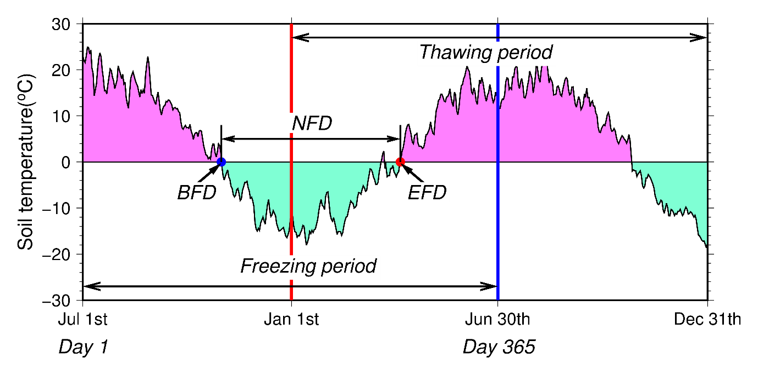
Figure S1. The definition of BFD, EFD and NFD.
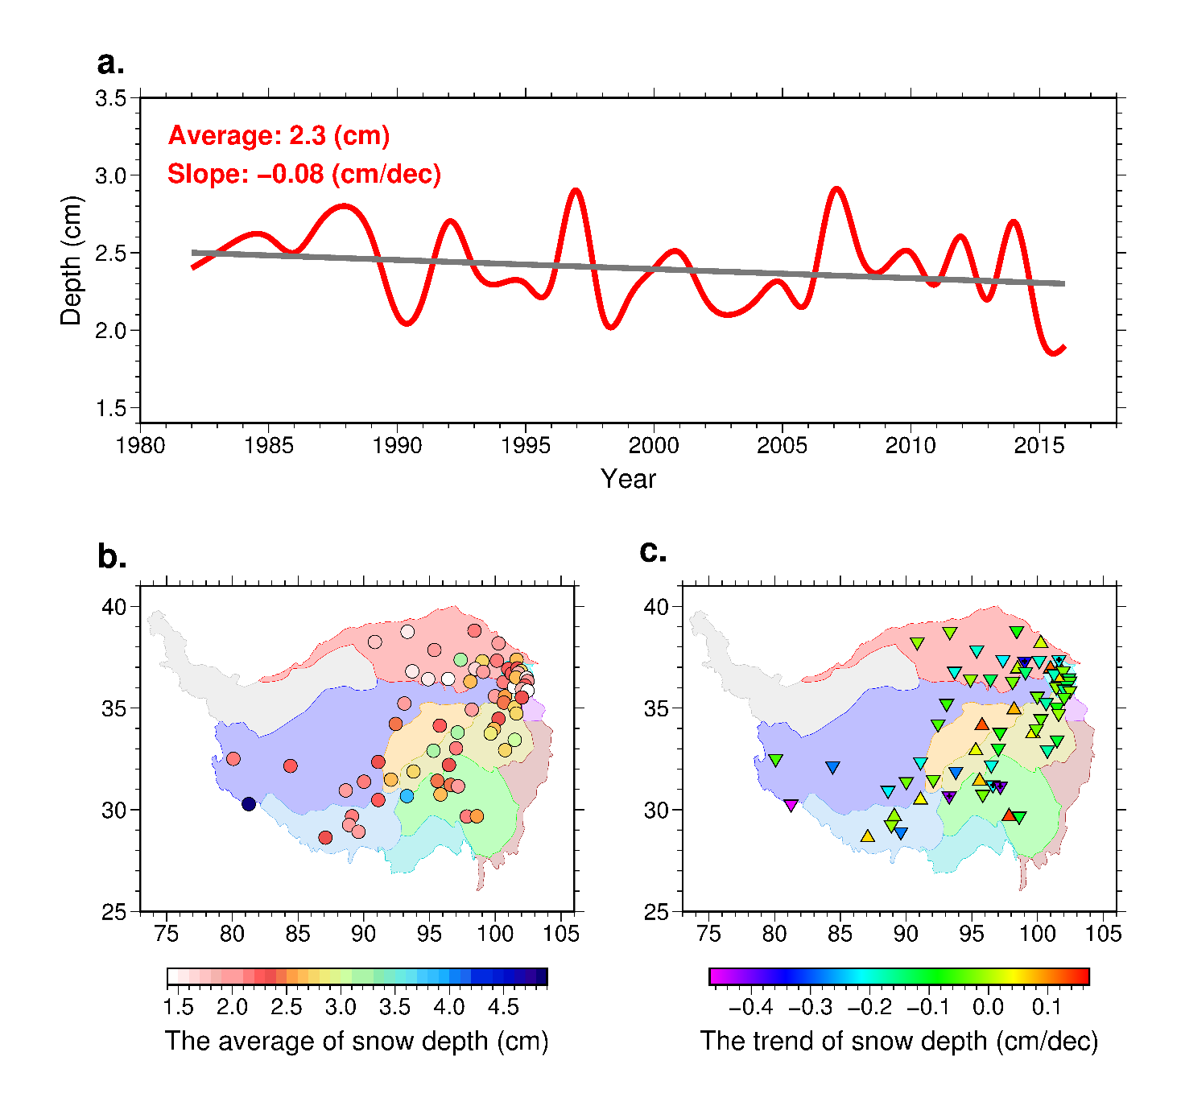
Figure S2. Spatial and temporal characteristics of snow depth (SD). Annual time series and trends of domain and layer averaged snow depth during July 1982 to June 2017 (a). Spatial distribution of the annual means (b) and trends (c) of snow depth. The black dot at the center of a triangle/inverted triangle in c indicates trend significance at p < 0.05. And the background colors in (b) and (c) represent the vegetation types.
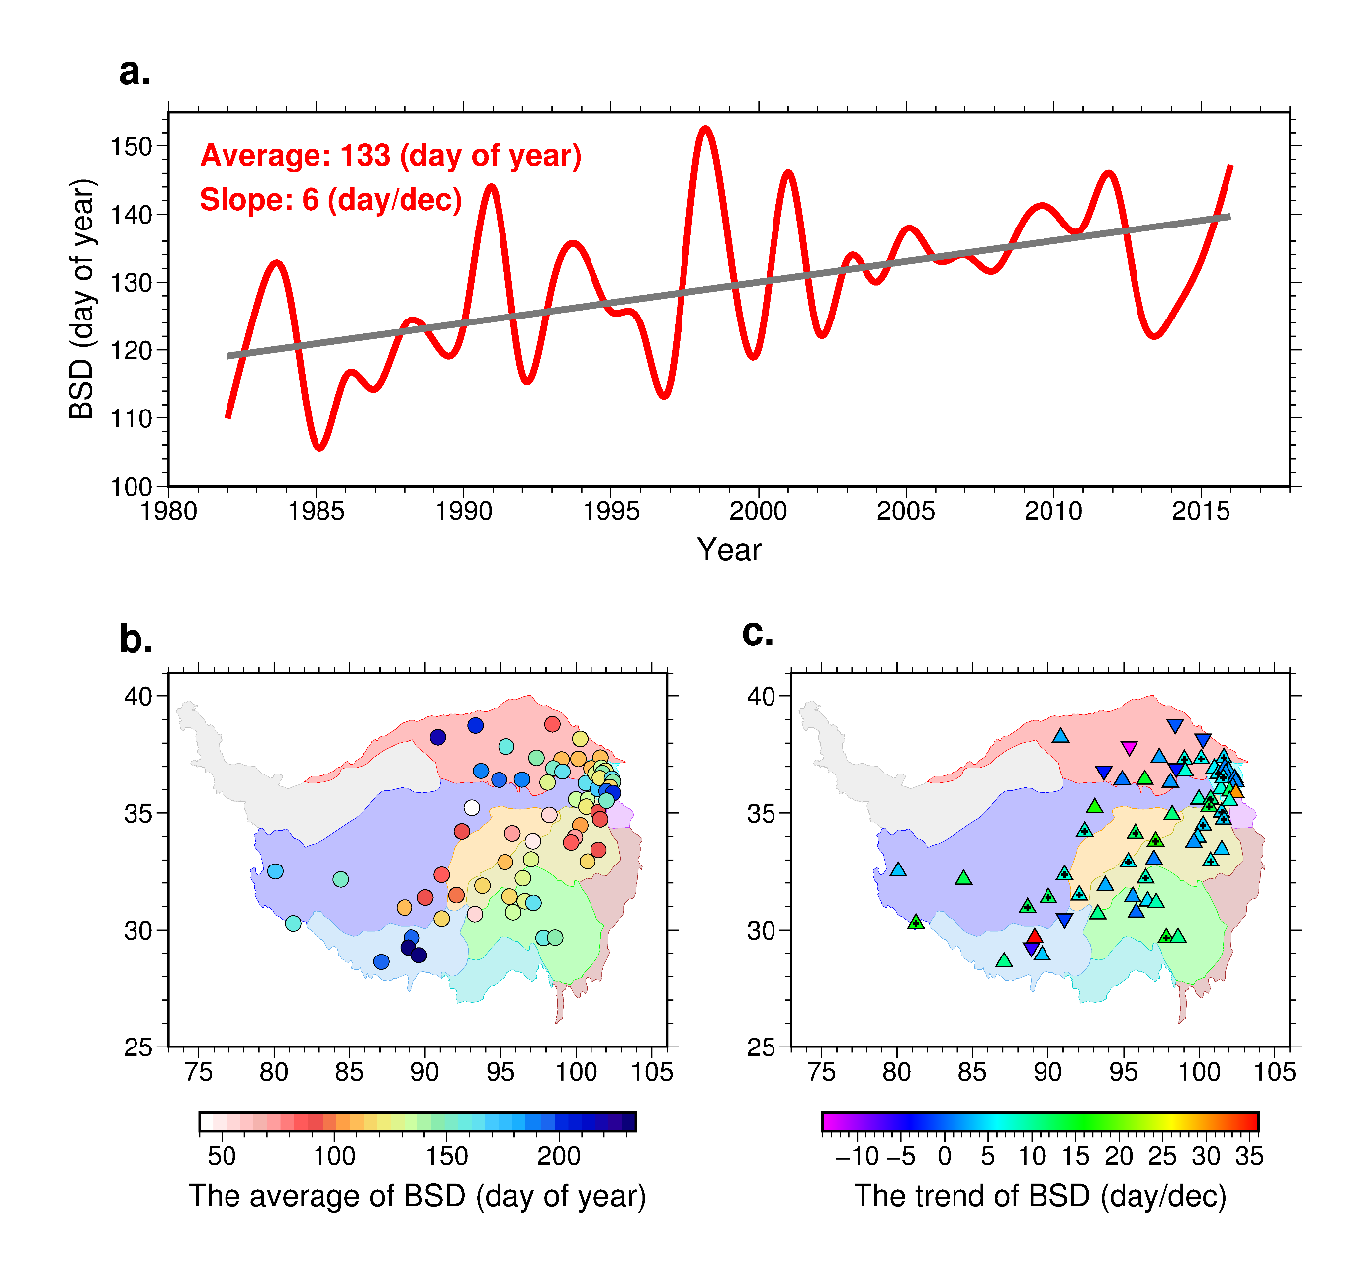
Figure S3. Same as Fig. S2 except for beginning snow day (BSD).

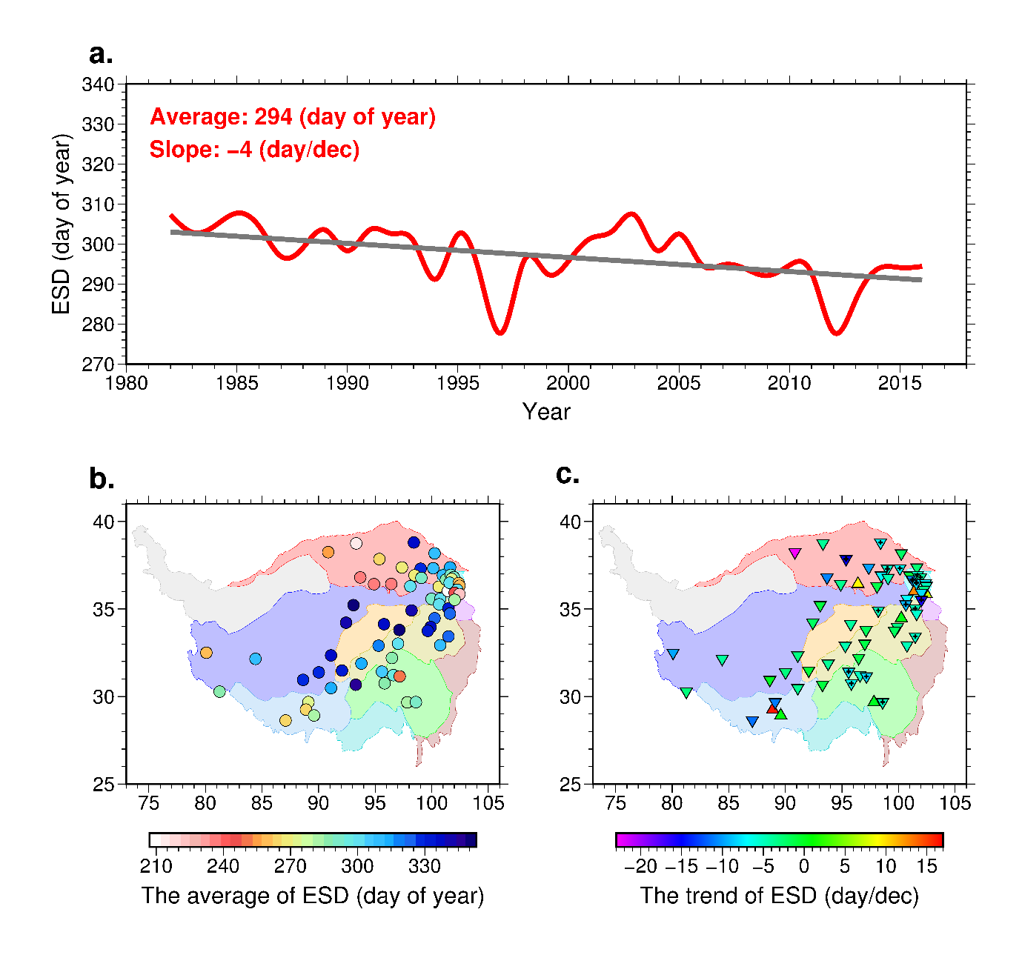
Figure S4. Same as Fig. S2 except for ending snow day (ESD).

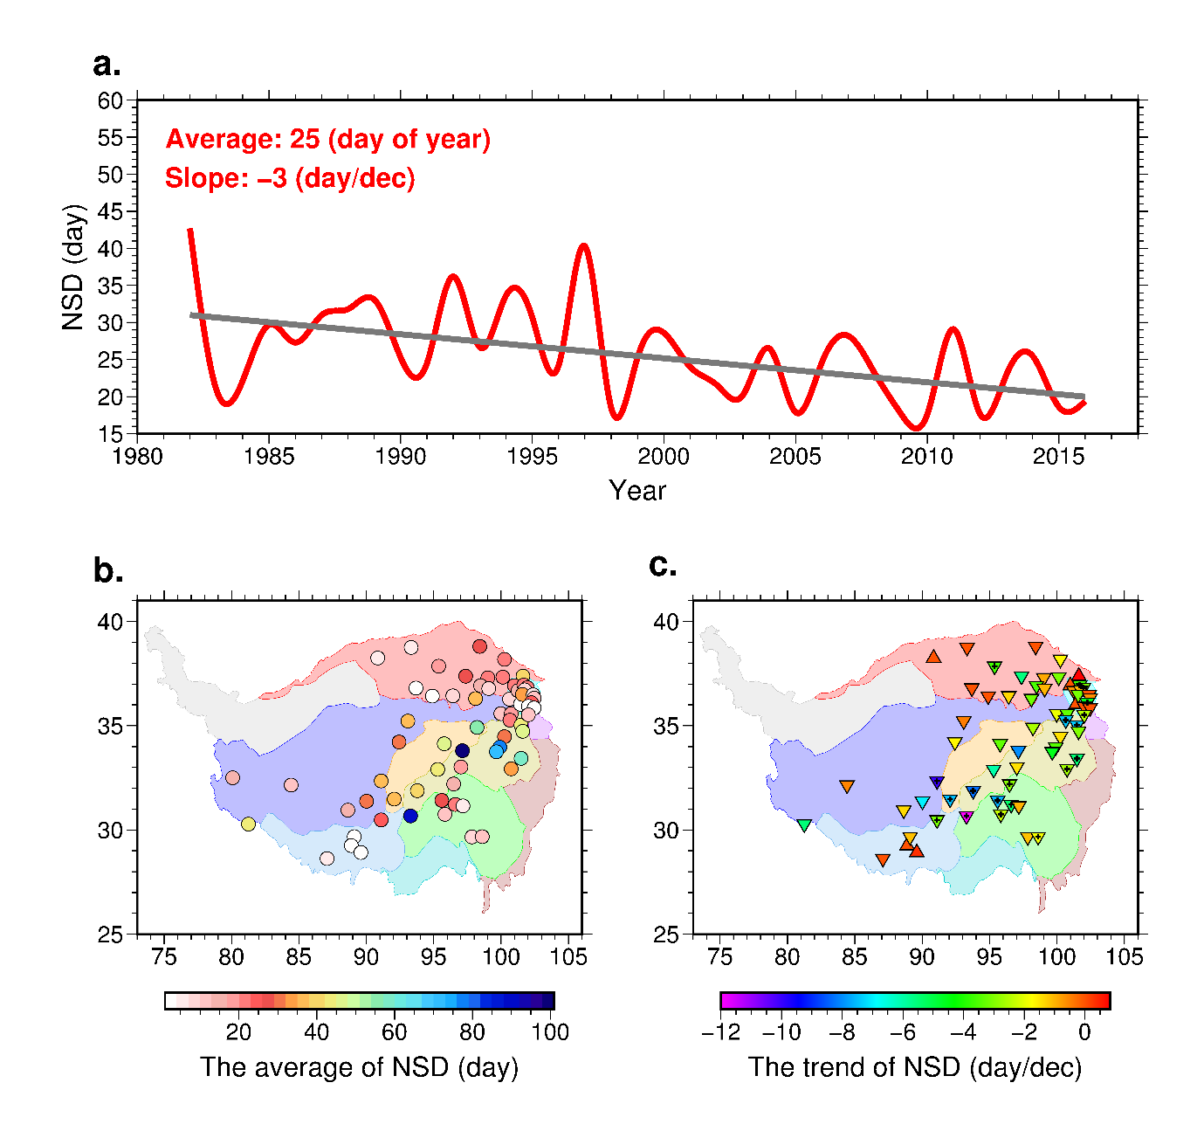
Figure S5. Same as Fig. S2 except for the number of snow day (NSD).

