Supplementally Table A. Percentage of participants’ choice of own race by condition and group and results of χ² and post hoc tests
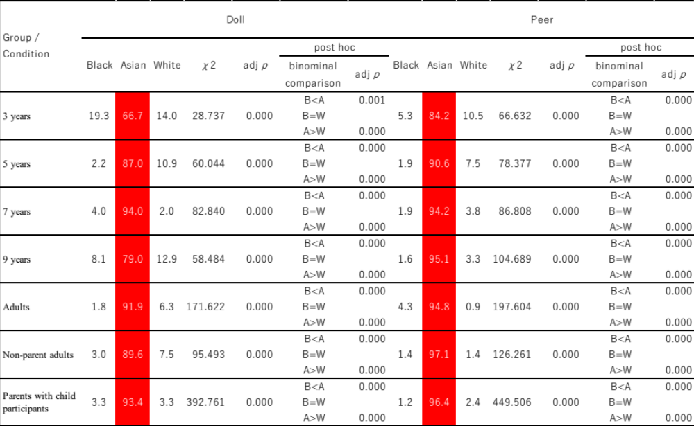
*A race in red colored cells were most likely to be selected by the participants. % in white and bold letters indicated the race that was significantly most selected by the participants.

Supplementally Table B. Percentage of participants’ choice of race for likeliness question by condition and group and results of χ² and post hoc tests
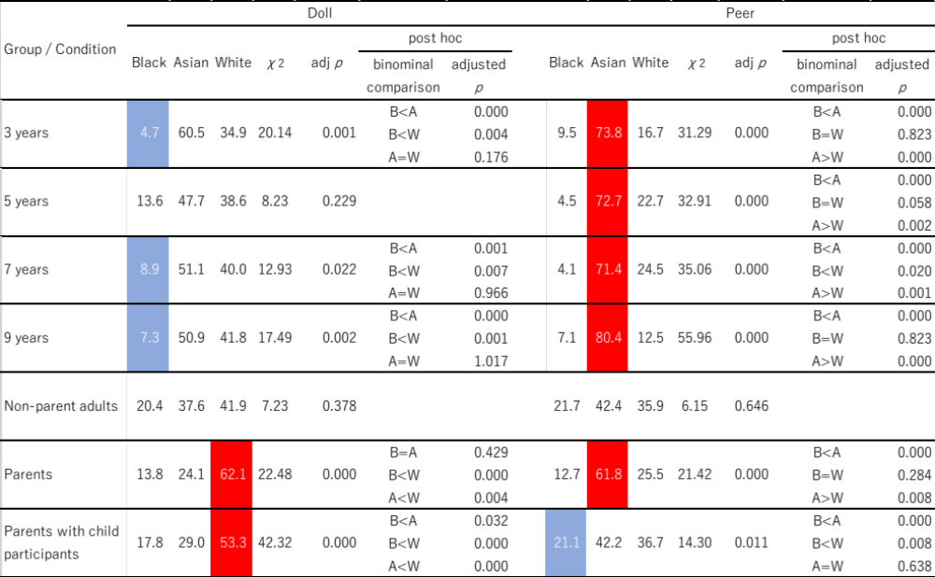
*A race in red colored cells were most likely to be selected by the participants. A race in blue colored cells were less likely to be selected by the participants. % in white and bold letters indicated the race that was significantly most selected by the participants.

Supplementally Table C. Percentage of participants’ choice of race for attractiveness question by condition and group and results of χ² and post hoc tests
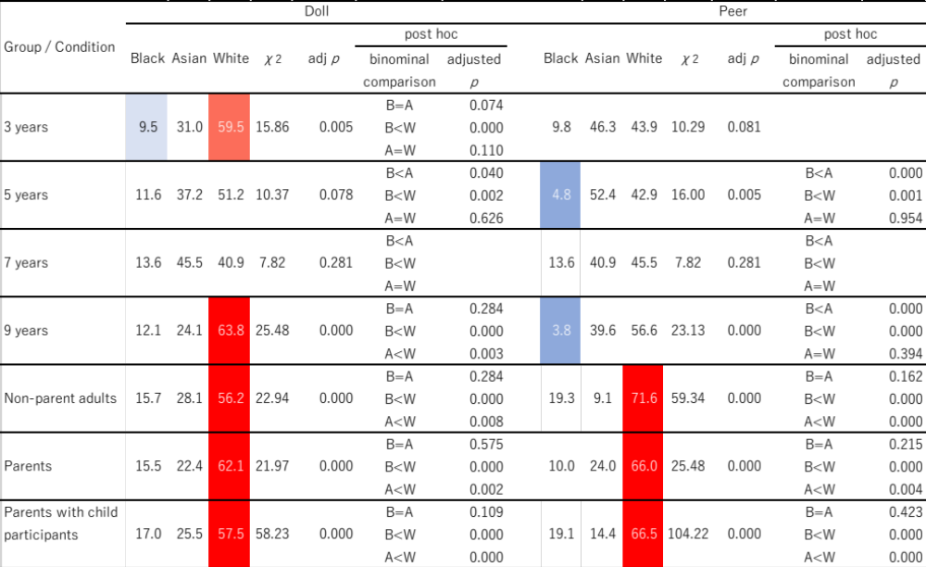
*A race in red colored cells were most likely to be selected by the participants. A race in blue colored cells were less likely to be selected by the participants. A race in light red colored cell and in light blue colored cell in one age group suggested that the participants’ choice were significantly different between these two races. % in white and bold letters indicated the race that was significantly most selected by the participants.

Supplementally Table D. Percentage of participants’ choice of race for kindness question by condition and group and results of χ² and post hoc tests
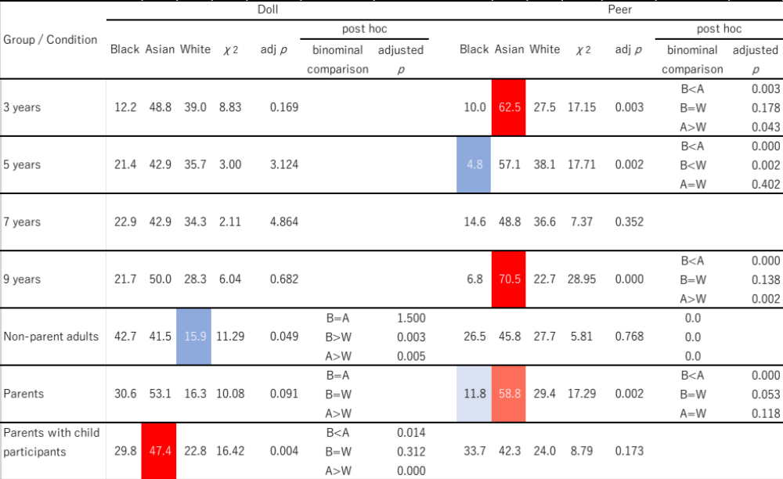
*A race in red colored cells were most likely to be selected by the participants. A race in blue colored cells were less likely to be selected by the participants. A race in light red colored cell and in light blue colored cell in one age group suggested that the participants’ choice were significantly different between these two races. % in white and bold letters indicated the race that was significantly most selected by the participants.

Supplementally Table E. Percentage of participants’ choice of race for likeliness questions in the parent task by condition and group results of χ² and post hoc tests
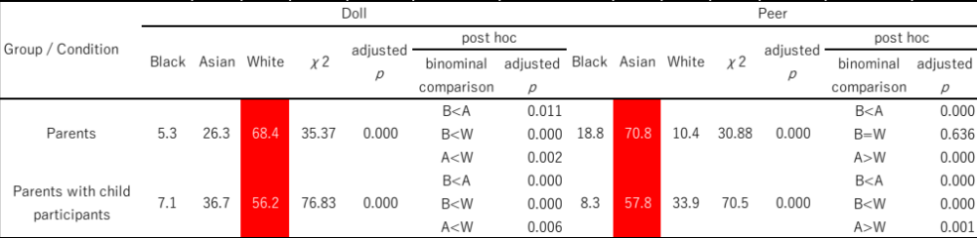
*A race in red colored cells were most likely to be selected by the participants. % in white and bold letters indicated the race that was significantly most selected by the participants.

Supplementally Table F. Number of each reason stated by parents with child participants.
