SUPPLEMENTARY MATERIAL

Table S1. The definition of biochemical control criteria of the included studies

Table S2. Risk of bias assessment according to RoB-2 tool.

Table S3. Risk of bias summary for nonrandomized studies of intervention, based on ROBINS-I.
Figure S1. (A) Prevalence of GIS Adverse events, (B) Prevalence of biliary related adverse events, (C) Prevalence of adverse events (grade ≥ 3) in the overall population.
Figure S2. (A) Leave-one out analysis of the prevalence of Biochemical Control; (B) Leave-one out analysis of the prevalence of the Normal IGF-1 levels; (C) Leave-one out analysis of the prevalence of the low GH levels.
Figure S3. (A) Funnel Plot analysis of the Biochemical Control; (B) Funnel Plot analysis of the Normalised IGF-1 levels; (C) Funnel Plot analysis of the low level of GH levels.
Figure S4. (A) Funnel Plot analysis of the DM; (B) Funnel Plot analysis of the hyperglycemia; (C) Funnel Plot analysis of the GIS adverse events; (D) Funnel Plot analysis of the biliary adverse events; (E) Funnel Plot analysis of the of adverse events (grade ≥ 3).

Table S1. The definition of biochemical control criteria of the included studies

Study | IGF-1 | GH
Chiloiro 2022 | IGF-1< ULN | GH< 1 μg /L
Colao 2014 | IGF-1< ULN | GH< 2.5 μg/L
Corica 2023 | IGF-1≤ ULN | N/A
Gadelha 2019 | IGF-1< ULN | GH< 1 μg /L
Lasolle 2019 | IGF-1≤ ULN | GH≤ 1 μg/L
PAOLA 2014 | IGF-1< ULN | GH<2.5 μg/L
Shimon | IGF-1< ULN | N/A
Stelmachowska | IGF-1≤ ULN | GH≤ 1 μg/L
Tahara | IGF-1< ULN | GH<2.5 μg/L

Supplementary Table S2. Risk of bias assessment according to RoB-2 tool.
Study | Bias from randomization process | Bias due to deviations from intended interventions | Bias due to missing outcome data | Bias in measurement of the outcomes | Bias in selection of the reported result | Overall risk of bias
Colao 2014 | Low | Low | Low | Low | Low | Low
PAOLA 2014 | Low | Low | Low | Low | Low | Low
Tahara 2017 | Some Concerns | Low | Low | Low | Low | Some Concerns

Supplementary Table S3. Risk of bias summary for nonrandomized studies of intervention, based on ROBINS-I.
Study | Bias due to confounding | Bias in selection of participants | Bias in classification of interventions | Bias due to deviations from intended interventions | Bias due to missing data | Bias in measurement of outcomes | Bias in selection of the reported result | Overall risk of bias judgement
Chiloiro 2022 | Serious | Low | Low | Low | Low | Moderate | Low | Serious
Corica 2023 | Moderate | Low | Low | Low | Low | Moderate | Low | Moderate
Gadelha 2019 | Moderate | Low | Low | Low | Low | Moderate | Low | Moderate
Lasolle 2019 | Moderate | Low | Low | Low | Low | Moderate | Low | Moderate
Shimon 2018 | Moderate | Low | Low | Low | Low | Moderate | Low | Moderate
Stelmachowska 2022 | Moderate | Low | Low | Low | Low | Moderate | Low | Moderate

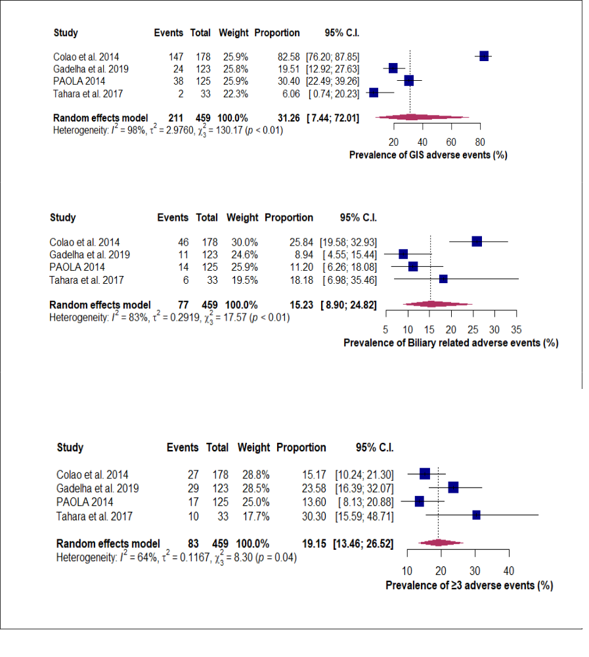
C
B
A
Supplementary Figure S1. (A) Prevalence of GIS Adverse events, (B) Prevalence of biliary related adverse events, (C) Prevalence of adverse events (grade ≥ 3) in the overall population.

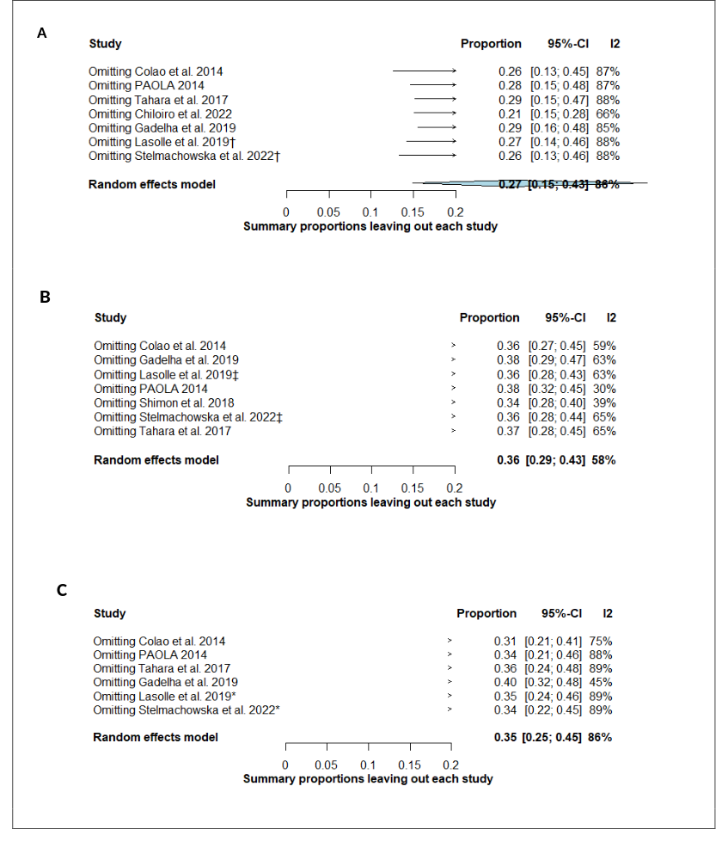
Supplementary Figure 2. (A) Leave-one out analysis of the prevalence of Biochemical Control; (B) Leave-one out analysis of the prevalence of the Normal IGF-1 levels; (C) Leave-one out analysis of the prevalence of the low GH levels.

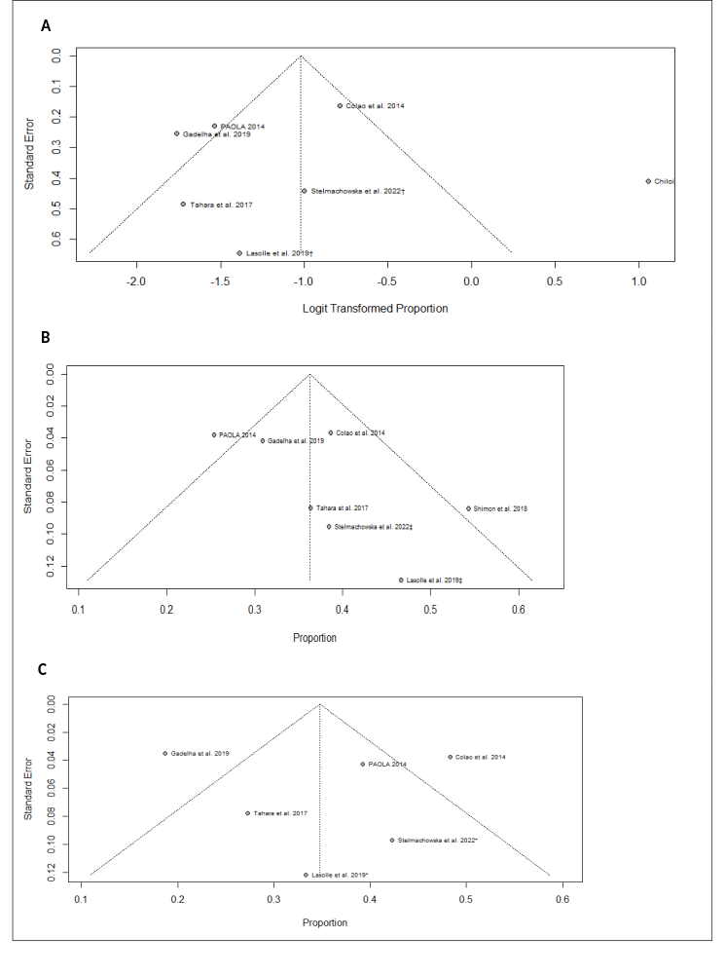
Supplementary Figure 3. (A) Funnel Plot analysis of the Biochemical Control; (B) Funnel Plot analysis of the Normalised IGF-1 levels; (C) Funnel Plot analysis of the low level of GH levels.
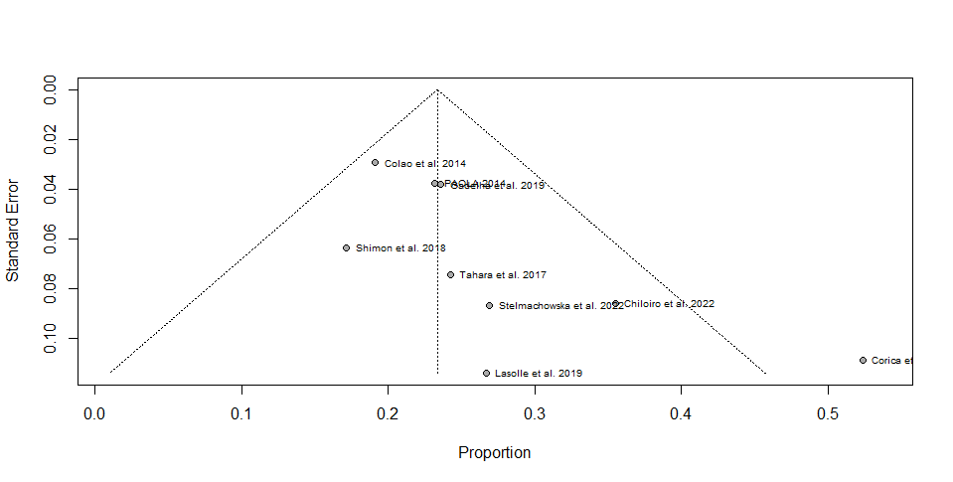
A
B
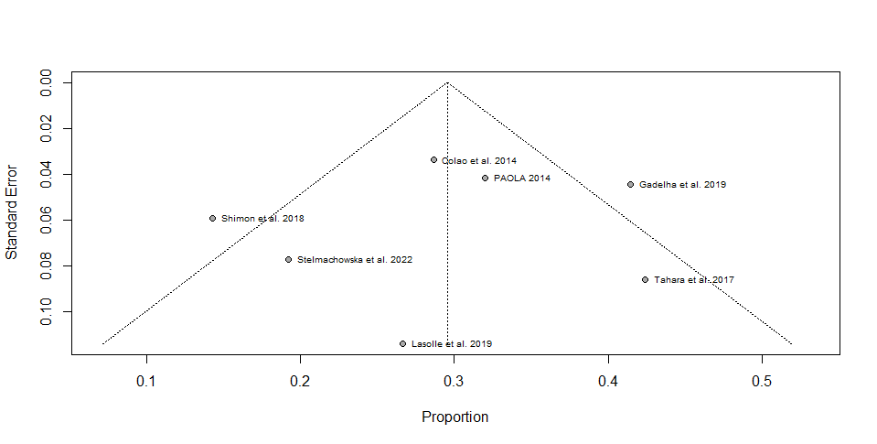
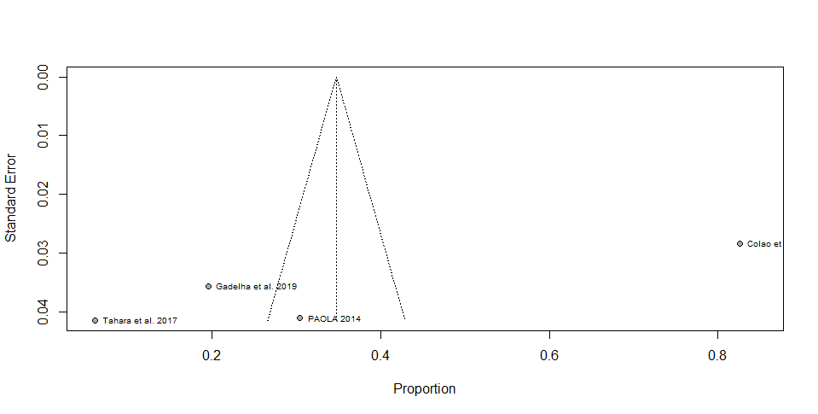
C
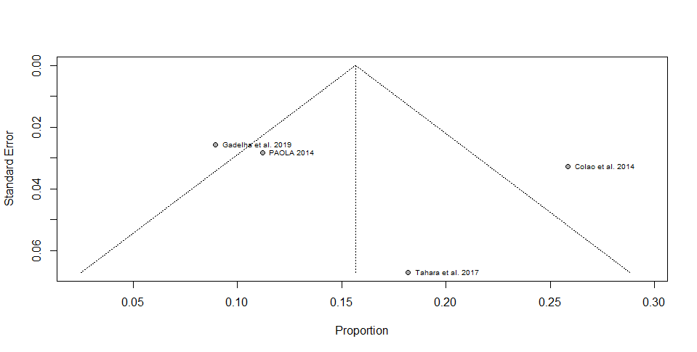
D
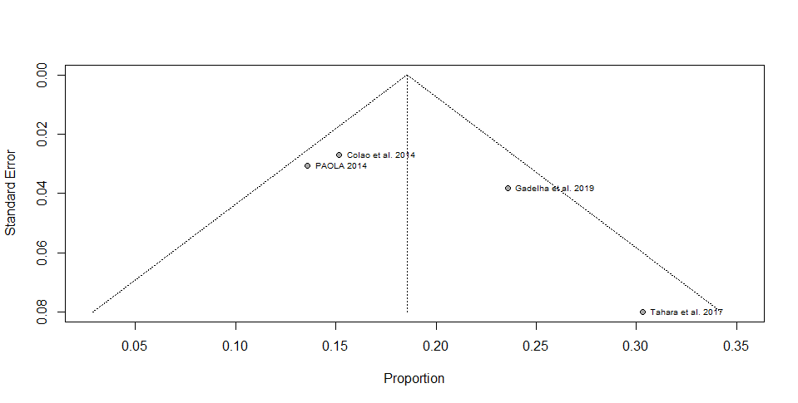
E

Supplementary Figure 4. (A) Funnel Plot analysis of the DM; (B) Funnel Plot analysis of the hyperglycemia; (C) Funnel Plot analysis of the GIS adverse events; (D) Funnel Plot analysis of the biliary adverse events; (E) Funnel Plot analysis of the of adverse events (grade ≥ 3).

