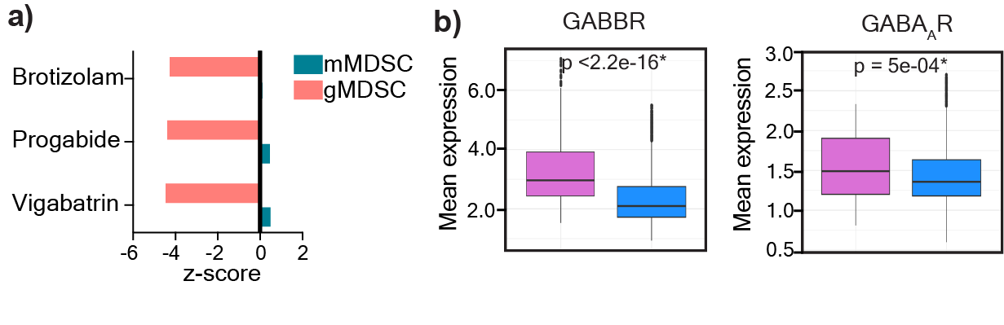
Extended Figure 1: GABA receptor expression in MDSCs. a) Three drug candidates were predicted to target the GABA pathway in gMDSCs. Vigabatrin, a GABA transaminase inhibitor; progabide, a GABA analog, and brotizolam, a GABA receptor allosteric ligand were among the 20 candidate genes predicted to target gMDSCs based on network medicine analysis. b) Mean expression levels of GABBR and GABA_{A}R in female (n=5) and male (n=8) glioma patients. *p<0.05 as determined by Wilcoxon Rank-Sum test.

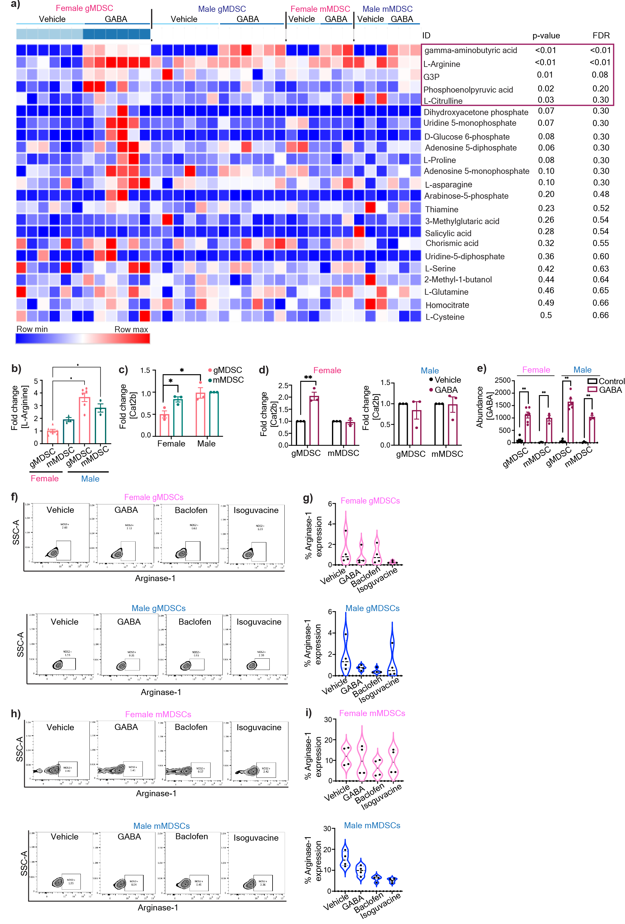
Extended Figure 2: GABA-mediated metabolic alteration of female gMDSCs. a) Heatmap demonstrating differentially regulated metabolites in male and female mMDSCs and gMDSCs upon GABA stimulation. Data was normalized to the average sum of metabolites from all the samples and analyzed using Morpheus. b) Relative baseline L-Arginine levels in female and male gMDSCs (n=6) and mMDSCs (n=3), *p<0.01 as determined by two-way ANOVA. c) Relative expression of the L-Arginine transporter Cat2b in male and female mMDSC and gMDSC. d) Change in the frequency of Cat2b expression in female (left) and male (right) MDSCs treated with 100 μM GABA. n=3, * p<0.05 by unpaired t-test compared to vehicle. e) Enrichment plots depicting the top 25 pathways upregulated in female gMDSCs with GABA stimulation. f) Intracellular abundance of GABA in female and male gMDSCs (n=6) and mMDSCs (n=3) following GABA treatment, *p<0.01 as determined by two-way ANOVA.

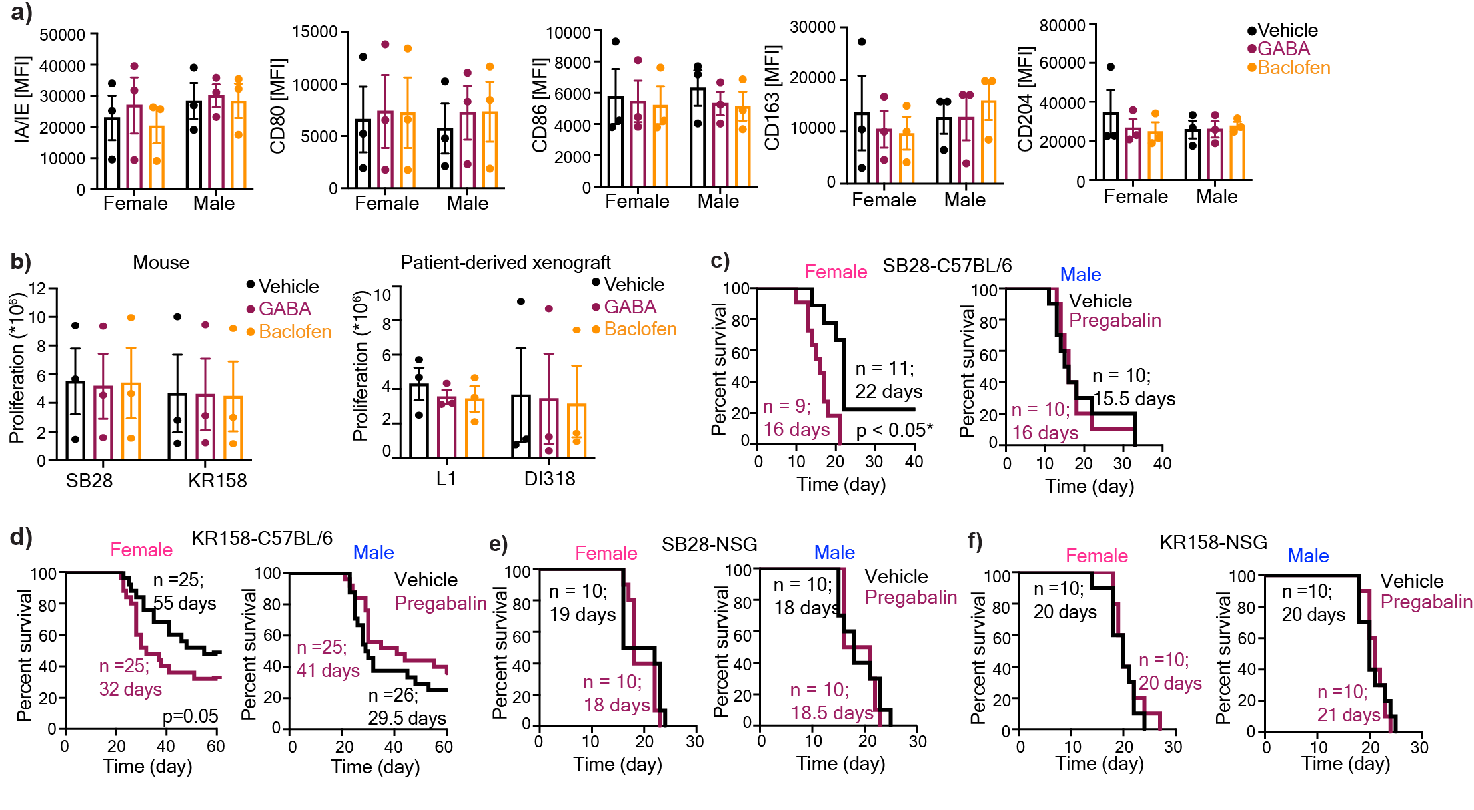

Extended Figure 3: GABA analogs truncates survival in immunocompetent females. a) Bone marrow-derived cells were stimulated with 50ng/ml M-CSF and polarized into macrophages over a period of 6 days. Macrophages were stimulated overnight with 100 µM GABA or baclofen. Mean fluorescence intensity (MFI) of the pro-inflammatory macrophage markers IA/IE, CD80, and CD86 and the immunosuppressive markers CD163, CD204. Data shown as mean + SEM from n=3. b) Proliferation rates of the mouse GBM cells SB28 and KR158 (left) and the patient-derived xenograft (PDX) lines L1 and DI318 (right), were analyzed after daily stimulation with 100 µM GABA or Baclofen. Data shown as mean + SEM. c) Female and male C57BL/6 mice were intracranially implanted with 30,000 (females) and 20,000 (males) SB28 cells, or d) 50,000 KR158 cells. NSG mice were implanted with e) 10,000 SB28 or f) KR158 cells. Seven days post-tumor implantation, the mice were intraperitoneally injected with 25 mg/kg pregabalin daily, following a 5-days-on, 2-days-off schedule. Kaplan-Meier curves depicting the median survival of female (left) and male (right) mice. For each group Data were combined from 2-3 independent experiments. * p<0.05 based on the log-rank test.

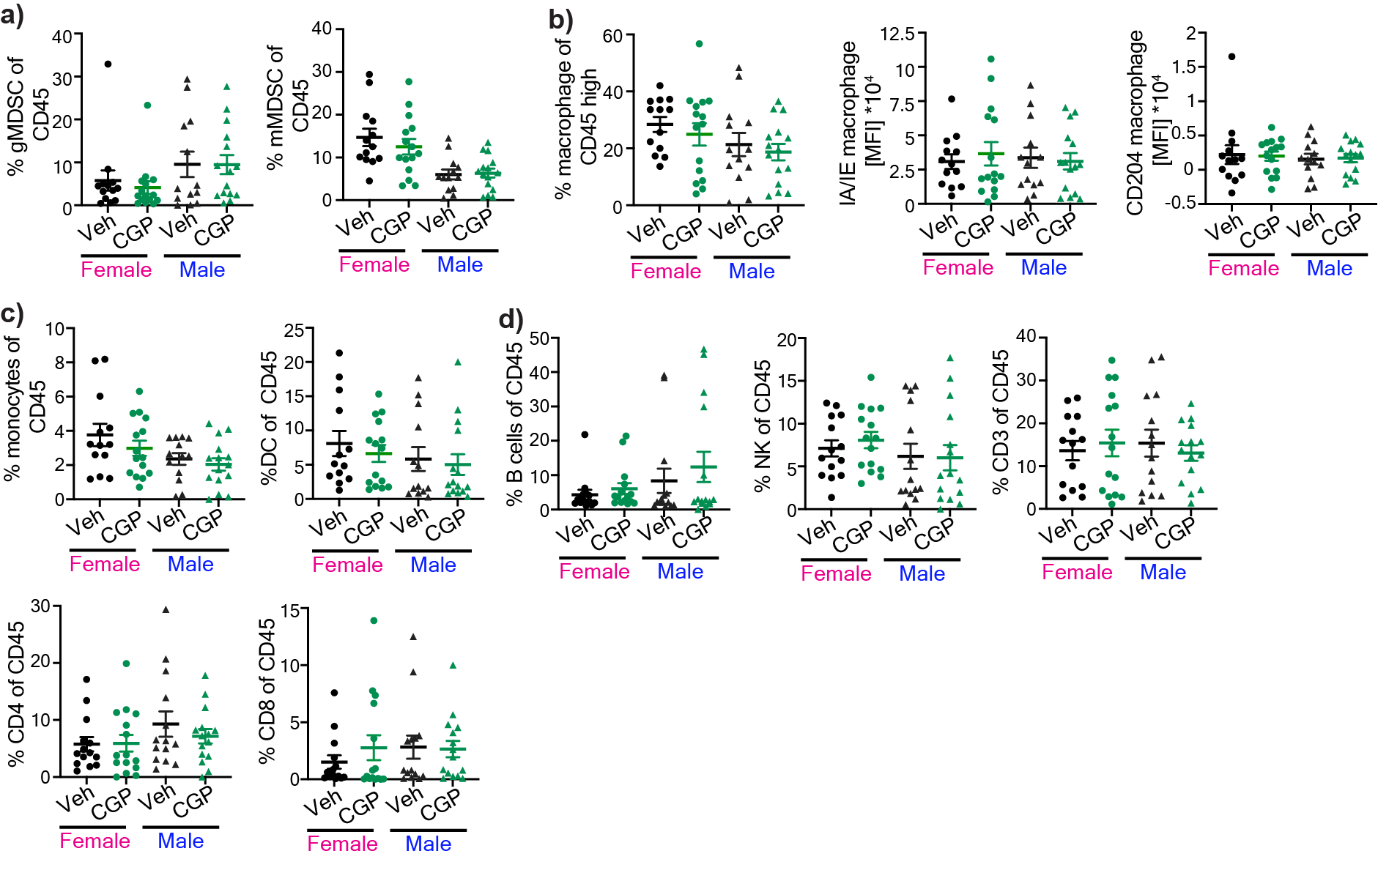

Extended Figure 4: Effect of GABBR modulation on tumor-infiltrating immune populations. Tumor-infiltrating immune populations from SB28-bearing male and female mice following CGP 35348 treatment. Percentage of a) gMDSCs (left) and mMDSCs (right). b) Percentage of macrophages and MFI of IA/IE (left) and CD204 (right) of macrophages. c) Percentage of monocytes (left) and dendritic cells (right) d) B cells, NK cells, CD3+ T cells, CD4+ T cells, and CD8+ T cells (n= 13-15). Data shown from individual animals from three independent experiments.

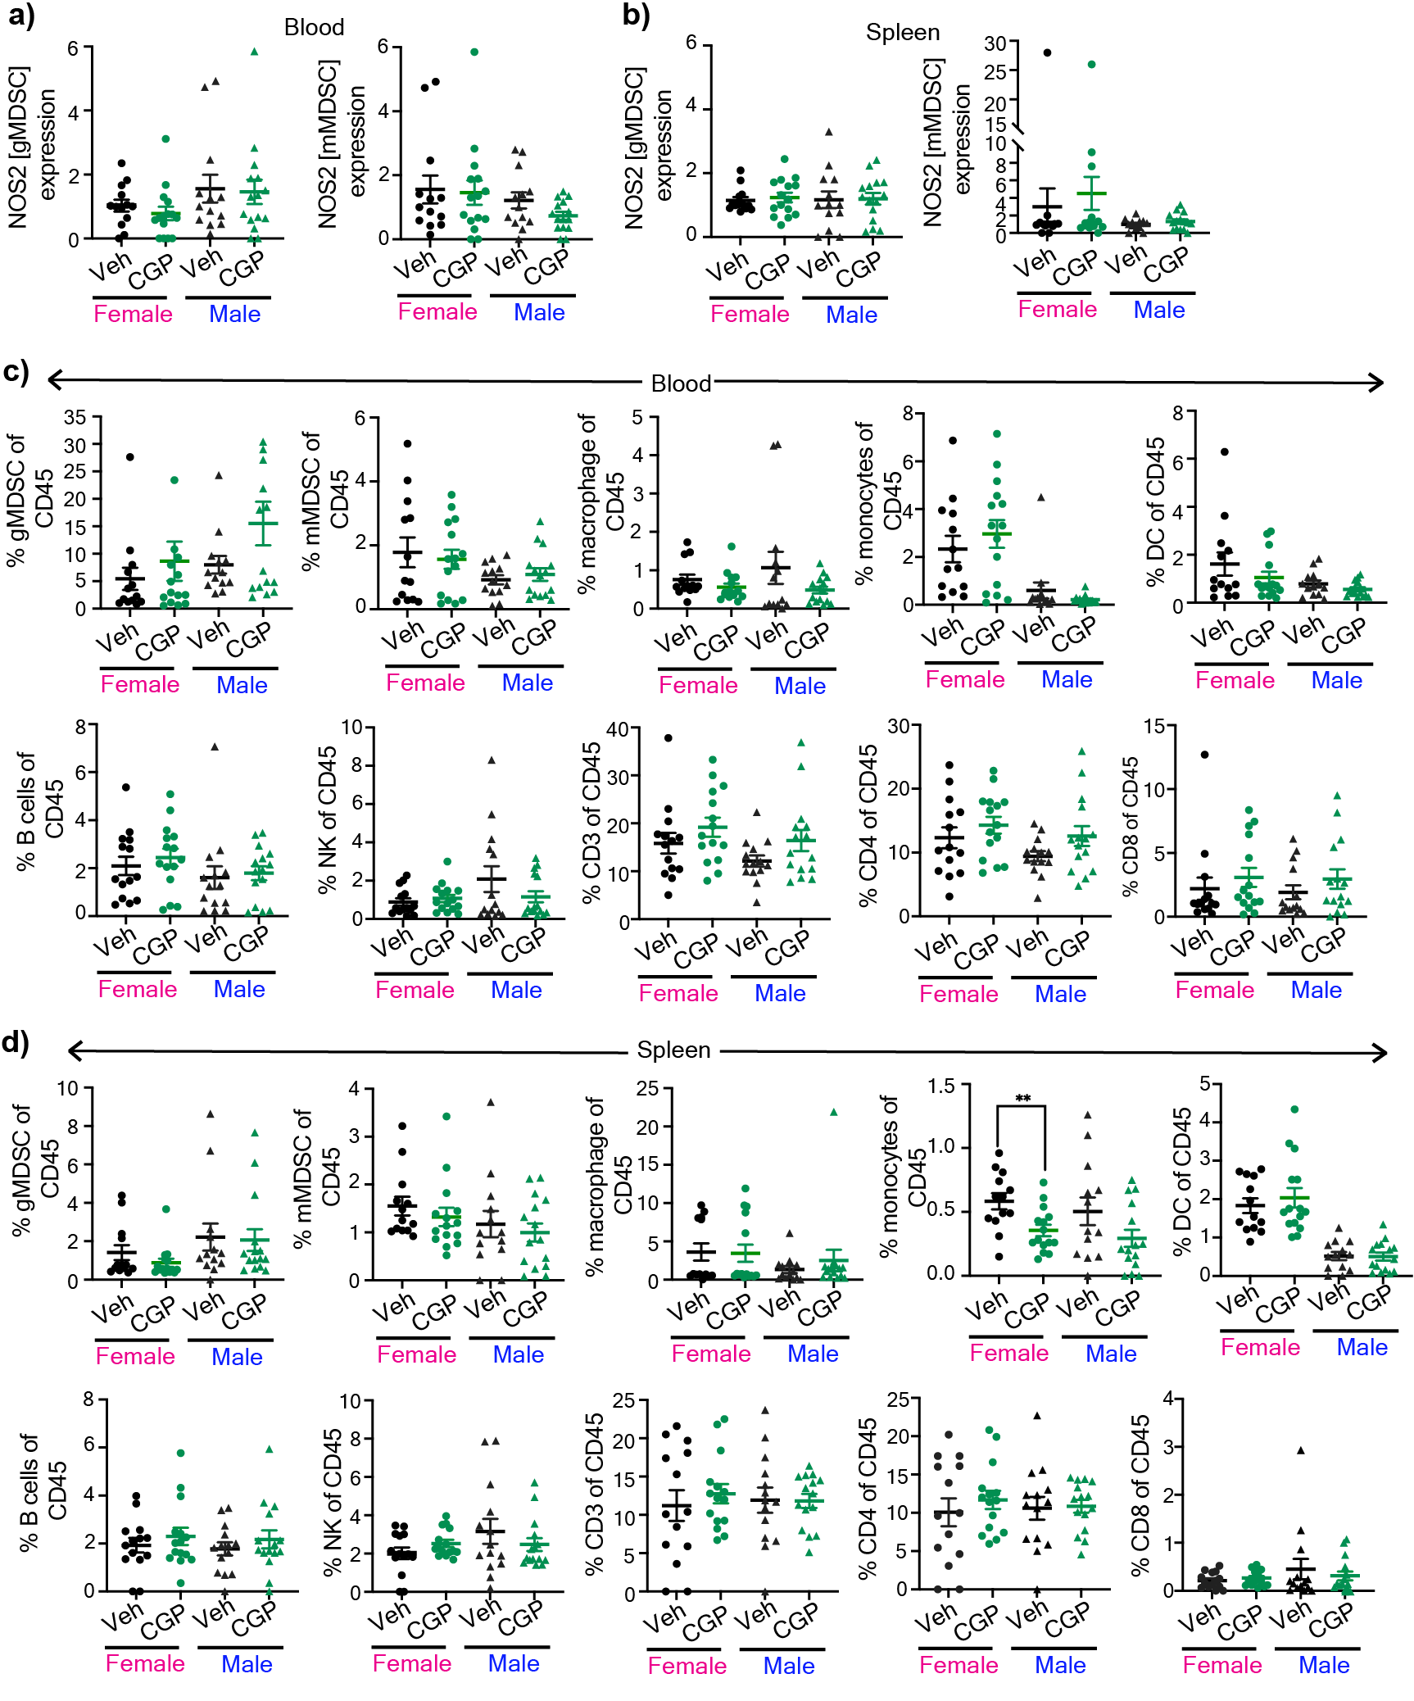

Extended Figure 5: GABBR inhibition does not alter peripheral immune responses. Peripheral immune populations from SB28-bearing male and female mice following CGP 35348 treatment. Graphs showing percentage of NOS2+ gMDSCs (left) and NOS2+ mMDSCs (right) from a) blood and b) spleen. c) Graphs showing the percentage of gMDSCs, mMDSCs, macrophages, monocytes, dendritic cells (left to right, top panel) and B cells, NK, CD3, CD4+, and CD8+ (left to right, bottom panel) from blood. d) Graphs showing the percentage of gMDSCs, mMDSCs, macrophages, monocytes, dendritic cells (left to right, top panel) and B cells, NK, CD3, CD4+, and CD8+ (left to right, bottom panel) from spleen. Data shown from individual animals (n= 13-15) from three independent experiments.

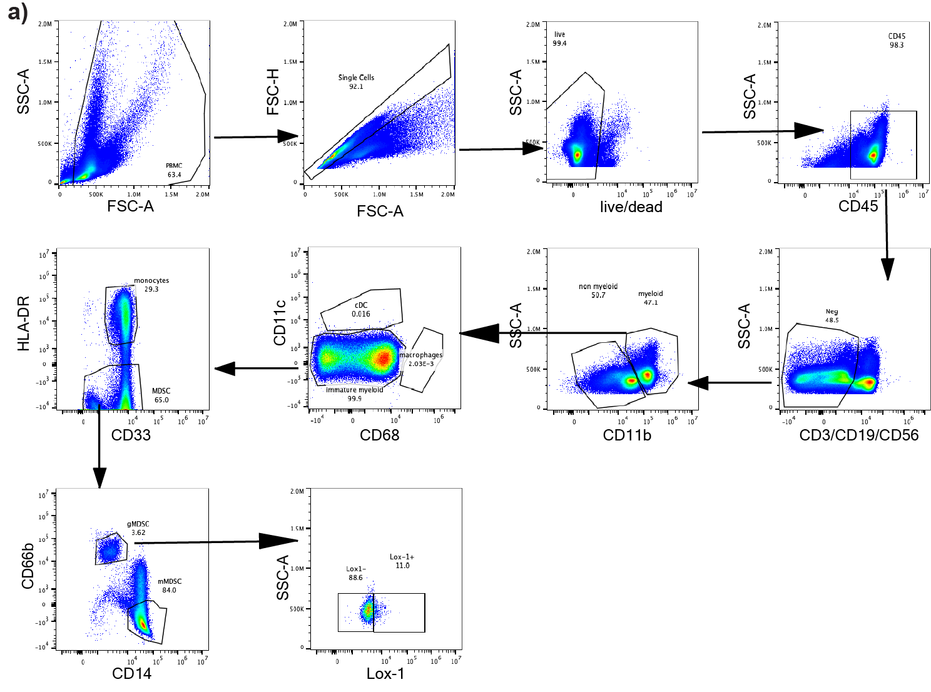

Supplementary Figure 1: Identification of immune populations from human PBMCs. Gating strategy of immune populations from healthy human PBMCs.

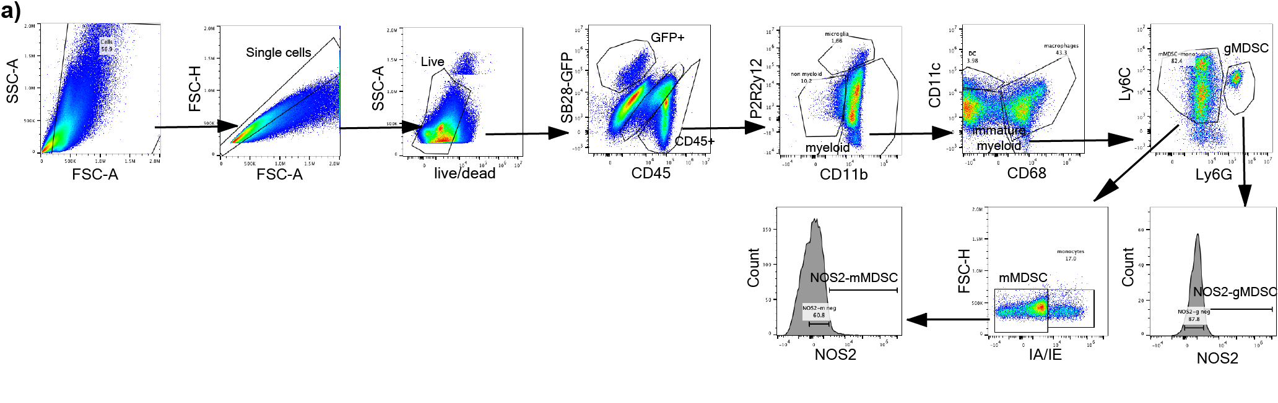
Supplementary Figure 2: Gating strategy for immune populations from SB28-bearing mice. Gating strategy of immune populations and NOS2 expression from vehicle or CGP 35348 treated mice.

