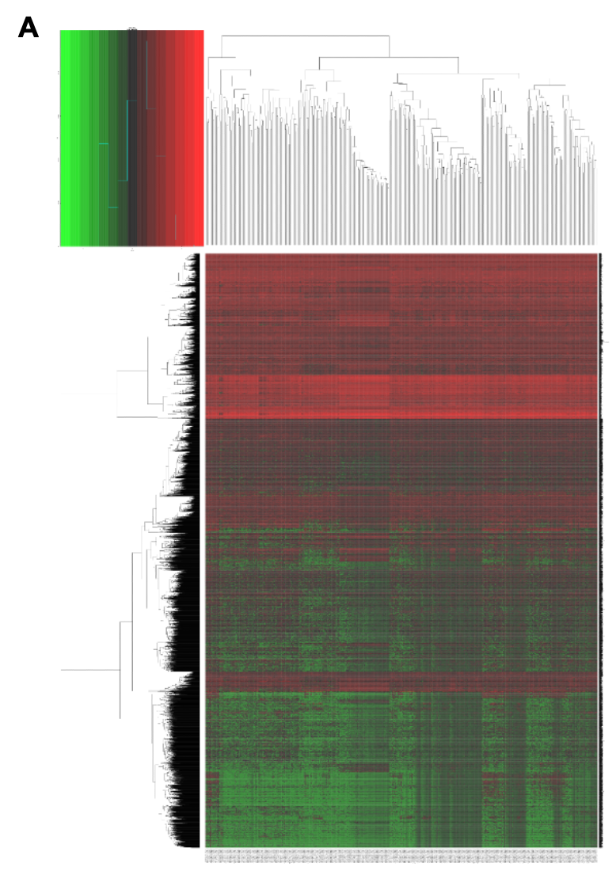
Fig.S1 TCGA dataset analysis the DEmRNAs from HCC samples associated with prognosis.
(A) The heatmaps of 3256 DEmRNAs from HCC samples (n =374) and noncancerous samples (n = 50) in the TCGA dataset.

