Supplementary files
Table S1. RNA-Seq data for different flax stem tissues from control (non-inclined) and gravistimulated plants
Table S2. RNA-Seq data for analysis of difference between the tissues located at the pulling and opposite stem sides in gravistimulated flax plants
Table S3. RNA-Seq data for Fig. 8 (hormone-related), Fig. 11 (TCW-related), Fig. 12 (final scheme and Fig. S2)

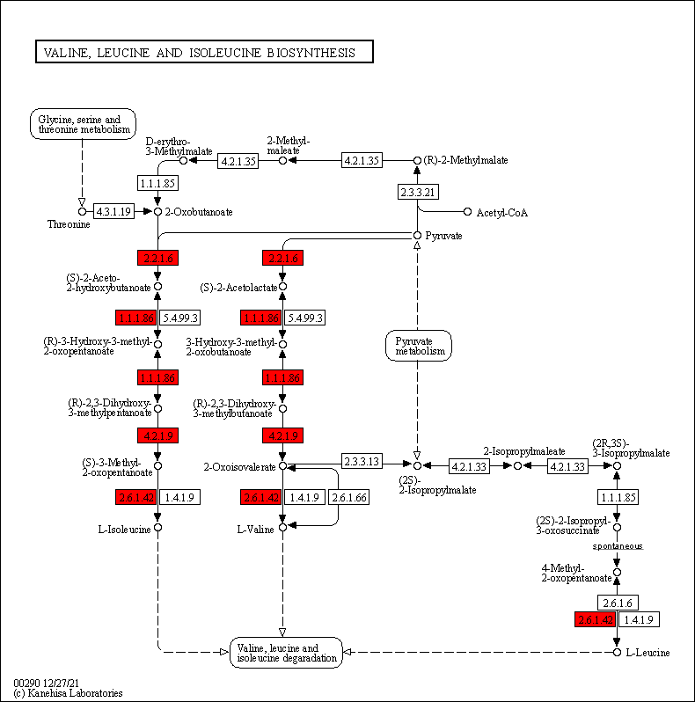
Fig. S1 BCAA biosynthetic pathway. Visualization of the flax DEGs profile from cluster 1 (mean FC value for each gene across all comparison pairs of cluster 1 is less than or greater than 2, padj≤0.01) with the KEGG Mapper Color tool. The pathway "Valine, leucine and isoleucin biosynthesis" for the corresponding Arabidopsis homologs is shown. “Red color” – activation of the steps of BCAA synthesis by up-regulation of the expression of genes encoding the corresponding proteins.

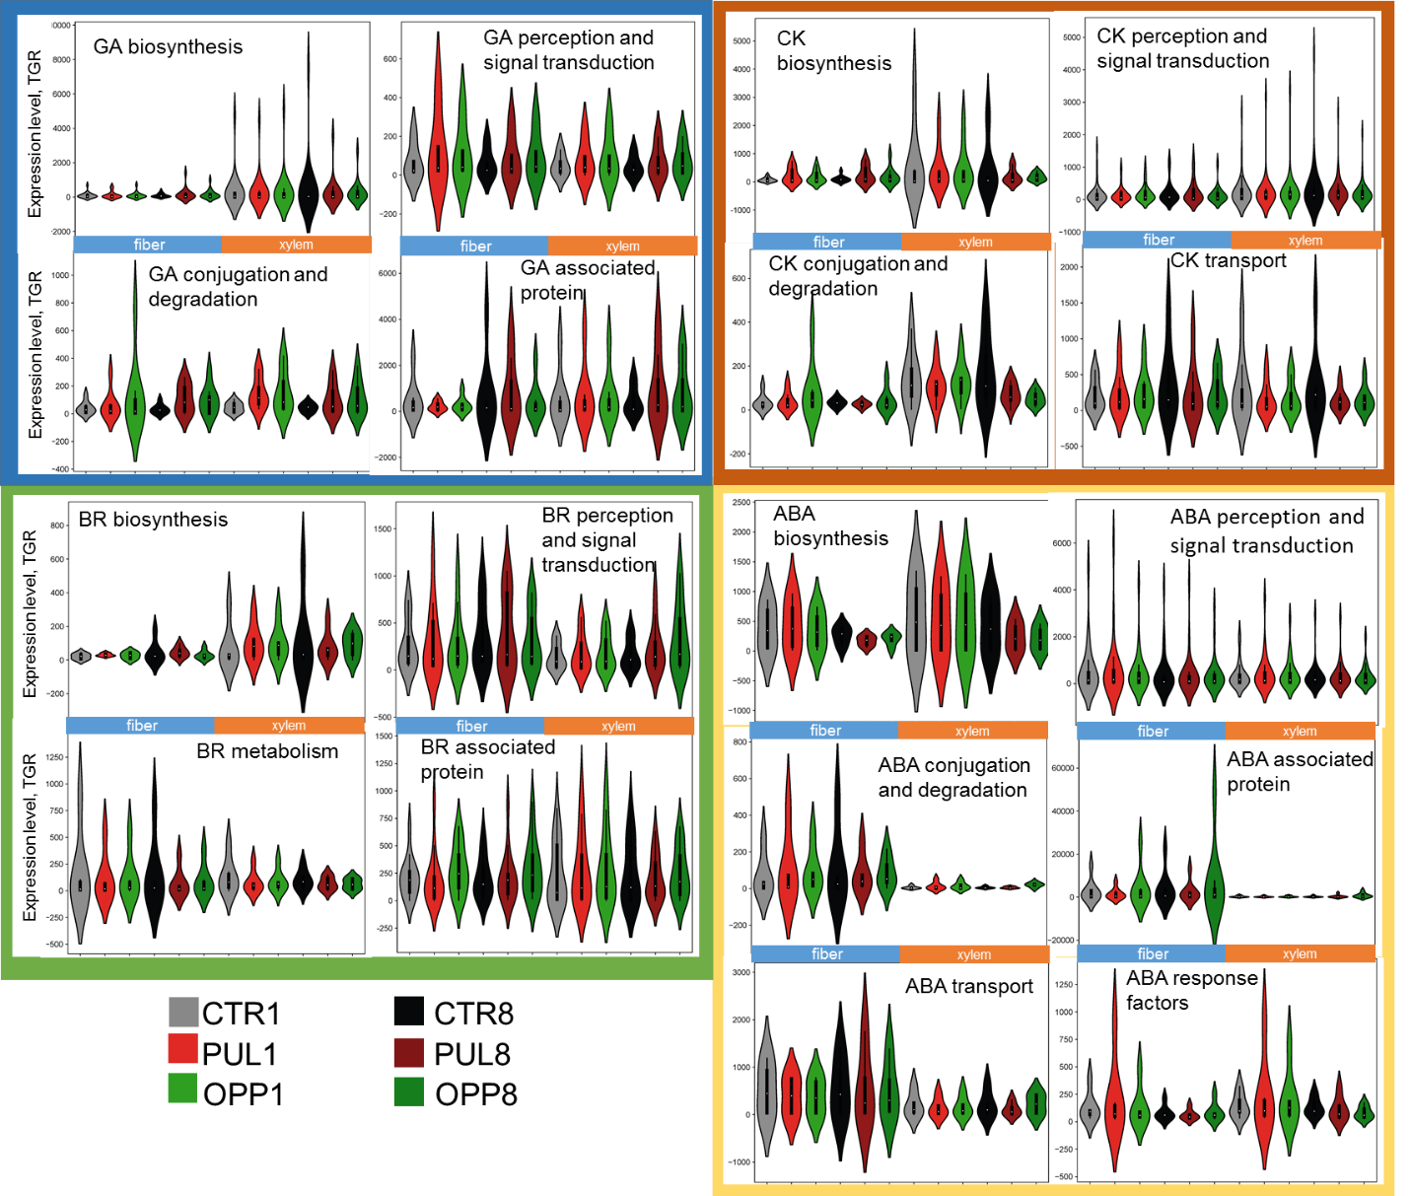

Fig. S2 Violin plots representing the distribution of gene expression (TGR (total gene reads) see in Table S3) for key hormone-related proteins: GA – gibberellic acid, CK – cytokinins, BR – brassinosteroids, ABA – abscisic acid

