Extended Data for

Human genetic variation determines 24-hour rhythmic gene expression and disease risk

Ying Chen, Panpan Liu, Aniko Sabo, Dongyin Guan

Corresponding author: Dongyin Guan, Email: dongyin.guan@bcm.edu

The PDF file includes:

Extended Data Figures 1 to 6
Captions for Supplementary Tables 1 to 10

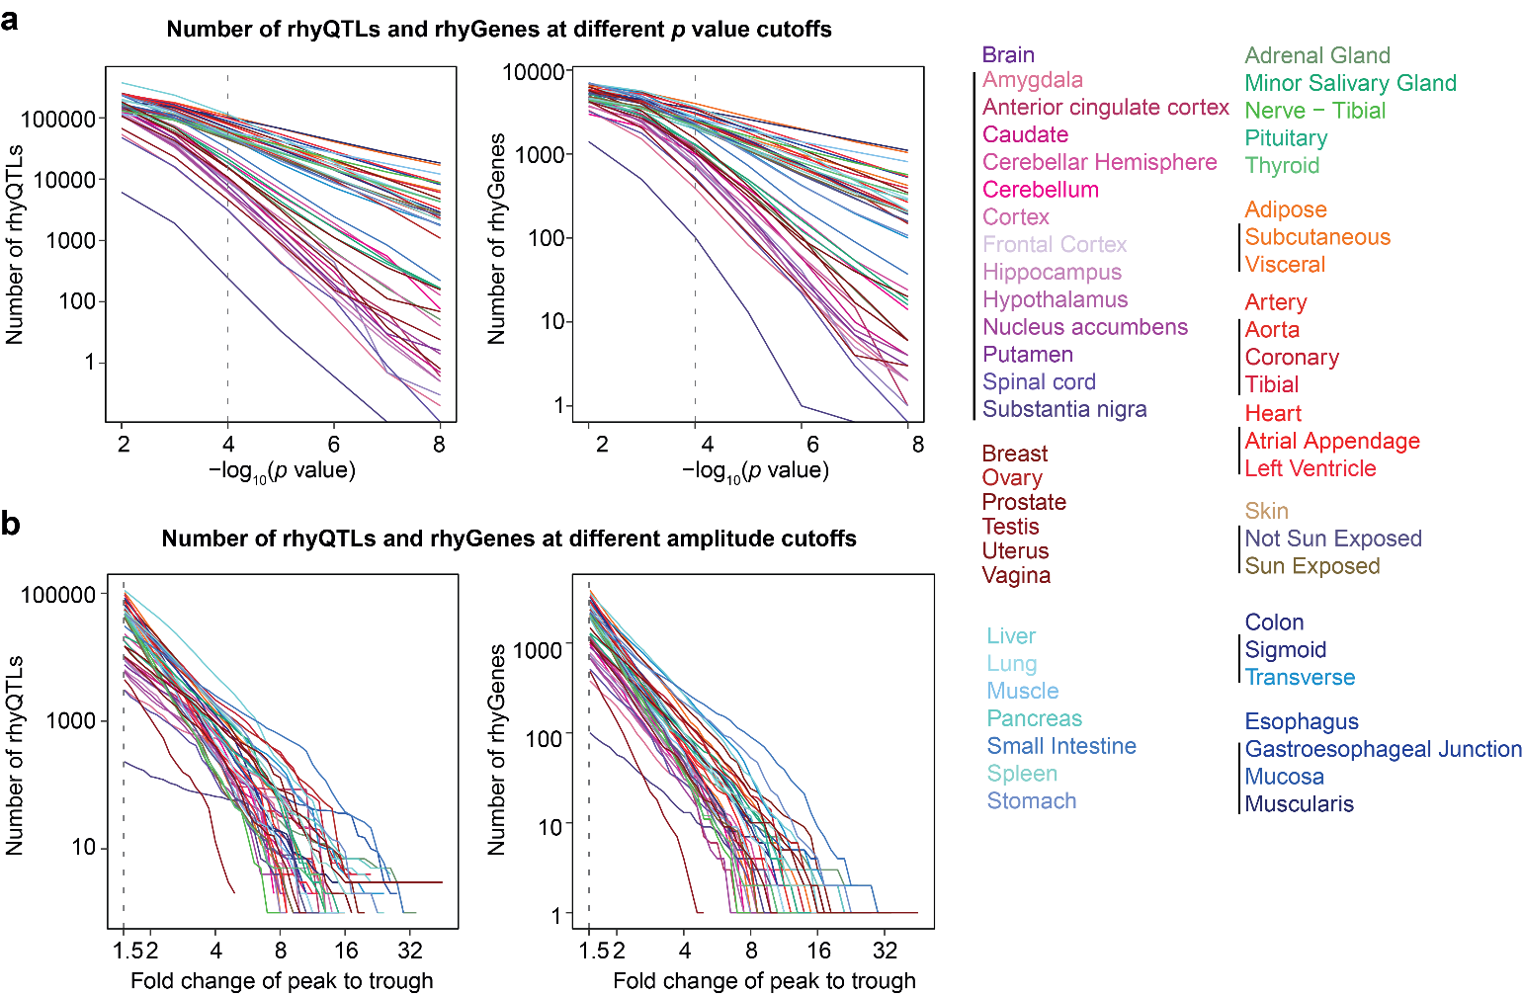
Extended Data Fig. 1 The number of rhyQTLs and rhyGenes at different cutoffs of p value (a) and fold change of peak to trough (b). Cutoffs were set at a p value of ≤ 10⁻⁴ and a fold change of peak to trough ≥ 1.5 (indicated by dashed lines) for further analysis in this study. Amplitude is defined as the log₂ fold change of peak-to-trough.

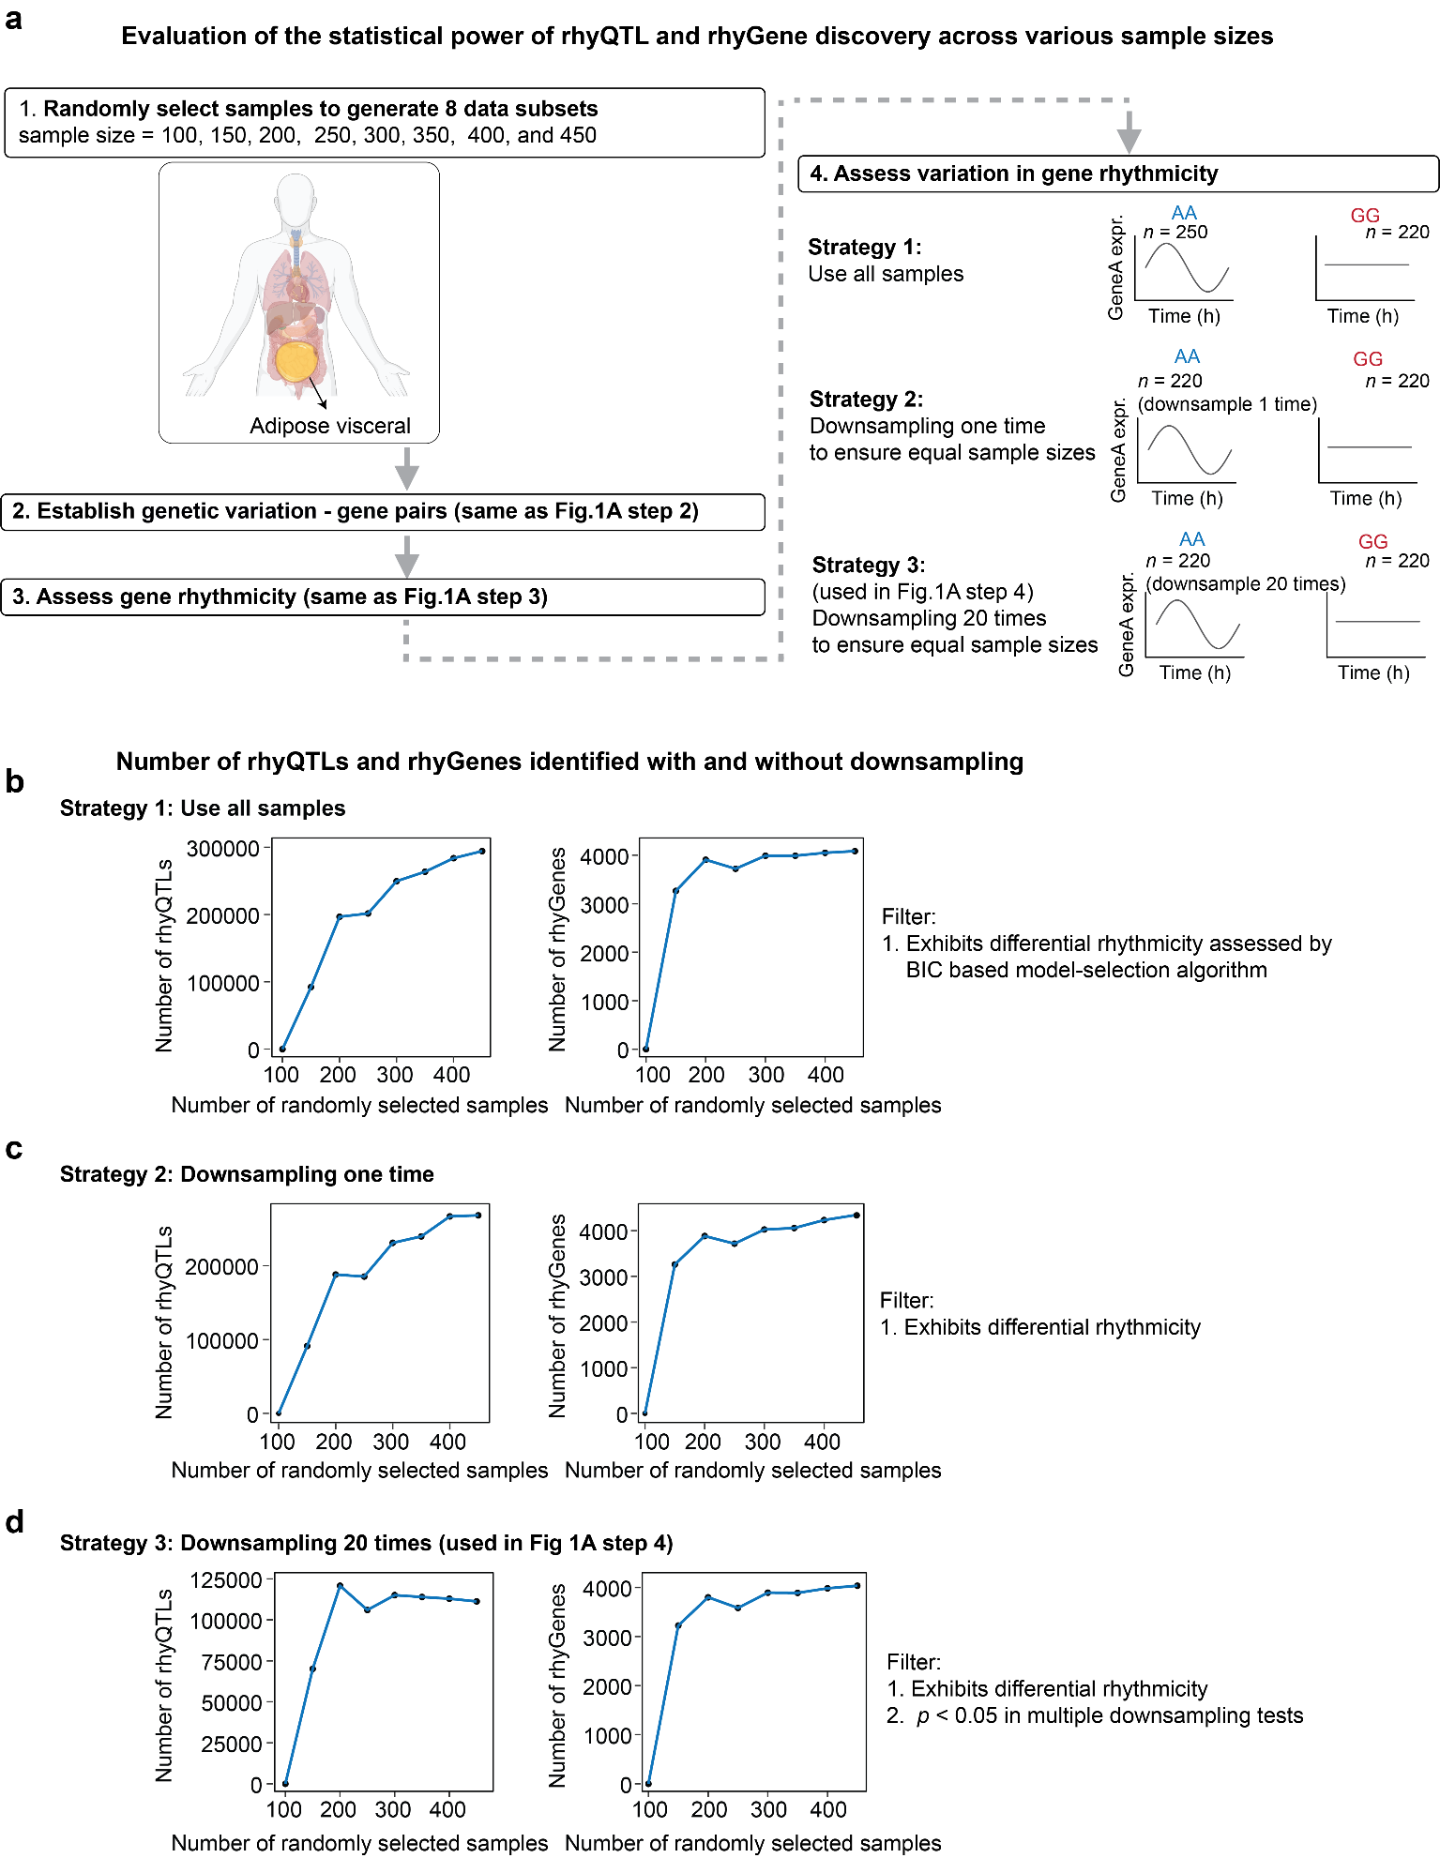
Extended Data Fig. 2 Assessing the performance of our rhyQTL mapping strategy through random sample selection. a, Evaluation of the statistical power of rhyQTL and rhyGene discovery across various sample sizes. Samples are randomly selected from 469 GTEx adipose visceral tissue samples with the most rhyQTLs to create 8 data subsets. The sample sizes in each subset range from 100 to 450 at intervals of 50. In each data subset, genetic variation-gene pairs are established, and gene rhythmicity is assessed using the same methods as in Fig. 1A, steps 2 and 3. To evaluate and mitigate biases associated with sample size, variations in gene rhythmicity across different genotypes are assessed both with and without employing a downsampling strategy. b-d,The number of rhyQTLs and rhyGenes identified using different strategies to assess variations in gene rhythmicity. These strategies included using all samples in the two compared genotypes (b), downsample the genotype group with more samples to match the sample size of the smaller genotype group once (c), and downsample 20 times (d). The differential rhythmicity across different genotypes is assessed by dryR, which is a Bayesian information criterion (BIC) based model-selection algorithm (7). The strategy of downsampling 20 times is used in this study to map rhyQTLs to avoid the potential biases arising from sample size and single-time sampling.

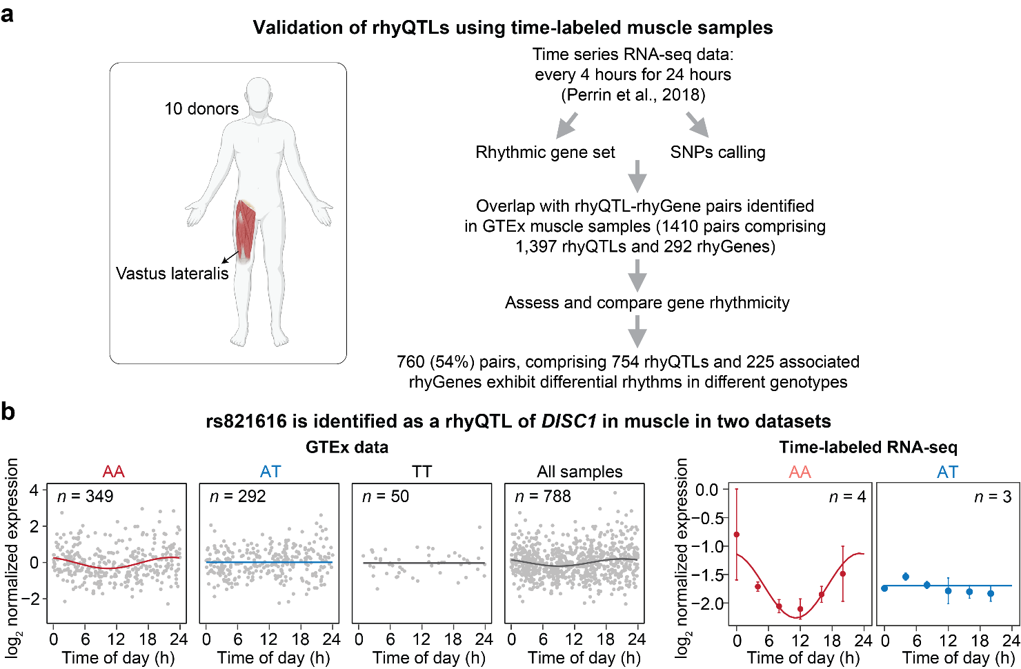
Extended Data Fig. 3 Validation of rhyQTLs using time-labeled muscle samples. a, Time series RNA-seq data from vastus lateralis muscle are used to validate the rhyQTLs identified in GTEx muscle samples. The RNA-seq data from 10 donors were generated in a previous study¹⁹ and SNPs among these 10 individuals are identified based on the RNA-seq data. b, SNP rs821616 is shown as a representative rhyQTL identified in the two datasets. SNP rs821616 was not detected in the RNA-seq data from 3 donors.

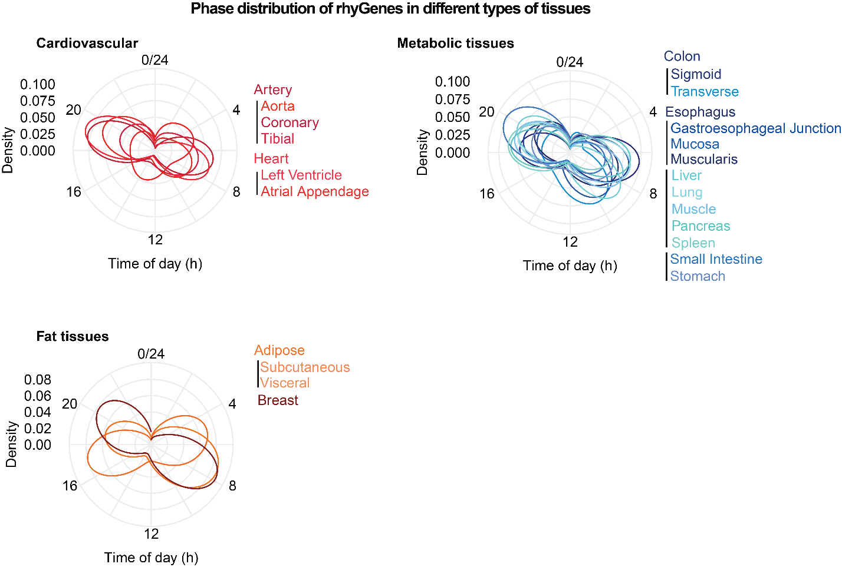

Extended Data Fig. 4 Polar plot illustrating the peak phase distribution of rhyGenes across different tissue categories. Various tissues are classified into different categories based on their functions. The peak phase of each rhyGene is defined as the time point at which it exhibits the expression peak. For rhyGenes with more than one rhyQTLs, the median value of phases corresponding to all rhyQTLs is taken as the phase of the rhyGene.

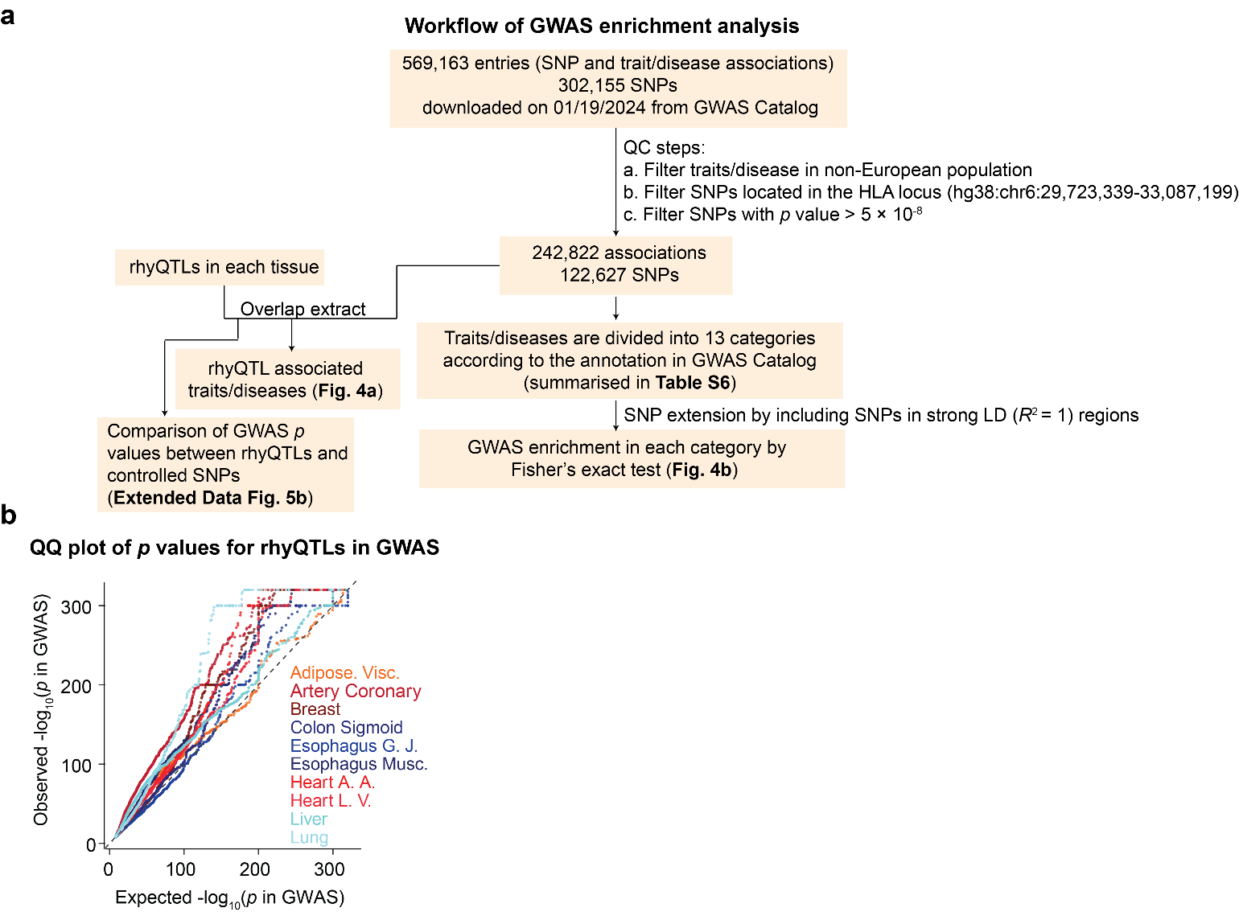
Extended Data Fig. 5 Enrichment of rhyQTLs in GWAS tag SNPs. a, Workflow for enrichment analysis of rhyQTL in SNPs that contribute to human traits and diseases. b, Quantile–quantile plots of p values for rhyQTLs from GWAS. rhyQTLs in each tissue are intersected with GWAS SNPs, and the p values of the overlapping SNPs are shown as observations. An equal number of SNPs are randomly selected from the GWAS SNPs, and their p values are shown as the expectations. The top 10 tissues with the highest number of rhyQTLs are displayed.
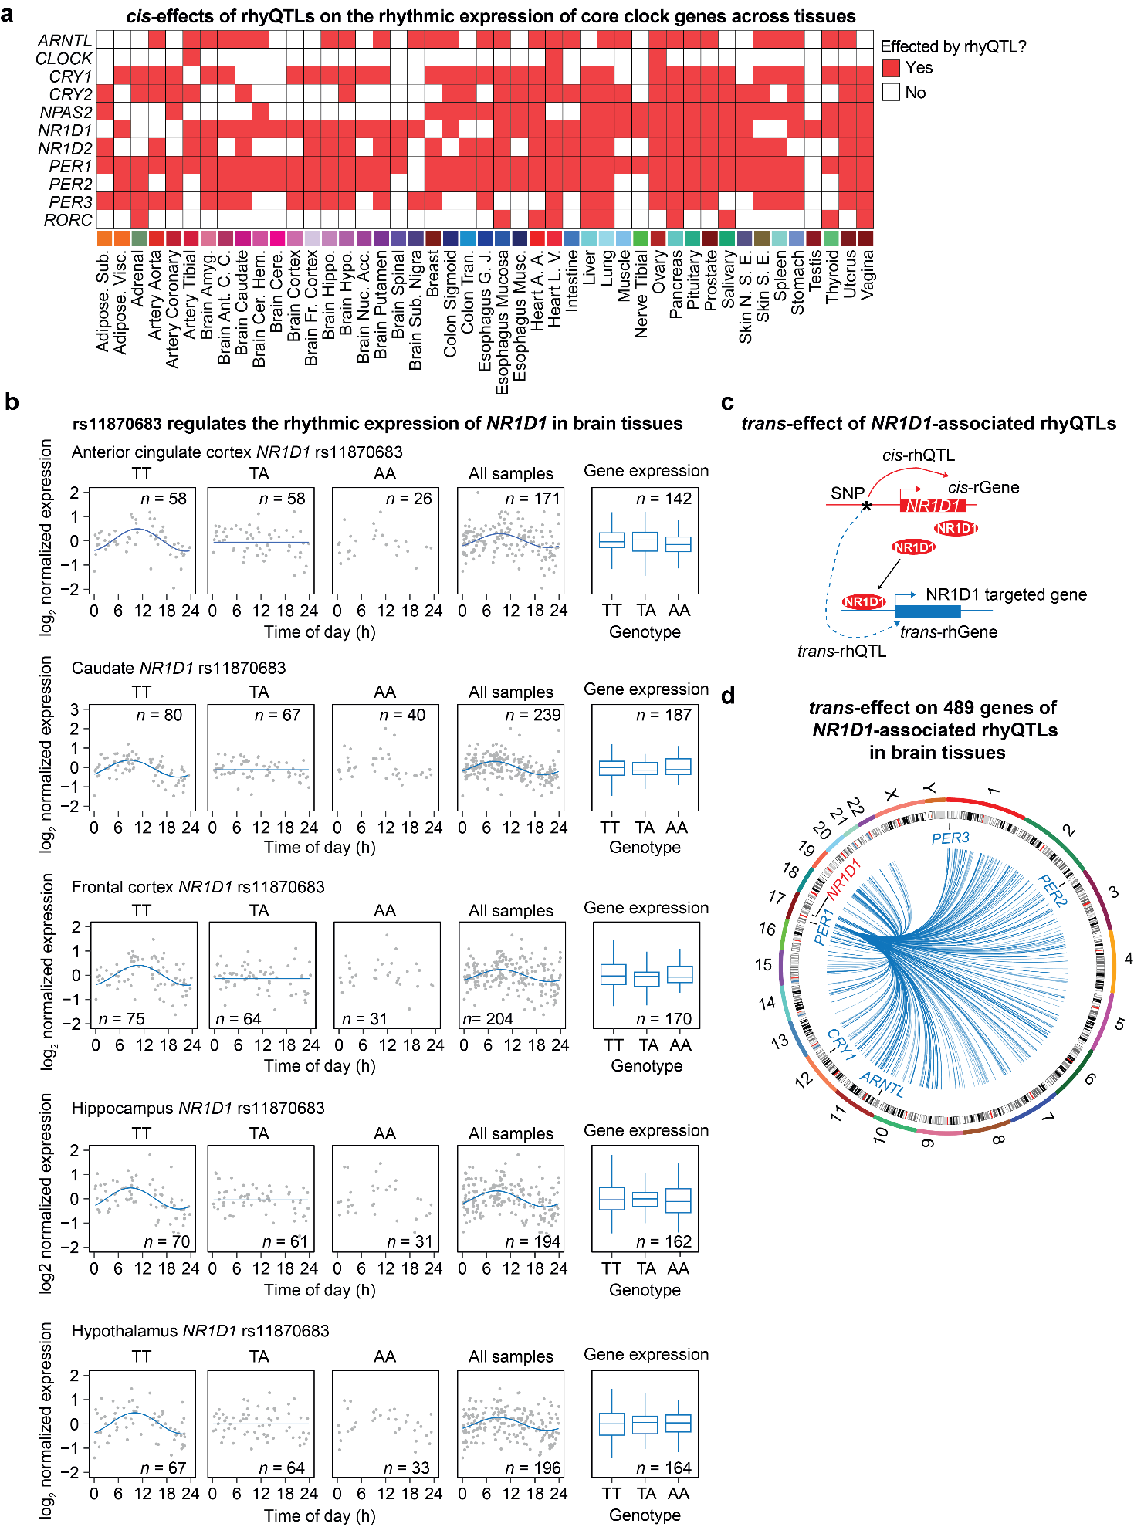
Extended Data Fig. 6 Trans-effects of rhyQTL on rhythmic gene expression. a, The rhythmic expression of core clock genes is affected by rhyQTLs in cis in various issues. The core clock genes with identified rhyQTLs in the corresponding tissue were color-coded in red. b, SNP rs11870683 as a representative rhyQTL determines the rhythmic expression of NR1D1 in the subpopulation with TT genotype but not in other genotypes across various brain tissues. SNP rs11870683 has been identified in GWAS as being associated with bipolar disorder²¹, which is consistent with observations in mice, where genetic deletion or pharmacological inhibition of NR1D1 activity in the ventral midbrain induces mania-like behavior²². c, The diagram illustrates the trans-effect of rhyQTLs on the rhythmic expression of distal genes, which are termed as trans-rhyGenes. d, The rhythmic expression of 489 genes is trans-regulated by rhyQTLs of NR1D1 in brain tissues. Each line originates from NR1D1 and points towards each of the trans-rhyGenes.

Supplementary Tables

Supplementary Table 1. Tissues for rhyQTL mapping. Related to Fig. 1a.
Supplementary Table 2. rhyQTLs and rhyGenes in 45 tissues. Related to Fig. 2.
Supplementary Table 3. Phase of rhyGenes. Related to Fig. 2.
Supplementary Table 4. Enrichment of rhyQTLs in genomic regulatory elements. Related to Fig. 3b.
Supplementary Table 5. rhyQTL-associated traits/diseases. Related to Fig. 4a.
Supplementary Table 6. Summary of human trait or disease categories. Related to Fig. 4b.
Supplementary Table 7. rhyQTLs contributing to human traits that are independent of eQTLs. Related to Fig. 4d and 4e.
Supplementary Table 8. Obesity-related traits measured in VIVA cohort. Related to Fig. 4f.
Supplementary Table 9. SNPs associated with obesity-related traits identified by GWAS. Related to Fig. 4f and 4g.
Supplementary Table 10. Trans-rhyGenes mediated by NR1D1-associated cis-rhyQTLs in brain tissues. Related to Extended Data Fig. 6.

