Supplementary material
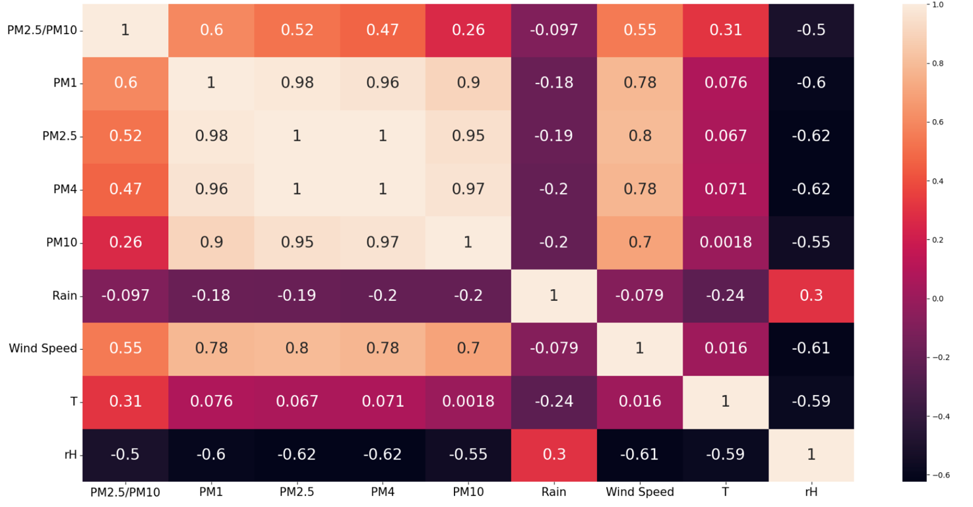
Figure 1 Pearson's correlation index for all variables measured during the first measurement campaign held in Culuccia island from November 16, 2022 to November 24, 2022.

