Supplementary Materials:
Rhythmic control of the plant-microbiome holobiont
Tao Lu^{1†}, Zhenyan Zhang^{1†}, Yan Li¹, Qi Zhang¹, Liwei Sun¹, W.J.G.M. Peijnenburg ², Josep Peñuelas^{3,4}, Lizhong Zhu⁵, Yong-Guan Zhu⁶, Jianmeng Chen¹, Haifeng Qian^{1*}
¹College of Environment, Zhejiang University of Technology, Hangzhou, 310032, P.R. China;
² Institute of Environmental Sciences (CML), Leiden University, 2300 RA, Leiden, The Netherlands;
³CSIC, Global Ecology Unit, CREAF- CSIC-UAB, Barcelona, Catalonia, Spain;
⁴CREAF, Cerdanyola del Vallès, Barcelona, Catalonia, Spain;
⁵Department of Environmental Science, Zhejiang University, Hangzhou, 310058, P.R. China;
⁶Key Lab of Urban Environment and Health, Institute of Urban Environment, Chinese Academy of Sciences, Xiamen, 361021, P.R. China;

Figure S1. The fresh weight of 28 d seedlings of wild-type Arabidopsis and the cca1-1, toc1-101 mutant. Different letters represent significant differences (p < 0.05).
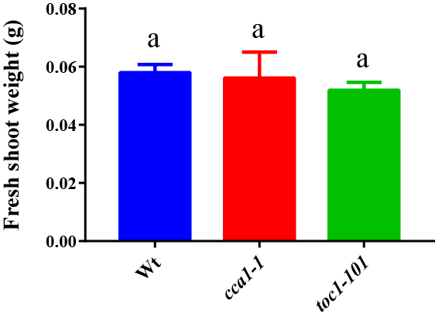

Figure S2. The bolting rate of wild-type Arabidopsis and the cca1-1, toc1-101 mutant after 15~28 d of culturing.
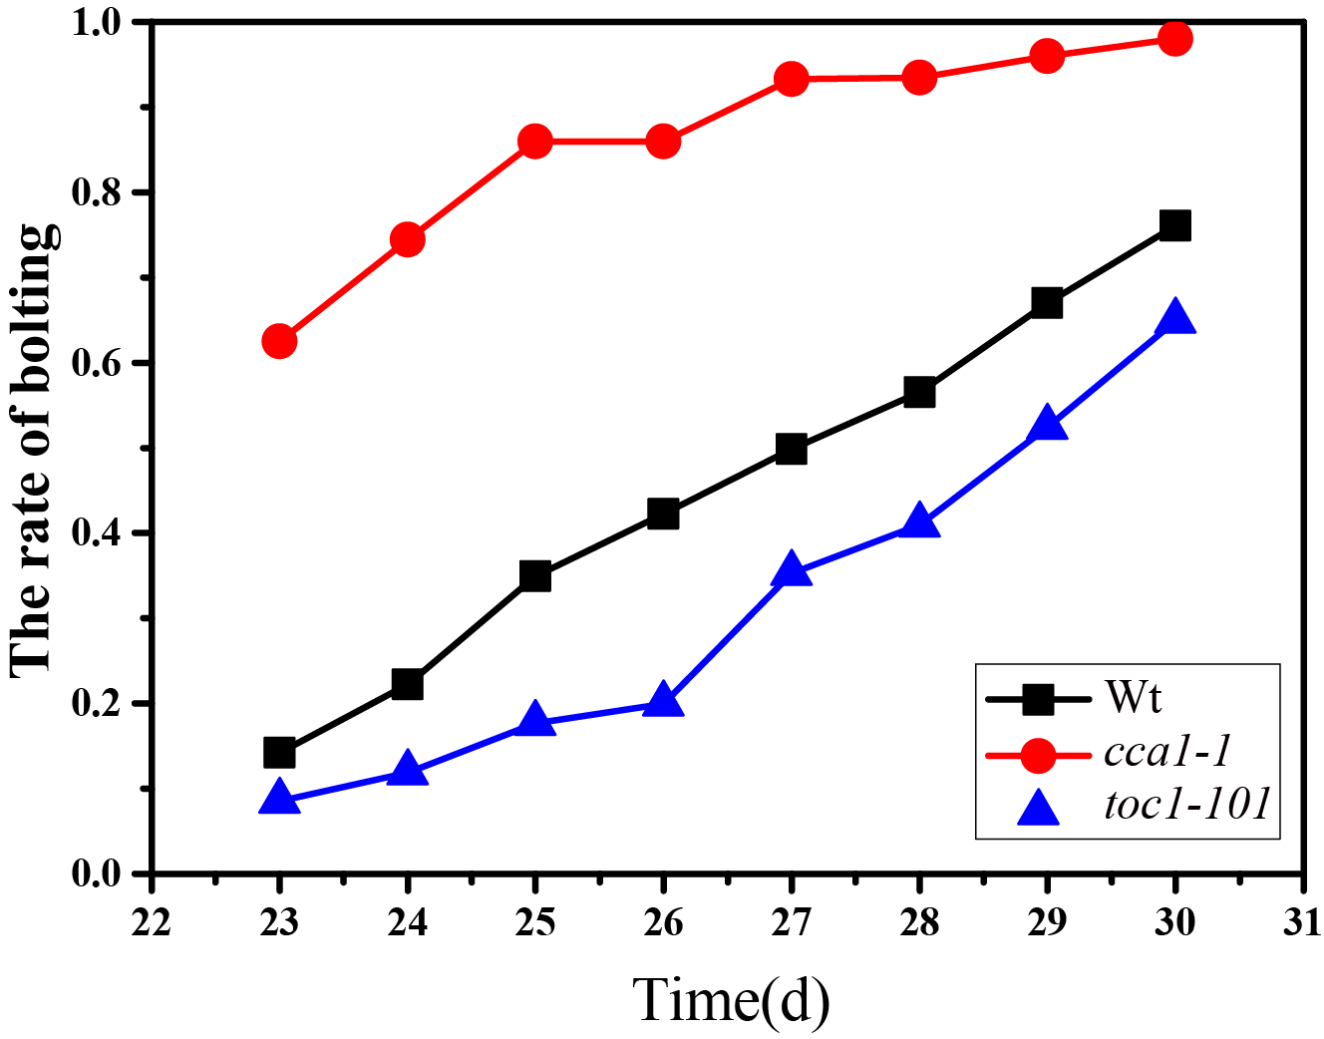

Figure S3. Transcriptional oscillations in wild-type Arabidopsis and the cca1-1, toc1-101 mutant.
(a) Heatmap representation of shared cycling genes between wild-type Arabidopsis and the cca1-1 mutant of genes uniquely cycling in wild-type, and of genes uniquely oscillating in the cca1-1 mutant (ARSER-Cycle, p < 0.05);
(b) KEGG analysis of genes in (a);
(c) Heatmap representation of shared cycling genes between wild-type Arabidopsis and the toc1-101 mutant, of genes uniquely cycling in wild-type, and of genes uniquely oscillating in toc1-101 mutant (ARSER-Cycle, p < 0.05);
(d) KEGG analysis of genes in (c).
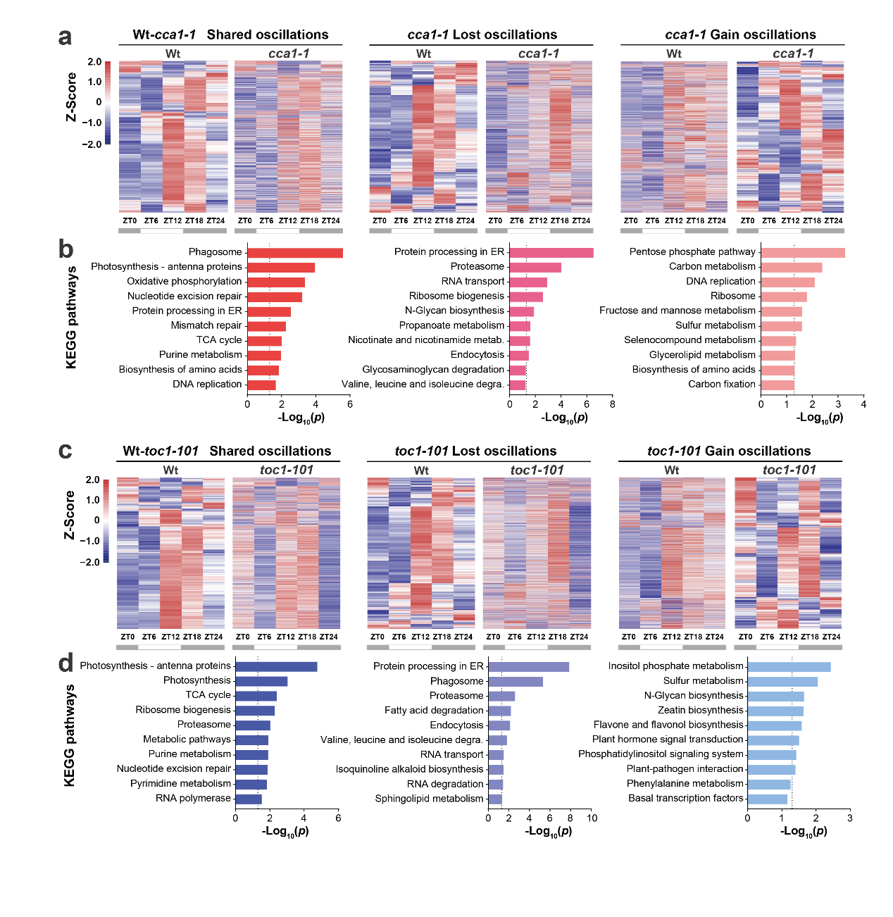

Figure S4. Correlations between rhythmic genes and all detected root exudates as determined by Procrustes analysis. Circles and triangles reflect the root exudates and gene features of each group, respectively.
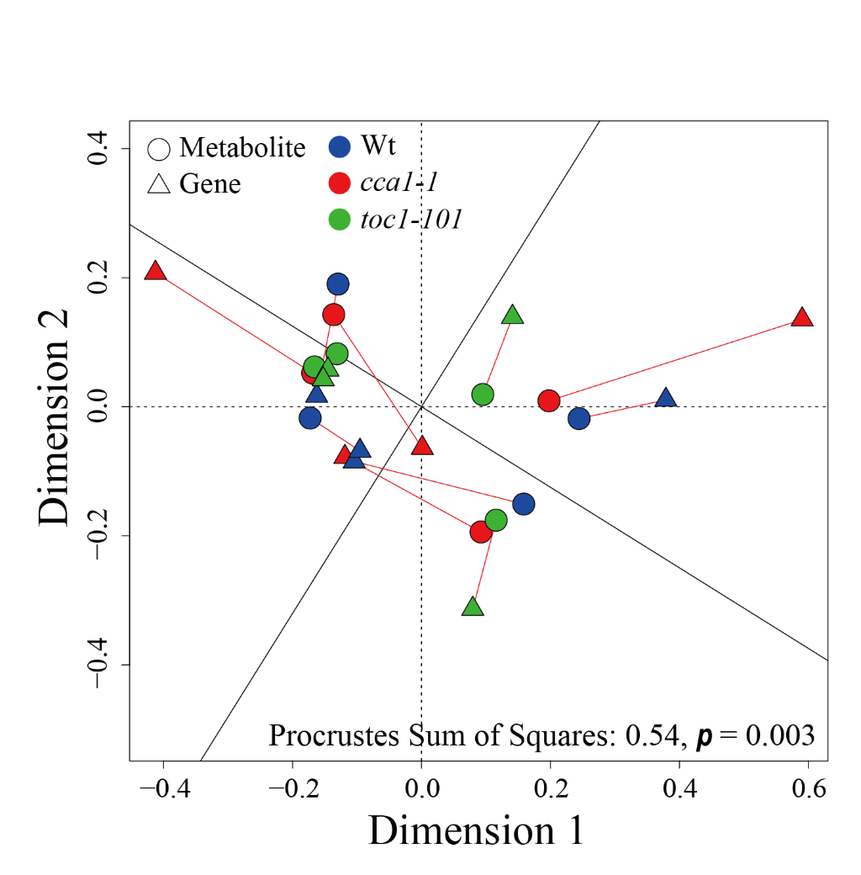

Figure S5. PCoA combined with permutational analysis of variance (PERMANOVA) as performed to evaluate the root exudates dissimilarity between time points using Bray Curtis distance in wild-type Arabidopsis and the cca1-1, toc1-101 mutant.
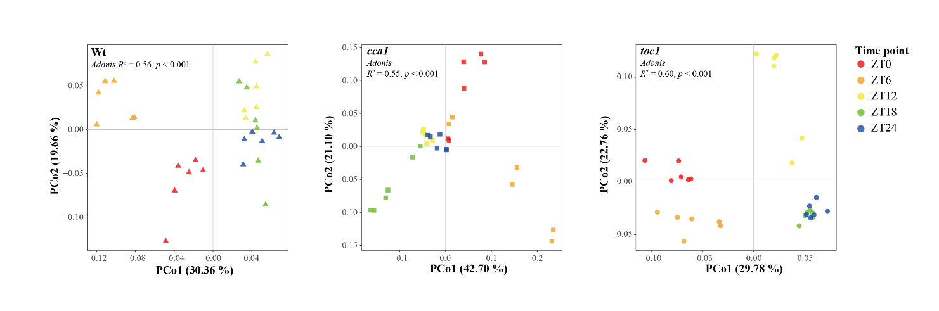
Figure S6. Venn diagram of shared and unique rhythmic exudates in Wt and cca1-1, toc1-101 mutant, p < 0.05.
Figure S7. Heatmap representation of shared cycling exudates between wild-type Arabidopsis and the mutant, and of exudates uniquely cycling in wild-type, and of exudates uniquely oscillating in mutant (ARSER-Cycle, p < 0.05).
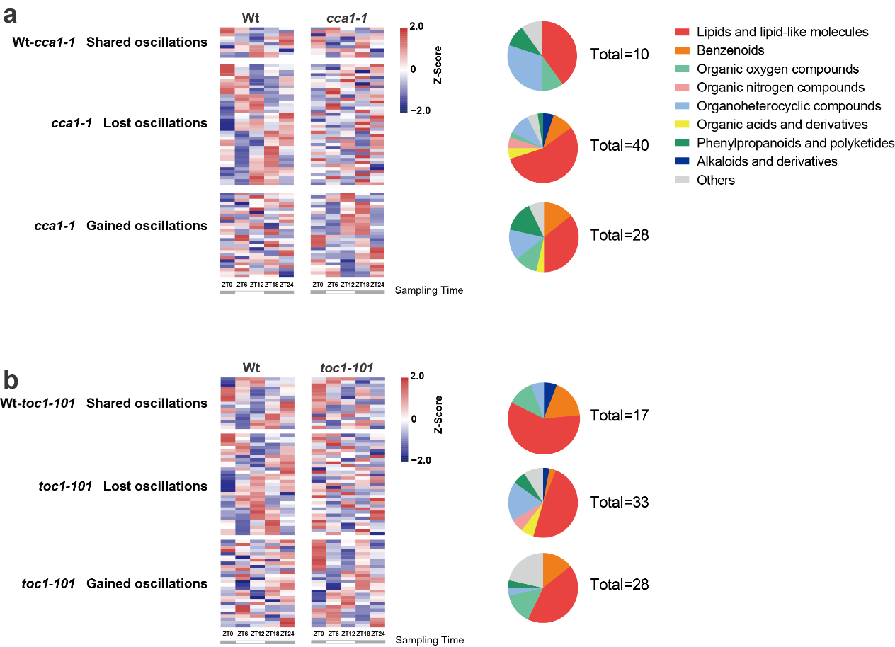

Figure S8. Bulk soil (a) and rhizosphere soil (b) microbiota composition in two mutants and wild-type Arabidopsis according to PCoA analysis based on Unweighted UniFrac distances.
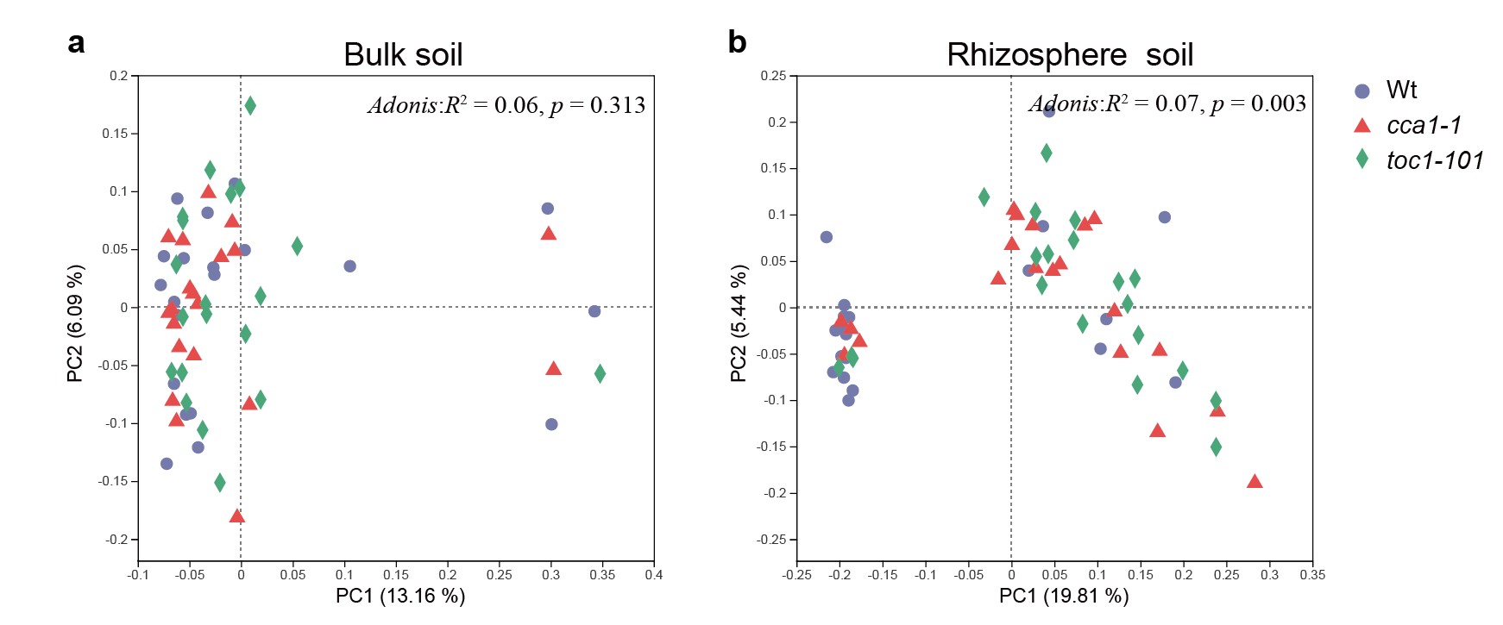

Figure S9. PCoA based on unweighted UniFrac distance of rhizosphere soil microbiota composition in five time points for wild-type Arabidopsis and cca1-1, toc1-101 mutants.
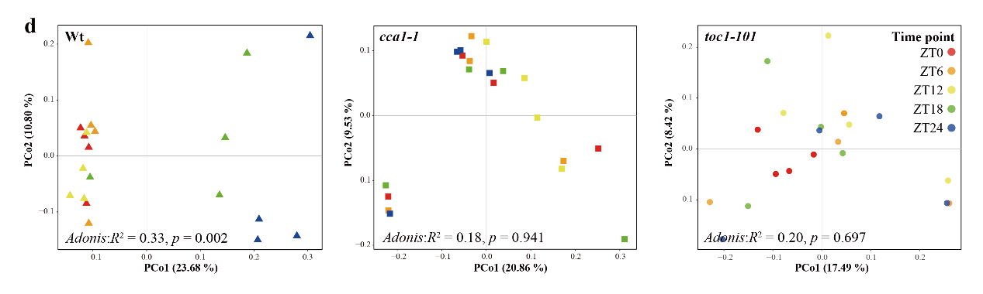

Figure S10. Ratio of rhythmic genus in rhizosphere soil of wild-type Arabidopsis and cca1-1, toc1-101 mutants.
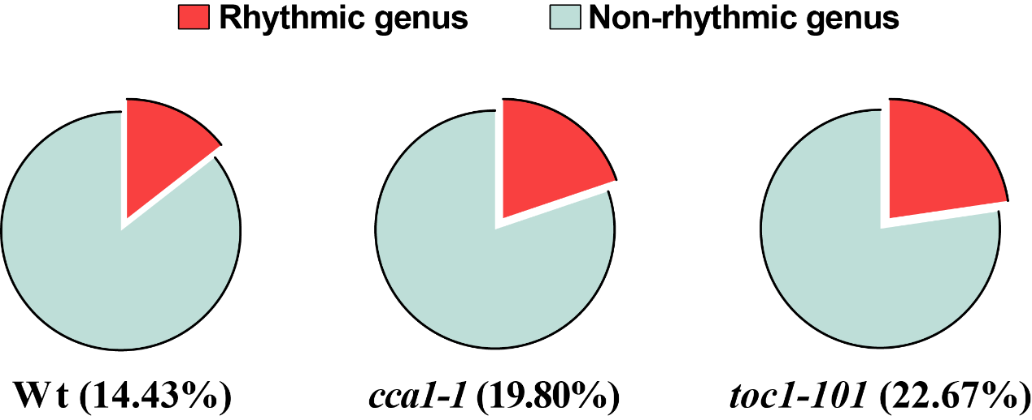
Figure S11. Network showing the results of multiple linear regression analysis. Arrows represent root exudates negatively (green arrows) or positively (red arrows) impacting the top 10 phylum or Proteobacteria classes. The width reflects the strength of the regulation. Root exudates are annotated into six major classes and the size of each node is proportional to the number of connections.
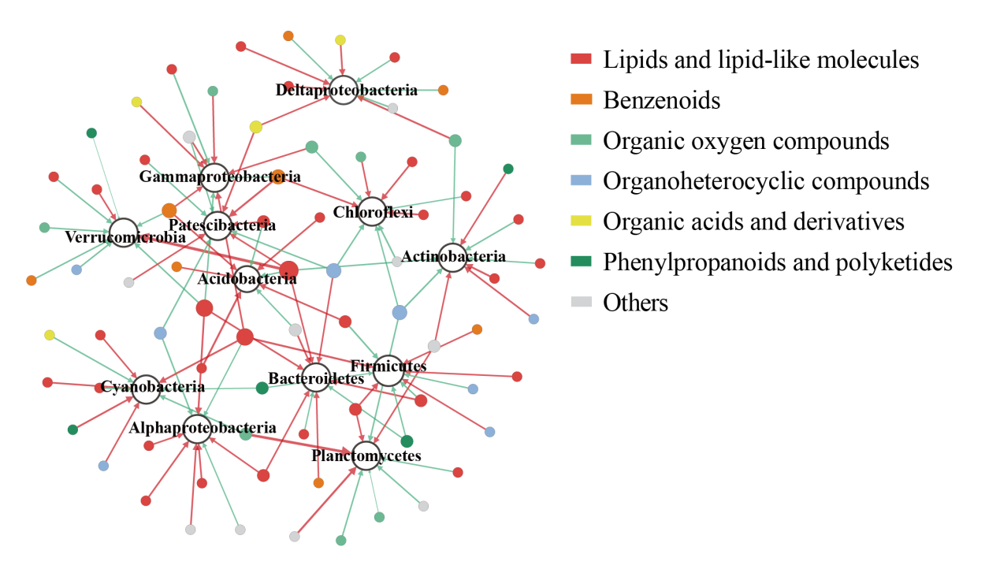

Table S1 Properties of the co-occurrence networks of bacterial communities in rhizosphere soil in wild-type Arabidopsis and cca1-1, toc1-101 mutants. Correlations between bacteria were obtained by psych package in R. Spearman’s r > 0.8 and < -0.8 with p < 0.05 represented positive and negative correlations, respectively. Other properties of network were all calculated in Gephi.
Network properties | Wt | cca1-1 | toc1-101
Number of nodes | 373 | 382 | 399
Number of edges | 3085 | 1777 | 1612
Positive edges | 3033 | 1762 | 1548
Negative edges | 52 | 15 | 64
Network diameter | 15 | 11 | 13
Average path length | 3.4 | 4.0 | 4.3
Average degree | 16.542 | 9.321 | 7.96
Average clustering coefficient | 0.517 | 0.462 | 0.443

Data set S1 Root exudates identified from three Arabidopsis lines. The values were represented by the intensity of the peak.
Data set S2 Root exudates significantly correlated to the abundance of certain phyla or Proteobacteria classes. The values represented the standard regression coefficient calculated by the multiple linear regression in SPSS (v 20.0.0).

† T Lu and Z Zhang contributed equally to this work. *Correspondence Author: E-mail address: hfqian@zjut.edu.cn (H.Q.)

