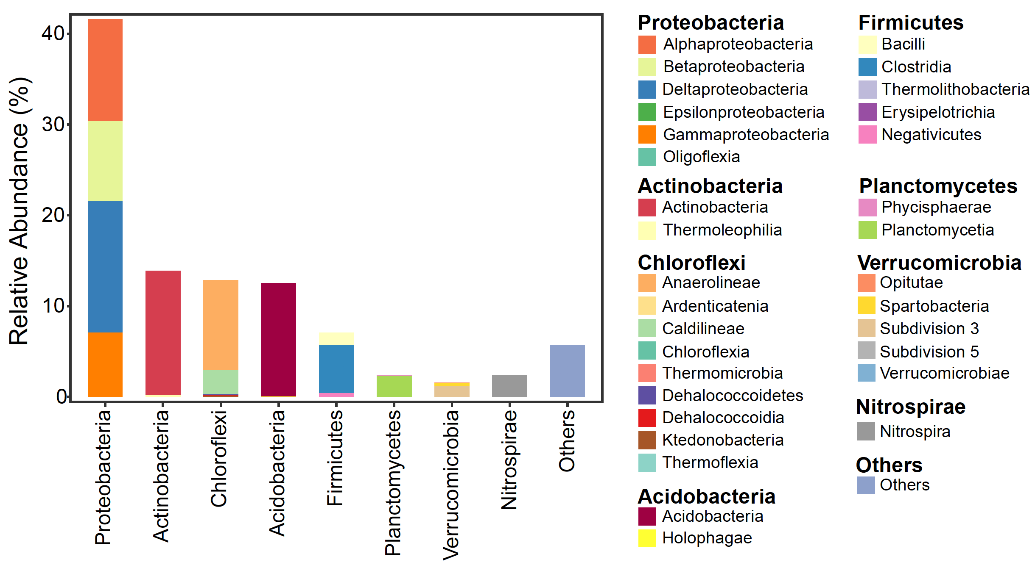
Figure S1 Microbial community composition (relative abundance; %) of the soil matrix at phylum and class level.

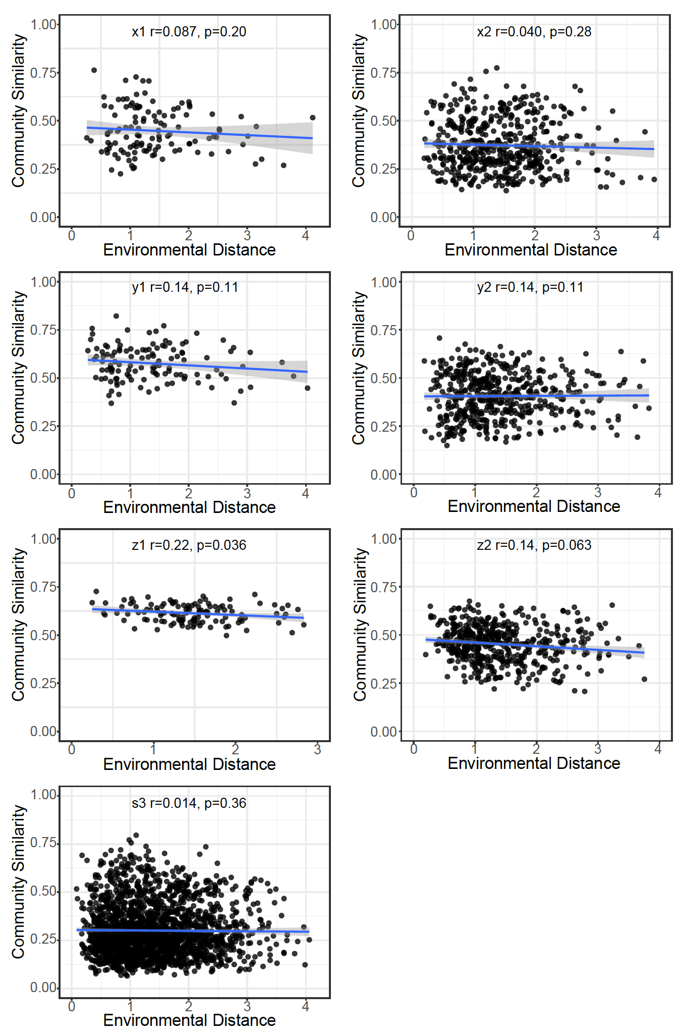

Figure S2 Relationship between community similarity and environmental distance from the three orientations (Figure 1). Linear trends are ordinary least-squares linear regressions; shaded area indicates confidence interval (0.95).

Table S1 Correlation (r value; Partial Mantel tests) between variable matrices (environmental and spatial) and community similarity before and after controlling for variable distances (environmental and spatial).
 | x1 | x2 | y1 | y2 | z1 | z2 | z3
Environmental  distance | 0.065 | 0.036 | -0.056 | -0.013 | 0.17 | 0.12 | -0.0049
Spatial  distance | 0.12 | 0.12* | 0.69*** | 0.22*** | 0.21* | 0.14* | 0.16***
* P≤0.05, **P≤0.01, ** P≤0.001

Table S2 Significant environmental factors, spatial factors and spatial canonical axes selected by forward selection based on partial redundancy analysis.

Factors | Factors selected
Factors | x1 | x2 | y1 | y2 | z1 | z2 | z3
Environmental  variables | - | porosity, S | N, S | porosity, H, S | H, S | porosity | porosity, H, S
Spatial variables | PCNM2 | PCNM1 | PCNM1, 2, 3, 6 | PCNM1, 3, 5,6 | PCNM2 | PCNM1, 3, 5, 15, 17 | PCNM2, 3, 4, 8, 11, 14, 17, 24
Spatial canonical axes | - | x | x, z | x, y, z | x | x, z | z

Table S3 Correlation (r value; Mantel and Partial Mantel tests) between variable matrices (environmental and spatial) and phylogenetic turnover (βNTI) before and after controlling for variable distances (environmental and spatial; ‘None’ indicates before control).
 | Controlling  for | x1 | x2 | y1 | y2 | z1 | z2 | z3
Environmental  distance | None | 0.12 | -0.11 | -0.12 | -0.12 | -0.14 | -0.018 | 0.032
Spatial  distance | None | -0.11 | 0.11* | -0.046 | 0.15** | -0.10 | -0.065 | 0.0010
Environmental  distance | Spatial  distance | 0.15 | -0.11 | -0.11 | -0.13 | -0.12 | -0.0068 | 0.031
Spatial  distance | Environmental  distance | -0.14 | 0.12* | -0.016 | 0.16* | -0.068 | -0.063 | 0.025
* P≤0.05, **P≤0.01

