Table 2 Petrography of three samples
 | Sample81-3-1 | Sample81-3-2 | Sample81-3-3
PPL | 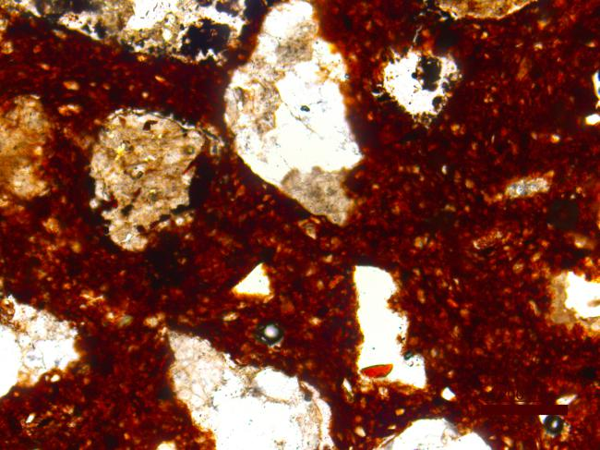 | 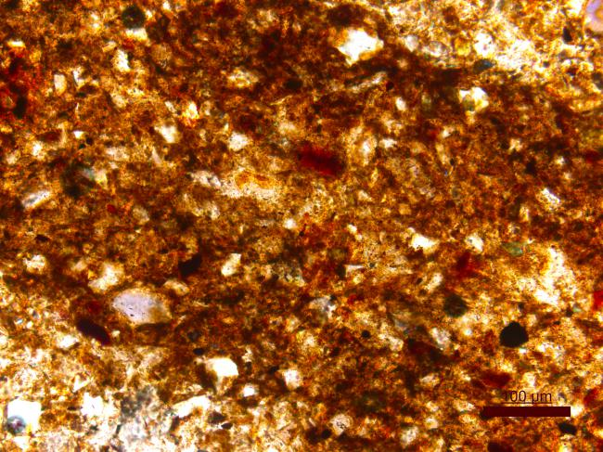 | 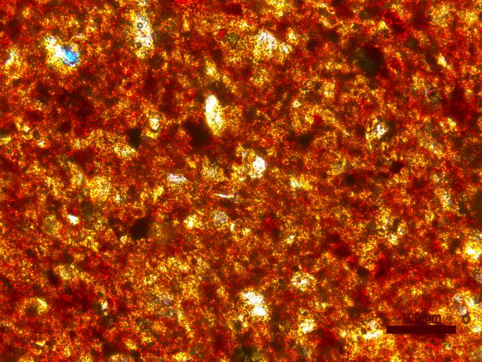
XP | 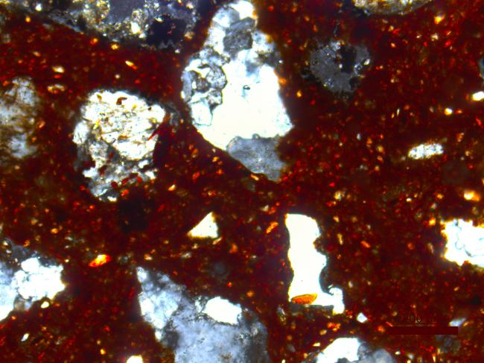 | 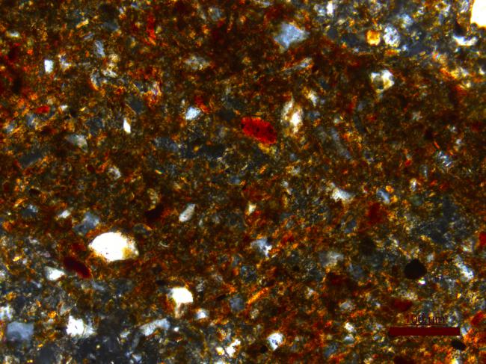 | 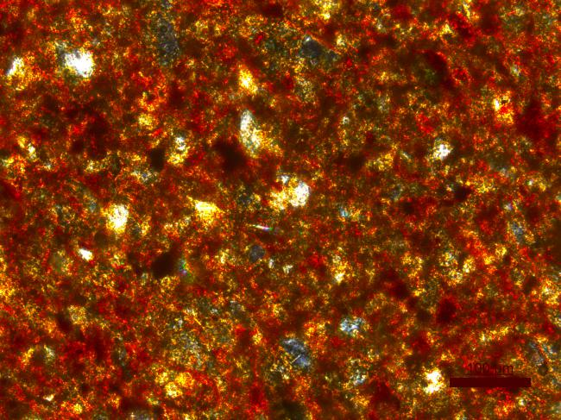
Grain Size Distribution Histogram | 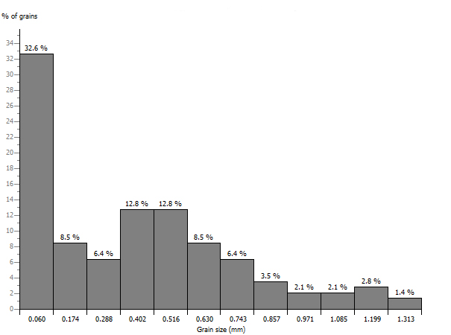 | 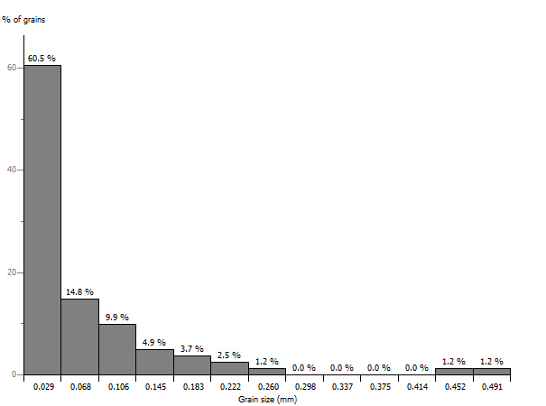 | 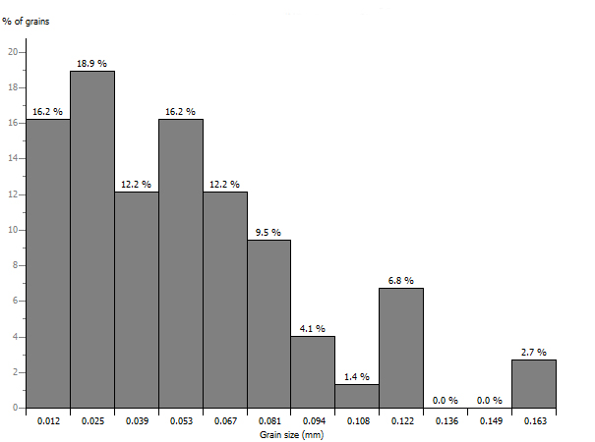
Three component percentage stacked bar chart | 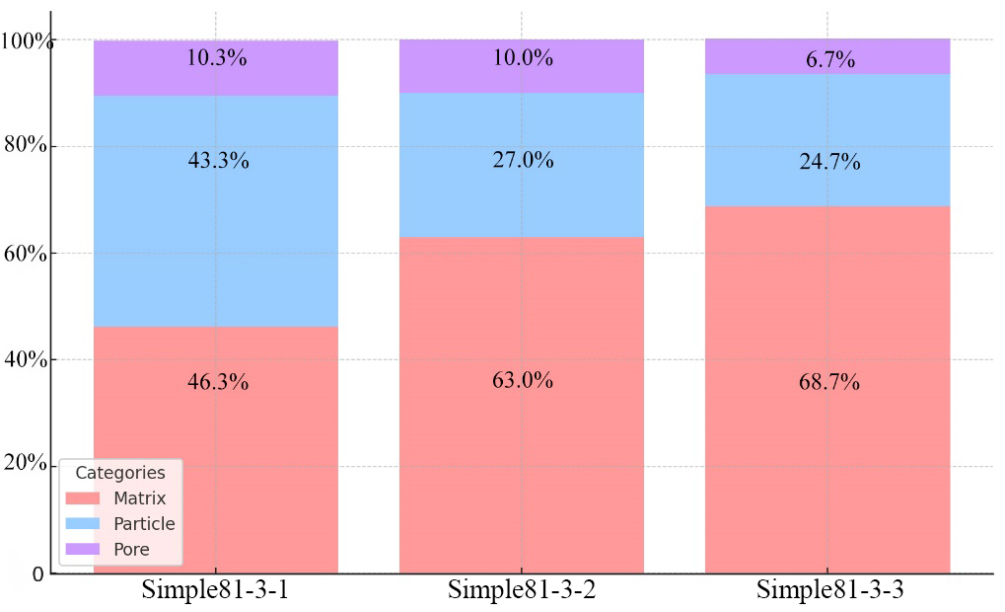

Table 3 X-ray fluorescence analysis results of Qin dynasty seals sample(wt%)
Sample/  element | Na₂O | MgO | Al₂O₃ | SiO₂ | P₂O₅ | K₂O | CaO | TiO₂ | CrO₂ | MnO | Fe₂O₃ | NiO | CuO | ZnO | As₂O₃ | Rb₂O | SrO | Y₂O₃ | ZrO₂ | BaO | PbO
1 | 2.374 | 3.498 | 12.719 | 63.967 | 1.880 | 3.299 | 3.810 | 0.742 | 0.020 | 0.212 | 7.338 | 0.009 | 0.014 | 0.014 | 0.024 | 0.005 | 0.012 | 0.006 | 0.005 | 0.049 | 0.005
2 | 0.592 | 4.101 | 10.972 | 67.723 | 7.140 | 1.880 | 2.176 | 0.682 | 0.016 | 0.123 | 4.504 | 0.008 | 0.006 | 0.010 | 0.017 | 0.004 | 0.008 | 0.005 | 0.006 | 0.028 | 0.002
3 | 1.303 | 2.863 | 12.142 | 68.154 | 2.951 | 2.181 | 3.374 | 0.669 | 0.015 | 0.142 | 6.081 | 0.010 | 0.015 | 0.012 | 0.021 | 0.004 | 0.011 | 0.005 | 0.006 | 0.036 | 0.004
4 | 3.441 | 5.405 | 10.689 | 61.075 | 6.407 | 2.418 | 3.950 | 0.699 | 0.020 | 0.122 | 5.631 | 0.009 | 0.015 | 0.013 | 0.021 | 0.004 | 0.011 | 0.006 | 0.007 | 0.052 | 0.004
5 | 0.276 | 2.678 | 11.968 | 62.884 | 6.403 | 3.034 | 4.058 | 0.783 | 0.025 | 0.146 | 7.566 | 0.005 | 0.032 | 0.016 | 0.029 | 0.007 | 0.017 | 0.011 | 0.009 | 0.048 | 0.004
6 | 0.749 | 6.100 | 12.116 | 67.505 | 1.767 | 2.360 | 3.250 | 0.671 | 0.015 | 0.095 | 5.267 | 0.009 | 0.006 | 0.012 | 0.017 | 0.004 | 0.011 | 0.005 | 0.005 | 0.034 | 0.003
7 | 0.159 | 5.434 | 11.950 | 65.479 | 4.498 | 2.144 | 4.455 | 0.668 | 0.008 | 0.177 | 4.925 | 0.004 | 0.009 | 0.009 | 0.016 | 0.004 | 0.012 | 0.006 | 0.006 | 0.032 | 0.003
8 | 0.220 | 7.128 | 13.368 | 64.825 | 1.286 | 1.965 | 4.727 | 0.787 | 0.011 | 0.138 | 5.448 | 0.005 | 0.013 | 0.010 | 0.012 | 0.004 | 0.011 | 0.006 | 0.007 | 0.027 | 0.002
9 | 0.600 | 4.610 | 11.231 | 62.367 | 3.724 | 2.372 | 9.240 | 0.684 | 0.010 | 0.090 | 4.933 | 0.006 | 0.010 | 0.009 | 0.008 | 0.004 | 0.023 | 0.005 | 0.007 | 0.060 | 0.006
10 | 0.550 | 5.628 | 12.762 | 62.383 | 6.742 | 2.510 | 2.645 | 0.690 | 0.013 | 0.186 | 5.744 | 0.005 | 0.007 | 0.012 | 0.013 | 0.004 | 0.015 | 0.005 | 0.006 | 0.078 | 0.003
11 | 0.777 | 3.939 | 13.003 | 66.032 | 1.305 | 2.708 | 5.316 | 0.718 | 0.014 | 0.074 | 6.007 | 0.007 | 0.013 | 0.013 | 0.016 | 0.004 | 0.009 | 0.004 | 0.005 | 0.032 | 0.003
12 | 0.768 | 4.773 | 12.749 | 63.670 | 2.863 | 3.344 | 3.256 | 0.833 | 0.027 | 0.096 | 7.462 | 0.010 | 0.011 | 0.012 | 0.033 | 0.005 | 0.011 | 0.006 | 0.005 | 0.062 | 0.005
13 | 0.156 | 8.930 | 11.658 | 67.578 | 0.019 | 2.138 | 3.531 | 0.629 | 0.018 | 0.064 | 5.157 | 0.006 | 0.017 | 0.009 | 0.021 | 0.004 | 0.019 | 0.006 | 0.006 | 0.030 | 0.004
14 | 0.029 | 4.430 | 11.304 | 64.614 | 6.151 | 2.178 | 5.751 | 0.648 | 0.016 | 0.101 | 4.689 | 0.006 | 0.010 | 0.010 | 0.012 | 0.004 | 0.013 | 0.007 | 0.006 | 0.017 | 0.003
15 | 0.220 | 5.416 | 12.838 | 61.725 | 3.635 | 3.360 | 4.583 | 0.847 | 0.016 | 0.086 | 7.132 | 0.011 | 0.012 | 0.014 | 0.025 | 0.005 | 0.014 | 0.005 | 0.005 | 0.049 | 0.003
16 | 0.514 | 4.866 | 11.256 | 55.566 | 13.287 | 2.552 | 4.974 | 0.630 | 0.018 | 0.070 | 6.164 | 0.006 | 0.009 | 0.012 | 0.019 | 0.004 | 0.016 | 0.005 | 0.005 | 0.023 | 0.004
17 | 0.088 | 4.219 | 13.620 | 69.261 | 3.174 | 1.913 | 1.817 | 0.655 | 0.013 | 0.047 | 5.028 | 0.005 | 0.046 | 0.014 | 0.008 | 0.006 | 0.014 | 0.014 | 0.012 | 0.041 | 0.005
18 | 0.250 | 2.323 | 6.474 | 42.086 | 31.874 | 1.524 | 7.938 | 0.543 | 0.015 | 0.058 | 6.774 | 0.004 | 0.005 | 0.009 | 0.038 | 0.004 | 0.019 | 0.003 | 0.005 | 0.047 | 0.005
19 | 0.476 | 5.349 | 12.517 | 63.509 | 4.214 | 2.848 | 4.665 | 0.741 | 0.015 | 0.054 | 5.409 | 0.009 | 0.084 | 0.010 | 0.025 | 0.004 | 0.014 | 0.006 | 0.005 | 0.022 | 0.023
20 | 0.170 | 5.328 | 12.744 | 61.706 | 5.568 | 2.555 | 4.254 | 0.868 | 0.014 | 0.172 | 6.417 | 0.005 | 0.008 | 0.011 | 0.011 | 0.005 | 0.016 | 0.005 | 0.005 | 0.135 | 0.003
21 | 0.776 | 3.021 | 11.762 | 62.767 | 5.659 | 3.093 | 5.613 | 0.717 | 0.021 | 0.077 | 6.377 | 0.010 | 0.008 | 0.013 | 0.020 | 0.005 | 0.015 | 0.005 | 0.004 | 0.033 | 0.003
22 | 0.453 | 4.921 | 13.164 | 60.349 | 7.106 | 3.191 | 3.425 | 0.663 | 0.018 | 0.093 | 6.523 | 0.006 | 0.012 | 0.012 | 0.016 | 0.005 | 0.012 | 0.005 | 0.003 | 0.023 | 0.003
23 | 0.242 | 3.151 | 15.544 | 63.791 | 2.963 | 2.190 | 5.160 | 0.739 | 0.021 | 0.152 | 5.917 | 0.005 | 0.011 | 0.012 | 0.018 | 0.005 | 0.014 | 0.008 | 0.006 | 0.046 | 0.003
24 | 1.085 | 5.033 | 8.761 | 55.820 | 13.999 | 2.671 | 4.425 | 0.823 | 0.019 | 0.088 | 7.097 | 0.005 | 0.018 | 0.014 | 0.041 | 0.005 | 0.013 | 0.004 | 0.005 | 0.070 | 0.004
25 | 0.863 | 3.280 | 11.382 | 62.614 | 0.603 | 2.566 | 12.597 | 0.644 | 0.011 | 0.067 | 5.262 | 0.006 | 0.010 | 0.012 | 0.030 | 0.005 | 0.015 | 0.006 | 0.006 | 0.018 | 0.003
26 | 0.148 | 4.073 | 8.948 | 54.668 | 20.591 | 1.987 | 3.443 | 0.651 | 0.015 | 0.084 | 5.281 | 0.007 | 0.008 | 0.011 | 0.019 | 0.004 | 0.014 | 0.004 | 0.006 | 0.037 | 0.002
27 | 0.743 | 5.662 | 12.737 | 59.098 | 6.570 | 2.603 | 5.353 | 0.714 | 0.021 | 0.091 | 6.291 | 0.006 | 0.013 | 0.017 | 0.019 | 0.005 | 0.013 | 0.006 | 0.005 | 0.029 | 0.003
28 | 0.858 | 3.231 | 13.158 | 63.041 | 1.233 | 2.172 | 10.423 | 0.634 | 0.010 | 0.087 | 5.031 | 0.008 | 0.009 | 0.011 | 0.025 | 0.004 | 0.015 | 0.003 | 0.006 | 0.039 | 0.003
29 | 0.026 | 3.724 | 13.265 | 67.275 | 3.915 | 2.261 | 4.001 | 0.687 | 0.018 | 0.027 | 4.694 | 0.007 | 0.005 | 0.012 | 0.018 | 0.006 | 0.012 | 0.005 | 0.007 | 0.030 | 0.004
30 | 0.722 | 3.670 | 12.138 | 63.659 | 6.836 | 2.000 | 4.140 | 0.743 | 0.014 | 0.145 | 5.819 | 0.008 | 0.016 | 0.012 | 0.020 | 0.006 | 0.011 | 0.005 | 0.005 | 0.027 | 0.003
31 | 0.999 | 3.739 | 11.338 | 66.126 | 3.391 | 2.606 | 5.819 | 0.638 | 0.009 | 0.114 | 5.088 | 0.007 | 0.008 | 0.011 | 0.017 | 0.004 | 0.014 | 0.004 | 0.005 | 0.059 | 0.002
32 | 0.126 | 1.948 | 11.229 | 70.168 | 2.056 | 2.123 | 4.926 | 0.903 | 0.019 | 0.054 | 6.253 | 0.008 | 0.044 | 0.017 | 0.022 | 0.005 | 0.010 | 0.006 | 0.007 | 0.070 | 0.004
33 | 0.328 | 8.832 | 8.687 | 64.355 | 5.843 | 1.410 | 4.891 | 0.716 | 0.015 | 0.029 | 4.742 | 0.007 | 0.020 | 0.009 | 0.039 | 0.004 | 0.016 | 0.004 | 0.006 | 0.043 | 0.003
34 | 1.955 | 3.268 | 9.061 | 60.251 | 12.412 | 2.114 | 3.396 | 0.955 | 0.021 | 0.083 | 6.362 | 0.007 | 0.009 | 0.012 | 0.020 | 0.004 | 0.011 | 0.003 | 0.007 | 0.047 | 0.003
35 | 0.108 | 1.323 | 8.810 | 62.330 | 18.235 | 1.347 | 2.371 | 0.715 | 0.015 | 0.038 | 4.576 | 0.005 | 0.013 | 0.009 | 0.033 | 0.003 | 0.016 | 0.004 | 0.006 | 0.040 | 0.003
36 | 0.023 | 2.944 | 11.692 | 61.424 | 8.104 | 2.038 | 8.048 | 0.575 | 0.012 | 0.101 | 4.907 | 0.003 | 0.020 | 0.013 | 0.026 | 0.005 | 0.016 | 0.007 | 0.006 | 0.035 | 0.001
37 | 3.195 | 4.243 | 11.563 | 67.075 | 1.383 | 2.335 | 3.344 | 0.760 | 0.016 | 0.058 | 5.880 | 0.007 | 0.019 | 0.010 | 0.030 | 0.004 | 0.009 | 0.005 | 0.009 | 0.051 | 0.006
38 | 0.285 | 8.825 | 8.297 | 60.541 | 6.804 | 1.835 | 6.885 | 0.682 | 0.011 | 0.126 | 5.565 | 0.005 | 0.018 | 0.016 | 0.034 | 0.005 | 0.011 | 0.004 | 0.008 | 0.041 | 0.003
39 | 0.687 | 4.659 | 13.975 | 62.802 | 0.809 | 2.878 | 7.592 | 0.661 | 0.017 | 0.093 | 5.724 | 0.007 | 0.008 | 0.011 | 0.017 | 0.004 | 0.013 | 0.003 | 0.004 | 0.032 | 0.002
40 | 2.085 | 2.248 | 11.441 | 70.197 | 2.138 | 2.482 | 2.565 | 0.727 | 0.019 | 0.115 | 5.796 | 0.004 | 0.030 | 0.011 | 0.023 | 0.005 | 0.010 | 0.007 | 0.013 | 0.077 | 0.004
41 | 0.019 | 6.865 | 13.839 | 61.728 | 0.858 | 2.343 | 7.036 | 0.698 | 0.019 | 0.053 | 6.440 | 0.006 | 0.026 | 0.011 | 0.010 | 0.005 | 0.010 | 0.006 | 0.005 | 0.019 | 0.003
42 | 0.914 | 2.941 | 13.702 | 66.127 | 3.181 | 3.020 | 2.631 | 0.767 | 0.015 | 0.098 | 6.471 | 0.009 | 0.007 | 0.014 | 0.015 | 0.005 | 0.016 | 0.004 | 0.006 | 0.055 | 0.004
43 | 0.380 | 4.404 | 13.892 | 66.562 | 1.481 | 2.368 | 2.276 | 0.903 | 0.020 | 0.205 | 7.358 | 0.015 | 0.048 | 0.014 | 0.017 | 0.006 | 0.010 | 0.004 | 0.004 | 0.029 | 0.003
44 | 0.048 | 6.410 | 11.370 | 53.759 | 15.181 | 2.493 | 4.043 | 0.593 | 0.014 | 0.148 | 5.819 | 0.005 | 0.006 | 0.011 | 0.010 | 0.004 | 0.019 | 0.005 | 0.004 | 0.054 | 0.003
45 | 2.074 | 3.586 | 11.324 | 61.700 | 4.045 | 2.795 | 7.670 | 0.671 | 0.019 | 0.079 | 5.919 | 0.009 | 0.010 | 0.015 | 0.015 | 0.005 | 0.016 | 0.006 | 0.006 | 0.033 | 0.003

