Appendix A
The transferred ozone dose (TOD), i.e. the accumulated amount of ozone transferred, was calculated as follows (Buffle et al., 2006) :
$TOD\left(\frac{mg}{L}\right)=\frac{∑{\left(c_{o3, in}-c_{o3, out}\right)}_{mg/L}∙{gas flowrate}_{L/min}}{{volume}_{L}}$ ×∆t(min) Eq. 1
Ozone consumption (%) was calculated as follows:
$Ozone consumption (\%)=100\%×\frac{c_{o3, in}-c_{o3, out}}{c_{o3 , in}}$ Eq. 2
where,
C_{O3,in} = ozone concentration in the inlet gas,
C_{O3},_{out} = ozone concentration in the outlet gas, representing the unreacted ozone exiting the reactor,
L = water volume in the reactor,
dt = the time interval between measurements (here, 10 s).

Table A.1. Analysis of Variance (ANOVA) Results—ozone consumption
Source of Variation | SS | df | MS | F | P-value | F crit
Sample | 1139103.32 | 2.00 | 569551.66 | 21167.23 | 0.00 | 3.00
Columns | 555991.31 | 359.00 | 1548.72 | 57.56 | 0.00 | 1.14
Interaction | 423043.09 | 718.00 | 589.20 | 21.90 | 0.00 | 1.10
Within | 58119.64 | 2160.00 | 26.91
Total | 2176257.36 | 3239.00

Table A.2. Analysis of Variance (ANOVA) Results—transferred ozone dose (TOD)
Source of Variation | SS | df | MS | F | P-value | F crit
Sample | 1101499.34 | 2.00 | 550749.67 | 1307.93 | 0.00 | 3.00
Columns | 7436756.35 | 420.00 | 17706.56 | 42.05 | 0.00 | 1.13
Interaction | 927444.60 | 840.00 | 1104.10 | 2.62 | 0.00 | 1.10
Within | 1063660.17 | 2526.00 | 421.08
Total | 10529360.46 | 3788.00

Table A.3. ORP to PPM (mg_O₃/L), Calibration curve (Çatal & İbanoğlu, 2013)
mV | ppm (mg/L) | mV | ppm (mg/L)
100 | 0 | 1125 | 3.5
200 | 0.04 | 1150 | 3.75
300 | 0.08 | 1175 | 4
400 | 0.13 | 1200 | 4.25
500 | 0.16 | 1225 | 4.5
600 | 0.2 | 1250 | 4.75
700 | 0.22 | 1275 | 5
750 | 0.25 | 1300 | 5.25
800 | 0.39 | 1325 | 5.5
860 | 0.5 | 1350 | 5.75
875 | 1 | 1375 | 6
900 | 1.25 | 1400 | 6.25
925 | 1.5 | 1425 | 6.5
950 | 1.75 | 1450 | 6.75
975 | 2 | 1475 | 7
1000 | 2.25 | 1500 | 7.25
1025 | 2.5 | 1525 | 7.5
1050 | 2.75 | 1550 | 7.75
1075 | 3 | 1575 | 8
1100 | 3.25 | 1600 | 8.25

Table A.4. Analysis of Variance (ANOVA) Results—dissolved ozone
Source of Variation | SS | Df | MS | F | P-value | F crit
Sample | 241.56 | 2.00 | 120.78 | 1865.88 | 0.00 | 3.06
Columns | 106.44 | 21.00 | 5.07 | 78.30 | 0.00 | 1.64
Interaction | 79.23 | 42.00 | 1.89 | 29.14 | 0.00 | 1.48
Within | 8.54 | 132.00 | 0.06
Total | 435.77 | 197.00

Table A.5. EDS data of ozone-treated cardboard waste—fiber surface
Background: 1 h ozone-treated cardboard | Wt% | Wt% Sigma | Atomic %
C | 111.68 | 3.07 | 46.94
O | 165.81 | 3.81 | 52.32
Al | 1.61 | 0.32 | 0.30
Ca | 3.56 | 0.36 | 0.45
Total | 282.66 |  | 100.00

Table A.6. EDS data of cardboard waste without ozone treatment—crystal shape morphology
Untreated crystal shape | Wt% | Wt% Sigma | Atomic %
O | 109.48 | 2.56 | 82.20
Ca | 59.38 | 0.77 | 17.80
Total | 168.86 |  | 100.00

Table A.7. EDS data of cardboard waste without ozone treatment—fiber surface
Background: Untreated crystal shape | Wt% | Wt% Sigma |  | Atomic %
C | 127.98 | 3.76 |  | 52.73
O | 149.32 | 4.64 |  | 46.19
Al | 2.18 | 0.41 |  | 0.40
Ca | 5.55 | 0.49 |  | 0.69
Total | 285.02 |  |  | 100.00

For the untreated samples, the EDS shows a high content of calcium for the ‘crystal shape’ morphology, while the background (the fiber surface) of both ozone treated and untreated cardboard shows a low quantity of calcium. This result correlates with the XRD analysis for the presence of calcium carbonate crystals on the untreated cardboard surface.

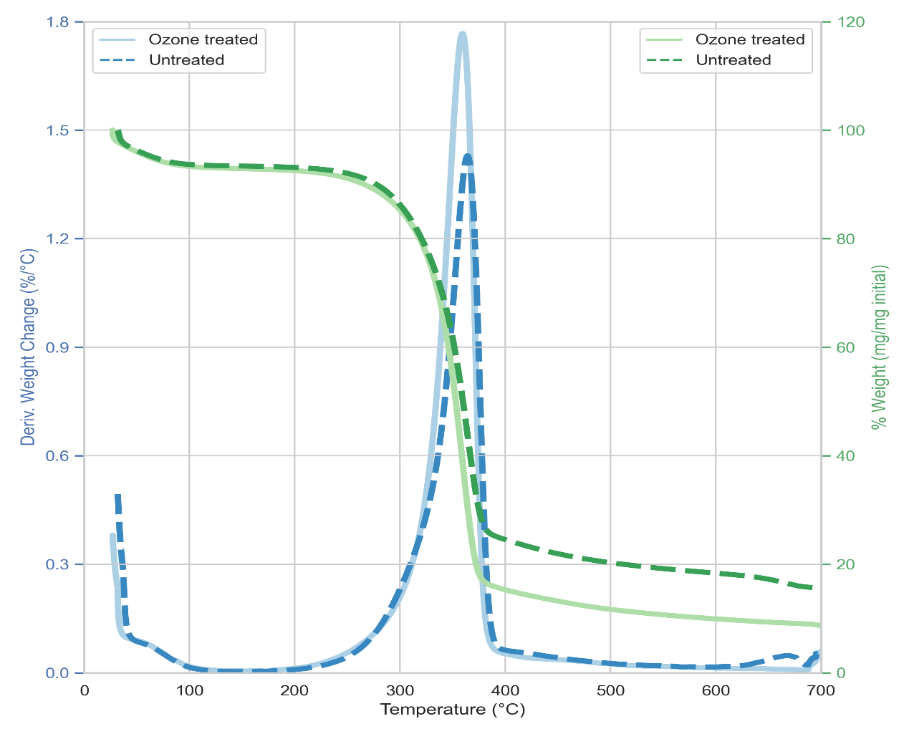
Figure A.1. TGA of cardboard waste with and without 1 h ozone treatment. Analysis of the data is presented in Table 1.

(a) Calibration curve (100<y<750 [mV]) y=2630.4*x +88.647,
R²=0.994
(b)Calibration curve (700<y<860 [mV]) y=515.81*x +602.12,
R²=0.956
(c)Calibration curve (875<y<1600 [mV]) y=100*x +775,
R²= 1
Figure A.2. Based on previous work (Çatal & İbanoğlu, 2013), it is feasible to estimate the concentration of dissolved ozone in the buffer, representing the unreacted ozone that remains after the ozone pretreatment process. The data from Table S1 was used to plot the graph. The curve was divided into three distinguishable segments: (a) 100<50, (b) 700<860, and (c) 860<1600, with regression (R²)

