Supplementary Information for
Sulfate as an Alternative Electron Acceptor: A Potential Strategy to Mitigate N₂O Emissions in Upland Arable Soils

Content of the file: Supplementary table 1, 2, 3, and 4, supplementary figure 1 and 2.

Supplementary Table 1. DADA2 denoising statistics of 16S rRNA gene amplicon sequence variants among treatments
Treatment | No. of input paired reads | Merged reads¹ | Quality filtered reads | Denoised reads | Chimera-filtered reads | Taxa-filtered reads²
CON | 61,072 | 57,028 | 46,312 | 41,584 | 41,157 | 41,125
CON | 61,279 | 56,905 | 45,880 | 40,434 | 39,865 | 39,824
CON | 58,338 | 55,104 | 45,378 | 41,258 | 40,782 | 40,746
MS | 67,952 | 64,665 | 50,117 | 45,267 | 44,729 | 44,638
MS | 46,418 | 43,860 | 43,355 | 38,786 | 38,447 | 38,378
MS | 61,582 | 57,748 | 53,201 | 47,556 | 46,946 | 46,862
ZVM | 65,179 | 61,444 | 53,815 | 48,766 | 47,911 | 47,851
ZVM | 55,552 | 52,649 | 35,708 | 31,479 | 31,154 | 31,118
ZVM | 68,042 | 64,525 | 47,497 | 42,534 | 41,957 | 41,872
¹Forward and reverse reads were merged using FLASH2
²Amplicon sequence variants identified as unassigned, mitochondria, chloroplast were filtered out

Supplementary Table 2. Analysis of compositions of microbiomes with bias correction 2 (ANCOME-BC2) (Attached excel file)

Supplementary Table 3. Soil characteristics of the studied soil for the microcosm and field-based manipulation experiments
Items | Value
Particle size distribution  Sand (%)  Silt (%)  Clay (%)  Soil texture  Bulk density (g cm⁻¹)  pH (1:5 with H₂O)  Organic matter (g kg⁻¹)  Total nitrogen (g kg⁻¹)  Available phosphate (mg kg⁻¹)  Exchangeable sulfate (mg kg⁻¹)  Exchangeable cations  K (cmol_{c} kg⁻¹)  Ca (cmol_{c} kg⁻¹)  Mg (cmol_{c} kg⁻¹)  Cation exchangeable capacity (cmol_{c} kg⁻¹) | 59.4  25.7  14.9  Sandy clay loam  1.31  6.70  17.6  1.05  142  26.9  0.42  4.76  1.02  6.85

Supplementary Table 4. Information of targeting primers
Primer | Sequence (5′ → 3′) | Annealing T. | Size (bp) | Reference
Bacterial 16S rRNA―341F | CGGCAACGAGCGCAACCC | 50ºC | 193 | (1)
Bacterial 16S rRNA―797R | CCATTGTAGCACGTGTGTAGCC | 50ºC | 193 | (1)
amoA-1F | GGGGTTTCTACTGGTGGT | 60ºC | 491 | (2)
amoA-2R | CCCCTCKGSAAAGCCTTCTTC | 60ºC | 491 | (2)
hao-1F | TGCGTGGAAGTGCTCAC | 50ºC | 992 | (3)
hao-3R | AGAGTAAGGAGTCTCGGGCAAA | 50ºC | 992 | (3)
nirK-1F | GGRATGGTKCCSTGGCA | 65ºC – 60ºC | 514 | (4)
nirK-5R | GCCTCGATCAGRTTRTGG | 65ºC – 60ºC | 514 | (4)
nirS-1F | CCTAYTGGCCGCCRCART | 65ºC – 60ºC | 890 | (4)
nirS-6R | CGTTGAACTTRCCGGT | 65ºC – 60ºC | 890 | (4)
cnorB-2F | GACAAGNNNTACTGGTGGT | 55ºC | 389 | (5)
cnorB-6R | GAANCCCCANACNCCNGC | 55ºC | 389 | (5)
nosZ-1F | WCSYTGTTCMTCGACAGCCAG | 65ºC – 60ºC | 700 | (6)
nosZ-2R | CAKRTGCAKSGCRTGGCAGAA | 65ºC – 60ºC | 700 | (6)
DSRp2060F | CCAACATCGTYCAYACCCAGGG | 55ºC | 350 | (7)
DSR4R | GTGTAGCAGTTACCGCA | 55ºC | 350 | (7)

Supplementary Fig. 1. N₂O emissions at time-batch microcosm experiments. Daily N₂O emissions comparison for (a) metal sulfates (control, FeSO₄, MnSO₄, and ZnSO₄) and (b) zero-valent metals (control, Fe⁰, Mn⁰, and Zn⁰) from incubated soils for 7, 14, and 21 day. Statistically significant differences among the treatment groups based on one-way ANOVA by the least significant difference test (P < 0.05) are indicated by differing letters
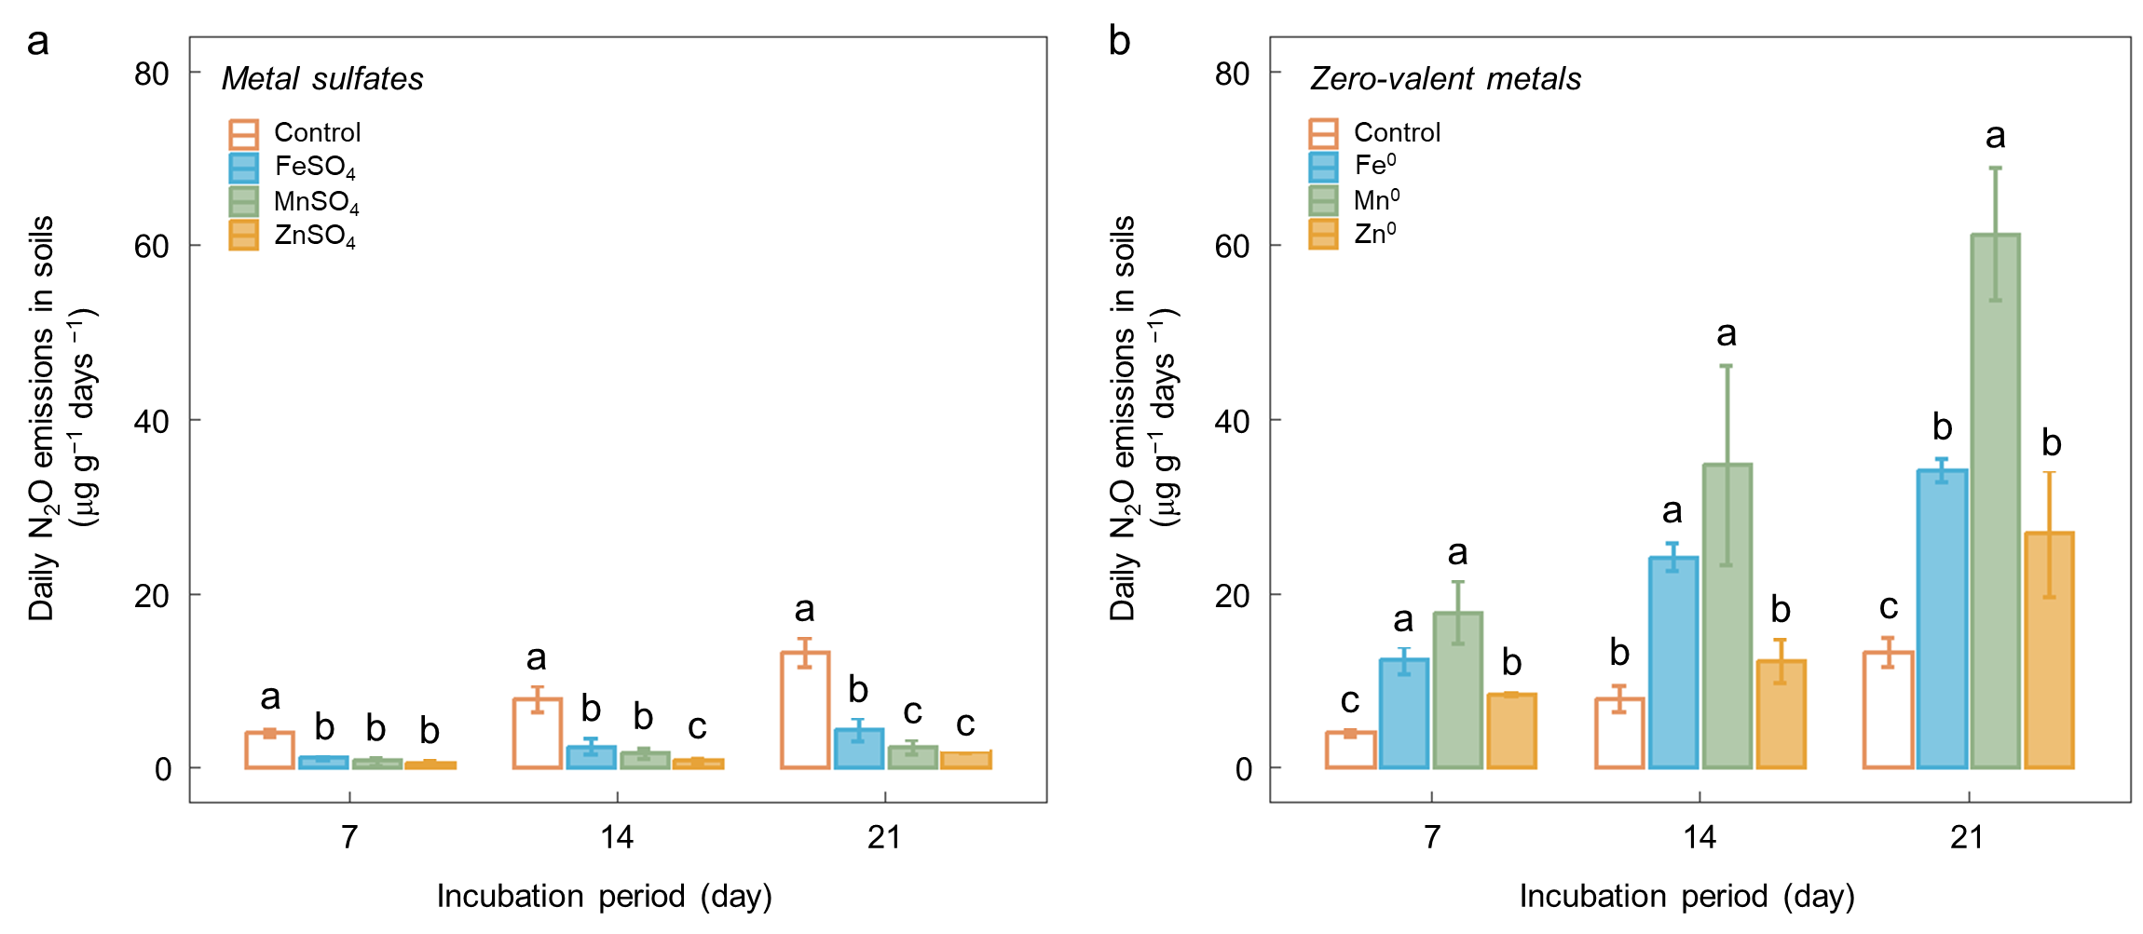
Supplementary Fig. 2. Activity of sulfate reducing bacteria in soils with treatments. The transcript abundance of dsrA gene per gram of dry soil treated with metal sulfates (FeSO₄, MnSO₄, and ZnSO₄) and zero-valent metals (Fe⁰, Mn⁰, and Zn⁰) after 21 days of incubation. The thick central line represents the median value, the boxed areas represent the interquartile range, and the whiskers show the maximum and minimum values (N = 6). Statistically significant differences among the treatment groups, determined by one-way ANOVA with the least significant difference test (P < 0.05), are indicated by differing letters.
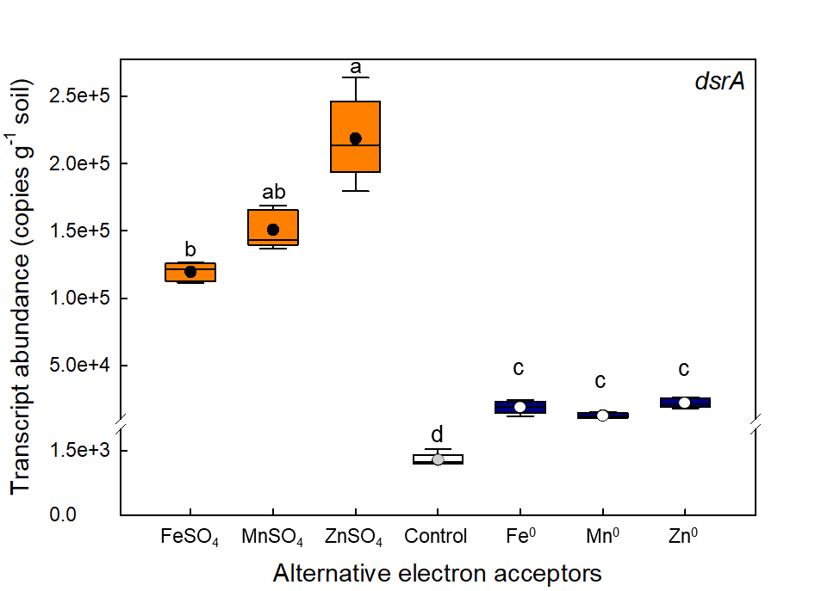

References
1. Denman SE, McSweeney CS. Development of a real-time PCR assay for monitoring anaerobic fungal and cellulolytic bacterial populations within the rumen. FEMS Microbiology Ecology. 2006;58(3):572-82.
2. Rotthauwe JH, Witzel KP, Liesack W. The ammonia monooxygenase structural gene amoA as a functional marker: molecular fine-scale analysis of natural ammonia-oxidizing populations. Applied and Environmental Microbiology. 1997;63(12):4704-12.
3. Schmid MC, Hooper AB, Klotz MG, Woebken D, Lam P, Kuypers MMM, et al. Environmental detection of octahaem cytochrome c hydroxylamine/hydrazine oxidoreductase genes of aerobic and anaerobic ammonium-oxidizing bacteria. Environmental Microbiology. 2008;10(11):3140-9.
4. Braker G, Fesefeldt A, Witzel K-P. Development of PCR Primer Systems for Amplification of Nitrite Reductase Genes (<i>nirK</i> and <i>nirS</i>) To Detect Denitrifying Bacteria in Environmental Samples. Applied and Environmental Microbiology. 1998;64(10):3769-75.
5. Braker G, Tiedje JM. Nitric Oxide Reductase (<i>norB</i>) Genes from Pure Cultures and Environmental Samples. Applied and Environmental Microbiology. 2003;69(6):3476-83.
6. Henry S, Bru D, Stres B, Hallet S, Philippot L. Quantitative Detection of the nosZ Gene, Encoding Nitrous Oxide Reductase, and Comparison of the Abundances of 16S rRNA, narG, nirK, and nosZ Genes in Soils. Applied and Environmental Microbiology. 2006;72(8):5181-9.
7. Miletto M, Bodelier PLE, Laanbroek HJ. Improved PCR-DGGE for high resolution diversity screening of complex sulfate-reducing prokaryotic communities in soils and sediments. Journal of Microbiological Methods. 2007;70(1):103-11.

