Supplementary Information
Article title: Future expansion of alpine forest-grassland ecotone under land-use and climate change
Journal name: Landscape Ecology
Author name: Sebastian Marzini, Erich Tasser, Camilla Wellstein, Katharina Albrich, Werner Rammer, Marco Mina
Corresponding author affilitaion & email address: Sebastian Marzini, Faculty of Agricultural, Environmental and Food Sciences, Free University of Bolzano/Bozen, Italy / Institute for Alpine Environment, Eurac Research, Bozen/Bolzano, Italy, sebastian.marzini@student.unibz.it

Contents
Supplementary Material and Methods 2
Model initialization: DEM, climate, and soil 2
Model initialization: tree vegetation 5
Supplementary Results 8
References 14

Supplementary Material and Methods

Model initialization: DEM, climate, and soil
We report here the distribution of the elevation gradient within the study area. The areas available for the expansion of the forest (i.e., grasslands and pastures) are located soon after the current forest edges, up to an elevation of 2500 m a.s.l. (see Fig. 1 in the main manuscript).

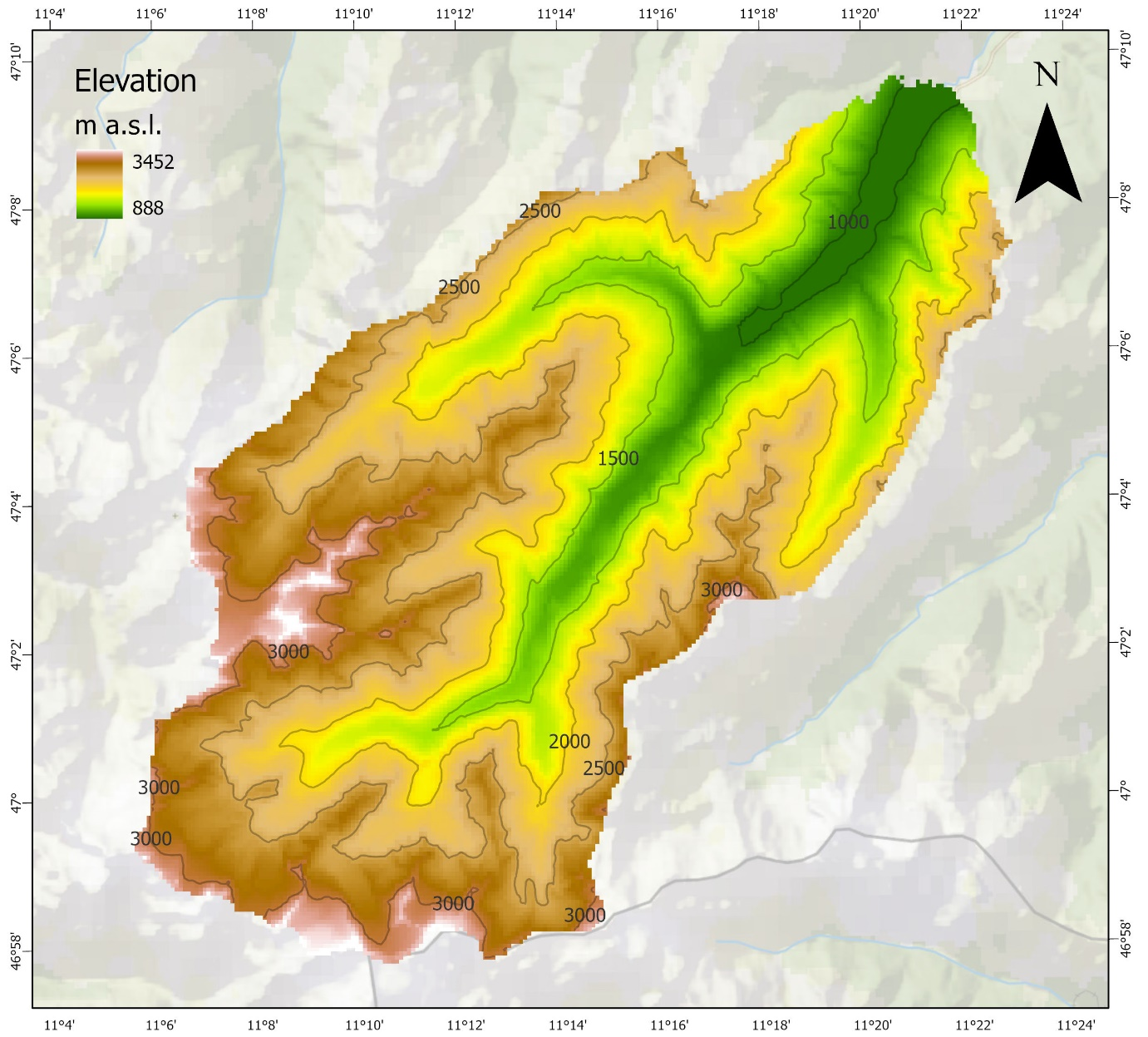
Fig. S1 Elevation of the study area.

Climate data such as daily temperature (minimum and maximum), precipitation, solar radiation and vapour pressure deficit were processed to suit the newly enlarged landscape. We followed the approach described in Seidl et al. (2019), using the same set of climate change projections (Table S1) to ensure comparability. Temporal development of the climatic variables for the four chosen scenarios are shown in Fig. S2.
Table S1. The climate change scenarios chosen in the study, with indication of their Representative Concentration Pathway (RCP), Global Circulation Model (GCM) and Regional Climate Model (RCP). These future scenarios were selected from an initial screening of 26 future trajectories (see details in Seidl et al. 2019).
Climate scenario | RCP | GCM | RCM
Moderate | 4.5 | EC-EARTH | KNMI-RACMO22E
Warm | 8.5 | EC-EARTH | KNMI-RACMO22E
Warm and wet | 8.5 | IPSLCM5A-MR | IPSL-INERIS-WRF331F
Hot and dry | 8.5 | HadGEM2-ES | CLMcomCCLM4-8-17

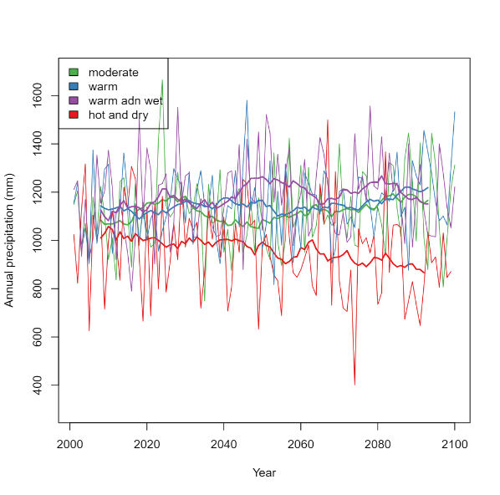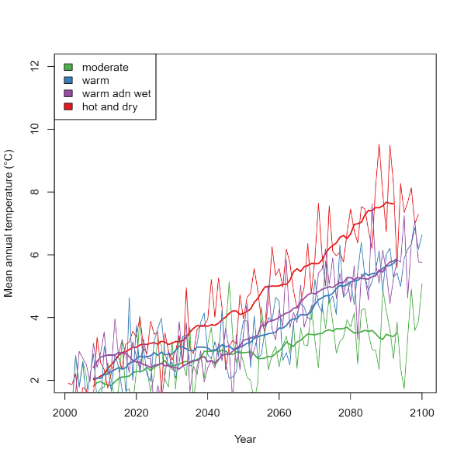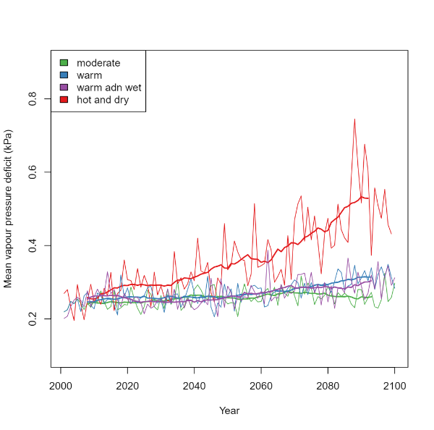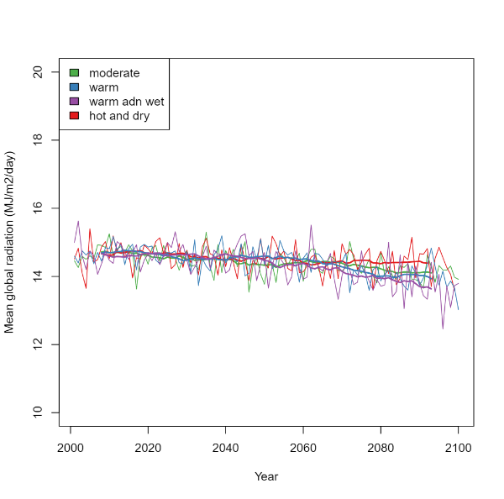
Fig. S2 Trends of the climate variables until 2100 related to the climate changes scenario used for the simulation.
A harmonized dataset of soil depth for the entire landscape was not available. As reported in the main manuscript (Materials and Methods), to cover the newly enlarged landscape we merged soil data that were derived for forest areas (Seidl et al. 2019) with estimates derived from plot-level measurements in pasture and grassland areas following the method described in Schirpke et al. (2020) for an analogous Alpine landscape. To our knowledge, this was the only data available that allowed to parameterize soil conditions for the enlarged landscape (E. Tasser, G. Leitinger, personal communication). Due to methodological differences between the two datasets, soil depth values show a noticeable decrease after a certain elevational limit (Fig. S3), often corresponding with the maximum area occupied by the vegetation at the end of the simulations. We acknowledge limitations related to soil data in the Discussion of the main manuscript (see Section 4.3). 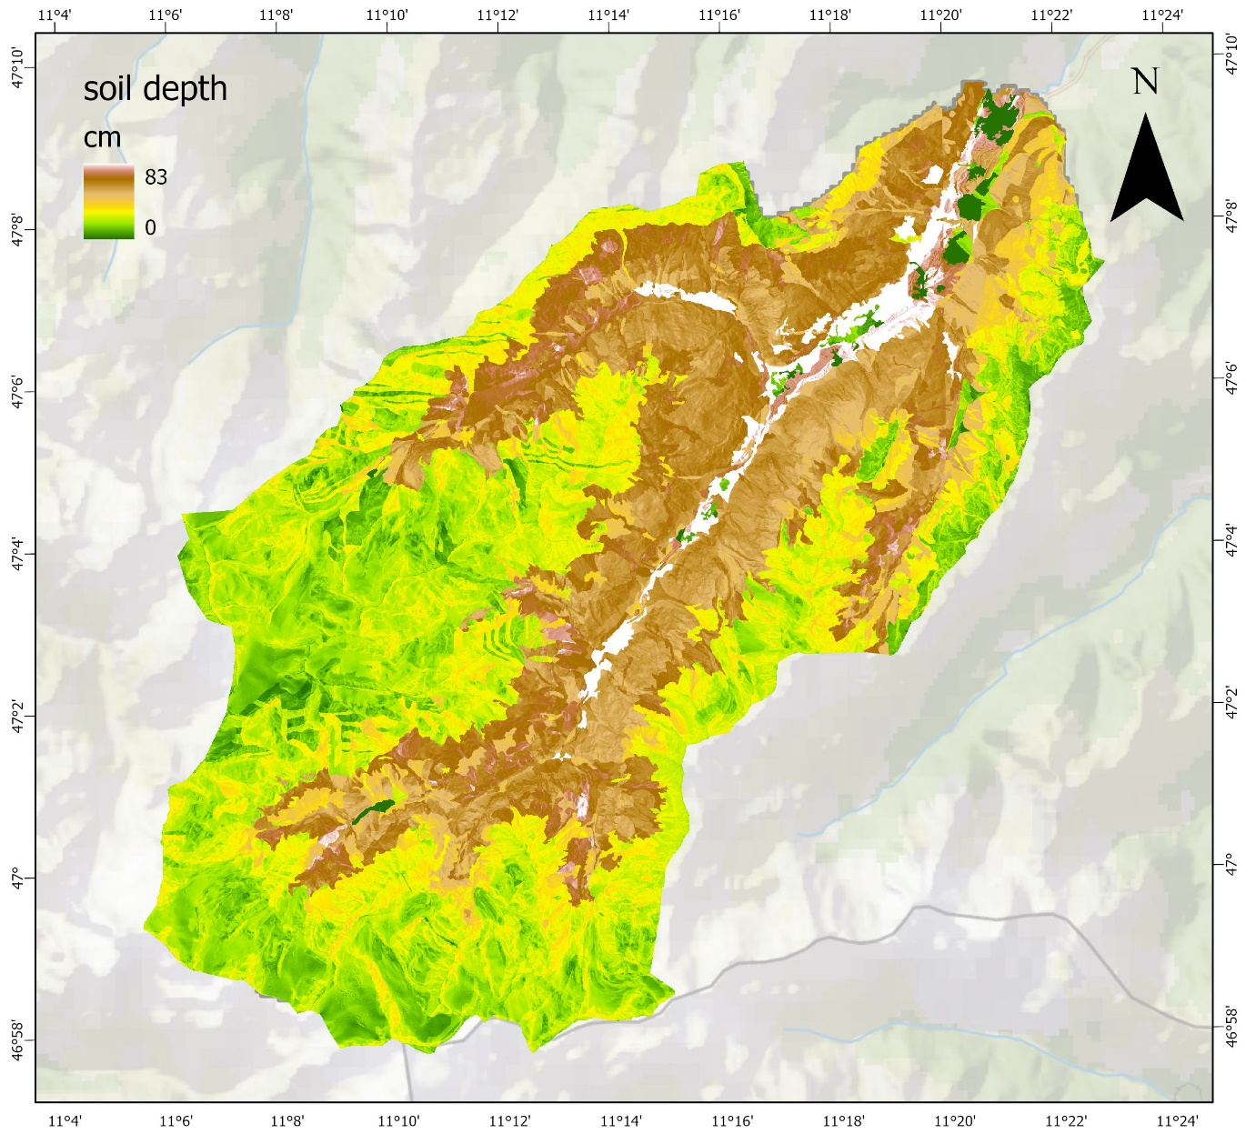
Fig. S3 Soil depth distribution in the study area.

Model initialization: tree vegetation
The initial conditions of the forest stands were derived by using same data and processes described in Seidl et al. (2019) and Albrich et al. (2020). The initialization and evaluation of iLand for the Stubai landscape is explained in detail in the Supplementary Material of Seidl et al. (2019). To (re)initialize the landscape on the enlarged study area, we ran the legacy spin-up routine described in Thom et al. (2018). This consisted in iteratively run the model including past management interventions under historical climate, until species composition reached an equilibrium state. We ran the legacy spinup for a period of 600 years. To let the forest expand, accordingly to the LULC map of the valley, we selected the most suitable type of land use for the establishment of the vegetation, mainly focusing on those presenting human activities and undergoing abandonment trends (see Fig. 1 in the main manuscript). These areas were inserted in the stockable area and during the spin up, a clear-cut management (i.e., complete high vegetation removal) was applied to keep them free from trees establishment.
We initialized mountain pine (Pinus mugo) stands in relation to the approach used in Berchtesgaden National Park – a landscape also located in the north of the Alps – presented by Thom & Seidl (2022). Differently from other common tree species currently parameterized in iLand (e.g., Norway spruce, European larch), data for this species was hardly available from the literature. Therefore, we relied on information about the spatial distribution of the species in the Stubai landscape and initialized it using quantitative values obtained by Thom & Seidl (2022). The latter showed a good compromise among all available sources, being reproduced using iLand as well and performing well within the Berchtesgaden National Park landscape. Overall, after the spin-up, the model generated a vegetation composition that matched well the observed data from the forest inventory (Fig. S4a). As we did not have quantitative reference data on mountain pine but only information about the land covering these communities, this species was not included in the numerical comparison of species share. Despite this, the distribution of mountain pine communities at the end of the iterative spinup routine (Fig. S4b) matched well the observed one.
Along with the simulations, mountain pine share showed a decline within the first 100 years of simulation at the expense of larch, especially on N-facing slopes (see Results in the main manuscript). We did not deeply analyse these changes and it is possible that these dynamics are due to the parameterization of mountain pine in the model, where this species gets mostly outcompeted by other species like European larch. We acknowledge that further studies should specifically address this species and improve the parameterization of its life history traits in the model, since mountain pine is an important species driving forest succession dynamics at the subalpine and alpine level (Dullinger et al., 2005).

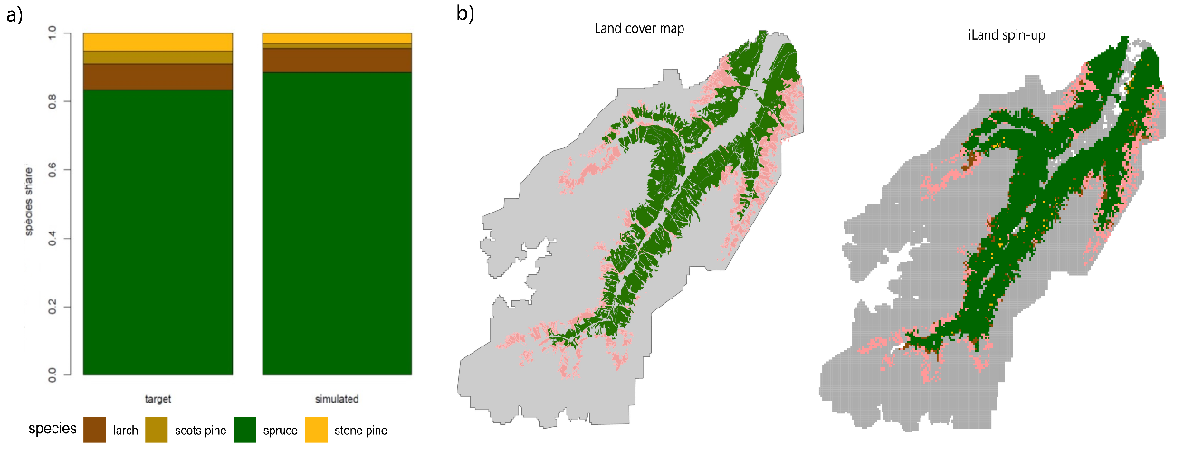
Fig. S4 Left panel: comparison between observation (i.e., target) and simulated mean species share via spin-up for the initialization of current vegetation composition. Right panel: comparison between observed land cover map and iLand initial vegetation conditions after the model spin-up. Colours indicate the tree species with the highest share of basal area within the 1-ha cells (green: Norway spruce; pink: mountain pine).

Supplementary Results
In the main manuscript, output results were presented as means among the 10 model runs for every scenario. To assess uncertainties related to stochastic processes within the model, we calculated the between-replicates coefficient of variation of basal area outputs every 30 years along the simulation time and for the different scenarios. Variability across model replicates were minimal, as shown in Table S2 here below.

Table S2. Coefficient of variation (CV) for the replicates of simulation outputs of every scenario expressed as percentage and calculated from basal area. Values were aggregated at the landscape level and for every 30 years outputs.
 | Historic | Moderate | Warm | Warm-and-wet | Hot-and-dry
2050 | 0.33 | 0.40 | 0.25 | 0.31 | 0.41
2080 | 0.29 | 0.64 | 0.37 | 0.44 | 0.75
2110 | 0.20 | 0.66 | 0.49 | 0.40 | 0.44
2140 | 0.38 | 0.35 | 1.49 | 0.28 | 0.73
2170 | 0.38 | 0.31 | 1.20 | 0.50 | 0.65
2200 | 0.31 | 0.48 | 0.65 | 0.54 | 0.43
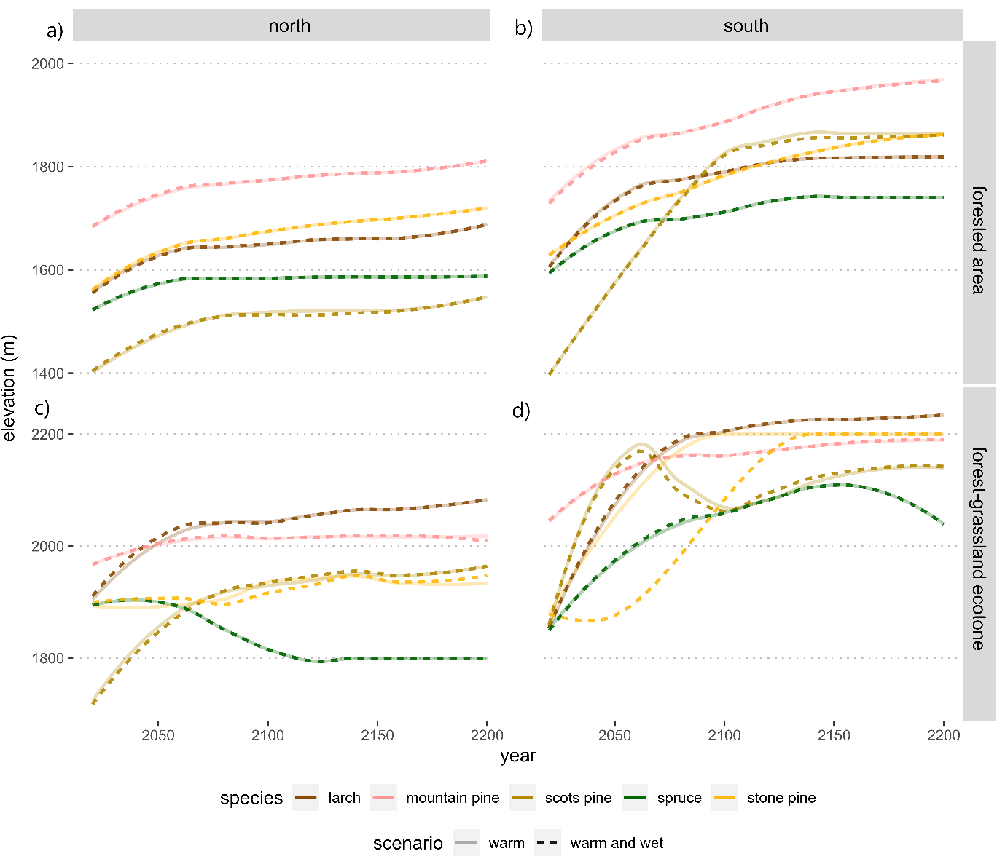Fig. S5 Tree species shift within the forested area and the forest-grassland ecotone for the two additional climate scenarios (warm and, warm-and-wet). Trends are showed in relation to aspect, colours represent the species while line types define the climate scenario
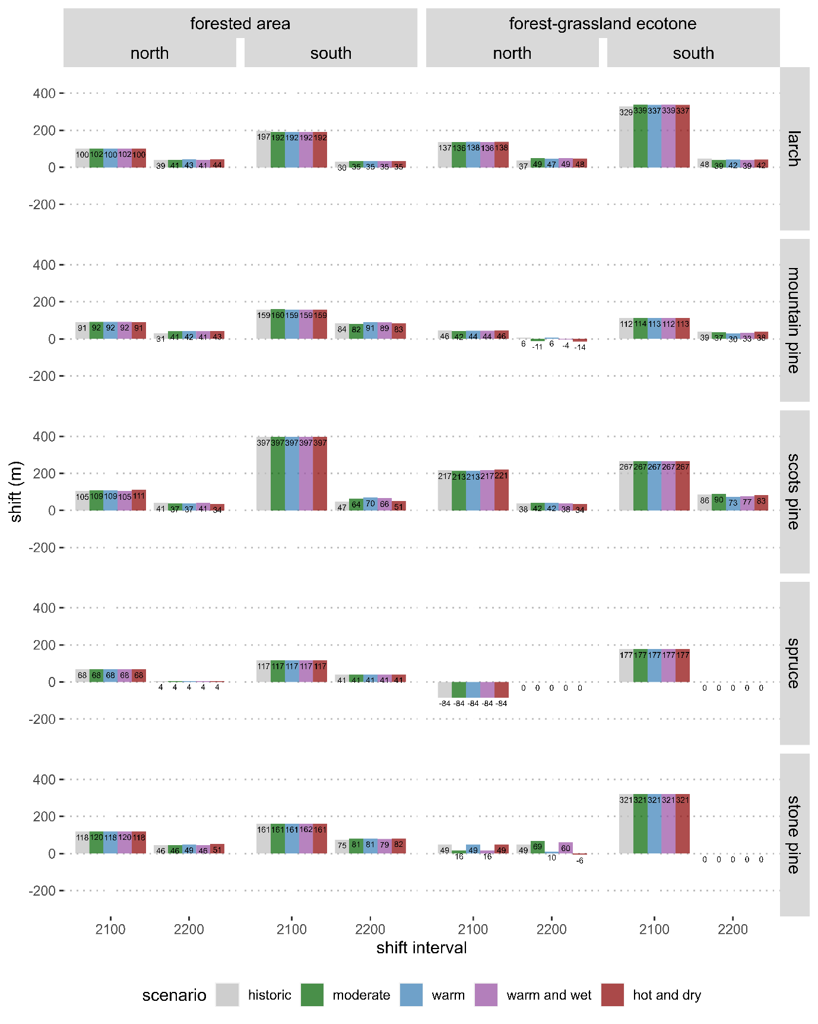Fig. S6 Quantification of the elevational shifts of the five tree species composing the forested area and the forest-grassland ecotone by aspect under every climate scenario (historic, moderate, hot-and-dry). The shifts were calculated as difference of elevation between 2100 and 2020 (2100), and between 2200 and 2100 (2200)
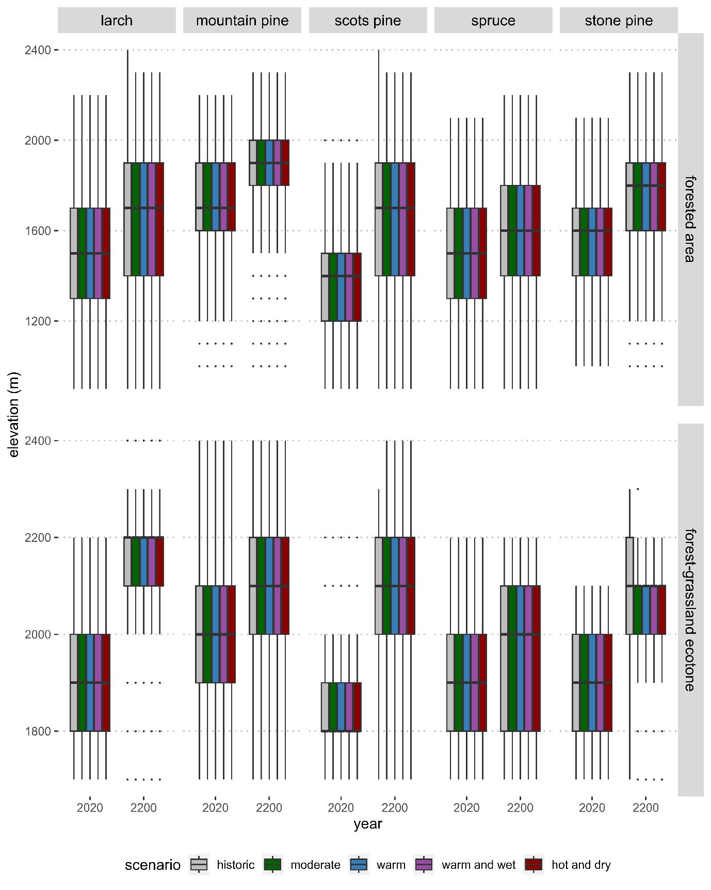
Fig. S7 Elevation distribution of the tree species in the forested area and the forest-grassland ecotone for the different climate scenarios, at the beginning and at the end of the simulation interval. Box ranges between 25th and 75th percentile, whiskers represent minimum and maximum values, and dots the outliers

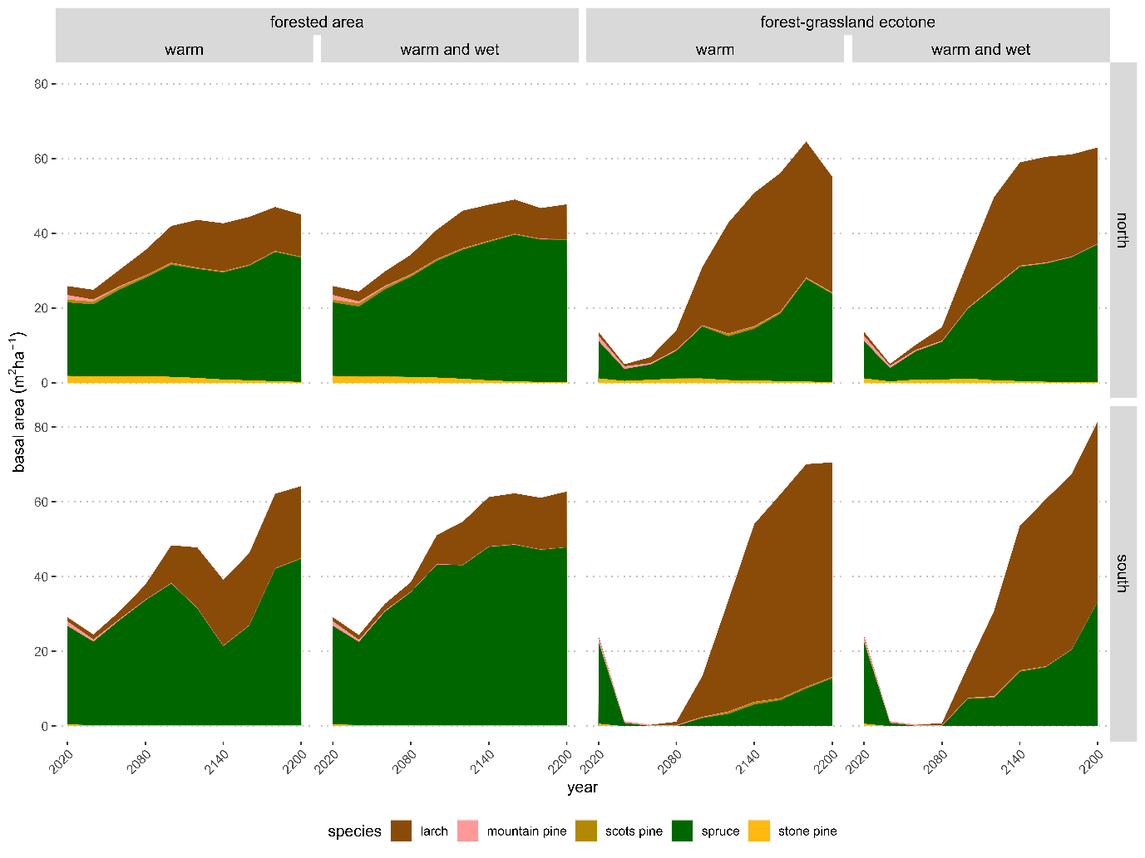
Fig. S8 Basal area trends for the forested area and the forest-grassland ecotone under the two additional climate scenarios (warm, and warm-and-wet) in relation to the aspect.

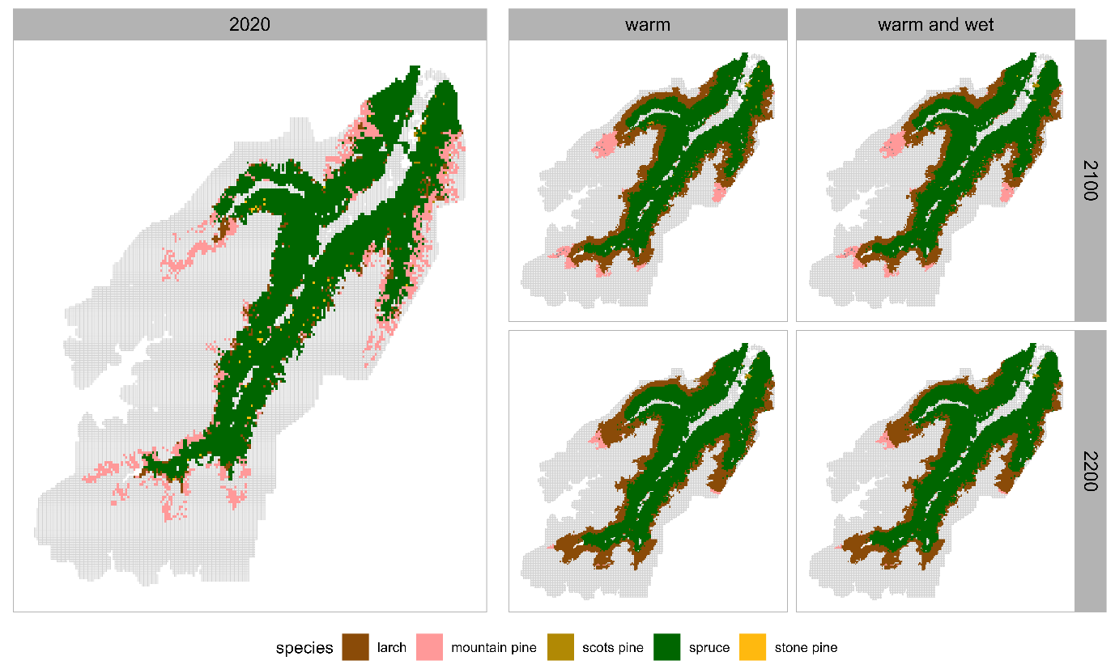Fig. S9 Distribution of the tree species under the two additional climate scenarios (warm, and warm-and-wet) at different time steps. Cells are filled with the colour of the species showing the highest share within them
- References
Albrich, K., Rammer, W., & Seidl, R. (2020). Climate change causes critical transitions and irreversible alterations of mountain forests. Global Change Biology, 26(7), 4013–4027. https://doi.org/10.1111/gcb.15118
Dullinger, S., Dirnbock, T., Kock, R., Hochbichler, E., Englisch, T., Sauberer, N., & Grabherr, G. (2005). Interactions among tree-line conifers: Differential effects of pine on spruce and larch. Journal of Ecology, 93(5), 948–957. https://doi.org/10.1111/j.1365-2745.2005.01036.x
Schirpke, U., Leitinger, G., Tasser, E., Rüdisser, J., Fontana, V., & Tappeiner, U. (2020). Functional spatial units are fundamental for modelling ecosystem services in mountain regions. Applied Geography, 118, 102200. https://doi.org/10.1016/j.apgeog.2020.102200
Seidl, R., Albrich, K., Erb, K., Formayer, H., Leidinger, D., Leitinger, G., Tappeiner, U., Tasser, E., & Rammer, W. (2019). What drives the future supply of regulating ecosystem services in a mountain forest landscape? Forest Ecology and Management, 445, 37–47. https://doi.org/10.1016/j.foreco.2019.03.047
Thom, D., Rammer, W., Garstenauer, R., & Seidl, R. (2018). Legacies of past land use have a stronger effect on forest carbon exchange than future climate change in a temperate forest landscape. Biogeosciences, 15(18), 5699–5713.
Thom, D., & Seidl, R. (2022). Accelerating Mountain Forest Dynamics in the Alps. Ecosystems, 25(3), 603–617. https://doi.org/10.1007/s10021-021-00674-0

