Supplementary table 1. Antibodies informations
Antibodies | SOURCE | IDENTIFIER
Rabbit anti-HMGCS2 | Abcam | Cat# ab137043
Mouse anti-HSD3β | Santa | Cat# sc515120
Rabbit anti-CYP17A1 | CST | Cat# 94004S
Rabbit anti-γ-H2AX | Abcam | Cat# ab26350
Rabbit anti-P21 | Abcam | Cat# ab188224
Rabbit anti-FOXO3a | CST | Cat# 2497S
Rabbit anti-H3K9ac | CST | Cat# 9649S
Rabbit anti-H3K9bhb | PTM | Cat# PTM1250RM
Mouse anti-Histone H3 | Santa | Cat# sc517576
Rabbit anti-GAPDH | HUABIO | Cat# et1601-4
Chicken anti-mCHERRY | Abcam | Cat# ab205402
Goat Anti-rabbit Alexa Fluor 488 | Invitrogen | Cat# A11037
Goat Anti-rabbit Alexa Fluor 647 | Invitrogen | Cat# A32733
Goat Anti-mouse Alexa Fluor 555 | Invitrogen | Cat# A32727
Goat Anti-chicken Alexa Fluor 555 | Invitrogen | Cat# A32932
Goat Anti-rabbit Alexa Fluor 594 | Invitrogen | Cat# A32740
Anti-Mouse-IgG HRPLINKED | CST | Cat# 7074S
Anti-Rabbit-IgG HRPLINKED | CST | Cat# 7076S

Supplementary table 2. Chemicals and recombinant proteins information.
 | SOURCE | IDENTIFIER
Avertin | Sigma-Aldrich | Cat# 7076S
Triton X-100 | Sigma-Aldrich | Cat# X100
Chorionic gonadotropin human (hCG) | Sigma-Aldrich | Cat# 1297001
Bouin’s solution | Sigma-Aldrich | Cat# HT10132
DAPI | Invitrogen | Cat# P36966
Bovine Serum Albumin | Sigma-Aldrich | Cat# A7030
Tissue-Tek® O.C.T. Compound | Sakura | Cat# 4583
Recombinant NovoScript 1st Strand cDNA Synthesis Kit | Novoprotein | Cat# E041
RNeasy Kits | YIBIN | Cat# 74116
LightCycler® 480 SYBR Green I | Roche | Cat# 04887352001
Senescence β-Galactosidase Staining Kit | Beyotime | Cat# C0602
LH Elisa Kit | Cloud-clone | Cat# CEA441Mu
FSH Elisa Kit | Cloud-clone | Cat# CEA830Mu
Insl3 Elisa Kit | Phoenix | Cat# EK-035-43
Acetoacetate Assay kit (Colorimetric) | Abcam | Cat# ab180875
β-Hydroxybutyrate (Ketone Body) Colorimetric Assay Kit | Cayman | Cat# 700190
RNA Quick Purification kit | Yibin | Cat# RN001
SimpleChIP® Enzymatic Chromatin IP Kit (Magnetic Beads) | CST | Cat# 9003
PFA | Phygene | Cat# PH0427
TIAN amp Genomic DNA kit | TIANGEN | Cat# 4992254
Hymeglusin | MCE | Cat# HY-117430
3-Hydroxybutyric acid sodium | MEC | Cat# HY-W010452
Lithium acetoacetate | Sigma-Aldrich | Cat# A8509
Vorinostat | MCE | Cat# SML0061
Hydrogen peroxide (3%) | Hengjian | NA
Doxorubicin | MCE | Cat# D1515
DNase I | Gibco | Cat# 18047019
Type IV Collagenase | Gibco | Cat# 17104019
StemPro Accutase® | Invitrogen | Cat# A1110501
0.25% Trypsin-EDTA | Gibco | Cat# 25200072
GlutaMAX | Gibco | Cat# 35050061
KetoForce | KetoSports | NA
Citrate Antigen Retrieval Solution | Beyotime | Cat# C0602-1
RIPA buffer | Beyotime | Cat# P0013B
Supplementary table 3. Primers informations for Quantitative RT-PCR
Gene | Primers for Quantitative RT-PCR
Hmgcs2 | forward: AGAGAGCGATGCAGGAAACTT  reverse: AAGGATGCCCACATCTTTTGG
Acat | forward: CAGGAAGTAAGATGCCTGGAAC  reverse: TGCAGCAGTACCAAGTTTAGTG
Hmgcl | forward: CAGGTGAAGATCGTGGAAGTC  reverse: GGAGCCCTGCTTCGGAAAC
Cxcl1 | forward: CTGGGATTCACCTCAAGAACATC  reverse: CAGGGTCAAGGCAAGCCTC
Cxcl10 | forward: CCAAGTGCTGCCGTCATTTTC  reverse: GGCTCGCAGGGATGATTTCAA
P16 | forward: CTTCTGCTCAACTACGGTGC  reverse: GCACGATGTCTTGATGTCCC
P21 | forward: CCTGGTGATGTCCGACCTG  reverse: CCATGAGCGCATCGCAATC
Pai1 | forward: TTCAGCCCTTGCTTGCCTC  reverse: ACACTTTTACTCCGAAGTCGGT
β-Actin | forward: ACCGTGAAAAGATGACCCAG  reverse: GTACGACCAGAGGCATACAG
Hdac1 | forward: AGTCTGTTACTACTACGACGGG  reverse: TGAGCAGCAAATTGTGAGTCAT
Hdac2 | forward: GGAGGAGGCTACACAATCCG  reverse: TCTGGAGTGTTCTGGTTTGTCA
Hdac3 | forward: GCCAAGACCGTGGCGTATT  reverse: GTCCAGCTCCATAGTGGAAGT
Supplementary table 4. Primers informations for Genotyping
Gene | Primers for Genotyping
Hmgcs2 (5'arm) | forward: CTTATGGAGATCAGACGCATAC  reverse: TGCATGTATGTTTGCAGGC
Hmgcs2 (3'arm) | forward: CCCAGCACTTATGTATCCTCTG  reverse: CGGCTCAGGGAACATCAC
Supplementary table 5. Primers informations for chip-qPCR
Gene | Primers for chip-qPCR
Foxo3a-1 | forward: GGGGAACCTGTCCTATGCC  reverse: TCATTCTGAACGCGCATGAAG
Foxo3a-2 | forward: CATGCGCGTTCAGAATGAAGG  reverse: GACTGTCGTCTGCCGACTC
Foxo3a-3 | forward: CTGGGGGAACCTGTCCTATG  reverse: TCATTCTGAACGCGCATGAAG
Supplementary table 6. sh-RNA target sequence
sh-RNA | Target sequence
Hmgcs2-1 | GGGAACATGTACACCTCTTCC
Hmgcs2-2 | GGAAGCAAGCTGGAAACAACC
Hdac1-1 | GATGTTGGAAACTACTATTAT
Hdac1-2 | GCCAGTCATGTCCAAAGTAAT
Foxo3a-1 | GGATGACGTCCAGGATGATGA
Foxo3a-2 | GGAGCTTGGAATGTGACATGG

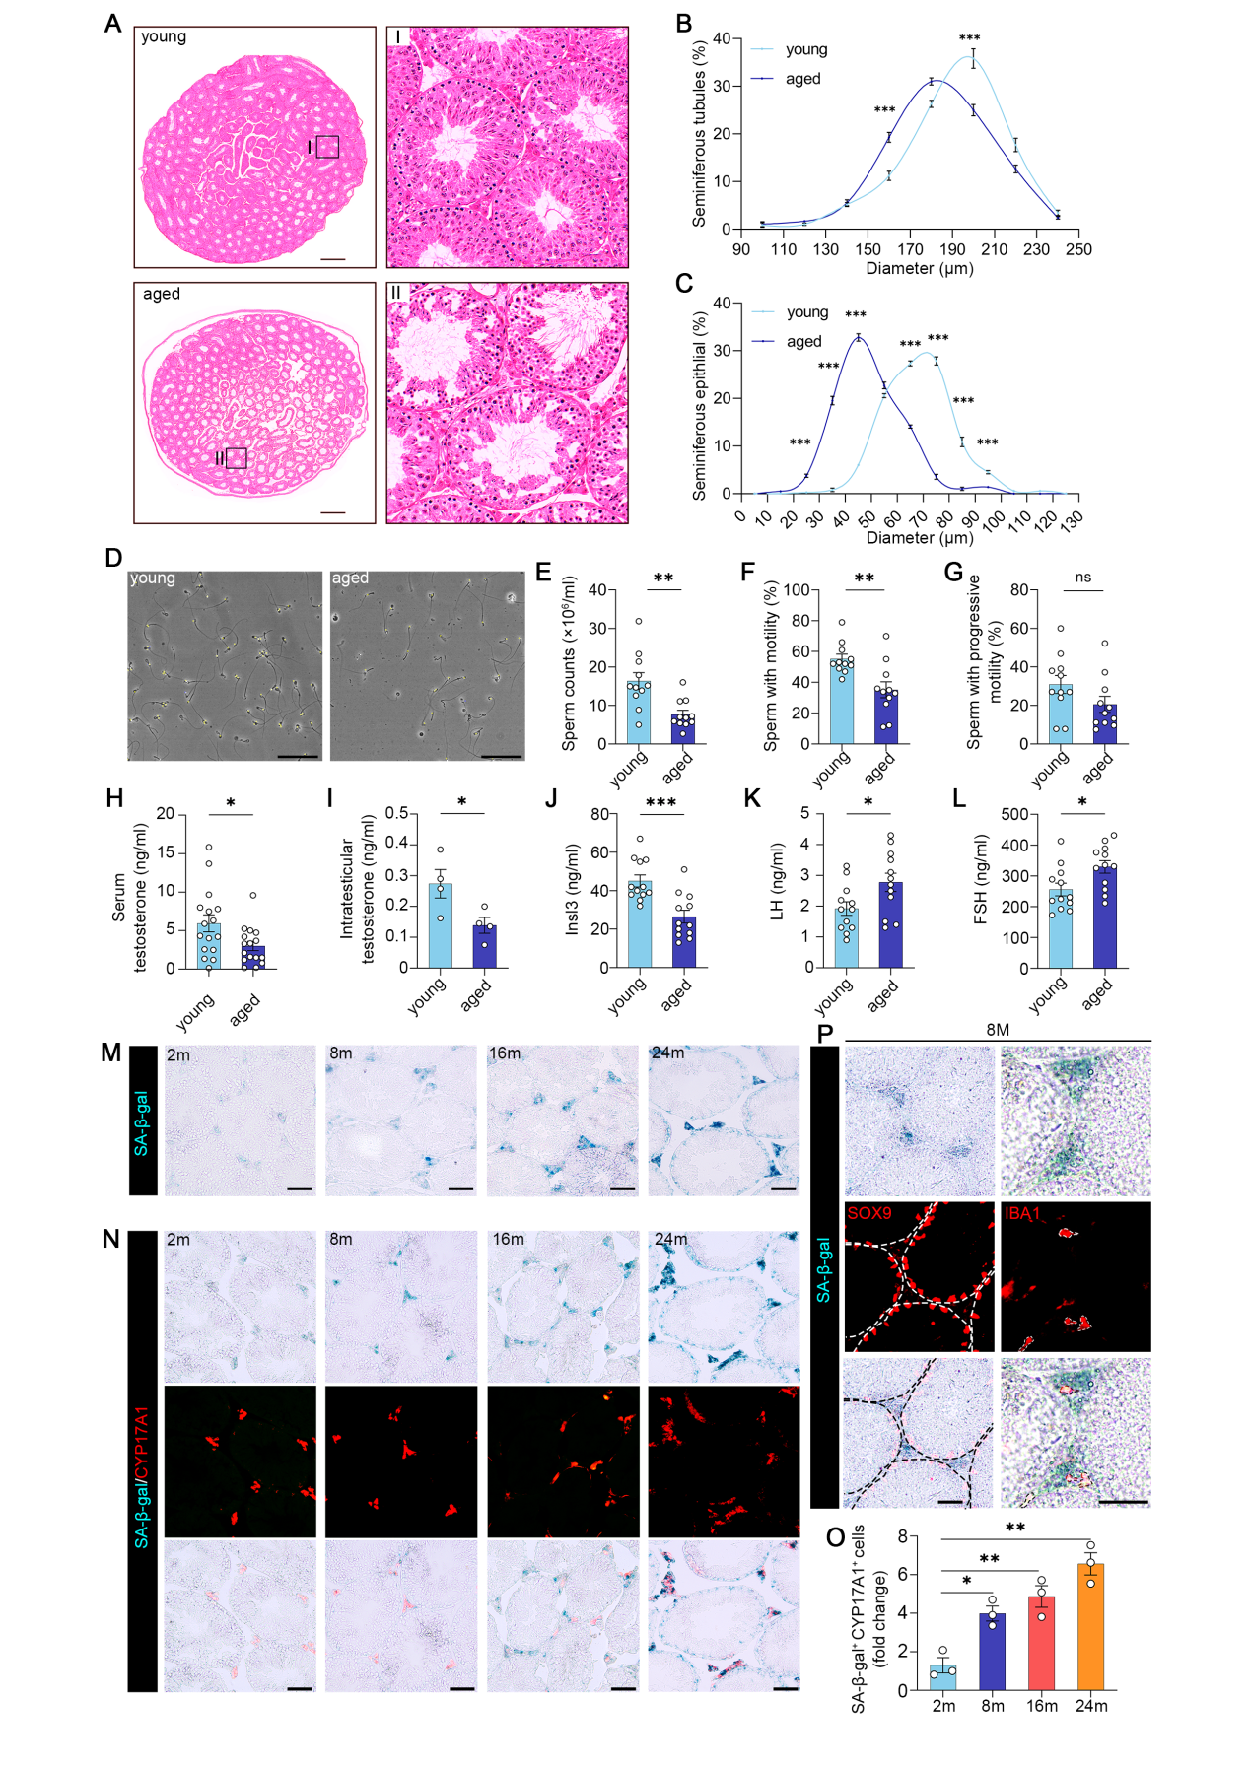
Figure S1. Aging-related phenotypes of mice testes.
(A-C) Representative HE staining images of testes sections obtained from young and aged testes. Scale Bar: 500 μm (A). The percentage of seminiferous tubules with different diameters (B) and the percentage of seminiferous epithelium with different diameters (C). n=3 per group. (D-G) Representative light micrographs of sperm acquired from indicated groups. Scale Bar: 100 μm (D). Sperm counts (E), proportion of sperm with motility (F), proportion of sperm with progressive motility (G). n=11 per group. (H-L) Serum testosterone (H), intratesticular testosterone (I), Serum Insl3 (J), Serum LH (K), Serum FSH (Follicle Stimulating Hormone) (L) level of the indicated groups. n=16 per group in (H), n=4 per group in (I), n=12 per group in (J-L). (M) Representative images of sections from testicular tissue of different ages. The sections were stained with SA-β-gal. Scale Bar: 75μm. (N) Representative images of sections from testicular tissue of different ages. The sections were stained with LCs marker CYP17A1 and SA-β-gal. Scale Bar: 75μm. (O) Quantitative analysis of the CYP17A1⁺ SA-β-gal⁺ cells in (N). n=3 per group. (P) Representative images of sections from testicular tissue of 8-month-old mouse. The sections were stained with SA-β-gal and Sertoli cell marker SOX9 (SRY-related high-mobility group box 9) or macrophage marker IBA1 (ionized calcium-binding adapter molecule 1). Scale Bar: 25μm.
Data in the histogram (B and C) were expressed as mean ± SEM. Significance was determined by two-way ANOVA. * P < 0.05, ** P < 0.01, *** P < 0.001, ns = not significant. Data in the bar graph (E-L) were expressed as mean ± SEM. Significance was determined by two-tailed unpaired t-tests. * P < 0.05, ** P < 0.01, *** P < 0.001, ns = not significant. Data in the bar graph (O) were expressed as mean ± SEM. Significance was determined by one-way ANOVA. * P < 0.05, ** P < 0.01, *** P < 0.001, ns = not significant.

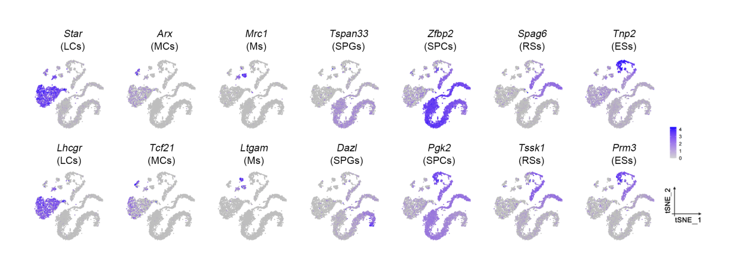
Figure S2. t-SNE plot showing the expression profiles of the indicated cell type-specific marker genes in scRNA-seq data of mice testes.

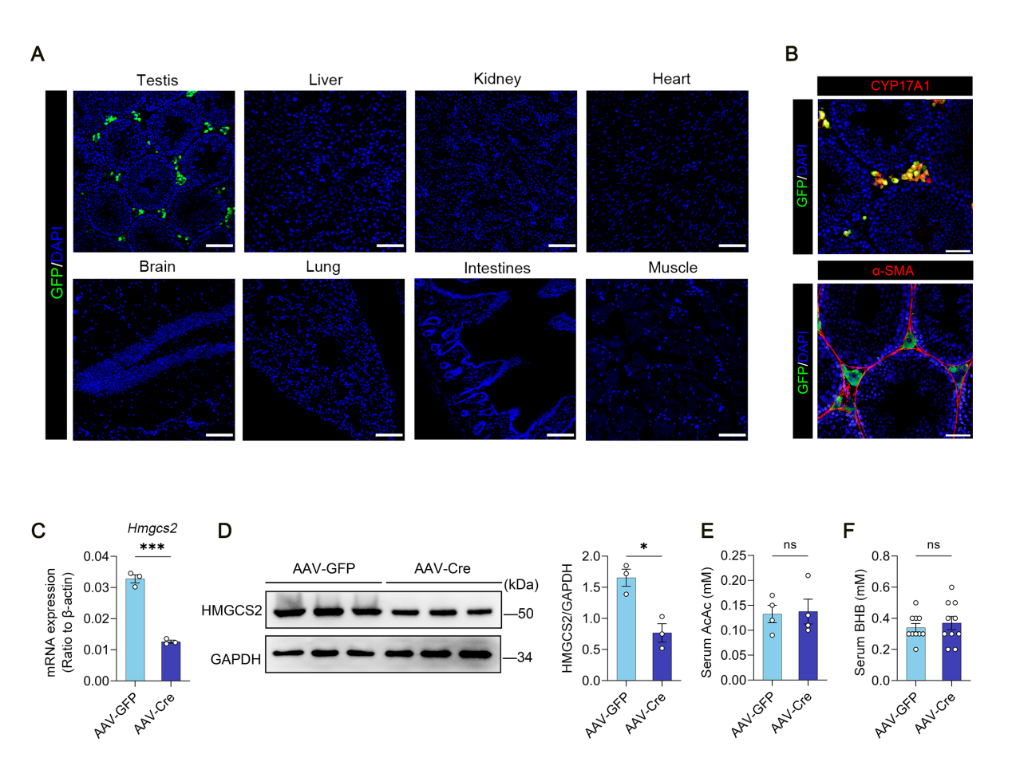
Figure S3. Testicular injection of AAVDJ showed a clear testis tropism and the downregulation of HMGCS2 in injected testes
(A) One weeks after injection, the representative images of GFP expression in indicated organs of AAV-GFP infected mice. Scale bar: 50 μm. (B) Representative confocal images of sections from AAV-GFP infected testis. The sections were stained with LCs marker CYP17A1 or PTMs (peritubular myoid cells) marker α-SMA (α-Smooth Muscle Actin), GFP, and DAPI. (C) Quantitative RT-PCR analysis of Hmgcs2 from testicular tissues of AAV infected mice. (D) Left: 4 weeks after injection, the representative western blots for HMGCS2 and GAPDH from AAV-GFP and AAV-Cre infected testes. Right: quantitative analysis of the HMGCS2 protein level, relative to GAPDH. n=3 per group. (E-F) The concentration of AcAc and BHB in serum of indicated groups. n=4 per group in (E), n=10 per group in (F).
Data in the bar graph are expressed as mean ± SEM. Significance was determined by two-tailed unpaired t-tests. * P < 0.05, ** P < 0.01, *** P < 0.001, ns = not significant.

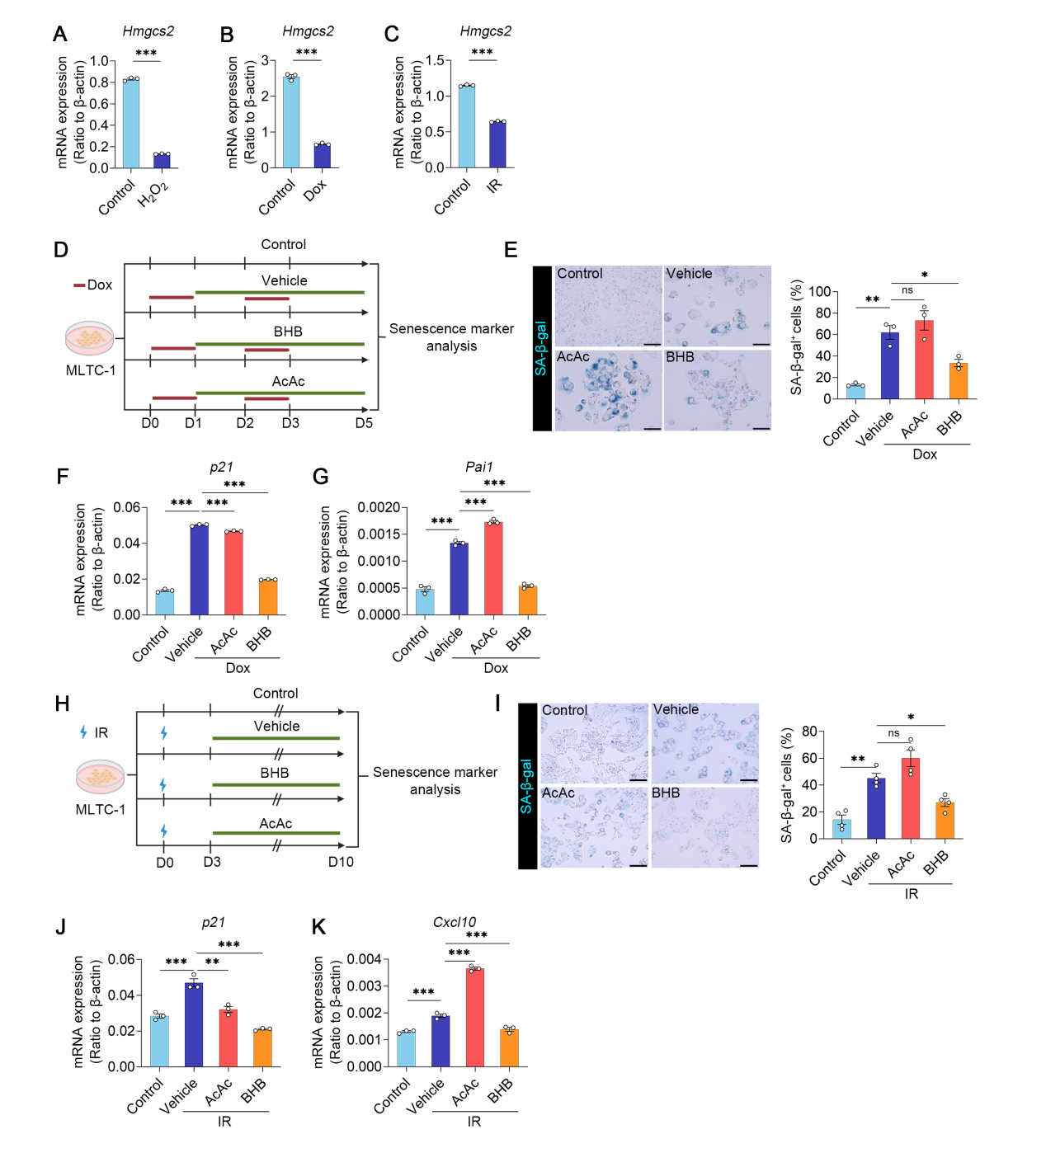Figure S4. BHB alleviates irradiation and doxorubicin induced cellular senescence
(A-C) Quantitative RT-PCR analysis of Hmgcs2 after H₂O₂ (A), Dox (doxorubicin) (B), IR (irradiation) (C) treatment. n=3 per group. (D) Experimental scheme of Dox (doxorubicin) induced senescence and treatment. (E) Left: representative images of SA-β-gal staining in MLTC-1 cells of the indicated groups. Scale Bar: 75μm. Right: quantitative analysis of the SA-β-gal⁺ cells. n=3 per group. (F-G) Quantitative RT-PCR analysis of senescence markers (p21, pai1) of the indicated groups. n=3 per group. (H) Experimental scheme of IR (irradiation) induced senescence and treatment. (I) Left: representative images of SA-β-gal staining in MLTC-1 cells of the indicated groups. Scale Bar: 75μm. Right: quantitative analysis of the SA-β-gal⁺ cells. n=3 per group. (J-K) Quantitative RT-PCR analysis of senescence markers (p21, pai1) of the indicated groups. n=3 per group.
Data in the bar graph (A-C) were expressed as mean ± SEM. Significance was determined by two-tailed unpaired t-tests. * P < 0.05, ** P < 0.01, *** P < 0.001, ns = not significant. Data in the bar graph (E-G, I-K) were expressed as mean ± SEM. Significance was determined by one-way ANOVA. * P < 0.05, ** P < 0.01, *** P < 0.001, ns = not significant.

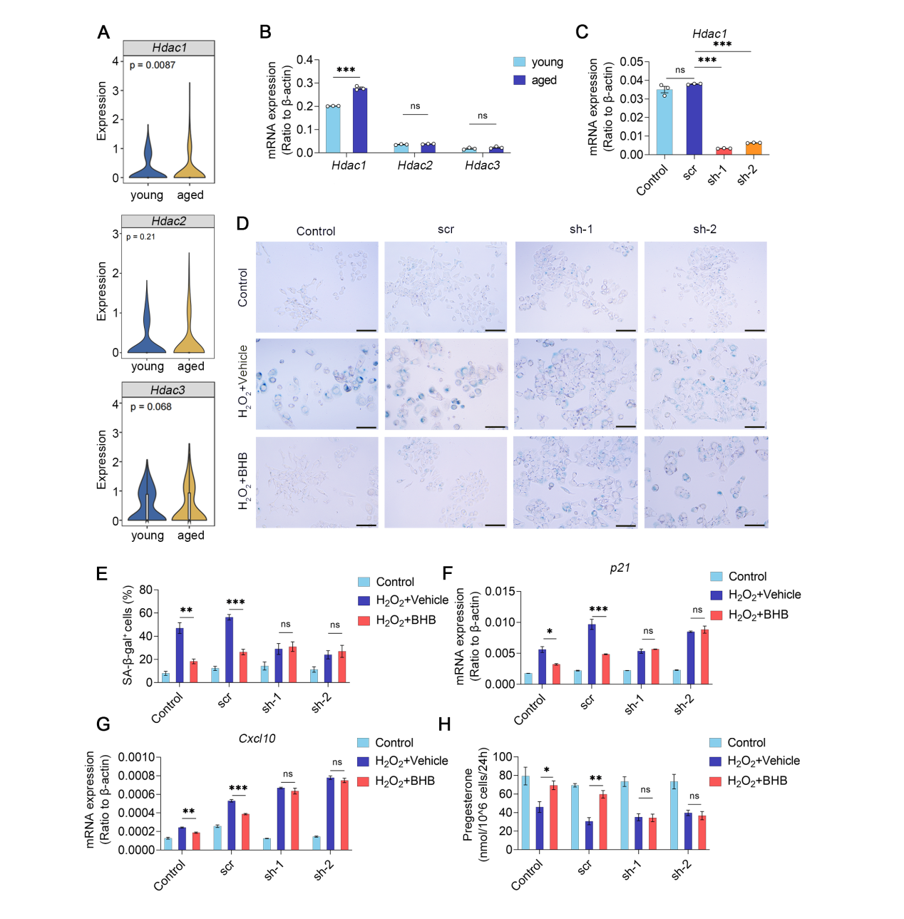
Figure S5. BHB-mediated HDAC1 inhibition alleviated MLTC-1 cells senescence
(A) Violin plots showing Hdac expression of young and aged LCs. (B) Quantitative RT-PCR analysis of Hdac in primary LCs. n=3 per group. (C) Quantitative RT-PCR analysis of Hdac1 in MLTC-1 after transfection with either shRNA to Hdac1 or a scrambled (scr) shRNA. n=3 per group. (D-E) D: representative images of SA-β-gal staining. MLTC-1 cells were induced senescence by H₂O₂ as the experimental scheme in (A) after transfection. Scale Bar: 75μm. (E) quantitative analysis of the SA-β-gal⁺ cells in (D). n=3 per group. (F-G) Quantitative RT-PCR analysis of senescence markers (p21, Cxcl10) of indicated groups. n=3 per group. (H) Progesterone production of MLTC-1 cells after transfection with either shRNA to Hdac1 or a scrambled (scr) shRNA. n=3 per group.
Data in the violin plots (A) significance was determined by Mann-Whitney U test. Data in the bar graph (B) were expressed as mean ± SEM. Significance was determined by two-tailed unpaired t-tests. * P < 0.05, ** P < 0.01, *** P < 0.001, ns = not significant. Data in the bar graph (C, E-H) were expressed as mean ± SEM. Significance was determined by one-way ANOVA. * P < 0.05, ** P < 0.01, *** P < 0.001, ns = not significant.

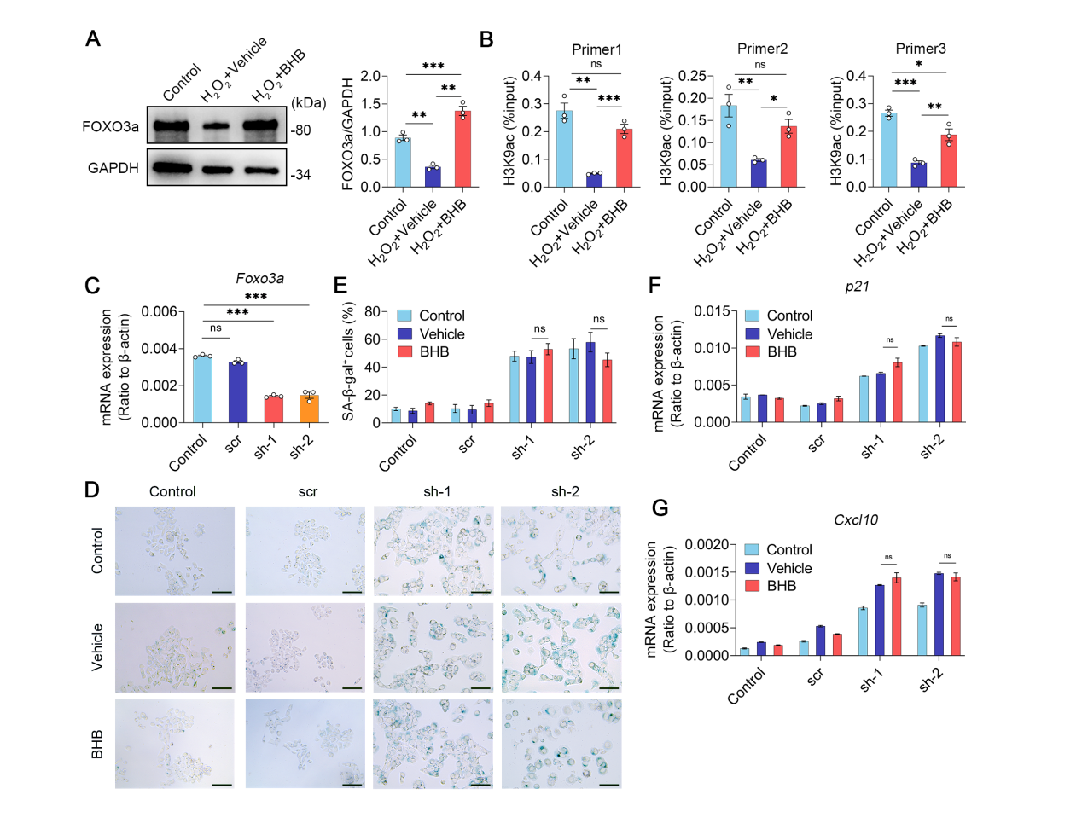
Figure S6. BHB alleviated senescence by enhancing Foxo3a expression.
(A) Left: representative western blots for FOXO3a and GAPDH. MLTC-1 cells were treated as the experimental scheme in Figure 5 (A). Right: quantitative analysis of the FOXO3a protein level, relative to GAPDH. n=3 per group. (B) ChIP–qPCR analyses of H3K9ac enrichment at the promoter of Foxo3a. MLTC-1 cells were treated as the experimental scheme in Figure 5 (A). n=3 per group. (C) Quantitative RT-PCR analysis of Foxo3a in MLTC-1 after transfection after transfection with either shRNA to Foxo3a or a scrambled (scr) shRNA. n=3 per group. (D-E) D: representative images of SA-β-gal staining from transfected cells after BHB (5mM) treatment. Scale Bar: 75μm. E: quantitative analysis of the SA-β-gal⁺ cells in (D). n=3 per group. (F-G) Quantitative RT-PCR analysis of senescence markers (p21, Cxcl10). n=3 per group.
Data in the bar graph (A-C, E-G) were expressed as mean ± SEM. Significance was determined by one-way ANOVA. * P < 0.05, ** P < 0.01, *** P < 0.001, ns = not significant.

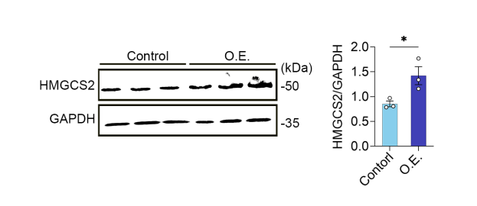
Figure S7. AAV-Hmgcs2 increased the expression of HMGCS2 in LCs of aged mice.
Left: representative Western blots for HMGCS2 and GAPDH in AAV-Control and AAV-O.E. infected testes. Right: quantitative analysis of the HMGCS2 protein level, relative to GAPDH. n=3 per group.
Data in the bar graph were expressed as mean ± SEM. Significance was determined by two-tailed unpaired t-tests. * P < 0.05, ** P < 0.01, *** P < 0.001, ns = not significant.

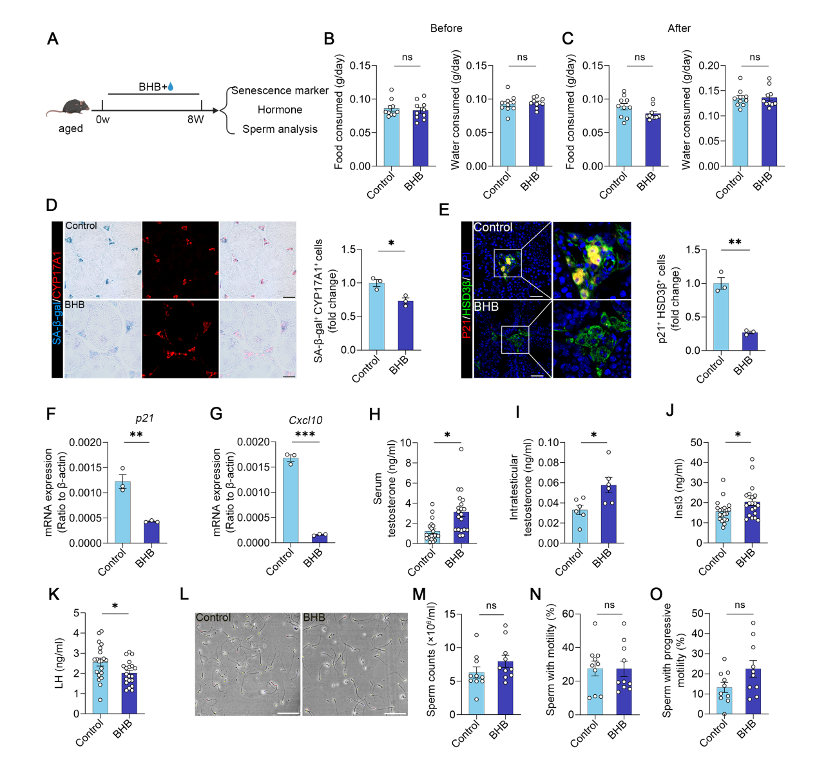
Figure S8. Oral administration of BHB partially alleviates testicular aging in aged mice.
(A) Schematic of oral BHB and mice used in the study. (B and C) Water and food consumption between salt and BHB treated mice. Before oral BHB (B), after oral BHB (C). (D) Left: representative images of testicular sections from indicated groups. The sections were stained with LCs marker CYP17A1, and SA-β-gal. Scale Bar: 75 μm. Right: quantitative analysis of the CYP17A1⁺ SA-β-gal⁺ cells. n=3 per group. (E) Left: representative confocal images of testicular sections from indicated groups. The sections were stained with senescence marker p21, HSD3β, and DAPI. Scale Bar: 50 μm. Right: quantitative analysis of the p21⁺ HSD3β⁺ cells. n=3 per group. (F and G) Quantitative RT-PCR analysis of senescence markers (p21, cxcl10). (H-K) Serum testosterone (H), intratesticular testosterone (I), serum Insl3 (J), serum LH (K) level of the indicated groups. n=20 per group in (H), n=6 per group in (I), n=20 per group in (J), n=20 per group in (K). (L-O) Representative light micrographs of sperm acquired from indicated groups (L). Scale Bar: 100 μm. Sperm counts (M), proportion of sperm with motility (N), proportion of sperm with progressive motility (O). n=10 per group.
Data in the bar graphs were expressed as mean ± SEM. Significance was determined by two-tailed unpaired t-tests. * P < 0.05, ** P < 0.01, *** P < 0.001, ns = not significant.

