Supplementary material of:
Analysis of the macroseismic cumulative damage in the seismic sequences in Italy

Gianfranco Vannucci^{1*}

¹Istituto Nazionale di Geofisica e Vulcanologia , Sezione di Bologna

*Corresponding author

Statements & Declarations

Funding
This article benefitted from funding provided by the European Union within the ambit of the H2020 project RISE (Number 821115).

Competing Interests
The authors have no relevant financial or non-financial interests to disclose.

Author Contributions
The author contributed to the study conception, design, material preparation, and analysis.

Data Availability
There are no data produced by this work.

Description of the Supplementary Material

This supplementary material contains Figures and Tables to provide further information and details for the main text. Moreover, we added the observation section that follows.

Observations on decreasing intensities in sequences

We applied the CIS method varying systematically the intensity threshold and for some earthquakes of sequences, we observed a strong variation of the macroseismic parameters, due to the subtraction of localities and relative intensity that change the original MDP distribution (Tables S3 and S4). In some sequences, we observed a decrease in intensity of previously affected and heavily damaged common localities (intensity >9) to which high intensities were assessed in subsequent earthquakes. For example, the wide distance and difference in magnitude (about 83 km and 1 degree respectively) for the 14 August 1851 earthquake (2.40 p.m., sequence n. 28, Mw=5.48 in CPTI15) and for CIS threshold 9.5, derives from the exclusion of a single locality (Tables S3 and S4). For the 23 January 1909 earthquake (sequence n. 39) the distance ~30-40 km and 1 degree difference in magnitude compared to the initial MDP distribution depends on the exclusion of only 2 localities (with CIS intensity thresholds 10) and 4 localities (with CIS intensity thresholds 9.5). Analysing the corresponding MDPs in detail the earthquake of 14 August 1851 (14:40) has only 10 MDPs, 8 of which are “felt”, one intensity 3.5 and one intensity of 8.5 (Melfi town). This locality has intensity 10 assigned in the previous earthquake of 14 August 1851 (13:10). The earthquake of 23 January 1909 (sequence n. 39, Mw=5.15 in CPTI15) also has four localities with intensities 7.5 (Messina) and 7 (Cannitello, Reggio di Calabria and Villa San Giovanni). The same localities had already been hit and strongly damaged a few weeks earlier by the 28 December 1908 (Mw=7.1) earthquake with assigned intensity 10.5 (Messina and Cannitello) and 10 (Reggio di Calabria and Villa San Giovanni). A few months later the situation was repeated with the earthquake of 1 July 1909 (sequence n. 39, Mw=5.49 in CPTI15) with intensity 8 still assessed to the already destroyed Messina and Reggio di Calabria. We also noted an extreme case for the earthquake of 26 December 1857 (sequence n. 29, Mw=5.33 in CPTI15) for which it is not possible to estimate any parameter with CIS methodology (Tables S3 and S4). This event has only one MDP (intensity 7.5) in the locality of Montemurro, which was completely destroyed (intensity 11) ten days earlier by the 16 December 1857 (Mw=7.12) earthquake.
Assessing intensities above the damage threshold for previously affected sites near the level of total destruction is rather questionable and the CIS method allows to highlight such peculiarities. It is clear that the calculated parameters could influence local hazard estimates and seismotectonic analyses. We also bring these cases to the attention of the CPTI authors for any expert decisions they may make (e.g., the earthquake of 1703 Jan. 16, which is also present in other catalogues (CFTI4med and CFTI5med, Table S1), has not been parameterized in CPTI15.

Date | Time | Lat | Lon | Mw | n MDPs | Catalogue | Reference
1456/12/05 |  | 41.302 | 14.711 | 7.19 | 199 | CPTI15 | MELAL988
1456/12/05 |  | 41.5328* | 14.508* | 7.15* | 89 | CFTI5med | FR&VA007
1456/12/05 |  | 41.1843* | 14.8743* | 7.07* | 82 | CFTI5med | FR&VA007
1456/12/05 |  | 42.1938* | 13.9102* | 6.46* | 17 | CFTI5med | FR&VA007
1456/12/05 |  | 41.0903* | 15.661*7 | 6.22* | 18 | CFTI5med | FR&VA007
1693/01/09 | 21:-- | 37.141 | 15.035 | 6.07 | 30 | CPTI15 | CFTI4med
1693/01/11 | 13:30 | 37.140 | 15.013 | 7.32 | 179 | CPTI15 | CFTI4med
1703/01/14 | 18:-- | 42.708 | 13.071 | 6.92 | 197 | CPTI15 | CFTI4med
1703/01/16 | 13:30 | 42.623* | 13.102* | 5.93* | 22 | CFTI5med | CFTI4med
1703/02/02 | 11:05 | 42.434 | 13.292 | 6.67 | 69 | CPTI15 | CFTI4med
1857/12/16 | 21:15 | 40.352 | 15.842 | 7.12 | 340 | CPTI15 | CFTI4med
1962/08/21 | 18:09 | 41.248 | 15.069 | 5.68 | - | CPTI15 | -
1962/08/21 | 18:19 | 41.230 | 14.953 | 6.21 | 562 | CPTI15 | GIZZI012
1962/08/21 | 18:44 | 41.158 | 15.065 | 5.34 | - | CPTI15 | -
1918/11/10 | 15:12 | 43.917 | 11.933 | 5.96 | 187 | CPTI15 | CFTI4med
1919/06/29 | 15:06 | 43.957 | 11.482 | 6.38 | 565 | CPTI15 | CFTI4med
1980/11/23 | 18:34 | 40.842 | 15.283 | 6.81 | 1394 | CPTI15 | CFTI4med

Table S1: some examples of sequences. Benchmarks (Lat, Lon, Mw) for earthquakes are taken from CPTI15, except those calculated in this work (*). Number of MDPs (n MDPs) from the corresponding Catalogue. Original references are indicated as acronyms, with correspondence in the reference section.

n.S | Date | Time | Locality/area | Tl | Lat | Lon | Tm | Mw | N | nCI | Reference
1 | 1348/09/13* | --:-- | Subiaco | M | 41.925 | 13.095 | M | 5.56±.46 | 1 |  | CFTI4med
1 | 1349/09/09 | --:-- | App.laz.-abruz. | M | 42.27 | 13.118 | M | 6.27±.14 | 17 |  | CFTI4med
2 | 1501/06/05* | 10:00 | Modenese | M | 44.519 | 10.844 | M | 6.05±.19 | 17 |  | CFTI4med
2 | a:1504/12/31 | 04:00 | Bolognese | Mm | 44.494 | 11.343 | M | 5.02±.28 | 15 |  | CFTI4med
2 | b:1505/01/03 | 02:00 | Bolognese | M | 44.507 | 11.23 | M | 5.62±.21 | 31 |  | CFTI4med
3 | 1561/07/31* | 19:45 | Vallo di Diano | M | 40.65 | 15.389 | M | 6.34±.1 | 22 |  | CASAL008
3 | 1561/08/19 | 15:50 | Vallo di Diano | M | 40.563 | 15.505 | M | 6.72±.17 | 32 |  | CASAL008
4 | 1597/08/03* | 23:40 | Mugello | M | 43.987 | 11.429 | M | 5.28±.23 | 24 |  | CFTI4med
4 | 1599/11/16 | --:-- | Casentino | M | 43.774 | 11.716 | M | 5.1±.46 | 2 |  | CAMAL011b
5 | 1624/02/03* | --:-- | Calabria centrale | M | 39.027 | 16.283 | M | 5.1±.46 | 4 |  | SCIAL006
5 | 1626/04/04 | 12:45 | Calabria centrale | M | 38.851 | 16.456 | M | 6.07±.44 | 7 |  | CFTI4med
6 | 1627/07/30* | 10:50 | Capitanata | M | 41.737 | 15.342 | M | 6.66±.1 | 64 |  | CFTI4med
6 | a:1627/07/30 | 11:05 | Capitanata | M | 41.685 | 15.381 | M | 5.8±.46 | 1 |  | CFTI4med
6 | b:1627/08/07 | 16:40 | Capitanata | M | 41.758 | 15.328 | M | 6.03±.46 | 5 |  | CFTI4med
6 | c:1627/09/06 | 15:50 | Capitanata | M | 41.597 | 15.358 | M | 5.8±.46 | 2 |  | CFTI4med
7 | 1640/06/19* | --:-- | Calabria centrale | M | 38.632 | 16.491 | M | 5.8±.46 | 3 |  | CAMAL011b
7 | 1640/06/22 | --:-- | Calabria centrale | M | 38.568 | 16.524 | M | 5.33±.46 | 1 |  | CAMAL011b
8 | 1692/03/04* | 22:20 | Irpinia | M | 40.903 | 15.196 | M | 5.88±.36 | 9 |  | CAMAL011b
8 | 1694/09/08 | 11:40 | Irpinia-Basilicata | M | 40.862 | 15.406 | M | 6.73±.1 | 251 |  | CFTI4med
9 | 1693/01/09* | 21:-- | Sicilia SE | M | 37.141 | 15.035 | M | 6.07±.23 | 30 |  | CFTI4med
9 | 1693/01/11 | 13:30 | Sicilia SE | M | 37.14 | 15.013 | M | 7.32±.1 | 179 |  | CFTI4med
10 | 1703/01/14* | 18:00 | Valnerina | M | 42.708 | 13.071 | M | 6.92±.1 | 197 |  | CFTI4med
10 | 1703/02/02 | 11:05 | Aquilano | M | 42.434 | 13.292 | M | 6.67±.11 | 69 |  | CFTI4med
11 | 1719/06/27* | 06:30 | Valnerina | M | 42.876 | 13.047 | M | 5.59±.26 | 16 |  | CFTI4med
11 | 1721/06/18 | --:-- | App.umb.-marc. | M | 43.052 | 12.855 | M | 5.1±.46 | 1 |  | CFTI4med
12 | 1747/04/17* | --:-- | App.umb.-marc. | M | 43.204 | 12.769 | M | 6.05±.12 | 63 |  | CAST003b
12 | a:1747/09/22 | --:-- | App.umb.-marc. | M* | 43.255 | 12.826 | M | 5.42±.32 | 11 | 2D | CAST003b
12 | b:1751/07/27 | 01:00 | App.umb.-marc. | M | 43.225 | 12.739 | M | 6.38±.1 | 66 |  | CFTI4med
13 | 1777/10/05* | 15:45 | Val di Paglia | M | 42.88 | 11.757 | M | 5.14±.42 | 11 |  | ENEL995
13 | 1781/01/03 | 02:30 | Crete Senesi | M* | 43.171 | 11.537 | M | 5.19±.28 | 22 | 9D | CAMAL011b
14 | 1779/06/04* | 07:00 | Bolognese | M | 44.443 | 11.479 | M | 5.22±.43 | 12 |  | CFTI4med
14 | a:1780/02/06 | 04:00 | Bolognese | M* | 44.567 | 11.31 | M | 5.06±.49 | 9 | 1D | CFTI4med
14 | b:1781/04/04 | 21:20 | Faentino | M | 44.251 | 11.798 | M | 6.12±.12 | 96 |  | CFTI4med
14 | c:1781/07/17 | 09:40 | Faentino | M | 44.268 | 11.987 | M | 5.61±.17 | 46 |  | CFTI4med
15 | 1780/03/28* | --:-- | Sicilia NE | M | 37.866 | 15.316 | M | 5.52±.42 | 10 |  | CAMAL011b
15 | 1780/09/14 | --:-- | Golfo di Patti | M | 38.081 | 14.982 | M | 5.33±.46 | 5 |  | MARI995
16 | 1783/02/05* | 12:00 | Calabria S | M | 38.297 | 15.97 | M | 7.1±.1 | 356 |  | CFTI4med
16 | a:1783/02/07 | 13:10 | Calabria centrale | M | 38.58 | 16.201 | M | 6.74±.1 | 191 |  | CFTI4med
16 | b:1783/03/28 | 18:55 | Calabria centrale | M | 38.785 | 16.464 | M | 7.03±.1 | 323 |  | CFTI4med
16 | c:1784/10/14 | --:-- | Calabria S | M | 38.293 | 16.21 | M | 5.1±.46 | 3 |  | AMGNDT995
17 | 1786/01/15* | --:-- | Bacino di Gubbio | M | 43.351 | 12.577 | M | 5.1±.46 | 1 |  | CASAL016
17 | 1789/09/30 | 10:00 | Alta Valtiberina | M | 43.51 | 12.217 | M | 5.89±.13 | 73 |  | CAST002
18 | 1791/10/11* | 13:05 | App.umb.-marc. | M | 42.95 | 12.861 | M | 5.57±.23 | 54 |  | MONCA992
18 | 1793/04/21 | --:-- | App.umb.-marc. | M | 43.025 | 12.811 | M | 5.33±.46 | 1 |  | CFTI4med
19 | 1794/06/07* | 00:45 | Prealpi Friulane | M | 46.306 | 12.821 | M | 5.96±.21 | 19 |  | CFTI4med
19 | 1794/06/30 | 04:45 | Prealpi Friulane | M | 46.297 | 12.795 | M | 5.4±.32 | 8 |  | CFTI4med
20 | 1799/05/29* | 19:00 | Bresciano | M | 45.404 | 10.27 | M | 5.04±.51 | 12 |  | ENEL985
20 | 1802/05/12 | 09:30 | Valle dell'Oglio | M | 45.424 | 9.839 | M | 5.6±.14 | 94 |  | ALBRV010
21 | 1808/04/02* | 16:43 | Val Pellice | M | 44.838 | 7.248 | M | 5.64±.1 | 105 |  | CFTI4med
21 | a:1808/04/02 | 20:15 | Val Pellice | M | 44.823 | 7.261 | M | 5.02±.58 | 15 |  | CFTI4med
21 | b:1808/04/16 | 01:15 | Val Pellice | M | 44.846 | 7.316 | M | 5.34±.32 | 21 |  | CFTI4med
21 | c:1808/04/18 | 03:00 | Val Pellice | M | 44.88 | 7.188 | M | 5.11±.38 | 5 |  | SISFR014
22 | 1810/12/25* | 00:45 | Pianura emiliana | M | 44.9 | 1.719 | M | 5.06±.2 | 33 |  | ENEL985
22 | 1811/07/15 | 22:44 | Modenese-Regg. | M | 44.572 | 1.728 | M | 5.13±.34 | 19 |  | ENEL985
23 | 1818/09/08* | 09:50 | Monti Madonie | M | 37.813 | 14.082 | M | 5.34±.26 | 24 |  | CFTI4med
23 | 1819/02/24 | 23:20 | Monti Madonie | M | 37.939 | 14.042 | M | 5.37±.37 | 24 |  | CFTI4med
24 | 1831/09/11* | 18:15 | Pianura emiliana | M | 44.753 | 1.544 | M | 5.48±.26 | 25 |  | CFTI4med
24 | 1832/03/13 | 03:30 | Reggiano | M | 44.765 | 1.494 | M | 5.51±.12 | 97 |  | CFTI4med
25 | 1832/01/13* | 13:00 | Valle Umbra | M | 42.98 | 12.605 | M | 6.43±.1 | 101 |  | CFTI4med
25 | 1832/12/04 | 19:00 | App.umb.-marc | M | 43.005 | 13.07 | M | 5.35±.44 | 6 |  | CFTI4med
26 | 1834/02/14* | 13:15 | V. di Taro-Lunig. | M | 44.432 | 9.859 | M | 5.96±.11 | 112 |  | CFTI4med
26 | a:1834/07/04 | 00:45 | V. di Taro-Lunig. | M | 44.531 | 9.948 | M | 5.08±.29 | 24 |  | CFTI4med
26 | b:1837/04/11 | 17:00 | Lunigiana | M | 44.175 | 1.182 | M | 5.94±.14 | 60 |  | CFTI4med
27 | 1838/01/05* | 14:00 | Valnerina | M | 42.765 | 12.788 | M | 5.1±.58 | 8 |  | CFTI4med
27 | a:1838/02/14 | 07:30 | Valnerina | M | 42.84 | 12.909 | M | 5.48±.36 | 24 |  | CFTI4med
27 | b:1838/08/05 | 17:15 | Valnerina | M | 42.877 | 12.884 | M | 5.19±.4 | 10 |  | CFTI4med
28 | 1851/08/14* | 13:20 | Vulture | M | 40.96 | 15.669 | M | 6.52±.11 | 103 |  | CFTI4med
28 | 1851/08/14 | 14:40 | Vulture | M | 40.994 | 15.653 | M | 5.48±.27 | 10 |  | CFTI4med
29 | 1857/12/16* | 21:15 | Basilicata | M | 40.352 | 15.842 | M | 7.12±.1 | 340 |  | CFTI4med
29 | a:1857/12/26 | 05:00 | Basilicata | M | 40.297 | 15.991 | M | 5.33±.46 | 1 |  | CFTI4med
29 | b:1858/03/07 | 14:00 | Campania v | M | 40.108 | 15.612 | M | 5.39±.3 | 9 |  | CAMAL011b
30 | 1873/07/12* | 06:06 | Val Comino | M | 41.686 | 13.778 | M | 5.38±.16 | 61 |  | CFTI4med
30 | a:1874/12/06 | 15:50 | Val Comino | M | 41.655 | 13.827 | M | 5.48±.22 | 43 |  | CFTI4med
30 | b:1877/08/24 | 02:45 | Lazio S | M | 41.71 | 13.351 | M | 5.21±.17 | 54 |  | CFTI4med
31 | 1878/09/15* | 07:20 | Valle Umbra | M | 42.851 | 12.673 | M | 5.46±.22 | 34 |  | CFTI4med
31 | 1879/02/23 | 18:30 | Valnerina | M | 42.766 | 13.043 | M | 5.59±.32 | 15 |  | CFTI4med
32 | 1879/04/27* | 04:06 | App.tosco-emil. | M | 44.168 | 11.587 | M | 5.03±.32 | 20 |  | CFTI4med
32 | 1881/01/24 | 16:14 | Bolognese | M | 44.401 | 11.349 | M | 5.22±.19 | 38 |  | CFTI4med
33 | 1881/07/22* | 02:45 | Belledonne-Pelv. | M | 45.444 | 6.1 | M | 5.39±.1 | 145 |  | SISFR014
33 | 1881/08/05 | 00:30 | Belledonne-Pelv. | M | 45.525 | 5.679 | M | 5.03±.15 | 32 |  | SISFR014
34 | 1881/09/10* | 07:00 | Chietino | M | 42.237 | 14.335 | M | 5.41±.18 | 43 |  | SAVAL011
34 | 1882/02/12 | --:-- | Chietino | M | 42.291 | 14.347 | M | 5.26±.52 | 8 |  | AMGNDT995
35 | 1886/03/06* | --:-- | Cosentino | M | 39.338 | 16.191 | M | 5.57±.33 | 10 |  | AMGNDT995
35 | 1887/12/03 | 03:45 | Calabria N | M | 39.564 | 16.221 | M | 5.55±.12 | 142 |  | CFTI4med
36 | 1889/12/08* | --:-- | Gargano | M | 41.83 | 15.688 | M | 5.47±.12 | 122 |  | MELMO985
36 | a:1892/04/20 | --:-- | Gargano | M | 41.762 | 16.097 | M | 5.02±.27 | 15 |  | AMGNDT995
36 | b:1893/08/10 | 20:52 | Gargano | M | 41.713 | 16.075 | M | 5.39±.19 | 69 |  | CFTI4med
37 | 1898/06/27* | 23:38 | Reatino | M | 42.414 | 12.903 | M | 5.5±.1 | 186 |  | SPAAL985c
37 | a:1899/07/19 | 13:18 | Colli Albani | M | 41.798 | 12.686 | M | 5.1±.14 | 122 |  | CFTI4med
37 | b:1901/04/24 | 14:20 | Sabina | M | 42.1 | 12.736 | M | 5.25±.23 | 44 |  | SPAAL985d
38 | 1898/08/25* | 16:37 | Valnerina | M | 42.895 | 12.994 | M | 5.03±.37 | 67 |  | CFTI4med
38 | 1898/09/12 | 14:14 | Valnerina | M | 42.908 | 12.975 | M | 5.48±.39 | 16 |  | CFTI4med
39 | 1907/10/23* | 20:28 | Aspromonte | M | 38.086 | 15.985 | Ma | 5.96±.08 | 274 |  | CFTI4med
39 | a:1908/12/28 | 04:20 | Stretto Messina | M | 38.146 | 15.687 | I | 7.1±.18 | 772 |  | CFTI4med
39 | b:1909/01/23 | 18:28 | Stretto Messina | M | 38.187 | 15.624 | M | 5.15±.3 | 21 |  | BARAL980
39 | c:1909/07/01 | 06:24 | Stretto Messina | M | 38.147 | 15.601 | M | 5.49±.36 | 35 |  | BARAL980
40 | 1909/08/25* | 00:22 | Crete Senesi | M | 43.15 | 11.403 | Ma | 5.34±.08 | 259 |  | CASAL996
40 | 1911/09/13 | 22:29 | Chianti | M | 43.436 | 11.344 | Ma | 5.08±.09 | 115 |  | CFTI4med
41 | 1911/02/19* | 07:18 | Forlivese | M | 44.117 | 12.074 | Ma | 5.26±.08 | 181 |  | CFTI4med
41 | a:1911/03/20 | 15:47 | Forlivese | M | 44.189 | 12.193 | Ma | 5.09±.12 | 25 |  | POST990
41 | b:1911/03/26 | 13:51 | Riminese | M | 44.061 | 12.508 | Ma | 5.04±.15 | 9 |  | POST990
42 | 1915/01/13* | 06:52 | Marsica | M | 42.014 | 13.53 | Ma | 7.08±.08 | 1041 |  | MOLAL999b
42 | a:1915/01/18 | 23:31 | Marsica | Mp | 41.983 | 13.6 | I | 5.02±.15 | 2 |  | MOLAL999a
42 | b:1915/09/23 | 18:07 | Marsica | M | 42.415 | 13.076 | Ma | 5.07±.13 | 18 |  | MOLAL999a
42 | c:1916/04/22 | 04:33 | Aquilano | M | 42.292 | 13.397 | Ma | 5.09±.12 | 9 |  | AMGNDT995
42 | d:1916/11/16 | 06:35 | Alto Reatino | M | 42.646 | 13.169 | Ma | 5.5±.13 | 40 |  | SGA002
43 | 1916/05/17* | 12:50 | Riminese | M4 | 44.119 | 12.748 | Ma | 5.82±.08 | 132 |  | CFTI4med
43 | 1916/08/16 | 07:06 | Riminese | M4 | 44.019 | 12.737 | Ma | 5.82±.08 | 257 |  | CFTI4med
44 | 1917/04/26* | 09:35 | Alta Valtiberina | M | 43.467 | 12.129 | Ma | 5.99±.08 | 134 |  | CFTI4med
44 | 1919/10/25 | 13:51 | Alta Valtiberina | M | 43.571 | 12.132 | Ma | 5.03±.11 | 30 |  | CASAL996
45 | 1917/12/02* | 17:39 | App.forlivese | M | 44.059 | 11.829 | Ma | 5.09±.12 | 32 |  | CASAL996
45 | a:1918/11/10 | 15:12 | App.forlivese | M | 43.917 | 11.933 | Ma | 5.96±.08 | 187 |  | CFTI4med
45 | b:1919/06/29 | 15:06 | Mugello | M | 43.957 | 11.482 | Ma | 6.38±.08 | 565 |  | CFTI4med
46 | 1924/05/12* | 08:46 | Carnia | M | 46.409 | 12.912 | Ma | 5.04±.12 | 20 |  | IAMO978
46 | a:1924/12/12 | 03:29 | Carnia | M | 46.462 | 12.982 | Ma | 5.42±.1 | 78 |  | BARAL990
46 | b:1928/03/27 | 08:32 | Carnia | M | 46.372 | 12.975 | Ma | 6.02±.08 | 359 |  | BARAL990
46 | c:1931/12/25 | 11:41 | Friuli | M | 46.259 | 13.104 | Ma | 5.25±.11 | 45 |  | IAMO978
47 | 1928/05/30* | 20:01 | Senigallia | M4 | 43.865 | 13.228 | Ma | 5.02±.13 | 17 |  | AMGNDT995
47 | 1930/10/30 | 07:13 | Senigallia | M4 | 43.689 | 13.385 | Ma | 5.83±.08 | 268 |  | MOLMU992
48 | 1929/04/10* | 05:44 | Bolognese | M | 44.445 | 11.387 | Ma | 5.05±.08 | 87 |  | CAMMO994
48 | a:1929/04/19 | 04:16 | Bolognese | M | 44.496 | 11.202 | Ma | 5.13±.09 | 82 |  | CAMMO994
48 | b:1929/04/20 | 01:10 | Bolognese | M | 44.481 | 11.15 | Ma | 5.36±.08 | 109 |  | CAMMO994
48 | c:1929/04/22 | 08:26 | Bolognese | M | 44.482 | 11.111 | Ma | 5.1±.11 | 41 |  | CAMMO994
48 | d:1929/04/29 | 18:36 | Bolognese | M | 44.489 | 11.11 | Ma | 5.2±.11 | 45 |  | CAMMO994
48 | e:1929/05/11 | 19:23 | Bolognese | M | 44.479 | 11.112 | Ma | 5.29±.1 | 64 |  | CAMMO994
49 | 1935/03/19* | 07:27 | Embrunais | M | 44.657 | 6.614 | Ma | 5.25±.07 | 254 |  | SISFR014
49 | 1938/07/18 | 00:57 | Queyras | M | 44.612 | 6.582 | Ma | 5.07±.08 | 381 |  | SISFR014
50 | 1941/12/19* | --:-- | Monti Sibillini | M | 42.758 | 13.283 | M | 5.02±.29 | 30 |  | TERAL008
50 | a:1943/01/16 | --:-- | Monti Sibillini | M* | 42.795 | 13.267 | M | 5.04±.27 | 22 | 4D | TERAL008
50 | b:1943/10/03 | 08:28 | Ascolano | M | 42.94 | 13.626 | Ma | 5.67±.08 | 170 |  | TERAL015
51 | 1948/08/18* | 21:12 | Gargano | M | 41.575 | 15.748 | Ma | 5.55±.1 | 58 |  | CFTI4med
51 | 1951/01/16 | 01:11 | Gargano | M | 41.808 | 15.9 | Ma | 5.22±.11 | 73 |  | MELMO985
52 | 1950/09/05* | 04:08 | GranSasso | M | 42.547 | 13.457 | Ma | 5.69±.08 | 386 |  | TERAL006
52 | 1951/08/08 | 19:56 | GranSasso | M | 42.466 | 13.461 | Ma | 5.25±.08 | 94 |  | TERAL006
53 | 1956/11/05* | 19:45 | Carnia | M | 46.506 | 13.039 | Ma | 5.04±.14 | 27 |  | AMGNDT995
53 | 1959/04/26 | 14:45 | Carnia | M | 46.484 | 13.021 | Ma | 5.21±.07 | 122 |  | BARAL990
54 | 1957/05/20* | 19:57 | Tirreno S | I | 38.505 | 14.191 | I | 5.19±.13 | 3 |  | MOLAL008
54 | 1957/05/21 | 11:44 | Tirreno S | I | 38.726 | 14.17 | I | 5.3±.14 | 2 |  | MOLAL008
55 | 1958/06/24* | 06:07 | Aquilano | M | 42.317 | 13.498 | Ma | 5.04±.07 | 222 |  | ROSAL005
55 | a:1961/10/31 | 13:37 | Reatino | M | 42.407 | 13.064 | Ma | 5.09±.11 | 84 |  | DEMO980
55 | b:1962/08/30 | 12:10 | Valnerina | M | 42.734 | 12.989 | M | 5.02±.24 | 35 |  | MOLAL008
55 | c:1962/10/20 | 09:27 | Valle Umbra | Mm | 42.751 | 12.706 | M | 5.34±.65 | 7 |  | MOLAL008
56 | 1967/10/31* | 21:08 | Monti Nebrodi | M | 37.862 | 14.413 | Ma | 5.33±.14 | 60 |  | CFTI4med
56 | 1968/06/16 | 13:03 | Monti Nebrodi | I | 37.78 | 14.65 | I | 5.15±.4 | 4 |  | AMGNDT995
57 | 1968/01/14* | 12:28 | Valle del Belice | I | 37.85 | 13.02 | Ma | 5.1±.24 | 15 |  | BARAL980
57 | a:1968/01/14 | 15:48 | Valle del Belice | I | 37.9 | 13.03 | Ma | 4.84±.17 | 18 |  | BARAL980
57 | b:1968/01/15 | 01:33 | Valle del Belice | M | 37.756 | 12.995 | Ma | 5.37±.18 | 15 |  | CFTI4med
57 | c:1968/01/15 | 02:01 | Valle del Belice | M | 37.756 | 12.981 | Ma | 6.41±.09 | 162 |  | CFTI4med
57 | d:1968/01/16 | 16:42 | Valle del Belice | I | 37.86 | 12.99 | Ma | 5.45±.15 | 17 |  | BARAL980
57 | e:1968/01/25 | 09:56 | Valle del Belice | I | 37.71 | 13.06 | Ma | 5.37±.15 | 32 |  | BARAL980
58 | 1973/12/30* | 06:30 | Valle d Chiascio | M* | 43.18 | 12.604 | M | 5.11±.35 | 16 | 1HD | MOLAL008
58 | 1974/01/05 | 07:33 | Valle d Chiascio | M* | 43.183 | 12.583 | Ma | 5.28±.67 | 15 | 1HD, 1D | MOLAL008
59 | 1975/01/16 | 00:09 | Stretto di Messina | M | 38.114 | 15.643 | I | 5.18±.08 | 346 |  | CFTI4med
59 | 1978/03/11 | 19:20 | Aspromonte | I | 38.055 | 16.073 | I | 5.22±.1 | 126 |  | CFTI4med
60 | 1976/05/06* | 20:00 | Friuli | M | 46.241 | 13.119 | I | 6.45±.1 | 770 |  | AMGNDT995
60 | a:1976/09/11 | 16:35 | Friuli | I | 46.256 | 13.233 | I | 5.6±.1 | 40 |  | CFTI4med
60 | b:1976/09/15 | 09:21 | Friuli | I | 46.3 | 13.174 | I | 5.95±.1 | 54 |  | CFTI4med
60 | c:1977/09/16 | 23:48 | Friuli | I | 46.283 | 13.019 | I | 5.26±.1 | 94 |  | MOLAL008
61 | 1980/11/23* | 18:34 | Irpinia-Basilicata | M | 40.842 | 15.283 | I | 6.81±.1 | 1394 |  | CFTI4med
61 | 1982/08/15 | 15:09 | Irpinia | M | 40.832 | 15.244 | I | 5.32±.1 | 24 |  | BMING984
62 | 1984/05/07* | 17:50 | Monti della Meta | M | 41.667 | 14.057 | I | 5.86±.1 | 911 |  | CFTI4med
62 | 1984/05/11 | 10:41 | Monti della Meta | I | 41.651 | 13.843 | I | 5.47±.1 | 342 |  | CFTI4med
63 | 1990/05/05* | 07:21 | Potentino | I | 40.738 | 15.741 | I | 5.77±.1 | 1375 |  | BMING991b
63 | 1991/05/26 | 12:25 | Potentino | I | 40.689 | 15.821 | I | 5.08±.1 | 597 |  | BMING994
64 | 1997/09/26* | 00:33 | App.umb.-marc- | I | 43.022 | 12.891 | I | 5.66±.07 | 760 |  | CFTI4med
64 | a:1997/09/26 | 09:40 | App.umb.-marc- | I | 43.014 | 12.853 | I | 5.97±.07 | 869 |  | CFTI3
64 | b:1997/10/03 | 08:55 | App.umb.-marc- | I | 43.042 | 12.824 | I | 5.22±.07 | 490 |  | BMING001c
64 | c:1997/10/06 | 23:24 | App.umb.-marc- | I | 43.027 | 12.846 | I | 5.47±.07 | 437 |  | BMING001c
64 | d:1997/10/14 | 15:23 | Valnerina | I | 42.898 | 12.898 | I | 5.62±.07 | 786 |  | BMING001c
64 | e:1998/03/21 | 16:45 | App.umb.-marc- | I | 42.948 | 12.914 | I | 5±.07 | 141 |  | BMING002a
64 | f:1998/03/26 | 16:26 | App.umb.-marc- | I | 43.145 | 12.809 | I | 5.26±.07 | 409 |  | BMING002a
64 | g:1998/04/03 | 07:26 | App.umb.-marc- | I | 43.185 | 12.756 | I | 5.1±.07 | 144 |  | BMING002a
65 | 2002/10/31* | 10:32 | Molise | I | 41.716 | 14.893 | I | 5.74±.07 | 51 |  | BSIAL002
65 | 2002/11/01 | 15:09 | Molise | I | 41.741 | 14.843 | I | 5.72±.07 | 638 |  | BMINGV011
66 | 2003/03/29* | 17:42 | Adriatico centrale | I | 43.135 | 15.339 | I | 5.43±.07 | 68 |  | BMINGV011
66 | 2004/11/25 | 06:21 | Adriatico centrale | I | 43.189 | 15.359 | I | 5.25±.07 | 13 |  | BMINGV011
67 | 2012/05/20* | 02:03 | Pianura emiliana | I | 44.895 | 11.263 | I | 6.09±.07 | 53 | 13D | TERAL012
67 | 2012/05/29 | 07:00 | Pianura emiliana | I | 44.841 | 11.065 | I | 5.9±.07 | 87 | 17D | TERAL012
68 | 2016/08/24* | 01:36 | Monti della Laga | I | 42.698 | 13.233 | I | 6.18±.07 | 221 | 2HD,  12D | ROSAL019
68 | a:2016/10/26 | 19:18 | Valnerina | I | 42.904 | 13.09 | I | 6.07±.07 | 77 | 2D | ROSAL019
68 | b:2016/10/30 | 06:40 | Valnerina | I | 42.83 | 13.109 | I | 6.61±.07 | 379 | 9HD, 16D | ROSAL019
68 | c:2017/01/18 | 10:14 | Aquilano | I | 42.531 | 13.283 | I | 5.7±.07 | 280 | 1D | ROSAL019

Table S2: sequences, indicated by a sequence number (n.S), identified in the CPTI15 by the DBSCAN method (Ester et al., 1996) within a radius of 40 km and a time interval of 4 years. Location and magnitude taken from CPTI15 reference parameters. “n” indicates the original number of MDPs for each earthquake in CPTI15, and “*” the first shock of each sequence. “Tl” and “Tm” columns for location and magnitude, respectively, identify the origin of the reference dataset: macroseismic (M) or instrumental (I), while further symbols identify the choice of reference dataset: CPTI15 expert decision (m); Geodynamics Finalised Project (p, Postpichl et al., 1985), BOXER code method 4 (4), average between macroseismic and instrumental data (a). The number of unconventional intensities (e.g. D, HD) are indicated in column “nCI” (e.g. “4D” means “4” localities with “D” intensity). Original works are indicated as acronyms (Reference) with correspondence in the reference section.

n.S | Date | Time | n. MDPs | n. excluded MDPs for CIS threshold
 |  |  |  | 10 | 9.5 | 9 | 8.5 | 8 | 7.5 | 7 | 6.5 | 6
1 | 1349/09/09 | 00:00 | 15 |  |  |  |  |  | 1 | 1 | 1 | 1
2a | 1504/12/31 | 04:00 | 15 |  |  |  |  |  |  | 1 | 1 | 1
2b | 1505/01/03 | 02:00 | 31 |  |  |  |  |  |  | 1 | 1 | 2
3 | 1561/08/19 | 15:50 | 32 |  |  | 1 | 3 | 12 | 12 | 13 | 14 | 14
6a | 1627/08/07 | 16:40 | 5 |  | 2 | 3 | 3 | 4 | 4 | 4 | 4 | 4
6b | 1627/09/06 | 15:50 | 2 |  | 1 | 1 | 1 | 1 | 1 | 2 | 2 | 2
7 | 1640/06/22 | 00:00 | 1 |  |  |  | 1 | 1 | 1 | 1 | 1 | 1
8 | 1694/09/08 | 11:40 | 248 |  |  |  |  |  | 2 | 3 | 3 | 5
9 | 1693/01/11 | 13:30 | 179 |  |  |  |  | 5 | 11 | 14 | 18 | 19
10 | 1703/02/02 | 11:05 | 69 |  | 1 | 1 | 3 | 3 | 5 | 8 | 10 | 11
12a | 1747/09/22 | 00:00 | 9 |  |  |  |  |  |  | 2 | 2 | 8
12b | 1751/07/27 | 01:00 | 66 |  |  |  | 2 | 4 | 4 | 10 | 12 | 17
14a | 1780/02/06 | 04:00 | 8 |  |  |  |  |  |  |  | 1 | 1
14c | 1781/07/17 | 09:40 | 46 |  |  |  |  |  | 1 | 4 | 10 | 11
16a | 1783/02/07 | 13:10 | 191 |  |  | 6 | 34 | 66 | 93 | 105 | 117 | 132
16b | 1783/03/28 | 18:55 | 323 |  |  |  | 9 | 37 | 71 | 89 | 106 | 114
16c | 1784/10/14 | 00:00 | 3 |  |  |  |  |  | 2 | 2 | 2 | 2
19 | 1794/06/30 | 04:45 | 8 |  |  |  | 1 | 1 | 3 | 3 | 3 | 3
21a | 1808/04/02 | 20:15 | 15 |  |  |  |  |  | 2 | 2 | 2 | 2
21b | 1808/04/16 | 01:15 | 21 |  |  |  |  |  | 2 | 4 | 5 | 6
21c | 1808/04/18 | 03:00 | 5 |  |  |  |  |  |  |  | 1 | 1
23 | 1819/02/24 | 23:20 | 21 |  |  |  |  |  |  | 2 | 4 | 4
24 | 1832/03/13 | 03:30 | 97 |  |  |  |  |  |  | 2 | 10 | 12
26 | 1834/07/04 | 00:45 | 24 |  |  |  |  |  | 1 | 1 | 1 | 1
27a | 1838/02/14 | 07:30 | 23 |  |  |  |  |  |  |  | 1 | 1
27b | 1838/08/05 | 17:15 | 10 |  |  |  |  |  | 4 | 4 | 4 | 5
28 | 1851/08/14 | 14:40 | 10 |  | 1 | 1 | 1 | 1 | 1 | 1 | 1 | 1
29a | 1857/12/26 | 05:00 | 1 | 1 | 1 | 1 | 1 | 1 | 1 | 1 | 1 | 1
29b | 1858/03/07 | 14:00 | 8 |  |  |  |  |  | 1 | 1 | 1 | 1
30a | 1874/12/06 | 15:50 | 43 |  |  |  |  |  |  | 2 | 7 | 7
30b | 1877/08/24 | 02:45 | 54 |  |  |  |  |  |  |  | 2 | 2
33 | 1881/08/05 | 00:30 | 32 |  |  |  |  |  |  |  | 1 | 1
34 | 1882/02/12 | 00:00 | 8 |  |  |  |  |  |  | 2 | 4 | 5
35 | 1887/12/03 | 03:45 | 115 |  |  |  |  |  |  | 1 | 1 | 1
36 | 1893/08/10 | 20:52 | 41 |  |  |  |  |  |  |  |  | 2
38 | 1898/09/12 | 14:14 | 12 |  |  |  |  |  |  | 1 | 4 | 5
39a | 1908/12/28 | 04:20 | 766 |  |  |  | 1 | 5 | 31 | 60 | 112 | 151
39b | 1909/01/23 | 18:28 | 21 | 2 | 4 | 4 | 4 | 4 | 6 | 6 | 6 | 6
39c | 1909/07/01 | 06:24 | 18 | 1 | 2 | 2 | 2 | 2 | 3 | 3 | 3 | 3
40 | 1911/09/13 | 22:29 | 86 |  |  |  |  |  |  |  |  | 1
41 | 1911/03/20 | 15:47 | 25 |  |  |  |  |  |  |  | 2 | 2
42b | 1915/09/23 | 18:07 | 17 |  |  |  |  |  |  | 1 | 1 | 1
42c | 1916/04/22 | 04:33 | 9 |  |  |  |  |  | 1 | 3 | 3 | 3
42d | 1916/11/16 | 06:35 | 40 |  |  |  |  |  |  |  |  | 1
43 | 1916/08/16 | 07:06 | 256 |  |  |  |  |  | 2 | 2 | 9 | 15
44 | 1919/10/25 | 13:51 | 30 |  |  | 1 | 1 | 1 | 1 | 2 | 3 | 3
45a | 1918/11/10 | 15:12 | 182 |  |  |  |  |  |  |  |  | 3
45b | 1919/06/29 | 15:06 | 491 |  |  |  | 3 | 4 | 15 | 40 | 82 | 87
46a | 1924/12/12 | 03:29 | 78 |  |  |  |  |  |  |  |  | 1
46b | 1928/03/27 | 08:32 | 359 |  |  |  |  |  |  |  | 3 | 8
46c | 1931/12/25 | 11:41 | 43 |  |  |  |  |  | 1 | 1 | 2 | 2
48a | 1929/04/20 | 01:10 | 107 |  |  |  |  |  |  |  |  | 1
48b | 1929/04/22 | 08:26 | 41 |  |  |  |  |  |  |  | 3 | 4
48c | 1929/04/29 | 18:36 | 44 |  |  |  |  |  |  |  |  | 1
48d | 1929/05/11 | 19:23 | 64 |  |  |  |  |  |  |  | 3 | 5
49 | 1938/07/18 | 00:57 | 256 |  |  |  |  |  |  |  | 5 | 5
51 | 1951/01/16 | 01:11 | 56 |  |  |  |  |  |  | 2 | 3 | 4
52 | 1951/08/08 | 19:56 | 88 |  |  |  |  |  | 1 | 7 | 14 | 16
57a | 1968/01/14 | 15:48 | 18 |  |  |  |  |  |  |  |  | 4
57b | 1968/01/15 | 01:33 | 15 |  |  |  |  |  |  |  | 3 | 3
57c | 1968/01/15 | 02:01 | 161 |  |  |  |  |  | 5 | 5 | 10 | 12
57d | 1968/01/16 | 16:42 | 17 |  | 2 | 2 | 4 | 5 | 6 | 11 | 16 | 17
57e | 1968/01/25 | 09:56 | 32 |  | 2 | 2 | 4 | 6 | 10 | 18 | 27 | 30
58 | 1974/01/05 | 07:33 | 11 |  |  |  |  |  |  |  |  | 1
59 | 1978/03/11 | 19:20 | 123 |  |  |  |  |  |  |  |  | 3
60a | 1976/09/11 | 16:35 | 40 |  |  | 1 | 5 | 11 | 14 | 14 | 15 | 15
60b | 1976/09/15 | 09:21 | 54 |  |  | 4 | 9 | 12 | 15 | 19 | 21 | 21
60c | 1977/09/16 | 23:48 | 87 |  |  | 3 | 5 | 6 | 10 | 12 | 12 | 12
61 | 1982/08/15 | 15:09 | 24 |  | 1 | 1 | 2 | 2 | 2 | 2 | 2 | 2
62 | 1984/05/11 | 10:41 | 273 |  |  |  |  |  | 3 | 7 | 32 | 50
63 | 1991/05/26 | 12:25 | 459 |  |  |  |  |  |  |  | 2 | 11
64a | 1997/09/26 | 09:40 | 869 |  |  |  |  |  |  | 2 | 4 | 25
64b | 1997/10/03 | 08:55 | 456 |  |  |  |  |  |  | 2 | 5 | 19
64c | 1997/10/06 | 23:24 | 420 |  |  |  |  |  | 1 | 3 | 5 | 20
64d | 1997/10/14 | 15:23 | 655 |  |  |  |  |  | 1 | 4 | 6 | 13
64e | 1998/03/21 | 16:45 | 132 |  |  |  |  |  |  |  | 1 | 1
64f | 1998/03/26 | 16:26 | 215 |  |  |  |  |  |  |  | 1 | 6
64g | 1998/04/03 | 07:26 | 14 |  |  |  |  |  |  |  |  | 1
65 | 2002/11/01 | 15:09 | 631 |  |  |  |  |  |  |  | 3 | 4
67 | 2012/05/29 | 07:00 | 70 |  |  |  |  |  |  |  | 3 | 7
68a | 2016/10/26 | 19:18 | 74 |  |  |  |  |  |  | 1 | 2 | 3
68b | 2016/10/30 | 06:40 | 352 |  | 2 | 3 | 3 | 8 | 20 | 33 | 49 | 63
68c | 2017/01/18 | 10:14 | 277 |  |  |  |  |  |  | 1 | 3 | 6

Table S3: Number of excluded MDPs for different CIS intensity thresholds compared to the total number of original MDPs (n. MDPs). Only the earthquakes from the 68 sequences (n.S) that have variations from the original data are reported. The CIS threshold 7, proposed by Graziani et al. (2022), is indicated by marking the corresponding column.

n.S | Date | Time | Bx-0 |  |  |  |  |  |  |  |  |  | Bx-1
n.S | Date | Time | All  MDPs | CIS datasets (MDPs) |  |  |  |  |  |  |  |  | All  MDPs
 |  |  |  | 10 | 9.5 | 9 | 8.5 | 8 | 7.5 | 7 | 6.5 | 6 | All  MDPs
1 | 1349/09/09 | 00:00 |  |  |  |  |  |  |  |  |  |  | 6.3
2a | 1504/12/31 | 04:00 | 62.07 |  |  |  |  |  |  | 69.17 | 69.17 | 69.17 | nd
2b | 1505/01/03 | 02:00 |  |  |  |  |  |  |  | .04 | .04 | 2.23 | .84
3 | 1561/08/19 | 15:50 |  |  |  | 4.49 | 4.49 | 2.81 | 2.81 | 2.81 | 6.14 | 6.14 | 1.08
6a | 1627/08/07 | 16:40 |  |  | 5.85 | 26.15 | 26.15 | 27.8 | 27.8 | 27.8 | 27.8 | 27.8 | nd
6b | 1627/09/06 | 15:50 |  |  | 10.08 | 10.08 | 10.08 | 10.08 | 10.08 | nd | nd | nd | nd
8 | 1694/09/08 | 11:40 |  |  |  |  |  |  | 1.9 | 1.9 | 1.9 | 1.9 | 1.25
9 | 1693/01/11 | 13:30 |  |  |  |  |  | 15.14 | 34.49 | 36.53 | 38.85 | 38.85 | 7.37
10 | 1703/02/02 | 11:05 |  |  |  |  |  |  | 1.56 | 1.56 | 1.56 | 1.56 | 5.75
12a | 1747/09/22 | 00:00 | 3.06* |  |  |  |  |  |  | 3.21 | 3.21 | 84.44 | 3.03*
12b | 1751/07/27 | 01:00 |  |  |  |  |  |  |  |  |  |  | 2.24
14a | 1780/02/06 | 04:00 | 4.86* |  |  |  |  |  |  |  | 58.97 | 58.97 | nd
14c | 1781/07/17 | 09:40 |  |  |  |  |  |  |  |  |  |  | 2.81
16a | 1783/02/07 | 13:10 |  |  |  |  |  |  |  |  |  | .29 | 4.72
16b | 1783/03/28 | 18:55 |  |  |  |  |  |  |  |  |  | .7 | 3.21
16c | 1784/10/14 | 00:00 |  |  |  |  |  |  | 43.27 | 43.27 | 43.27 | 43.27 | nd
19 | 1794/06/30 | 04:45 |  |  |  |  | .19 | .19 | 71.39 | 71.39 | 71.39 | 71.39 | nd
21a | 1808/04/02 | 20:15 |  |  |  |  |  |  | 2.5 | 2.5 | 2.5 | 2.5 | nd
21b | 1808/04/16 | 01:15 |  |  |  |  |  |  | 5.79 | 9.61 | 14.34 | 13.77 | 6.35
21c | 1808/04/18 | 03:00 |  |  |  |  |  |  |  |  | 20.15 | 20.15 | nd
23 | 1819/02/24 | 23:20 |  |  |  |  |  |  |  |  | 2.56 | 2.56 | 2.49
24 | 1832/03/13 | 03:30 |  |  |  |  |  |  |  | .44 | .95 | .66 | 4.44
26 | 1834/07/04 | 00:45 |  |  |  |  |  |  | 6.01 | 6.01 | 6.01 | 6.01 | 8.84
27a | 1838/02/14 | 07:30 |  |  |  |  |  |  |  |  | .84 | .84 | 2.25
27b | 1838/08/05 | 17:15 |  |  |  |  |  |  | 7.55 | 7.55 | 7.55 | 10.19 | 1.63
28 | 1851/08/14 | 14:40 |  |  | 83.97 | 83.97 | 83.97 | 83.97 | 83.97 | 83.97 | 83.97 | 83.97 | nd
29a | 1857/12/26 | 05:00 |  |  |  |  |  | nd | nd | nd | nd | nd | nd
29b | 1858/03/07 | 14:00 |  |  |  |  |  |  | 2.02 | 2.02 | 2.02 | 2.02 | nd
30a | 1874/12/06 | 15:50 |  |  |  |  |  |  |  | 4.47 | 6.47 | 6.47 | 3.58
30b | 1877/08/24 | 02:45 |  |  |  |  |  |  |  |  | 7.07 | 7.07 | 7.78
33 | 1881/08/05 | 00:30 |  |  |  |  |  |  |  |  | 19.55 | 19.55 | nd
34 | 1882/02/12 | 00:00 |  |  |  |  |  |  |  | 5.11 | 1.15 | 13.71 | 4.47
35 | 1887/12/03 | 03:45 |  |  |  |  |  |  |  |  |  |  | 5.8
36 | 1893/08/10 | 20:52 |  |  |  |  |  |  |  |  |  | 1.6 | 1.65
38 | 1898/09/12 | 14:14 |  |  |  |  |  |  |  | 1.16 | 3.34 | 8.85 | .72
39a | 1908/12/28 | 04:20 |  |  |  |  | .02 | .02 | .02 | .02 | 1.65 | 3.04 | 4.13
39b | 1909/01/23 | 18:28 |  | 27.91 | 40.56 | 40.56 | 40.56 | 40.56 | 37.65 | 37.65 | 37.65 | 37.65 | 3.18
39c | 1909/07/01 | 06:24 |  | 5.92 | 26.69 | 26.69 | 26.69 | 26.69 | 27.4 | 27.4 | 27.4 | 27.4 | 1.69
40 | 1911/09/13 | 22:29 |  |  |  |  |  |  |  |  |  | 1.1 | 4.63
41 | 1911/03/20 | 15:47 |  |  |  |  |  |  |  |  | 15.53 | 15.53 | nd
42b | 1915/09/23 | 18:07 |  |  |  |  |  |  |  | 33.49 | 33.49 | 33.49 | nd
42c | 1916/04/22 | 04:33 |  |  |  |  |  |  | 3.91 | 28.86 | 28.86 | 28.86 | nd
42d | 1916/11/16 | 06:35 |  |  |  |  |  |  |  |  |  | 1.37 | 1.02
43 | 1916/08/16 | 07:06 | 8.3 |  |  |  |  |  | 8.47 | 8.47 | 9.19 | 9.25 | 4.61
44 | 1919/10/25 | 13:51 |  |  |  | 3.16 | 3.16 | 3.16 | 3.16 | 8.55 | 9.25 | 9.25 | 4.14
45a | 1918/11/10 | 15:12 |  |  |  |  |  |  |  |  |  |  | 1.5
45b | 1919/06/29 | 15:06 |  |  |  |  |  |  |  |  |  |  | 9.07
46a | 1924/12/12 | 03:29 |  |  |  |  |  |  |  |  |  |  | .59
46b | 1928/03/27 | 08:32 |  |  |  |  |  |  |  |  |  |  | .82
46c | 1931/12/25 | 11:41 |  |  |  |  |  |  | .04 | .04 | 4.46 | 4.46 | .59
48a | 1929/04/20 | 01:10 |  |  |  |  |  |  |  |  |  | .97 | .19
48b | 1929/04/22 | 08:26 |  |  |  |  |  |  |  |  | 2.86 | 4.43 | 3.8
48c | 1929/04/29 | 18:36 |  |  |  |  |  |  |  |  |  | 3. | 4.94
48d | 1929/05/11 | 19:23 |  |  |  |  |  |  |  |  | 2.03 | 2.18 | 2.23
49 | 1938/07/18 | 00:57 |  |  |  |  |  |  |  |  | 2.28 | 2.28 | 5.65
51 | 1951/01/16 | 01:11 |  |  |  |  |  |  |  | 9.05 | 7.37 | 10.18 | 14.74
52 | 1951/08/08 | 19:56 |  |  |  |  |  |  | 5.59 | 5.59 | 6.49 | 11.49 | 3.
57a | 1968/01/14 | 15:48 | 17.6 |  |  |  |  |  |  |  |  | 18.9 | 16.38
57b | 1968/01/15 | 01:33 |  |  |  |  |  |  |  |  | 2.99 | 2.99 | 2.07
57c | 1968/01/15 | 02:01 |  |  |  |  |  |  | 6.99 | 6.99 | 9.53 | 16.29 | 1.06
57d | 1968/01/16 | 16:42 | 12.42 |  | 13.26 | 13.26 | 12.72 | 14.37 | 14.37 | 10.91 | 43.21 |  | 12.42
57e | 1968/01/25 | 09:56 | 7.28 |  | 8 | 8 | 7.26 | 4.78 | 5.22 | 12.02 | 22.01 | 18.37 | 8.56
58 | 1974/01/05 | 07:33 | 5.9* |  |  |  |  |  |  |  |  | 5.44 | 5.71*
59 | 1978/03/11 | 19:20 | 9.78 |  |  |  |  |  |  |  |  | 9.78 | 8.24
60a | 1976/09/11 | 16:35 | 4.75 |  |  | 4.58 | 5.27 | 18.91 | 55.3 | 55.3 | 73.5 | 73.5 | 4.44
60b | 1976/09/15 | 09:21 | 6.78 |  |  | 7.83 | 9.49 | 9.09 | 22.71 | 40.2 | 53.57 | 53.57 | 12.98
60c | 1977/09/16 | 23:48 | 10.54 |  |  | 15.16 | 20.28 | 18.48 | 25.08 | 15.16 | 15.16 | 15.16 | 7.33
61 | 1982/08/15 | 15:09 |  |  | .89 | .89 | 1.13 | 1.13 | 1.13 | 1.13 | 1.13 | 1.13 | 5.03
62 | 1984/05/11 | 10:41 | 20.6 |  |  |  |  |  | 17.47 | 17.81 | 21.43 | 25.99 | 12.22
63 | 1991/05/26 | 12:25 | 2.82 |  |  |  |  |  |  |  | 3.78 | 2.07 | 2.97
64a | 1997/09/26 | 09:40 | 2.18 |  |  |  |  |  |  | 2.18 | 2.18 | 2.18 | 6.22
64b | 1997/10/03 | 08:55 | 6.73 |  |  |  |  |  |  | 19.6 | 20.9 | 35.39 | 9.
64c | 1997/10/06 | 23:24 | .51 |  |  |  |  |  | 9.29 | 18.52 | 2.95 | 32.46 | 5.8
64d | 1997/10/14 | 15:23 | 8.18 |  |  |  |  |  | 8.18 | 9.82 | 2.61 | 7.9 | 5.36
64e | 1998/03/21 | 16:45 | 19.16 |  |  |  |  |  |  |  | 19.95 | 19.95 | 14.74
64f | 1998/03/26 | 16:26 | 24.35 |  |  |  |  |  |  |  | 28.89 | 40.79 | 25.94
64g | 1998/04/03 | 07:26 | 10.35 |  |  |  |  |  |  |  |  | 13.45 | nd
65 | 2002/11/01 | 15:09 | 10 |  |  |  |  |  |  |  | 10.9 | 11.36 | 7.89
67 | 2012/05/29 | 07:00 | 4.69 |  |  |  |  |  |  |  | 9.79 | 12.05 | 5.75
68a | 2016/10/26 | 19:18 | 4.33 |  |  |  |  |  |  | 5.46 | 5.46 | 5.46 | 3.7
68b | 2016/10/30 | 06:40 | 17.57 |  | 17.15 | 16.5 | 16.5 | 10.11 | 8.38 | 7.51 | 6.13 | 8.87 | 12.6
68c | 2017/01/18 | 10:14 | 19.27 |  |  |  |  |  |  | 17.23 | 17.73 | 15.12 | 18.37
68aC | 2016/10/26 | 19:18 | 4.62 |  |  |  |  |  |  | 6.22 | 6.23 | 6.23 | 1.7
68bC | 2016/10/30 | 06:40 | 23.57 |  | 23.27 | 22.61 | 22.61 | 15.48 | 12.67 | 11.89 | 9.19 | 4.8 | 17.94
68aR | 2016/10/26 | 19:18 | 1.86 |  |  |  |  |  |  | 2.16 | 2.16 | 2.16 | 3.68
68bR | 2016/10/30 | 06:40 | 12.05 |  | 11.76 | 11.1 | 11.1 | 3.96 | 1.81 | 1.02 | 2.76 | 9.63 | 6.48

Table S4: Distance computed by BOXER-0 and BOXER-1 (Bx-0 and Bx-1, respectively) from the reference epicentre in CPTI15, using the original distribution of MDPs (All MDPs) and different CIS thresholds (in combination with BOXER-0 only). The type of CPTI15 reference epicentre is indicated with different characters in columns “n.S”, “Date” and “Time”: instrumental (in bold character), manual-expert choice or BOXER method 4 (in italic character), otherwise macroseismic (i.e. assessed by BOXER-0). The asterisk in column “All MDPs” indicates a difference depending on unconventional intensities “D” and “HD”, excluded in the present work but used in CPTI15. Only those earthquakes in the 68 sequences (n.S) that have a distance >0 from the CPTI15 reference epicentre are shown. “nd” indicates that the data cannot be computed (insufficient number of MDPs). The CIS threshold 7, proposed by Graziani et al. (2022), is indicated by marking the corresponding column. The last rows of the table show: the distance calculated from the centroid of the corresponding maximum slip distribution Chiaraluce et al., 2017) for (68aC and 68bC events), and from the Reference Location Value (RefL, Vannucci et al., 2019) for (68aR and 68bR events).

n.S | Date | Time | Bx-0 |  |  |  |  |  |  |  |  |  | Bx-1
n.S | Date | Time | All  MDPs | CIS datasets (MDPs) |  |  |  |  |  |  |  |  | All  MDPs
 |  |  |  | 10 | 9.5 | 9 | 8.5 | 8 | 7.5 | 7 | 6.5 | 6 | All  MDPs
2c | 1504/12/31 | 04:00 |  |  |  |  |  |  |  | -.14 | -.14 | -.14
2b | 1505/01/03 | 02:00 |  |  |  |  |  |  |  | .02 | .02 | -.17
3 | 1561/08/19 | 15:50 |  |  |  | .02 | .02 | -.26 | -.26 | -.23 | -.2 | -.2
9 | 1693/01/11 | 13:30 |  |  |  |  |  | -.03 | -.05 | -.23 | -.24 | -.24
10 | 1703/02/02 | 11:05 |  |  |  |  | -.01 | -.01 | -.02 | -.03 | -.03 | -.03
12a | 1747/09/22 | 00:00 |  |  |  |  |  |  |  | -.35 | -.35 | nd
14a | 1780/02/06 | 04:00 |  |  |  |  |  |  |  |  | -.44 | -.44
16a | 1783/02/07 | 13:10 |  |  |  | .01 | -.01 | -.01 | -.04 | -.04 | -.02 | -.01
16b | 1783/3/28 | 18:55 |  |  |  |  |  | -.01 | .02 | 0 | 0 | 0
19a | 1794/06/30 | 04:45 |  |  |  |  | .01 | .01 | nd | nd | nd | nd
21a | 1808/04/02 | 20:15 |  |  |  |  |  |  | -.56 | -.56 | -.56 | -.56
21b | 1808/04/16 | 01:15 |  |  |  |  |  |  | 0 | .03 | .03 | -.23
26 | 1834/07/04 | 00:45 |  |  |  |  |  |  | -.01 | -.01 | -.01 | -.01
27a | 1838/02/14 | 07:30 |  |  |  |  |  |  |  |  | .01 | .01
27b | 1838/08/05 | 17:15 |  |  |  |  |  |  | .01 | .01 | .01 | -.2
28 | 1851/08/14 | 14:40 |  |  | -1.09 | -1.09 | -1.09 | -1.09 | -1.09 | -1.09 | -1.09 | -1.09
29a | 1857/12/26 | 05:00 |  |  |  |  |  | nd | nd | nd | nd | nd
29b | 1858/03/07 | 14:00 |  |  |  |  |  |  | -.21 | -.21 | -.21 | -.21
30a | 1874/12/06 | 15:50 |  |  |  |  |  |  |  | .01 | -.01 | -.01
30b | 1877/08/24 | 02:45 |  |  |  |  |  |  |  |  | -.35 | -.35
33 | 1881/08/05 | 00:30 |  |  |  |  |  |  |  |  | -.18 | -.18
34 | 1882/02/12 | 00:00 |  |  |  |  |  |  |  | .01 | nd | nd
36 | 1893/08/10 | 20:52 |  |  |  |  |  |  |  |  |  | -.33
39a | 1908/12/28 | 04:20 | .02 |  |  |  | .02 | .02 | .02 | .04 | .06 | .05 | .01
39b | 1909/01/23 | 18:28 |  | -.01 | -.32 | -.32 | -.32 | -.32 | -.63 | -.63 | -.63 | -.63
39c | 1909/07/01 | 06:24 |  | -.36 | -.99 | -.99 | -.99 | -.99 | -.95 | -.95 | -.95 | -.95
40 | 1911/09/13 | 22:29 | .1 |  |  |  |  |  |  |  |  | .1 | .11
41 | 1911/03/20 | 15:47 | -.4 |  |  |  |  |  |  |  | -.68 | -.68
42b | 1915/09/23 | 18:07 | -.33 |  |  |  |  |  |  | -.7 | -.7 | -.7
42c | 1916/04/22 | 04:33 | -.06 |  |  |  |  |  | -.16 | -.68 | -.68 | -.68
42d | 1916/11/16 | 06:35 | .05 |  |  |  |  |  |  |  |  | .05 | .05
43 | 1916/08/16 | 07:06 | -.47 |  |  |  |  |  | -.48 | -.48 | -.48 | -.48 | -.45
44 | 1919/10/25 | 13:51 | -.32 |  |  | -.31 | -.31 | -.31 | -.31 | -.34 | -.48 | -.48 | -.31
45a | 1918/11/10 | 15:12 |  |  |  |  |  |  |  |  |  |  | .12
45b | 1919/06/29 | 15:06 | .17 |  |  |  |  | -17 | .17 | .17 | .16 | .16 | .19
46a | 12/12/24 | 03:29 |  |  |  |  |  |  |  |  |  |  | -.3
46b | 27/03/28 | 08:32 |  |  |  |  |  |  |  |  |  |  | -.09
46c | 1931/12/25 | 11:41 | -.31 |  |  |  |  |  | -.31 | -.31 | -.31 | -.31 | -.3
48a | 1929/04/20 | 01:10 | -.3 |  |  |  |  |  |  |  |  | -.3 | -.3
48b | 1929/04/22 | 08:26 | -.23 |  |  |  |  |  |  |  | -.38 | -.38 | -.22
48c | 1929/04/29 | 18:36 | -.43 |  |  |  |  |  |  |  |  | -.43 | -.45
48d | 1929/05/11 | 19:23 | -.39 |  |  |  |  |  |  |  | -.53 | -.53 | -.38
49 | 1938/07/18 | 00:57 | -.11 |  |  |  |  |  |  |  | -.11 | -.11 | -.1
51 | 1951/01/16 | 01:11 | .09 |  |  |  |  |  |  | .13 | .11 | -.25 | .14
52 | 1951/08/08 | 19:56 | .04 |  |  |  |  |  | .03 | .04 | -.13 | -.13 | .04
57a | 1968/01/14 | 15:48 |  |  |  |  |  |  |  |  |  | .61 | .55
57b | 1968/01/15 | 01:33 | .38 |  |  |  |  |  |  |  | .37 | .37 | .38
57c | 1968/01/15 | 02:01 | .89 |  |  |  |  |  | .34 | .34 | .15 | .13 | .88
57d | 1968/01/16 | 16:42 | .37 |  | .24 | .24 | .25 | .25 | .25 | .23 | nd | nd | .37
57e | 1968/01/25 | 09:56 | .55 |  | .56 | .56 | .57 | .57 | .57 | .05 | .06 | nd | .55
58 | 1974/01/05 | 07:33 |  |  |  |  |  |  |  |  |  | -.18
59 | 1978/03/11 | 19:20 | .31 |  |  |  |  |  |  |  |  | .31 | .31
60a | 1976/09/11 | 16:35 | -.02 |  |  | -.02 | -.02 | -.14 | -.47 | -.47 | -.46 | -.46 | -.02
60b | 1976/09/15 | 09:21 | .07 |  |  | -.05 | -.01 | -.01 | .01 | -.16 | -.15 | -.15 | .08
60c | 1977/09/16 | 23:48 | -.12 |  |  | -.12 | -.16 | -.16 | -.3 | -.39 | -.39 | -.39 | -.12
61 | 1982/08/15 | 15:09 | -.56 |  | -.7 | -.7 | -.7 | -.7 | -.7 | -.7 | -.7 | -.7 | -.55
62 | 1984/05/11 | 10:41 | -.16 |  |  |  |  |  | -.31 | -.31 | -.3 | -.46 | -.16
63 | 1991/05/26 | 12:25 | .14 |  |  |  |  |  |  |  | -.04 | -.03 | .14
64a | 1997/09/26 | 09:40 | -.08 |  |  |  |  |  |  | -.08 | -.08 | -.08 | -.08
64b | 1997/10/03 | 08:55 | .16 |  |  |  |  |  |  | -.17 | -.17 | -.31 | .16
64c | 1997/10/06 | 23:24 | -.05 |  |  |  |  |  | -.05 | -.23 | -.39 | -.38 | -.06
64d | 1997/10/14 | 15:23 | -.19 |  |  |  |  |  | -.19 | -.19 | -.2 | -.54 | -.19
64e | 1998/03/21 | 16:45 | -.29 |  |  |  |  |  |  |  | -.45 | -.45 | -.29
64f | 1998/03/26 | 16:26 | -.15 |  |  |  |  |  |  |  | -.15 | -.14 | -.15
64g | 1998/04/03 | 07:26 | -.31 |  |  |  |  |  |  |  |  | -.31
65 | 2002/11/01 | 15:09 | -.51 |  |  |  |  |  |  |  | -.51 | -.67 | -.5
67 | 2012/05/29 | 07:00 | -.47 |  |  |  |  |  |  |  | -.47 | -.47 | -.47
68a | 2016/10/26 | 19:18 | -.35 |  |  |  |  |  |  | -.35 | -.35 | -.35 | -.35
68b | 2016/10/30 | 06:40 | .41 |  | .01 | .01 | .01 | -.19 | -.41 | -.42 | -.42 | -.45 | .4
68c | 2017/01/18 | 10:14 | -.03 |  |  |  |  |  |  | -.21 | -.38 | -.38 | -.03

Table S5: as in Table S4 for magnitude difference between macroseismic calculated parameters and CPTI15 reference values. The typology of the CPTI15 reference magnitude is indicated in the “n.S”, “Date” and “Time” columns, highlighting the instrumental data (bold character) and the CPTI15 magnitude values estimated as a combination of macroseismic and instrumental data (italic character), otherwise, the macroseismic magnitude is assessed. The absence of values in the “All MDPs” columns for Bx-0 and Bx-1 indicates no numerical change from the CPTI15 reference data.

n.S | Date | Time | Bx0 |  |  |  |  |  |  |  |  | Bx1 | Instr.  Ref.
n.S | Date | Time | All  MDPs | CIS datasets (MDPs) |  |  |  |  |  |  |  | All  MDPs | Instr.  Ref.
 |  |  |  | 9.5 | 9 | 8.5 | 8 | 7.5 | 7 | 6.5 | 6 | All  MDPs | Instr.  Ref.
57a | 1968/01/14 | 15:48 | 37.751 (±3.5)  12.965 (±3.2) |  |  |  |  |  |  |  | 37.752 (±5.7)  12.925 (±4.2) | 37.756 (±5.2)  12.992 (±4.7) | 37.9  13.03
57d | 1968/01/16 | 16:42 | 37.748 (±2.7)  12.99 (±1.) | 37.741 (±4.4)  12.987 (±4.) | 37.741 (±4.4)  12.987 (±4.) | 37.746 (±6.8)  13.006 (±4.5) | 37.738 (±5.5)  13.043 (±3.5) | 37.738 (±5.5)  13.043 (±3.5) | 37.784 (±2.9)  13.068 (±3.8) | 38.115 (nd)  13.362 (nd) | nd  nd | 37.749 (±2.7)  12.979 (±2.5) | 37.86  12.99
57e | 1968/01/25 | 09:56 | 37.736 (±1.5)  12.984 (±2.8) | 37.733 (±1.8)  12.974 (±3.1) | 37.733 (±1.8)  12.974 (±3.1) | 37.71 (±4.2)  12.978 (±2.8) | 37.705 (±5.8)  13.006 (±1.8) | 37.67 (±14.6)  13.03 (±3.8) | 37.783 (±7.)  13.161 (±11.5) | 37.7893 (±20.3)  13.2893 (±4.2) | 37.849 (±18.7)  12.947 (±37.9) | 37.732 (±2.2)  12.967 (±1.7) | 37.71  13.06
59 | 1978/03/11 | 19:20 | 38.011 (±2.1)  15.976 (±3.6) |  |  |  |  |  |  |  | 38.011 (±2.1)  15.976 (±3.6) | 38.014 (±1.6)  15.994 (±1.5) | 38.055  16.073
60a | 1976/09/11 | 16:35 | 46.272 (±2.8)  13.176 (±3.1) |  | 46.277 (±3.1)  13.182 (±2.6) | 46.28 (±4.9)  13.174 (±4.3) | 46.278 (±14.2)  12.989 (±36.5) | 46.216 (±18.6)  12.516 (±49.4) | 46.216 (±18.6)  12.516 (±49.4) | 46.267 (±20.7)  12.277 (±63.9) | 46.267 (±20.7)  12.277 (±63.9) | 46.291 (±2.7)  13.206 (±2.7) | 46.256  13.233
60b | 1976/09/15 | 09:21 | 46.258 (±1.6)  13.110 (±3.5) |  | 46.247 (±2.2)  13.107 (±4.7) | 46.249 (±2.7)  13.075 (±11.) | 46.256 (±3.1)  13.075 (±8.1) | 46.174 (±6.6)  13.407 (±14.1) | 46.083 (±20.5)  13.592 (±15.4) | 45.975 (±20.1)  13.688 (±17.1) | 45.975 (±20.1)  13.688 (±17.1) | 46.213 (±3.)  13.062 (±3.8) | 46.3  13.174
60c | 1977/09/16 | 23:48 | 46.213 (±2.8)  12.926 (±5.7) |  | 46.196 (±3.)  12.867 (±5.5) | 46.189 (±1.4)  12.793 (±3.4) | 46.194 (±1.3)  12.816 (±4.6) | 46.185 (±1.7)  12.725 (±2.8) | 46.207 (±6.4)  12.855 (±8.1) | 46.207 (±6.4)  12.855 (±8.1) | 46.207 (±6.4)  12.855 (±8.1) | 46.251 (±3.)  12.936 (±4.) | 46.283  13.019
62 | 1984/05/11 | 10:41 | 41.715 (±2.6)  14.076 (±3.4) |  |  |  |  | 41.711 (±5.3)  14.038 (±3.9) | 41.702 (±5.5)  14.046 (±4.) | 41.749 (±8.1)  14.066 (±6.) | 41.75 (±11.7)  14.127 (±9.1) | 41.707 (±2.4)  13.969 (±1.8) | 41.651  13.843
63 | 1991/05/26 | 12:25 | 40.668 (±5.5)  15.803 (±9.1) |  |  |  |  |  |  | 40.657 (±5.6)  15.804 (±9.4) | 40.684 (±6.5)  15.845 (±5.2) | 40.697 (±2.5)  15.855 (±2.6) | 40.689  15.821
64a | 1997/09/26 | 09:40 | 43.019 (±3.1)  12.879 (±1.4) |  |  |  |  |  | 43.019 (±3.1)  12.879 (±1.4) | 43.019 (±3.1)  12.879 (±1.4) | 43.019 (±3.1)  12.879 (±1.4) | 43.069 (±1.)  12.869 (±1.1) | 43.014  12.853
64b | 1997/10/03 | 08:55 | 43.069 (±1.4)  12.899 (±11.7) |  |  |  |  |  | 43.168 (±5.8)  12.994 (±7.) | 43.182 (±6.8)  12.996 (±8.2) | 43.206 (±8.9)  13.198 (±18.5) | 43.111 (±2.8)  12.881 (±2.4) | 43.042  12.824
64c | 1997/10/06 | 23:24 | 43.031 (±4.3)  12.842 (±8.6) |  |  |  |  | 43.107 (±15.8)  12.880 (±7.6) | 43.153 (±6.4)  12.995 (±5.5) | 43.17 (±6.4)  13.014 (±5.5) | 43.217 (±11.1)  13.15 (±10.2) | 43.074 (±2.6)  12.876 (±2.3) | 43.027  12.846
64d | 1997/10/14 | 15:23 | 42.946 (±7.)  12.978 (±2.7) |  |  |  |  | 42.946 (±7.)  12.974 (±2.7) | 42.981 (±10.3)  12.941 (±1.1) | 42.888 (nd)  12.927(nd) | 42.835 (±14.5)  12.942 (±5.3) | 42.925 (±1.7)  12.952 (±1.6) | 42.898  12.898
64e | 1998/03/21 | 16:45 | 43.059 (±4.7)  13.094 (±4.7) |  |  |  |  |  |  | 43.064 (±4.9)  13.102 (±4.9) | 43.064 (±4.9)  13.102 (±4.9) | 43.044 (±2.8)  13.039 (±2.6) | 42.948  12.914
64f | 1998/03/26 | 16:26 | 43.252 (±11.2)  13.071 (±8.7) |  |  |  |  |  |  | 43.261 (±11.3)  13.128 (±8.3) | 43.403 (±10.4)  13.167 (±7.2) | 43.196 (±5.)  13.121 (±3.4) | 43.145  12.809
64g | 1998/04/03 | 07:26 | 43.134 (±12.6)  12.863 (±17.9) |  |  |  |  |  |  |  | 43.13 (±10.8)  12.90 (±14.) | nd  nd | 43.185  12.756
65 | 2002/11/01 | 15:09 | 41.652 (±2.9)  14.827 (±4.4) |  |  |  |  |  |  | 41.644 (±4.)  14.821 (±5.1) | 41.643 (±3.5)  14.804 (±4.2) | 41.677 (±1.5)  14.883 (±1.8) | 41.741  14.843
67 | 2012/05/29 | 07:00 | 44.866 (±1.5)  11.017 (±4.6) |  |  |  |  |  |  | 44.882 (±2.2)  10.955 (±2.6) | 44.888 (±2.4)  10.927 (±4.1) | 44.893 (±2.)  11.069 (±2.6) | 44.841  11.065
68a | 2016/10/26 | 19:18 | 42.941 (±2.3)  13.105 (±1.4) |  |  |  |  |  | 42.953 (±2.1)  13.094 (±1.2) | 42.953 (±2.1)  13.094 (±1.2) | 42.953 (±2.1)  13.094 (±1.2) | 42.922 (±2.)  13.129 (±2.1) | 42.904  13.09
68b | 2016/10/30 | 06:40 | 42.717 (±3.1)  13.26 (± .9) | 42.717 (±1.2)  13.252 (± .4) | 42.722 (±1.6)  13.248 (± .3) | 42.722 (±1.6)  13.248 (± .3) | 42.782 (±4.1)  13.215 (±1.8) | 42.81 (±5.3)  13.208 (±2.3) | 42.813 (±6.9)  13.198 (±3.4) | 42.836 (±7.4)  13.184 (±1.) | 42.897 (± .3)  13.169 (± .8) | 42.766 (±1.8)  13.236 (±1.4) | 42.83  13.109
68c | 2017/01/18 | 10:14 | 42.656 (±4.5)  13.446 (±4.7) |  |  |  |  |  | 42.64 (±5.1)  13.433 (±4.5) | 42.637 (±5.1)  13.445 (±4.3) | 42.61 (±5.)  13.434 (±4.5) | 42.667 (±2.1)  13.41 (±2.) | 42.531  13.283

Table S6: numerical values for macroseismic epicentres (latitude and longitude, in degrees) and relative formal uncertainties (in km), computed by BOXER code (Gasperini et al., 2010) for earthquakes with CPTI15 instrumental benchmarks (Instr. Ref.). Symbols and annotations as in Fig. S4.

n.S | Date | Time | Bx0 |  |  |  |  |  |  |  |  | Bx1 | Instr.  Ref.
n.S | Date | Time | All  MDPs | CIS datasets (MDPs) |  |  |  |  |  |  |  | All  MDPs | Instr.  Ref.
 |  |  |  | 9.5 | 9 | 8.5 | 8 | 7.5 | 7 | 6.5 | 6 | All  MDPs | Instr.  Ref.
39a | 28/12/1908 | 04:20 | 7.12 (± .03) |  |  | 7.12 (± .03) | 7.12 (± .03) | 7.12 (± .04) | 7.14 (± .04) | 7.16 (± .04) | 7.15 (± .04) | 7.11 (± .03) | 7.1 (± .18)
59 | 11/03/1978 | 19:20 | 5.53 (± .11) |  |  |  |  |  |  |  | 5.53 (± .11) | 5.53 (± .11) | 5.22 (± .1)
60a | 11/09/1976 | 16:35 | 5.58 (± .16) |  | 5.58 (± .16) | 5.6 (± .18) | 5.46 (± .24) | 5.13 (± .23) | 5.13 (± .23) | 5.14 (± .23) | 5.14 (± .23) | 5.58 (± .16) | 5.6 (± .1)
60b | 15/09/1976 | 09:21 | 6.02 (± .13) |  | 5.9 (± .15) | 5.94 (± .17) | 5.94 (± .18) | 5.96 (± .19) | 5.79 (± .21) | 5.8 (± .24) | 5.8 (± .24) | 6.03 (± .12) | 5.95 (± .1)
60c | 16/09/1977 | 23:48 | 5.14 (± .15) |  | 5.14 (± .16) | 5.1 (± .11) | 5.1 (± .11) | 4.96 (± .11) | 4.87 (± .17) | 4.87 (± .17) | 4.87 (± .17) | 5.14 (± .15) | 5.26 (± .1)
61 | 15/08/1982 | 15:09 | 4.76 (± .34) | 4.62 (± .36) | 4.62 (± .36) | 4.62 (± .36) | 4.62 (± .36) | 4.62 (± .36) | 4.62 (± .36) | 4.62 (± .36) | 4.62 (± .36) | 4.77 (± .34) | 5.32 (± .1)
62 | 11/05/1984 | 10:41 | 5.31 (± .07) |  |  |  |  | 5.16 (± .07) | 5.16 (± .07) | 5.17 (± .07) | 5.01 (± .08) | 5.31 (± .07) | 5.47 (± .1)
63 | 26/05/1991 | 12:25 | 5.22 (± .05) |  |  |  |  |  |  | 5.04 (± .05) | 5.05 (± .05) | 5.22 (± .05) | 5.08 (± .1)
64a | 26/09/1997 | 09:40 | 5.89 (± .04) |  |  |  |  |  | 5.89 (± .04) | 5.89 (± .04) | 5.89 (± .04) | 5.89 (± .04) | 5.97 (± .07)
64b | 03/10/1997 | 08:55 | 5.38 (± .05) |  |  |  |  |  | 5.05 (± .05) | 5.05 (± .05) | 4.91 (± .05) | 5.38 (± .05) | 5.22 (± .07)
64c | 06/10/1997 | 23:24 | 5.42 (± .05) |  |  |  |  | 5.42 (± .05) | 5.24 (± .05) | 5.08 (± .05) | 5.09 (± .05) | 5.41 (± .05) | 5.47 (± .07)
64d | 14/10/1997 | 15:23 | 5.43 (± .04) |  |  |  |  | 5.43 (± .04) | 5.43 (± .04) | 5.42 (± .04) | 5.08 (± .04) | 5.43 (± .04) | 5.62 (± .07)
64e | 21/03/1998 | 16:45 | 4.71 (± .1) |  |  |  |  |  |  | 4.55 (± .1) | 4.55 (± .1) | 4.71 (± .1) | 5 (± .07)
64f | 26/03/1998 | 16:26 | 5.11 (± .08) |  |  |  |  |  |  | 5.11 (± .08) | 5.12 (± .08) | 5.11 (± .08) | 5.26 (± .07)
64g | 03/04/1998 | 07:26 | 4.79 (± .45) |  |  |  |  |  |  |  | 4.79 (± .45) |  | 5.1 (± .07)
65 | 01/11/2002 | 15:09 | 5.21 (± .04) |  |  |  |  |  |  | 5.21 (± .04) | 5.05 (± .04) | 5.22 (± .04) | 5.72 (± .07)
67 | 29/05/2012 | 07:00 | 5.43 (± .19) |  |  |  |  |  |  | 5.43 (± .17) | 5.43 (± .18) | 5.43 (± .19) | 5.9 (± .07)
68a | 26/10/2016 | 19:18 | 5.72 (± .13) |  |  |  |  |  | 5.72 (± .13) | 5.72 (± .13) | 5.72 (± .13) | 5.72 (± .13) | 6.07 (± .07)
68b | 30/10/2016 | 06:40 | 7.02 (± .05) | 6.62 (± .05) | 6.62 (± .05) | 6.62 (± .05) | 6.42 (± .05) | 6.2 (± .06) | 6.19 (± .06) | 6.19 (± .06) | 6.16 (± .06) | 7.01 (± .05) | 6.61 (± .07)
68c | 18/01/2017 | 10:14 | 5.67 (± .05) |  |  |  |  |  | 5.49 (± .05) | 5.32 (± .05) | 5.32 (± .05) | 5.67 (± .05) | 5.7 (± .07)

Table S7: as in Table S6 for macroseismic magnitudes and relative uncertainties (both in m.u).

n.S. | Date | Time | All MDPs | CIS datasets (MDPs)
 |  |  |  | 10 | 9.5 | 9 | 8.5 | 8 | 7.5 | 7 | 6.5 | 6
1 | 1349/09/09 | 00:00 | 100.2(±12.3)r |  |  |  |  |  | 100.2(±12.3)r | 100.2(±12.3)r | 100.2(±12.3)r | 100.2(±12.3)r
2a | 1504/12/31 | 04:00 | 13.7(±19.5) |  |  |  |  |  |  | 11.3(±15.6) | 11.3(±15.6) | 11.3(±15.6)
2b | 1505/01/03 | 02:00 | 92.7(±14.6) |  |  |  |  |  |  | 92.7(±14.6) | 92.7(±14.6) | 107.1(±61)
3 | 1561/08/19 | 15:50 | 88(±37.3) |  |  | 67.7(±20.9) | 63(±18.2) | 101.9(±83) | 101.9(±83) | 101.9(±83) | 123.2(±52.4) | 123.2(±52.4)
8 | 1694/09/08 | 11:40 | 125(±7.5)rk |  |  |  |  |  | 126(±6.9)rk | 126.6(±7)rk | 126.6(±7)rk | 126.6(±7)rk
9 | 1693/01/11 | 13:30 | 12.6(±4.1)rk |  |  |  |  | 23.7(±2.8)rk | 23.4(±2.7)rk | 23.3(±2.6)rk | 24.1(±2.8)rk | 24.1(±2.8)rk
10 | 1703/02/02 | 11:05 | 124.2(±7.3)rk |  | 124.2(±7.3)rk | 124.2(±7.3)rk | 128.3(±7.1)rk | 128.3(±7.1)rk | 136.7(±11.4)rk | 136.7(±11.4)rk | 136.8(±12.5)r | 136.8(±12.5)r
12a | 1747/09/22 | 00:00 | 176.7(±8.4)rk |  |  |  |  |  |  | 28.1(±13.1) | 28.1(±13.1) | nd
12b | 1751/07/27 | 01:00 | 151.1(±7.4)r |  |  |  | 152(±7.1)r | 152(±7.1)r | 152(±7.1)r | 155.5(±6.6)r | 155.5(±6.6)r | 156.3(±6.8)r
14a | 1780/02/06 | 04:00 | nd |  |  |  |  |  |  |  | 2.7(±21.8) | 2.7(±21.8)
14c | 1781/07/17 | 09:40 | 136.4(±13.4) |  |  |  |  |  | 136.4(±13.4) | 136.4(±13.4) | 134.5(±10.8)r | 134.5(±10.8)r
16a | 1783/02/07 | 13:10 | 65.9(±11.7)rk |  |  | 67.4(±13)rk | 43.3(±11.8)r | 39.4(±9.4)r | 40.3(±9)rk | 40.3(±9)rk | 39.4(±10.3)rk | 39.4(±10.3)rk
16b | 1783/03/28 | 18:55 | 3(±21.4) |  |  |  | 3(±21.4) | 3(±21.4) | 3(±21.4) | 3(±21.4) | 7(±15.6) | 21.7(±8.5)r
19 | 1794/06/30 | 04:45 | 169(±9.1) |  |  |  | nd | nd | nd | nd | nd | nd
21a | 1808/04/02 | 20:15 | nd |  |  |  |  |  | 166.8(±31.8) | 166.8(±31.8) | 166.8(±31.8) | 166.8(±31.8)
21b | 1808/04/16 | 01:15 | 54(±6.3)rk |  |  |  |  |  | 51.7(±9.1) | 31(±9.1) | 72.2(±2.1)rk | 78.1(±10.7)
23 | 1819/02/24 | 23:20 | 104.4(±10.3)r |  |  |  |  |  |  | 104.4(±10.3)r | 90.8(±11.1) | 90.8(±11.1)
24 | 1832/03/13 | 03:30 | 71.9(±12.7) |  |  |  |  |  |  | 68.2(±12.6) | 75.6(±15.2) | 71.1(±15.4)
26 | 1834/07/04 | 00:45 | 52.6(±43.1) |  |  |  |  |  | 82.6(±22.4) | 82.6(±22.4) | 82.6(±22.4) | 82.6(±22.4)
27a | 1838/02/14 | 07:30 | 170.7(±22.6) |  |  |  |  |  |  |  | 170.2(±12.2)r | 170.2(±12.2)r
27b | 1838/08/05 | 17:15 | 41.8(±11.9)r |  |  |  |  |  | 42.1(±14.5) | 42.1(±14.5) | 42.1(±14.5) | 18.9(±42.2)
28 | 1851/08/14 | 14:40 | nd
29b | 1858/03/07 | 14:00 | 177.2(±16.6) |  |  |  |  |  | nd | nd | nd | nd
30a | 1874/12/06 | 15:50 | 118.8(±25.6) |  |  |  |  |  |  | 115.4(±19.6) | 108.4(±22.3) | 108.4(±22.3)
30b | 1877/08/24 | 02:45 | 112.4(±5.8)rk |  |  |  |  |  |  |  | 111.7(±6.7)rk | 111.7(±6.7)rk
33 | 1881/08/05 | 00:30 | 100.9(±56.2) |  |  |  |  |  |  |  | 107.3(±29.6) | 107.3(±29.6)
34 | 1882/02/12 | 00:00 | 173.7(±33.1) |  |  |  |  |  |  | 127.4(±27.1) | nd | nd
35 | 1887/12/03 | 03:45 | 135(±1.7) |  |  |  |  |  |  | 135(±1.7) | 135(±1.7) | 135(±1.7)
36 | 1893/08/10 | 20:52 | 46(±11.4)r |  |  |  |  |  |  |  |  | 84.5(±15)
38 | 1898/09/12 | 14:14 | 149.3(±5)rk |  |  |  |  |  |  | 151.4(±12.7) | nd | nd
39a | 1908/12/28 | 04:20 | 172.5(±6.6)rk |  |  |  | 172.5(±6.6)rk | 172.5(±6.6)rk | 171(±6.7)rk | 169.6(±6.7)rk | 165.9(±6.7)rk | 169.3(±7.3)rk
39b | 1909/01/23 | 18:28 | 39.7(±61.9) | 79.5(±6.2)rk | 116(±10.8) | 116(±10.8) | 116(±10.8) | 116(±10.8) | 7.2(±7.2) | 7.2(±7.2) | 7.2(±7.2) | 7.2(±7.2)
39c | 1909/07/01 | 06:24 | nd | nd | 101(±2)rk | 101(±2)rk | 101(±2)rk | 101(±2)rk | 98.4(±0.9)rk | 98.4(±0.9)rk | 98.4(±0.9)rk | 98.4(±0.9)rk
40 | 1911/09/13 | 22:29 | 134(±19.1) |  |  |  |  |  |  |  |  | 120.7(±14.2)
41 | 1911/03/20 | 15:47 | 73.8(±20.7) |  |  |  |  |  |  |  | 23.1(±10.3) | 23.1(±10.3)
42b | 1915/09/23 | 18:07 | nd |  |  |  |  |  |  | 136(±34.4) | 136(±34.4) | 136(±34.4)
42c | 1916/04/22 | 04:33 | 124.2(±78.7) |  |  |  |  |  | nd | 163.4(±38.1) | 163.4(±38.1) | 163.4(±38.1)
42d | 1916/11/16 | 06:35 | 56.4(±7.7)rk |  |  |  |  |  |  |  |  | 52.4(±5.9)rk
43 | 1916/08/16 | 07:06 | 119.1(±9.6)rk |  |  |  |  |  | 119.9(±11.1)r | 119.9(±11.1)r | 121.1(±14.3) | 117.4(±14.9)
44 | 1919/10/25 | 13:51 | 13.2(±14.3) |  |  | 17.4(±22.3) | 17.4(±22.3) | 17.4(±22.3) | 17.4(±22.3) | 6.8(±5.4)r | 15.6(±11.5) | 15.6(±11.5)
45a | 1918/11/10 | 15:12 | 148.6(±4.1)rk |  |  |  |  |  |  |  |  | 148.6(±4.1)rk
45b | 1919/06/29 | 15:06 | 80.3(±6.9)rk |  |  |  | 80.3(±6.9)rk | 80.3(±6.9)rk | 80.3(±6.9)rk | 80.3(±6.9)rk | 80.3(±6.9)rk | 80.3(±6.9)rk
46a | 1924/12/12 | 03:29 | 17.6(±15.8) |  |  |  |  |  |  |  |  | 17.6(±15.8)
46b | 1928/03/27 | 08:32 | 21.9(±6.7)rk |  |  |  |  |  |  |  | 21.9(±6.7)rk | 20.9(±6.8)rk
46c | 1931/12/25 | 11:41 | 117.6(±15.3) |  |  |  |  |  | 117.6(±15.3) | 117.6(±15.3) | 120.3(±32.2) | 120.3(±32.2)
48a | 1929/04/20 | 01:10 | 24.9(±30.7) |  |  |  |  |  |  |  |  | 9.6(±22.2)
48b | 1929/04/22 | 08:26 | 56.3(±11.3) |  |  |  |  |  |  |  | 49.4(±27.7) | 29.1(±15.5)
48c | 1929/04/29 | 18:36 | 116.7(±13.5)r |  |  |  |  |  |  |  |  | 147.6(±42.4)
48d | 1929/05/11 | 19:23 | 64.3(±17) |  |  |  |  |  |  |  | 67(±18.5) | 98.8(±21.1)
49 | 1938/07/18 | 00:57 | 22.5(±70.6) |  |  |  |  |  |  |  | 123(±31.3) | 123(±31.3)
51 | 1951/01/16 | 01:11 | 64.2(±17.7) |  |  |  |  |  |  | 78.3(±10.6) | 73.9(±11.5) | 98.8(±9.2)
52 | 1951/08/08 | 19:56 | 56.1(±64) |  |  |  |  |  | 94.1(±211.4) | 94.1(±211.4) | 53.6(±12.6) | 46.3(±149.4)
57a | 1968/01/14 | 15:48 | 145.5(±39.9) |  |  |  |  |  |  |  |  | 151.7(±22.2)
57b | 1968/01/15 | 01:33 | 173.4(±10.5)r |  |  |  |  |  |  |  |  | 168.4(±10.6)
57c | 1968/01/15 | 02:01 | 176(±11.7) |  |  |  |  |  | 55.2(±24.6) | 55.2(±24.6) | 55.2(±24.6) | 159.5(±9.1)
57d | 1968/01/16 | 16:42 | 1(±19.9) |  | 61.4(±16.9) | 61.4(±16.9) | 45.2(±12.1)r | 12.4(±38.7) | 12.4(±38.7) | 53.1(±2.2)rk | nd | nd
57e | 1968/01/25 | 09:56 | 2.7(±54.6) |  | 87.7(±49.3) | 87.7(±49.3) | 32.7(±19.8) | 15.6(±4.3)rk | 8(±11.9) | 148.1(±28.4) | 171.5(±20.3) | nd
58 | 1974/01/05 | 07:33 | 155(±12.3) |  |  |  |  |  |  |  |  | 145.9(±14.3)
59 | 1978/03/11 | 19:20 | 86.3(±31.3) |  |  |  |  |  |  |  |  | 86.3(±31.3)
60a | 1976/09/11 | 16:35 | 138.6(±75.1) |  |  | 147.9(±60.8) | 120.6(±15.6) | 114.1(±30.2) | 108.7(±7.7)rk | 108.7(±7.7)rk | 109.3(±12.7) | 109.3(±12.7)
60b | 1976/09/15 | 09:21 | 13.7(±213.6) |  |  | 51.7(±26.9) | 73.8(±4.9)r | 77.6(±12.2) | 112.3(±10.5)r | 118.6(±13.5) | 132.9(±17.3) | 132.9(±17.3)
60c | 1977/09/16 | 23:48 | 76.1(±5.6)rk |  |  | 86(±11.5)r | 141(±15.4) | 119(±12.6) | 39(±52) | 77.7(±9)rk | 77.7(±9)rk | 77.7(±9)rk
61 | 1982/08/15 | 15:09 | 153.5(±59.5) |  | 10.1(±21.2) | 10.1(±21.2) | 163.5(±66.9) | 163.5(±66.9) | 163.5(±66.9) | 163.5(±66.9) | 163.5(±66.9) | 163.5(±66.9)
62 | 1984/05/11 | 10:41 | 64.1(±30.5) |  |  |  |  |  | 153(±17.8) | 167.3(±13.6) | 173.6(±9.8)r | 156.5(±8.3)rk
63 | 1991/05/26 | 12:25 | 40.1(±11.1)r |  |  |  |  |  |  |  | 40.7(±9.1)r | 45.1(±9.6)r
64a | 1997/09/26 | 09:40 | 152.8(±5.4)rk |  |  |  |  |  |  | 152.8(±5.4)rk | 152.8(±5.4)rk | 152.8(±5.4)rk
64b | 1997/10/03 | 08:55 | 83.7(±5.6)rk |  |  |  |  |  |  | 145.9(±25) | 106.4(±12.6) | 123.8(±22.5)
64c | 1997/10/06 | 23:24 | 131.7(±88.5) |  |  |  |  |  | 154.1(±24.1) | 143.6(±15.7) | 137.3(±12.1)r | 138.8(±15.5)
64d | 1997/10/14 | 15:23 | 16.9(±15.3) |  |  |  |  |  | 16.9(±15.3) | nd | nd | 36.4(±20.9)
64e | 1998/03/21 | 16:45 | 90.9(±22) |  |  |  |  |  |  | 90.9(±22) | 109.6(±25.3) | 109.6(±25.3)
64f | 1998/03/26 | 16:26 | 90.1(±20.5) |  |  |  |  |  |  | 90.1(±20.5) | 97.8(±14.8) | 164.4(±42.5)
64g | 1998/04/03 | 07:26 | 134(±20.9) |  |  |  |  |  |  | 134(±20.9) | 134(±20.9) | 109.8(±23.8)
65 | 2002/11/01 | 15:09 | 112.7(±11.2) |  |  |  |  |  |  |  | 104(±16.3) | 118.5(±8.2)
67 | 2012/05/29 | 07:00 | 135.3(±25.8) |  |  |  |  |  |  |  | 130.3(±20.4) | 159.1(±31.5)
68a | 2016/10/26 | 19:18 | 151.6(±9)r |  |  |  |  |  |  | 157.5(±13.9) | 157.5(±13.9) | 157.5(±13.9)
68b | 2016/10/30 | 06:40 | 170.1(±6.9)rk |  | 165(±4.4)rk | 166.2(±4.7)rk | 166.2(±4.7)rk | 162.5(±5.1) | 159.4(±4.4)rk | 163.1(±6.2)rk | 169.3(±4.6)rk | 151.4(±15.8)
68c | 2017/01/18 | 10:14 | 31.1(±6.2)rk |  |  |  |  |  |  | 32.4(±7.8)rk | 30.1(±7.5)rk | 42.3(±5.6)

Table S8: Azimuth of the seismogenic source computed via BOXER-0 with hessian uncertainty (values in brackets). Rayleigh (r) and Kuiper (k) parametric and non-parametric tests are indicated for reliable source orientation (in bold and italic characters). The source orientation is unreliable when both tests did not reject the H0 hypothesis (i.e. the uniformity of the distribution) and Rayleigh and Kuiper tests were larger than 0.1. “nd” indicates that the data cannot be computed. The CIS threshold 7, by Graziani et al. (2022), is indicated by delimiting the corresponding column. Symbols and annotations as in Fig. S4.

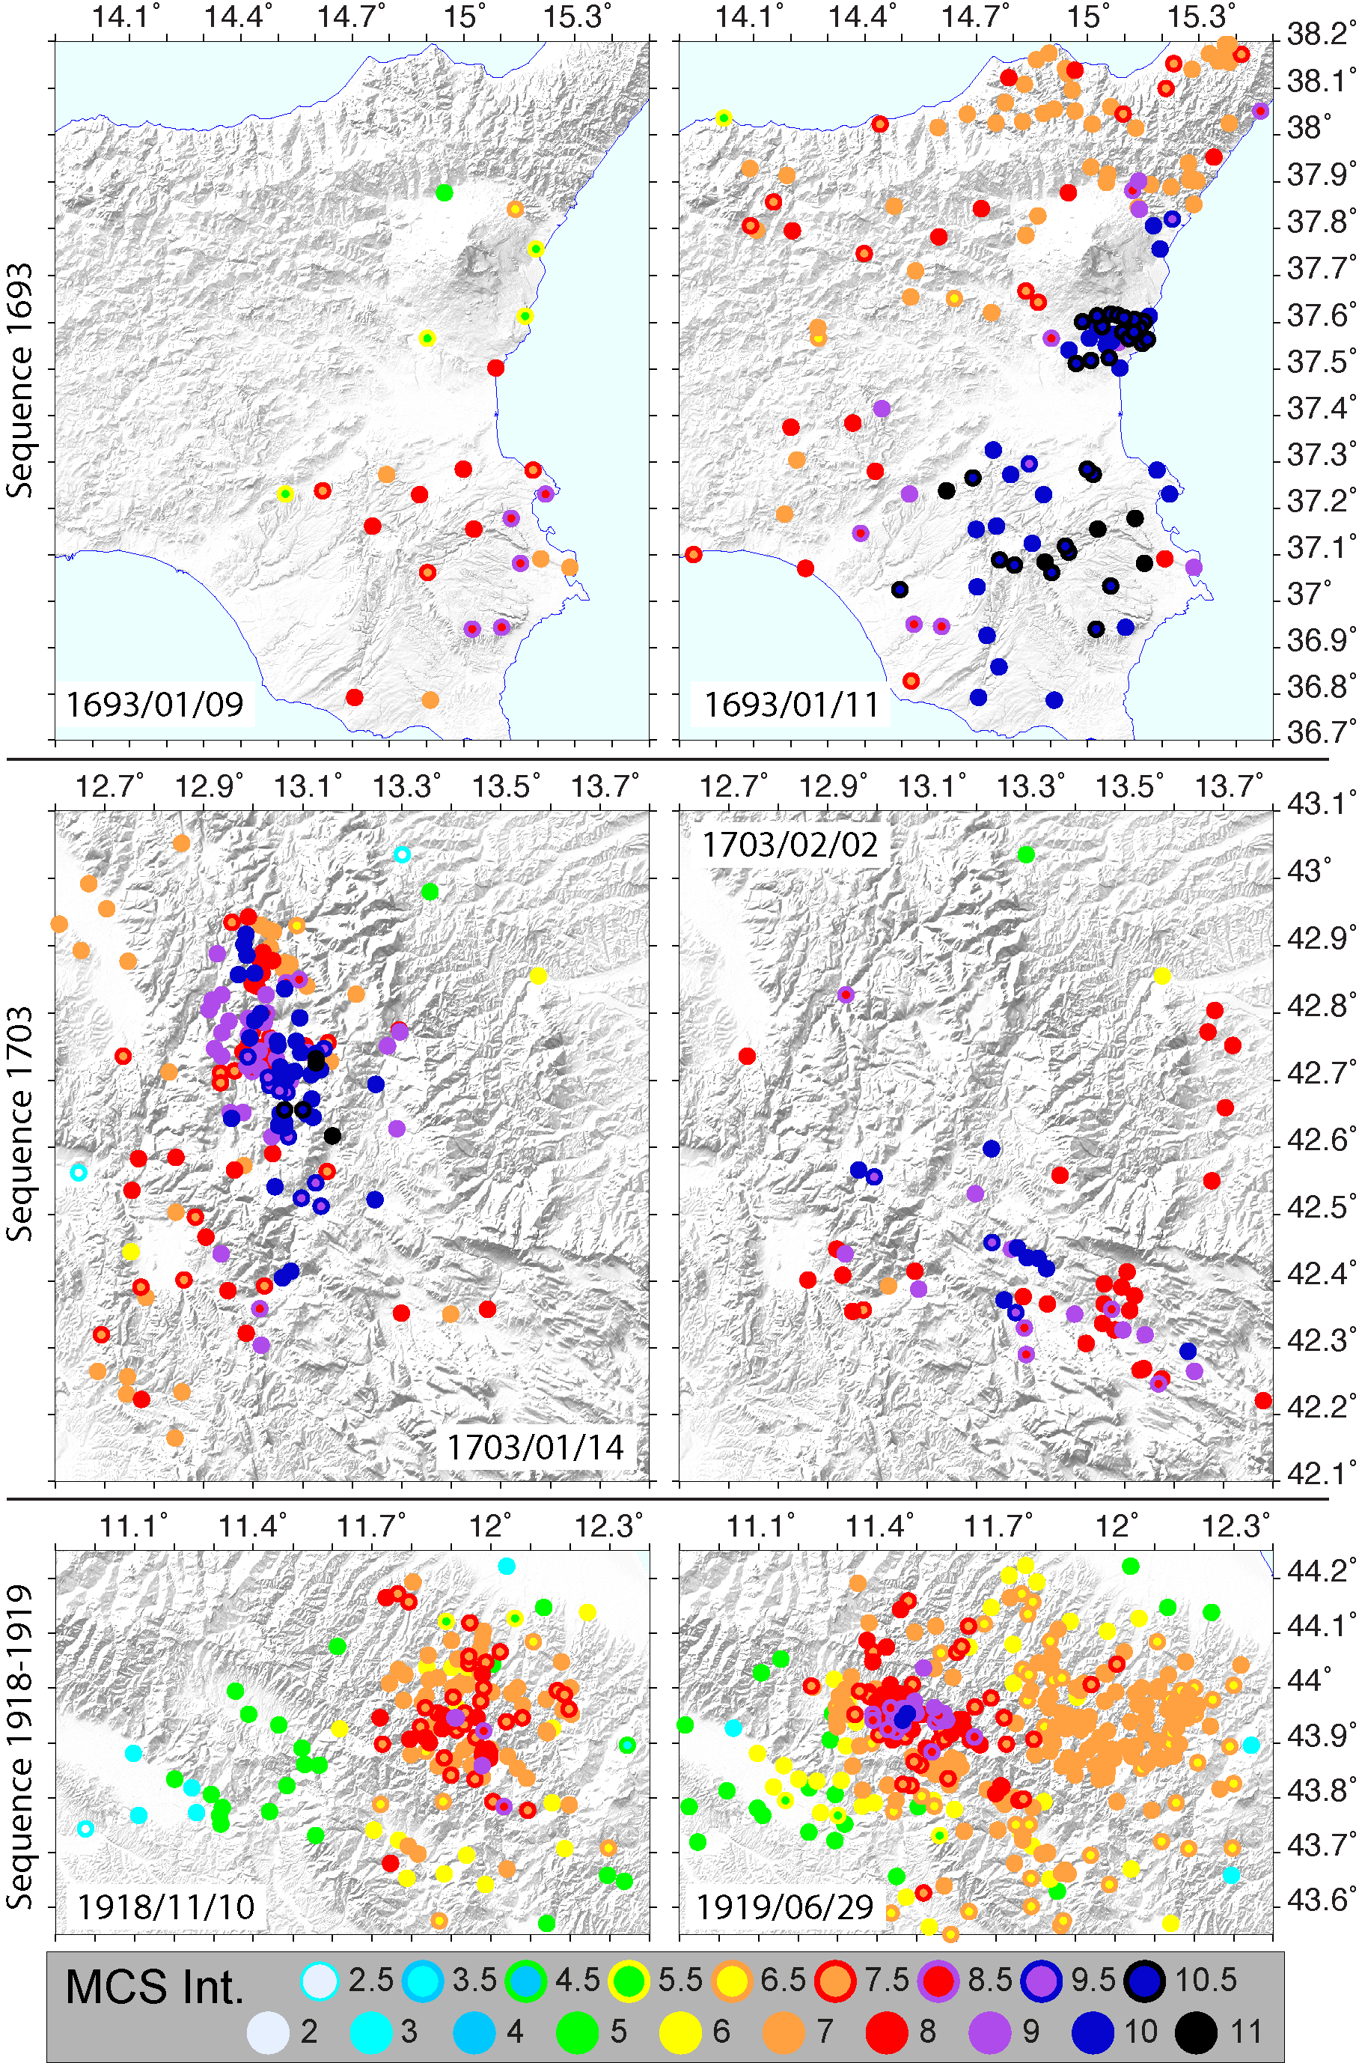
Figure S1: Examples of earthquakes during three sequences (1693, 1703 and 1918-1919) to show the overlapping of MDPs. For each sequence right and left panels represent the same geographic area.

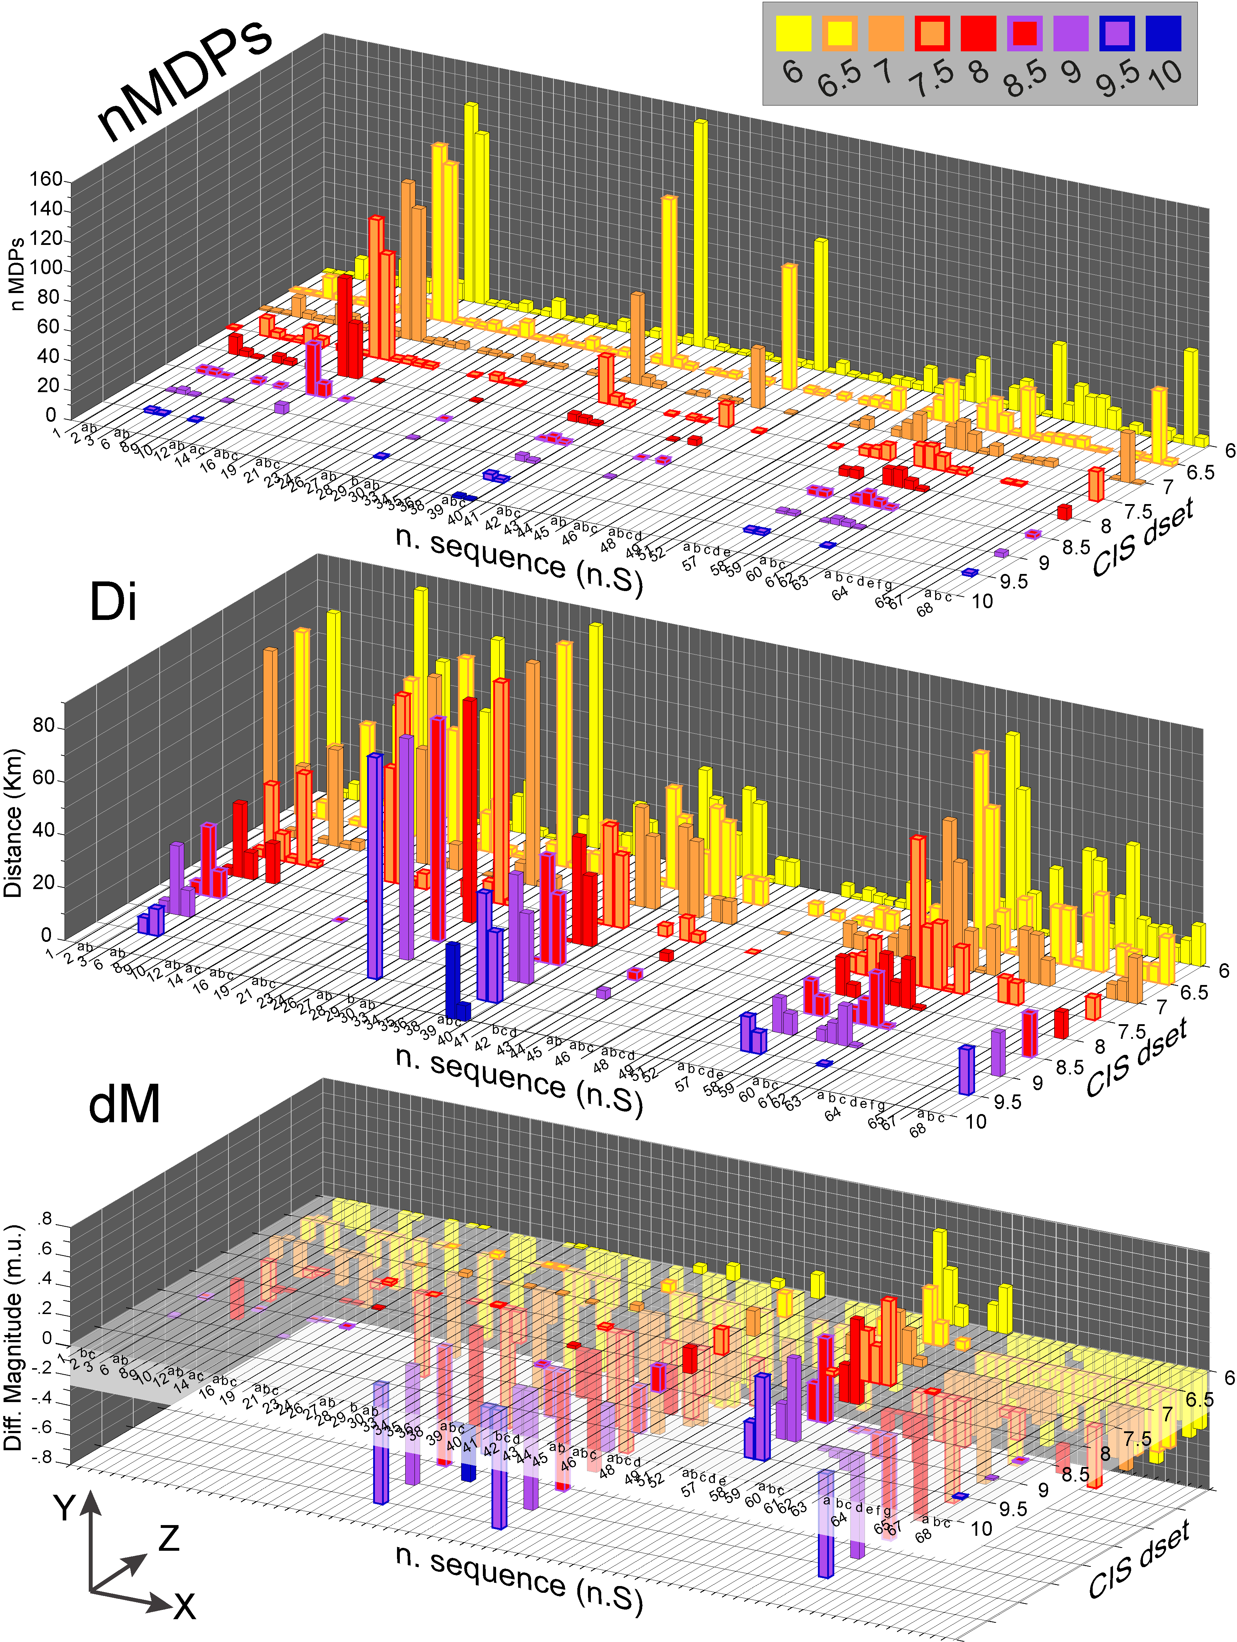

Figure S2: macroseismic parameters (Y-axis) for number of MDPs (nMDPs), distance (Di, in Km) and difference of magnitude (dM, in m.u.) of sequences (X-axis) in function of the intensity datasets (Z-axis). Sequences and earthquakes are indicated with an identification acronym (n.S, see earthquakes list below). Parameters are computed with respect to benchmarks in CPTI15. Intensity subdatasets (CIS dset) following the CIS procedure for different intensity thresholds. Corresponding numerical values in Tables S3-S4.
Earthquake list
n.S | Date | Time | n.S | Date | Time | n.S | Date | Time
1 | 1349/09/09 | 00:00 | 29a | 1857/12/26 | 05:00 | 49 | 1938/07/18 | 00:57
2a | 1504/12/31 | 04:00 | 29b | 1858/03/07 | 14:00 | 51 | 1951/01/16 | 01:11
2b | 1505/01/03 | 02:00 | 30a | 1874/12/06 | 15:50 | 52 | 1951/08/08 | 19:56
3 | 1561/08/19 | 15:50 | 30b | 1877/08/24 | 02:45 | 57a | 1968/01/14 | 15:48
6a | 1627/08/07 | 16:40 | 33 | 1881/08/05 | 00:30 | 57b | 1968/01/15 | 01:33
6b | 1627/09/06 | 15:50 | 34 | 1882/02/12 | 00:00 | 57c | 1968/01/15 | 02:01
7 | 1640/06/22 | 00:00 | 35 | 1887/12/03 | 03:45 | 57d | 1968/01/16 | 16:42
8 | 1694/09/08 | 11:40 | 36 | 1893/08/10 | 20:52 | 57e | 1968/01/25 | 09:56
9 | 1693/01/11 | 13:30 | 38 | 1898/09/12 | 14:14 | 58 | 1974/01/05 | 07:33
10 | 1703/02/02 | 11:05 | 39a | 1908/12/28 | 04:20 | 59 | 1978/03/11 | 19:20
12a | 1747/09/22 | 00:00 | 39b | 1909/01/23 | 18:28 | 60a | 1976/09/11 | 16:35
12b | 1751/07/27 | 01:00 | 39c | 1909/07/01 | 06:24 | 60b | 1976/09/15 | 09:21
14a | 1780/02/06 | 04:00 | 40 | 1911/09/13 | 22:29 | 60c | 1977/09/16 | 23:48
14c | 1781/07/17 | 09:40 | 41 | 1911/03/20 | 15:47 | 61 | 1982/08/15 | 15:09
16a | 1783/02/07 | 13:10 | 42b | 1915/09/23 | 18:07 | 62 | 1984/05/11 | 10:41
16b | 1783/03/28 | 18:55 | 42c | 1916/04/22 | 04:33 | 63 | 1991/05/26 | 12:25
16c | 1784/10/14 | 00:00 | 42d | 1916/11/16 | 06:35 | 64a | 1997/09/26 | 09:40
19 | 1794/06/30 | 04:45 | 43 | 1916/08/16 | 07:06 | 64b | 1997/10/03 | 08:55
21a | 1808/04/02 | 20:15 | 44 | 1919/10/25 | 13:51 | 64c | 1997/10/06 | 23:24
21b | 1808/04/16 | 01:15 | 45a | 1918/11/10 | 15:12 | 64d | 1997/10/14 | 15:23
21c | 1808/04/18 | 03:00 | 45b | 1919/06/29 | 15:06 | 64e | 1998/03/21 | 16:45
23 | 1819/02/24 | 23:20 | 46a | 1924/12/12 | 03:29 | 64f | 1998/03/26 | 16:26
24 | 1832/03/13 | 03:30 | 46b | 1928/03/27 | 08:32 | 64g | 1998/04/03 | 07:26
26 | 1834/07/04 | 00:45 | 46c | 1931/12/25 | 11:41 | 65 | 2002/11/01 | 15:09
27a | 1838/02/14 | 07:30 | 48a | 1929/04/20 | 01:10 | 67 | 2012/05/29 | 07:00
27b | 1838/08/05 | 17:15 | 48b | 1929/04/22 | 08:26 | 68a | 2016/10/26 | 19:18
28 | 1851/08/14 | 14:40 | 48c | 1929/04/29 | 18:36 | 68b | 2016/10/30 | 06:40
 |  |  | 48d | 1929/05/11 | 19:23 | 68c | 2017/01/18 | 10:14

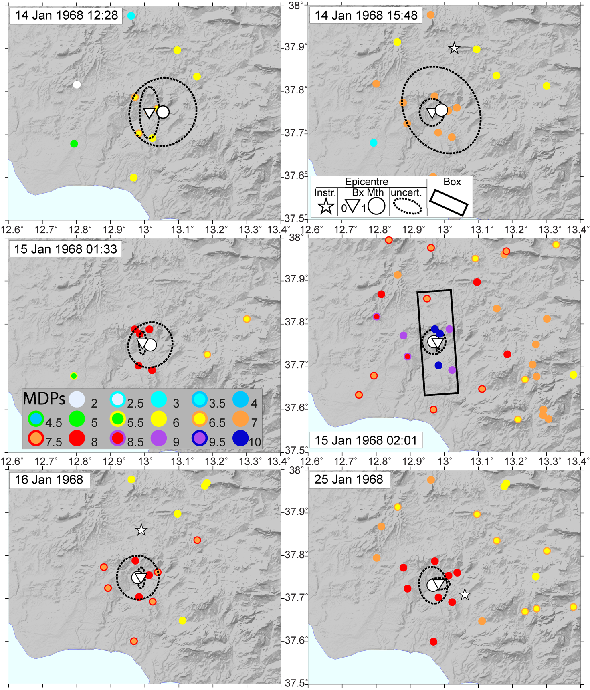
Figure S3: MDP distribution of the 1968 sequence (Valle del Belice, Sicily) earthquake, sequence number: 57 in Tables S2-S6). Data from DBMI15 (Locati et al., 2022) and CPTI15 (Rovida et al., 2020). Reference for MDPs of each earthquake in Table S2. Macroseismic parameters (location with ellipse uncertainties by formal Hessian approach at 90% of confidence, and seismogenic box for M>5.6) by BOXER code (Gasperini et al., 2010) methods 0 (triangle) and 1 (circle). Instrumental epicentre (star) is indicated.

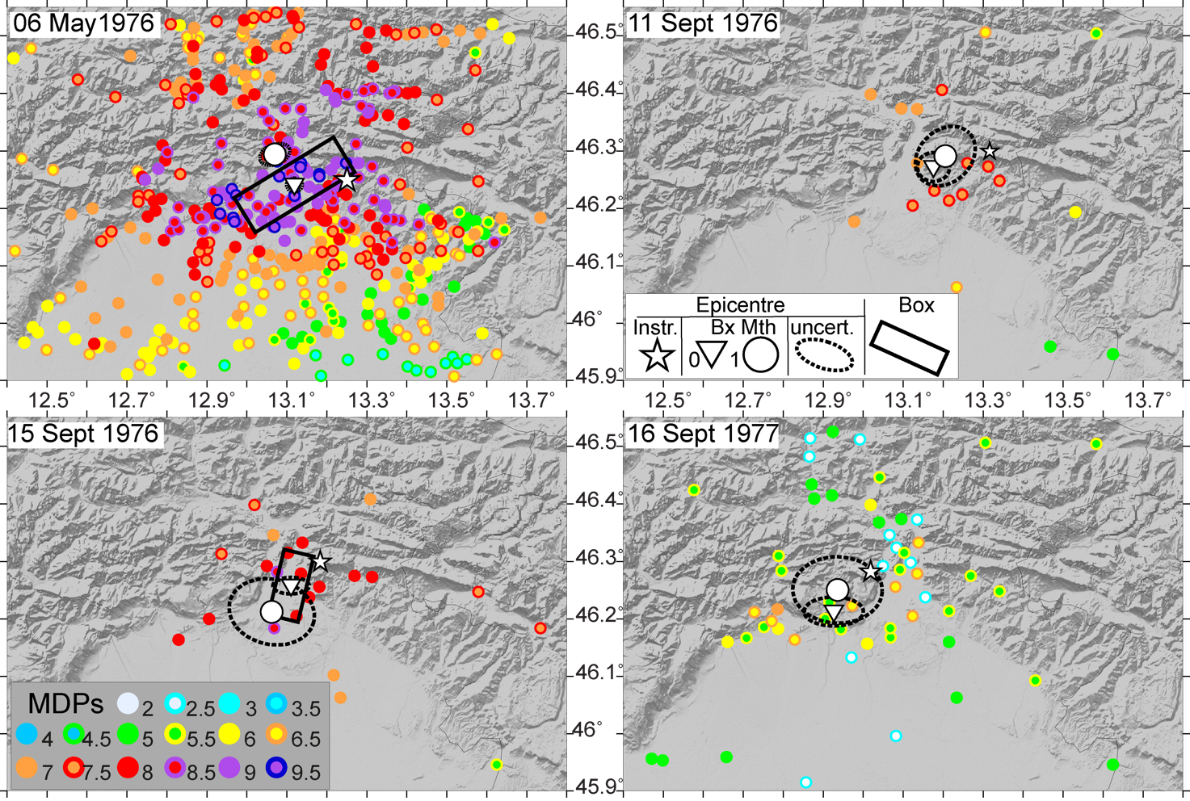
Figure S4: as in Figure S3 for the 1976 (Friuli) sequence.

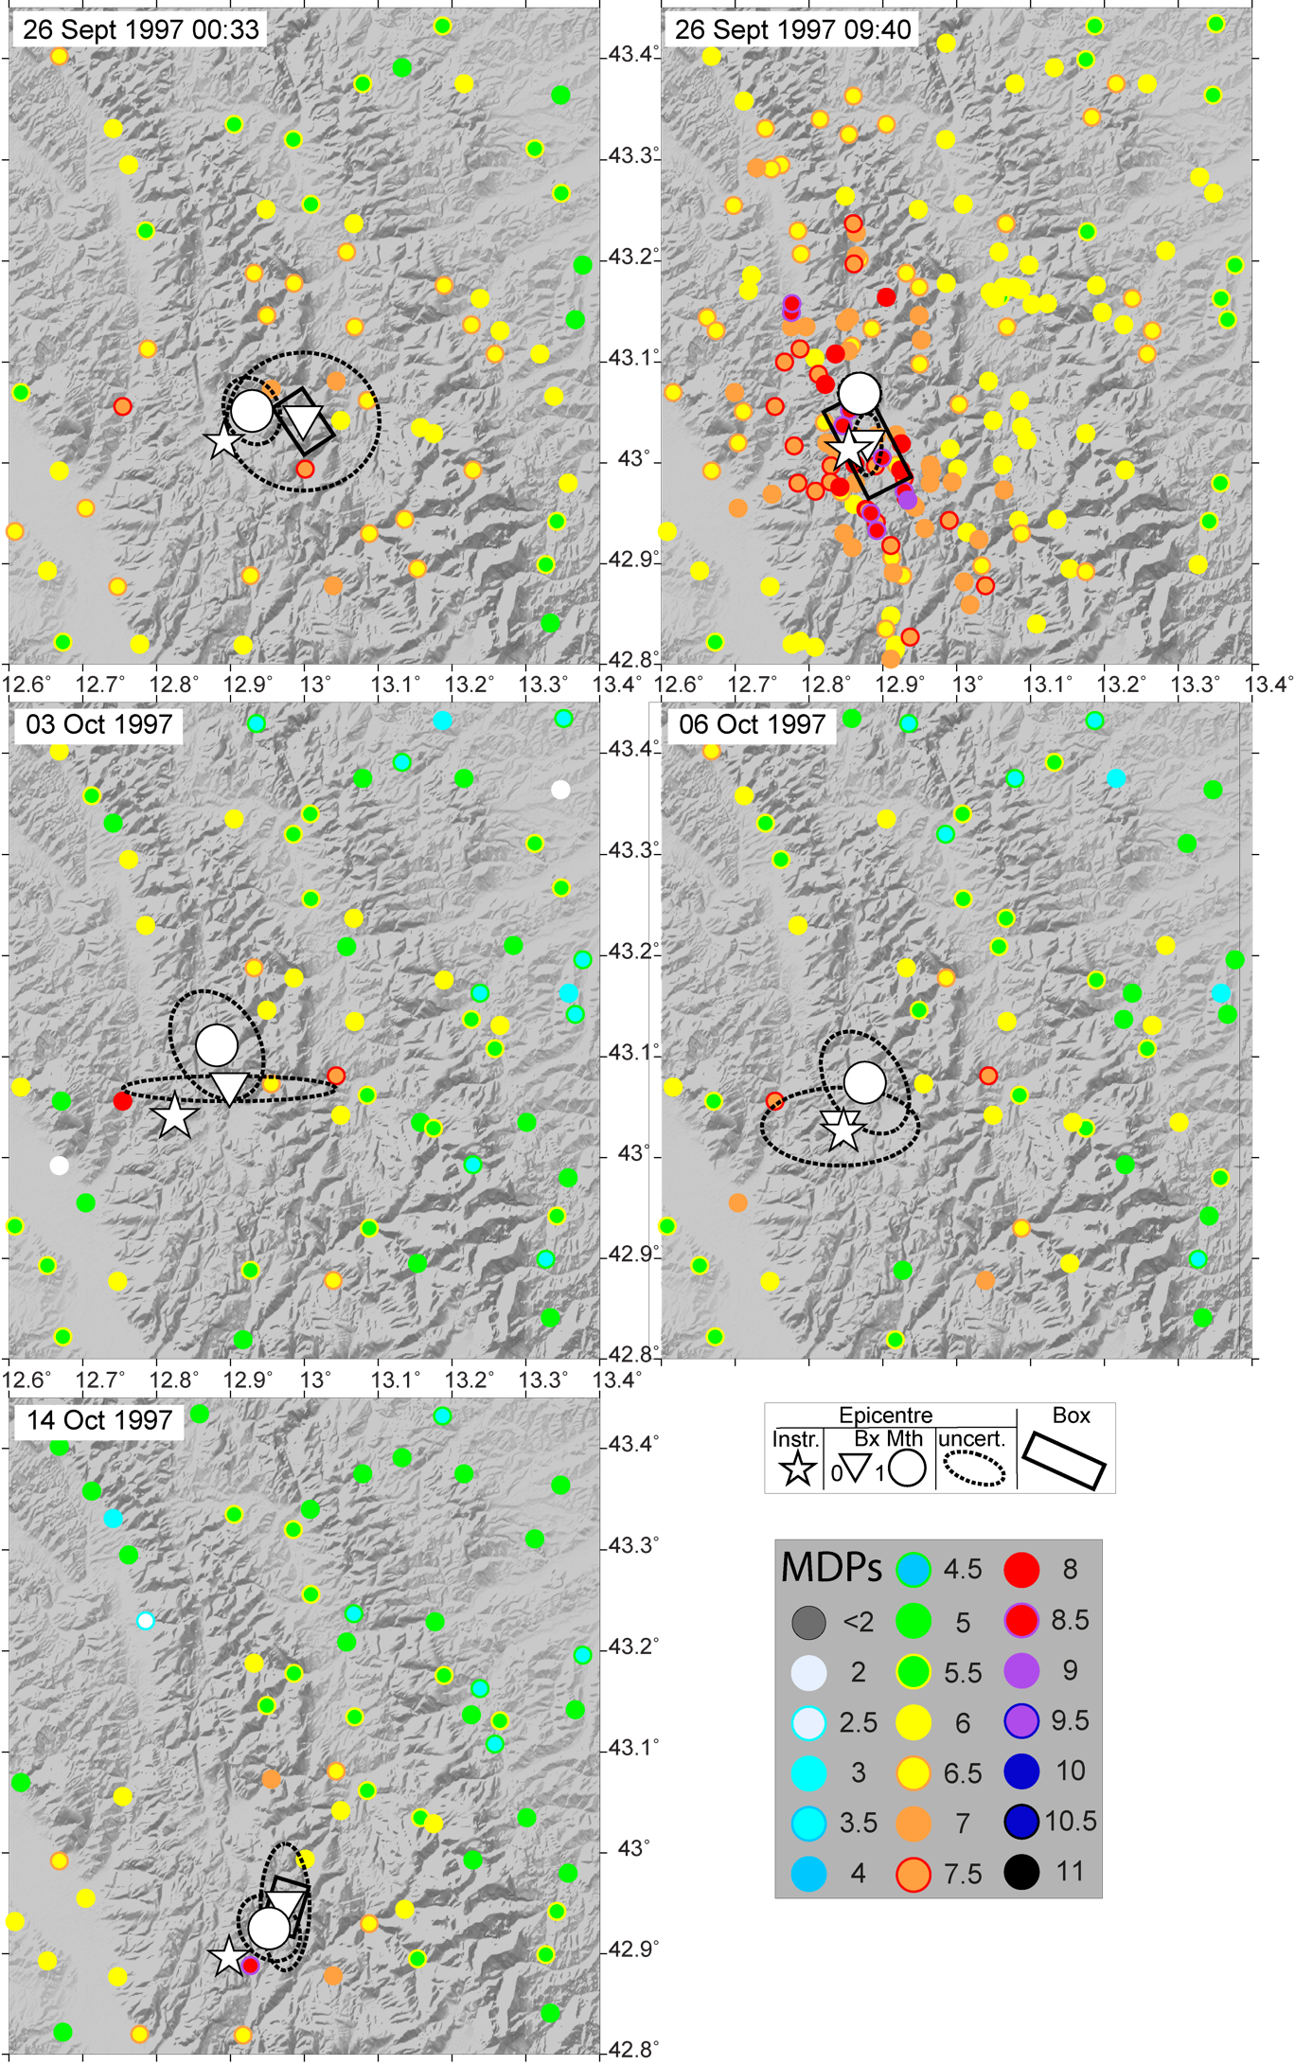
Figure S5: as in Figure S3 for the 1997 (Central Italy) sequence.

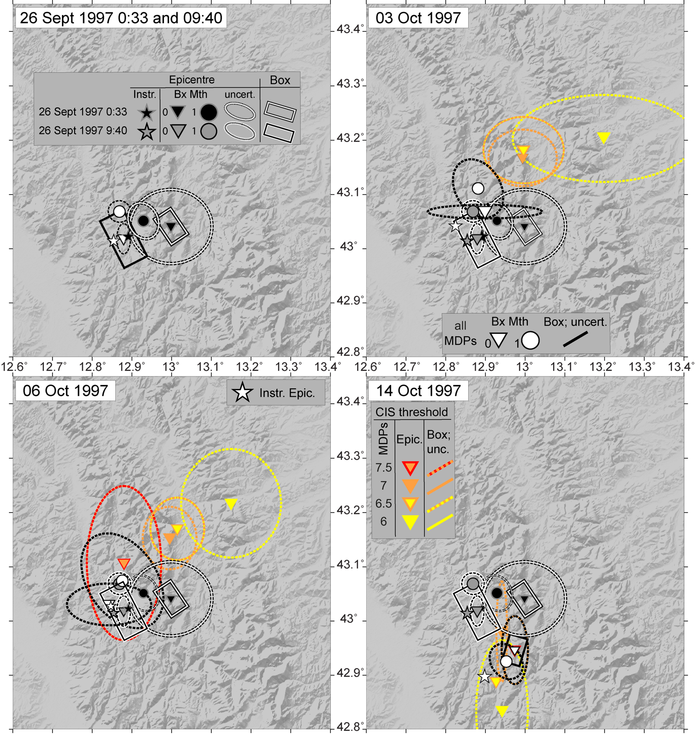
Figure S6: main earthquakes of the sequence 1997-1998 (n.64) by applying systematically the CIS method to different thresholds of intensity. Epicentres of BOXER method 0 and 1 with their ellipse uncertainties, using the formal Hessian approach at the 90 % confidence level (Gasperini et al., 2010) are plotted. The macroseismic box (for earthquakes with macroseismic magnitude >5.6) is shown.

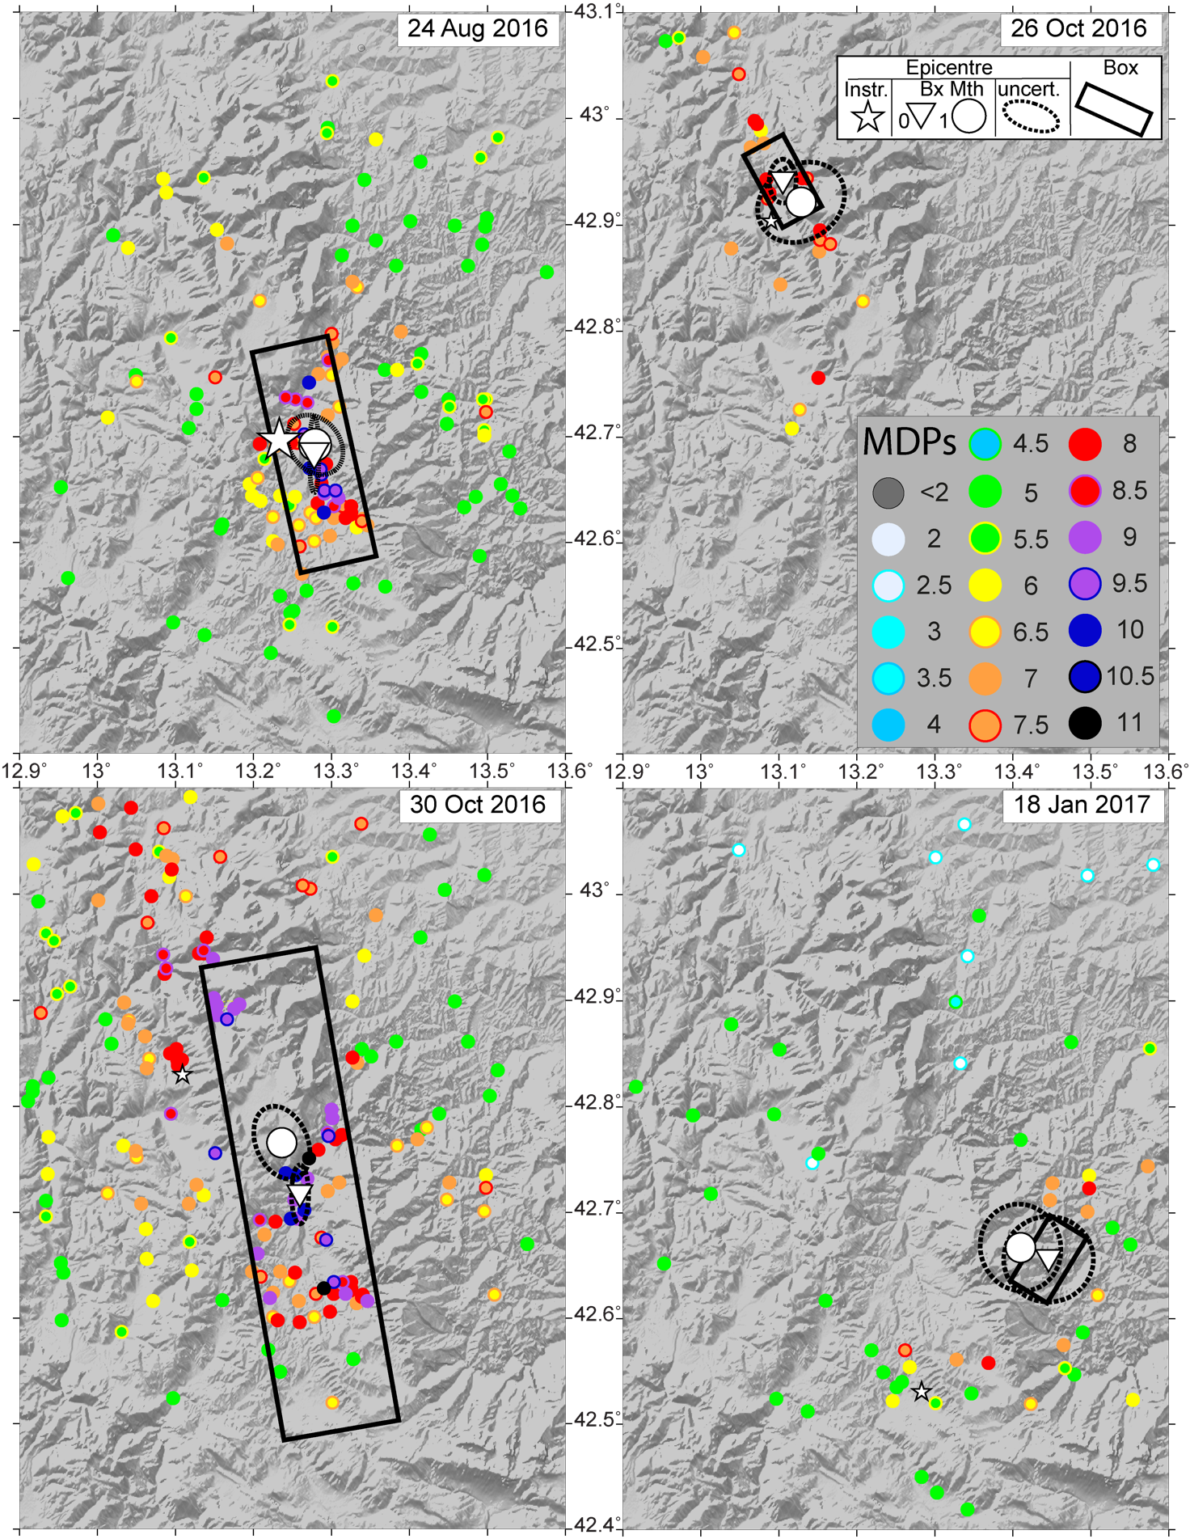

Figure S7: as in Figure S3 for the 2016-2017 (Central Italy) sequence.

References

Albini P., Rovida A., 2010. The 12 May 1802 earthquake (N Italy) in its historical and seismological context. J. Seismol., 14, 629-651. https://doi.org/10.1007/s10950-010-9187-6 (ALBRV010)

Archivio Macrosismico GNDT, 1995. Studi preliminari di terremoti attraverso i repertori sismologici. Archivio macrosismico del GNDT, Milano. (AMGNDT995)

Barbano M.S., Cosentino M., Lombardo G., Patané G., 1980. Isoseismal maps of Calabria and Sicily earthquakes (Southern Italy). CNR-PFG, pubbl. 341, Catania, 116 pp. (BARAL980)

Barbano M.S., Riggio A.M., Catalan T., Sclippa P., Toffoli D., 1990. Revisione di alcuni terremoti dell'Italia nord-orientale nella prima metà del XX secolo. GNDT, Rapporto interno, Udine, 349 pp. (BARAL990)

Boschi E., Guidoboni E., Ferrari G., Mariotti D., Valensise G., Gasperini P. (eds), 2000. Catalogue of Strong Italian Earthquakes from 461 B.C. to 1997. Annali di Geofisica, 43, 4, 609-868. (CFTI3)

Bosi V., et al., 2002. Rilievo degli effetti prodotti dalla sequenza sismica molisana dell'ottobre-novembre 2002. Rapporto tecnico QUEST, Istituto Nazionale di Geofisica e Vulcanologia (INGV), Roma, 13 pp. https://doi.org/10.13127/QUEST/20021031 (BSIAL002)

BRGM-EDF-IRSN/SisFrance, 2014. Histoire et caractéristiques des séismes ressentis en France. http://www.sisfrance.net/ (SISFR014)

Camassi R., Castelli V., Molin D., Bernardini F., Caracciolo C. H., Ercolani E., Postpischl L., 2011. Materiali per un catalogo dei terremoti italiani: eventi sconosciuti, rivalutati o riscoperti. Quaderni di Geofisica, 96, Istituto Nazionale di Geofisica e Vulcanologia (INGV), Roma, 53 pp. (CAMAL011b)

Camassi R., Molin D. (eds.), 1994. I terremoti bolognesi del 1929. Comune di Bologna, Assessorato all'Ambiente e Territorio, Bologna, 175 pp. (CAMMO994)

Castelli V., 2002. Il terremoto del 1789 a Città di Castello: ricostruzione dell'impatto e della distribuzione dei danni a partire da documenti inediti. Ingegneria Sismica, 1, 78-85. (CAST002)

Castelli V., 2003b. Revisione delle conoscenze sui terremoti del 1558 (Valdambra), 1561 (Campania-Basilicata), 1639 (Amatriciano) e 1747 (Nocera Umbra-Gualdo Tadino). Rapporto tecnico, Istituto Nazionale di Geofisica e Vulcanologia (INGV), Milano, 16 pp. (CAST003b)

Castelli V., Camassi R., Cattaneo M., Cece F., Menichetti M., Sannipoli E. A., Monachesi G., 2016. Materiali per una storia sismica del territorio di Gubbio: terremoti noti e ignoti, riscoperti e rivalutati. Quaderni di Geofisica, 133, 200 pp. https://doi.org/10.13127/qdg/133 (CASAL016)

Castelli V., Galli P., Camassi R., Caracciolo C.H., 2008. The 1561 earthquake(s) in Southern Italy: New Insights into a Complex Seismic Sequence. Journal of Earthquake Engineering, 12, 7, 1054-1077. https://doi.org/10.1080/13632460801890356 (CASAL008)

Castelli V., Monachesi G., Moroni A., Stucchi M. (eds.), 1996. I terremoti toscani dall'anno 1000 al 1880: schede sintetiche. GNDT, Rapporto interno, Macerata-Milano, 314 pp. (CASAL996)

Chiaraluce, L., Di Stefano, R., Tinti, E., Scognamiglio, L., Michele, M., Casarotti, E., Marzorati, S., 2017. The 2016 Central Italy Seismic Sequence: A First Look at the Mainshocks, Aftershocks, and Source Models. Seism. Res. Lett., 88, 1-15, doi: 10.1785/0220160221.

Dell'Olio A., Molin D., 1980. Catalogo macrosismico del Lazio dall'anno 1000 al 1975. ENEA, Rapporto interno, Roma, 143 pp. (DEMO980)

ENEL, 1985. Studi e indagini per l'accertamento della idoneità tecnica delle aree suscettibili di insediamento di impianti nucleari per le Regioni Piemonte, Lombardia e Puglia: indagini di sismica storica. Rapporti tecnici predisposti da ISMES-SGA, Roma. (ENEL985)

ENEL, 1995. Ricerche sui terremoti dell'area di Latera (VT). Rapporto interno, IRRS-OGSM, Milano-Macerata, 274 pp. (ENEL995)

Ester M., H.P. Kriegel, J. Sander, and X. Xiaowei (1996). A Density-Based Algorithm for Discovering Clusters in Large Spatial Databases with Noise. KDD’96: Proceedings of the Second International Conference on Knowledge Discovery and Data Mining, 226-231.

Fracassi U., and G. Valensise (2007), Unveiling the sources of the catastrophic 1456 multiple earthquake: Hints to an unexplored tectonic mechanism in southern Italy. Bull. Seism. Soc. Am., 97(3), 725-748, doi: 10.1785/0120050250. (FR&VA2007)

Gasparini C., Conte S., Vannucci C. (ed), 2011. Bollettino macrosismico 2001-2005. Istituto Nazionale di Geofisica e Vulcanologia, Roma. CD-ROM. (BMINGV011)

Gasparini C., et al., 1991b. Bollettino macrosismico 1990. Istituto Nazionale di Geofisica, Roma, 210 pp. (BMING991b)

Gasparini C., et al., 2001c. Bollettino macrosismico - Terzo quadrimestre 1997. Istituto Nazionale di Geofisica, Roma, 154 pp. (BMING001c)

Gasparini C., Tertulliani A., Riguzzi F., Anzidei M., Maramai A., Murru M., De Rubeis V., Vecchi M., Del Mese S., Vannucci C., Conte S., Massucci A., Saraceni A.M., 1994. Bollettino macrosismico 1991. Istituto Nazionale di Geofisica, Roma, 285 pp. (BMING994)

Gasparini et al., 2002a. Bollettino macrosismico - Primo quadrimestre 1998. Istituto Nazionale di Geofisica, Roma, 92 pp. (BMING002a)

Gasperini, P., Vannucci, G., Tripone, D., Boschi, E., 2010. The location and sizing of historical earthquakes using the attenuation of macroseismic intensity with distance. Bull. Seismol. Soc. Am. 100, 2035-2066, doi: /10.1785/0120090330.

Gizzi F.T., 2012. Il "Terremoto Bianco" del 21 Agosto 1962. Aspetti macrosismici, geologici, risposta istituzionale. Zaccara editore, 736 pp. (GIZZI012)

Graziani L., A. Rovida and A. Tertulliani (2022). The Influence of Cumulative Intensity on Macroseismic Source Parameters: The Case of 2016–2017 and 1703 Seismic Sequences (Central Italy). Seismol. Res. Lett, 94 (2A), 759-774. doi:10.1785/0220220038

Guidoboni E., Ferrari G., Mariotti D., Comastri A., Tarabusi G., Valensise G., 2007. CFTI4Med, Catalogue of Strong Earthquakes in Italy (461 B.C.-1997) and Mediterranean Area (760 B.C.-1500). INGV-SGA. http://storing.ingv.it/cfti4med/ (CFTI4med)

Iaccarino E., Molin D., 1978. Raccolta di notizie macrosismiche dell'Italia Nord-orientale dall'anno 0 all'anno 1976. CNEN, RT/disp (78)/7, 66 pp. (IAMO978)

Locati M., Camassi R., Rovida A., Ercolani E., Bernardini F., Castelli V., Caracciolo C.H., Tertulliani A., Rossi A., Azzaro R., D’Amico S., Antonucci A. (2022). Database Macrosismico Italiano (DBMI15), versione 4.0. Istituto Nazionale di Geofisica e Vulcanologia (INGV)., doi:10.13127/DBMI/DBMI15.4

Mariotti D., 1995. An unknown destructive earthquake in 18th century Sicily. In: E. Boschi, R. Funiciello, E. Guidoboni, A. Rovelli (eds.), Earthquakes in the past: multidisciplinary approaches. Annali di Geofisica, 38, 5-6, 551-554. https://doi.org/10.4401/ag-4060 (MARI995)
Meletti C., Patacca E., Scandone P., Figliuolo B., 1988. Il terremoto del 1456 e la sua interpretazione nel quadro sismotettonico dell'Appennino meridionale. In: Figliuolo B. (ed), Il terremoto del 1456, Napoli, I, 1, 71-108. (MELAL988)

Meloni F., Molin D., 1985. I terremoti garganici del 6 dicembre 1875 e 8 dicembre 1889. Atti del 4° Convegno Annuale del GNGTS, Roma, 1, 297-312. (MELMO985)

Molin D., Bernardini F., Camassi R., Caracciolo C.H., Castelli V., Ercolani E., Postpischl L., 2008. Materiali per un catalogo dei terremoti italiani: revisione della sismicità minore del territorio nazionale. Quaderni di Geofisica, 57, Istituto Nazionale di Geofisica e Vulcanologia (INGV), Roma, 75 pp. (MOLAL008)

Molin D., Galadini F., Galli P., Mucci L., Rossi A., 1999a. Catalogo macrosismico della zona del Fucino. In: S. Castenetto e F. Galadini (eds.), 13 gennaio 1915. Il terremoto nella Marsica, Roma, Appendice A, 569-629. (MOLAL999a)

Molin D., Galadini F., Galli P., Mucci L., Rossi A., 1999b. Terremoto del Fucino del 13 gennaio 1915. Studio macrosismico. In: S. Castenetto e F. Galadini (eds.), 13 gennaio 1915. Il terremoto nella Marsica, Roma, 321-340; 631-661. (MOLAL999b)

Molin D., Mucci L., 1992. Il terremoto di Senigallia del 30 Ottobre 1930. Risposta dell'area urbana di Ancona. Atti del 9° Convegno Annuale del GNGTS, Roma, 1, 31-45. (MOLMU992)

Monachesi G., Castelli V. (eds.), 1992. Sismicità dell'area aquilano-teramana dalla "analisi attraverso i cataloghi". Rapporto tecnico per la Regione Abruzzo, Osservatorio Geofisico Sperimentale, Macerata, 245 pp. (MONCA992)

Postpischl D. (ed.), 1990. Valutazione del rischio sismico per il territorio della Repubblica di San Marino. Istituto di Topografia, Geodesia e Geofisica Mineraria, Università di Bologna, RPT/TGGM/1/90, 826 pp. (POST990)

Postpischl D. ed. (1985) - Catalogo dei terremoti italiani dall’anno 1000 al 1980. Consiglio Nazionale delle Ricerche, Progetto Finalizzato Geodinamica (CNR-PFG). Quaderni de “La Ricerca Scientifica”, n. 1145, 2b, pp. 239. Bologna.

Rossi A., et al., 2019. The 2016-2017 earthquake sequence in central Italy: macroseismic survey and damage scenario through the EMS-98 intensity assessment. Bulletin of Earthquake Engineering, 17, 2407-2431. https://doi.org/10.1007/s10518-019-00556-w (ROSAL019)

Rossi A., Tertulliani A., Vecchi M., 2005. Studio macrosismico del terremoto dell'aquilano del 24 giugno 1958. Il Quaternario, 18, 2, 101-112. (ROSAL005)

Rovida A., Locati M., Camassi R., Lolli B., Gasperini P. (2020). The Italian earthquake catalogue CPTI15. Bulletin of Earthquake Engineering, 18(7), 2953-2984, doi: 10.1007/s10518-020-00818-y

Savarese F., Tertulliani A., Galadini F., 2011. Le fonti sul terremoto del 10 settembre 1881 in provincia di Chieti: revisione critica e nuove conoscenze. Bullettino della Deputazione Abruzzese di Storia Patria, Annata CII (CXXIII dell'intera collezione), L'Aquila, pp. 155-177. (SAVAL011)

Scionti V., Galli P., Chiodo G., 2006. The Calabrian seismicity during the Viceroyalty of Naples: sources silence or silent sources? The case of the strong 1744 earthquake. Bollettino di Geofisica Teorica e Applicata 47, 1-2, 53-72. (SCIAL006)

SGA, 2002. Ricerche, revisioni e confronti. Terremoti storici. Rapporto Tecnico, Incarico INGV-MI, 01/2002, 25 gennaio 2002, RPT 248/02, Bologna, 214 pp. + CD-ROM. (SGA002)

Spadea M.C., Vecchi M., Del Mese S., 1984. Bollettino macrosismico 1982. Istituto Nazionale di Geofisica, Roma, 23 pp. (BMING984)

Spadea M.C., Vecchi M., Gardellini P., Del Mese S., 1985c. The Rieti earthquake of June 28, 1898. In: Postpischl D. (ed.), Atlas of isoseismal maps of Italian earthquakes, Quaderni della Ricerca Scientifica, 114, 2A, Roma, 110-111. (SPAAL985c)

Spadea M.C., Vecchi M., Gardellini P., Del Mese S., 1985d. The Palombara Sabina earthquake of April 24, 1901. In: Postpischl D. (ed.), Atlas of isoseismal maps of Italian earthquakes, Quaderni della Ricerca Scientifica, 114, 2A, Roma, 112-113. (SPAAL985d)

Tertulliani A., Castelli V., Rossi A., Vecchi M., 2015. Reappraising a wartime earthquake: the October 3, 1943 event in the southern Marches (Central Italy). Annals of Geophysics, 57, 6. https://doi.org/10.4401/ag-6645 (TERAL015)

Tertulliani A., et al., , 2012. The Emilia 2012 sequence: a macroseismic survey. Annals of Geophysics, supplement to v. 55, n. 4., 679-687. https://doi.org/10.4401/ag-6140 (TERAL012)

Tertulliani A., Galadini F., Mastino F., Rossi A., Vecchi M., 2006. Studio macrosismico del terremoto del Gran Sasso (Italia centrale) del 5 settembre 1950: implicazioni sismotettoniche. Il Quaternario, 19, 2, 195-214. (TERAL006)

Tertulliani A., Rossi A., Castelli V., Vecchi M., Gottardi F., 2008. Terremoti dispersi al confine tra Marche, Umbria e Lazio nel 1941-1943. Quaderni di Geofisica, 58, Istituto Nazionale di Geofisica e Vulcanologia (INGV), Roma, 23 pp. (TERAL008)

Vannucci G., Gasperini P., Lolli, B. and L. Gulia, 2019. Fast characterization of sources of recent Italian earthquakes from macroseismic intensities. Tectonophysics 750, 70-92, doi: 10.1016/j.tecto.2018.11.002

