Supplemental Digital Appendix 1: Figure of Participants and Actors in Different Scenarios of the RER
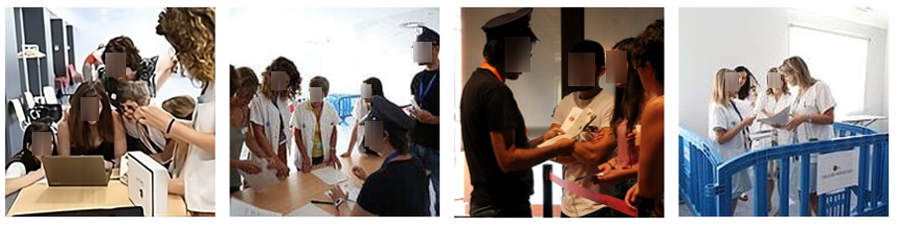
Note: The images below capture distinct moments from two sessions of the RER experience. The first image showcases one of the intricate puzzle boxes, essential for acquiring one of the necessary codes for progression. The second image depicts the Passport Office', where participants must solve a language-based puzzle by decoding codes to advance further. The third and fourth images provide a glimpse into the varied interactive encounters within the RER, featuring a scenario with a corrupt official demanding a bribe and a quarantine zone setup, respectively. These images illustrate the diversity and complexity of the challenges that participants face in the RER. All participants featured in these images have given their consent for the photographs to be taken and used for this purpose. Additionally, faces were blurred for privacy.

Supplemental Digital Appendix 2: Exploratory Factor Analysis Results with Eigenvalues and Explained Variance
 |  | Initial Eigenvalues |  | Extraction Sums of Squared Loadings |  |  | Rotation Sums of Squared Loadings
Component | Total | % of Variance | Cumulative % | Total | % of Variance | Cumulative % | Total | % of Variance |  | Cumulative %
1 | 4.12 | 27.514 | 27.514 | 4.127 | 27.514 | 27.514 | 3.248 | 21 |  | 21
2 | 3.05 | 20.354 | 47.868 | 3.053 | 20.354 | 47.868 | 3.167 | 21 |  | 42
3 | 1.55 | 10.332 | 58.200 | 1.550 | 10.332 | 58.200 | 2.068 | 13 |  | 56
4 | 1.13 | 7.567 | 65.766 | 1.135 | 7.567 | 65.766 | 1.339 | 8 |  | 65
5 | 1.08 | 7.251 | 73.017 | 1.088 | 7.251 | 73.017 | 1.131 | 7 |  | 73
6 | 842 | 5.612 | 78.629
7 | .685 | 4.563 | 83.193
Note: The table presents the results of an exploratory factor analysis, showing the initial eigenvalues, extraction sums of squared loadings, and rotation sums of squared loadings for each of the first seven components. The total variance explained by each component is also provided, as well as the cumulative percentage of variance.

Supplemental Digital Appendix 3: Reliability Analysis of Outcome Indicators in Intercultural Competence, Self-efficacy, and Knowledge Scales
Outcome Indicator | Subscale | Area of focus | Item # | Cronbach's Alpha
Intercultural Competence | Subjective Knowledge | Self-perceived knowledge-base on health disparities of VMRs | 4 | 0.79 | 0.86
Intercultural Competence | Attitudes | Attitudes towards factors contributing to health disparities of VMRs | 6 | 0.79 | 0.84
Intercultural Competence | Awareness | Awareness of racial, ethnic, or cultural stereotypes related to VMRs | 1 | 0.79 | -
Intercultural Competence | Importance | Importance of cultural competency training for health professionals | 1 | 0.79 | -
Intercultural Competence | Empathy | Empathic perspective taking & empathic awareness related to VMR | 3 | 0.79 | 0.7
Self-efficacy | - | Awareness on the personal capacity to assess factors related VMR | 4 | 0.87
Knowledge | - | Objective epidemiological/public health knowledge-base on VMRs | 5 | -
Note: The table presents the reliability analysis results for each subscale and item of the outcome indicators. Cronbach's alpha coefficient is reported for each subscale and for the overall scale, indicating the internal consistency reliability. The number of items included in each subscale is reported.

Supplemental Digital Appendix 4: Pretest to assess the impact on Intercultural Competence, Self-efficacy, and Knowledge of the Refuge Escape Room
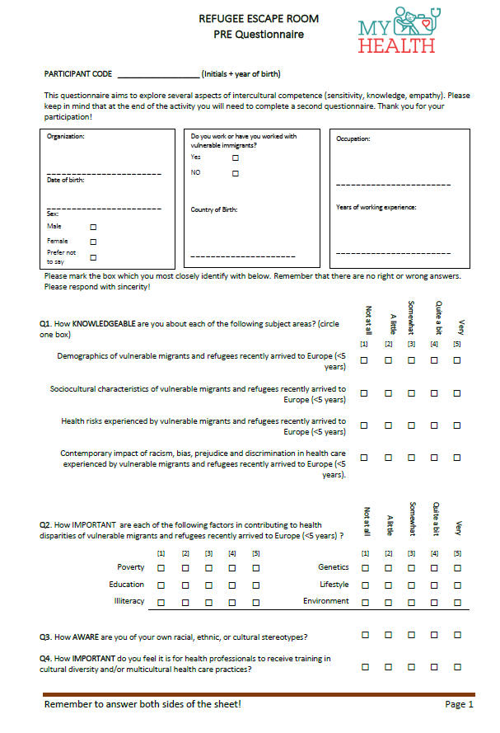
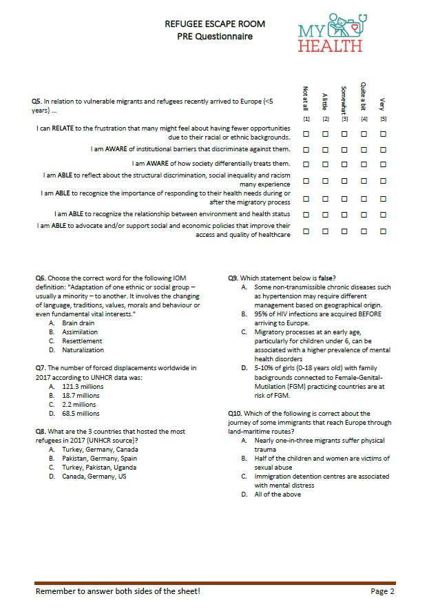

Supplemental Digital Appendix 5: Posttest to assess the impact on Intercultural Competence, Self-efficacy, and Knowledge of the Refuge Escape Room
