Supporting Information

Elucidating the Roles of Redox and Structure for Grain Growth in Mn-doped UO₂
Murphy et al.
Corresponding authors:
Gabriel L. Murphy (g.murphy@fz-juelich.de)

Supplementary Information Note 1. Synchrotron X-ray Powder Diffraction
Supplementary Figure 1 displays Rietveld refinement profiles for Mn-doped UO₂ (0, 500, 1000 and 2000 ppm Mn addition) made against synchrotron X-ray diffraction (S-XRD) data at ambient temperature obtained at BM20 ROBL ESRF. Measured samples are single phase fluorite structures in space group Fm$\overline{3}$m.
Supplementary Figure 1. Rietveld fit of the S-XRD data at ambient temperature for UO₂ with 0 (a), 500 (b), 1000 (c) and 2000 (d) ppm Mn addition. The black crosses, upper red line, lower red line and vertical black markers respectively represent observed data, calculated profile, difference profile and allowed reflections for UO₂ according to the space group Fm$\overline{3}$m. Respective wR_{p}/R values are 6.66%/5.23%, 6.53%/5.08%, 5.34%/4.35%, and 8.55%/6.19%, all for λ = 0.7749 Å.
Supplementary Information Note 2. Single Crystal X-ray Diffraction
Supplementary Table 1 provides the structural solution for the Mn-doped UO₂ single crystal (SC1) shown in Figure 1 of the manuscript and measured with SEM-EDS and HERFD-XANES, indicating the occurrence of the Mn doped-UO₂ fluorite structure in space group Fm$\overline{3}$m. No attempts were made to refine the Mn position. Supplementary Table 2 provides the structural solution for additional Mn-doped UO₂ single crystal also extracted and subject to SEM-EDS analysis but not HERFD-XANES measurements.
Supplementary Table 1. Crystallographic data for a Mn doped UO₂ single crystal grain (SC1).
Compound | Mn-doped UO₂
Formula weight (g mol⁻¹) | 270.03
Crystal system | Cubic
Space group | Fm$\overline{3}$m
a (Å) | 5.4653(2)
b (Å) | 5.4653(2)
c (Å) | 5.4653(2)
α (º) | 90
β (º) | 90
γ (º) | 90
Volume (Å³) | 163.246(18)
Z | 4
F(000) | 432.0
d_{calcd} (g cm⁻³) | 10.987
GOF | 1.455
Final R₁ ª [I > 2σ(I)] | 0.0136
Final wR₂ ^{b} [I > 2σ(I)] | 0.0295

ª R₁ = ∑||F_{o}| -|F_{c}||/∑|F_{o}|,
^{b} wR2 = {∑w[(F_{o})² - (F_{c})² ] ²/∑w [(F_{o})²] ²}^{½}
Supplementary Table 2. Crystallographic data for a Mn-doped UO₂ single crystal grain (SC2).
Compound | Mn-doped UO₂
Formula weight (g mol⁻¹) | 270.03
Crystal system | Cubic
Space group | Fm$\overline{3}$m
a (Å) | 5.4881(3)
b (Å) | 5.4881(3)
c (Å) | 5.4881(3)
α (º) | 90
β (º) | 90
γ (º) | 90
Volume (Å³) | 165.30(3)
Z / μ (mm⁻¹) | 4
F(000) | 432
d_{calcd} (g cm⁻³) | 10.851
GOF | 1.225
Final R₁ ª [I > 2σ(I)] | 0.0196
Final wR₂ ^{b} [I > 2σ(I)] | 0.0416

ª R₁ = ∑||F_{o}| -|F_{c}||/∑|F_{o}|,
^{b} wR2 = {∑w[(F_{o})² - (F_{c})² ] ²/∑w [(F_{o})²] ²}^{½}

Supplementary Information Note 3. High Energy Resolution Fluorescence Detection X-ray Absorption Near Edge Structure (HERFD-XANES) Analysis
HERFD-XANES measurements were performed on the Mn K-edge for the Mn-doped UO₂ single crystal and powder using the standards metallic Mn (Mn⁰), Mn⁺²Cl₂·4H₂O, Mn⁺³F₃, Mn⁺²O, Mn⁺³₂O₃ and Mn⁺⁴O₂. The results of these are presented in Supplementary Figure 2.
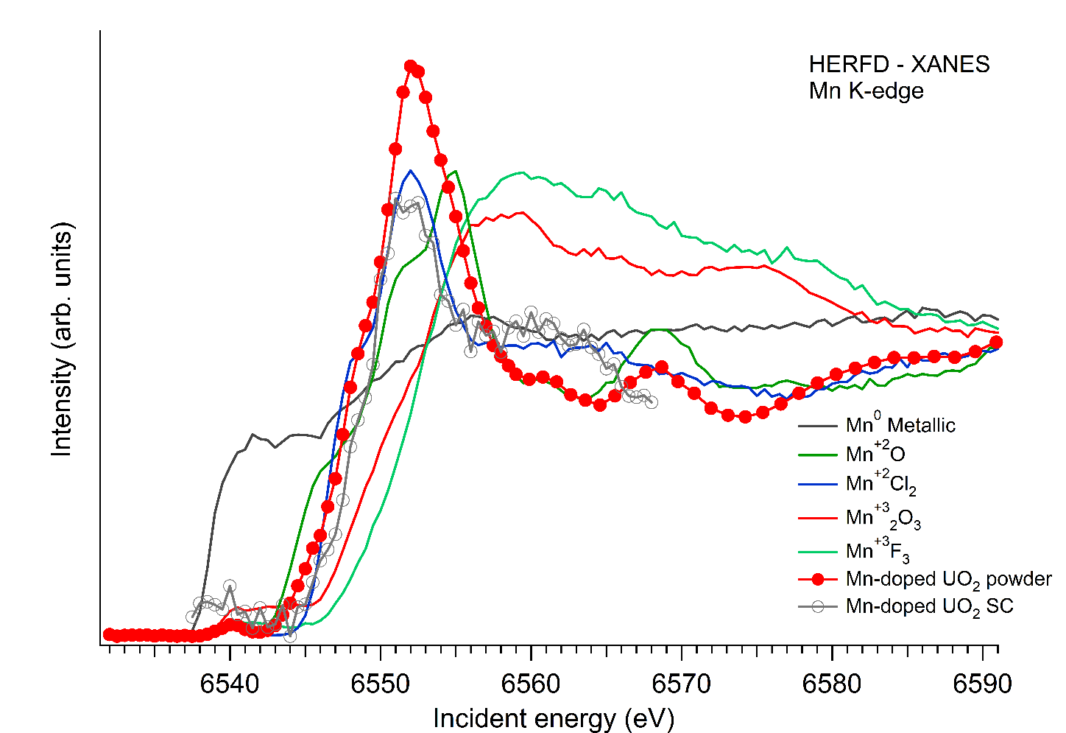
Supplementary Figure 2. Normalised Mn K-edge HERFD XANES spectra for UO₂ and Mn-doped UO₂ powder with 2000 ppm addition as Mn with Mn standards as listed in the inset. The increased noise in the single crystal grain line spectra is due to its significantly smaller size. Note a.u. denotes arbitrary units.

Supplementary Information Note 4. Extended X-ray Absorption Fine Structure (EXAFS) Analysis
Supplementary Figure 3. k³-weighted Mn K–edge EXAFS spectra (left) and corresponding Fourier transforms (FT) in the spectral range from 2.0 to 8.8 Å⁻¹ (right) of the Mn-doped UO₂ powder using two Mn-O shells (bottom) and only one Mn-O shell (top). Phase shifts (Δ) are not corrected in the FTs.
Supplementary Table 3. EXAFS structural parameters for the Mn K-edge spectrum of Mn-doped UO₂ bulk material with 2000 ppm doped Mn. The parameters are determined from analysis with (top) and without (bottom) the first Mn-O shell split.
Path | CN | R/Å | σ²/Å² | dE0/eV
First shell Mn-O interaction split in two shells
Mn-O | 3.0(8) | 2.14(2) | 0.009(8) | 8.95(9)
Mn-O | 3.0+ | 2.32(3) | 0.009/ | 8.95/
Mn-Mn | 3(1) | 3.100(7) | 0.002(4) | 8.95/
Mn-O | 4(1) | 3.73(6) | 0.008f | 8.95/
Mn-Mn | 5.7(8) | 4.10(1) | 0.008f | 8.95/
Mn-O | 5(3) | 4.97(7) | 0.008f | 8.95/
Mn-Mn | 15(2) | 5.45(1) | 0.008f | 8.95/
Mn-U | 13(4) | 5.70(2) | 0.008f | 8.95/
Mn-U | 12(4) | 6.00(3) | 0.008f | 8.95/
Mn-Mn | 21(4) | 7.05(2) | 0.008f | 8.95/
Mn-U | 18(4) | 7.34(2) | 0.008f | 8.95/
First shell Mn-O interaction not split in two shells
Mn-O | 6.9(8) | 2.215(9) | 0.023(3) | 8.95(9)
Mn-Mn | 2.7(1) | 3.100(7) | 0.002(4) | 8.95/
Mn-O | 4(1) | 3.73(6) | 0.008f | 8.95/
Mn-Mn | 5.6(8) | 4.10(1) | 0.008f | 8.95/
Mn-O | 5(3) | 4.98(7) | 0.008f | 8.95/
Mn-Mn | 15(2) | 5.45(1) | 0.008f | 8.95/
Mn-U | 13(3) | 5.70(2) | 0.008f | 8.95/
Mn-U | 12(4) | 6.00(3) | 0.008f | 8.95/
Mn-Mn | 21(4) | 7.05(2) | 0.008f | 8.95/
Mn-U | 18(4) | 7.35(2) | 0.008f | 8.95/
CN - coordination number, R - radial distance, σ² – squared Debye-Waller factor, dE0 - shift in energy threshold, f - fixed parameter, / - linked parameter, + - constant sum. Estimated standard deviations of the variable parameter as calculated by EXAFSPAK [1].

Supplementary Information Note 5. References
[1] G.N. George, I.J. Pickering, EXAFSPAK: A Suite Of Computer Programs For Analysis Of X-Ray Absorption Spectra, Stanford Synchrotron Radiation Laboratory, Stanford, CA, USA, 1995.

