Chart 1: Graph indicating percent on “Purpose of visits”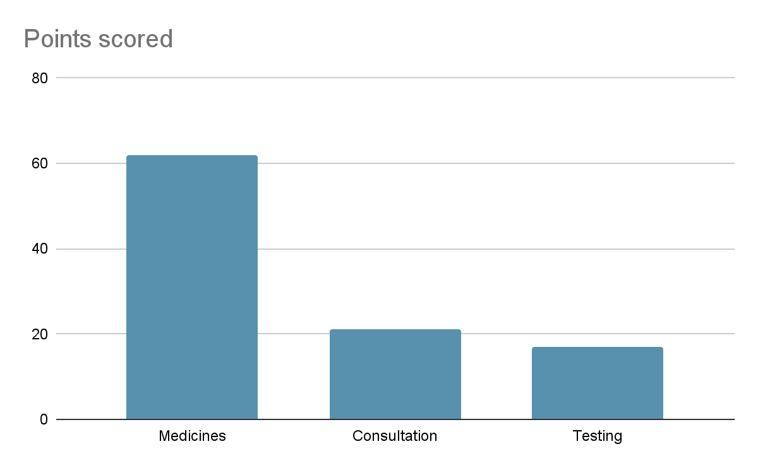
Chart 2: Graph indicating percent on “distance of Mohalla Clinic from their place of residence”
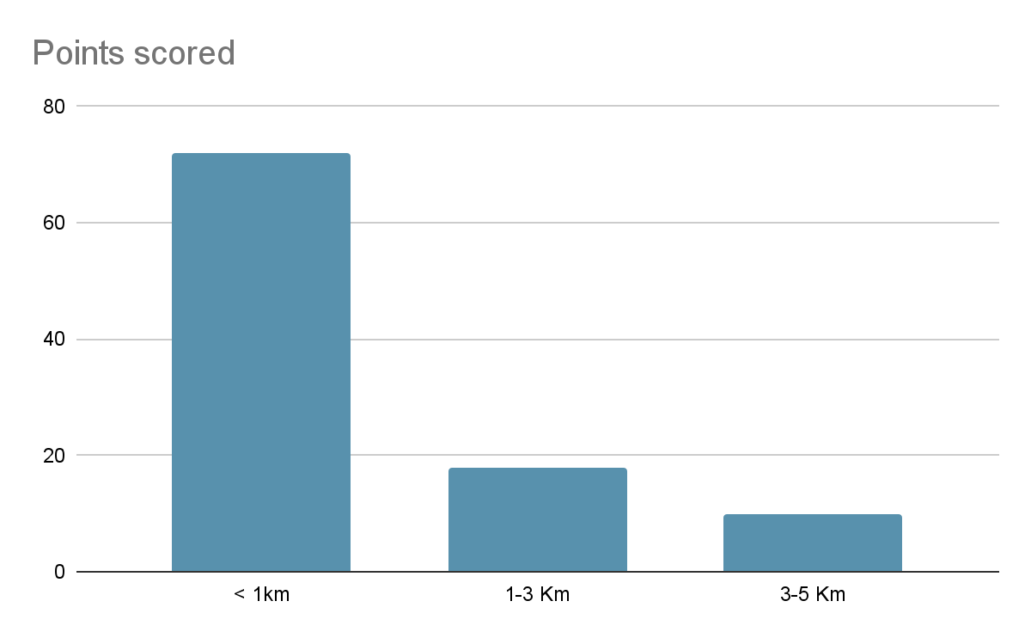
Chart 3: Graph on Travel expenditure incurred on Patient Visiting AAMC
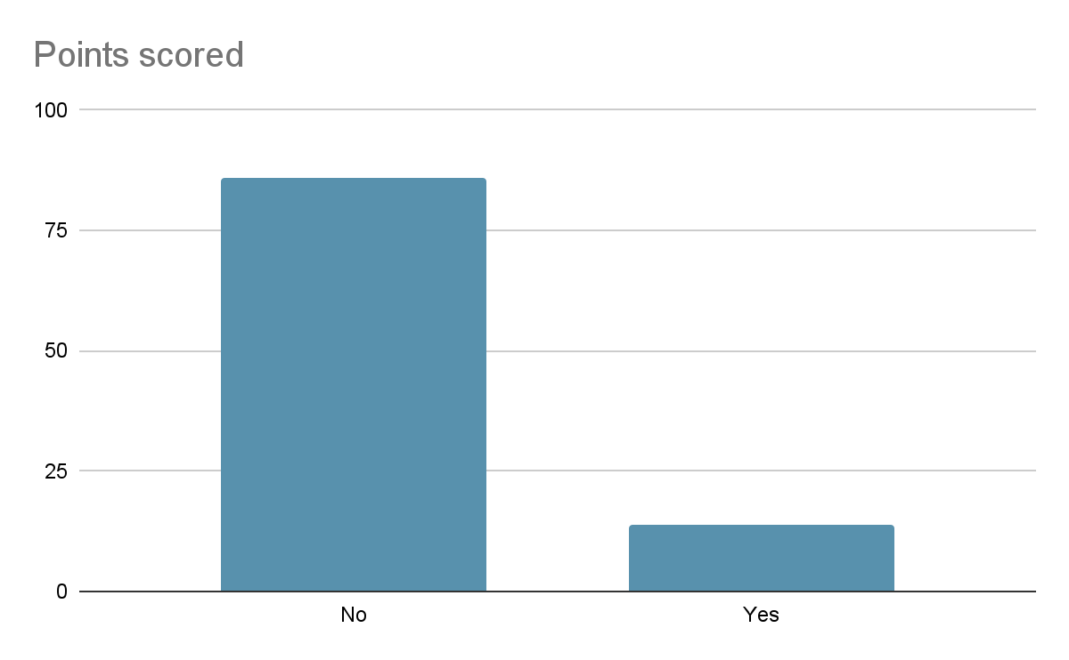

Chart 4: Graph on gender of patient visiting AAMC
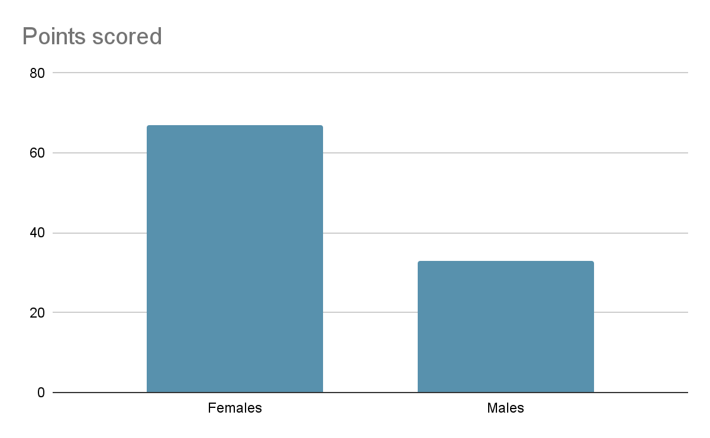
Chart 5: Graph on Satisfaction level of the Patient
