Natural Hazard
Supplementary Information (SI)
for
Record-breaking rainfall in Sri Lanka in 2014 enhanced by the MJO
Pathmarasa Kajakokulan^{1*},
Kieran M R Hunt^{2,3}
¹Department of Oceanography and Marine Geology, Faculty of Fisheries and Marine Sciences & Technology, University of Ruhuna, Matara, Sri Lanka.
²Department of Meteorology, University of Reading, Reading, United Kingdom.
³National Centre for Atmospheric Science, University of Reading, Reading, United Kingdom

*Corresponding author
Email: kajakokulan45@gmail.com
Department of Oceanography and Marine Geology, Faculty of Fisheries and Marine Sciences & Technology, University of Ruhuna, Matara, Sri Lanka.

ORCID
Pathmarasa Kajakokulan - 0009-0007-7361-9620
Kieran Hunt - 0000-0003-1480-3755
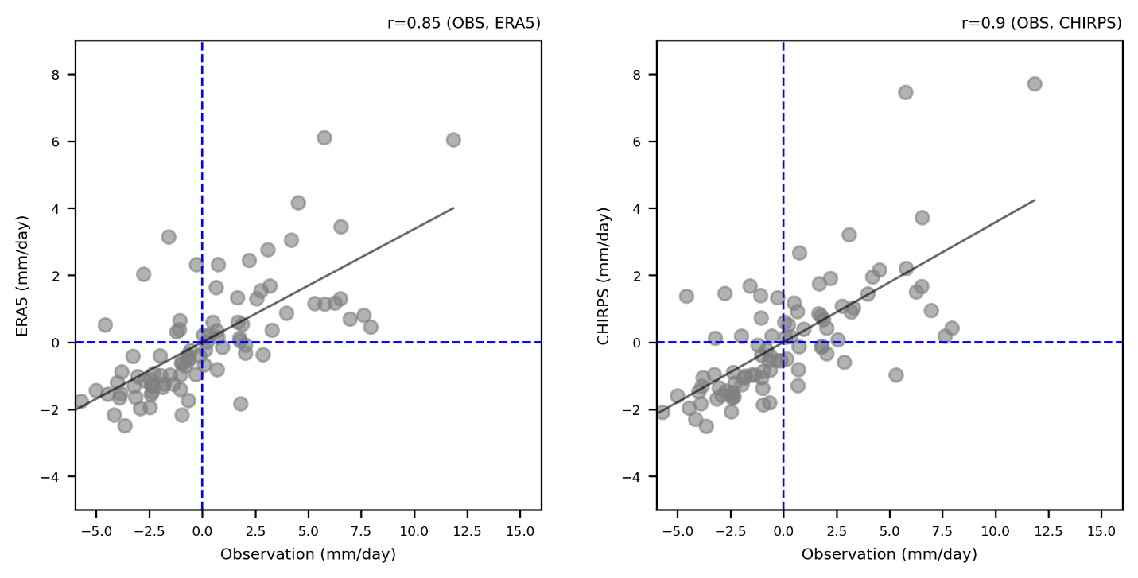
Fig. S1 The correlation between the observations of the rainfall data and a) the ERA5 rainfall data and b) the CHIRPS rainfall data.

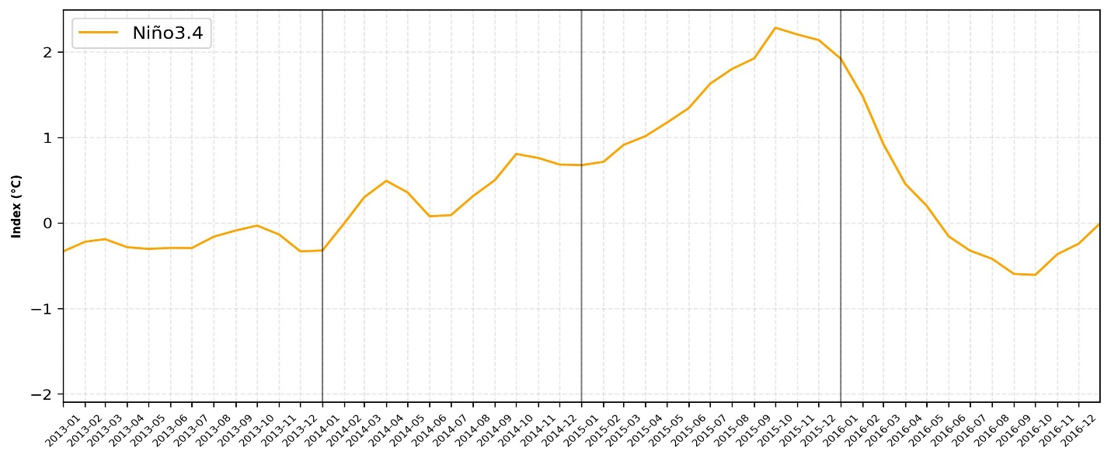
Fig. S2 Time-series of Niño3.4 index from January 2013 to December 2016 (Source: ERSSTV5). The thick vertical line indicates that Niño 3.4 peaking year.
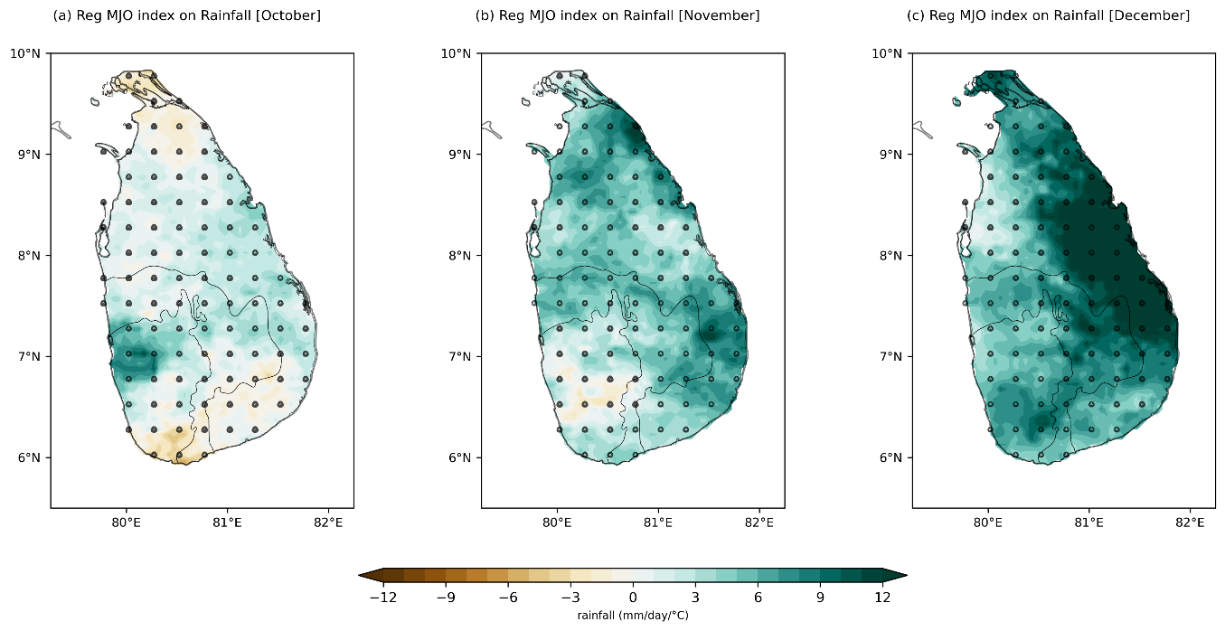
Fig. S3 Regression rainfall anomalies over the SL onto MJO index during 2014 d) October, e) November, f) December. The black dots indicate statistically significant regions with a 95% confidence level from CHIRPS rainfall data.

