Supporting Information

Ultra-sensitive Fluorescence-Activated Droplet Single-cell Sorting based on Tetramer-HCR-EvaGreen Amplification

Long Chen ^{a,b,d,1}, Yi Xu ^{a,b,1}, Lele Zhou ^{c}, Ding Ma ^{a,d}, Rong Zhang ^{c} Yifan Liu ^{c,f,g,}*, Xianqiang Mi ^{a,b,d,e,}*

ª National Key Laboratory of Materials for Integrated Circuits, Shanghai Institute of Microsystem and Information Technology, Chinese Academy of Sciences, Shanghai 200050, China
^{b} Shanghai Advanced Research Institute, Chinese Academy of Sciences, Shanghai 201210, China
^{c} School of Physical Science and Technology, ShanghaiTech University, Shanghai 201210, China
^{d} University of Chinese Academy of Sciences, Beijing 100049, China
^{e} School of Physics and Optoelectronic Engineering Hangzhou Institute for Advanced Study, University of Chinese Academy of Sciences, Chinese Academy of Sciences, Hangzhou, 310024, China
^{f} Shanghai Clinical Research and Trial Center, Shanghai 201210, China
^{g} State Key Laboratory of Advanced Medical Materials and Devices, ShanghaiTech University, Shanghai 201210, China

*Corresponding author
Email address: mixq@mail.sim.ac.cn

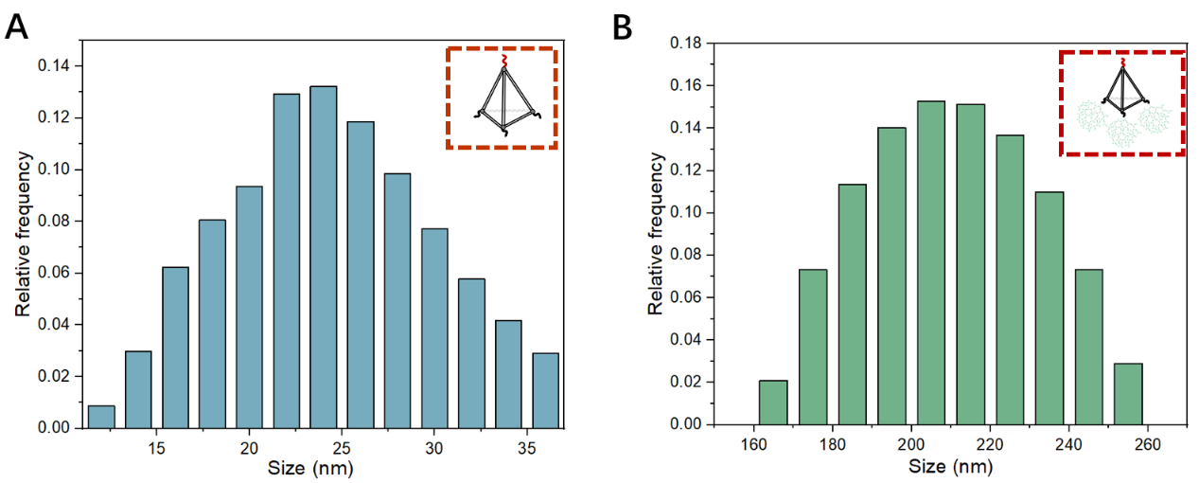
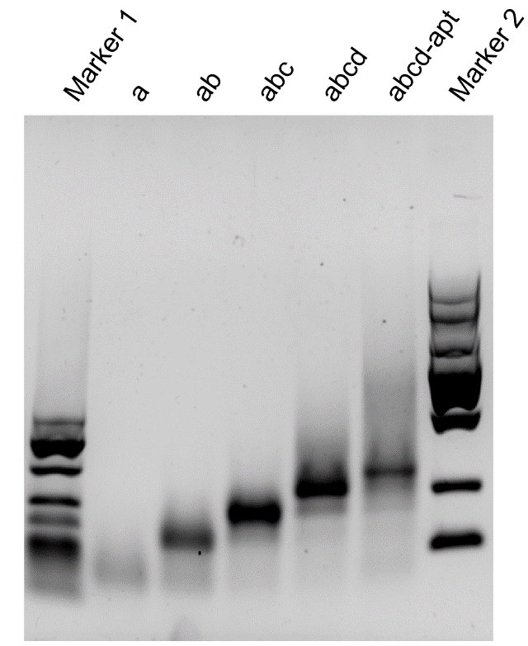
Supporting Figures and Tables
Figure S2. Hydrodynamic particle size distribution of (A) Apt-TDNs and (B) Apt-TDNs-dendrimers.

Figure S1. PAGE characterization of the Apt-TDNs. Lane 1, 25-500 bp marker; Lane 2-6, single strand (a), double-strand combination (ab), triple-strand combination (abc), four-strand combination (abcd) and Apt-TDNs (abcd-apt); Lane 7, 100-2000 bp marker.

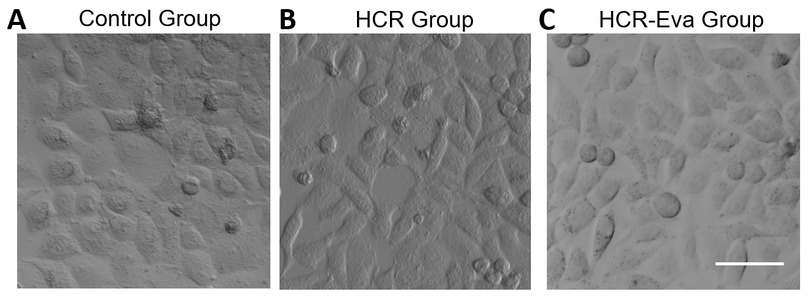
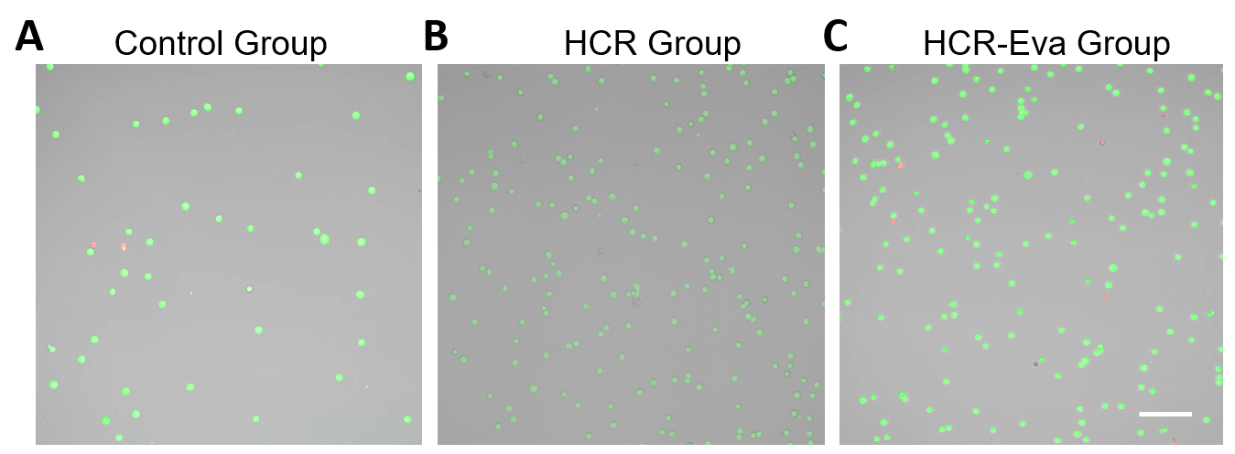
Figure S4. Confocal images of the MCF-7 cells after a two-day reculture for control group, HCR group and HCR-Eva group. The scale bar is 50 μm.

Figure S3. Confocal fluorescence images of the MCF cells after live/dead staining for control group, HCR group and HCR-Eva group. The scale bar is 100 μm.
Figure S5. The sorting purity of the MCF-7 cells acquired by THE-FADS when MCF-7 cells with varying numbers (20, 200, 1000, 2000) were spiked into the Hela cells.

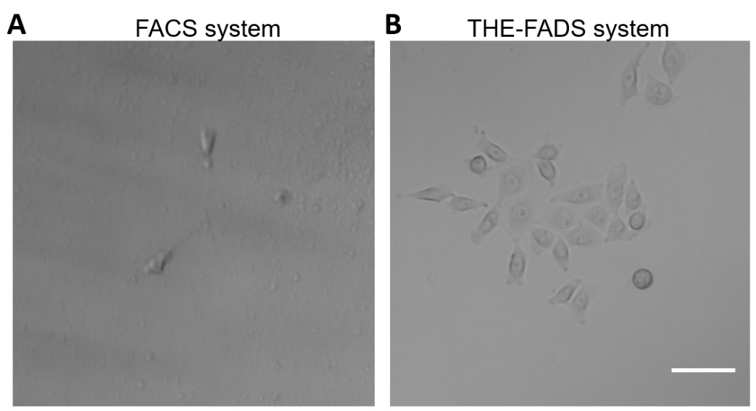
Figure. S7. Confocal images of the MCF-7 cells obtained from FACS (A, left) and THE-FADS (B, right) in PBS solution after three-day reculture. The scale bar is 50 μm.
Figure S6. Regression analysis of the THE-FADS sorted MCF-7 cell number versus the spiked MCF-7 cell number in PBS solution.

Name | Sequence（5’-3’）
Aptamer | CACTACAGAGGTTGCGTCTGTCCCACGTTGTCATGGGGGGTTGGCCTG TTTTTTTTTTTTTTT GCTTATCAGACTGATGTTG
Aptamer-F | CACTACAGAGGTTGCGTCTGTCCCACGTTGTCATGGGGGGTTGGCCTG TTTTTTTTTTTTTTT GCTTATCAGACTGATGTTG-FAM
Tetra-A | ACATTCCTAAGTCTGAAACATTACAGCTTGCTACACGAGAAGAGCCGCCATAGTA TTTTTTTTTTTTTTT CAACATCAGTCTG ATAAGC
Tetra-B | TATCACCAGGCAGTTGACAGTGTAGCAAGCTGTAATAGATGCGAGGGTCCAATAC TTTTTTTTTTTTTTTT GACGAACTAGTT GATGAAGCTG
Tetra-C | TCAACTGCCTGGTGATAAAACGACACTACGTGGGAATCTACTATGGCGGCTCTTC TTTTTTTTTTTTTTTT GACGAACTAGTT GATGAAGCTG
Tetra-D | TTCAGACTTAGGAATGTGCTTCCCACGTAGTGTCGTTTGTATTGGACCCTCGCA TTTTTTTTTTTTTTTTT GACGAACTAGTTG ATGAAGCTG
SubstrateA-F | FAM-GTGTGCCTATTATGTCTCCTCCTGTGTGCCTATTATGTC TCCTCCT CAGCTTCATCAACTAGTT CGTCA
SubstrateA-Q | AACTAGTTGATGAAGCTG GACATAATAGGCACAC GACATA ATAGGCACAC-BHQ1
Assistant-A | GTGCCTATTATGTCGTGTGCCTATTATGTCCAGCTT
SubstrateB-F | AGGAGGA GACATAATAGGCACAC TGACGAACTAGTTG ATG AAGCTG-FAM
SubstrateB-Q | TAMRA-CAGCTTCATCAACTAGGTGTGCCTATTATGTCTC
Assistant-B | GCACACCTAGTTGATGAAGC
CK19-FP | GACTACAGCCACTACTACACGACCAT
CK19-RP | GAGCGGAATCCACCTCCACACT
EGFR-FP | CCAGTGACTGCTGCCACAACCA
EGFR-RP | CGCCGTCTTCCTCCATCTCATAGC
Table S1. Sequences for oligonucleotide used in this work

