Supplementary file 2

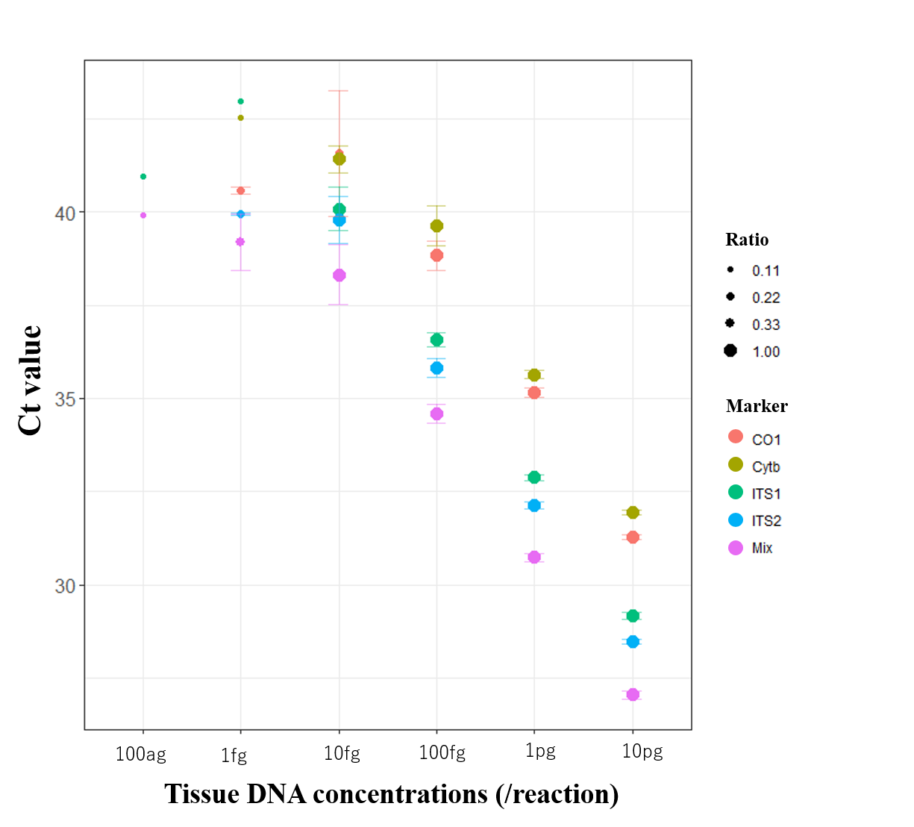

Supplementary file 2. Visualization of LOD test results (positive detection rates and Ct values). The visualization of the LOD test results (positive detection rates and Ct values). The horizontal axis represents the concentration of tissue DNA utilized per well. The vertical axis represents the average Ct values of the Real-time PCR for each assay, with error bars indicating the standard deviation. The size of the plot indicates the probability of detection of PCR performed in nine repeats.

