Supplementary materials

Joint Association of Diet Quality and Physical Activity with Metabolic Syndrome: A Population-Based Cross-Sectional Study in Western China
Xieyire Hamulati^{1†} , Qian Zhao^{1†} , Ying Wang², Munire Mutalifu¹, Lei Deng³, Niyaziaili Adili¹, Fen Liu¹, Yining Yang^{1,2,4*}, Xiaomei Li^{1,4*}

¹ Department of Cardiology, State Key Laboratory of Pathogenesis, Prevention and Treatment of High Incidence Diseases in Central Asia, First Afliated Hospital of Xinjiang Medical University, Urumqi, China.
² Department of Cardiology, People’s Hospital of Xinjiang Uygur Autonomous Region, Urumqi, China.
³ Baoshihua Korla Hospital, Korla, China. 5 Xinjiang Key Laboratory of Cardiovascular Disease Research, Clinical Medical Research Institute of Xinjiang Medical University, Urumqi, China.
⁴ Xinjiang Key Laboratory of Cardiovascular Disease Research, Clinical Medical Research Institute of Xinjiang Medical University, Urumqi, China.

†Corresponding author: 1st ,Prof. Xiao-Mei Li; 2nd, Prof. Yi-Ning Yang
*Contribute equally to this study

Prof. Xiao-Mei Li, State Key Laboratory of Pathogenesis, Prevention and Treatment of High Incidence Diseases in Central Asia, Department of Cardiology, First Affiliated Hospital of Xinjiang Medical University; and Xinjiang Key Laboratory of Cardiovascular Disease Research, Clinical Medical Research Institute of Xinjiang Medical University, Urumqi, China. Email: Tel: 13079926866, Fax: 730718, Email: lixm505@163.com.

Prof. Yi-Ning Yang, PhD, Department of Cardiology, People’s Hospital of Xinjiang Uygur Autonomous Region; State Key Laboratory of Pathogenesis, Prevention and Treatment of High Incidence Diseases in Central Asia, Department of Cardiology, First Affiliated Hospital of Xinjiang Medical University; and Xinjiang Key Laboratory of Cardiovascular Disease Research, Clinical Medical Research Institute of Xinjiang Medical University, Urumqi, China. Email: yangyn5126@163.com.

Additional Table 1 Characteristics of participants according to gender
Variables | Overall  (n=10192) | Male  (n=5251, 51.5%) | Female  (n=4941, 48.5%) | P-value
Age (years) | 47.53±8.98 | 48.58±8.50 | 46.42±9.33 | ＜0.001
Ethnic, n (%) |  |  |  | ＜0.001
Han | 8680 (85.5) | 4603 (87.7) | 4077 (82.5) | -
Others | 1512 (14.8) | 648 (12.3) | 864 (17.5) | -
Marital status, n (%) |  |  |  | ＜0.001
Married | 9547 (93.7) | 5009 (95.4) | 4538 (91.8) | -
Others | 645 (6.3) | 242 (4.6) | 403 (8.2) | -
Education level, n (%) |  |  |  | 0.043
High school or below | 2044 (20.1) | 1094 (20.8) | 950 (19.2) | -
College and above | 8148 (79.9) | 4157 (79.2) | 3991 (80.8) | -
Income level, n (%) |  |  |  | ＜0.001
Low | 203 (2.0) | 76 (1.4) | 127 (2.6) | -
Moderate | 1773 (17.4) | 753 (14.3) | 1020 (20.6) | -
High | 3606 (35.4) | 1689 (32.2) | 1917 (38.8) | -
Very high | 4610 (45.2) | 2733 (25.0) | 1877 (38.0) | -
Smoking status, n (%) |  |  |  | ＜0.001
Never | 7175 (70.4) | 2276 (43.3) | 4899 (99.1) | -
Former | 610 (6.0) | 604 (11.5) | 6 (0.1) | -
Current | 2407 (23.6) | 2371 (45.2) | 36 (0.7) | -
Alcohol drinking, n (%) |  |  |  | ＜0.001
Never/no in past 1 year | 4527 (44.4) | 1278 (24.3) | 3249 (65.8) | -
Sometimes | 4761 (46.7) | 3119 (59.4) | 1642 (33.2) | -
Always | 904 (8.9) | 854 (16.3) | 50 (1.0) | -
PA |  |  |  | ＜0.001
Low | 2282 (22.4) | 1127 (21.5) | 1155 (23.4) | -
Moderate | 4692 (46.0) | 2349 (44.7) | 2343 (47.4) | -
High | 3218 (31.6) | 1775 (33.8) | 1443 (29.2) | -
DQ |  |  |  | 0.050
Poor | 1985 (19.5) | 1070 (20.4) | 915 (18.5) | -
Intermediate | 7584 (74.4) | 3871 (73.7) | 3713 (75.1) | -
Good | 623 (6.1) | 310 (5.9) | 313 (6.3) | -
WC (cm) | 84.53±11.14 | 91.28±8.58 | 77.77±9.14 | ＜0.001
SBP (mmHg) | 126.69±17.59 | 130.76±16.72 | 121.64±17.28 | ＜0.001
DBP (mmHg) | 79.98±12.18 | 83.43±12.00 | 76.24±11.24 | ＜0.001
FPG (mmol·L-1) | 5.36±1.39 | 5.55±1.58 | 5.15±1.12 | ＜0.001
TG (mmol·L-1) | 1.35 (0.92,2.02) | 1.65 (1.15,2.45) | 1.08 (0.78,1.56) | ＜0.001
HDL-c (mmol·L-1) | 1.26±0.30 | 1.16±0.27 | 1.36±0.30 | ＜0.001
WC, Waist circumference; SBP, systolic blood pressure; DBP, diastolic blood pressure; FPG, fasting plasma glucose; HDL-c, high density lipoprotein; TG, Triglycerides.

Additional Table 2 The joint association of physical activity and diet quality score with MetS.
DQ | PA | N | Case (%) | OR (95%CI) | P for trend | P-interaction
Good |  |  |  |  | 0.009 | 0.041
Good | High | 961 | 275 (36.0) | 1.00 (Ref) |  | 0.041
Good | Moderate | 1069 | 339 (44.4) | 1.404 (1.078-1.827) |  | 0.041
Good | Low | 482 | 150 (19.6) | 1.326 (1.077-1.632) |  | 0.041
Intermediate |  |  |  |  | <0.001 | 0.041
Intermediate | High | 2131 | 606 (27.6) | 1.00 (Ref) |  | 0.041
Intermediate | Moderate | 3404 | 1132 (51.7) | 1.195 (1.022-1.398) |  | 0.041
Intermediate | Low | 1654 | 453 (20.7) | 1.408 (1.239-1.601) |  | 0.041
Poor |  |  |  |  | 0.643 | 0.041
Poor | High | 126 | 39 (41.9) | 1.00 (Ref) |  | 0.041
Poor | Moderate | 219 | 77 (40.1) | 0.876 (0.500-1.534) |  | 0.041
Poor | Low | 146 | 57 (29.7) | 0.703 (0.419-1.179) |  | 0.041
Adjusted for sex, age, married status, education level, smoking status, alcohol consumption.
MetS metabolic syndrome, PA physical activity, DQ diet quality.

Additional Table 3 The joint association of physical activity and diet quality score with MetS
DQ | PA | N | Case (%) | OR (95%CI) | P value | P-interaction
Good | High | 961 | 275 (36.0) | 1.00 (Ref) | - | 0.012
Good | Moderate | 1069 | 339 (44.4) | 2.142 (1.441-3.183) | 0.005 | 0.012
Good | Low | 482 | 150 (19.6) | 2.903 (1.709-4.929) | ＜0.001 | 0.012
Intermediate | High | 2131 | 606 (27.6) | 1.560 (1.145-2.127) | ＜0.001 | 0.012
Intermediate | Moderate | 3404 | 1132 (51.7) | 1.995 (1.470-2.707) | ＜0.001 | 0.012
Intermediate | Low | 1654 | 453 (20.7) | 1.822 (1.328-2.501) | ＜0.001 | 0.012
Poor | High | 126 | 39 (41.9) | 2.935 (1.723-4.999) | ＜0.001 | 0.012
Poor | Moderate | 219 | 77 (40.1) | 2.510 (1.807-3.486) | ＜0.001 | 0.012
Poor | Low | 146 | 57 (29.7) | 2.247 (1.577-3.203) | ＜0.001 | 0.012
Adjusted for sex, age, married status, education level, income level, smoking status, alcohol consumption.

Additional.Figure 1 Logistic regression analysis results of influencing factors. PA, physical activity; DQ, diet quality.

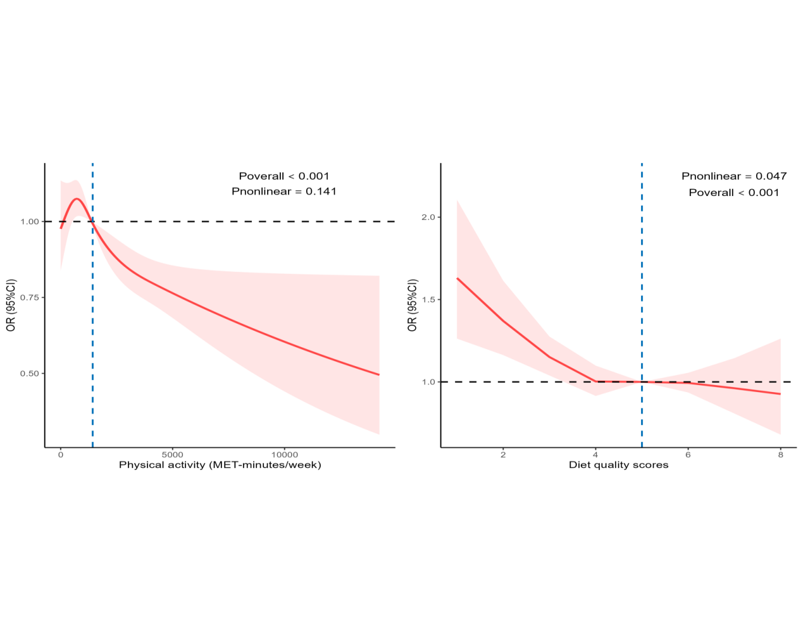
Additional.Figure 2 Dose-response association between physical activity, diet quality score with MetS. Adjusted for sex, age, education level, smoking status, alcohol consumption and diet quality score or physical activity.

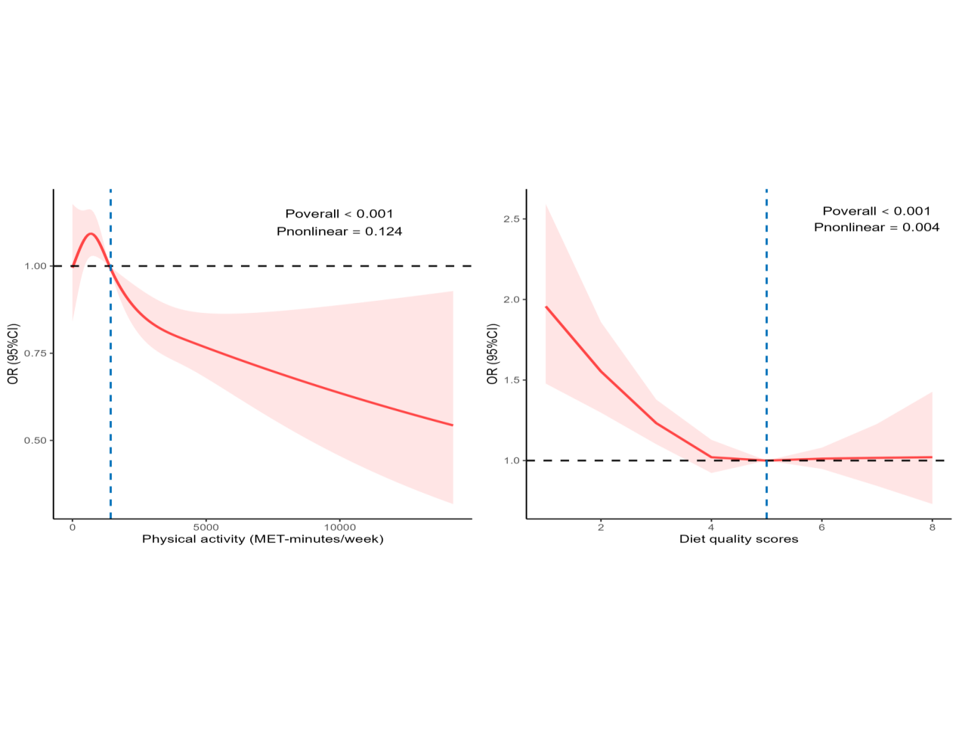
Additional.Figure 3 Dose-response association between physical activity, diet quality score with MetS in different diagnostic standard. Adjusted for sex, age, education level, smoking status, alcohol consumption and diet quality score or physical activity.

