eFig. 1 Flow chart for patient selection
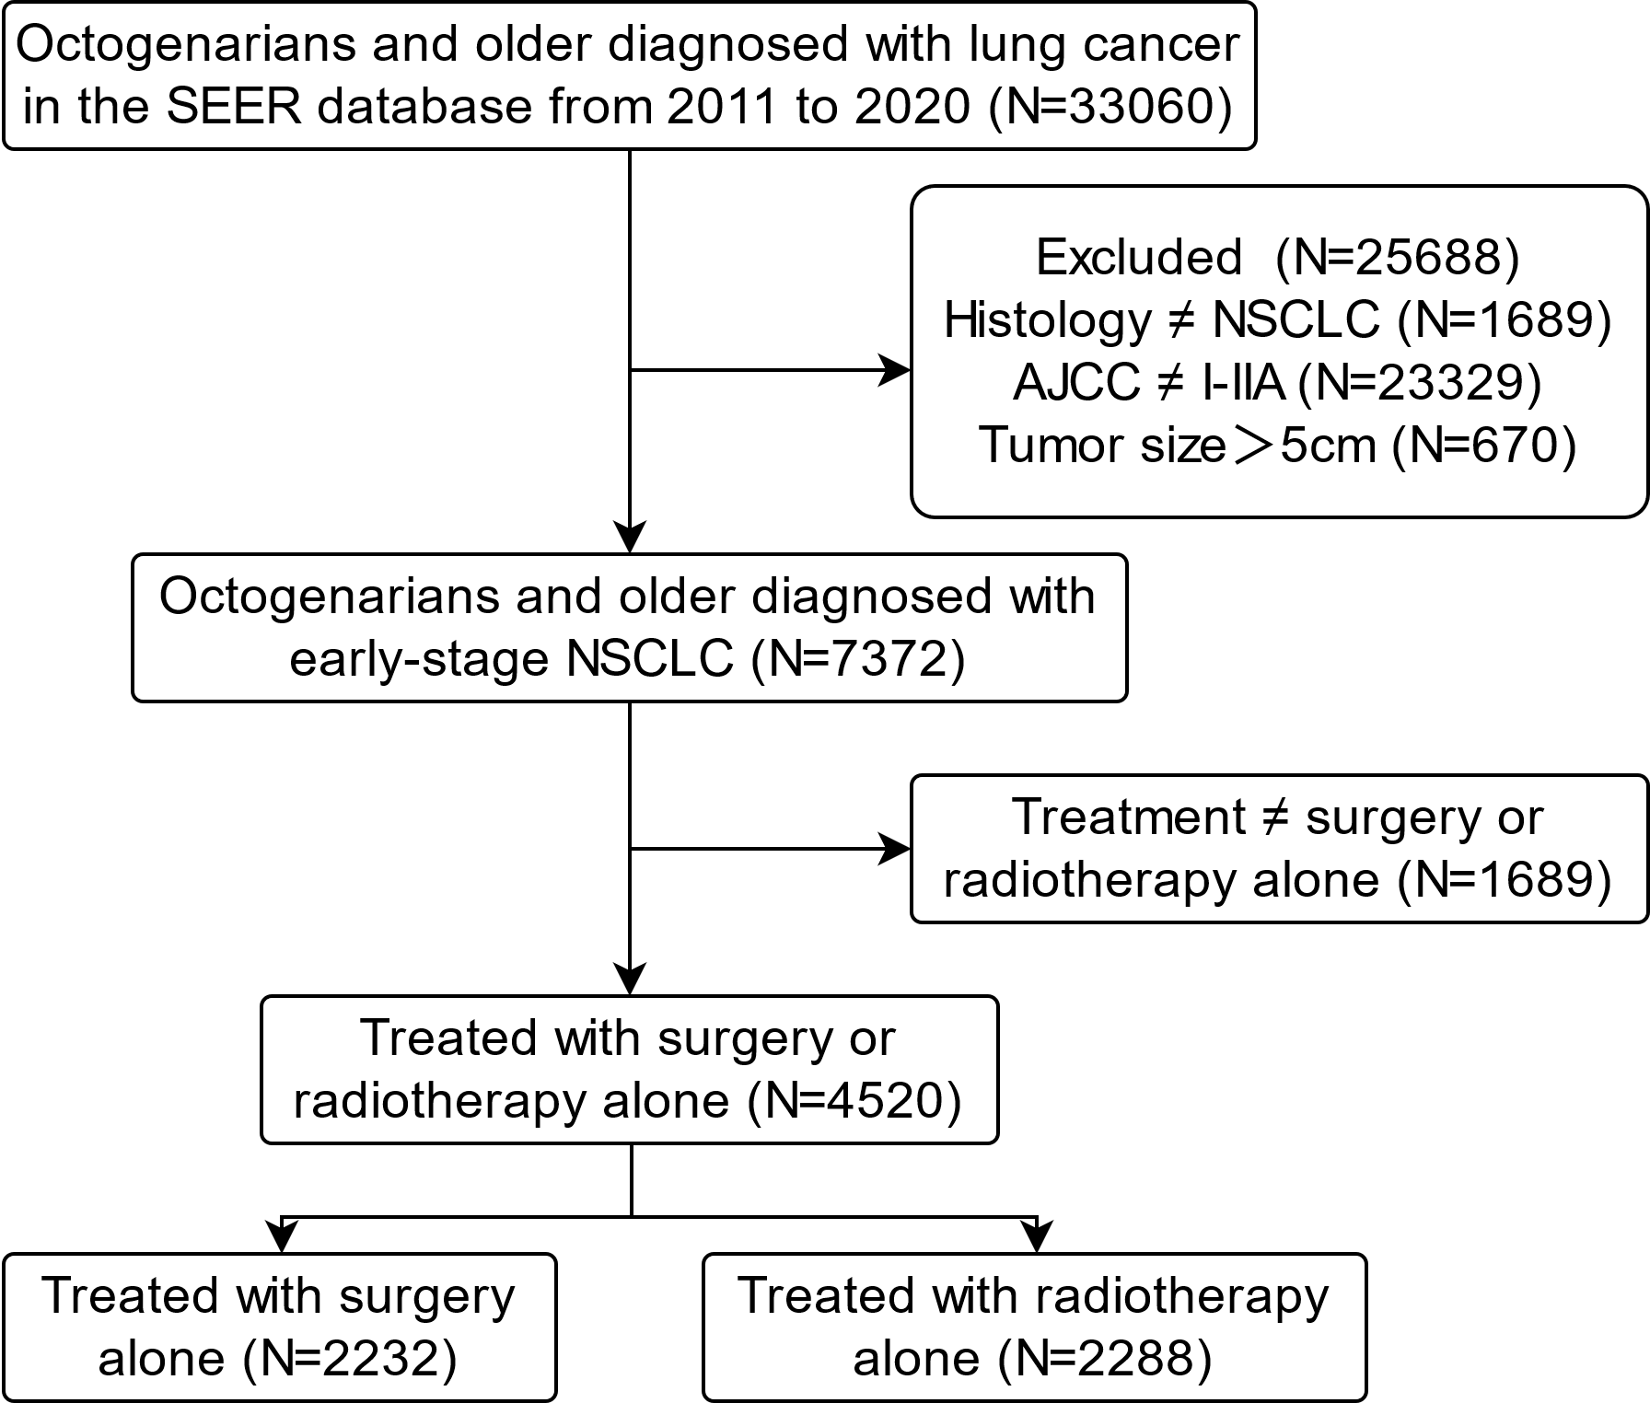
eFig. 2 Comparison of OS and CSS between surgery and radiotherapy by tumor size
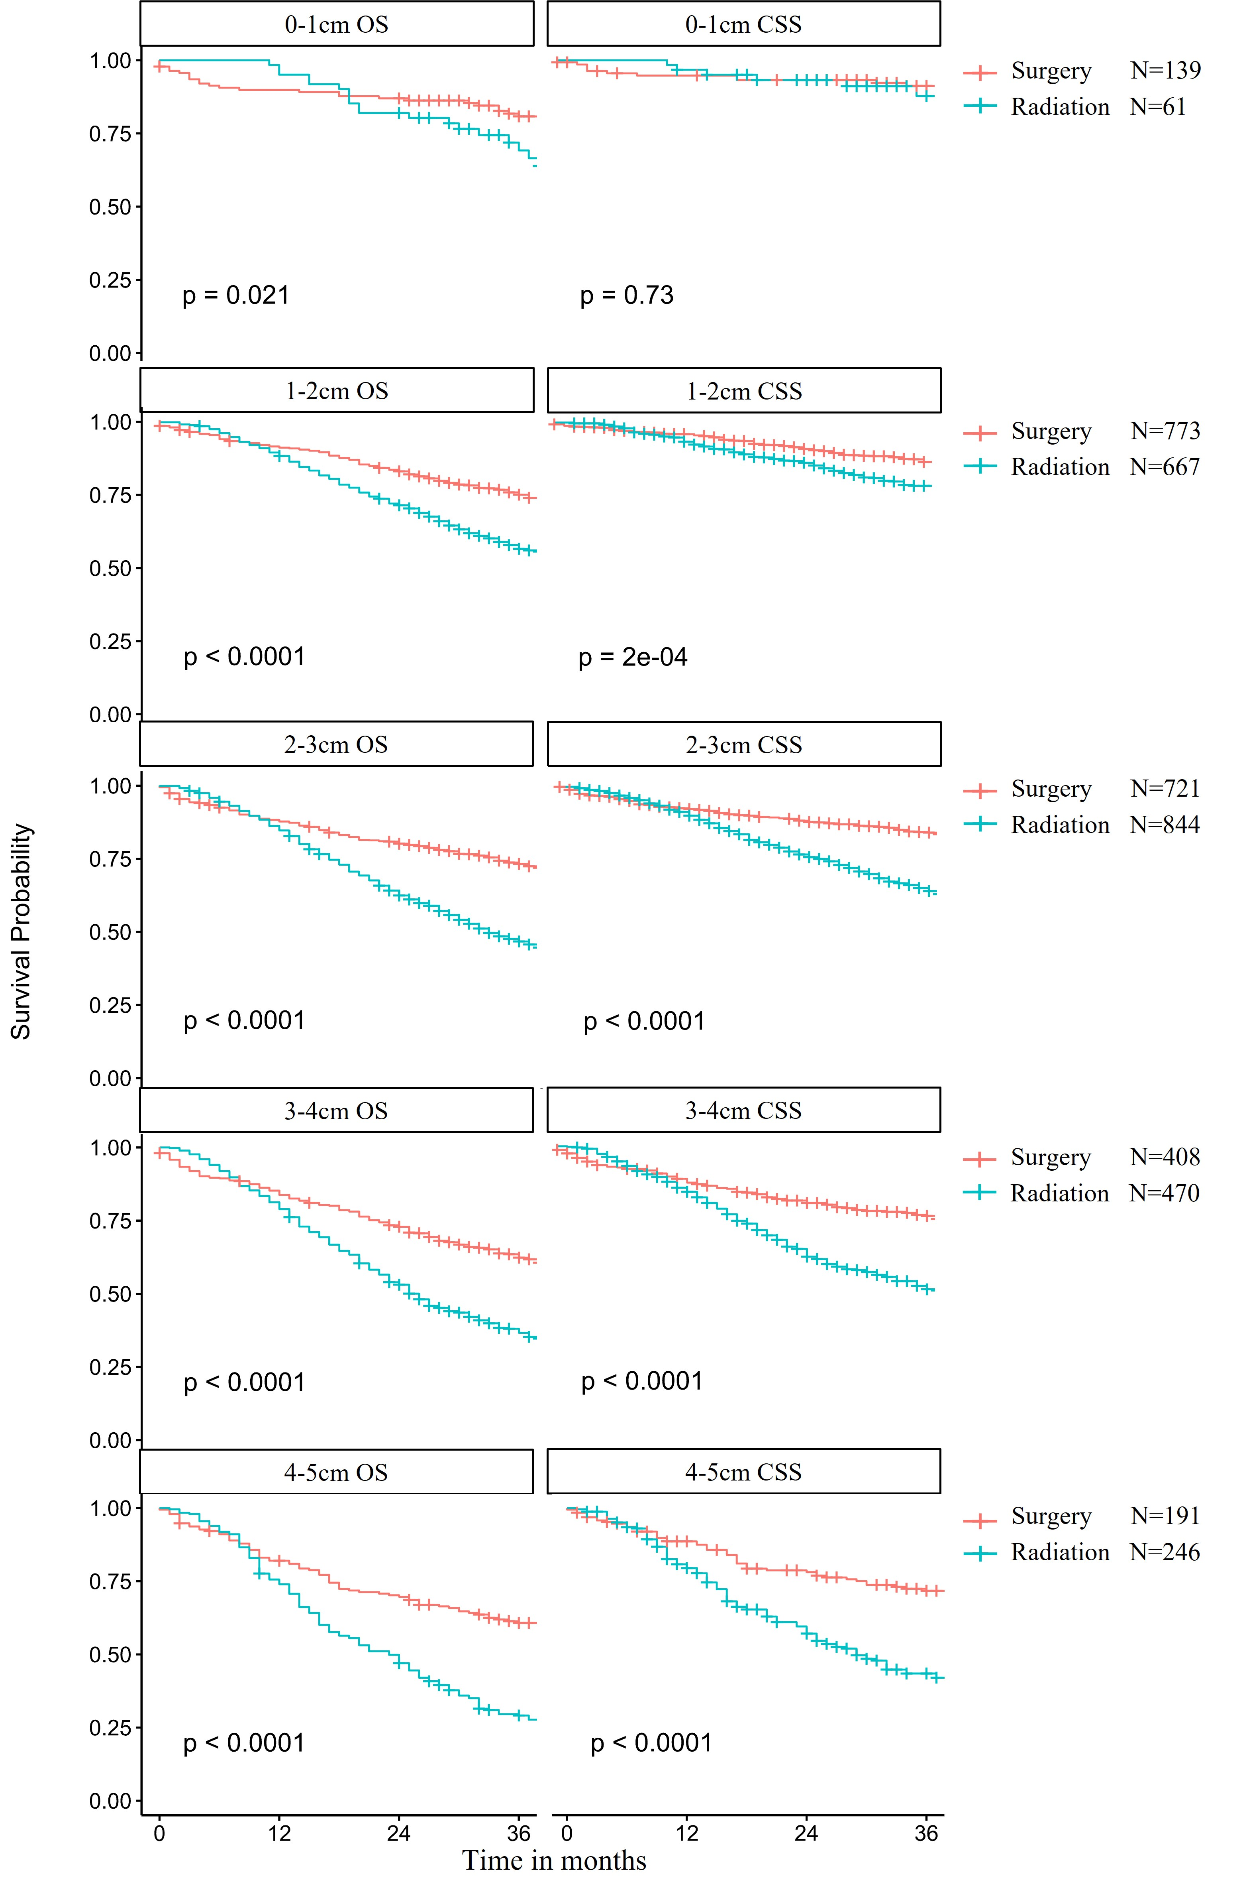
eTable 1 Comparison of OS and CSS between surgery without LNE and radiotherapy by tumor size
 | Before PSM |  |  |  |  | After PSM
 | N |  | P value |  |  | N |  | P value
Size(cm) | Radiation | Surgery | OS | CSS |  | Radiation | Surgery | OS | CSS
0-1 | 61 | 70 | 0.19 | 0.94 |  | 25 | 70 | 0.12 | 0.9
1-2 | 667 | 351 | <0.001 | 0.065 |  | 178 | 351 | <0.001 | 0.011
2-3 | 844 | 234 | <0.001 | 0.00068 |  | 159 | 234 | <0.001 | 0.021
3-4 | 470 | 117 | 0.0015 | 0.023 |  | 74 | 117 | 0.0062 | 0.037
4-5 | 246 | 42 | 0.00061 | 0.0037 |  | 37 | 42 | 0.028 | 0.058
eTable 2 Comparison of OS and CSS between surgery and radiation (refused surgery) by tumor size
 | Before PSM |  |  |  |  | After PSM
 | N |  | P value |  |  | N |  | P value
Size(cm) | Radiation | Surgery | OS | CSS |  | Radiation | Surgery | OS | CSS
0-1 | 2 | 139 | The sample size is too small to analyze
1-2 | 48 | 773 | 0.057 | 0.45 |  | 48 | 48 | 0.11 | 0.73
2-3 | 62 | 721 | 0.00024 | 0.00088 |  | 62 | 62 | 0.012 | 0.032
3-4 | 43 | 408 | 0.01 | 0.00017 |  | 43 | 43 | 0.0078 | 0.0011
4-5 | 21 | 191 | 0.096 | 0.53 |  | 21 | 21 | 0.51 | 0.95

