Supplementary materials

Supplementary Table 1

RA | Irregularly enlarged capillaries | Giant  capillaries | Haemorrhages | Loss of  capillaries | Disorganisation of the vascular array | Capillary  ramifications | Total scores
CTD-non-PAH | 0.18±0.46 | 0 | 0.16±0.38 | 0.29±0.57 | 1.03±0.60 | 0.99±0.80 | 2.65±1.62
CTD-PAH | 0.50±0.76 | 0 | 0.50±0.50 | 0.36±0.63 | 1.35±0.56 | 1.36±0.69 | 4.07±1.20
P value | 0.107 | - | 0.034 | 0.769 | 0.185 | 0.251 | 0.029
Differences in nailfold videocapillaroscopy score between CTD-PAH and CTD-non-PAH in rheumatoid arthritis were analyzed by Student's t-test, and score were expressed as mean ± standard deviation, with P<0.05 considered statistically different, CTD-PAH pulmonary arterial hypertension associated with connective tissue disease, CTD-non-PAH connective tissue disease not complicated with pulmonary arterial hypertension, RA rheumatoid arthritis.

Supplementary Table 2

SS | Irregularly enlarged capillaries | Giant  capillaries | Haemorrhages | Loss of  capillaries | Disorganisation of the vascular array | Capillary  ramifications | Total scores
CTD-non-PAH | 0.47±0.80 | 0.10±0.36 | 0.48±0.66 | 0.44±0.73 | 1.21±0.78 | 0.97±0.88 | 3.66±2.56
CTD-PAH | 0.82±1.09 | 0.39±0.68 | 1.04±1.00 | 1.46±1.15 | 1.39±0.78 | 1.29±0.87 | 6.39±4.02
P value | 0.187 | 0.034 | 0.018 | 0.000 | 0.452 | 0.240 | 0.003
Differences in nailfold videocapillaroscopy score between CTD-PAH and CTD-non-PAH in Sjögren's syndrome were analyzed by Student's t-test, and score were expressed as mean ± standard deviation, with P<0.05 considered statistically different, CTD-PAH pulmonary arterial hypertension associated with connective tissue disease, CTD-non-PAH connective tissue disease not complicated with pulmonary arterial hypertension, SS Sjögren's syndrome.

Supplementary Table 3
 | Rheumatoid Arthritis | Systemic Lupus Erythematosus | Dermatomyositis | Sjögren's Syndrome | Systemic Sclerosis | All  Participants
CTD-non-PAH | 10.35±3.36 | 13.67±11.54 | 15.67±7.37 | 12.15±4.27 | 21.57±10.76 | 14.41±9.25
CTD-PAH | 11.48±4.33 | 14.04±6.52 | 20.74±4.88 | 16.74±10.11 | 22.74±7.26 | 17.06±8.22
P value | 0.420 | 0.896 | 0.139 | 0.016 | 0.705 | 0.044
Differences in capillary diameter between CTD-PAH and CTD-non-PAH were analyzed by Student's t-test, and diameter were expressed as mean ± standard deviation, with P<0.05 considered statistically different, CTD-PAH pulmonary arterial hypertension associated with connective tissue disease, CTD-non-PAH connective tissue disease not complicated with pulmonary arterial hypertension.

Supplementary Table 4
 | Age | PLT | nailfold videocapillaroscopy Score | TSH
OR | 1.026 | 0.991 | 1.113 | 1.099
95% CI | 1.003~1.049 | 0.987~0.996 | 1.012~1.224 | 1.002-1.205
P value | 0.028 | 0.000 | 0.027 | 0.016
The OR and 95% CI of risk and protective factors associated with the development of pulmonary hypertension are presented in the table, and one-way regression analyses with P values <0.05 were included in the logistic regression equations, and P<0.05 was considered statistically significant, PLT platelet, TSH thyroid-stimulating hormone, OR odd ratio, CI confidence interval.

Supplementary Figure 1
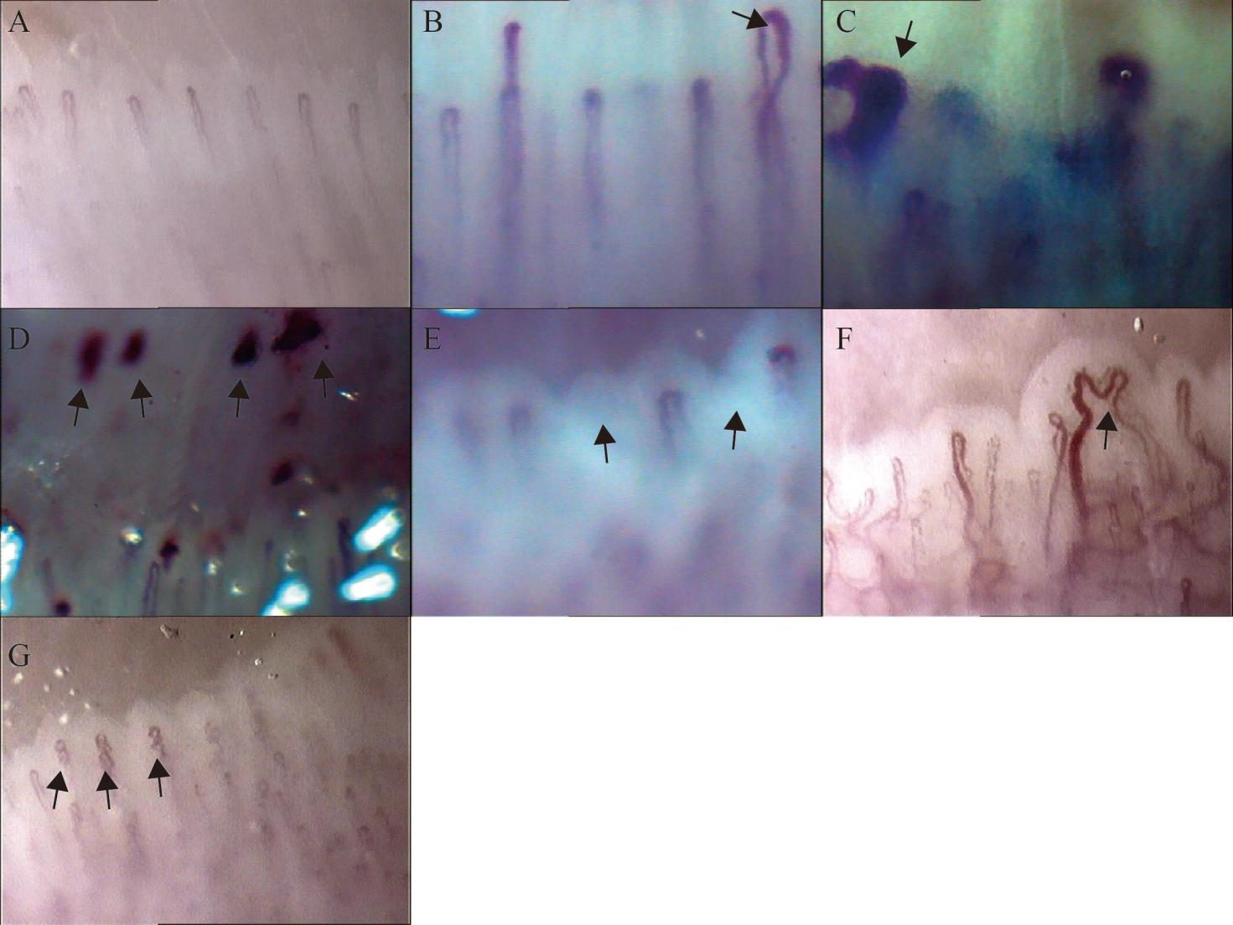
Representative images of nailfold videocapillaroscopy abnormality assessment, (A) normal nailfold videocapillaroscopy image, (B) Irregularly enlarged capillaries: Capillary diameter (homogeneous or irregular) >20μm, (C) Giant capillaries:homogeneously enlarged capillary loops of 50μm, (D) Haemorrhages;Dark spots formed by hemosiderin deposits, (E) Loss of capillaries:capillaries below normal density (7 capillary loops per field of view), (F)Disorganisation of the vascular array:irregular distribution and morphology of capillary loops, (G)Capillary ramifications:branches and convolutions of capillary loops. (nailfold videocapillaroscopy images with a 200× magnification)

Supplementary Figure 2
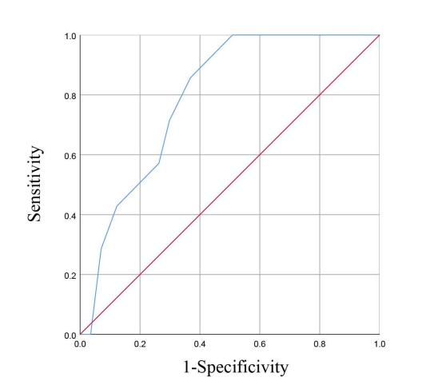
ROC curve of nailfold videocapillaroscopy score for PAH in rheumatoid arthritis was obtained from ROC analysis, AUC and cut-off values were acquired, P<0.05 was considered statistically significant, PAH pulmonary arterial hypertension, ROC receiver operating characteristic, AUC Area under the curve.

Supplementary Figure 3
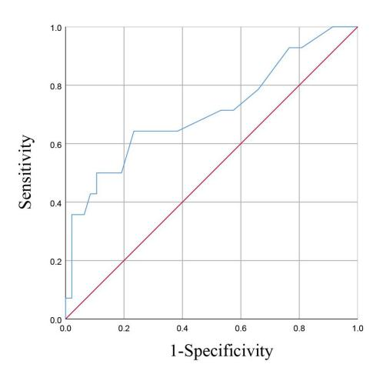
ROC curve of nailfold videocapillaroscopy score for PAH in Sjögren's syndrome was obtained from ROC analysis, AUC and cut-off values were acquired, P<0.05 was considered statistically significant, PAH pulmonary arterial hypertension, ROC receiver operating characteristic, AUC Area under the curve.

