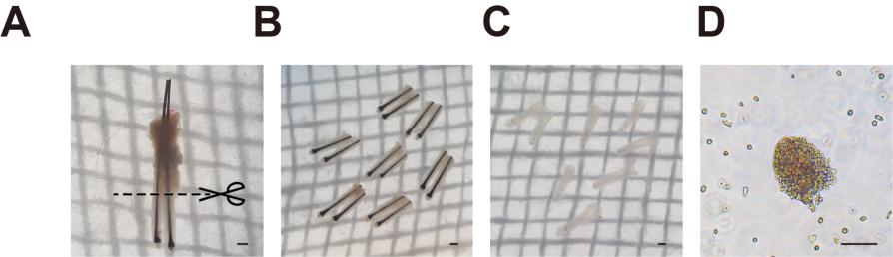
Fig. S1. Harvesting of dermal papilla (DP) spheres from human scalp hair follicles by ficoll density gradient sedimentation (FDGS). (A) Human hair follicles obtained using follicular unit extraction. (B) Lower part was transferred into new plate containing 0.25% dispase solution and incubated for 30–60 min. (C) Collected dermal component using #5 forceps after enzymatic digestion. (D) Mixed cell suspension of DP spheres and dermal sheath cells before Ficoll PM400 density separation treatment.

